Kevin Wong

November 26, 2019

Foundations of Programming: Python

University of Washington

Professor: Randal Root

Assignment 08 – Objects and Classes

GitHub Repository Link: https://github.com/mynameiswong/IntroToProg-Python-Mod08

**Introduction**

For assignment 8, we are provided a starter code to modify and make our own and complete. The code is similar to previous assignments where the user is provide a menu of options to view, add and save a list in a text file. We are then required to post our work on our GitHub repository for others to review. This time, we will installing GitHub Desktop to post our work to GitHub.

**Assignment**

In this assignment, we are provided a started code to complete. Reading the psuedocode, we see that we are to provide the user a menu of options to view, add, delete or save to a text file, “products.txt”. The text file consist of two columns of data. The first column is the product name and second colum is the products price.

Starting the script in the command shell, we can see user is provided 6 options, as shown in Figure 1.

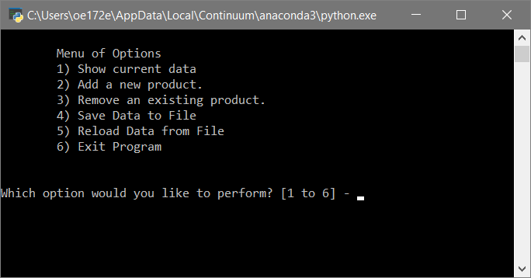

**Figure 1. Screenshot of the scipt starting out and providing the user a menu of options.**

The script also loads the data from the text file “products.txt” in the list of dictionary rows. The opened text file from Windows is shown in Figure 2.

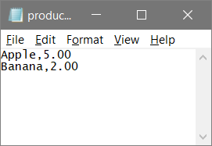

**Figure 2. Screenshot of text file “products.txt”.**

If the user selects option 1, the script will print out the loaded dictionary row, as shown in Figure 3.

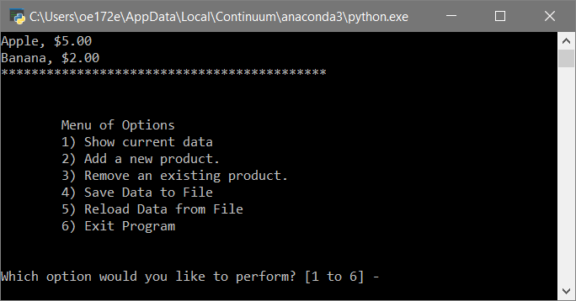

**Figure 3. Screenshot when Option 1 is selected to show current data.**

Next, if the user chooses option 2 to add a new product, he/she will be prompted for the products name and then for the products price. In our case, the user decides to add the product “Orange” with the price of “3”. This example is shown in Figure 4.

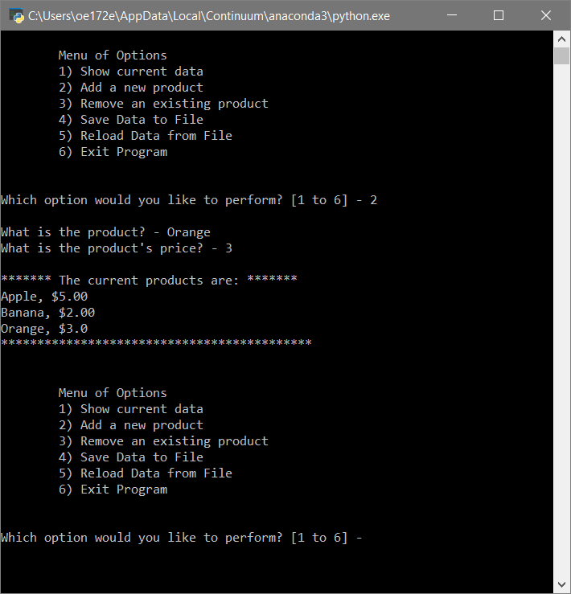

**Figure 4. Screenshot when Option 2 is chosen to add a new product.**

To save the data in to the ext file, the user can then choose option 4. The script will prompt the user to confirm that he/she really want to save the data. A “y” input will saved the data. This is shown in Figure 5.

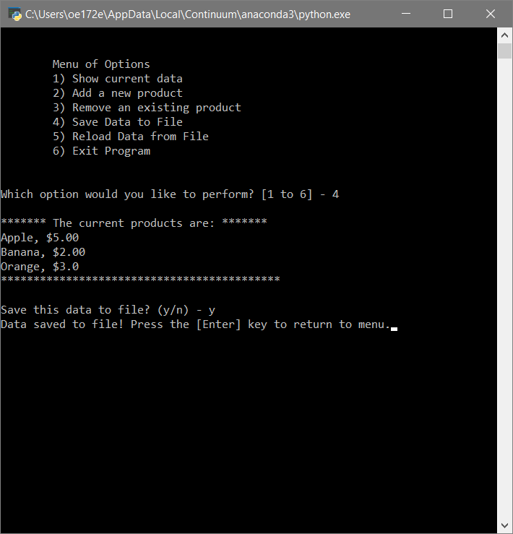

**Figure 5. A screenshot when option 4 is selected to save the data.**

This assignment also ask of use to InstallGitHub Desktop and use it to log into our GitHub account. We will then create a repository for Module 8 on our local computer using the GitHub Desktop. Creating a repository this way will create a new folder on our computer. We can then upload our assignment work uing the GitHub Desktop.

**Summary**

I found classes and objects in python very useful and I can see the benefits of using them. But I found trying to understand this topic has been very challenging. I still feel I haven’t grasp the complete knowledge of classes. I initially stumbled and had a hard time wrapping my head around all the new symantics and definations. For example, in a class a function is called a method. And data is fields. I’m not sure why they have to give it a new name, but it just added to the confusion, especially when learning something new.

**Readings**

1. **Chapter 8 ofPython Programming for the Absolute Beginner(Third Edition) by Michael Dawson.**

## **Module 8 PDF - _Mod8PythonProgrammingNotes.pdf**

# A Beginner's Python Tutorial/Classes

# <https://en.wikibooks.org/wiki/A_Beginner%27s_Python_Tutorial/Classes>

**Videos**

# Python Mod8 Project by Randal Root

# <https://youtu.be/ZnTabY0Z-XE>

# Starting Assignment08 by Randal Root

# <https://youtu.be/Zmgsg6HPxSM>

# [Python OOP Tutorials - Working with Classes](https://www.youtube.com/watch?v=ZDa-Z5JzLYM&list=PL-osiE80TeTsqhIuOqKhwlXsIBIdSeYtc)

<https://www.youtube.com/playlist?list=PL-osiE80TeTsqhIuOqKhwlXsIBIdSeYtc>

1. **Git and GitHub**

<https://youtu.be/IHaTbJPdB-s>

1. **GitHub Desktop (for Everyone)**

<https://youtu.be/77W2JSL7-r8>

1. **GitHub Desktop (for Mac students only)**

<https://youtu.be/oT1QweCzHB4>