Name: Izz Hafeez Bin Zek Hazley

Student Number: A0234693X

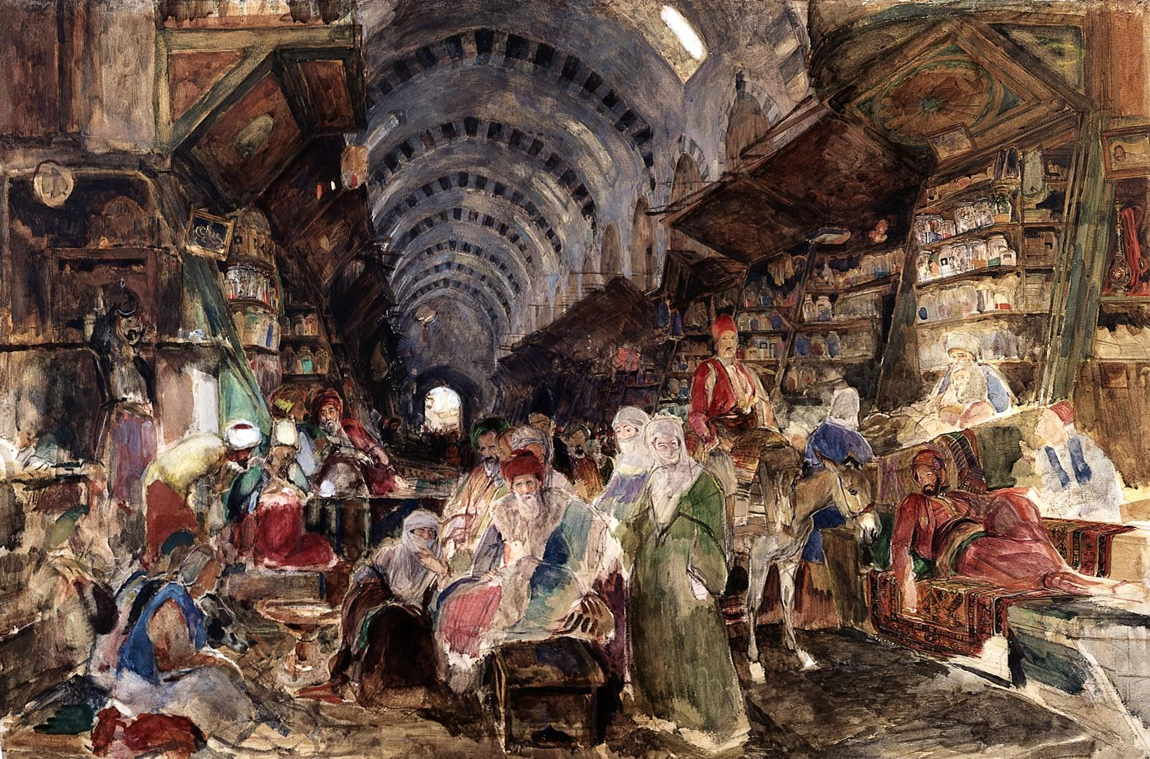

This watercolour painting depicts a typical sight at Istanbul’s Grand Bazaar. Having served as Istanbul’s commercial centre, I have chosen the marketplace to demonstrate Istanbul’s role as a “Commercial City”.

The diverse selection of silk and spices in the background indicates that Istanbul was rich in trade and had extensive global influence. Like Melaka’s control over the China-India trade route, this success can partly be attributed to Istanbul’s geographic position along key trade routes. Specifically, Istanbul’s control over lucrative trade routes such as the Silk Road had turned it into a central hub for both Eastern and Western merchants. (Lybyer, 1915)

As seen in the painting, a large proportion of traders was Muslim, which also contributed to Istanbul’s success as a commercial hub. Under a unified set of Islamic rules for conducting trade, many regional merchants found it easier to sell their goods in the market. There was also trust amongst Muslim merchants, as they would often look after each other’s belongings when they went for prayers.

Apart from religion, the guild system also fostered trust and mutual understanding between traders. It controlled the price and quality of goods, and provided materials to its members (Wohl, 2015). This system of trade contributed to the sustained stability and reliability of Istanbul as a trading hub, which was necessary for retaining merchants.

Lastly, the painting also illustrates that the market was covered, which was uncommon at the time (Kramer, Kathryn & Rennie Short, John., 2011). Both the merchants and their goods are protected, hence leading to its popularity.

[249 words]

*Citations*

1. “File:Stamboul Bazaar; by J.F. Lewis Wellcome L0027290.Jpg ...,” accessed February 13, 2022, <https://commons.wikimedia.org/wiki/File:Stamboul_bazaar;_by_J.F._Lewis_Wellcome_L0027290.jpg?uselang=fr>.
2. Sharon Wohl, “The Grand Bazaar in Istanbul: The Emergent Unfolding of A Complex Adaptive System,” DSpace Angular, accessed February 13, 2022, <https://dr.lib.iastate.edu/entities/publication/20c6f72d-ca1c-473a-ac58-aa436d57e451>.
3. Lybyer, A. H. “The Ottoman Turks and the Routes of Oriental Trade.” *The English Historical Review* 30, no. 120 (1915): 577–88. <http://www.jstor.org/stable/551296>.
4. Kramer, Kathryn & Rennie Short, John. (2011). Flânerie and the globalizing city. City. 15. 322-342. 10.1080/13604813.2011.595100.

*Lecture Material*

1. Lecture 3.1 Melaka
2. Lecture 3.2 Amsterdam
3. Lecture 5 Ancient Invisible Cities: Istanbul (2018)