ONLINE ELECTION COMMISSION

MANAGEMENT SYSTEM

DELHI

Sofware Requirement

Team:

Rahul Kumar

12bce0427

**Table of Contents**

1. Introduction 4

1.1 Purpose 4

1.2 Scope 4

1.3 Definitions, Acronyms and Abbreviations 4

1.4 References 4

1.5 Overview 4

2. Overall Description 5

2.1 Use-Case Model Survey 5

2.1.1 Actors 8

2.1.2 Use-Cases 8

2.1.3 Use-Case Risk List 8

2.1.4 Use-Case Specifications 8

2.1.4.1 Vote 8

2.1.4.2 Save 10

2.1.4.3 Update 11

2.2 Assumptions and Dependencies 12

3. Specific Requirements 12

3.1 Functionality 12

3.2 Usability 12

3.3 Reliability 12

3.4 Performance 12

3.5 Supportability 12

3.6 Design Constraints 12

**Software Requirements Specification**

**1.Introduction**

**1.1 Purpose:**

This Software Requirements Specification document describes the behavior and requirements of the “Election Management System” software package.

1.2 Scope

This SRS document applies to the “Election Management System” software package

## 1.3 Definitions, Acronyms and Abbreviations

Admin: An administrator.

Candidate: A person who seeks or is nominated for an office.

Cast: The process by which one votes.

Database: A collection of data arranged for ease and speed of retrieval or search.

Election: The selection of a person or persons for office by vote, or a public vote on a proposed submittal.

Electorate: The body of persons enlisted to vote in an election.

Jurisdiction: The territory over which an election occurs.

Poll: The place where votes are taken.

Referendum: A measure proposed or passed by a legislative body to the vote of the electorate for approval or rejection.

## 1.4References

None.

## Overview

The remainder of this document identifies the actors, use-cases, use-case scenarios, activity diagrams, assumptions and dependencies needed for the analysis and design of the “Election Management System” software package. All diagrams conform to UML standards

# Overall Description

## Use-Case Model Survey

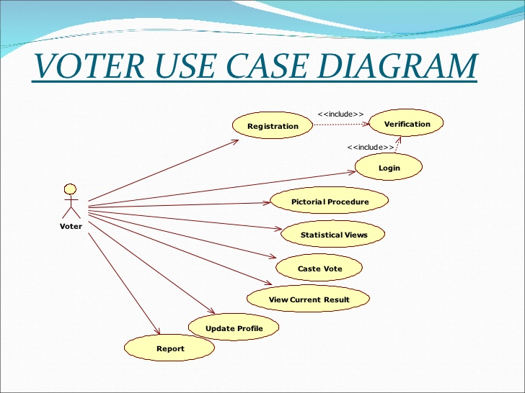

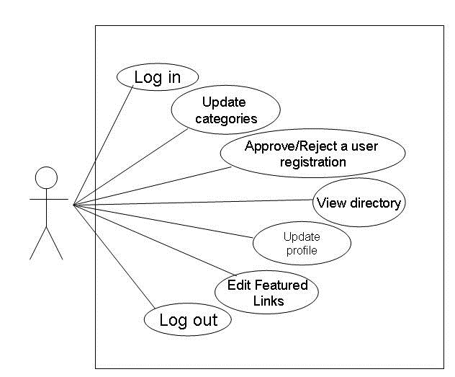

**Fig2-Administrator model**

### Actors

Voter: A member of the electorate, one who uses the “Electronic Commission Management ” software to form a voter card

Admin: A hired employee or volunteer for the agency sponsoring a vote, one who administrates the “Election Management Commission” software.

Database: A database for storing of sensitive vote id information and officer information.

Printer: A secure printer.

### Use-Cases

Voter id : This use-case describes the process by which a voter id creation.

Activate: This use-case describes the process of verifying a voter’s eligibility to vote. It ensures the voter is a member of the electorate.

Save: This use-case describes the process by which the system securely records a voter’sinformation to the database.

Print: This use-case describes the process the system uses to print a paper record, or audit trail, of a voter’s information.

Info: This use-case describes the process through which a voter may obtain vote-specific information during the general voter id procedure.

Update: This use-case describes the process by which an admin may add, remove or update voter id information

Initialize: This use-case describes the process through which the system first initializes during startup.

Login: This use-case describes the process of verifying an administrator’s identity. It ensures that the admin is allowed access to the non-voting capabilities of the “Election management System” software package.

### Use-Case Risk List

Highest: Vote, Save

Average: Update, Info, Print

Lowest: Initialize, Activate, Login

### Use-Case Specifications

### Vote id

* **Brief Description**

This use-case describes the process by which a voter id creation

* **Actors**

Voter

* **Dependencies**

Activate, Save, Print, Info

* **Basic Flow of Events: Voting, No Changes**

1. The use-case begins when a voter selects “Vote id creation”.
   * The system verifies the voter through the “Activate” use-case.
2. While there are more items on the Voter id
   * The system displays the current voter item fill and options.
   * The voter selects an option.
   * The voter presses the “Submit ” button.
   * The system retrieves the voter if information

### Save

* **Brief Description**

This use-case describes the process by which the system securely records a voter’s id information to the database.

* **Actors**

Database

* **Dependencies**

None.

* **Basic Flow of Events: Saving, No Errors**

1. The use-case begins when called from the “Voter id ” use-case.
2. The system checks the voter id and choices for data integrity.
3. The system creates a voter id record.
   * The system calculates a unique record signature.
4. The system encrypts the record.
5. The system adds the record to the Database.
   * The system checks to verify that the record was saved correctly.
   * The system checks the Database to ensure there is enough space for the next record.
6. The system displays a message confirming the voter’s ballot has been cast.
7. The use-case ends.

### Update

* **Brief Description**

This use-case describes the process by which an admin may add, remove or update voter id and officer location items.

* **Actors**

Administrator

* **Dependencies**

Login

* **Basic Flow of Events: Update, Multiple Ballot Items**

1. The use-case begins when an admin selects “Update”.
   * The system verifies the admin through the “Login” use-case.
2. While the admin does not press the “Logout” button:
   * The system displays options for possible administrative action.
   * The admin presses the “Update voter id Item” button.
   * The system displays a list of voter id to be updated.
   * The admin chooses a voter id and officer information
   * The admin enters new information for the ballot item.
   * The admin presses the “Update” button.
     + The system updates the ballot item information.
3. The system closes the session.
4. The use-case ends.

## Assumptions and Dependencies

* The Database system is fully functional and has enough space for at least 100 voter id.
* It can store at least five polling station officer information.
* The Printer device is fully functional and has the capability to print at least one audit trail.

# Specific Requirements

## Functionality

1. **The details about the related constituencies of the district.**
2. **The details about the polling booths in the respective constituency such as normal booths, sensitive booths, hyper sensitive booths.**
3. **The details of the EVM Machine is fed into the computer.**
4. **The Voter id creation**
5. **officers such that non of the polling officers will have the duty in their residential area and their working area**

* be possible through special means.

## Usability

* A voter may only create a one voter id if they are eligible to vote.
* A officer place at only polling both.

## Reliability

* The “Election management System” software will be available for voter use only during normal aelection During this time it shall be operational for as long as is possible.
* Administrators will have 24 hour access to the system.

## Performance

* The “Election management System” software package will perform all functions with minimal delay from the time of the initial request.
* The software will only accommodate one user at a time. No simultaneous use of the system by multiple voters, administrators, or a combination thereof shall be allowed.

## Supportability

The “Election management System” software shall have a clear and easily maintainable interface for managing election specific updates.

## Design Constraints

Due to the sensitive nature of the information handled by the “Electronic Voting System” software, a good deal of specific design constraints will be taken into consideration:

* The system shall only have the ability to write vote id (not read).
* The system shall not have the ability to overwrite any previously written vote id.
* Officer information.