Week3 Practical
Task 1) Document Modeling — create a book_metadata collection with embedded patterns (reviews list inside the book document) and referenced patterns (linking to member_id in SQL). 2) Advanced Querying — use comparison operators ($gt, $in) to find books rated above 4, and a regex query to find books with "Digital" formats. 3) Aggregation Pipeline — match books published after 2020, $unwind the reviews array, then $group by title and compute the average rating. 4) Indexing for Speed — create a text index on the review comments field and use .explain() to check whether the query uses the index.
- Document Modeling
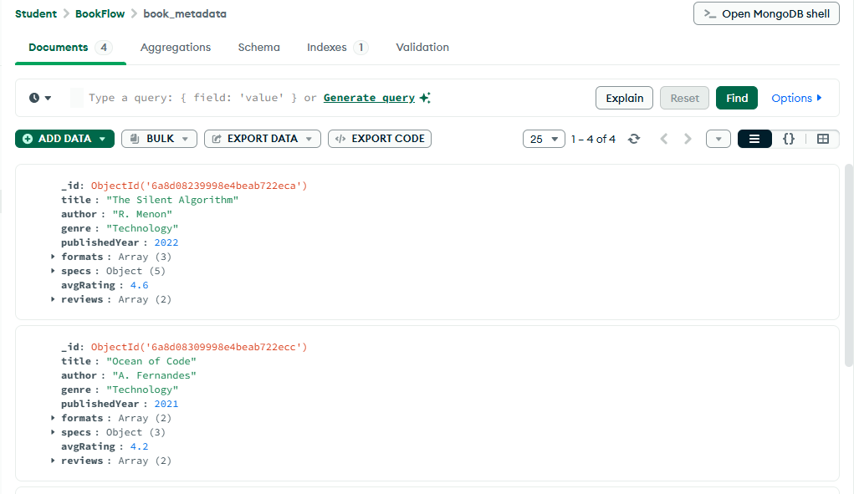
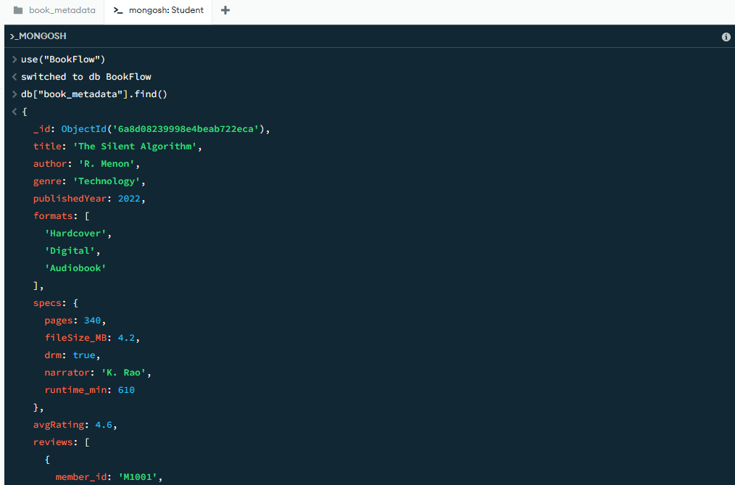
Task2: Advanced Querying

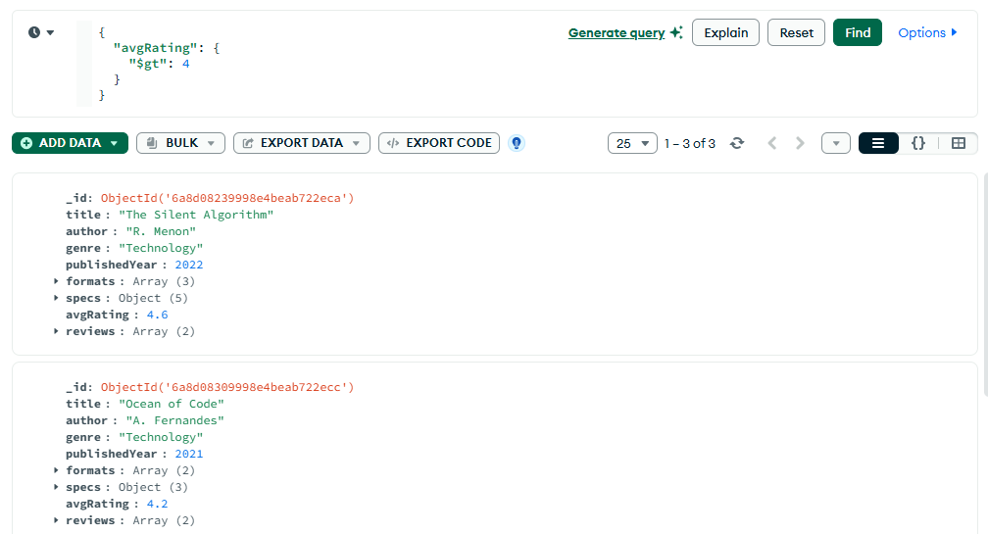
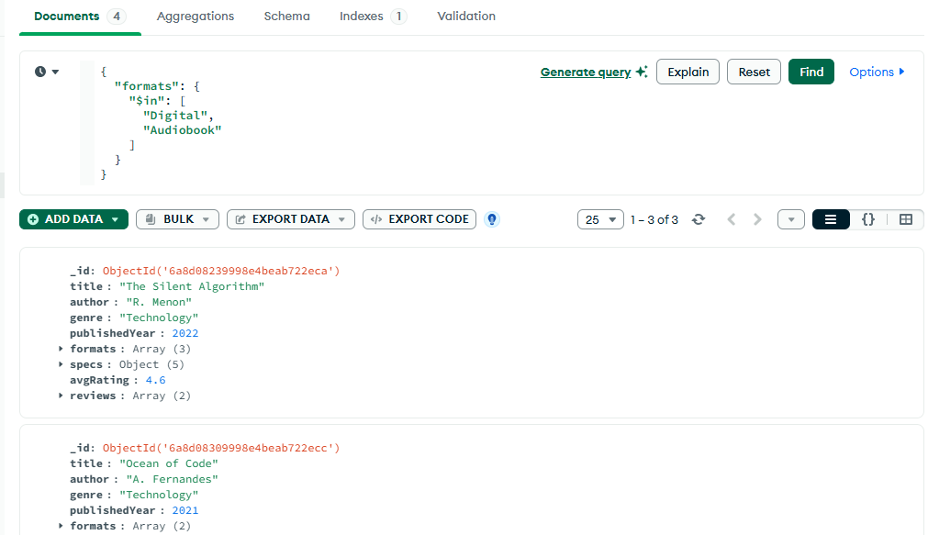
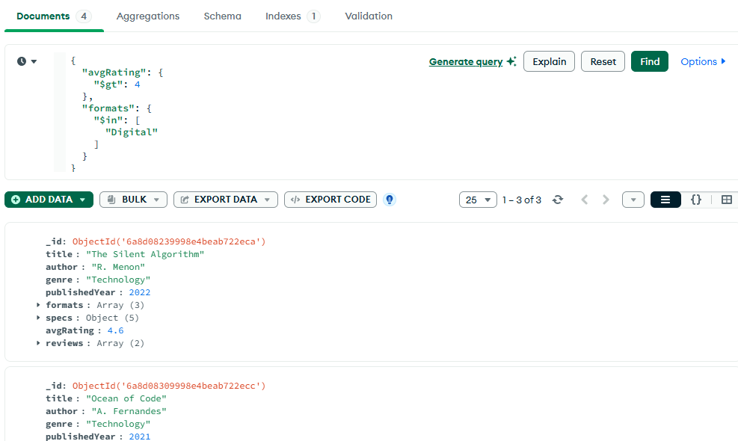
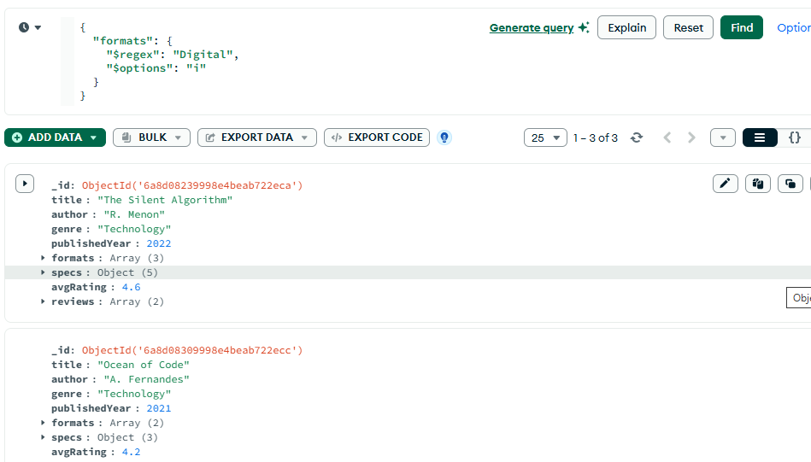
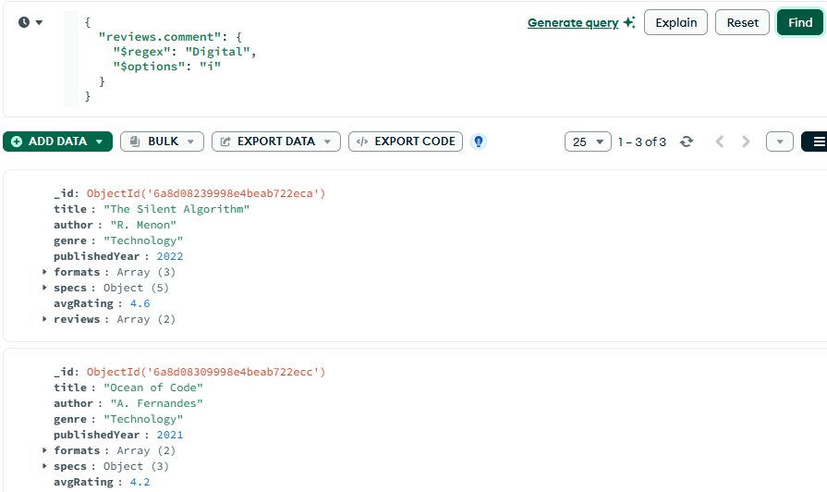

Task3: Aggregation Pipeline
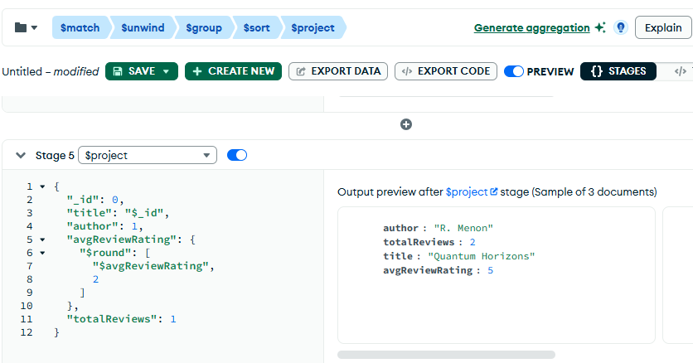
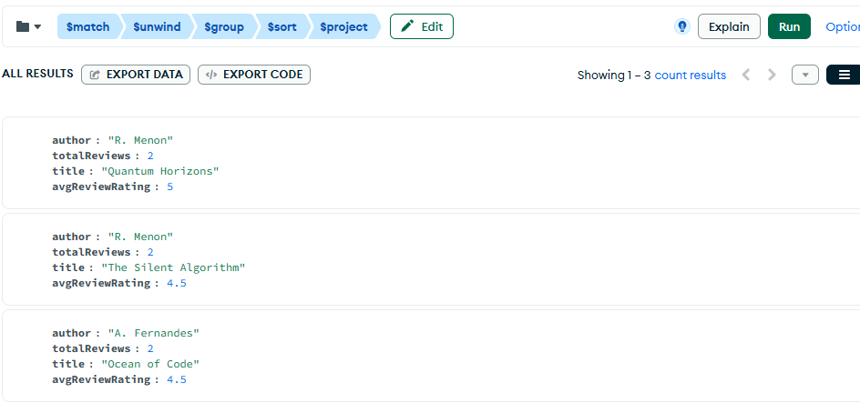

Task4: Indexing for Speed
