PRACTICAL 7
Linux Process Address Space and Virtual Memory Analysis

TASK 1
Write a program that prints the addresses of code, global, static, heap, and stack variables. Analyze the Linux process address space layout and explain each memory segment.
Screenshot 1 – Successful compilation of the Task 1 program.
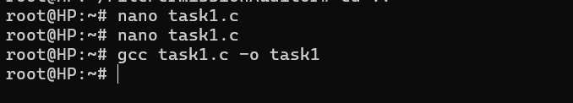
Screenshot 2 – Task 1 output showing the addresses of code, global, static, heap, and stack variables.
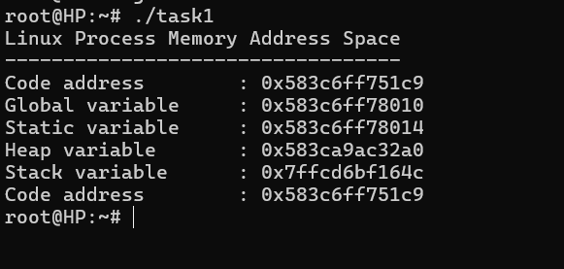

TASK 2
Make use of the /proc/<PID>/maps file and memory analysis tools to study the memory organization of a running process. Prepare a report explaining virtual memory mappings.
Screenshot 3 – Successful compilation of the Task 2 program.
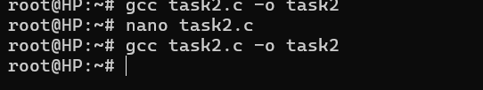
Screenshot 4 – Task 2 running process showing PID and memory addresses.
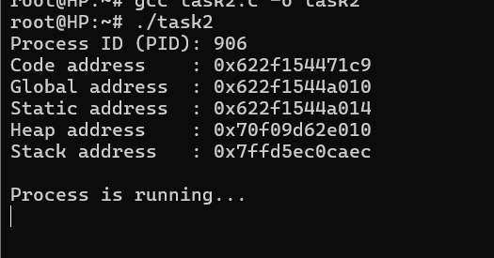
Screenshot 5 – /proc/906/maps displaying the virtual memory mappings of the process.
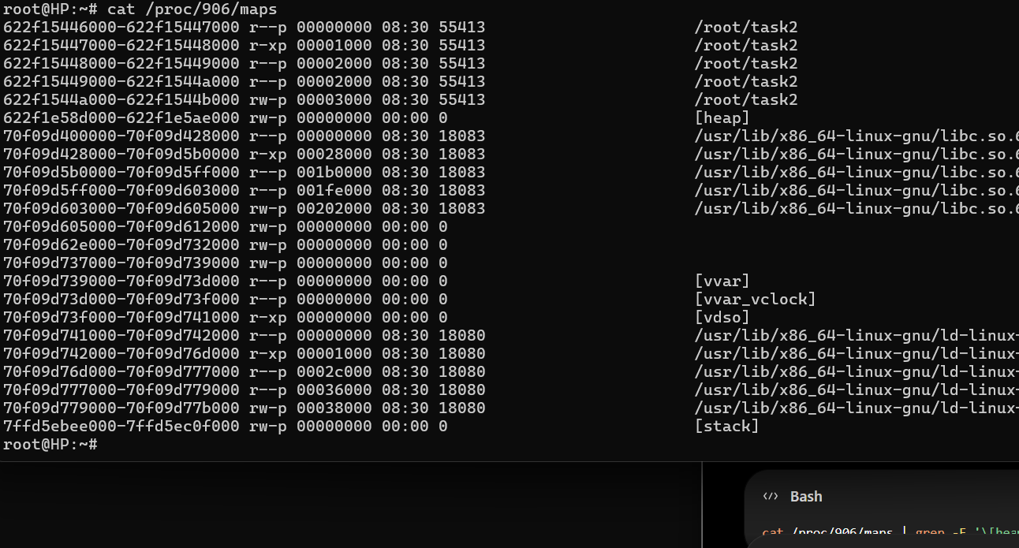
Screenshot 6 – Filtered mappings showing the executable, heap, and stack regions.
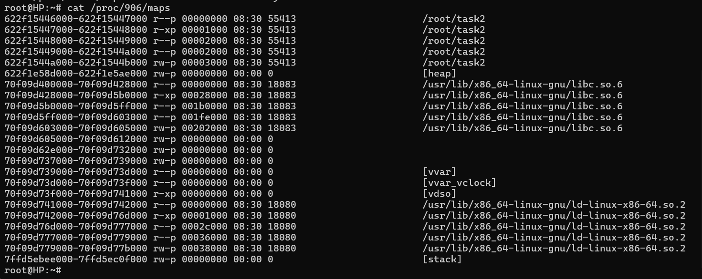
Screenshot 7 – Process memory information from /proc/906/status.
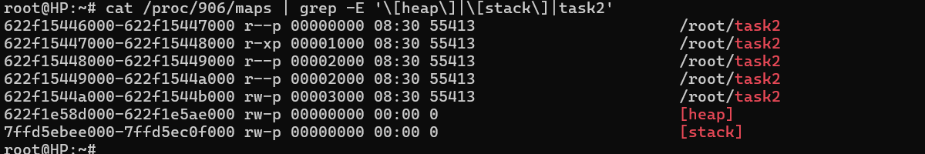
Screenshot 8 – pmap displaying the memory regions and total memory of the process.
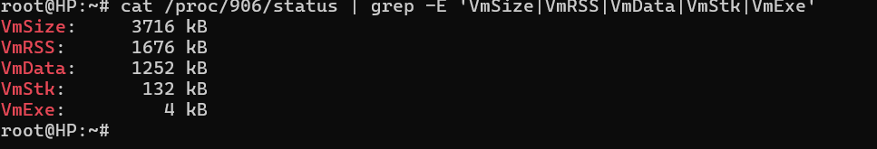
Screenshot 9 – ps displaying the virtual and resident memory usage of the process.
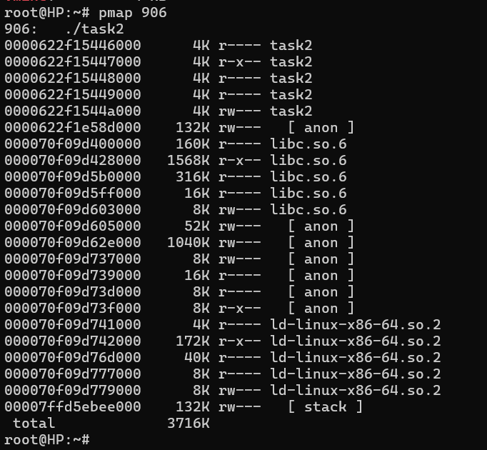
Screenshot 10 – top displaying the running process and its memory usage.
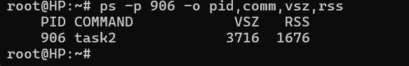

FINAL OBSERVATION
The practical demonstrated the Linux process address space and virtual memory organization. The addresses of code, global, static, heap, and stack variables were observed, and the virtual memory mappings of a running process were studied using /proc/906/maps and memory analysis tools.

