**Visualizing Relationships**

**Energy Consumption vs GSDP Region**

**Mynampati Prudvi.**

GDP and Energy Consumption across regions

The relationship between GDP and Energy Consumption across regions of year 2017.

|  |  |  |
| --- | --- | --- |
| Region | Energy Consumption | GSDP |
| Eastern Region | 116612.1 | 1515693 |
| North-East Region | 10601.92 | 289690 |
| Northern Region | 265048 | 2908480 |
| Southern Region | 339261 | 3445511 |
| Western Region | 339261 | 3545638 |

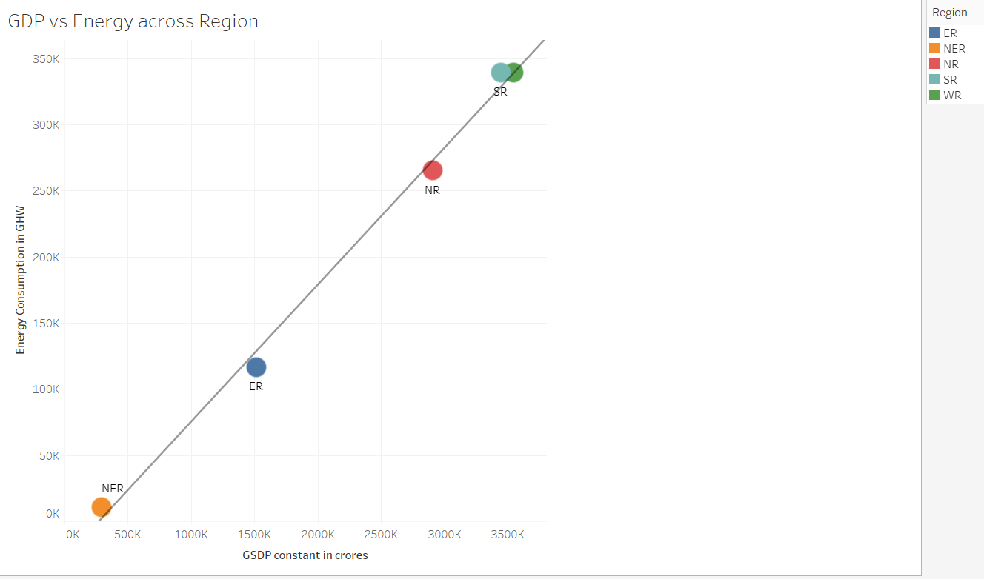

The Relationship is Higher in Southern and Western Region.

As per the data of year(2017) of Consumption and GDP , Energy utilization is same between SR and WR but the GDP is bit variable (Western Region have highest GDP )

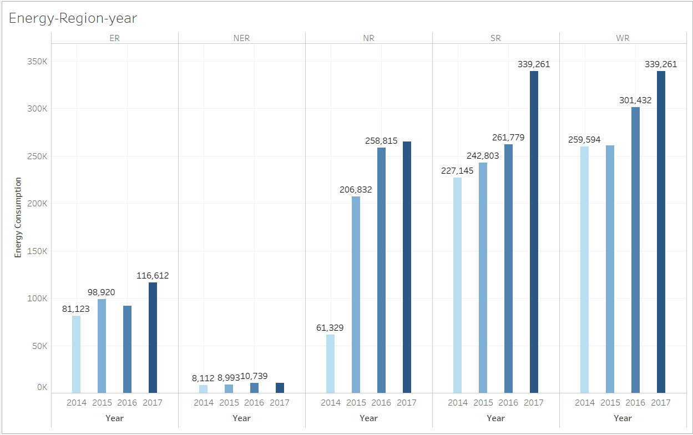

Western Regions have highest Energy Consumption and GDP also.

North Eastern Region consume less Energy than any other Regions.

Relationship among GDP vs Energy across Region:

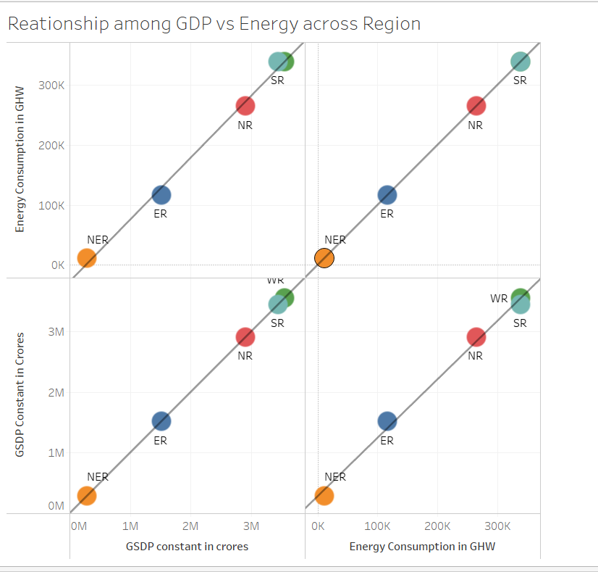

The relationship between GSDP and Energy Consumption across Region shows positive trend line

From the data and trend line we can see that they both are correlated and having high R-square value

R-Squared=0.995265

P-value=0.0001385

As P-value < 0.5 we can reject Hypothesis and say that they both are correlated to each other.

2.1:State Wise GDP vs Consumption with Growth rate

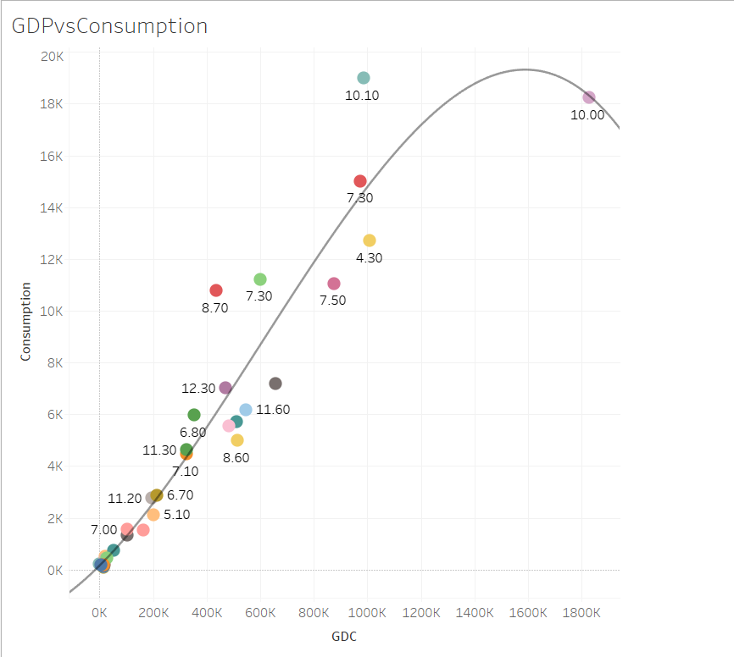

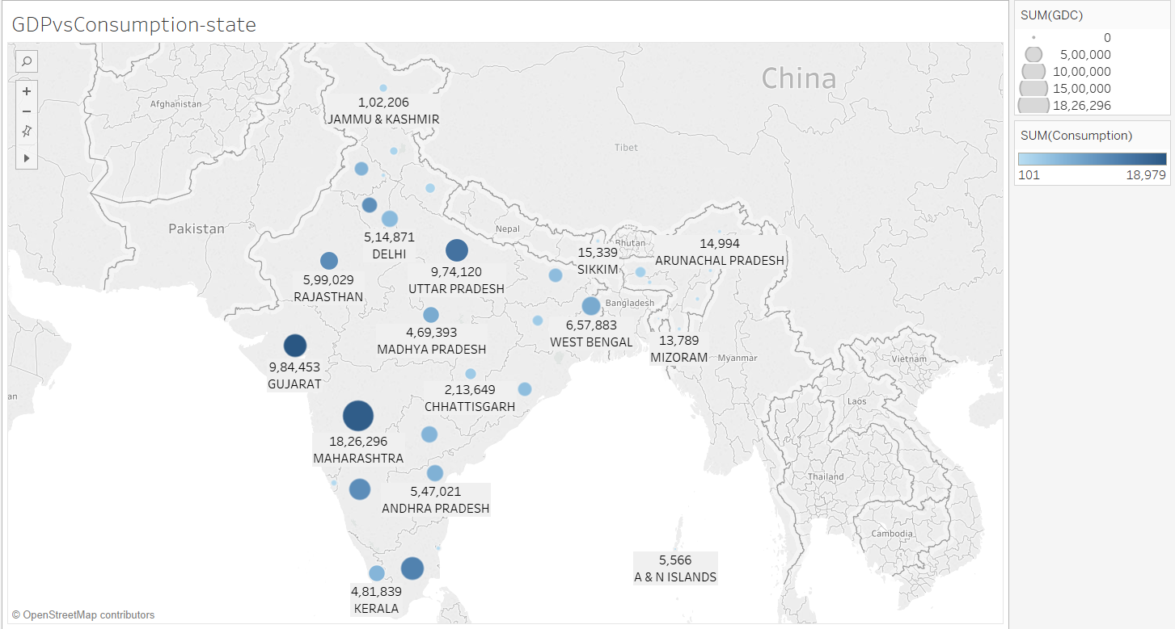

Maharashtra has highest GDP and Energy consumption where there is no deficit or surplus for this state.

The reason for this western region have huge amount of renewable and non-renewable energy resource available .

2.2: GDP and Energy evolved over the last 4 years (between 2014-17)

As per the data records of 4 years from 2014-2017 rise in GDP of Southern and Western region is increasing rapidly year by year .

Form this Visualization we can observe that Western Regions have higher GDP and there growth is also increasing high every year.

North Eastern Region have GDP fluctuates from the corresponding years as they use very less energy than any other region.

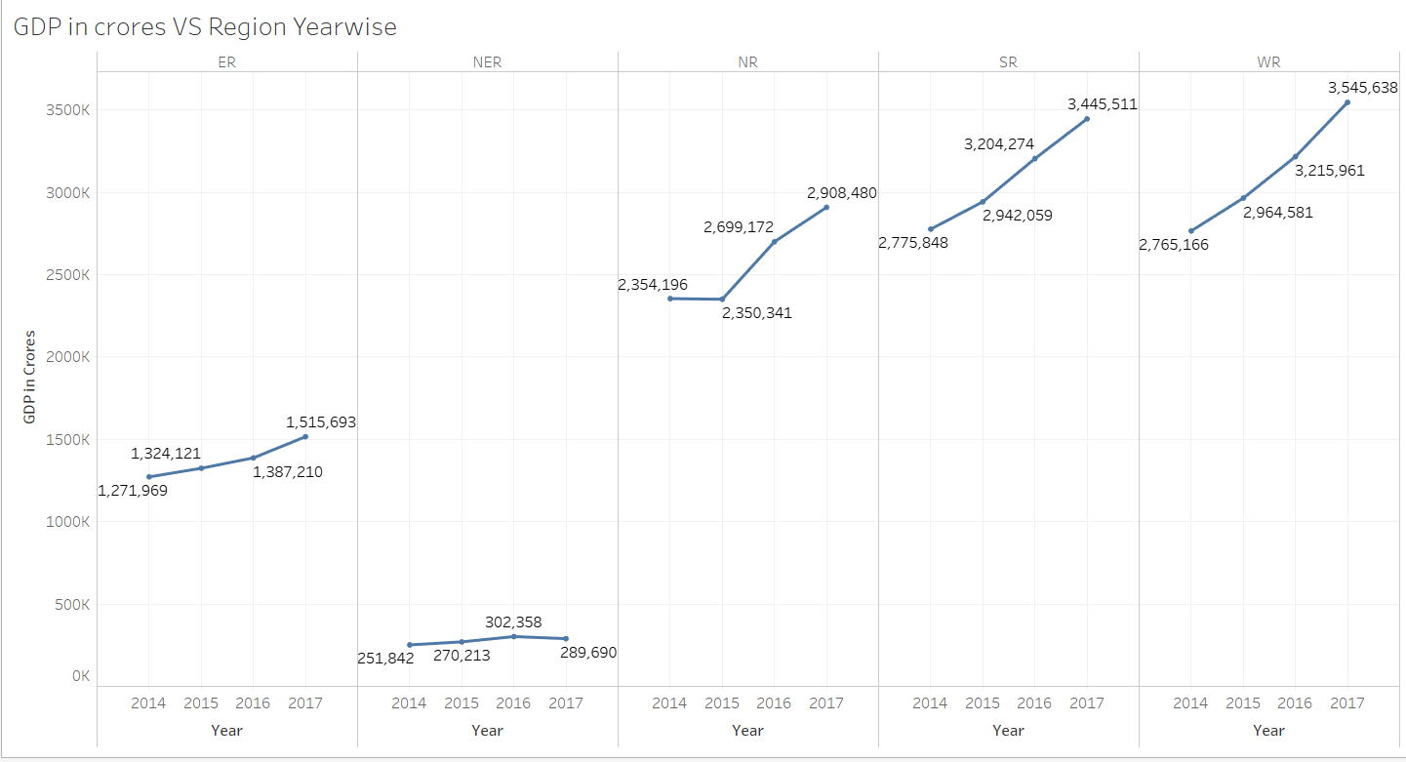

As per the data records of 4 years from 2014-2017 the utilization of energy in southern and Western region is increasing rapidly year by year .

By considering this data from 2016-2017 the southern region utilized 2 times whatever the electricity used by Western region.

Remaining 3 regions are varying approximately 10% from what they are utilizing every year

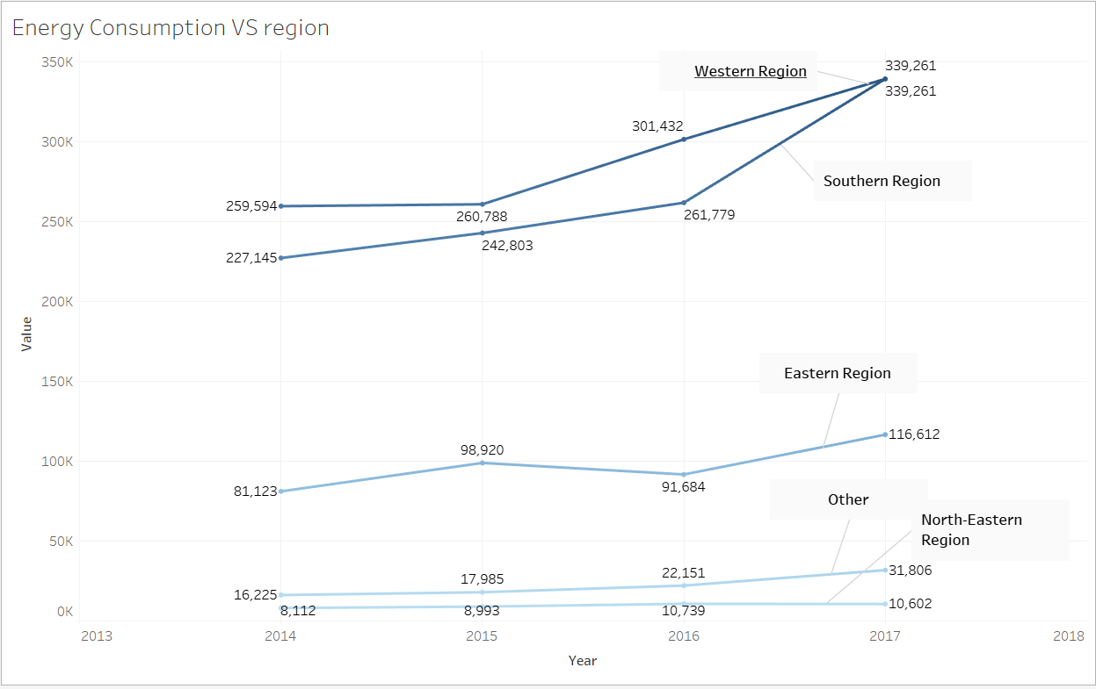

Overall Observation between Energy Consumption and GDP over a period of 2014-2017.

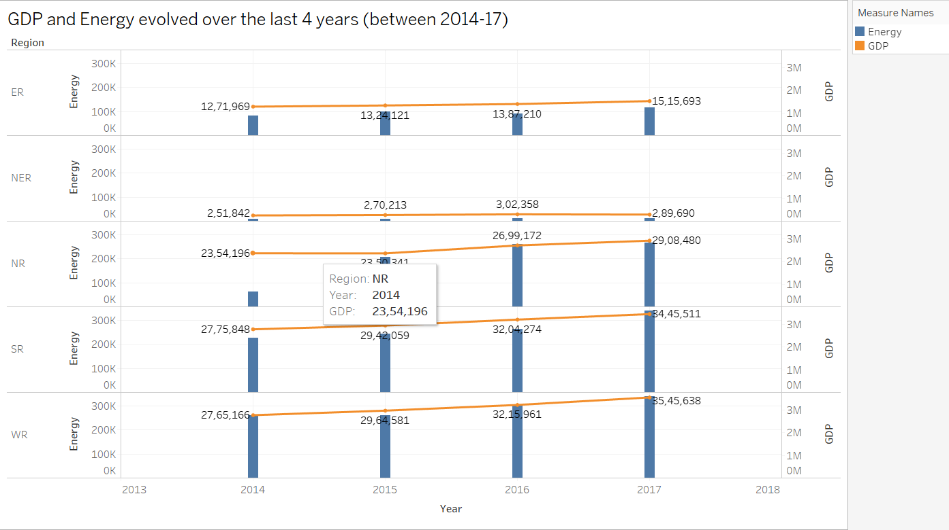

Western Regions are in the leading position till 2017 as their energy and GDP are on the top and Southern Region takes 2nd position in both aspects.

Southern Region utilized 2 times whatever the electricity used by Western region in last 2 years of energy consumption .so, there we can have huge opportunity for higher GDP Growth in the coming years.

North Eastern Region consume lower energy than any other region and also have low GDP rate .

Extra credit and cutting edge:

Yes ,Maharashtra state in western Region is doing exceptionally well because this region has both renewable and non-renewable resource sufficiently and climate conditions are also help full in this states and region with highest potential green energy than other regions.

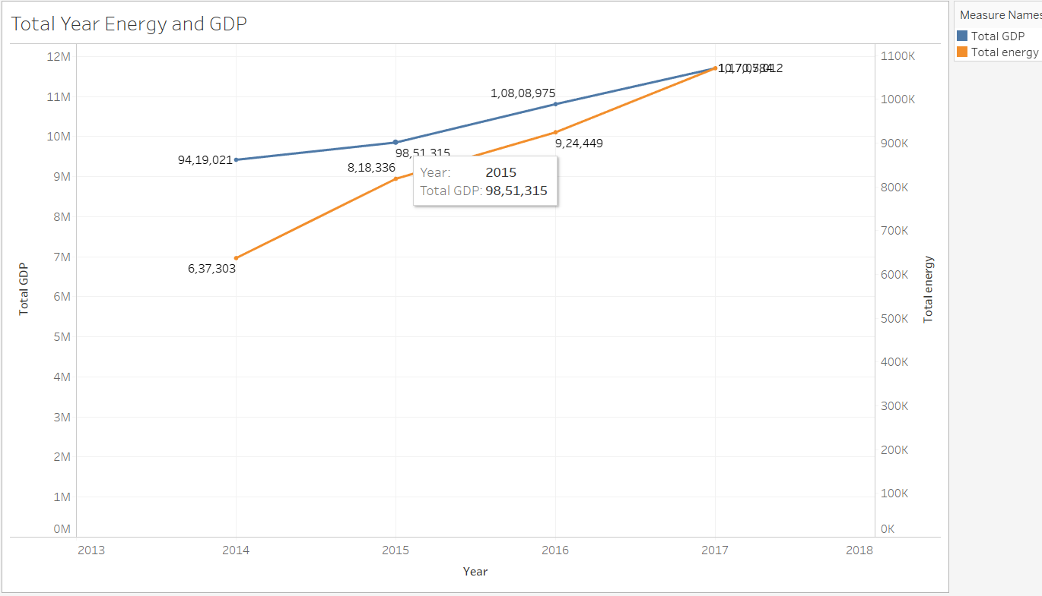

Overall observation the usage of energy is increasing year by year for the fulfillment of industrial, household and agriculture usage increasing significantly.