**Documentation**

* **Screenshots of:**

1.Docker installation & version check.

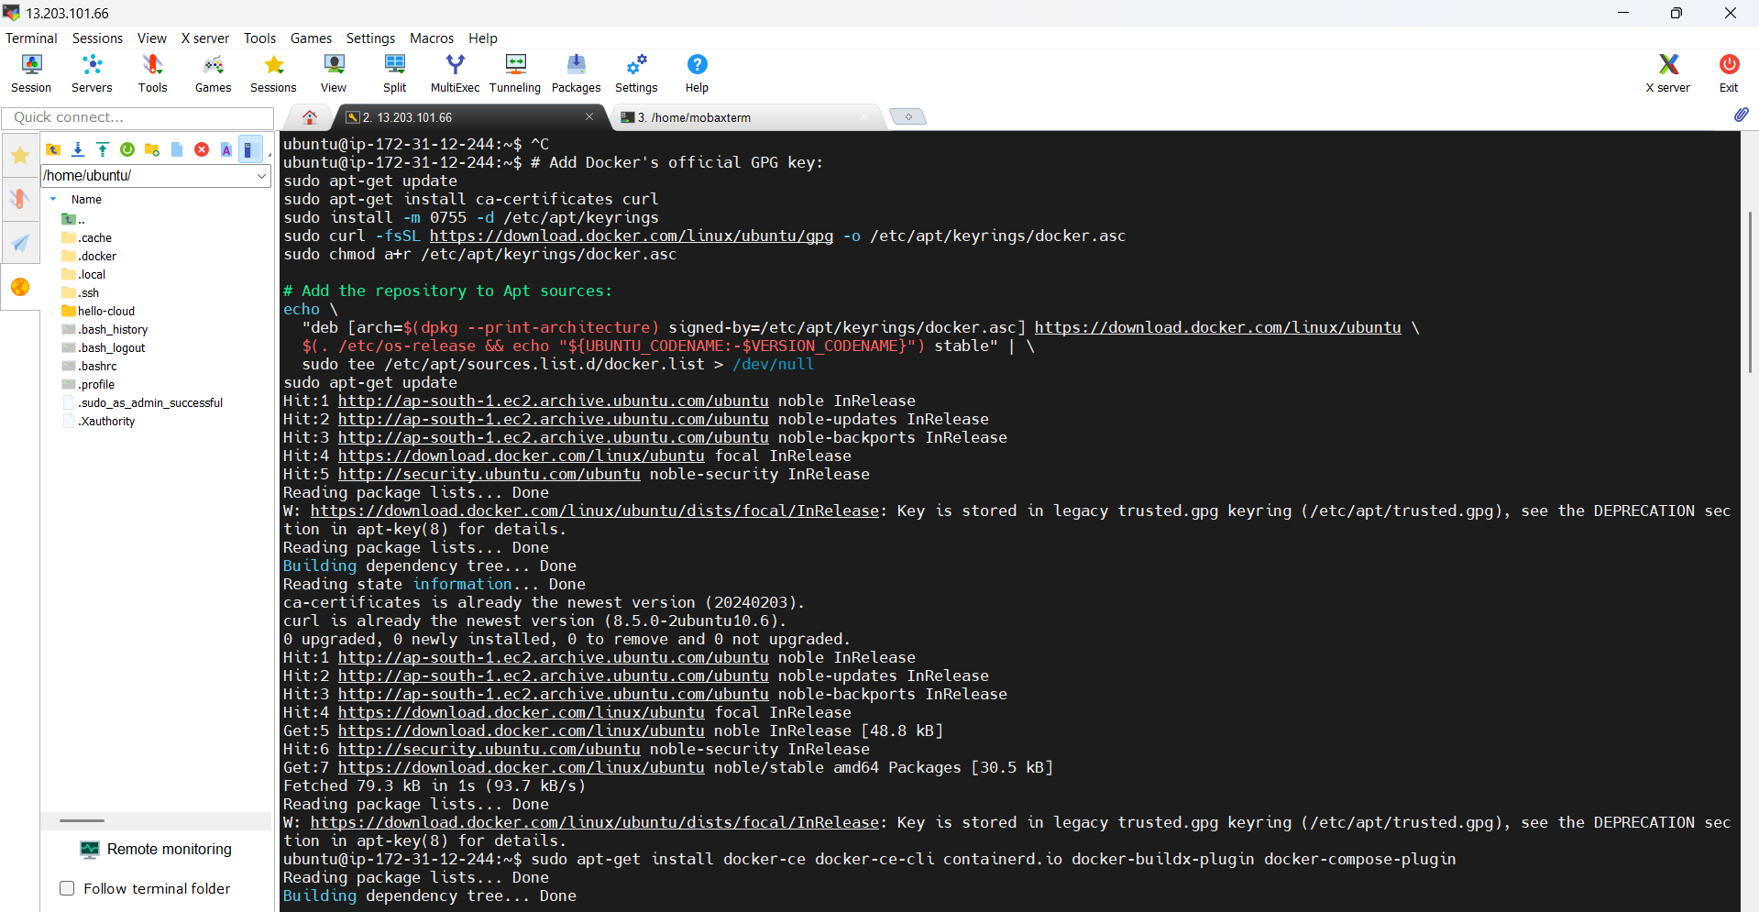

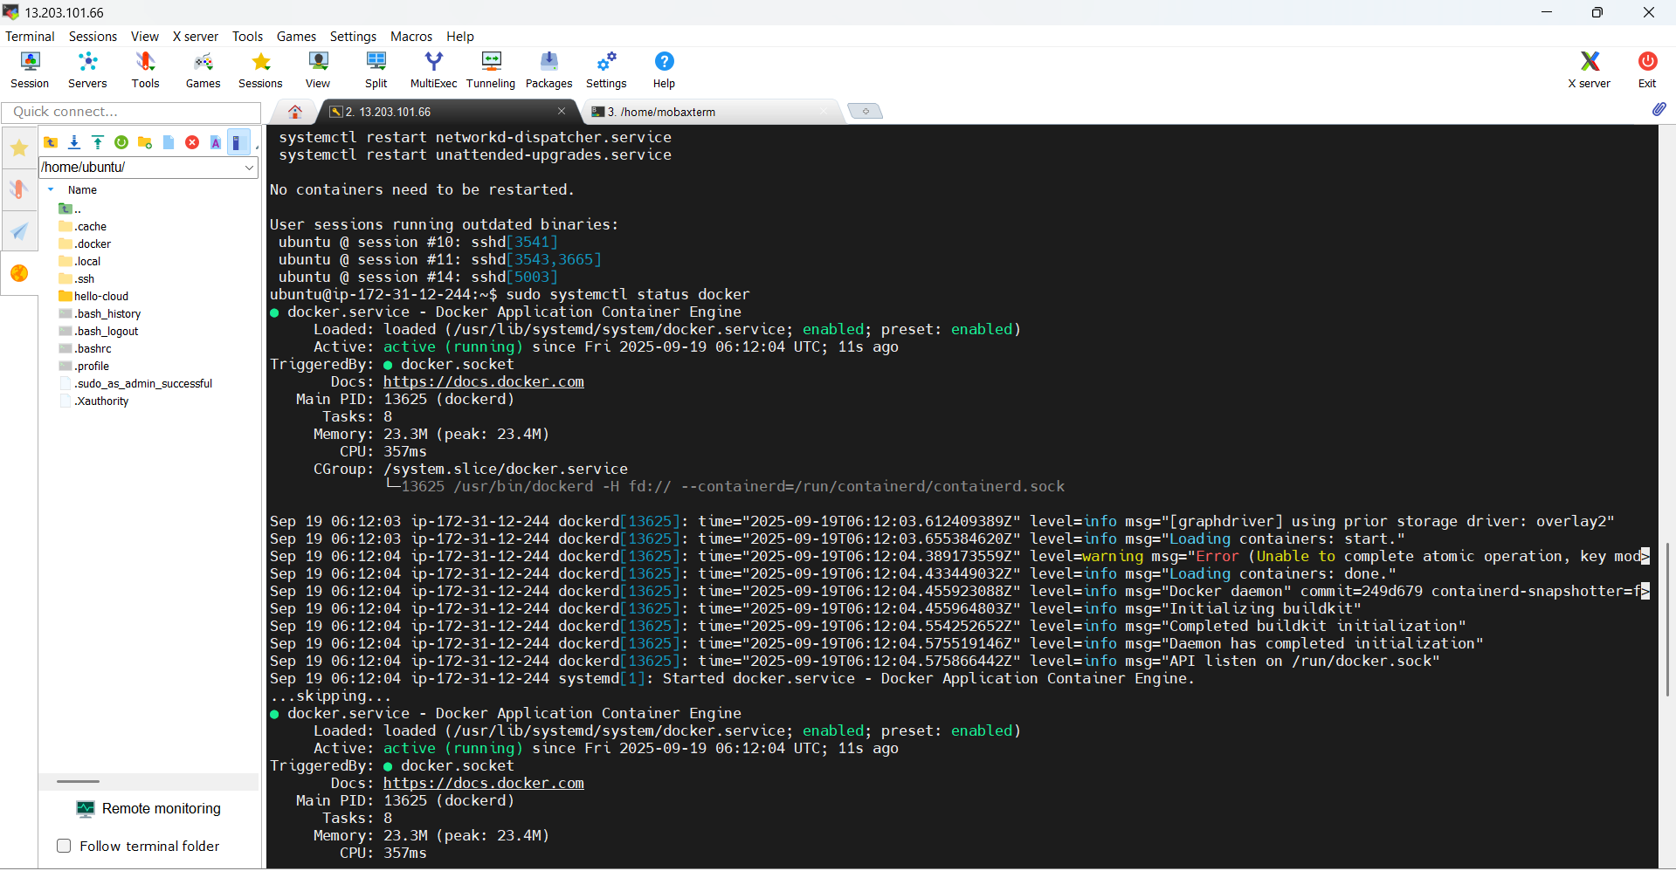

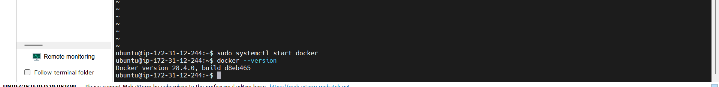

2.Docker file creation & Container build

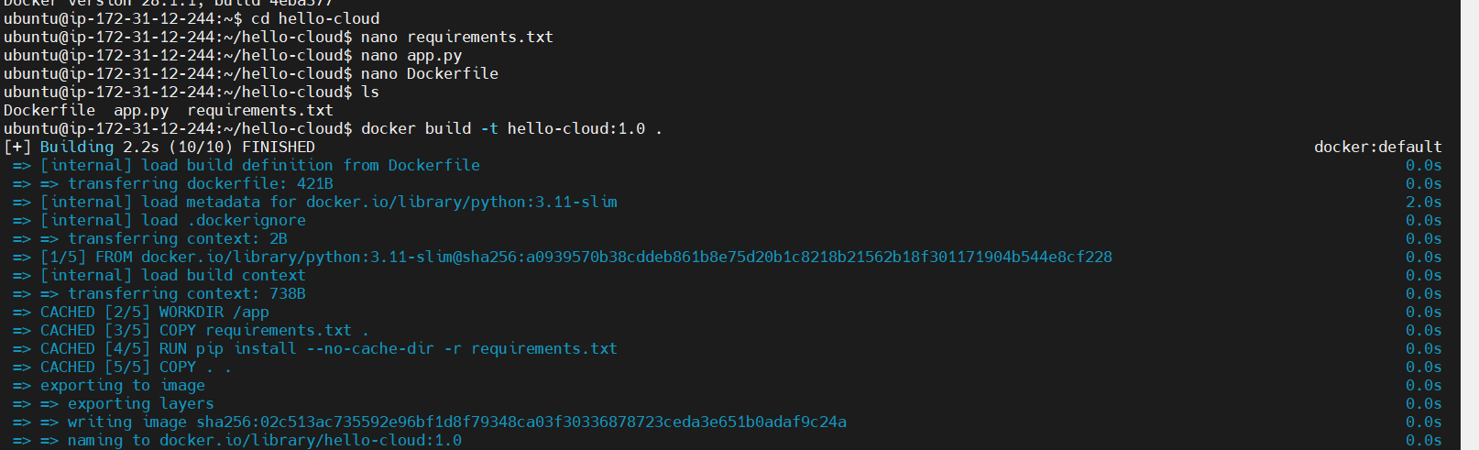

3.Container running and webpage accessible in browser



* Include the public URL/IP:port link to the web app:

<http://13.203.75.97:5000>

