1. The bride couldn't stop smiling 💛

Look what Mehshuka has to say:

"I couldn't have asked for a more perfect bridal dress than the one I found at Myn Attire. From the moment I walked in, their team made me feel like a queen. They listened to my ideas and designed an Anarkali that exceeded my wildest dreams. The craftsmanship and attention to detail were impeccable, and the dress fit like a glove.

Thank you, Myn Attire, for making my dreams come true!"

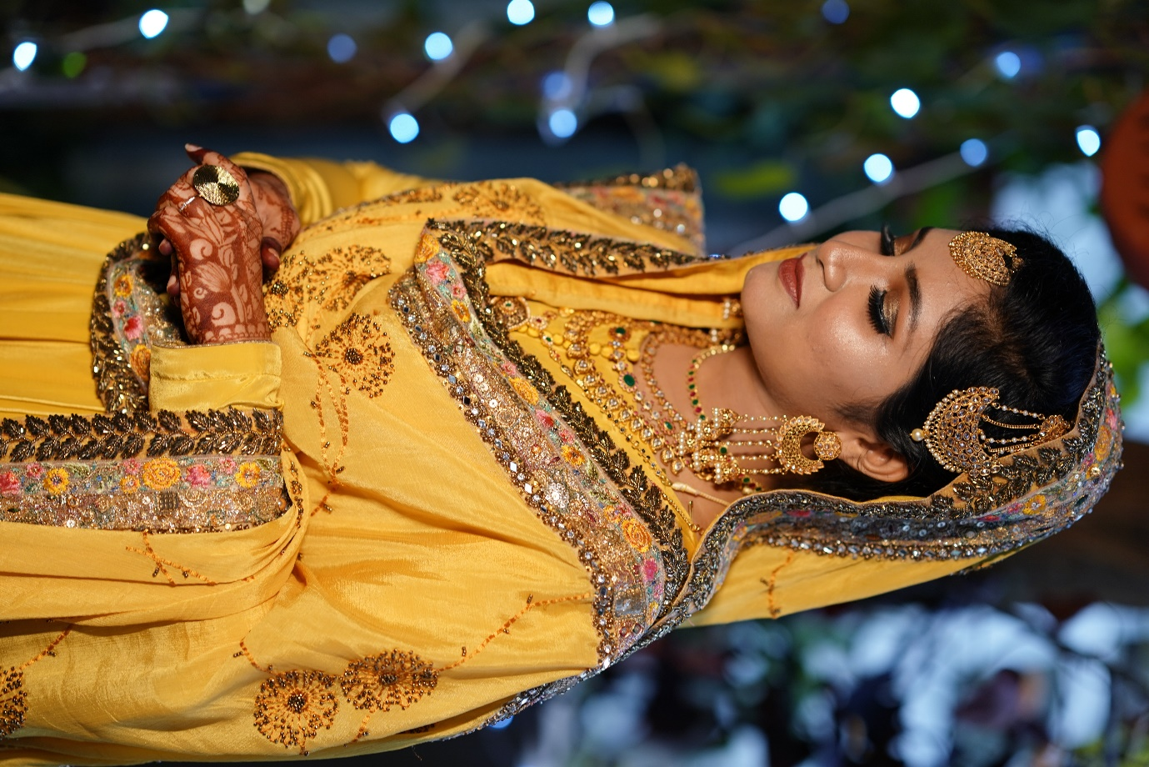

**I couldn't have asked for a more perfect mehendi dress than the one I found at Myn Attire**.

1. One happy bride at a time.

Look what Karthika has to say:

"Myn Attire is the best choice I have taken for my wedding outfits. The stitching is so perfect and neat, exactly how I wanted it to be. In particular, Mehnaz chechi went above and beyond to help me with my order and ensure that I was happy with the final result.

I highly recommend Myn Attire for anyone looking for high-quality stitching and excellent customer service."

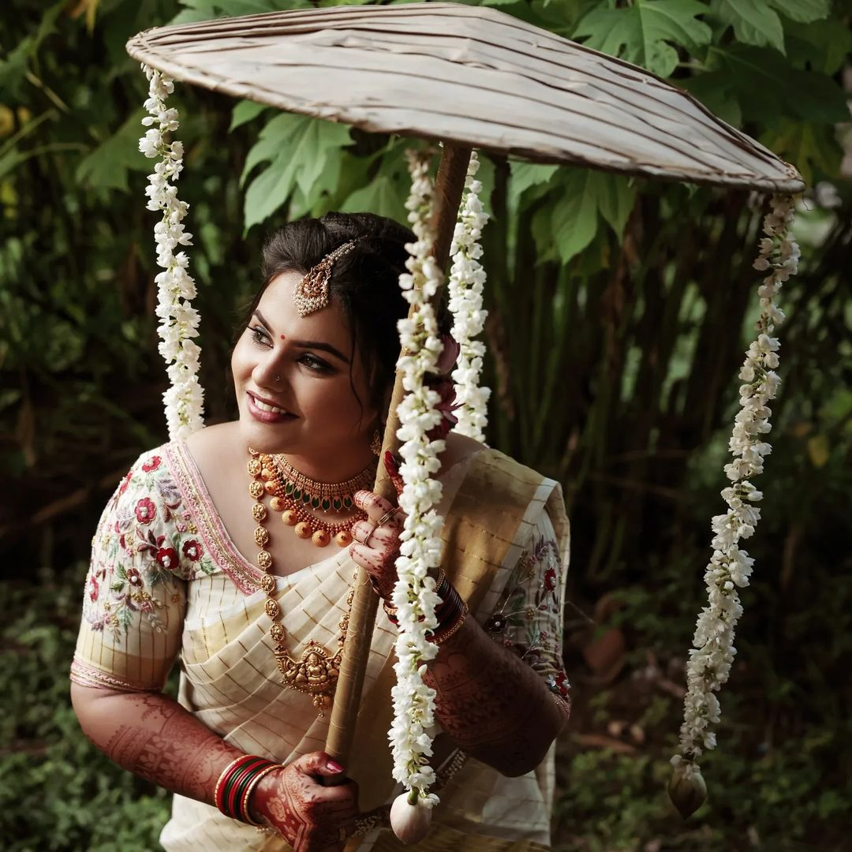

**The stitching is so perfect and neat, exactly how I wanted it to be**

1. Anjana on her engagement attire.

"I had an unforgettable experience with Myn Attire! They designed and stitched the perfect attire that captured my vision and made me feel like a princess. I also loved the personalized touch they added to my dress, making it uniquely mine.

Thanks to Myn Attire. I couldn't be happier with the result!"

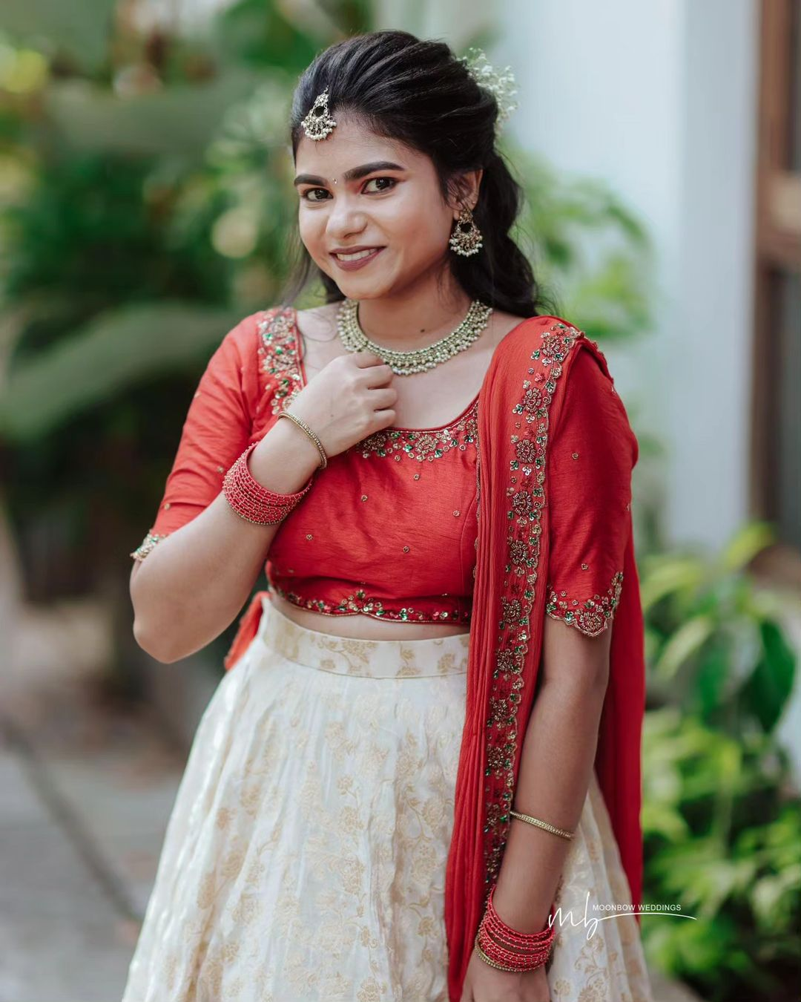

**Myn Attire designed and stitched the perfect attire that captured my vision and made me feel like a princess.**

1. Always happy to hear from you.

Look what Sruthi has to say:

"The most recommended boutique. You really do take care of each and every detailing in you work.

Thank you for making my wedding attire look to its beautiful best."

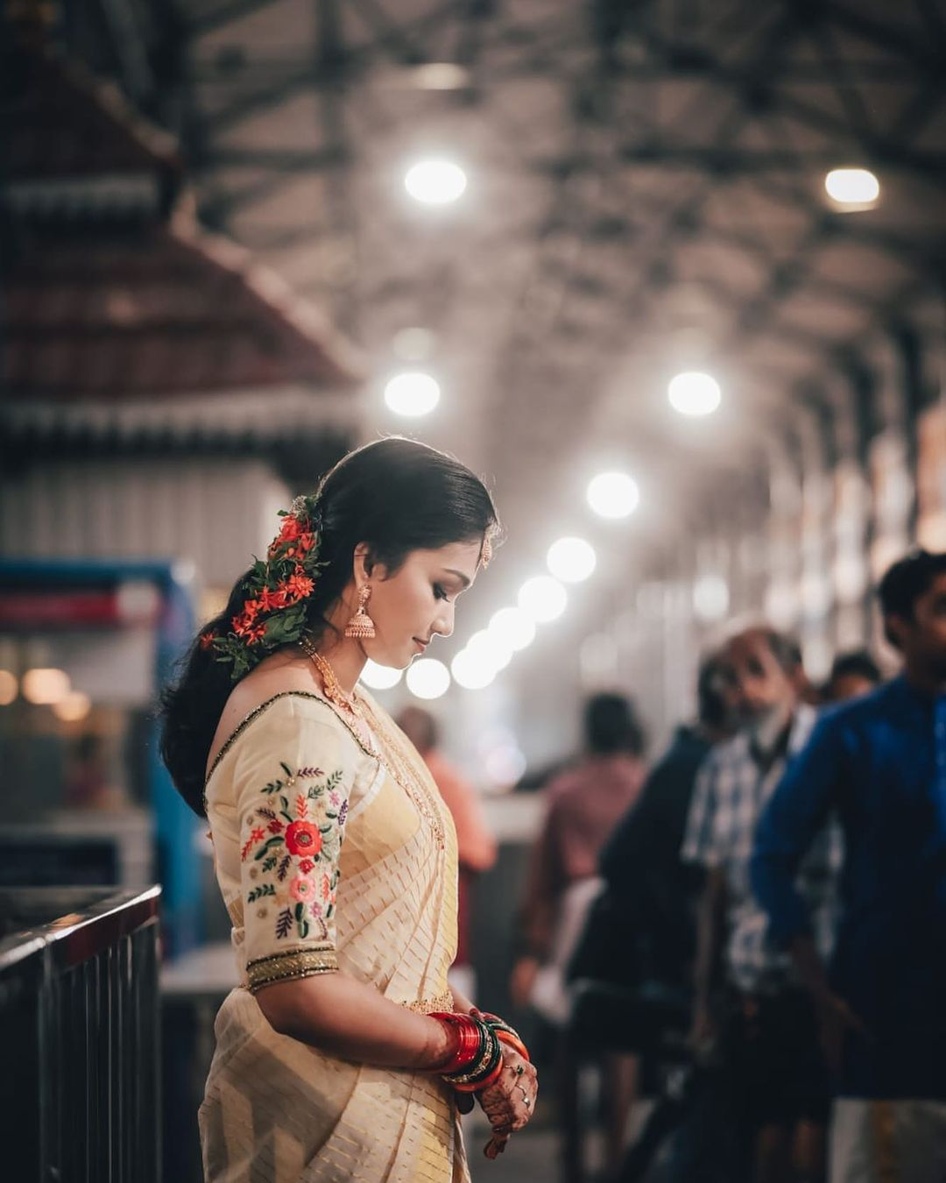

**You really do take care of each and every detailing in your work.**

1. Thank you, Fasila.

Fasila's testimonial:

"My wedding outfits were the topic of conversation, thanks to Mehnaztha’s patience and attention to every little detail. Thank you so much for doing such an amazing job. It is exactly what i wanted and i absolutely loved wearing it. The whole process from design to completion has been such an enjoyable experience. I can't wait to recommend your services to my friends and family when they begin planning their own weddings!"

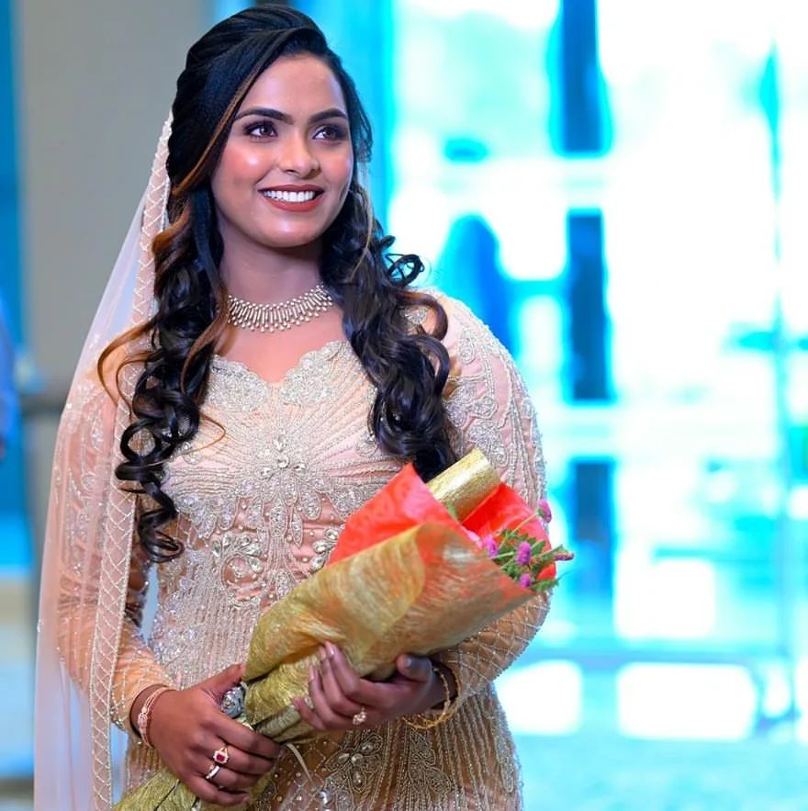

**My wedding outfits were the topic of conversation, thanks to Mehnaztha’s patience and attention to every little detail.**

1. Harsha on the wedding blouse.

"My experience with Myn Attire was simply amazing! They designed and stitched the most beautiful blouse that perfectly reflected my style. The attention to detail was evident in every stitch. I couldn't have asked for a better one!"

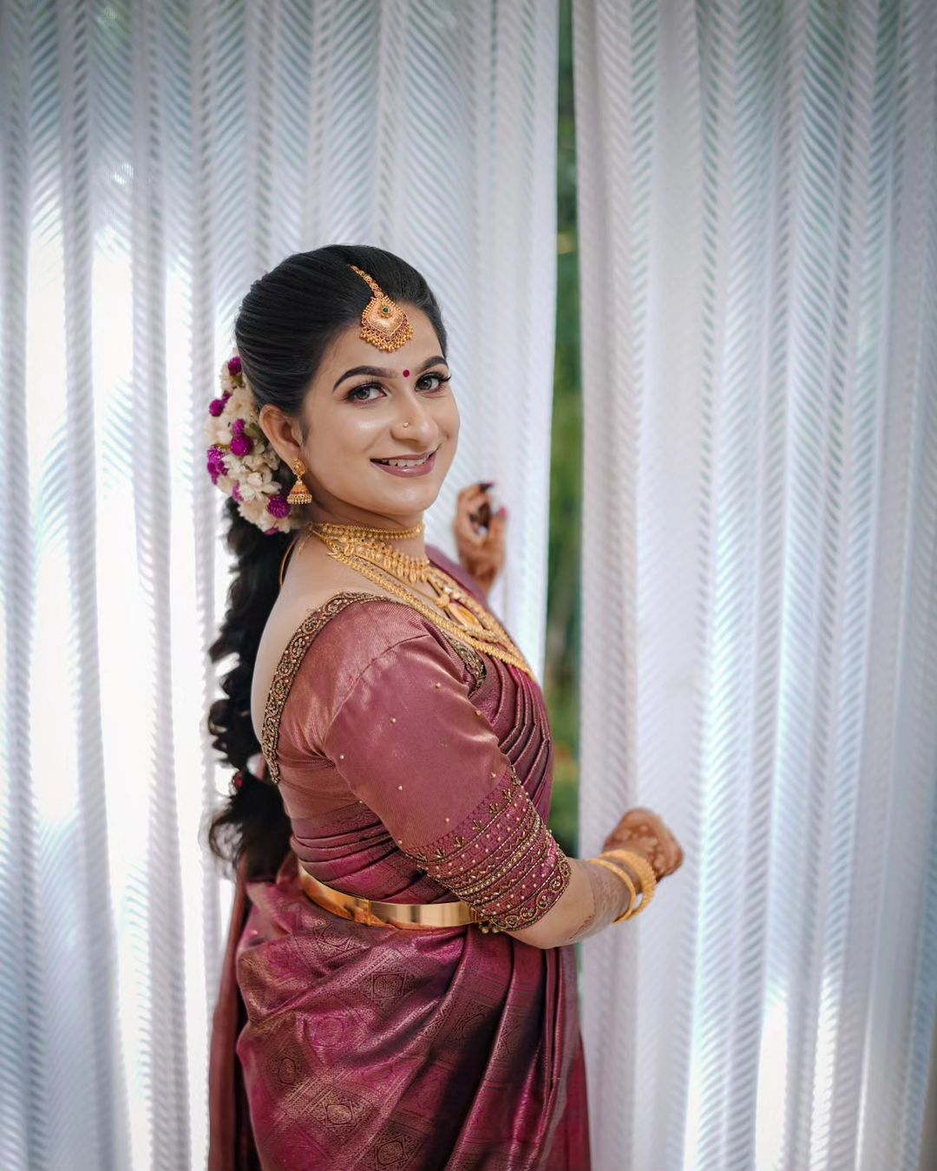

**They designed and stitched the most beautiful blouse that perfectly reflected my style.**