Registered Email For Certification Expiry[90 Days Expiry]:
https://manage.sslforfree.com/
Username: amol.babar@mynexthire.com
Password: #@ewN{p8|c)GX

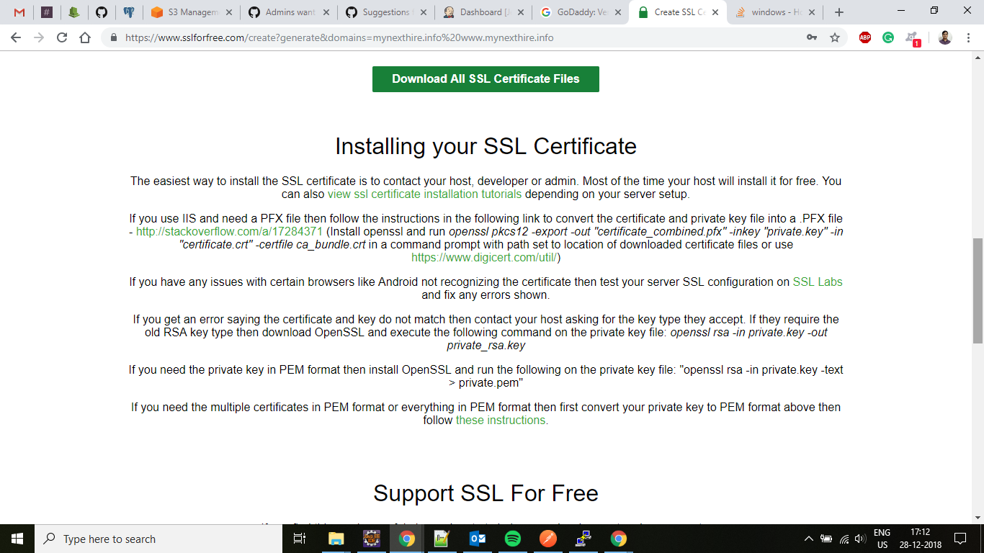

Generate PFX file from .crt and .key on Ubuntu with OPENSSL:

openssl pkcs12 -export -out certificate.pfx -inkey private.key -in certificate.crt
https://www.ssl.com/how-to/create-a-pfx-p12-certificate-file-using-openssl/

Certificate Password:
@Root1234

