My Nguyen – 914 329 026 Project 2

Jasmin Adzic – 999 883 011

1. **Part 1:**
   1. Derivation of Packet Loss Probability:

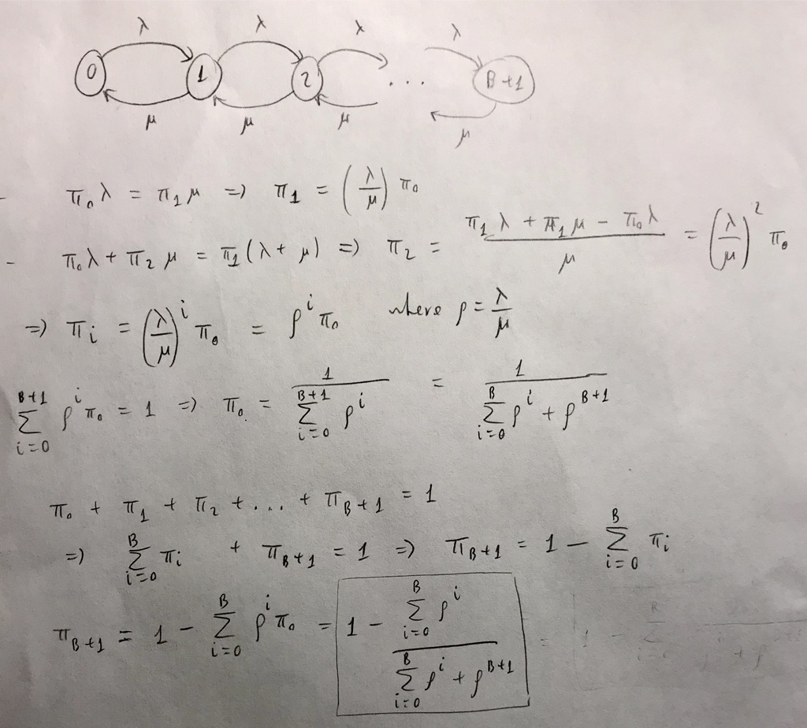

* 1. Simulation vs. Theoretical:

|  |  |  |
| --- | --- | --- |
| Lamda | Simulated | Theoretical |
| 0.2 | 1.251 | 1.250 |
| 0.4 | 1.658 | 1.667 |
| 0.6 | 2.529 | 2.500 |
| 0.8 | 4.996 | 5.000 |
| 0.9 | 9.558 | 10.000 |
| 0.99 | 86.938 | 100.000 |

* 1. Simulation Result:

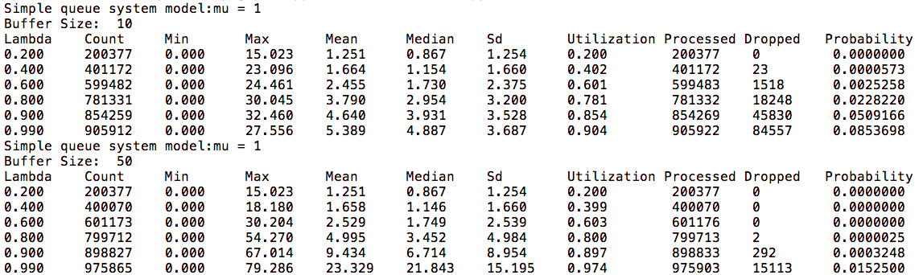

* 1. Packet Loss Probability:

|  |  |  |  |  |
| --- | --- | --- | --- | --- |
| Lamda | B = 10 | | B = 50 | |
| Simulated | Theoretical | Simulated | Theoretical |
| 0.2 | 0.0000000 | 0.000000016 | 0.0000000 | 0.000000000 |
| 0.4 | 0.0000573 | 0.000025166 | 0.0000000 | 0.000000000 |
| 0.6 | 0.0025258 | 0.001454354 | 0.0000000 | 0.000000001 |
| 0.8 | 0.0228220 | 0.018447577 | 0.0000025 | 0.000002283 |
| 0.9 | 0.0509166 | 0.0437323736 | 0.0003248 | 0.000465784 |
| 0.99 | 0.0853698 | 0.0788044927 | 0.0152500 | 0.0147151507 |

1. **Part 2:**
   1. Sample Execution:

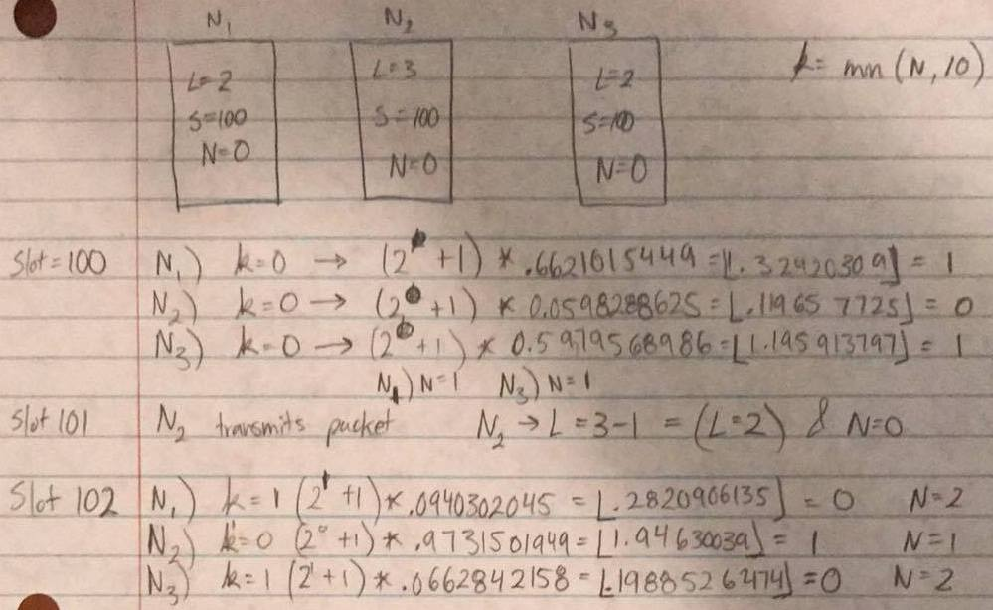

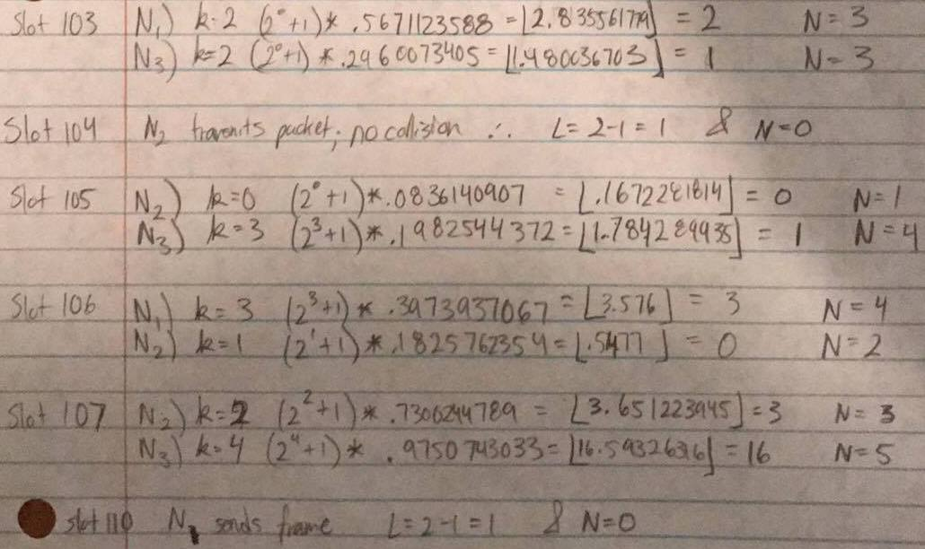

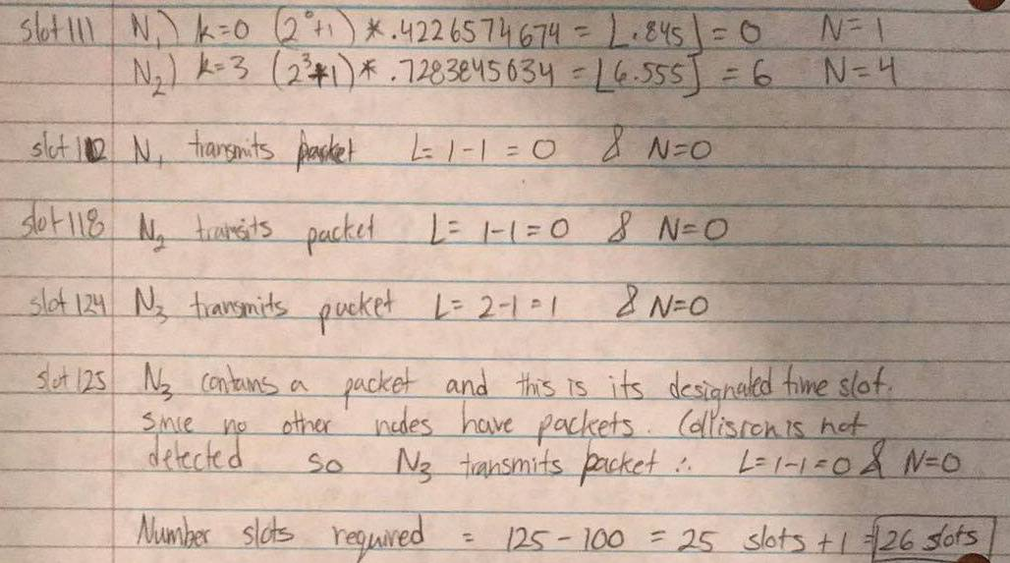

* 1. Simulation Result:

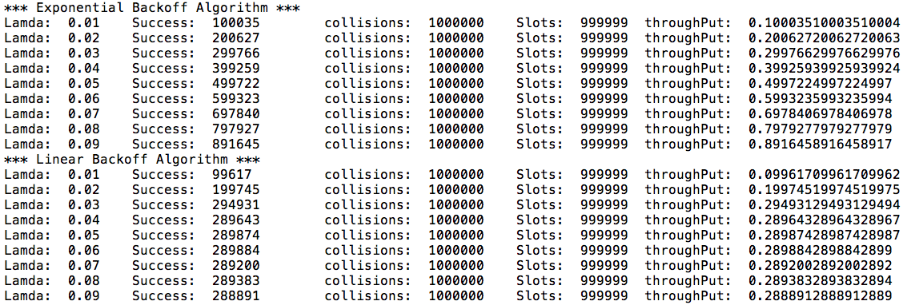

* 1. Exponential and Linear Backoff Algorithm Results:

|  |  |  |
| --- | --- | --- |
| Lamda | Exponential | Linear |
| 0.01 | 0.10003510003510004 | 0.09961709961709962 |
| 0.02 | 0.20062720062720063 | 0.19974519974519975 |
| 0.03 | 0.29976629976629976 | 0.29493129493129494 |
| 0.04 | 0.39925939925939924 | 0.28964328964328967 |
| 0.05 | 0.4997224997224997 | 0.28987428987428987 |
| 0.06 | 0.5993235993235994 | 0.2898842898842899 |
| 0.07 | 0.6978406978406978 | 0.2892002892002892 |
| 0.08 | 0.7979277979277979 | 0.2893832893832894 |
| 0.09 | 0.8916458916458917 | 0.2888912888912889 |