# Script: Retrieving Cisco ISE Authorization Profiles and Rules

## Preparation

### Step 1: Generate Base Authentication Header

1. Go to <https://www.debugbear.com/basic-auth-header-generator>
2. Enter Cisco ISE username and password.
3. Copy Authorization code including “Basic” and save it in notepad

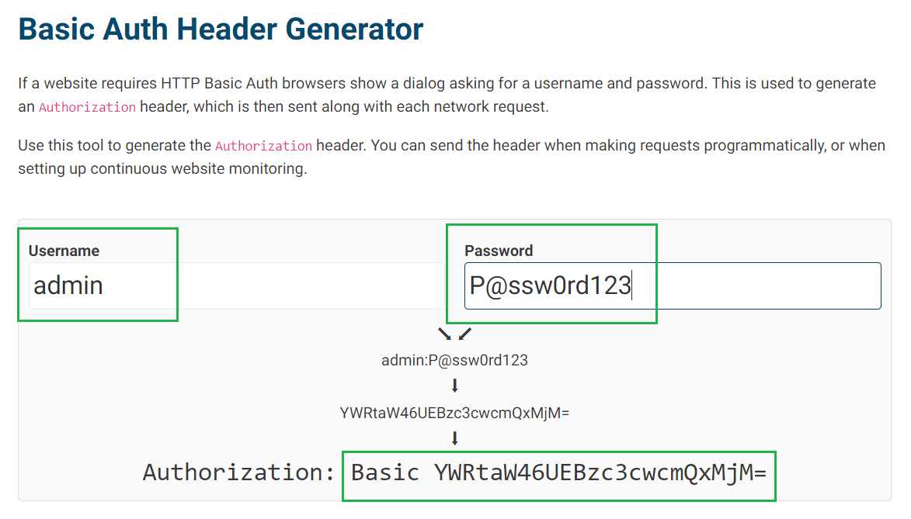

### Step 2: Copy the Script files to the Window machine which is reachable to the Cisco ISE over port TCP/9060 and TCP/433

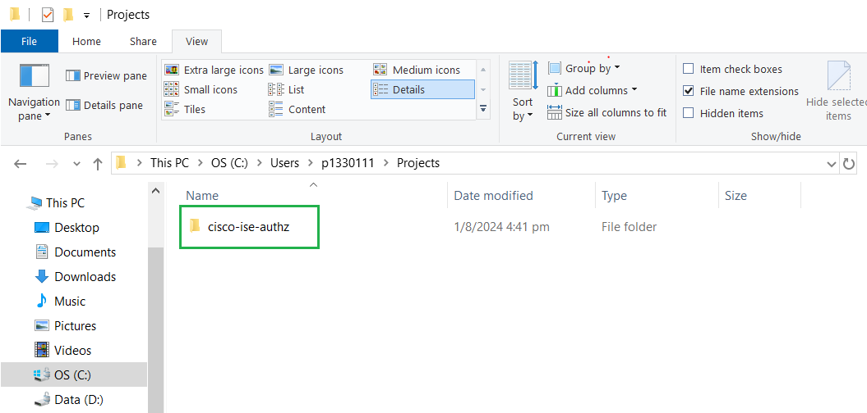

### Step 3: Update ISE Configuration file

1. Go to cisco-ise-authz > dist > open “ise_config.yml” in notepad

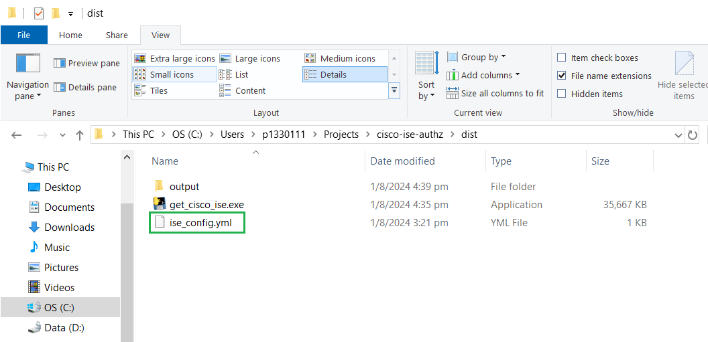

1. Replace “host_ip” with Cisco ISE mgmt ip address.
2. Replace “base64_auth” with the authorization code generated in Step 1:
3. Save the file.

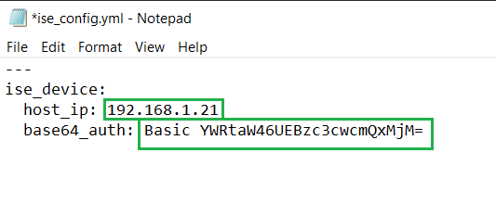

## Retrieving Cisco ISE Authorization Profiles

1. Open Window command prompt
2. Go to under “dist” folder.

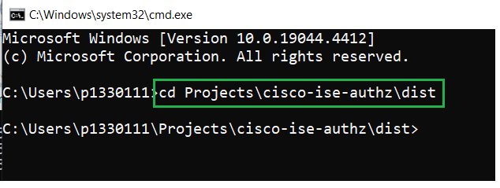

1. Type the command “get_cisco_ise.exe --config-file ise_config.yml” and press enter.
2. Type “1” to get Authorization Profiles and press enter.
3. Once it’s completed, the result will be saved to the “output” folder

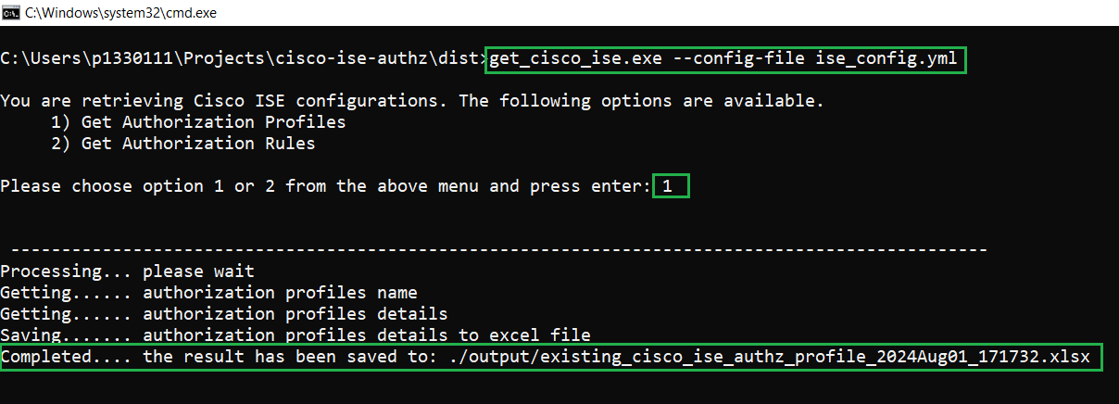

1. Go to “output” folder and open the excel file to verify.

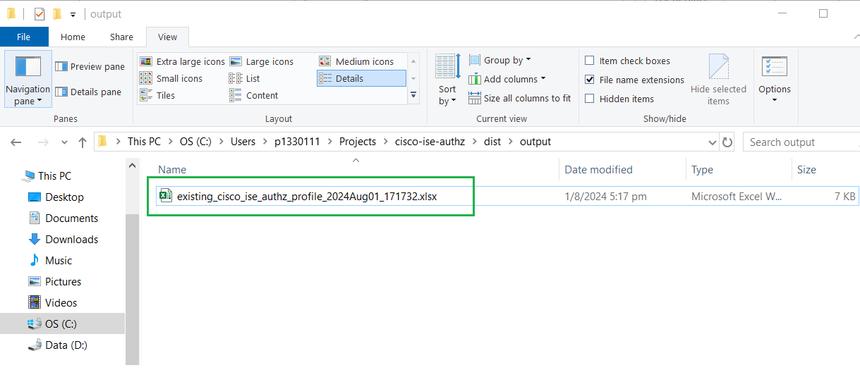

## Retrieving Cisco ISE Authorization Rules

1. Open Window command prompt
2. Go to under “dist” folder.

1. Type the command “get_cisco_ise.exe --config-file ise_config.yml” and press enter.
2. Type “2” to get Authorization Rules and press enter.
3. Once it’s completed, the result will be saved to the “output” folder.

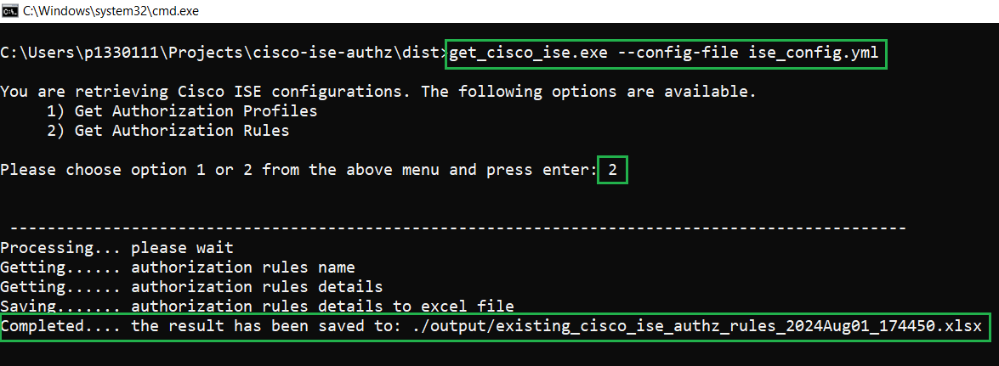

1. Go to “output” folder and open the excel file to verify.

