Health Facility Survey 2021 - Draft Report

The Malaria Control Section @ PNGIMR

Developed and written by Myo Minn Oo

23 March, 2022 12:03

# About

**Disclaimer**

This is a working document, not a final version!

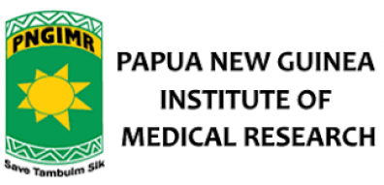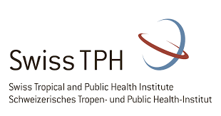

| Author | Email Address | Affiliation |
| --- | --- | --- |
| Myo Minn Oo | [myo.minnoo@swisstph.ch](mailto:myo.minnoo@swisstph.ch) | Swiss Tropical and Public Health Institute, PO Box, 4002 Basel, Switzerland |
|  |  | Papua New Guinea Institute of Medical Research (PNGIMR), Goroka, EHP 441, Papua New Guinea |
| Melvin Kualawi | [melvin.kualawi@pngimr.org.pg](mailto:melvin.kualawi@pngimr.org.pg) | Papua New Guinea Institute of Medical Research (PNGIMR), Goroka, EHP 441, Papua New Guinea |
| William Pomat | [william.pomat@pngimr.org.pg](mailto:william.pomat@pngimr.org.pg) | Papua New Guinea Institute of Medical Research (PNGIMR), Goroka, EHP 441, Papua New Guinea |
| Manuel W. Hetzel | [manuel.hetzel@swisstph.ch](mailto:manuel.hetzel@swisstph.ch) | Swiss Tropical and Public Health Institute, PO Box, 4002 Basel, Switzerland |

**Recommended Citation**

Oo MM, Kualawi M, Pomat W, Hetzel MW. The Papua New Guinea National Malaria Control Program: Health facility Surveys, 2010-2021. Papua New Guinea Institute of Medical Research, Goroka, 2022.

**Acknowledgement**

The authors would like to express their gratitude to the people who participated in these studies and to the provincial and district health authorities and the National Department of Health for their continuous support of the evaluation. Many thanks to all PNGIMR staff who participated in the collection and processing of the data and to all the support staff for creating an enabling environment for this work to be carried out. The authors would also like to acknowledge the operational support provided by PSI PNG during surveys between 2010 and 2022.

# Executive Summary

In the HFS 2021, an evaluation of health facility infrastructure, human resources, medicines, and supplies was completed in 52 health care facilities. In addition, 108 health worker interviews were completed, 351 consultation session of health workers with febrile patients were observed, and 262 febrile patients were interviewed for their malaria-related healthcare seeking experience. Primary outcome indicators and the respective findings are shown in Figure 1-4.

As demonstrated in Figures 1-4, the availability of RDTs and AL declined in 2016 and rised to the peak point in 2021 The number of health workers trained in the NMTP peaked in 2011 (Figure 3), the year in which the majority of training took place, and has decreased substantially since that time. However, as shown in Figure 4, major changes in health worker practice have taken place since 2011 – especially in regards to the greater use of diagnostic testing and reduced antimalarial prescription – and have been maintained ever since. The time trend data also suggest that health worker compliance with the new NMTP has continuously improved since its implementation, but has yet to reach the level of compliance observed in the final years of the former protocol (Figure 4).

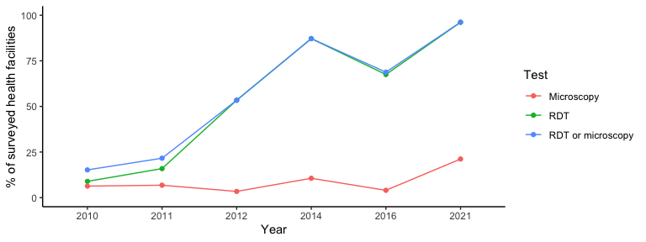

Figure 1. Proportion of health facilities with working microscopy or with malaria Rapid Diagnostic Tests (RDT) in stock

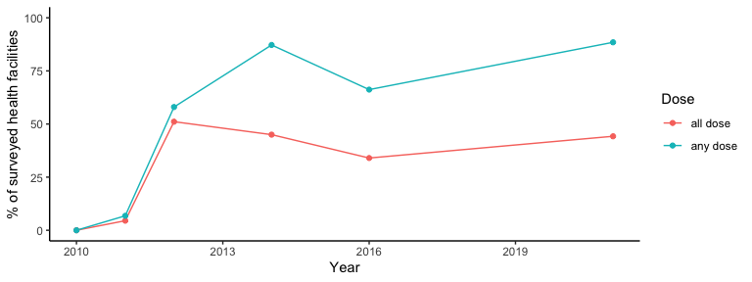

Figure 2. Proportion of health facilities with artemether-lumefantrine (AL) in stock for all age groups (all doses) or with any AL in stock (any doses)

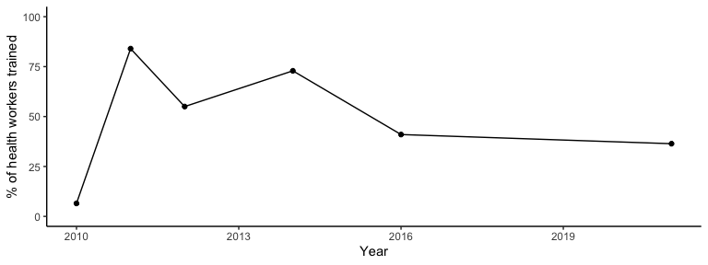

Figure 3. Proportion of health care providers trained in the new treatment guidelines and use of RDTs

# INTRODUCTION

The Government of Papua New Guinea (PNG), with support from the Global Fund to Fight AIDS, Tuberculosis and Malaria (GFATM), implemented a revised ‘test and treat’ national malaria treatment protocol (NMTP) in late 2011. Consistent with WHO recommendations [1], the new protocol stipulates that all fever or suspected malaria cases be tested for malaria infection by microscopy or RDT, introduced artemether-lumefantrine (AL) as the new first-line treatment for uncomplicated Plasmodium falciparum malaria and AL plus primaquine (PQ) as the new first-line treatment for uncomplicated Plasmodium vivax malaria and for mixed malaria infections [2]. The new NMTP represented a substantial change in both diagnostic and prescription practice. Under the former ‘presumptive’ treatment practice anti-malarials were routinely prescribed to all children with fever as well as all adults where microscopy was not available. First line treatments included amodiaquine plus sulphadoxine-pyrimethamine (SP) or chloroquine plus SP for the treatment of uncomplicated malaria.

The Papua New Guinea Institute of Medical Research (PNGIMR) was contracted to provide a range of monitoring and evaluation (M&E) activities in support of the PNG National Malaria Control Program. One component of the PNGIMR M&E plan, described in full elsewhere [3], included repeat, cross- sectional countrywide health facility surveys (HFS) designed to assess the availability of diagnostic tools, medicines and human resources as well as the quality of malaria case management. Five HFS have been completed to date: two in the two-year period prior to the implementation of the new NMTP (2010 and 2011) and three post-implementation of the new NMTP (2012, 2014 and 2016)[1]. This report presents time-trend analyses on key indicators from across all five HFS as well as selected findings from the 2016 HFS. The main outcome measures of the HFS include:

1. Proportion of health facilities with working microscopy or with malaria Rapid Diagnostic Tests (RDT) in stock

1. Proportion of health facilities with the new first-line anti-malarials (ACTs) in stock (for all age groups)
2. Proportion of health care providers trained in malaria case management (new treatment guidelines and use of RDTs)
3. Proportion of fever cases presenting to health facilities diagnosed and treated according to national guidelines

# METHODS

## Study Sites

All HFS were carried out country-wide in areas with endemic or potentially epidemic malaria.[2] The study sample for each HFS consisted of two Urban Clinics (UC), Health Centres (HC) or Sub-Health Centres (SC) (collectively referred to as HC in this report) and up to four Aid Posts (AP) selected from each province using a simple random sampling procedure. The sampling frame for each HFS included all HC operational in March 2010 inclusive of government and mission administered health facilities (N = 689). Aid Posts were randomly selected on site at participating (i.e. randomly selected and consenting) HC. The sampling frame for aid posts was all operational aid posts under the supervision of the HC at the time of survey.[3] All health facilities subsequently included in the survey are listed in Appendix 1.

## Survey Procedure

Each HFS was carried out from June to November in the respective survey year and was conducted by three trained field teams, each comprising two-to-three members, working simultaneously at different sites. The training program for field staff spanned 10 days and consisted of lectures on the project background, malaria facts and effects, survey methodology, and intensive instruction and practice on the survey instruments. Members of each survey team spent between three to five days at each participating HC and up to one day at each participating AP. Four distinct survey instruments were utilised (when possible) at each site: 1) a health facility checklist completed with the officer in charge of the health facility; 2) an interviewer administered questionnaire completed with clinical staff at each participating health facility; 3) an interviewer administered questionnaire completed with fever or suspected/confirmed malaria patients at the end of their clinical consultation; and 4) a clinical assessment instrument which involved non-participant observation of the clinical case management of fever or suspected malaria patients. The health facility checklist was only completed once at each site whilst the remaining three instruments were completed as many times as possible. The clinician and patient questionnaires were available in English or Tok Pisin versions. Completed survey instruments were reviewed by a senior scientist during the course of data collection as a quality control measure and supervisory field visits were conducted with each team to ensure research protocols were adhered to.

Prior to any health facility visit, the respective provincial and district health authorities were informed of the study objectives, sites, and timetable. The provincial health authority was also asked to commission a health officer to accompany the field team. Upon arriving at each HC or AP, the field team conducted a tok save (information session) with the officer in charge and, following this, with the health facility staff. Once permission to proceed had been obtained, the team leader established in consultation with the officer in charge an acceptable process for survey completion. Oral informed consent was sought from the officer in charge at all participating health facilities and from all participating clinicians and patients prior to interview or clinical observation. A health facility was excluded from participation if voluntary consent by the officer in charge was not obtained (nil occurrence). Individual health workers or patients were excluded from the study if they asked for something in exchange for their participation or if voluntary consent was not obtained. The surveys were approved and granted ethical clearance by the Medical Research Advisory Committee of PNG (MRAC No. 10.12; 26 Feb 2010, MRAC No. 15.21; 26 Oct 2015, & MRAC No. 21.05; 04 June 2021).

## Survey Instruments

### Health facility checklist

This instrument assessed the human resource capacity and the availability of supplies relevant to the treatment and management of malaria. Key questions included the number of clinical staff employed, the number of clinical staff trained in the new NMTP, the quantity of RDTs and artemether/lumefantrine (AL) in stock, the quantity of functional microscopes and availability of essential microscopy supplies, and the availability of a range of anti-malarial medications. Recorded numbers of clinical staff and staff trained in the new NMTP were based on figures provided by the officer in charge. All reported RDT stock, microscopes, including microscopy supplies essential to operation – Giemsa stain, slides and (in the case of electric microscopes) power supply – anti-malarials, and other reported medical equipment or supplies were observed by the respective PNGIMR field team leaders.

### Provider interview

This questionnaire contained a range of open and closed questions designed to elicit information regarding staff education, work experience and supervision as well as the type and utility of any malaria-related training he/she may have received (inclusive of NMTP training). This questionnaire also examined the knowledge, attitudes and practice of health workers relevant to malaria case management and, if applicable, their experiences implementing the new NMTP.

### Patient Provider Assessment

A checklist designed to assess the quality of malaria case management. The PNGIMR field team used this checklist to assess whether specified actions did or did not occur and to record the content of specific actions (e.g. whether an RDT was conducted or a referral was made and, if yes, what was the outcome?).

### Exit interview

This questionnaire contained a range of open and closed questions designed to elicit information regarding the patient’s treatment experience, his or her retention of clinical instruction (e.g. diagnosis, treatment counselling advice), treatment accessibility and cost, and pre-treatment behaviour.

## Data Analysis

All data were entered into Open Data Kit (ODK) Android version and uploaded into ODK Central Server as soon as the interview was completed. Data analysis was performed using R Software version 4.1.3. Characteristics of the various samples were tabulated across different regions and types of health facility. Main outcome indicators were described along with 95% confidence intervals (CIs) on selected measures. Differences on repeat measures across time were examined by chi-square or two-tailed t-tests as appropriate. Whereever possible, the calculation of CIs was adjusted for possible clustering at the health facility level by using the Stata ‘svy’ command set in which health facilities were defined as the primary sampling unit.

Since 2012, an antimalarial prescription was considered compliant with protocol if:

* AL was prescribed to P. falciparum cases;
* AL + PQ was prescribed to P. vivax or mixed malaria infection cases;
* AL or AL + PQ was prescribed to any malaria ‘positive’ case in which the species type was not identified.

The response options for each attitudinal statement were ‘agree’, ‘disagree’ and ‘don’t know’. ‘Don’t know’ responses were categorized as ‘incorrect’ in the analysis.

# RESULTS

## Health Facility Checklist

Table 1 presents the number of health facilities surveyed per year, by type, and region. As shown, between 52 and 52 health facilities were included in each survey approximately split into type (health center, aid post, and hospital) region with the notion that the HFS 2014 was conducted only in 10 provinces.

**Table** : Table 1. Number of surveyed health facilities by year, health facility type, and region

| **Year** | **Type** | **Region** | | | | | **Total** |
| --- | --- | --- | --- | --- | --- | --- | --- |
| **NCD** | **Highlands** | **Islands** | **Momase** | **Southern** |
| 2021 | Health Centres | 2 | 13 | 3 | 7 | 4 | 29 |
| Aid Posts | 0 | 6 | 3 | 8 | 2 | 19 |
| Hospital | 0 | 0 | 3 | 0 | 1 | 4 |
| Total | 2 (3.8) | 19 (36.5) | 9 (17.3) | 15 (28.8) | 7 (13.5) | 52 (100.0) |

### Availability of RDTs and working microscopy: outcome indicator one

The availability of RDTs increased across all surveys years and health facility types until 2016 when the first decrease in availability since 2010 was shown in Table 2. Though overall RDT availability decreased in 2016 (67.5%), this increases up to (96.2%) and the difference is statistically significant (96.2% vs. 67.5%; $x^{2}$ (1)=18.1775148, p-value = 0.00002. Table 2 also demonstrates a consistently low percentage in the availability of working microscopy across all survey years and health facility types.

**Table** : Table 2. Percentage of health facilities with unexpired RDT in stock, working microscopy available, or either unexpired RDT/working microscopy

| **Year** | **Diagnostic Test** | **Type** | | | **Overall** |
| --- | --- | --- | --- | --- | --- |
| **Health Centres** | **Aid Posts** | **Hospital** |
| 2021 | RDT | 100 (-) | 89.5 (65.5, 98.2) | 100 (-) | 96.2 (85.7, 99.3) |
| Microscopya | 24.1 (11.0, 43.9) | 0 (-) | 100 (-) | 21.2 (11.5, 35.1) |
| RDT or microscopy | 100 (-) | 89.5 (65.5, 98.2) | 100 (-) | 96.2 (85.7, 99.3) |
| aWorking microscopy is defined as the presence of a functional microscope, all essential supplies including Giemsa stain, slides and (in the case of electric microscopes) power and a trained RLA or MLA in employment. It was not expected in aid post settings (i.e. '0' was the expected result). | | | | | |

### Availability of artemether-lumefantrine (AL): outcome indicator two

Similar to the RDT availability, the AL availability across all surveyed health facilities resumes an upward trend after a sharp dip in 2016. Table 3 further suggests comparable AL availability in aid posts and health centres from 2014 onwards.

**Table** : Table 3. Percentage of health facilities with artemether-lumefantrine (AL) in $stock^{a}$

| **Year** | **AL dose** | **Type** | | | **Overall** |
| --- | --- | --- | --- | --- | --- |
| **Health Centres** | **Aid Posts** | **Hospital** |
| 2021 | Infant (5-15kg) | 58.6 (39.1, 75.9) | 47.4 (25.2, 70.5) | 75.0 (21.9, 98.7) | 55.8 (41.4, 69.3) |
| Child (15-25kg) | 79.3 (59.7, 91.3) | 57.9 (34.0, 78.9) | 100 (-) | 73.1 (58.7, 84.0) |
| Youth (25-35kg) | 86.2 (67.4, 95.5) | 68.4 (43.5, 86.4) | 100 (-) | 80.8 (67.0, 89.9) |
| Adult (35+kg) | 79.3 (59.7, 91.3) | 68.4 (43.5, 86.4) | 75.0 (21.9, 98.7) | 75.0 (60.8, 85.5) |
| All dosesb | 48.3 (29.9, 67.1) | 36.8 (17.2, 61.4) | 50.0 (15.0, 85.0) | 44.2 (30.7, 58.6) |
| Any dosesc | 93.1 (75.8, 98.8) | 78.9 (53.9, 93.0) | 100 (-) | 88.5 (75.9, 95.2) |
| aThe quantity of each medication was not accounted for in this analysis; rather, the data represent the percentage of health facilities that had at least one blister pack of the respective anti-malarial in stock | | | | | |
| bat least one blister pack in all age categories was present at the health facility | | | | | |
| cat least one blister pack from any age category was present at the health facility | | | | | |

### Health worker training: outcome indicator three

The highest percentage of trained health workers was initially observed in the 2011 survey as NMTP training was provided between late 2010 and early 2011 at 84% that decreased to 41% by 2016 (Table 4). The lowest percentage was found in 2010 while the majority of the HFS 2010 was completed before the formal NMTP training program was commenced. Although the number of employment increased two-fold between 2016 and 2021, the number of staffs trained in new NMTP was record-low at 36.4%.

**Table** : Table 4. The number and percentage of clinical staff employed in the surveyed health facilities who had been reported trained in the new NMTP

| **Year** | **Position** | **Employed** | **Trained in new NMTP** |
| --- | --- | --- | --- |
| **n** | **n (%)** |
| 2021 | MD | 29 | 14 (48.3) |
| HEO | 36 | 16 (44.4) |
| Nurse | 347 | 105 (30.3) |
| CHW | 352 | 141 (40.1) |
| RLA/MLA | 16 | 8 (50.0) |
| Total | 780 | 284 (36.4) |
| NMTP=National Malaria Treatment Protocol; MD=Medical Doctor; HEO=Health Extension Officer; CHW=Community Health Worker; RLA/MLA=Rural/Medical Laboratory Assistant; | | | |

### Availability of other anti-malarial medications

Table 5 shows the percentage of health facilities with the various anti-malarial combinations stipulated in the new NMTP in stock in the HFS 2021. While AL was the most widely available anti-malarial and DP the least available, these figures became reverse in 2021. Though AL was the only recommended anti-malarial widely available in 2016, this has changed in a way that several recommended anti-malarials were now present in more than half of surveyed health facilities in 2021. The combination QI + QT + DX was available in the majority of the health facilities in 2021.

| **Year** | **Medicationa** | **Type** | | | **Overall % (95% CI)** |
| --- | --- | --- | --- | --- | --- |
| **Health Centres % (95% CI)** | **Aid Posts % (95% CI)** | **Hospital % (95% CI)** |
| 2021 | ALb,c | 48.3 (32.9, 70.1) | 36.8 (38.6, 82.8) | 50.0 (15.0, 85.0) | 44.2 (41.4, 69.3) |
| AL + PQd | 44.8 (36.0, 73.0) | 21.1 (53.9, 93.0) | 50.0 (15.0, 85.0) | 36.5 (48.9, 76.0) |
| DPe | 13.8 (67.4, 95.5) | 10.5 (65.5, 98.2) | 25.0 (21.9, 98.7) | 13.5 (73.6, 94.0) |
| AI + ALf | 41.4 (39.1, 75.9) | 31.6 (43.5, 86.4) | 50.0 (15.0, 85.0) | 38.5 (47.0, 74.4) |
| AI + AL + PQg | 37.9 (42.4, 78.7) | 15.8 (59.5, 95.8) | 50.0 (15.0, 85.0) | 30.8 (54.7, 80.9) |
| QI + QT + DXh | 24.1 (56.1, 89.0) | 0 (-) | 25.0 (21.9, 98.7) | 15.4 (71.4, 92.7) |
| aThe quantity of each medication was not accounted for in this analysis; rather, the data represent the percentage of health facilities that had at least one vial or container(inclusive of a single, opened container) of the respective anti-malarial in stock | | | | | |
| bMeasured as the presence of blister packs in all four weight categories | | | | | |
| cFirst line treatment for uncomplicated *P.falciparum* infection | | | | | |
| dFirst line treatment for uncomplicated *P.vivax* infection | | | | | |
| eSecond line treatment for uncomplicated malaria infection | | | | | |
| fFirst line treatment for severe*P.falciparum* infection | | | | | |
| gFirst line treatment for severe *P.vivax* infection | | | | | |
| hSecond line treatment for severe malaria infection | | | | | |
| AL=artemether-lumefantrine, PQ=primaquine, DP=dihydroartemisinin-piperaquine, AI=artemether or artesunate injection, QI=quinine injection, QT= quinine tablets, DX= doxycycline. | | | | | |

## Provider Interview

## Patient Provider Assessment

## Exit Interview

# DISCUSSION

## Availability of RDTs and Operational Microscopy

## Availability of Artemether Lumefantrine

## Health Worker Training in the New National Malaria Treatment Protocol

## Health Worker Compliance with the New National Malaria Treatment Protocol

## Key Findings from Secondary Data Analyses

# REFERENCES

# APPENDIX

# TODO:list

* add a table
  + how many hf are from the inital list of random selection and how many from backup
* calculate weighted CI? weights = 1/p(HF being selected per province)? Not all HF are from the random list so will survey analysis make sense here?

1. At present, there are no plans to conduct additional HFS (the current PNGIMR M&E plan expires in December 2017).
2. The 2014 HFS was an exception. Due to financial and logistical constraints, the 2014 HFS was only completed in 10/20 provinces. This included all four provinces in the Momase region and two provinces each from the remaining regions.
3. Reliable records of the number of aid posts in operation are not available. Not all participating HC had operational aidposts under their supervision so the target of surveying four aid posts per province was not always achieved.