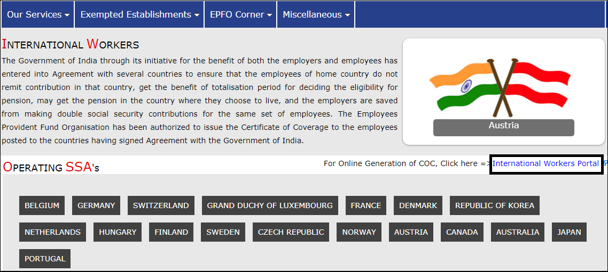
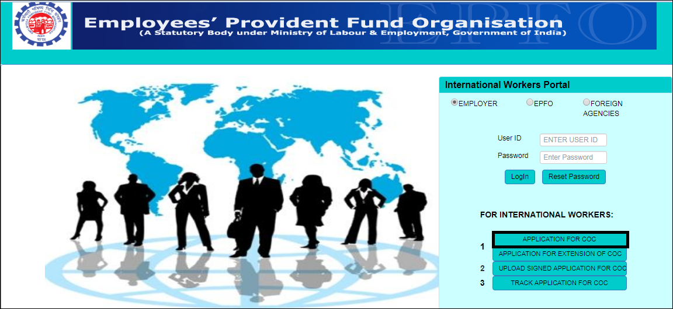
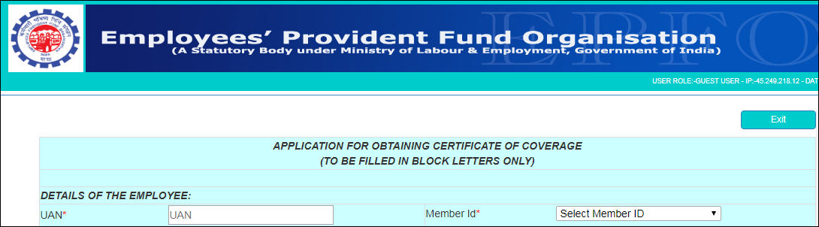
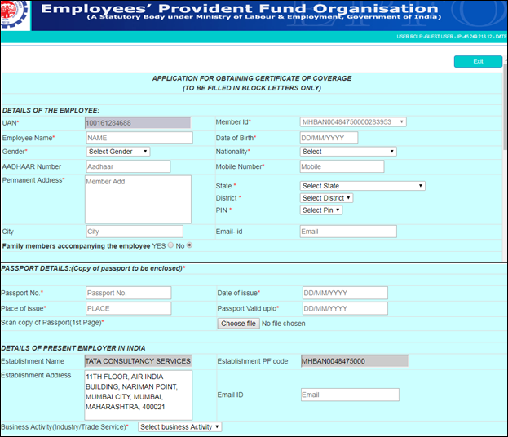
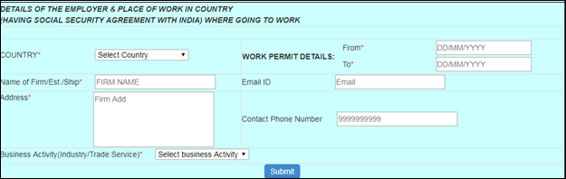
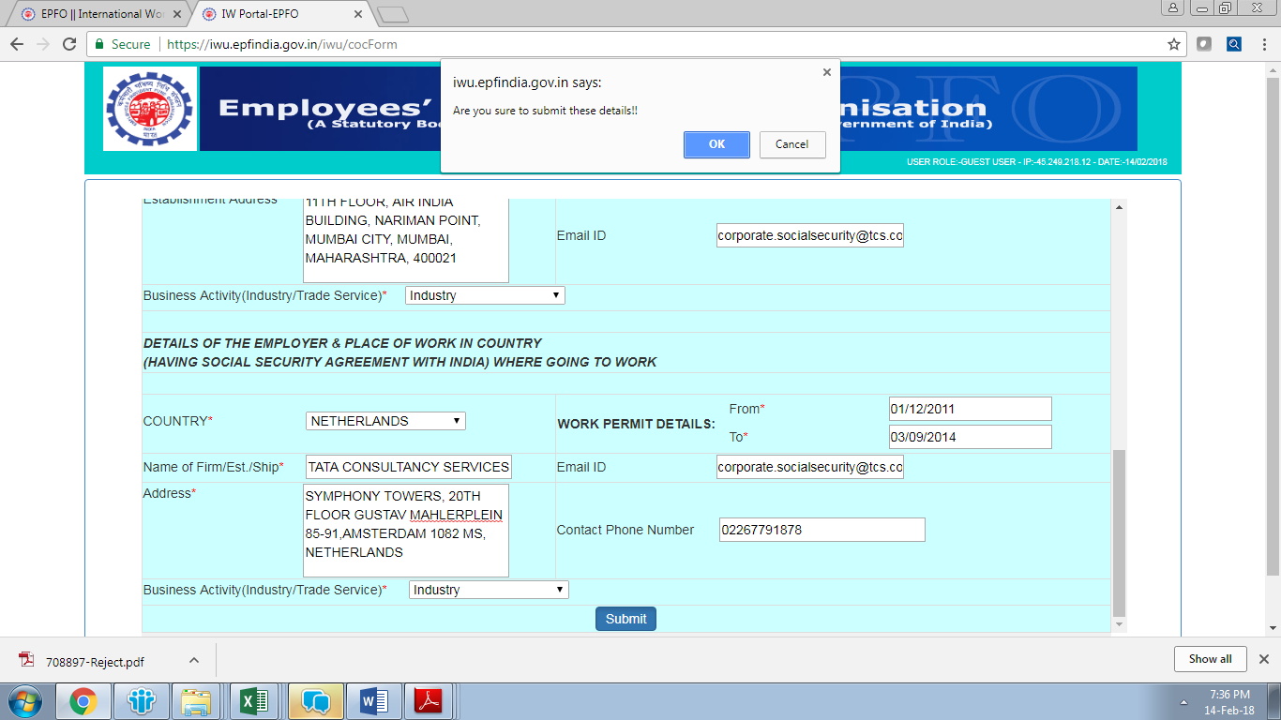
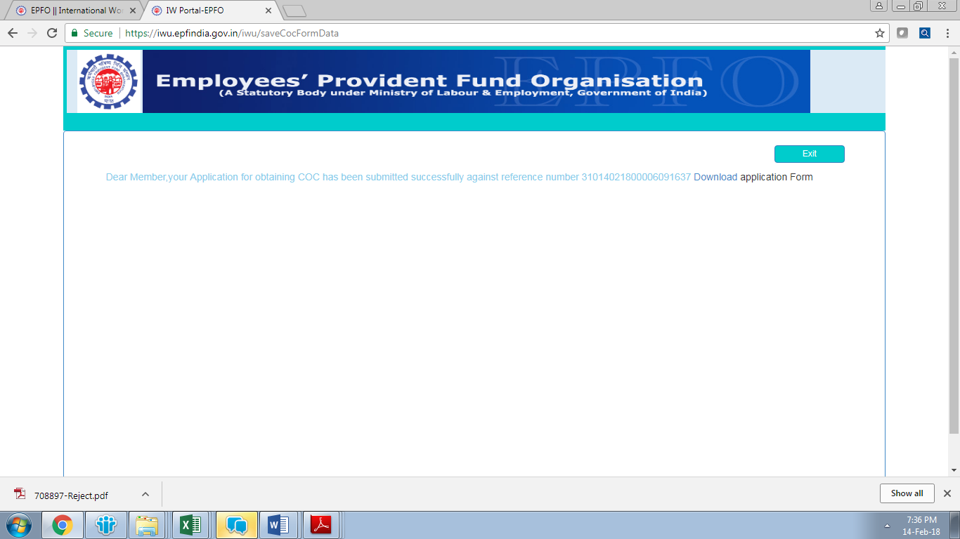
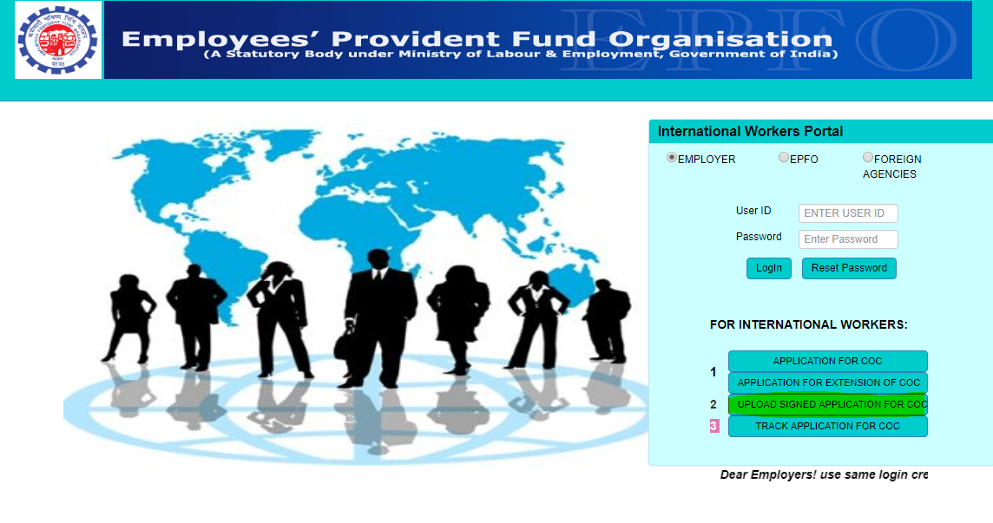
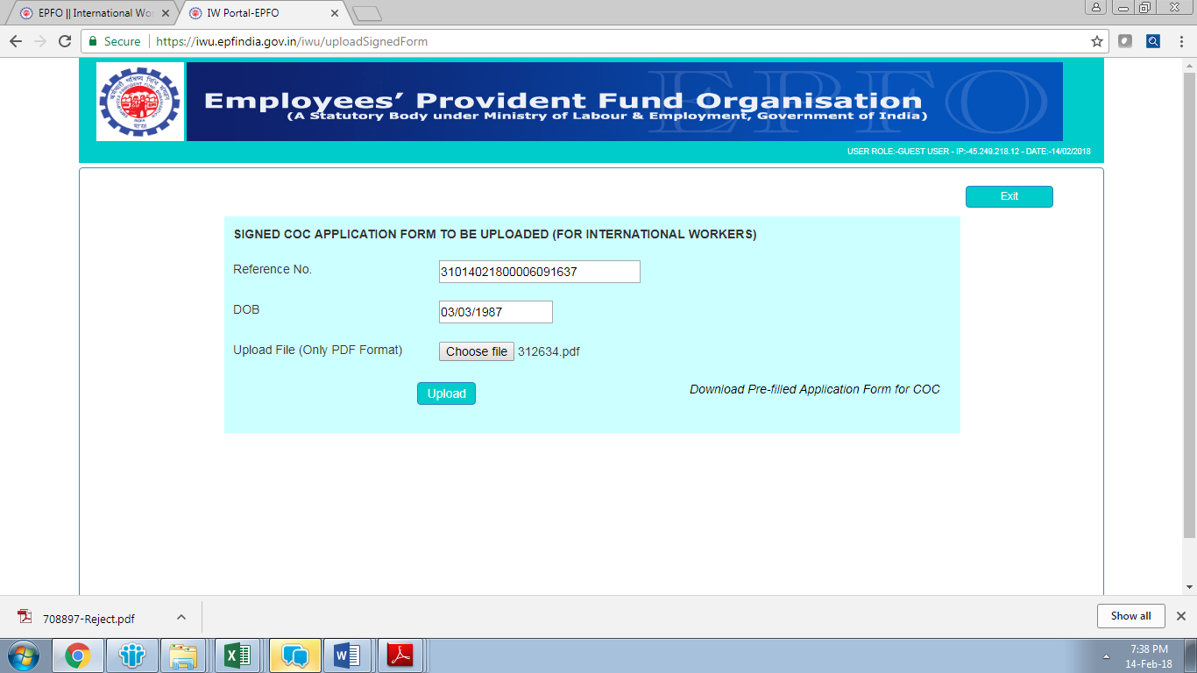
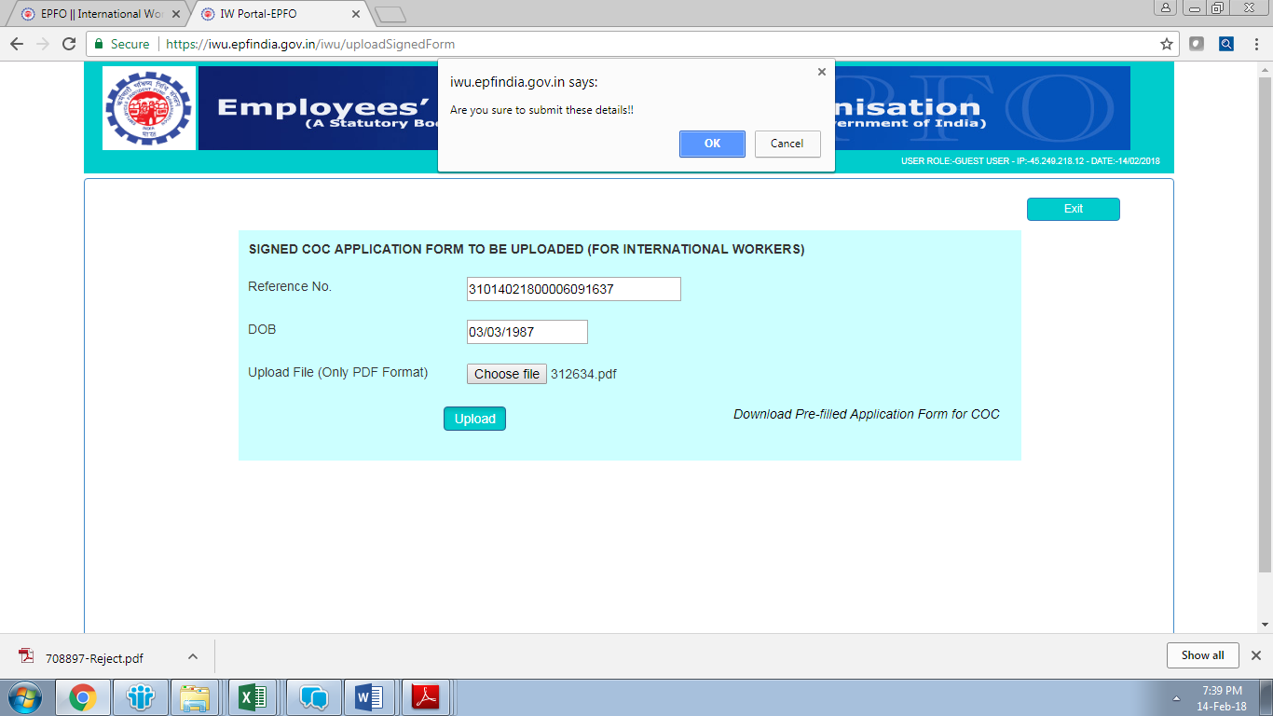
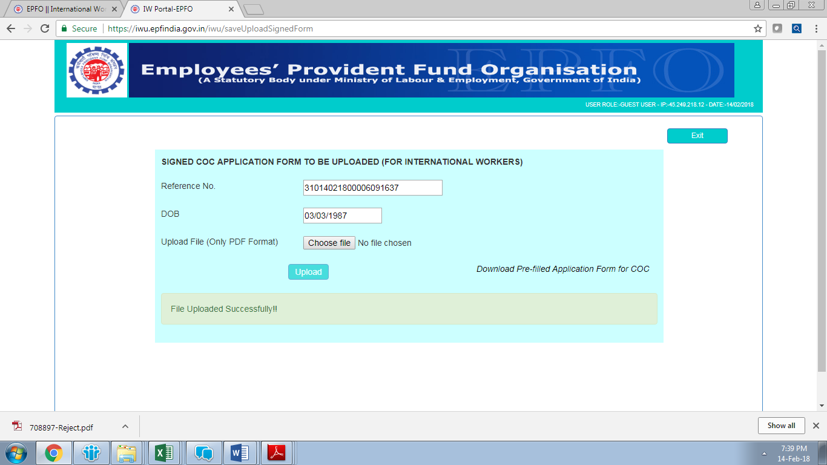
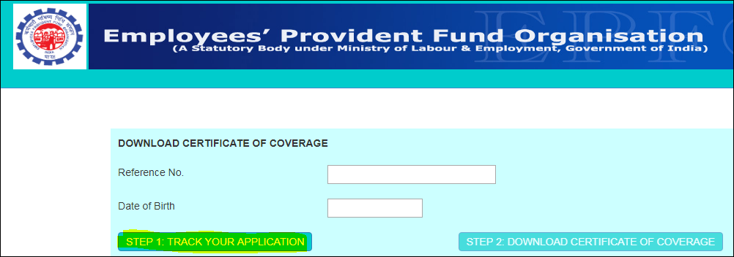
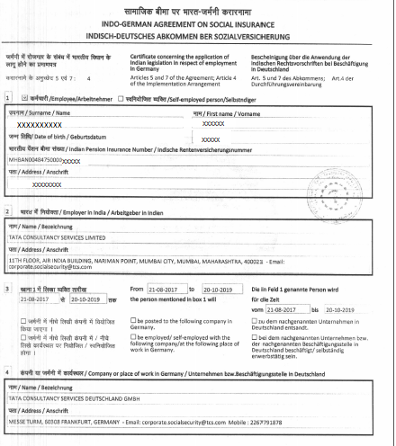
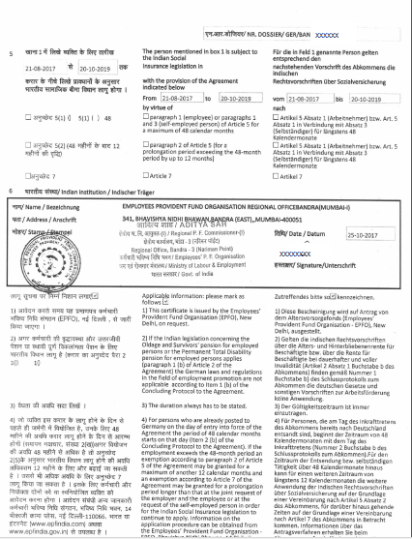
How to access Application Form for COC
Step 1: Go to http://www.epfindia.gov.in/site_en/International_workers.php?id=sm3_index
Step 2: Click on International Workers Portal for COC (Refer Figure 1a)

Figure 1(a): For online generation of COC, click on International Workers Portal on the Homepage.

Step 3: Click on Application for COC (Refer Figure 1b)

Figure 1(b): Application Form for COC link

Step 4: Enter UAN number

Figure 1(c): Application for obtaining Certificate for Coverage

**For Sweden & Japan, in case of short term deputation i.e. less than 92 days, COC is not applicable**

Guidelines to fill the COC Form
COC Application will be available to you on next screen. All fields marked in asterisk (*) are mandatory.
Step 5: Please fill all the details as per following instrctions:

- Enter your full Name as it appears on your Passport, Date of Birth, Gender, Aadhar Number, India Mobile Number and Nationality
- Mention valid passport details and permanent address as per passport & upload 1st page of passport copy (PDF format only)
- Dependent details are mandatory for employees travelling to Netherlands, Sweden and Luxembourg
- Employer Address in India is autopopulated, keep it as is
- Email ID in Employer Section (India) should be corporate.socialsecurity@tcs.com
- Business Activity is Industry
- Select the correct Country to which you are travelling from the drop down
- For name & address of the Employer in that Country, refer Table 1
- In WP column please mention WP dates or actual/expected travel date whichever is later and Work Permit end date should be deputation end date /Passport end date /Table 2 whichever is earlier.
- Email ID in SSA Country should be corporate.socialsecurity@tcs.com
- Contact number is any one of : 91-022-63716307, 63716330, 63716332, 63716306
- Business Activity is Industry

Figure 2: Guidelines to fill in CoC application

Step 6: Once all the details are filled, kindly verify the details and submit the COC request

Submitting the application:
- Update relevant information
- Verify the details.
- Click on Submit.

Figure 3: Submitting the details

Confirmation of CoC Reference Number
Post submitting the online CoC Form, a confirmation page will appear mentioning your CoC reference number.

Figure 4: Confirmation Page

Step 7: Download the duly filled COC application and sign across at the place of employee. (The employer will sign the CoC application at the time of processing, employee is not required to obtain Employer signature).

Step 8: It is compulsory to get your COC application verified from Global Compliance Team

Uploading the application on EPFO Portal:

Step 9: Post verification and approval from FDFU team, upload the application on EPFO portal

Figure 5(a): Upload the application on EPFO Portal

Upload duly signed COC application in PDF format only. The Scan COC application should be clear and complete.

Figure 5(b): Upload the application on EPFO Portal

Figure 5(c): Upload the application on EPFO Portal

Figure 5(d): Upload the application on EPFO Portal

Tracking status of online COC request on EPFO portal:

Step 10: You can track the status of your online COC request on EPFO portal

Employee can track the status of their COC application on https://iwu.epfindia.gov.in/iwu/trackAppStatus by entering the reference number of COC & DOB. You can also download and store the Original COC for future reference if it is available on EPFO portal.

Figure 6: Tracking the application on EPFO Portal

Table 1: Place of Work In (Country Name)
Guidelines to fill in the PLACE OF WORK IN (Country Name) section are as follows:
Travellers to Belgium
Name of Firm/Est./Ship | Client Name
Address | Client Address
Travellers to Denmark
Name of Firm/Est./Ship | TATA CONSULTANCY SERVICES
Address | KALVEBOD BRYGGE 45, 1560 COPENHAGEN, DENMARK
Travellers to France
Name of Firm/Est./Ship | TATA CONSULTANCY SERVICES FRANCE
Address | TOUR FRANKLIN 100-101 QUARTIER BOIELDIEU 92042 PARIS LA DEFENSE FRANCE
Travellers to Germany
Name of Firm/Est./Ship | TATA CONSULTANCY SERVICES DEUTSCHLAND GMBH
Address | MESSE TURM, 60308 FRANKFURT, GERMANY
Travellers to Hungary
Name of Firm/Est./Ship | TATA CONSULTANCY SERVICES
Address | SCIENCE PARK B, 1st FLOOR, IRINYI JOZSEF UTCA 4-20,  BUDAPEST - 1117, HUNGARY.
Travellers to Luxembourg
Name of Firm/Est./Ship | TATA CONSULTANCY SERVICES LUXEMBOURG SA
Address | WESTSIDE VILLAGE, RUE PAFEBRUCH 89 D,L-8308  CAPELLEN, LUXEMBOURG S.A
Travellers to Netherlands
Name of Firm/Est./Ship | TATA CONSULTANCY SERVICES NETHERLANDS B.V.
Address | SYMPHONY TOWERS, 20th FLOOR GUSTAV MAHLERPLEIN 85-91, AMSTERDAM 1082 MS, NETHERLANDS.
Travellers to Republic of Korea
Name of Firm/Est./Ship | TATA CONSULTANCY SERVICES APAC PTE LTD
Address | 3F, PINEAVENUE B, 100 EULJIRO JUNG-GU SEOUL KOREA 04551
Travellers to Switzerland
Name of Firm/Est./Ship | Client Name if working from client location or else TCS  TATA CONSULTANCY SERVICES SWITZERLAND LTD
Address | Client Address if working from client location or else TCS Address : MAIN TOWER, THURGAUERSTRASSE, 36/38, CH-8050, ZURICH, SWITZERLAND
Travellers to Finland
Name of Firm/Est./Ship | TATA CONSULTANCY SERVICES
Address | FILIAL I FINLAND, ITAMERENKATU 5, HELSINKI FI00180, FINLAND
Travellers to Sweden on WON
Name of Firm/Est./Ship | TATA CONSULTANCY SERVICES LTD.
Address | MASTER SAMUELSGATAN 42, 15TH FLOOR, SE-111 57 STOCKHOLM, SWEDEN.
Travellers to Sweden on SWON
Name of Firm/Est./Ship | TATA CONSULTANCY SERVICES SVERIGE AB
Address | MASTER SAMUELSGATAN 42, 15TH FLOOR, SE-111 57 STOCKHOLM, SWEDEN
Travellers to Norway
Name of Firm/Est./Ship | TATA CONSULTANCY SERVICES LIMITED
Address | SANDAKERVEIEN 116, 0484 OSLO, NORWAY
Travellers to Canada
Name of Firm/Est./Ship | TATA CONSULTANCY SERVICES CANADA INC.
Address | 400 UNIVERSITY AVE. 25TH FLOOR, TORONTO, ONTARIO M5G 1S5
Travellers to Australia
Name of Firm/Est./Ship | TATA CONSULTANCY SERVICES LIMITED
Address | LEVEL 6, 76 BERRY STREET, NORTH SYDNEY, NEW SOUTH WALES - 2060, AUSTRALIA
Travellers to Japan
Name of Firm/Est./Ship | TATA CONSULTANCY SERVICES JAPAN, LIMITED
Address | 4-1-4 SHIBAKOEN, MINATO-KU,TOKYO – 105-8508, JAPAN
Travellers to Portugal
Name of Firm/Est./Ship | TATA CONSULTANCY SERVICES PORTUGAL
Address | EDIFICIO ATLAS IV, AV.JOSE GOMES FERREIRA,15,PISO 7,MIRAFLORES,1495-139 ALGES, PORTUGAL
Travellers to Austria
Name of Firm/Est./Ship | Client Name
Address | Client Address

Note: For client location specify the details accordingly.
**For Sweden & Japan, in case of short term deputation i.e. less than 92 days, COC is not applicable**

Period of Work In (Country Name)
The following table shows the number of years for which COC is applied in each country for initial period of deputation. In the event the employee’s deputation is continued beyond the period for which COC is initially applied as per the table below, employee is required to submit fresh application for extending the period of COC.
Table 2: Number of Years as per Country
Country Name | Number of Years
Belgium | 2 Years
Denmark | 2 Years
Finland | 2 Years
France | 1 Year
Germany | 2 Years
Hungary | 2 Years
Luxembourg | 3 Years
Netherlands | 2 Years
Republic of Korea | 2 Years
Sweden | 2 Years
Switzerland | 1 Year
Norway | 3 Years
Canada | 3 Years
Australia | 3 years or visa expiry date whichever is earlier
Portugal | 2 Years
Austria | 1 Year
Japan | 2 Years
Note: 1) Employee travelling on Short Term Deputation should mention their actual Deputation Period end date if it is less than the period given above. .
2) Incase employees’ passport end date is prior to the period specified in table above, the passport end date shall be mentioned as COC end date
3) As per Canada fiancé if original CoC is received before December of the same year, adjustments will happen for that year, else adjustments for that year would not be possible due to year end closing in that case any applicable adjustments would be possible only by 1st January of the next year
For eg: if CoC application gets submitted by 17-November-2018 and the Original COC is received by 22-February-2019, any adjustments for 2018 would not be possible. Adjustments would be possible only from 1-January 2019.

Sample – Original CoC -

