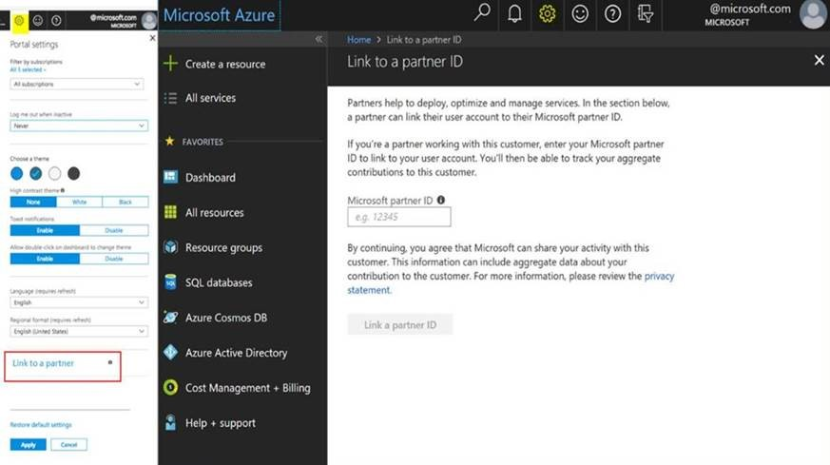




Partner Administrative Link (PAL) Tagging Process

Confidentiality Statement
This document contains confidential information of Tata Consultancy Services Limited, which is provided for the sole purpose of permitting the recipient to evaluate the proposal submitted herewith. In consideration of receipt of this document, the recipient agrees to maintain such information in confidence and to not reproduce or otherwise disclose this information to any person outside the group directly responsible for evaluation of its contents, except that there is no obligation to maintain the confidentiality of any information which was known to the recipient prior to receipt of such information from Tata Consultancy Services Limited, or becomes publicly known through no fault of recipient, or is received without obligation of confidentiality from a third party owing no obligation of confidentiality to Tata Consultancy Services Limited.

Tata Code of Conduct
We, in our dealings, are self-regulated by a Code of Conduct as enshrined in the Tata Code of Conduct. We request your support in helping us adhere to the Code in letter and spirit. We request that any violation or potential violation of the Code by any person be promptly brought to the notice of the Local Ethics Counselor or the Principal Ethics Counselor or the CEO of TCS. All communication received in this regard will be treated and kept as confidential.

Revision/ Version control Log
Version No. | Date | Revised By | Changes Done
1 | 12 Jan 2021 | Girish Rangwani | Initial Version.
2 | 13 Jan 2021 | Girish Rangwani | Approval table added, revision log added, appendix added.

Approvers
Approver Name | Project Role | Signature/Electronic Approval | Date
Girish Rangwani | TCS MBU Alliances | Girish | 14 Jan 2021
Nilesh Vibhandik | TCS MBU Alliances
Table of Content
1.What is Partner Administrative Link? 6
1.1.Benefit to TCS: 6
1.2.Benefit to Customer: 6
2.Get access from your customer 6
3.Steps to link your Partner ID with Azure account: 7
4.Appendix 9

What is Partner Administrative Link?

Microsoft requires partner to add their ID to the customer subscription, this will make TCS visible within the Microsoft system for acting on behalf of the customer for managing, configuring and supporting Azure Services.

Benefit to TCS:

PAL enables Microsoft to identify and recognize partners who drive Azure consumption and above all this will be a direct measure of the partnership. There is no monetary benefit to TCS as long as customer has signed the Enterprise Agreement with Microsoft directly or through an licensing solution provider (LSP).

Benefit to Customer:

TCS will be able to bring in the right level of attention and support from Microsoft. Additionally, TCS will be able to leverage the Microsoft Architect team and provide Azure environment for any PoC’s.

Get access from your customer

Before you link your partner ID, your customer must give you access to their Azure resources by using one of the following options:

- Guest user: Your customer can add you as a guest user and assign any Azure roles.
- Directory account: Your customer can create a user account for you in their own directory and assign any Azure role.
- Service principal: Your customer can add an app or script from your organization in their directory and assign any Azure role. The identity of the app or script is known as a service principal.
- Azure Lighthouse: Your customer can delegate a subscription (or resource group) so that your users can work on it from within your tenant.

Steps to link your Partner ID with Azure account:

- Connect to https://portal.azure.com with Account of the TCSer . (Refer screenshot below)
- Click on the settings wheel.
- Click "link to partner".
- Type "XXXXX" and submit. → MPN ID
** The MPN ID mentioned above is for illustration purpose. To get your regional TCS MPN ID please reach out to TCS MBU Alliances team for the specific country of your project/customer location.
This is required to be done by all TCS associates (Admin, Contributor) accessing the Azure Subscription.

Appendix

- For more information about linking Partner Id with Azure account refer to this link - https://docs.microsoft.com/en-us/azure/cost-management-billing/manage/link-partner-id

