6.Confirmation from you that you have gone through the Welcome to Canada PPT and understand the instructions provided.

I have Gone throuh the Welcome to Canada PPT and understood the instructions.

7.Confirmation from you that you have completed your TCS India Time sheet before travel.

Yes I have Completed the Time sheet for this Month and before travelling , Will complete the Time sheet. Once he Advance Timehseet is Open for Next Month.

8.Is your spouse working for TCS and travelling with you as a dependent? (If yes, please provide EMP # and confirm whether he/she applied for LWP) (Please do not mention " Not applicable" or " NO" or " NA ". We need the complete answer):

My Spouse is not working in TCS.

9.Your role in iTalent/iEvolve. Share me the screen shot of your role in system. Your role in iTalent/iEvolve and WP role should be same. If not, travel will not be approved. You can view your role in Ultimatix home screen top right.

Role : Technical Architect

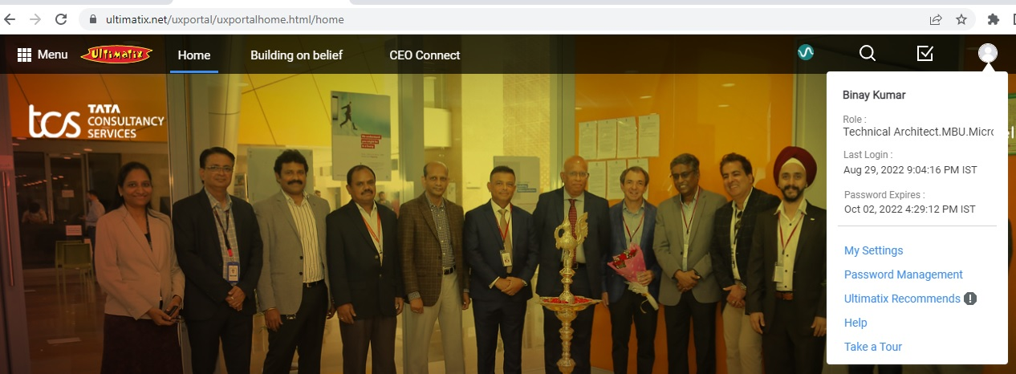

10. Kindly complete Mandatory training courses from HR Downloads and share screenshot (Not the courses from iEvolve). You will get email notification from HR Downloads within 24 to 48 hours in EST time zone.

Completed the HR Download all the Mandatory Training. Attached the Certificates with this mail.

Note: Downloaded ArriveCAN App and added the Traveller details along with Vaccination Certificate. Further It is Asking Trip Details (Flight Number , Travel Date). So that We can provide once Ticket is booked.

Downloaded and attached the duly filled CoC application and sign across at the place of employee. Please help on CoC application verification from location Globalmobility relocationcompliance team.
So that Post verification and approval from Globalmobility relocationcompliance team, upload the application on EPFO portal

Thanks
Binay Kumar
Employee ID : 365295

