**Team Members: Mike Young, Mark Yocum, Raphael Vazquez**

**Project/Description:**

Our project is to uncover the drivers for solar power uptake in 49 different US States, exploring whether socioeconomic status or local weather conditions are biggest drivers for people to adopt solar panel coverage.

**Hypothesis:**

* + Sunnier regions have more solar panels per person
  + Wealthier regions have more solar panels per person
  + Regions with higher electricity prices have more solar panels per person
  + Regions with better government incentives have more solar panels per person
  + Regions with higher educated households are more likely to have solar panels

**Questions:**

1. Does geographic location contribute to solar panel adoption?
2. Do government incentives actually incentivize solar panel adoption?
3. Does income level contribute to solar panel adoption?
4. Does education level contribute to solar panel adoption?
5. Do higher electricity prices contribute to solar panel adoption?

**Dataset from Stanford's DeepSolar Project:**

1. https://www.kaggle.com/tunguz/deep-solar-dataset/home
2. Openweather API
3. gmaps API

**Tasks:**

1. Organize Stanford dataset into workable dataframe.
2. Breakout location data and obtain weather conditions by county from OPENWEATHER API.
3. Establish consumer/demographic profiles as they relate to solar panel usage.
4. Visualize solar panel density and both weather and/or economic data on gmaps.
5. Run statistical testing on each variable.

**Major Findings:**

**Does geographic location contribute to solar panel adoption?**

Yes, in most parts of the country higher solar radiation correlated with solar panel uptake. 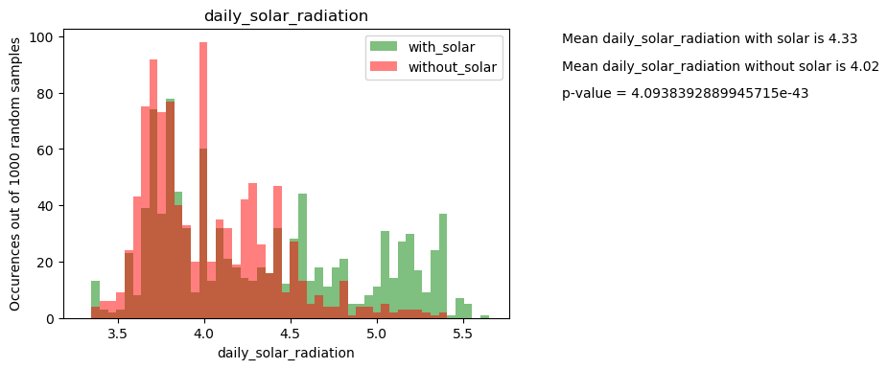

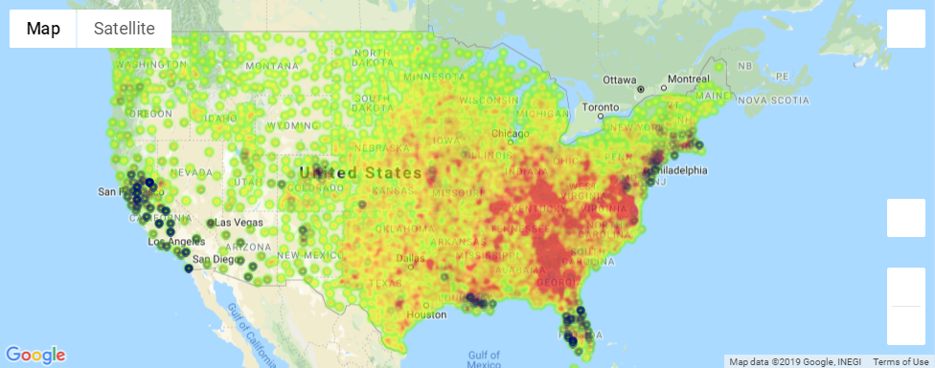

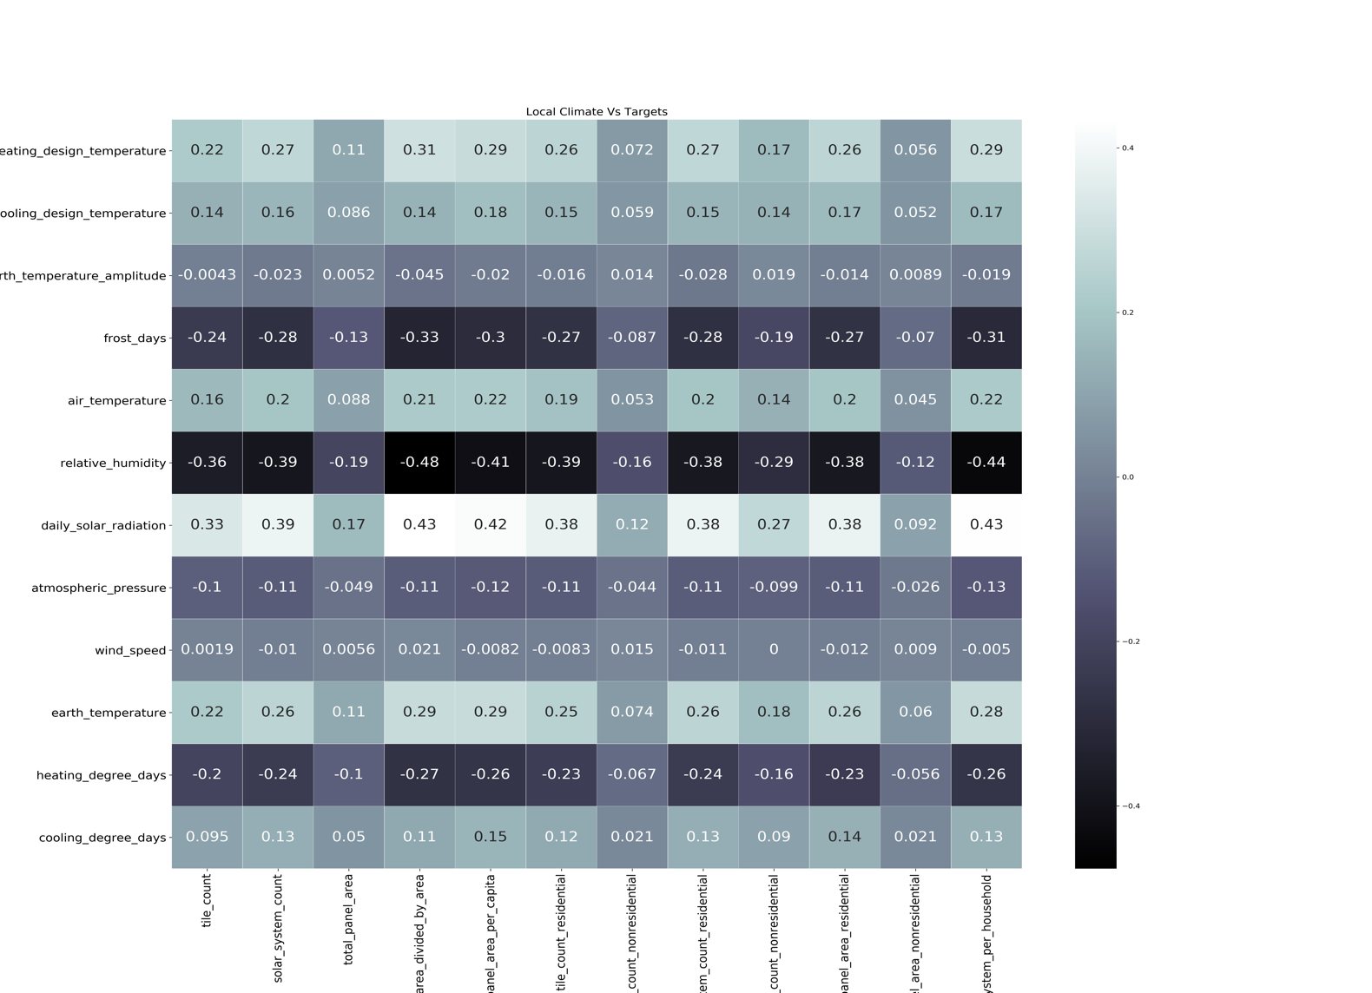

**Do government incentives actually incentivize solar panel adoption?**

Yes, government incentives do actually incentivize solar panel adoption, especially in the southwestern states plus Louisiana.

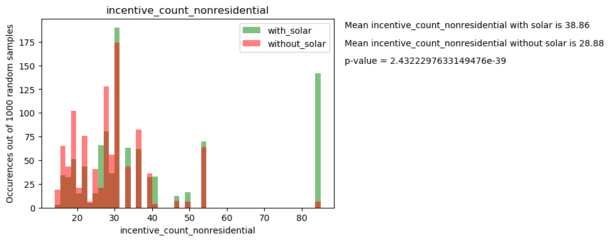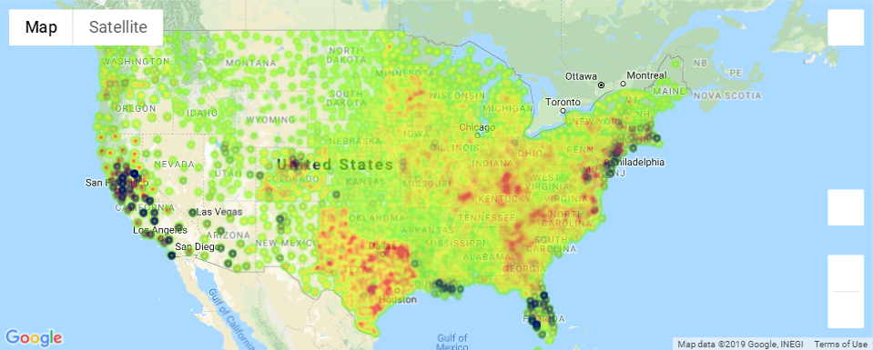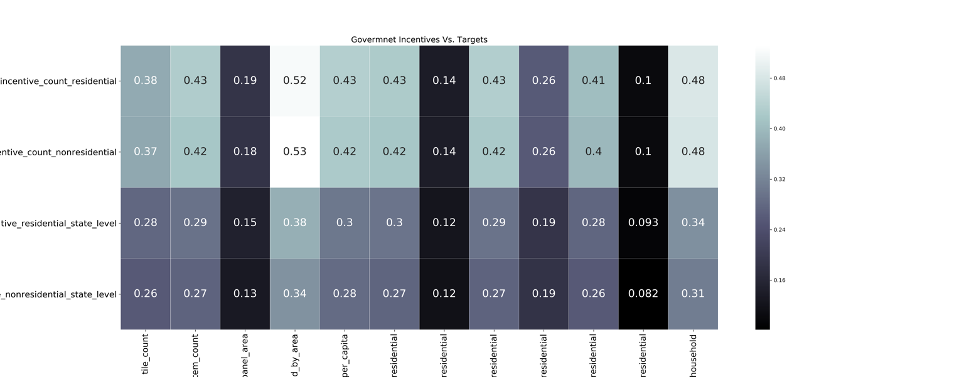

**Does income level contribute to solar panel adoption?**

Yes, wealthier people were shown to be more likely to have solar panels on their homes or businesses.

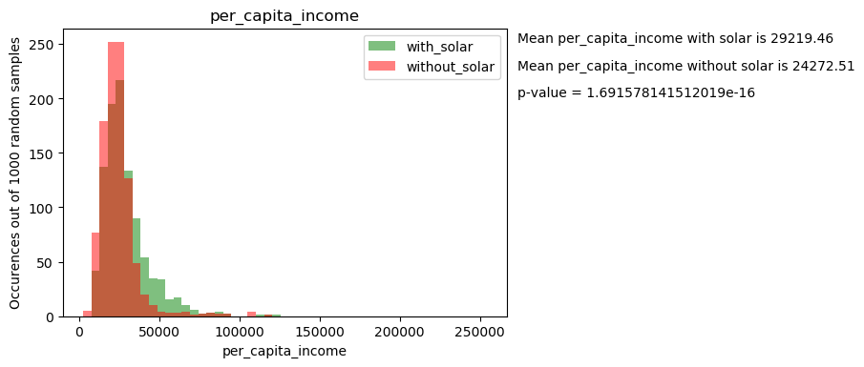

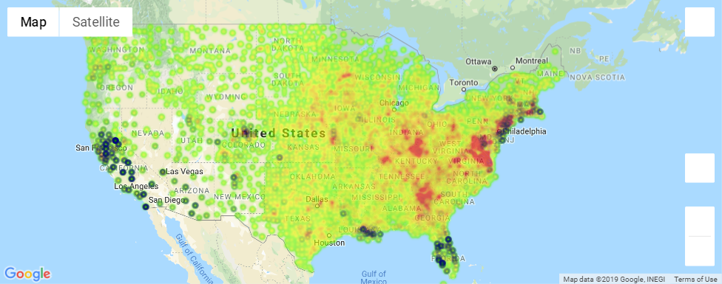

**Does education level contribute to solar panel adoption?**

Yes, people with only a high school education or lower were correlated with lower solar panel uptake. 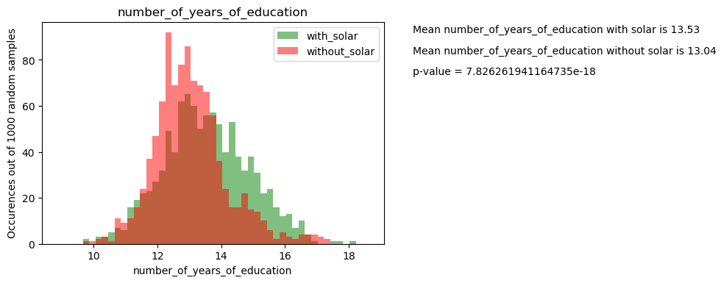

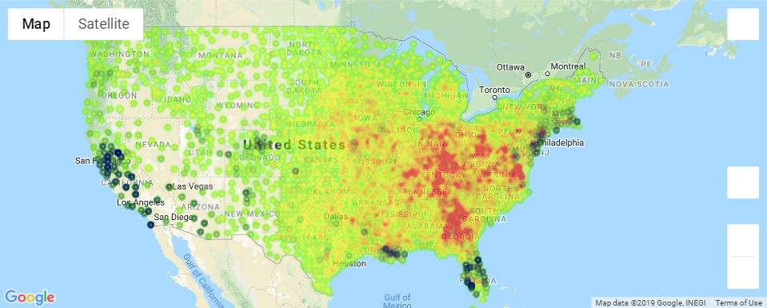

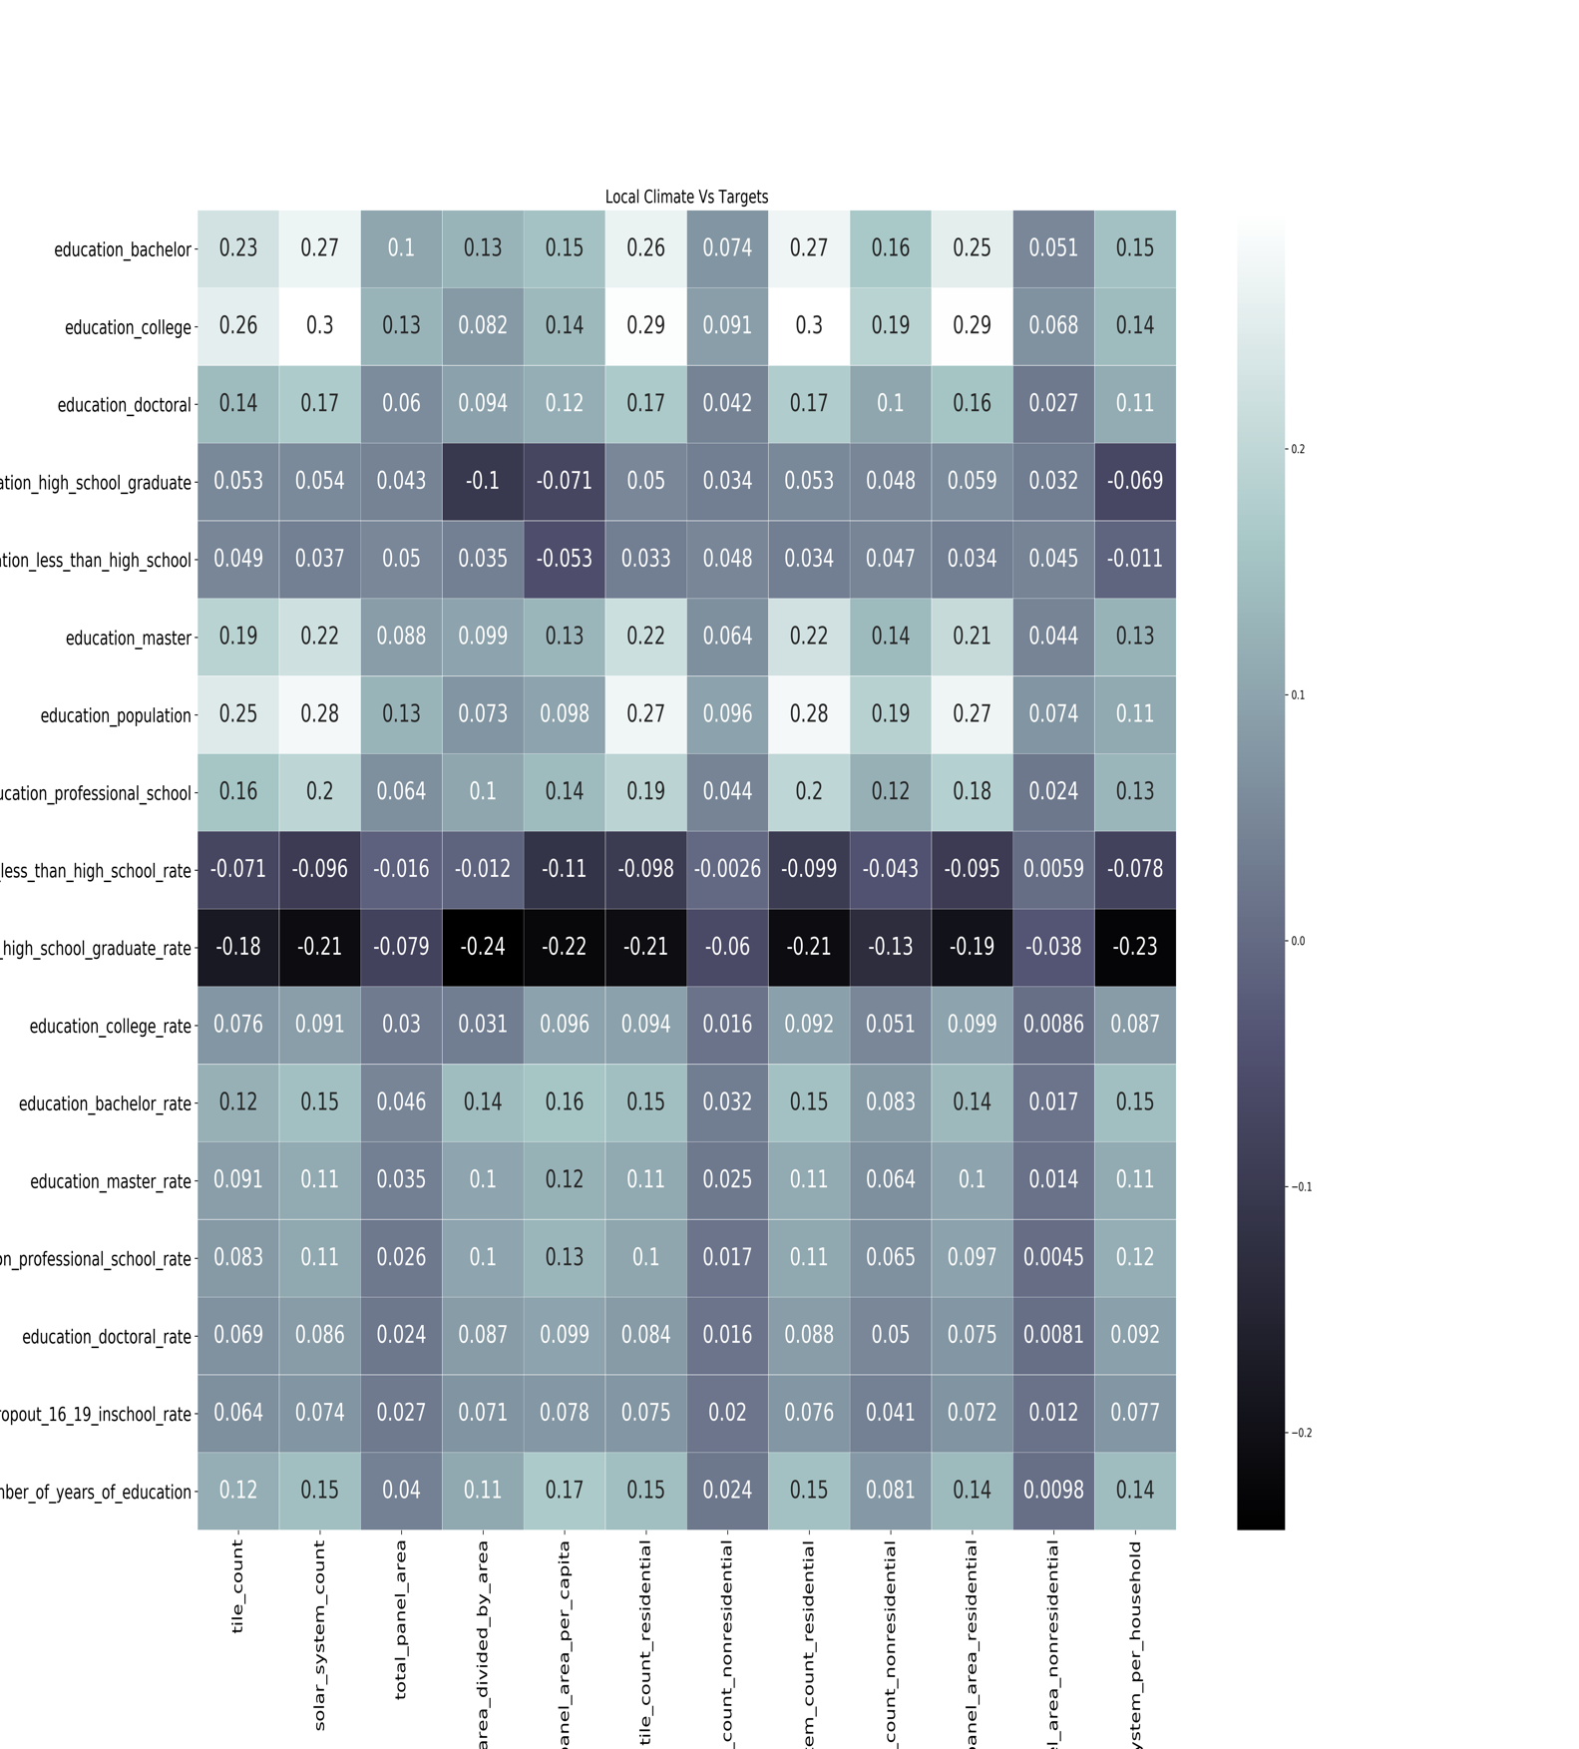

**Do higher electricity prices contribute to solar panel adoption?**

Yes, we found a higher correlation between electricity price – residential and solar panel uptake per household that determines electricity prices do contribute to the decision to use solar panels.

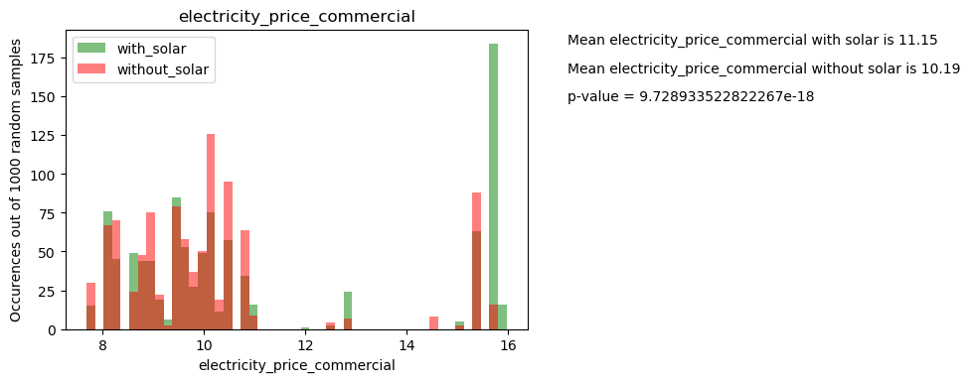

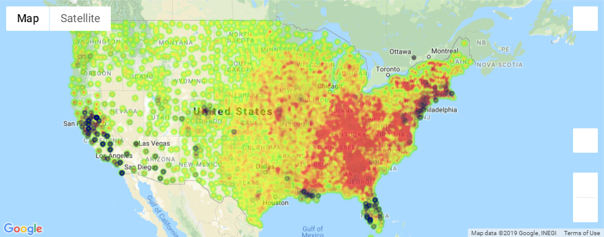

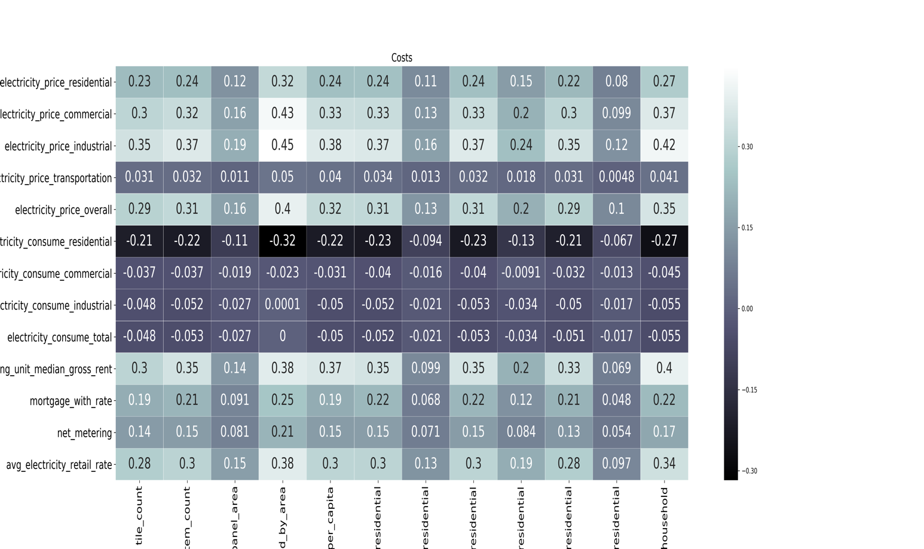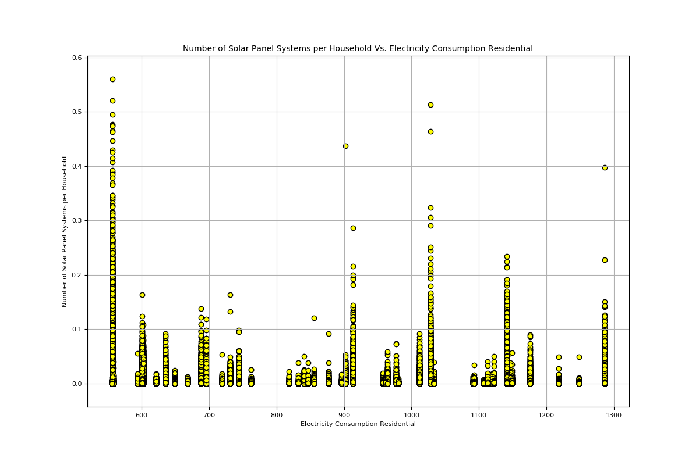

**Conclusion:**

* In general, our findings were consistent with our hypothesis. Most solar panel adoption was due to financial factors and government incentives. There are likely even more indicators, however we did not have time to further analyze
* We can infer that solar panel adoption is currently largely based on money factors