Mohammed Younus Mohiuddin
Tech Lead · Software Development
21+ years in insurance, aviation, and software — OutSystems, .NET, cloud, and AI-driven delivery.
Jeddah, Saudi Arabia · myounusmohiuddin@hotmail.com · +966 592889045 · linkedin.com/in/myounusm · github.com/myounusm · myounusm.in
PROFESSIONAL SUMMARY
Tech Lead with 21+ years of software development experience across the insurance, aviation, and software industries. Holds 13 OutSystems certifications, including Professional Developer and Architecture Specialist, and is certified in Microsoft Azure AI. Expert in enterprise solution design, digital transformation, and building scalable, high-performance systems — from architecture and integrations to mentoring teams and engaging business stakeholders.
EXPERIENCE
Tech Lead – Software Development Jan 2026 — Present
Wataniya Insurance Company · Jeddah, Saudi Arabia
• Lead technical architecture, solution design, engineering standards, and end-to-end delivery across enterprise insurance and digital transformation initiatives.
• Manage OutSystems LifeTime, including deployments across Development, UAT, and Production, along with hotfixes, rollbacks, release coordination, user access, roles, and permissions.
• Oversee production stability, troubleshoot critical application and integration issues, and manage incidents and service requests through ManageEngine.
• Mentor developers through technical guidance, solution reviews, code reviews, troubleshooting, performance optimization, security, and engineering best practices.
• Collaborate with business stakeholders, vendors, product teams, architects, and technology teams on release planning, impact analysis, technical risk assessment, and delivery of secure, scalable, and reliable enterprise solutions.
Stack: OutSystems • LifeTime • Service Studio • Integration Studio • C#/.NET • REST APIs • SOAP Web Services • SQL Server • Advanced SQL • ManageEngine • Application Monitoring • Release Management • Production Support • CI/CD • Enterprise Integrations
Senior OutSystems Low-Code Developer Jan 2023 — Dec 2025
Wataniya Insurance Company · Jeddah, Saudi Arabia
• Developed enterprise-grade OutSystems Reactive and Traditional Web applications for B2B, Partner Portal, quotation, policy issuance, renewals, payments, endorsements, and recovery processes.
• Built custom C#/.NET Extensions using Integration Studio, including email functionality, reusable components, and integration of external .NET libraries beyond standard OutSystems capabilities.
• Designed and consumed REST/SOAP APIs, integrating payment gateways, government services, internal insurance systems, SMS, WhatsApp, and third-party platforms.
• Worked extensively on AO Reduction, Advanced SQL, database optimization, application refactoring, performance tuning, Timers, background processing, caching, logging, and exception handling.
• Performed advanced debugging, root-cause analysis, technical-debt reduction, UAT support, production issue resolution, and permanent fixes for complex applications and integrations.
Stack: OutSystems • Service Studio • Integration Studio • Reactive Web • Traditional Web • C# • .NET Extensions • REST APIs • SOAP • Advanced SQL • SQL Server • Timers • Performance Optimization • AO Reduction
Senior .NET Software Developer Aug 2012 — Dec 2022
General Authority of Civil Aviation (GACA) · Jeddah, Saudi Arabia
Developed and supported enterprise-grade .NET solutions for aviation authority systems, with extensive hands-on experience across backend development, APIs, integrations, data access, performance, and production support.
• Enterprise .NET Development: Built and maintained large-scale applications using .NET Framework, C#, ASP.NET, Entity Framework, and layered enterprise architecture, supporting long-running and business-critical government systems.
• Database & Data Access Expertise: Worked extensively with Entity Framework using both Code First and Database First approaches, including data modeling, relationships, migrations, stored procedures, query optimization, and SQL Server integration.
• API Development & External Integrations: Designed and developed REST APIs and backend services, including integrations with ELM, government-sector APIs, external systems, and third-party services, with secure authentication, validation, logging, and error handling.
• Validation, Security & Code Quality: Implemented robust business and request validation using FluentValidation, along with secure coding practices, exception handling, reusable components, clean architecture principles, and maintainable application design.
• Full SDLC & Production Support: Handled the complete software development lifecycle from requirements analysis, design, development, testing, and deployment through production support, troubleshooting, performance optimization, and long-term application enhancement.
Stack: .NET Framework • C# • ASP.NET • Entity Framework • Code First • Database First • FluentValidation • REST APIs • External API Integration • ELM Integration • Government APIs • SQL Server • Stored Procedures • LINQ • Backend Services • Enterprise Architecture • Production Support
Senior .NET Software Developer Nov 2007 — Aug 2012
EVER TEAM · Riyadh, Saudi Arabia
Worked in a software house environment, delivering customized .NET solutions for multiple clients and supporting the full lifecycle from requirements gathering to on-premises production deployment.
• Multi-Client .NET Development: Developed and enhanced enterprise applications using C#, .NET Framework, ASP.NET, SQL Server, and service-oriented architecture, adapting solutions to different client requirements and business domains.
• Client-Facing Requirement Analysis: Visited client locations with the Project Manager to understand business requirements, analyze change requests, clarify technical needs, and translate them into practical software enhancements.
• Customization & Issue Resolution: Implemented client-specific features, modifications, integrations, and database changes while troubleshooting and fixing application issues reported from live environments.
• On-Premises Deployment & Production Support: Deployed application releases, patches, and database updates directly to client on-premises production servers, validating deployments and resolving post-release issues.
Stack: .NET Framework • C# • ASP.NET • SQL Server • Web Services • Service-Oriented Architecture (SOA) • Stored Procedures • Database Development • System Integration • On-Premises Deployment • Production Support • Client-Site Support
Software Developer Aug 2007 — Oct 2007
AFLAK Electronic Industries Co.
• Desktop Application Development: Developed and supported Windows desktop applications using VB.NET, integrated with electronic and peripheral devices.
• Biometric & Barcode Integration: Worked with fingerprint attendance systems, barcode devices, and related electronic peripherals, handling device data exchange and application-side processing.
• Retail Security Systems: Supported applications integrated with product security and detection devices used in shopping malls and retail environments.
Software Developer Mar 2005 — Jul 2007
AL AHLIA for Cooperative Insurance
• Insurance Desktop Application Development: Developed small .NET-based desktop applications used by insurance brokers to sell policies directly at customer and corporate locations.
• Oracle Database Development: Worked with Oracle Database, including SQL queries, Stored Procedures, data export/import, database backup activities, and application data management.
• Offline Sales & Data Synchronization: Supported broker applications that operated offline on laptops, allowing policies to be issued and printed remotely, with data synchronized to the central production database once connected to the company network.
CORE SKILLS
BACK-END: ASP.NET Core (MVC) · C# / .NET · OutSystems (Low-Code) · Entity Framework · Microservices & SOA · LINQ
APIS & FRONT-END: REST & SOAP APIs · JWT Authentication · Angular 14 · TypeScript / JavaScript · HTML5 & Bootstrap · Ocelot / RedHat 3Scale
DATA, AI & PLATFORMS: Cursor AI · GitHub Copilot · Microsoft SQL Server · Oracle / PL-SQL · Azure AI Services · OCR & Computer Vision · NLP & Machine Learning · SharePoint Integration
Core strengths: Building scalable enterprise solutions • Integrations & APIs • Data management • AI-powered capabilities • Performance & security • Modern development best practices
SELECTED WORK
Amazon Payfort – Digital Payment Integration · Wataniya · Payments · API Integration · Security
Secure, high-performance payment processing for direct sales — improving transaction reliability and customer experience.
Retail Renewal Process · Insurance · OutSystems · Workflows · Notifications
Automated policy renewals with smart notifications and self-service workflows to increase retention and operational efficiency.
Domestic Labor Insurance Platform · B2B · OutSystems · B2B · Insurance
Mission-critical B2B platform for real-time quotation, policy issuance, and activation for external partners.
Claims Recovery Automation · Insurance · BPT Workflows · Automation
Workflow-driven claim recovery automation that reduced manual effort and accelerated financial recovery cycles.
Partners Portal Platform · Insurance · Portal · Core Integration
Centralized broker portal for motors, marine, property, and more — integrated with core insurance systems.
ELM & Messaging Integrations · Enterprise · ELM · SMS · WhatsApp
Government ELM APIs for verified personal and vehicle data, plus SMS and WhatsApp automation for real-time engagement.
EDUCATION
Bachelor of Computer Science (BCA)
Osmania University · Mar 2003
CERTIFICATIONS
OutSystems Certifications
Platform Ops (O11) (Jun 24, 2025) · Tech Lead (O11) (Jun 18, 2025) · Associate Traditional Web Developer (O11) (Jun 27, 2024) · Professional Mobile Developer (O11) (Nov 03, 2023) · Professional Web Developer (O11) (Nov 03, 2023) · Associate Developer (ODC) (Jul 24, 2023) · Associate Developer (O11) (Jun 10, 2023)
OutSystems Specializations
Architecture Specialist (ODC) (Jan 17, 2026) · Web Developer Specialist (ODC) (Dec 28, 2024) · Architecture Specialist (O11) (Nov 03, 2023) · Security Specialist (O11 and ODC) (Sep 13, 2023) · Web Developer Specialist (O11) (Aug 25, 2023) · Mobile Developer Specialist (O11 and ODC) (Jul 13, 2023)
Additional Credentials
Microsoft Certified: Azure AI Fundamentals · Microsoft 365 Certified: Fundamentals · SCRUM Fundamentals

OutSystems Certification Journey
13 certifications · O11 + ODC · Jun 2023 → Jan 2026
Progressed from Associate Developer to Architecture Specialist and Tech Lead across OutSystems 11 and OutSystems Developer Cloud — spanning core development, mobile, security, platform operations, and architecture.
CERTIFICATION TIMELINE (MOST RECENT FIRST)
Jan 17, 2026 | ●  │ | 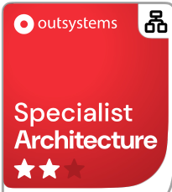 | Architecture Specialist (ODC)  Specialist · Architecture · ODC  Cloud-native architecture design for OutSystems Developer Cloud
Jun 24, 2025 | ●  │ | 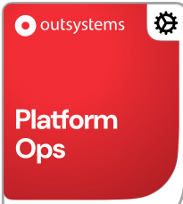 | Platform Ops (O11)  Ops · Platform Operations · O11  LifeTime governance, environments, releases, and platform reliability
Jun 18, 2025 | ●  │ | 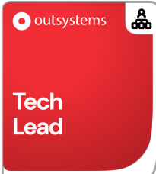 | Tech Lead (O11)  Tech Lead · Leadership · O11  Technical leadership, standards, mentoring, and delivery ownership
Dec 28, 2024 | ●  │ | 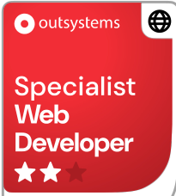 | Web Developer Specialist (ODC)  Specialist · Web Development · ODC  Advanced ODC web application patterns and specialist-level delivery
Jun 27, 2024 | ●  │ | 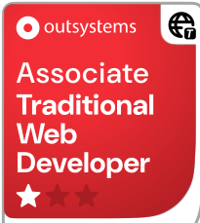 | Associate Traditional Web Developer (O11)  Associate · Traditional Web · O11  Traditional Web skills complementing Reactive/ODC delivery
Nov 03, 2023 | ●  │ | 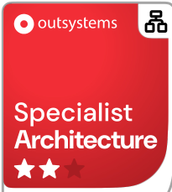 | Architecture Specialist (O11)  Specialist · Architecture · O11  Enterprise architecture, module design, and long-term maintainability
Nov 03, 2023 | ●  │ | 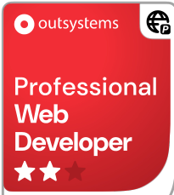 | Professional Web Developer (O11)  Professional · Web Development · O11  Professional-grade Reactive/Web application development
Nov 03, 2023 | ●  │ | 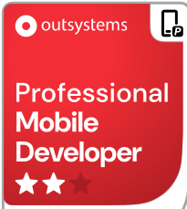 | Professional Mobile Developer (O11)  Professional · Mobile Development · O11  Mobile delivery with professional OutSystems mobile patterns
Sep 13, 2023 | ●  │ |  | Security Specialist (O11 and ODC)  Specialist · Security · O11 & ODC  Secure design, authentication, and platform security best practices
Aug 25, 2023 | ●  │ | 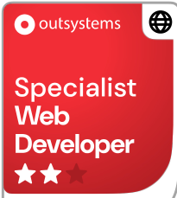 | Web Developer Specialist (O11)  Specialist · Web Development · O11  Specialist web patterns beyond professional developer baseline
Jul 24, 2023 | ●  │ | 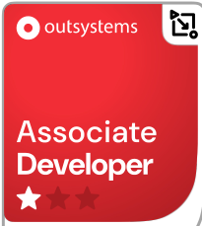 | Associate Developer (ODC)  Associate · Core Development · ODC  Foundational OutSystems Developer Cloud capability
Jul 13, 2023 | ●  │ | 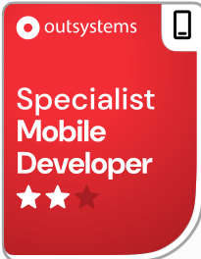 | Mobile Developer Specialist (O11 and ODC)  Specialist · Mobile Development · O11 & ODC  Cross-platform mobile specialist skills on O11 and ODC
Jun 10, 2023 | ● | 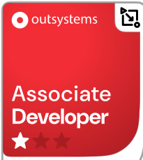 | Associate Developer (O11)  Associate · Core Development · O11  Entry point of the OutSystems certification journey
Source: Official OutSystems Certification Transcript · outsystems.com/certifications

