**«Дифференциальные уравнения»**

**Цель**: Решая предоставленные задания, изучить методы решения дифференциальных уравнений

**Задачи**:

Разработать программу, решающую дифференциальные уравнения

Решить предоставленные задачи

**Код программы**:

import math;

def func(a,b,y,n,func,br):

y0=y

x=a;

h=(b-a)/n

print(x, '|', y)

while x<b-h:

y=y+h*(eval(func))

x+=h

print(x, '|', y)

if (eval(br)):

break

**Входные данные**:

1. 0,100,83,1000,'-0.0373*(y-22)','y<=56
2. 0,10000,200,1000,'-0.00044*y','y<=y0/2'
3. 0,150,12,150,'(-(b*y*0.0001))','y<0'
4. 0,2,0,1000,'((300-y*150)/30)','y>1.98'

**Выходные данные**:

**1)**

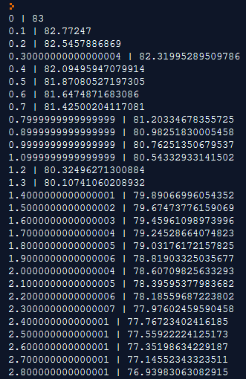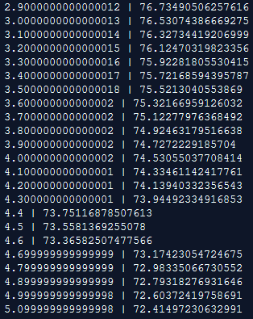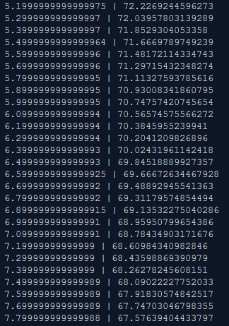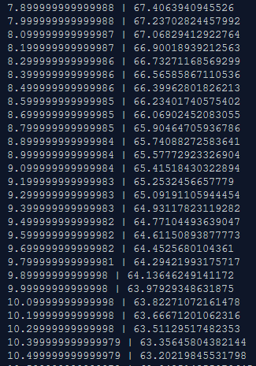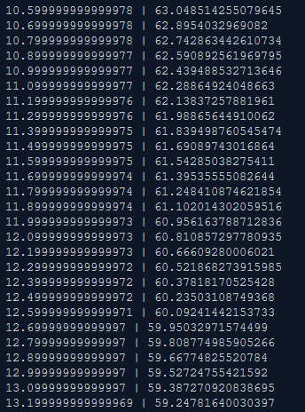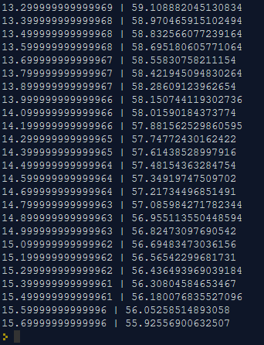

**2)**

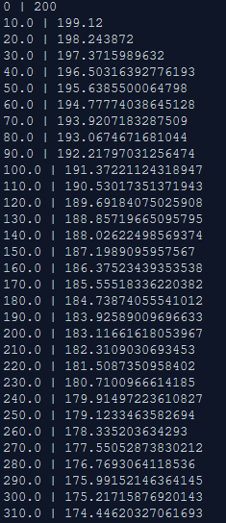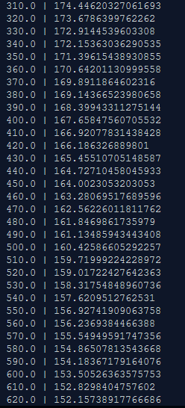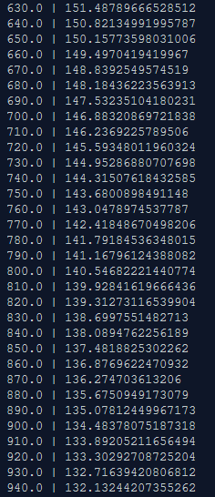

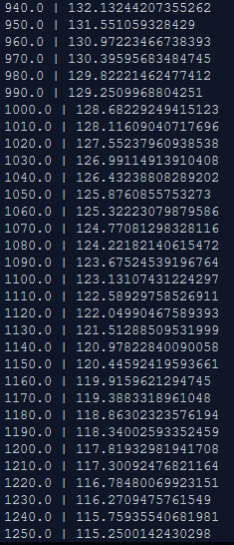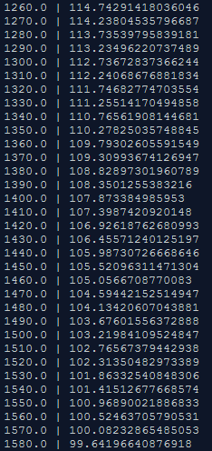

**3)**

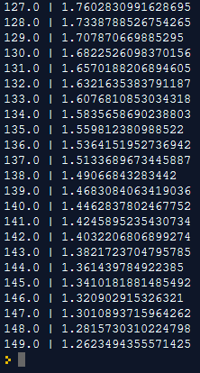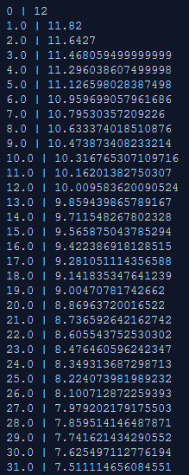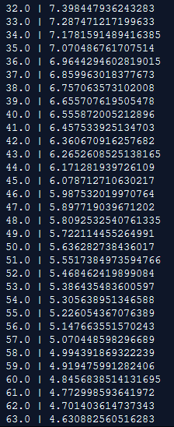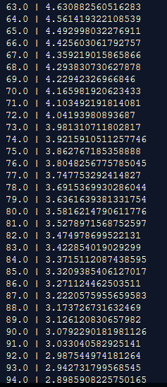

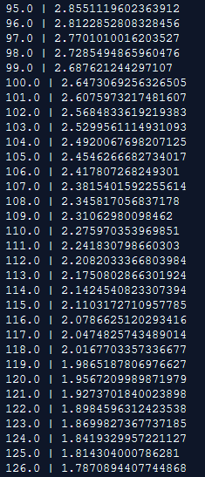

**4)**

Вставляю таблицу результатов из-за невозможности заскриншотить настолько большой объем данных.

|  |  |
| --- | --- |
| 0 | 0 |
| 0.002 | 0.02 |
| 0.004 | 0.0398 |
| 0.006 | 0.059401999999999996 |
| 0.008 | 0.07880798 |
| 0.01 | 0.09801990020000001 |
| 0.012 | 0.11703970119800002 |
| 0.014 | 0.13586930418602 |
| 0.016 | 0.15451061114415982 |
| 0.018000000000000002 | 0.1729655050327182 |
| 0.020000000000000004 | 0.19123584998239102 |
| 0.022000000000000006 | 0.2093234914825671 |
| 0.024000000000000007 | 0.22723025656774143 |
| 0.02600000000000001 | 0.24495795400206402 |
| 0.02800000000000001 | 0.2625083744620434 |
| 0.030000000000000013 | 0.27988329071742296 |
| 0.032000000000000015 | 0.2970844578102487 |
| 0.034000000000000016 | 0.31411361323214626 |
| 0.03600000000000002 | 0.3309724770998248 |
| 0.03800000000000002 | 0.34766275232882654 |
| 0.04000000000000002 | 0.36418612480553825 |
| 0.04200000000000002 | 0.3805442635574829 |
| 0.044000000000000025 | 0.39673882092190804 |
| 0.04600000000000003 | 0.41277143271268896 |
| 0.04800000000000003 | 0.4286437183855621 |
| 0.05000000000000003 | 0.4443572812017065 |
| 0.05200000000000003 | 0.4599137083896894 |
| 0.054000000000000034 | 0.4753145713057925 |
| 0.056000000000000036 | 0.4905614255927346 |
| 0.05800000000000004 | 0.5056558113368073 |
| 0.06000000000000004 | 0.5205992532234391 |
| 0.06200000000000004 | 0.5353932606912047 |
| 0.06400000000000004 | 0.5500393280842927 |
| 0.06600000000000004 | 0.5645389348034497 |
| 0.06800000000000005 | 0.5788935454554153 |
| 0.07000000000000005 | 0.5931046100008611 |
| 0.07200000000000005 | 0.6071735639008525 |
| 0.07400000000000005 | 0.621101828261844 |
| 0.07600000000000005 | 0.6348908099792255 |
| 0.07800000000000006 | 0.6485419018794333 |
| 0.08000000000000006 | 0.6620564828606389 |
| 0.08200000000000006 | 0.6754359180320325 |
| 0.08400000000000006 | 0.6886815588517122 |
| 0.08600000000000006 | 0.7017947432631951 |
| 0.08800000000000006 | 0.7147767958305632 |
| 0.09000000000000007 | 0.7276290278722576 |
| 0.09200000000000007 | 0.740352737593535 |
| 0.09400000000000007 | 0.7529492102175996 |
| 0.09600000000000007 | 0.7654197181154236 |
| 0.09800000000000007 | 0.7777655209342694 |
| 0.10000000000000007 | 0.7899878657249267 |
| 0.10200000000000008 | 0.8020879870676775 |
| 0.10400000000000008 | 0.8140671071970007 |
| 0.10600000000000008 | 0.8259264361250307 |
| 0.10800000000000008 | 0.8376671717637804 |
| 0.11000000000000008 | 0.8492905000461426 |
| 0.11200000000000009 | 0.8607975950456812 |
| 0.11400000000000009 | 0.8721896190952244 |
| 0.11600000000000009 | 0.8834677229042722 |
| 0.11800000000000009 | 0.8946330456752295 |
| 0.12000000000000009 | 0.9056867152184772 |
| 0.1220000000000001 | 0.9166298480662924 |
| 0.1240000000000001 | 0.9274635495856295 |
| 0.12600000000000008 | 0.9381889140897732 |
| 0.12800000000000009 | 0.9488070249488755 |
| 0.1300000000000001 | 0.9593189546993868 |
| 0.1320000000000001 | 0.969725765152393 |
| 0.1340000000000001 | 0.980028507500869 |
| 0.1360000000000001 | 0.9902282224258603 |
| 0.1380000000000001 | 1.0003259402016016 |
| 0.1400000000000001 | 1.0103226807995855 |
| 0.1420000000000001 | 1.0202194539915896 |
| 0.1440000000000001 | 1.0300172594516737 |
| 0.1460000000000001 | 1.039717086857157 |
| 0.1480000000000001 | 1.0493199159885855 |
| 0.1500000000000001 | 1.0588267168286998 |
| 0.1520000000000001 | 1.0682384496604127 |
| 0.1540000000000001 | 1.0775560651638085 |
| 0.1560000000000001 | 1.0867805045121703 |
| 0.1580000000000001 | 1.0959126994670487 |
| 0.16000000000000011 | 1.1049535724723782 |
| 0.16200000000000012 | 1.1139040367476545 |
| 0.16400000000000012 | 1.122764996380178 |
| 0.16600000000000012 | 1.1315373464163763 |
| 0.16800000000000012 | 1.1402219729522125 |
| 0.17000000000000012 | 1.1488197532226905 |
| 0.17200000000000013 | 1.1573315556904635 |
| 0.17400000000000013 | 1.1657582401335589 |
| 0.17600000000000013 | 1.1741006577322233 |
| 0.17800000000000013 | 1.182359651154901 |
| 0.18000000000000013 | 1.190536054643352 |
| 0.18200000000000013 | 1.1986306940969187 |
| 0.18400000000000014 | 1.2066443871559496 |
| 0.18600000000000014 | 1.2145779432843902 |
| 0.18800000000000014 | 1.2224321638515463 |
| 0.19000000000000014 | 1.230207842213031 |
| 0.19200000000000014 | 1.2379057637909006 |
| 0.19400000000000014 | 1.2455267061529915 |
| 0.19600000000000015 | 1.2530714390914617 |
| 0.19800000000000015 | 1.2605407247005471 |
| 0.20000000000000015 | 1.2679353174535417 |
| 0.20200000000000015 | 1.2752559642790062 |
| 0.20400000000000015 | 1.2825034046362163 |
| 0.20600000000000016 | 1.289678370589854 |
| 0.20800000000000016 | 1.2967815868839554 |
| 0.21000000000000016 | 1.3038137710151159 |
| 0.21200000000000016 | 1.3107756333049647 |
| 0.21400000000000016 | 1.317667876971915 |
| 0.21600000000000016 | 1.3244911982021959 |
| 0.21800000000000017 | 1.331246286220174 |
| 0.22000000000000017 | 1.3379338233579723 |
| 0.22200000000000017 | 1.3445544851243925 |
| 0.22400000000000017 | 1.3511089402731484 |
| 0.22600000000000017 | 1.357597850870417 |
| 0.22800000000000017 | 1.3640218723617128 |
| 0.23000000000000018 | 1.3703816536380957 |
| 0.23200000000000018 | 1.3766778371017148 |
| 0.23400000000000018 | 1.3829110587306976 |
| 0.23600000000000018 | 1.3890819481433907 |
| 0.23800000000000018 | 1.3951911286619567 |
| 0.24000000000000019 | 1.4012392173753372 |
| 0.2420000000000002 | 1.4072268252015838 |
| 0.2440000000000002 | 1.413154556949568 |
| 0.2460000000000002 | 1.4190230113800724 |
| 0.2480000000000002 | 1.4248327812662716 |
| 0.25000000000000017 | 1.4305844534536087 |
| 0.25200000000000017 | 1.4362786089190727 |
| 0.25400000000000017 | 1.4419158228298818 |
| 0.25600000000000017 | 1.447496664601583 |
| 0.2580000000000002 | 1.4530216979555672 |
| 0.2600000000000002 | 1.4584914809760117 |
| 0.2620000000000002 | 1.4639065661662516 |
| 0.2640000000000002 | 1.469267500504589 |
| 0.2660000000000002 | 1.474574825499543 |
| 0.2680000000000002 | 1.4798290772445475 |
| 0.2700000000000002 | 1.485030786472102 |
| 0.2720000000000002 | 1.490180478607381 |
| 0.2740000000000002 | 1.495278673821307 |
| 0.2760000000000002 | 1.500325887083094 |
| 0.2780000000000002 | 1.5053226282122631 |
| 0.2800000000000002 | 1.5102694019301406 |
| 0.2820000000000002 | 1.515166707910839 |
| 0.2840000000000002 | 1.5200150408317308 |
| 0.2860000000000002 | 1.5248148904234136 |
| 0.2880000000000002 | 1.5295667415191794 |
| 0.2900000000000002 | 1.5342710741039876 |
| 0.2920000000000002 | 1.5389283633629476 |
| 0.2940000000000002 | 1.543539079729318 |
| 0.2960000000000002 | 1.5481036889320248 |
| 0.2980000000000002 | 1.5526226520427044 |
| 0.3000000000000002 | 1.5570964255222774 |
| 0.3020000000000002 | 1.5615254612670546 |
| 0.3040000000000002 | 1.565910206654384 |
| 0.3060000000000002 | 1.5702511045878402 |
| 0.3080000000000002 | 1.5745485935419619 |
| 0.3100000000000002 | 1.5788031076065423 |
| 0.3120000000000002 | 1.583015076530477 |
| 0.3140000000000002 | 1.5871849257651722 |
| 0.3160000000000002 | 1.5913130765075205 |
| 0.3180000000000002 | 1.5953999457424453 |
| 0.32000000000000023 | 1.5994459462850208 |
| 0.32200000000000023 | 1.6034514868221705 |
| 0.32400000000000023 | 1.6074169719539488 |
| 0.32600000000000023 | 1.6113428022344094 |
| 0.32800000000000024 | 1.6152293742120654 |
| 0.33000000000000024 | 1.6190770804699448 |
| 0.33200000000000024 | 1.6228863096652453 |
| 0.33400000000000024 | 1.6266574465685928 |
| 0.33600000000000024 | 1.6303908721029068 |
| 0.33800000000000024 | 1.6340869633818778 |
| 0.34000000000000025 | 1.637746093748059 |
| 0.34200000000000025 | 1.6413686328105783 |
| 0.34400000000000025 | 1.6449549464824726 |
| 0.34600000000000025 | 1.648505397017648 |
| 0.34800000000000025 | 1.6520203430474716 |
| 0.35000000000000026 | 1.6555001396169968 |
| 0.35200000000000026 | 1.658945138220827 |
| 0.35400000000000026 | 1.6623556868386187 |
| 0.35600000000000026 | 1.6657321299702326 |
| 0.35800000000000026 | 1.6690748086705303 |
| 0.36000000000000026 | 1.672384060583825 |
| 0.36200000000000027 | 1.6756602199779866 |
| 0.36400000000000027 | 1.6789036177782068 |
| 0.36600000000000027 | 1.6821145816004248 |
| 0.36800000000000027 | 1.6852934357844205 |
| 0.3700000000000003 | 1.6884405014265762 |
| 0.3720000000000003 | 1.6915560964123104 |
| 0.3740000000000003 | 1.6946405354481873 |
| 0.3760000000000003 | 1.6976941300937054 |
| 0.3780000000000003 | 1.7007171887927683 |
| 0.3800000000000003 | 1.7037100169048407 |
| 0.3820000000000003 | 1.7066729167357924 |
| 0.3840000000000003 | 1.7096061875684345 |
| 0.3860000000000003 | 1.7125101256927502 |
| 0.3880000000000003 | 1.7153850244358226 |
| 0.3900000000000003 | 1.7182311741914644 |
| 0.3920000000000003 | 1.7210488624495497 |
| 0.3940000000000003 | 1.7238383738250542 |
| 0.3960000000000003 | 1.7265999900868036 |
| 0.3980000000000003 | 1.7293339901859357 |
| 0.4000000000000003 | 1.7320406502840764 |
| 0.4020000000000003 | 1.7347202437812357 |
| 0.4040000000000003 | 1.7373730413434234 |
| 0.4060000000000003 | 1.7399993109299892 |
| 0.4080000000000003 | 1.7425993178206893 |
| 0.4100000000000003 | 1.7451733246424825 |
| 0.4120000000000003 | 1.7477215913960578 |
| 0.4140000000000003 | 1.750244375482097 |
| 0.4160000000000003 | 1.752741931727276 |
| 0.4180000000000003 | 1.7552145124100034 |
| 0.4200000000000003 | 1.7576623672859033 |
| 0.4220000000000003 | 1.7600857436130444 |
| 0.4240000000000003 | 1.762484886176914 |
| 0.4260000000000003 | 1.7648600373151448 |
| 0.4280000000000003 | 1.7672114369419933 |
| 0.4300000000000003 | 1.7695393225725735 |
| 0.43200000000000033 | 1.7718439293468478 |
| 0.43400000000000033 | 1.7741254900533794 |
| 0.43600000000000033 | 1.7763842351528456 |
| 0.43800000000000033 | 1.7786203928013171 |
| 0.44000000000000034 | 1.780834188873304 |
| 0.44200000000000034 | 1.7830258469845708 |
| 0.44400000000000034 | 1.785195588514725 |
| 0.44600000000000034 | 1.7873436326295777 |
| 0.44800000000000034 | 1.789470196303282 |
| 0.45000000000000034 | 1.791575494340249 |
| 0.45200000000000035 | 1.7936597393968465 |
| 0.45400000000000035 | 1.795723142002878 |
| 0.45600000000000035 | 1.7977659105828494 |
| 0.45800000000000035 | 1.799788251477021 |
| 0.46000000000000035 | 1.8017903689622508 |
| 0.46200000000000035 | 1.8037724652726284 |
| 0.46400000000000036 | 1.805734740619902 |
| 0.46600000000000036 | 1.807677393213703 |
| 0.46800000000000036 | 1.809600619281566 |
| 0.47000000000000036 | 1.8115046130887502 |
| 0.47200000000000036 | 1.8133895669578628 |
| 0.47400000000000037 | 1.8152556712882841 |
| 0.47600000000000037 | 1.8171031145754013 |
| 0.47800000000000037 | 1.8189320834296472 |
| 0.48000000000000037 | 1.8207427625953507 |
| 0.4820000000000004 | 1.8225353349693971 |
| 0.4840000000000004 | 1.8243099816197033 |
| 0.4860000000000004 | 1.8260668818035062 |
| 0.4880000000000004 | 1.827806212985471 |
| 0.4900000000000004 | 1.8295281508556163 |
| 0.4920000000000004 | 1.83123286934706 |
| 0.4940000000000004 | 1.8329205406535896 |
| 0.4960000000000004 | 1.8345913352470538 |
| 0.4980000000000004 | 1.8362454218945832 |
| 0.5000000000000003 | 1.8378829676756374 |
| 0.5020000000000003 | 1.839504137998881 |
| 0.5040000000000003 | 1.841109096618892 |
| 0.5060000000000003 | 1.8426980056527031 |
| 0.5080000000000003 | 1.844271025596176 |
| 0.5100000000000003 | 1.8458283153402144 |
| 0.5120000000000003 | 1.8473700321868123 |
| 0.5140000000000003 | 1.848896331864944 |
| 0.5160000000000003 | 1.8504073685462947 |
| 0.5180000000000003 | 1.8519032948608318 |
| 0.5200000000000004 | 1.8533842619122236 |
| 0.5220000000000004 | 1.8548504192931015 |
| 0.5240000000000004 | 1.8563019151001705 |
| 0.5260000000000004 | 1.8577388959491687 |
| 0.5280000000000004 | 1.859161506989677 |
| 0.5300000000000004 | 1.8605698919197802 |
| 0.5320000000000004 | 1.8619641930005824 |
| 0.5340000000000004 | 1.8633445510705766 |
| 0.5360000000000004 | 1.8647111055598709 |
| 0.5380000000000004 | 1.866063994504272 |
| 0.5400000000000004 | 1.8674033545592295 |
| 0.5420000000000004 | 1.868729321013637 |
| 0.5440000000000004 | 1.8700420278035008 |
| 0.5460000000000004 | 1.8713416075254659 |
| 0.5480000000000004 | 1.8726281914502112 |
| 0.5500000000000004 | 1.873901909535709 |
| 0.5520000000000004 | 1.875162890440352 |
| 0.5540000000000004 | 1.8764112615359483 |
| 0.5560000000000004 | 1.8776471489205888 |
| 0.5580000000000004 | 1.878870677431383 |
| 0.5600000000000004 | 1.8800819706570693 |
| 0.5620000000000004 | 1.8812811509504985 |
| 0.5640000000000004 | 1.8824683394409936 |
| 0.5660000000000004 | 1.8836436560465837 |
| 0.5680000000000004 | 1.8848072194861178 |
| 0.5700000000000004 | 1.8859591472912567 |
| 0.5720000000000004 | 1.887099555818344 |
| 0.5740000000000004 | 1.8882285602601607 |
| 0.5760000000000004 | 1.889346274657559 |
| 0.5780000000000004 | 1.8904528119109836 |
| 0.5800000000000004 | 1.8915482837918738 |
| 0.5820000000000004 | 1.892632800953955 |
| 0.5840000000000004 | 1.8937064729444155 |
| 0.5860000000000004 | 1.8947694082149713 |
| 0.5880000000000004 | 1.8958217141328215 |
| 0.5900000000000004 | 1.8968634969914933 |
| 0.5920000000000004 | 1.8978948620215783 |
| 0.5940000000000004 | 1.8989159134013625 |
| 0.5960000000000004 | 1.8999267542673488 |
| 0.5980000000000004 | 1.9009274867246753 |
| 0.6000000000000004 | 1.9019182118574285 |
| 0.6020000000000004 | 1.9028990297388542 |
| 0.6040000000000004 | 1.9038700394414656 |
| 0.6060000000000004 | 1.904831339047051 |
| 0.6080000000000004 | 1.9057830256565806 |
| 0.6100000000000004 | 1.9067251954000148 |
| 0.6120000000000004 | 1.9076579434460146 |
| 0.6140000000000004 | 1.9085813640115545 |
| 0.6160000000000004 | 1.909495550371439 |
| 0.6180000000000004 | 1.9104005948677247 |
| 0.6200000000000004 | 1.9112965889190474 |
| 0.6220000000000004 | 1.912183623029857 |
| 0.6240000000000004 | 1.9130617867995585 |
| 0.6260000000000004 | 1.913931168931563 |
| 0.6280000000000004 | 1.9147918572422473 |
| 0.6300000000000004 | 1.9156439386698247 |
| 0.6320000000000005 | 1.9164874992831264 |
| 0.6340000000000005 | 1.9173226242902952 |
| 0.6360000000000005 | 1.9181493980473923 |
| 0.6380000000000005 | 1.9189679040669183 |
| 0.6400000000000005 | 1.9197782250262492 |
| 0.6420000000000005 | 1.9205804427759867 |
| 0.6440000000000005 | 1.9213746383482269 |
| 0.6460000000000005 | 1.9221608919647446 |
| 0.6480000000000005 | 1.922939283045097 |
| 0.6500000000000005 | 1.9237098902146461 |
| 0.6520000000000005 | 1.9244727913124997 |
| 0.6540000000000005 | 1.9252280633993748 |
| 0.6560000000000005 | 1.925975782765381 |
| 0.6580000000000005 | 1.926716024937727 |
| 0.6600000000000005 | 1.9274488646883499 |
| 0.6620000000000005 | 1.9281743760414665 |
| 0.6640000000000005 | 1.9288926322810518 |
| 0.6660000000000005 | 1.9296037059582414 |
| 0.6680000000000005 | 1.930307668898659 |
| 0.6700000000000005 | 1.9310045922096724 |
| 0.6720000000000005 | 1.9316945462875756 |
| 0.6740000000000005 | 1.9323776008246998 |
| 0.6760000000000005 | 1.9330538248164528 |
| 0.6780000000000005 | 1.9337232865682883 |
| 0.6800000000000005 | 1.9343860537026054 |
| 0.6820000000000005 | 1.9350421931655795 |
| 0.6840000000000005 | 1.9356917712339237 |
| 0.6860000000000005 | 1.9363348535215845 |
| 0.6880000000000005 | 1.9369715049863687 |
| 0.6900000000000005 | 1.937601789936505 |
| 0.6920000000000005 | 1.9382257720371399 |
| 0.6940000000000005 | 1.9388435143167684 |
| 0.6960000000000005 | 1.9394550791736007 |
| 0.6980000000000005 | 1.9400605283818646 |
| 0.7000000000000005 | 1.940659923098046 |
| 0.7020000000000005 | 1.9412533238670655 |
| 0.7040000000000005 | 1.9418407906283948 |
| 0.7060000000000005 | 1.9424223827221108 |
| 0.7080000000000005 | 1.9429981588948897 |
| 0.7100000000000005 | 1.9435681773059408 |
| 0.7120000000000005 | 1.9441324955328814 |
| 0.7140000000000005 | 1.9446911705775525 |
| 0.7160000000000005 | 1.9452442588717769 |
| 0.7180000000000005 | 1.9457918162830592 |
| 0.7200000000000005 | 1.9463338981202285 |
| 0.7220000000000005 | 1.9468705591390263 |
| 0.7240000000000005 | 1.947401853547636 |
| 0.7260000000000005 | 1.9479278350121596 |
| 0.7280000000000005 | 1.948448556662038 |
| 0.7300000000000005 | 1.9489640710954177 |
| 0.7320000000000005 | 1.9494744303844636 |
| 0.7340000000000005 | 1.949979686080619 |
| 0.7360000000000005 | 1.9504798892198127 |
| 0.7380000000000005 | 1.9509750903276146 |
| 0.7400000000000005 | 1.9514653394243384 |
| 0.7420000000000005 | 1.951950686030095 |
| 0.7440000000000005 | 1.9524311791697941 |
| 0.7460000000000006 | 1.9529068673780963 |
| 0.7480000000000006 | 1.9533777987043153 |
| 0.7500000000000006 | 1.953844020717272 |
| 0.7520000000000006 | 1.9543055805100993 |
| 0.7540000000000006 | 1.9547625247049982 |
| 0.7560000000000006 | 1.9552148994579484 |
| 0.7580000000000006 | 1.9556627504633688 |
| 0.7600000000000006 | 1.956106122958735 |
| 0.7620000000000006 | 1.9565450617291478 |
| 0.7640000000000006 | 1.9569796111118563 |
| 0.7660000000000006 | 1.9574098150007377 |
| 0.7680000000000006 | 1.9578357168507303 |
| 0.7700000000000006 | 1.958257359682223 |
| 0.7720000000000006 | 1.9586747860854008 |
| 0.7740000000000006 | 1.9590880382245468 |
| 0.7760000000000006 | 1.9594971578423013 |
| 0.7780000000000006 | 1.9599021862638784 |
| 0.7800000000000006 | 1.9603031644012396 |
| 0.7820000000000006 | 1.9607001327572273 |
| 0.7840000000000006 | 1.9610931314296551 |
| 0.7860000000000006 | 1.9614822001153587 |
| 0.7880000000000006 | 1.961867378114205 |
| 0.7900000000000006 | 1.962248704333063 |
| 0.7920000000000006 | 1.9626262172897324 |
| 0.7940000000000006 | 1.9629999551168351 |
| 0.7960000000000006 | 1.9633699555656667 |
| 0.7980000000000006 | 1.96373625601001 |
| 0.8000000000000006 | 1.96409889344991 |
| 0.8020000000000006 | 1.964457904515411 |
| 0.8040000000000006 | 1.9648133254702569 |
| 0.8060000000000006 | 1.9651651922155544 |
| 0.8080000000000006 | 1.965513540293399 |
| 0.8100000000000006 | 1.965858404890465 |
| 0.8120000000000006 | 1.9661998208415603 |
| 0.8140000000000006 | 1.9665378226331447 |
| 0.8160000000000006 | 1.9668724444068133 |
| 0.8180000000000006 | 1.9672037199627452 |
| 0.8200000000000006 | 1.9675316827631177 |
| 0.8220000000000006 | 1.9678563659354866 |
| 0.8240000000000006 | 1.9681778022761318 |
| 0.8260000000000006 | 1.9684960242533704 |
| 0.8280000000000006 | 1.9688110640108367 |
| 0.8300000000000006 | 1.9691229533707284 |
| 0.8320000000000006 | 1.9694317238370211 |
| 0.8340000000000006 | 1.969737406598651 |
| 0.8360000000000006 | 1.9700400325326646 |
| 0.8380000000000006 | 1.9703396322073379 |
| 0.8400000000000006 | 1.9706362358852645 |
| 0.8420000000000006 | 1.9709298735264118 |
| 0.8440000000000006 | 1.9712205747911478 |
| 0.8460000000000006 | 1.9715083690432362 |
| 0.8480000000000006 | 1.971793285352804 |
| 0.8500000000000006 | 1.972075352499276 |
| 0.8520000000000006 | 1.9723545989742832 |
| 0.8540000000000006 | 1.9726310529845403 |
| 0.8560000000000006 | 1.9729047424546948 |
| 0.8580000000000007 | 1.9731756950301478 |
| 0.8600000000000007 | 1.9734439380798463 |
| 0.8620000000000007 | 1.9737094986990478 |
| 0.8640000000000007 | 1.9739724037120574 |
| 0.8660000000000007 | 1.9742326796749368 |
| 0.8680000000000007 | 1.9744903528781874 |
| 0.8700000000000007 | 1.9747454493494054 |
| 0.8720000000000007 | 1.9749979948559113 |
| 0.8740000000000007 | 1.9752480149073521 |
| 0.8760000000000007 | 1.9754955347582785 |
| 0.8780000000000007 | 1.9757405794106957 |
| 0.8800000000000007 | 1.9759831736165887 |
| 0.8820000000000007 | 1.976223341880423 |
| 0.8840000000000007 | 1.9764611084616186 |
| 0.8860000000000007 | 1.9766964973770025 |
| 0.8880000000000007 | 1.9769295324032325 |
| 0.8900000000000007 | 1.9771602370792003 |
| 0.8920000000000007 | 1.9773886347084082 |
| 0.8940000000000007 | 1.9776147483613242 |
| 0.8960000000000007 | 1.977838600877711 |
| 0.8980000000000007 | 1.9780602148689337 |
| 0.9000000000000007 | 1.9782796127202444 |
| 0.9020000000000007 | 1.978496816593042 |
| 0.9040000000000007 | 1.9787118484271118 |
| 0.9060000000000007 | 1.9789247299428407 |
| 0.9080000000000007 | 1.9791354826434124 |
| 0.9100000000000007 | 1.9793441278169783 |
| 0.9120000000000007 | 1.9795506865388086 |
| 0.9140000000000007 | 1.9797551796734205 |
| 0.9160000000000007 | 1.9799576278766864 |
| 0.9180000000000007 | 1.9801580515979196 |

**Ответы:**

1) Чашка кофе остывает с 83 градусов до 56 градусов за 15,7 секунд

2) Период полураспада 200 г. радия равен 1580 секунд

3) Скорость ветра, прошедшего 150 метров в лесу равна 1.26234 метра в секунду

4) 99% предельной величины сила тока достигнет за 0,918 секунды