冶河灌区局域网建设项目
技

术

手

册

拓扑结构
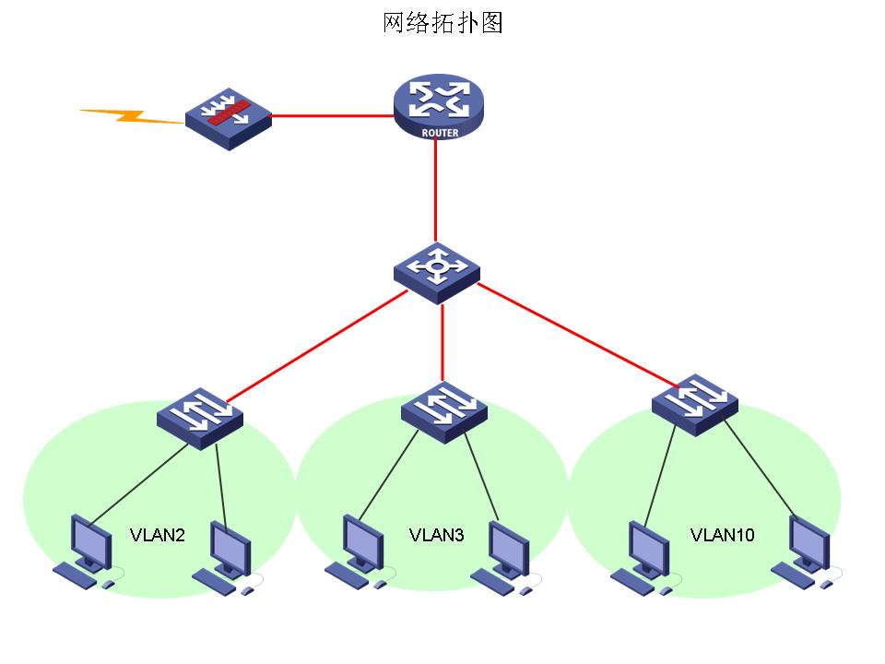

设备说明

防火墙：
防火墙采用cisco ASA 5505

路由器：
路由器采用cisco2801

交换机：
核心层采用cisco3560
接入层采用cisco2960

配置介绍
本文配置涉及到的技术有Nat，Dhcp，Vlan，security等技术，由于设备齐全，所以各个技术细节分布均匀，将security技术放在了ASA防火墙上去完成，NAT放在了路由器上专门去完成，还有默认路由的走向和回指。Vlan则放在了3560交换机上来完成，由于是vlan间的地址分配，所以dhcp也放在了3560交换机上来完成。

路由器
NAT:
RouterB(config)#ip nat inside source list 1 interface f0/0 overload
RouterB(config)#access-list 1 permit 192.168.1.0 0.0.0.255
RouterB(config)#access-list 1 permit 192.168.2.0 0.0.0.255
RouterB(config)#access-list 1 permit 192.168.3.0 0.0.0.255

Static route：
RouterB(config)#ip route 0.0.0.0 0.0.0.0 f0/0
RouterB(config)#ip route 192.168.1.0 255.255.255.0 192.168.0.2
RouterB(config)#ip route 192.168.2.0 255.255.255.0 192.168.0.2
RouterB(config)#ip route 192.168.3.0 255.255.255.0 192.168.0.2

交换机
Vlan
Switch(config)#vlan 2
Switch(config)#vlan 3
Switch(config)#vlan 10
Switch(config)#int rang f0/2 – 20
Switch(config)#switchport access vlan 10

Switch(config)#int f0/21
Switch(config)#switchport access vlan 2
Switch(config)#int f0/23
Switch(config)#switchport access vlan 2
Switch(config)#int f0/22
Switch(config)#switchport access vlan 3
Switch(config)#int f0/24
Switch(config)#switchport access vlan 3

interface Vlan1
ip address 192.168.0.2 255.255.255.0
!
interface Vlan2
ip address 192.168.2.1 255.255.255.0
!
interface Vlan3
ip address 192.168.3.1 255.255.255.0
!
interface Vlan10
ip address 192.168.1.1 255.255.255.0

Static route：
ip route 0.0.0.0 0.0.0.0 192.168.0.1

DHCP：
ip dhcp pool vlan2
network 192.168.2.0 255.255.255.0
default-router 192.168.2.1
dns-server 202.99.160.68 202.99.166.4
lease 0 23

ip dhcp pool vlan3
network 192.168.3.0 255.255.255.0
default-router 192.168.3.1
dns-server 202.99.160.68 202.99.166.4
lease 0 23
!
ip dhcp pool vlan10
network 192.168.1.0 255.255.255.0
default-router 192.168.1.1
dns-server 202.99.160.68 202.99.166.4
lease 0 23

防火墙：
class-map inspection_default

match default-inspection-traffic

policy-map type inspect dns preset_dns_map

parameters

message-length maximum 512

policy-map global_policy

class inspection_default

inspect dns preset_dns_map

inspect ftp

inspect h323 h225

inspect h323 ras

inspect netbios

inspect rsh

inspect rtsp

inspect skinny

inspect esmtp

inspect sqlnet

inspect sunrpc

inspect tftp

inspect sip

inspect xdmcp
service-policy global_policy global

以下是所有配置清单：

路由器：
Router#sh run
Building configuration...

Current configuration : 1115 bytes
!
version 12.4
service timestamps debug datetime msec
service timestamps log datetime msec
no service password-encryption
!
hostname Router
!
boot-start-marker
boot-end-marker
!
enable password cisco
!
no aaa new-model
!
!
ip cef
!
!
multilink bundle-name authenticated
!
!
!
archive
log config
hidekeys
!
!
!
!
!
interface FastEthernet0/0
ip address 218.207.77.54 255.255.255.240
ip nat outside
ip virtual-reassembly
duplex auto
speed auto
!
interface FastEthernet0/1
ip address 192.168.0.1 255.255.255.0
ip nat inside
ip virtual-reassembly
duplex auto
speed auto
!
ip forward-protocol nd
ip route 0.0.0.0 0.0.0.0 218.207.77.49
ip route 192.168.1.0 255.255.255.0 192.168.0.2
ip route 192.168.2.0 255.255.255.0 192.168.0.2
ip route 192.168.3.0 255.255.255.0 192.168.0.2
!
!
ip http server
ip nat inside source list 1 interface FastEthernet0/0 overload
!
access-list 1 permit 192.168.1.0 0.0.0.255
access-list 1 permit 192.168.2.0 0.0.0.255
access-list 1 permit 192.168.3.0 0.0.0.255
!
!
control-plane
!
!
line con 0
line aux 0
line vty 0 4
password cisco
login
!
scheduler allocate 20000 1000
!
End

交换机：
Switch#
Switch#sh run
Building configuration...

Current configuration : 2576 bytes
!
version 12.2
no service pad
service timestamps debug uptime
service timestamps log uptime
no service password-encryption
!
hostname Switch
!
enable password cisco
!
no aaa new-model
system mtu routing 1500
ip subnet-zero
ip routing
!
ip dhcp pool vlan2
network 192.168.2.0 255.255.255.0
default-router 192.168.2.1
dns-server 202.99.160.68 202.99.166.4
lease 0 23

ip dhcp pool vlan3
network 192.168.3.0 255.255.255.0
default-router 192.168.3.1
dns-server 202.99.160.68 202.99.166.4
lease 0 23
!
ip dhcp pool vlan10
network 192.168.1.0 255.255.255.0
default-router 192.168.1.1
dns-server 202.99.160.68 202.99.166.4
lease 0 23
!
!
!
!
no file verify auto
spanning-tree mode pvst
spanning-tree extend system-id
!
vlan internal allocation policy ascending
!
!
--More-- interface FastEthernet0/1
!
interface FastEthernet0/2
switchport access vlan 10
!
interface FastEthernet0/3
switchport access vlan 10
!
interface FastEthernet0/4
switchport access vlan 10
!
interface FastEthernet0/5
switchport access vlan 10
!
interface FastEthernet0/6
switchport access vlan 10
!
interface FastEthernet0/7
switchport access vlan 10
!
interface FastEthernet0/8
switchport access vlan 10
!
--More-- interface FastEthernet0/9
switchport access vlan 10
!
interface FastEthernet0/10
switchport access vlan 10
!
interface FastEthernet0/11
switchport access vlan 10
!
interface FastEthernet0/12
switchport access vlan 10
!
interface FastEthernet0/13
switchport access vlan 10
!
interface FastEthernet0/14
switchport access vlan 10
!
interface FastEthernet0/15
switchport access vlan 10
!
interface FastEthernet0/16
switchport access vlan 10
--More--
interface FastEthernet0/17
switchport access vlan 10
!
interface FastEthernet0/18
switchport access vlan 10
!
interface FastEthernet0/19
switchport access vlan 10
!
interface FastEthernet0/20
switchport access vlan 10
!
interface FastEthernet0/21
switchport access vlan 2
!
interface FastEthernet0/22
switchport access vlan 3
!
interface FastEthernet0/23
switchport access vlan 2
!
interface FastEthernet0/24
switchport access vlan 3
!
interface GigabitEthernet0/1
shutdown
!
interface GigabitEthernet0/2
shutdown
!
interface Vlan1
ip address 192.168.0.2 255.255.255.0
!
interface Vlan2
ip address 192.168.2.1 255.255.255.0
!
interface Vlan3
ip address 192.168.3.1 255.255.255.0
!
interface Vlan10
ip address 192.168.1.1 255.255.255.0
!
ip classless
ip route 0.0.0.0 0.0.0.0 192.168.0.1
ip http server
--More--
!
!
control-plane
!
!
line con 0
line vty 0 4
password cisco
login
line vty 5 15
login
!
End

防火墙：
sh run

: Saved

:

ASA Version 7.2(4)

!

hostname ciscoasa

enable password 8Ry2YjIyt7RRXU24 encrypted

passwd 2KFQnbNIdI.2KYOU encrypted

names

!

interface Vlan1

no nameif

no security-level

no ip address

!

interface Ethernet0/0

!

interface Ethernet0/1

!

interface Ethernet0/2

!

interface Ethernet0/3

!

interface Ethernet0/4

!

interface Ethernet0/5

<--- More --->

!

interface Ethernet0/6

!

interface Ethernet0/7

!

ftp mode passive

pager lines 24

no failover

icmp unreachable rate-limit 1 burst-size 1

asdm image disk0:/asdm-524.bin

no asdm history enable

arp timeout 14400

timeout xlate 3:00:00

timeout conn 1:00:00 half-closed 0:10:00 udp 0:02:00 icmp 0:00:02

timeout sunrpc 0:10:00 h323 0:05:00 h225 1:00:00 mgcp 0:05:00 mgcp-pat 0:05:00

timeout sip 0:30:00 sip_media 0:02:00 sip-invite 0:03:00 sip-disconnect 0:02:00

timeout sip-provisional-media 0:02:00 uauth 0:05:00 absolute

no snmp-server location

no snmp-server contact

snmp-server enable traps snmp authentication linkup linkdown coldstart

telnet timeout 5

ssh timeout 5

console timeout 0

!

class-map inspection_default

match default-inspection-traffic

!

!

policy-map type inspect dns preset_dns_map

parameters

message-length maximum 512

policy-map global_policy

class inspection_default

inspect dns preset_dns_map

inspect ftp

inspect h323 h225

inspect h323 ras

inspect netbios

inspect rsh

inspect rtsp

inspect skinny

inspect esmtp

inspect sqlnet

inspect sunrpc

inspect tftp

inspect sip

inspect xdmcp

service-policy global_policy global

prompt hostname context

Cryptochecksum:b7a54f8e2e180917c97462c8c86ac5ab

: end

