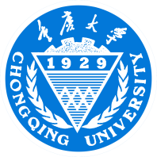
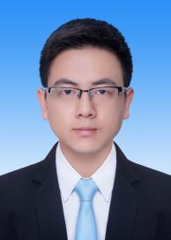
Ligeng Chan
Phone number：153-8188-7567
E-mail address：15381887567@163.com
Education Background
University：2013 .09-2017.06 Chongqing University Major in Computer Science
GPA：3.45/4.0 Ranking: 13/175 CET-6
Major Courses：Programming Foundations, Analysis and Design of Algorithms, Data Structures Computer Organization, Pulse Circuit and Digital Logic, Object-oriented Programming
Research Experience
“Saixiaomi” APP - One-stop Competition Assistant 2015.05-2016.05
· Taking the harsh competition environment that students are facing at present into consideration, we aspire to solve these problems from different respective: information portal and team building before the competition; communication and information managing during the competition; and CV boosting and docking recruitment after the competition.
· In this project, I mainly act as product manager for market analysis, analyzing user’s psychology, increasing product extension as well as enhancing the user experience.
Intelligent garbage collection 2015.04-2015.05
· The social investigation is mainly aimed at the problem of garbage disposal and collection in the urban environment. Not only do we develop a new concept of garbage collection according to the existing product, but also we outline the new pattern and function of the recycling bins.
· In this project, I am mainly responsible for the design of the function and user experience of the product, and simultaneously simulating the most like garbage box model according to the investigation.
Student Work
Monitor of CS Class 2, Chongqing University 2013.09-til now
· Work actively to guide students to complete class affairs, and lead class to win the title of Excellent Class of Chongqing University.
· Establish good style of study, helping class average sub GPA rank first, and scholarship rank first as well.
Counsellor Assistant and Grade Monitor of Chongqing University 2013.9.-til now
· Assist the counselor to deal with the grade affairs as a communication bridge between teachers and students, while getting the teacher and students’ unanimous praise.
· Participate in the management of school affairs as a representative, while winning the Outstanding Student Cadre Title in Chongqing.
Awards
Learning achievement：National Scholarship（2014）；Chongqing University scholarship（3 years）
Comprehensive quality：Chongqing outstanding student cadre
Chongqing University advanced individual innovation and Entrepreneurship(Top 10)
One plus mobile campus creative strategy contest runner up
Science and technology competition：
National University Students mobile application innovation contest runner up；
Chongqing youth APP contest creative class two ；Chongqing University Fourth College Students' Cup innovation and entrepreneurship competition first prize ；Interdisciplinary Contest In Modeling Meritorious Winner;Chongqing computer design contest two
Self-evalutaion
Three years of student work, the exercise of my administrative capacity, coordination and co-ordination; reasonably arrange a time, will be the best thing to do to maximize the benefits; self-learning ability, good interpersonal and versatile.

