The Nyquist Stability Criterion
Name:马宇佩 Class：测控2302 Student ID：202302502217

1. Introduction and Historical Background
In the realm of control systems engineering, ensuring the stability of dynamic systems stands as a paramount objective. The Nyquist Stability Criterion, a cornerstone of classical control theory, has emerged as an indispensable tool for analyzing the stability of feedback systems. Its development marked a significant milestone in the field, addressing a long-standing challenge of determining system behavior under feedback conditions.
The criterion was first formulated by Harry Nyquist, a prominent engineer and mathematician, in his groundbreaking 1932 paper titled "Regeneration Theory." During this era, the rapid advancement of electronic amplifiers and communication systems created an urgent need for understanding and mitigating instability issues. Amplifiers with feedback mechanisms often exhibited unpredictable behaviors, ranging from stable operation to uncontrollable oscillations or "runaway" conditions. Nyquist's work aimed to unravel the fundamental principles governing these phenomena, providing a systematic approach to assess stability.
What sets the Nyquist Stability Criterion apart is its unique position as a frequency domain stability test tailored for linear time-invariant (LTI) systems. Unlike time-domain methods that rely on solving differential equations or analyzing transient responses, the Nyquist criterion leverages frequency response data to draw conclusions about stability. This frequency domain approach offers several distinct advantages: it bypasses the need for solving complex higher-order differential equations, provides intuitive insights into system behavior across different frequency ranges, and enables engineers to evaluate not just absolute stability but also the relative degree of stability.
The relative stability assessment, quantified through phase and gain margins, is particularly valuable in practical engineering applications. Gain margin refers to the amount by which the system's gain can be increased before it becomes unstable, while phase margin represents the additional phase lag that can be introduced without causing instability. These margins serve as critical design parameters, guiding engineers in tuning controllers to achieve desired performance characteristics—such as fast response, minimal overshoot, and robustness against external disturbances and parameter variations.
Over the decades, the Nyquist Stability Criterion has retained its relevance and importance. From the early days of analog control systems to the modern era of digital control and complex mechatronic systems, this criterion continues to be a foundational tool in the design and analysis of feedback control systems. Its rigorous mathematical basis, combined with its practical applicability, has solidified its status as an essential concept in control engineering education and practice.
The Nyquist Stability Criterion is a fundamental method used to investigate the stability of feedback systems. It was originally derived by H. Nyquist in his 1932 paper, "Regeneration Theory," which explored conditions under which an amplifier's feedback results in a stable response or a runaway condition.
This criterion serves as a frequency domain stability test for time-invariant linear systems. Its significance lies in its ability to not only determine absolute stability but also assess the relative degree of system stability through phase and gain margins, which are essential for controller design.

2. System Representation and Theoretical Basis
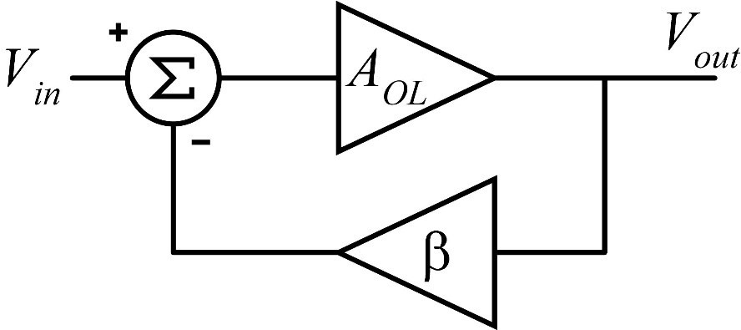
To understand the Nyquist Stability Criterion, we first start with the representation of a standard Single-Input Single-Output (SISO) linear time-invariant feedback system. This canonical structure serves as the building block for analyzing a wide range of practical control systems, from simple temperature controllers to complex aerospace guidance systems.

The analysis begins with a standard Single-Input Single-Output (SISO) feedback system, where:
$G(s)$ represents the system (forward path).
$H(s)$ is the feedback element.
The closed-loop transfer function, $M(s)$, is defined as:
$$M\left(s\right)=\frac{G(s)}{1+G(s)H(s)}$$
The stability of the closed-loop system depends on the location of its poles (the values for which $M\left(s\right)$ becomes infinity). These poles are the roots of the system's characteristic equation:
$$D\left(s\right)=1+G\left(s\right)H\left(s\right)$$
A critical relationship exists between the open-loop and closed-loop functions regarding $D\left(s\right)$:
Zeros of $D(s)$: Correspond to the closed-loop poles of $M\left(s\right)$.
Poles of $D(s)$: Correspond to the open-loop poles of $G(s)H(s)$ (the zeros of $M(s)$).
Therefore, determining stability is equivalent to finding if $D\left(s\right)$ has any zeros in the right-half $s$-plane (the unstable region).

3. Mathematical Foundation: Cauchy’s Principle of Argument
The Nyquist Stability Criterion is firmly rooted in a fundamental result from complex analysis known as Cauchy’s Principle of Argument. This principle establishes a profound relationship between the number of zeros and poles of an analytic function inside a closed contour in the complex plane and the number of times the function’s mapping encircles the origin.
The principle states: Let $F(s)$ be an analytic function inside a closed contour. As $s$ travels around this contour in a clockwise direction, the mapping of the function $F\left(s\right)$ will encircle the origin in the $F(s)$-plane $N$ times. The relationship is given by:
$$N=Z-P$$
Where:
$N$: The number of encirclements of the origin.
$Z$: The number of zeros of $F(s)$inside the contour.
$P$: The number of poles of $F(s)$inside the contour.
This can also be expressed in terms of the argument (angle) of the function:
$$\arg\left\{F\left(s\right)\right\}=\left(Z-P\right)2π=2πN$$

4. The Nyquist Stability Criterion
To apply this to control systems, a specific contour (the Nyquist path) is chosen in the $s$-plane that encloses the entire unstable right-half plane (where radius$R→∞$).
By applying Cauchy's principle to the function $D\left(s\right)$, we can relate the closed-loop stability to the open-loop properties. The number of unstable closed-loop poles is equal to the number of unstable open-loop poles plus the number of encirclements of the origin by the plot of $D\left(s\right)$.
A key insight that simplifies the application of the Nyquist Stability Criterion is recognizing that the plot of $D\left(s\right)=1+G\left(s\right)H\left(s\right)$is equivalent to shifting the plot of $G\left(s\right)H\left(s\right)$by 1 unit to the right in the complex plane. This shift has a profound impact on the reference point for counting encirclements: instead of counting encirclements of the origin (0, j0) in the $D\left(s\right)$-plane, we now count encirclements of the point (-1, j0) in the $G\left(s\right)H\left(s\right)$-plane.
To understand why this shift works, consider the following: a point $s$ for which $D\left(s\right)=0$ (i.e., a zero of $D(s)$) corresponds to $G\left(s\right)H\left(s\right)=-1$. In other words, the zeros of $D(s)$ map to the point (-1, j0) in the $G\left(s\right)H\left(s\right)$-plane. When $s$ traverses the Nyquist path, the $G\left(s\right)H\left(s\right)$ plot will encircle (-1, j0) the same number of times that the $D(s)$ plot encircles the origin. This is because the shift from $G\left(s\right)H\left(s\right)$ to $D\left(s\right)=1+G\left(s\right)H\left(s\right)$ translates all points in the $G\left(s\right)H\left(s\right)$-plane by (1, j0), so the origin in the $G\left(s\right)H\left(s\right)$-plane corresponds to (-1, j0) in the -plane.
This simplification is highly valuable in practice because plotting $G\left(s\right)H\left(s\right)$ (the open-loop frequency response) is straightforward using standard techniques such as Bode plots or polar plots. Engineers can measure or compute the open-loop frequency response data (magnitude and phase of $G\left(jω\right)H\left(jω\right)$ for $ω$ from 0 to $∞$) and plot it directly in the complex plane. The critical point (-1, j0) serves as the reference for determining stability, eliminating the need to plot the shifted function $D(s)$ .
Another important consideration in the simplified method is the direction of encirclements. A clockwise encirclement of the origin by the $D(s)$ plot corresponds to a clockwise encirclement of (-1, j0) by the $G\left(s\right)H\left(s\right)$ plot, and vice versa. This consistency ensures that the relationship between $Z$ ,$P$ , and $N$ (now defined in terms of encirclements of (-1, j0)) remains valid, with only the reference point changing.

5. Summary of the Stability Formula
Based on the modified Nyquist plot of $G\left(s\right)H(s)$, the stability is determined by the following formula:
$$Z=P-2N$$
Definitions of Variables:
$Z$: The number of unstable poles in the closed-loop gain $M(s)$(This value must be 0 for the system to be stable).
$P$: The number of unstable poles in the loop transmission $G\left(s\right)H(s)$.
$N$: The number of times the $GH(jω)$ plot wraps clockwise around the point$(-1,j0)$.
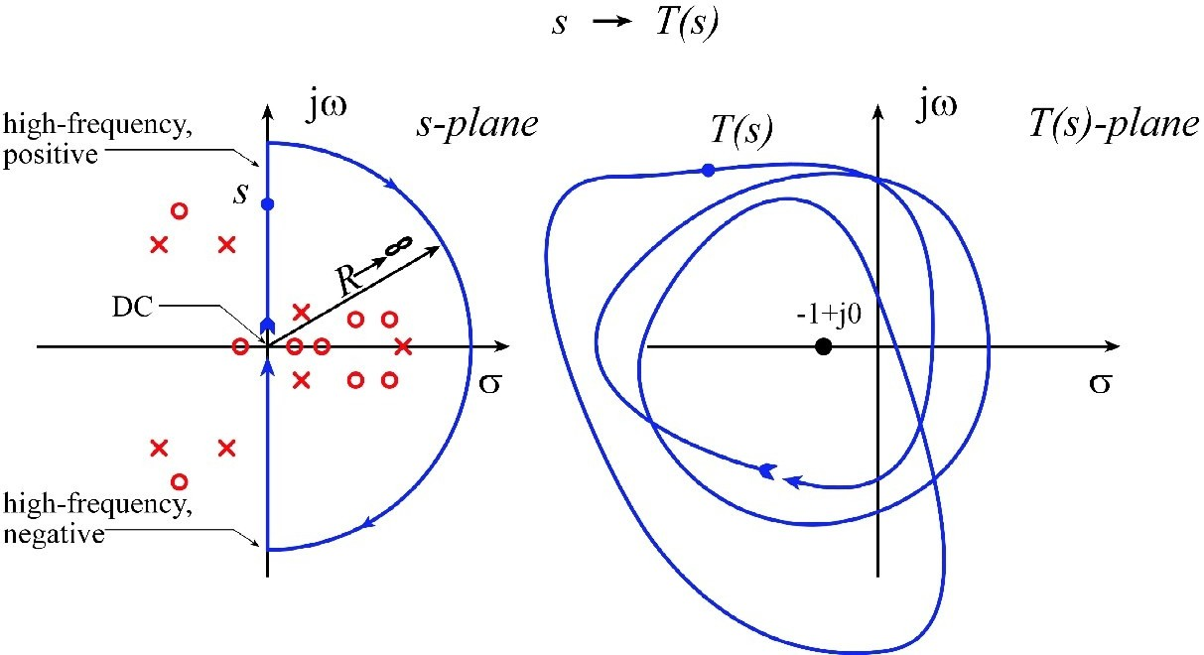

6. Conclusion
The Nyquist Stability Criterion stands as one of the most influential and enduring results in classical control theory, offering a rigorous and practical method for analyzing the stability of feedback control systems. By leveraging the mathematical power of Cauchy’s Principle of Argument and a clever simplification of the plotting process, this criterion enables engineers to determine the stability of closed-loop systems by examining the open-loop frequency response.
The key strength of the Nyquist Stability Criterion lies in its ability to not only determine absolute stability (whether a system is stable or unstable) but also to provide insights into relative stability through the analysis of phase and gain margins. These margins are critical for designing robust control systems that can withstand variations in system parameters, external disturbances, and noise. Unlike time-domain methods, which can be computationally intensive for high-order systems, the Nyquist criterion relies on frequency response data that is often easier to measure or compute.

