|  |  |
| --- | --- |
|  | SV500  USER MANUAL |
| SignalsSense.com  2025. 09. 05 | SV-500 Configuration manual for users |

| Date | Services performed by: | Services performed for: |
| --- | --- | --- |
| 05/09/2025 | SignalsSense.com  321 Sycamore Ave.  Albany, NY 76543 | Ian Hansson  123 South Street  Manhattan, NY 54321 |

|  |  |
| --- | --- |
|  | This document is a web server user manual for SV-500 equipment configuration and data monitoring. It consists of four sections: supported functions, equipment settings, data monitoring, and reports. |

# Supported Functions

1. Provides basic measurement data
2. When using Power Quality function, provides harmonics and waveform data for power quality measurement
3. When using diagnostic function, provides diagnostic results and trend data for facility status and power quality status
4. When using FTP function, provides waveform file transmission to designated FTP server
5. Provides corresponding functions when setting alarms, events, and trends.

※ When using FTP function after event setting, event files are transmitted to FTP server, and energy trend data is provided regardless of settings

# Login

|  |  |
| --- | --- |
|  | Initial login is possible with a pre-created administrator account. Please contact the person in charge for the administrator account. |

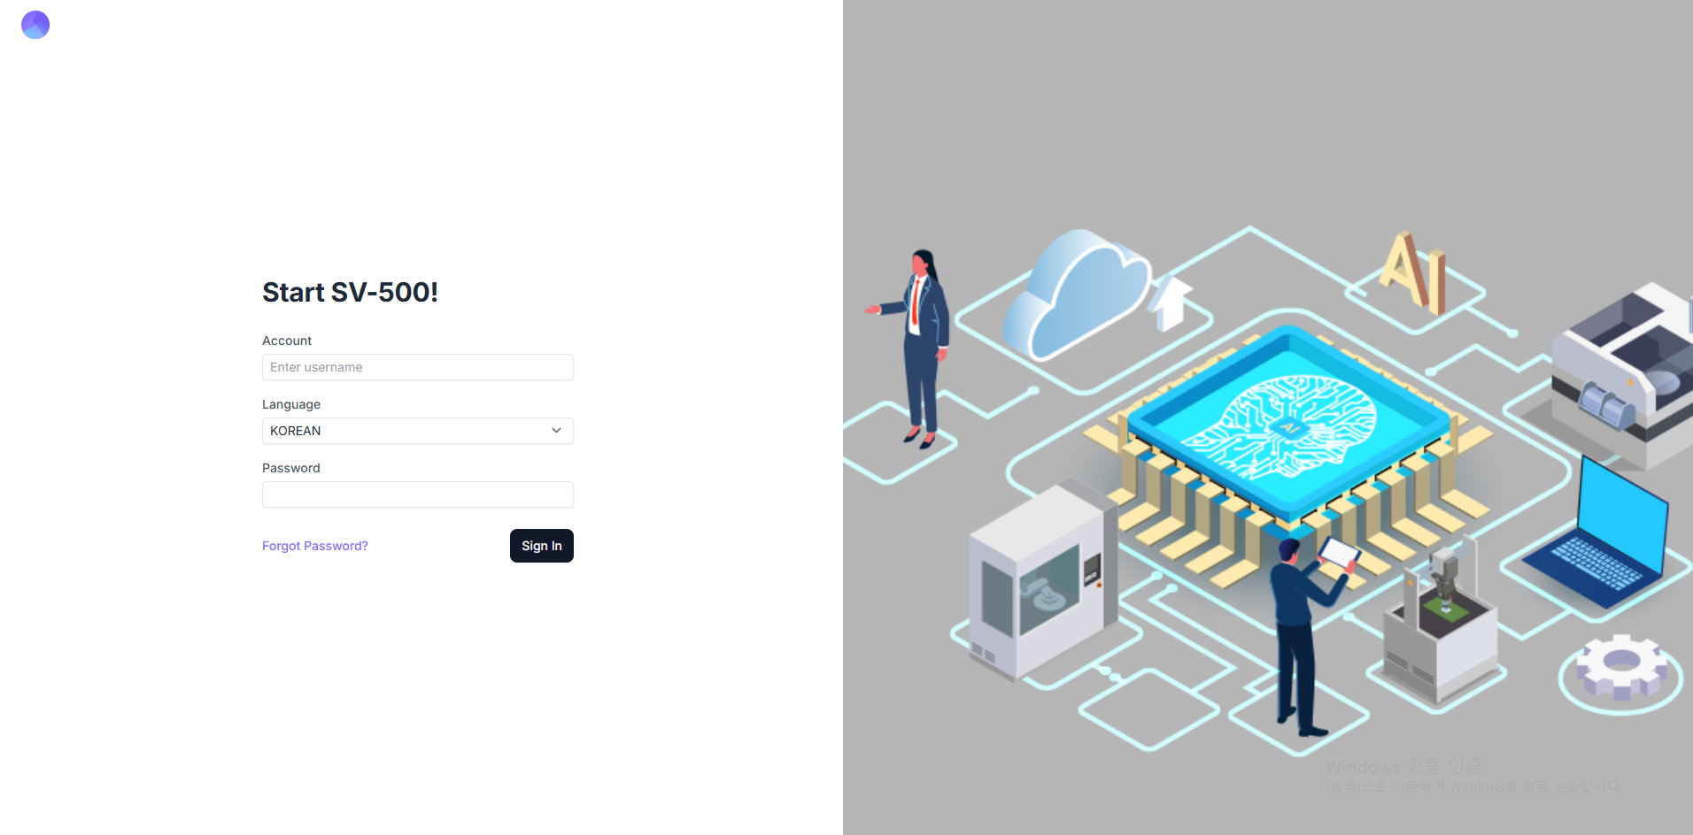

※ Password changes are not possible, and password reset is available through the email address registered to the account.

# Configuration

|  |  |
| --- | --- |
|  | Sidebar Menu - Settings: Administrator account login is required for equipment configuration |

# Top menu



1. This is a menu displayed at the top of all settings pages, where you configure the functions to be used in the device and decide on final saving and application.
2. After clicking the **Save** button and then the **Apply** button, a popup window appears.
3. 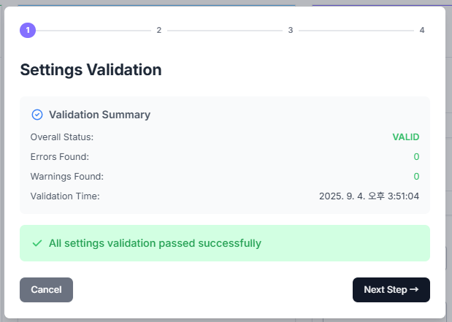In this window, the validity of the entered configuration values is checked. If there are no issues, a message is displayed indicating that the device’s data acquisition program will be restarted.
4. 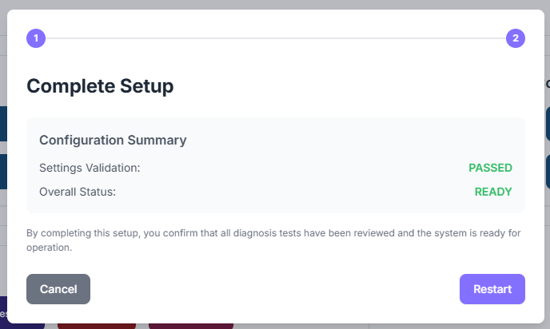When the **Restart** button is clicked, the device’s data acquisition program is restarted.

# Configuration > General

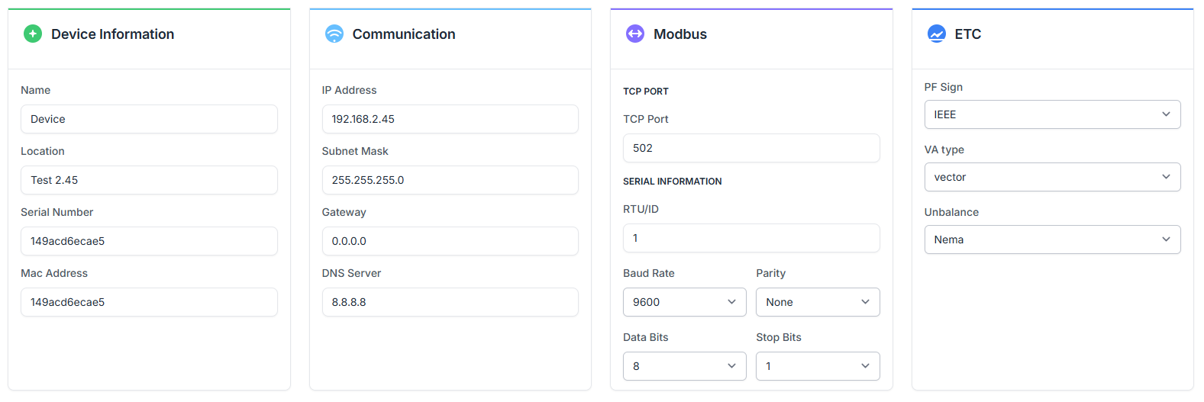

1. **Device Information**
   1. **Name**: Enter equipment name
   2. **Location**: Enter the location where equipment is installed.
   3. **Mac Address, Serial Number**: MAC address set in the equipment is automatically loaded.
2. **Communication**: Enter TCP/IP information for equipment communication.



1. **Modbus**: Enter Modbus information to be connected externally.
2. **ETC**: Specify power factor calculation method, unbalance calculation method, etc.

# Configuration > Main/Sub Channel

|  |  |
| --- | --- |
|  | Each Main/Sub channel operates independently. |

1. 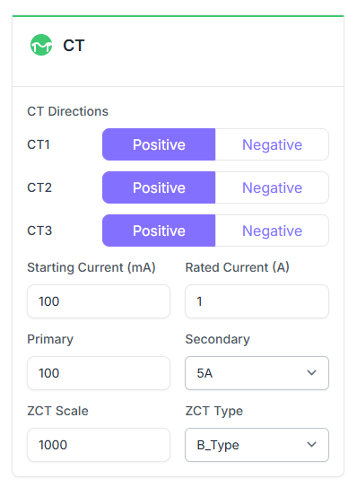**CT**
   1. **CT Direction**: Direction setting for CT1, CT2, CT3
   2. **Start Current**: Set current measurement lower limit value.
   3. **Rated Current**: Enter rated current.
   4. **Primary**: ZCT Scale, ZCT Type setting
   5. 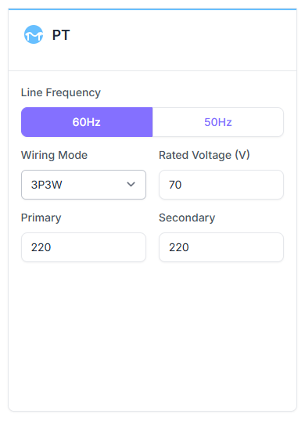**Secondary**: ZCT Scale, ZCT Type setting
2. **PT**
   1. **Line Frequency**: Select line frequency
   2. **Wiring Mode**: Select wiring method
   3. **Start Voltage**: Enter voltage measurement lower limit value
   4. **Rated Voltage**: Enter rated voltage
   5. Primary/Secondary

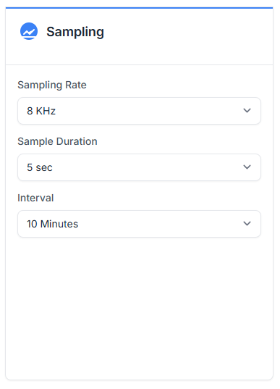

1. **Sampling** 
   1. Select sampling frequency
   2. Select sampling period
   3. Select sampling data acquisition timing
2. 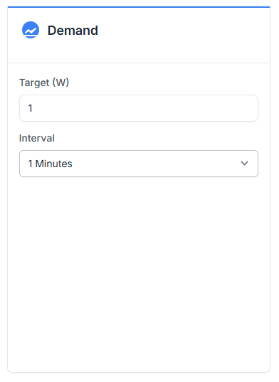**Demand**
   1. Enter Target
   2. Enter Interval
3. **Alarm**
   1. Up to 32 settings possible
   2. Enter Compare time delay, alarm occurrence recognition delay time
   3. Select parameter, select condition (Under: lower limit, Over: upper limit)
   4. 텍스트, 스크린샷, 번호, 평행이(가) 표시된 사진

      AI 생성 콘텐츠는 정확하지 않을 수 있습니다. Enter reference value (hysteresis: % compared to rating, Value: value)
4. 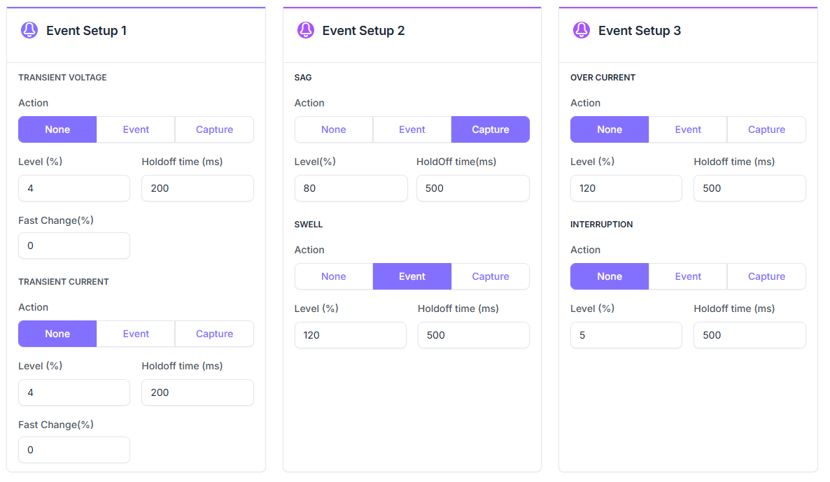**Event**
   1. Event Type
      1. Transient Voltage, Transient Current, Sag, Swell, Over Current, Interruption
   2. **Action**
      1. None: No action
      2. Event: Event message occurs.
      3. Capture: Acquire event waveform data.
   3. **Level**: Reference value of the rated voltage.
   4. **Holdoff time**: Idle time after the event occurs.
   5. **Fast Change(%)**: Reference value for the rate of change between samples.

* **Trend**

Trends do not provide separate configuration settings. The collection interval for measurement data is 5 minutes, while the collection interval for power consumption data is 1 hour.

# Configuration > System

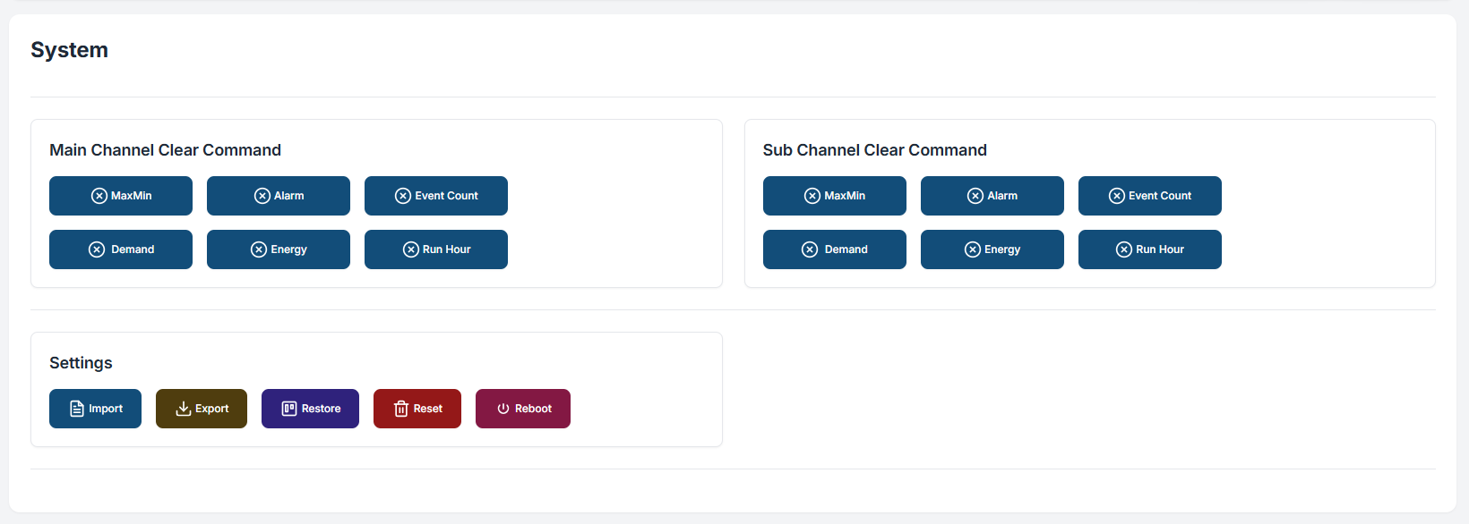

1. **Clear Command**
   1. Demand power, Max/Min, Energy, Alarm occurrence count, Event occurrence count
2. **Settings**
   1. **Import**: Upload pre-configured setup file (setup.json)
   2. **Export**: Download setup file configured in equipment
   3. **Restore**: Restore all information currently set in equipment to previous backup
   4. **Reset**: Initialize equipment settings, delete setup files
   5. **Reboot**: device rebooting

# Dashboard

|  |  |
| --- | --- |
|  | Dashboard output varies according to channel settings. |

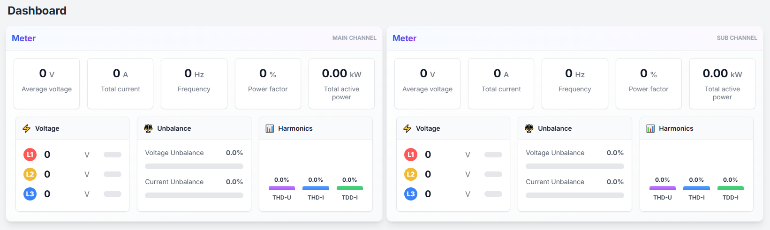

※The dashboard screen refresh rate is 10 seconds.

# Channel > Meter

|  |  |
| --- | --- |
|  | Real-time measurement information and power quality information for each main channel/sub-channel are displayed |

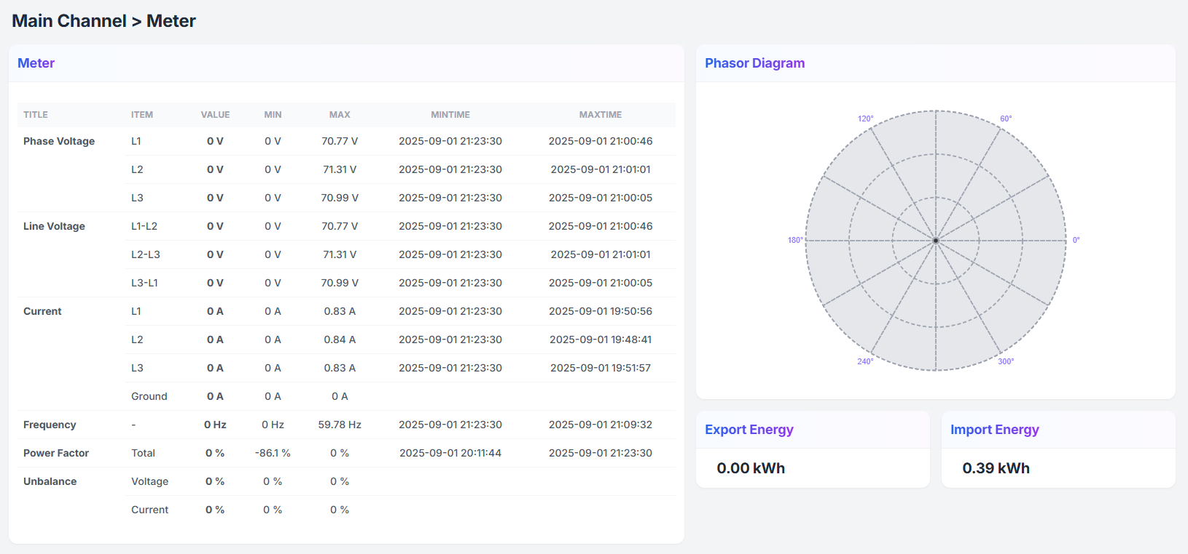

※The refresh rate for the Meter card section is 1 second, the phase diagram refresh rate is 1 minute, and the energy refresh rate is 1 hour.

※The refresh rate for the THD, Demand, and Power card sections is 15 minutes. 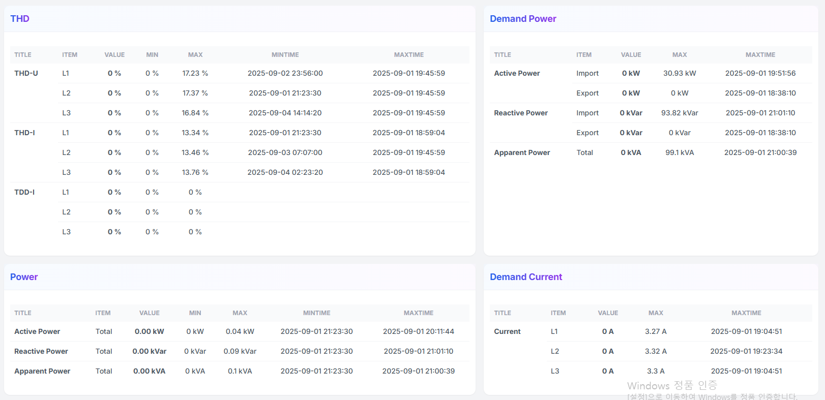

# Channel > Power Quality

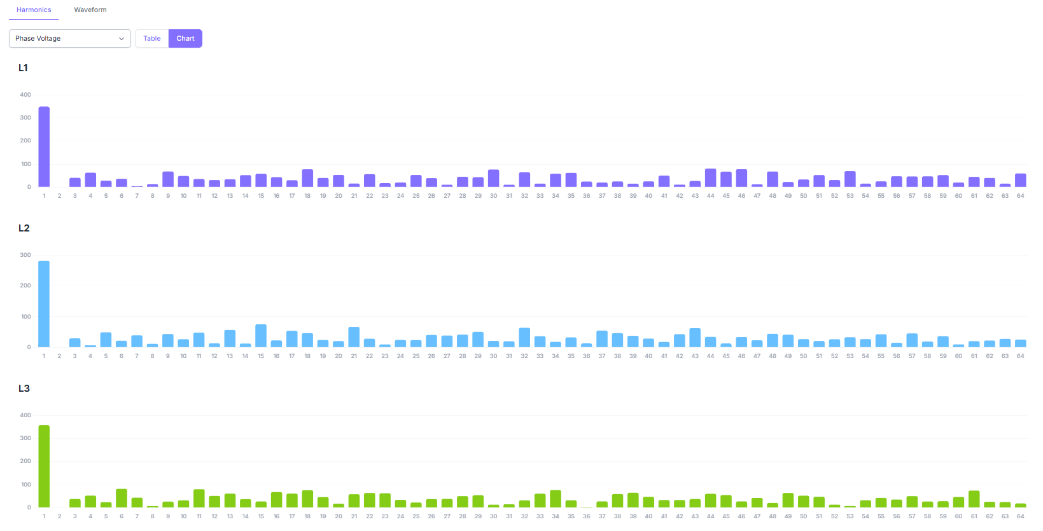

1. **Harmonics Tab**
   1. Select phase voltage/line voltage/phase current items, bar chart output
   2. Chart data is displayed in table format when table button is clicked
   3. The refresh rate is 1 second

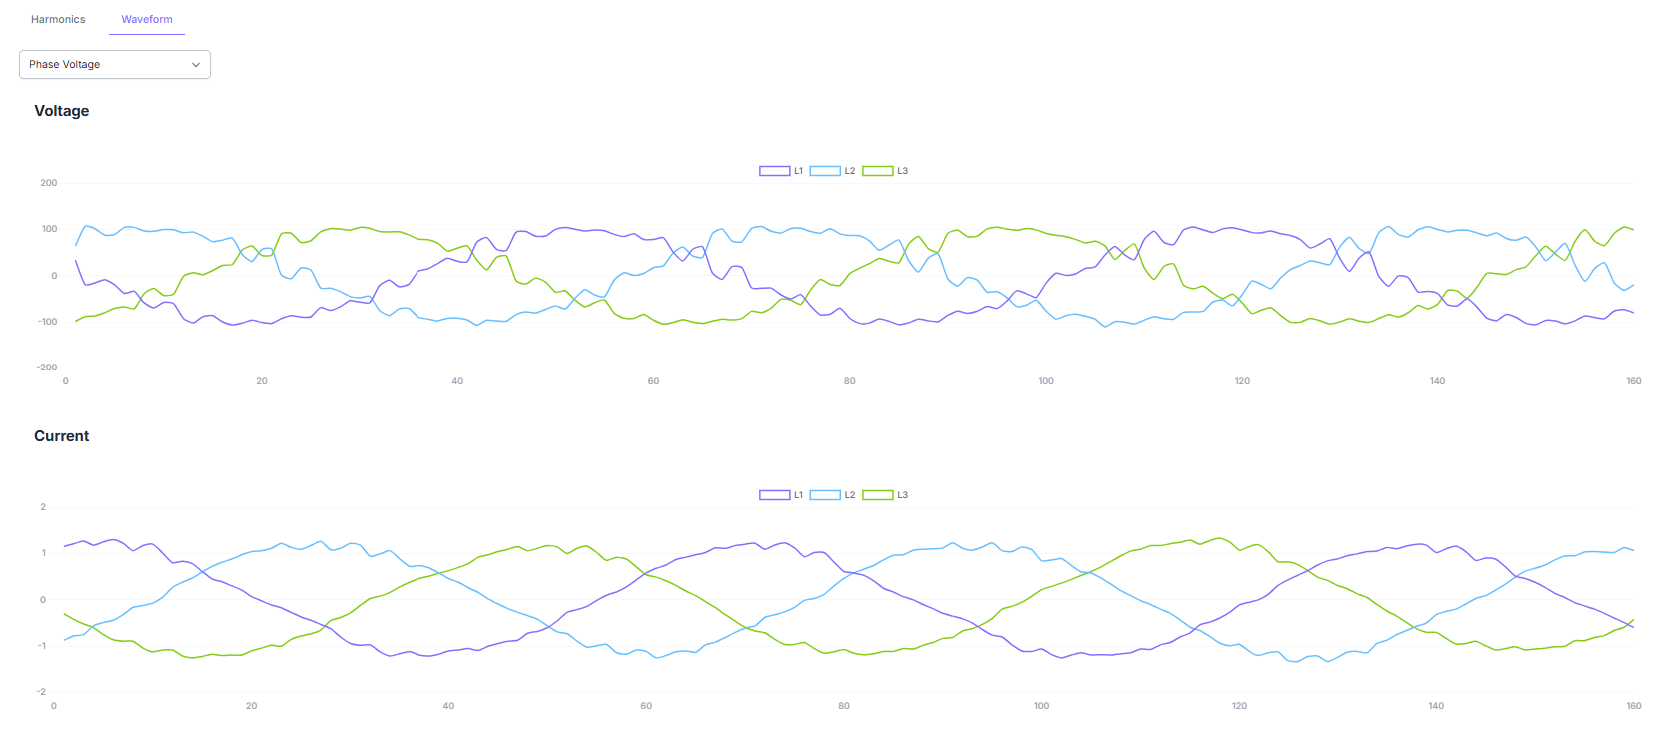

1. **Waveform Tab**
   1. Select phase voltage/line voltage items, 3-phase line chart output together with phase current at the bottom
   2. When clicking the waveform tab, data acquisition starts, so the chart is displayed after 3-4 seconds.
   3. The refresh rate is 1 second.

# Alarm/Event

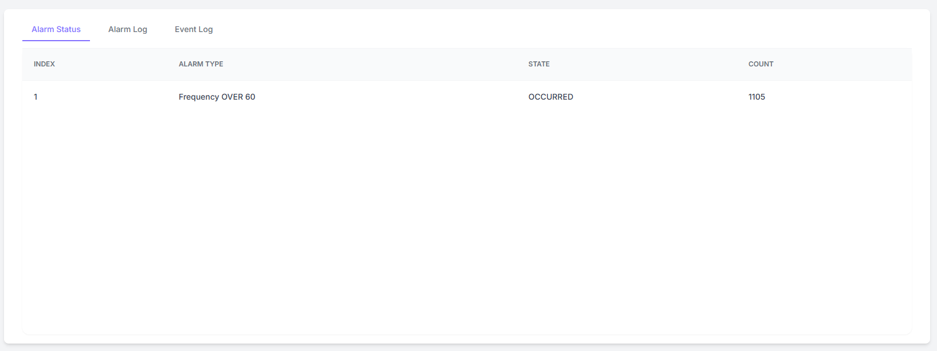

1. **Alarm Status Tab**
   1. Displays the current status of alarm settings registered in settings

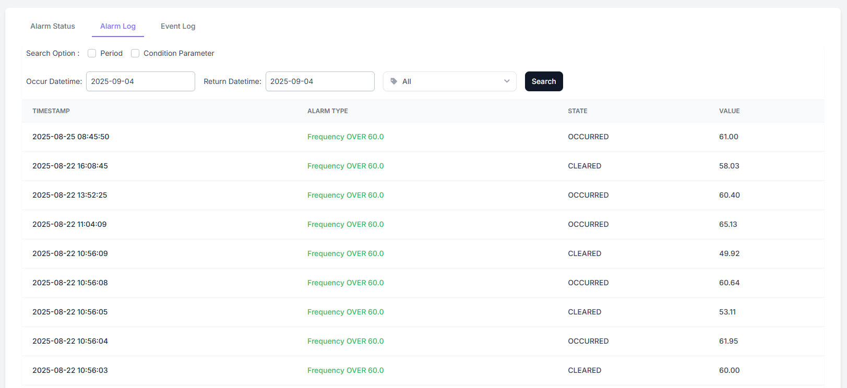

1. **Alarm Log Tab**
   1. Displays alarm logs for the last 30 days,
   2. After checking search options, search and inquiry by period and parameters is possible. Parameters display only the parameter list registered in settings.

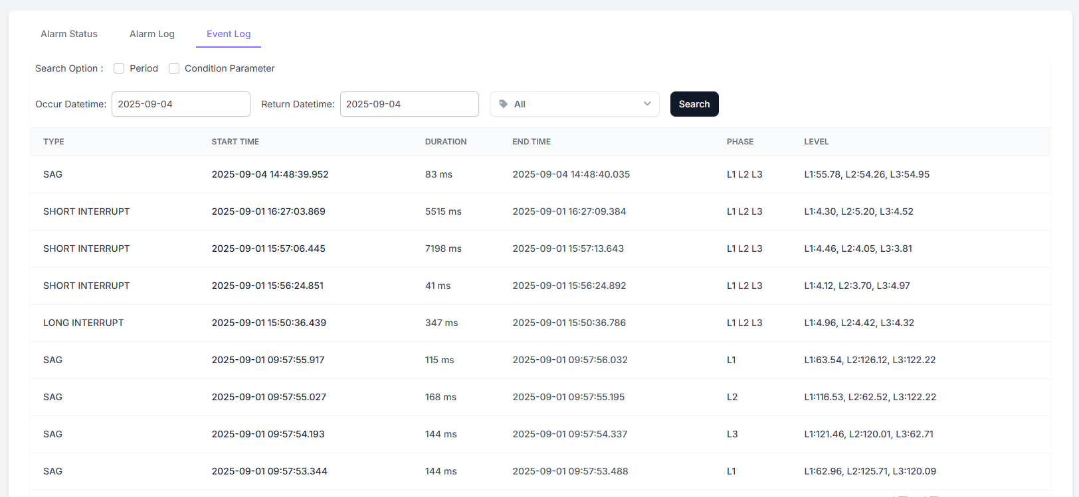

1. **Event Log Tab**
   1. Displays event logs for the last 30 days,
   2. After checking search options, search and inquiry by period and parameters is possible.

# Report

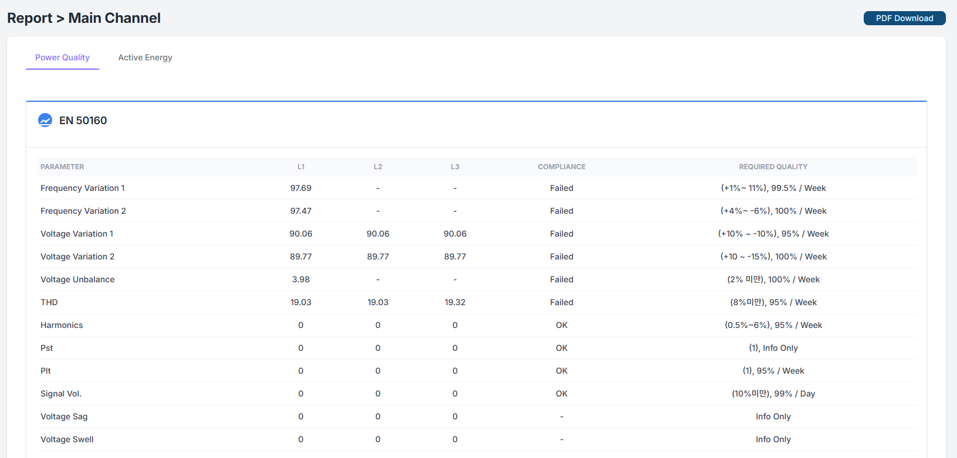

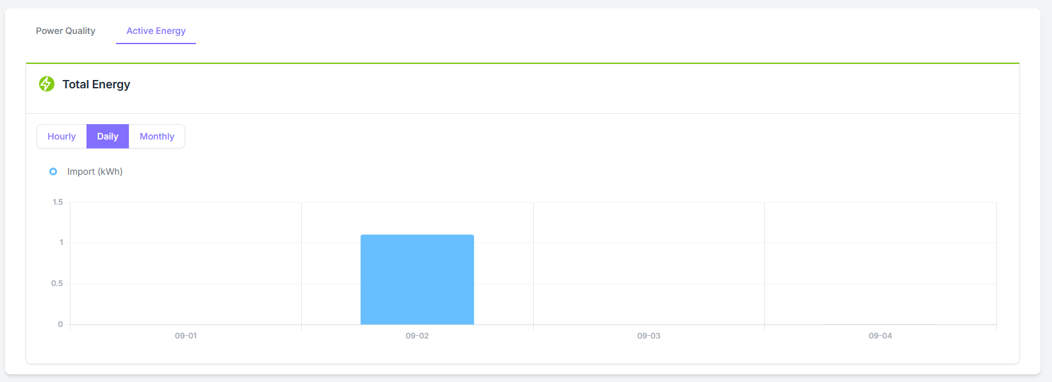

1. **Power Quality Tab**
   1. Composed of EN 50160 report and ITIC chart.
   2. The EN 50160 report is a current status report.
2. **Active Energy Tab**
   1. Provide power consumption data as bar charts by hour, day, and month.
3. When clicking the **Download PDF** button at the top of the screen, the report can be downloaded as a PDF file.

# Trend

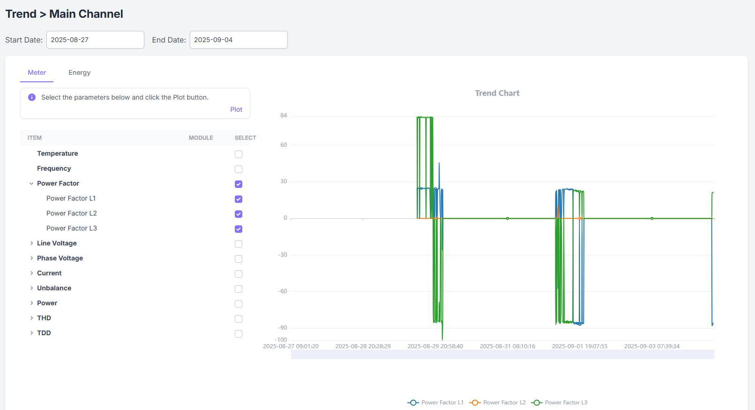

1. It consists of two tabs: **Meter** and **Energy**. The two items have different collection intervals.
2. Select the date at the top of the screen
3. choose the parameters to query from the tree table on the left, then click the **Plot** button above the table. When the parent item in the tree table is checked, all child items are automatically selected.
4. The chart will be displayed on the right side of the screen.