MODULE 5
PROFESSIONAL OPTION CHAIN ANALYSIS
LESSON 1
Understanding Every Column in the Option Chain
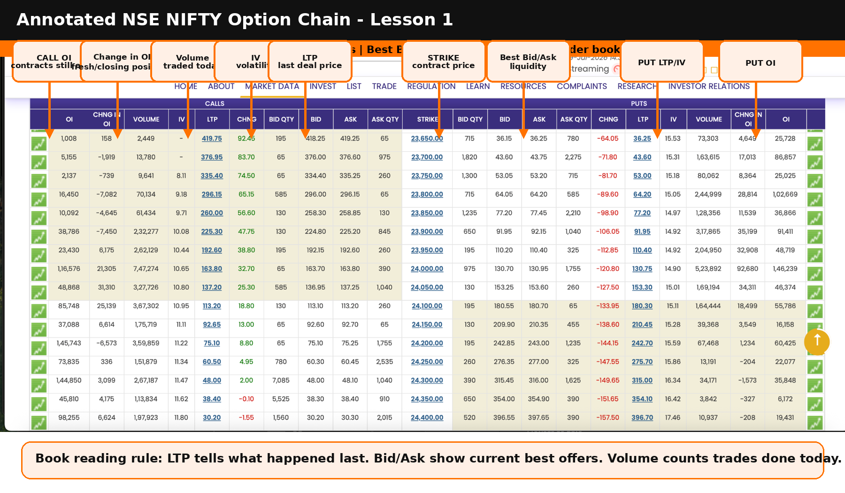
Based on the live NIFTY option chain screenshot shared for this lesson.
Course Motto
The option chain does not predict the market. It reveals where money is currently flowing, where contracts are open, and where traders may be building support or resistance.

1. Learning Objectives
After completing this chapter, you should be able to read the major columns of the NSE option chain, understand what Bid, Ask and LTP actually mean, separate Volume from Open Interest, and explain how option contracts are created, transferred and closed.
By the end of this lesson you should understand | Why it matters in trading
Strike Price, Call side and Put side | This tells you which option contract you are studying.
LTP, Bid and Ask | This tells you what traded last and where current buyers and sellers are waiting.
Volume vs Open Interest | This separates temporary activity from real positions still alive in the market.
Change in Open Interest | This is the first clue about fresh money entering or existing positions exiting.
Practical interpretation | You will know how to scan a live NIFTY option chain without guessing.

2. What is an Option Chain?
An option chain is a live table of all available call and put option contracts for an underlying such as NIFTY. It shows prices, quantities, volatility, trading activity and outstanding positions across different strike prices.
For a beginner, the option chain may look like a crowded railway timetable. For a professional trader, it is more like a market map showing where buyers, sellers and large positions are concentrated.
Beginner Translation
Do not try to read every number at once. First identify the spot price, locate the ATM strike, and then study Bid, Ask, LTP, Volume, OI and Change in OI one by one.

3. Annotated NIFTY Option Chain Screenshot

The left half shows Call options and the right half shows Put options. The centre column shows Strike Price. The same strike has both a call contract and a put contract. Around each strike, the option chain displays LTP, Bid, Ask, Volume, Open Interest, Change in Open Interest and IV.

4. Core Columns Explained in Simple Language
Column | Layman Meaning | Professional Interpretation | Beginner Mistake
Strike Price | The contract price level such as 24000, 24050 or 24500. | The strike tells you where the market is placing bets or hedges. | Thinking strike price alone is support or resistance.
LTP | The last price at which an actual trade happened. | LTP is history: it shows the latest completed deal, not the next guaranteed trade. | Buying only because LTP looks cheap.
Bid | The highest price currently offered by buyers. | Bid shows demand at the best available buying price. | Assuming every bid appears in the main table.
Ask | The lowest price currently asked by sellers. | Ask shows supply at the best available selling price. | Forgetting that immediate buying usually happens at Ask.
Volume | Total quantity traded today. | Volume shows activity, not direction. | Thinking high volume is always bullish.
Open Interest | Contracts still alive and not closed. | OI shows commitment and positioning. | Thinking OI means pending unmatched orders.
Change in OI | Increase or decrease in live positions from the previous value. | This helps detect fresh build-up or unwinding. | Ignoring it and looking only at LTP.
IV | Expected volatility implied by option prices. | High IV means options are expensive; low IV means relatively cheaper. | Buying high-IV options before events without understanding IV crush.

5. LTP, Bid and Ask - The Most Common Beginner Confusion
Imagine a vegetable market. One buyer says, I will buy tomatoes at Rs. 130.20. One seller says, I will sell only at Rs. 139.80. The last deal may have happened at Rs. 137.20. These three values are different because not every quote is a completed transaction.
Market Term | Plain English Meaning | In Your Option Example
Bid | Someone wants to buy at this price. | A user places a bid for 10 lots at 130.20.
Ask | Someone wants to sell at this price. | The best seller is asking 139.80.
LTP | The last actual trade price. | The option chain may show 137.20 because the last completed trade happened there.

Important
The Bid column in the main option chain normally shows the best bid, meaning the highest currently available buying price. It does not show all lower bids placed in the order book.

5.1 Example: Place Bid at 130.20 while the option chain shows 137.20
Suppose NIFTY 24500 CE shows Best Bid = 137.20 and Best Ask = 139.80. You place a buy bid for 10 lots at 130.20. Since your bid is lower than the current best bid, it will not normally appear in the main option chain Bid column. It may remain pending deeper inside the order book.
Situation | Does LTP change? | Does Volume change? | Does OI change? | Why?
You place low bid at 130.20; no seller matches | No | No | No | Only an offer is placed. No trade happened.
You place buy order at Ask 139.80 and seller is available | Yes, may update to 139.80 | Yes | Maybe | A real trade happened. OI depends on whether positions are opening or closing.
You cancel the pending bid | No | No | No | Cancelled orders are not trades.
You place market order | Yes, based on available sellers | Yes | Maybe | Order consumes available Ask prices in sequence.

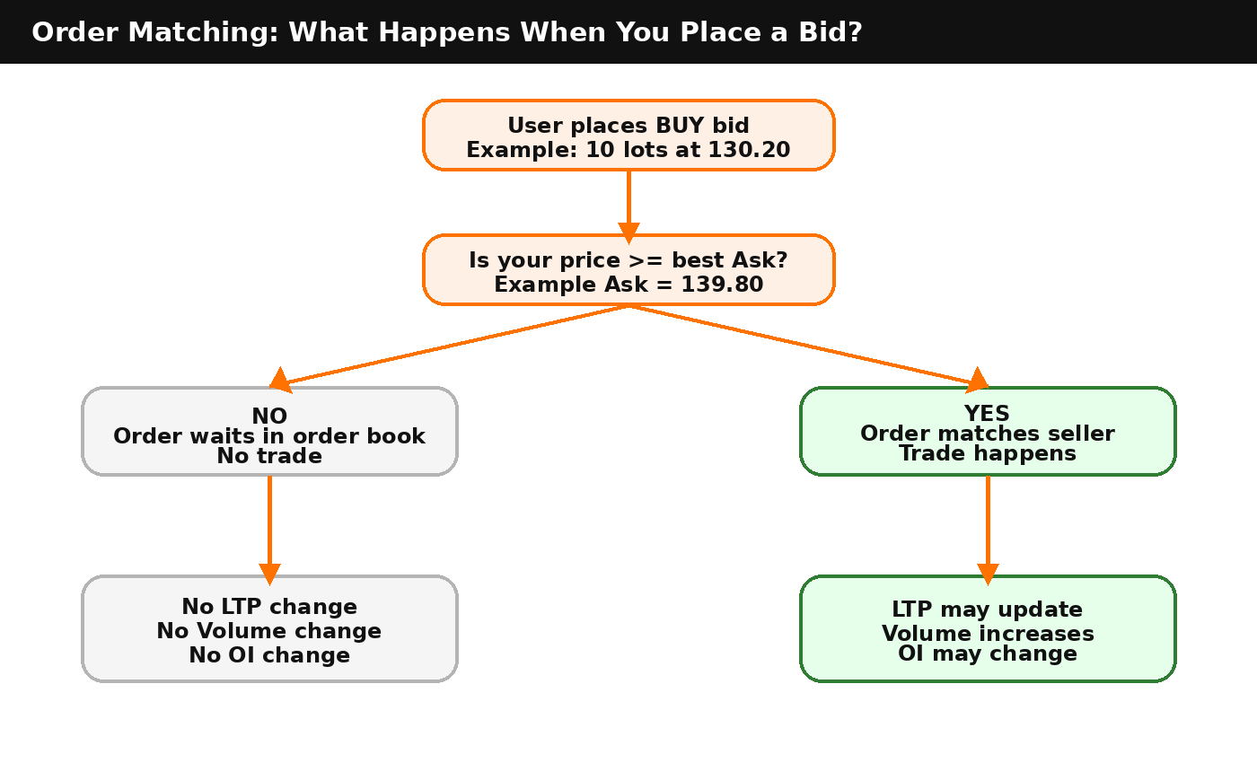

6. Volume vs Open Interest
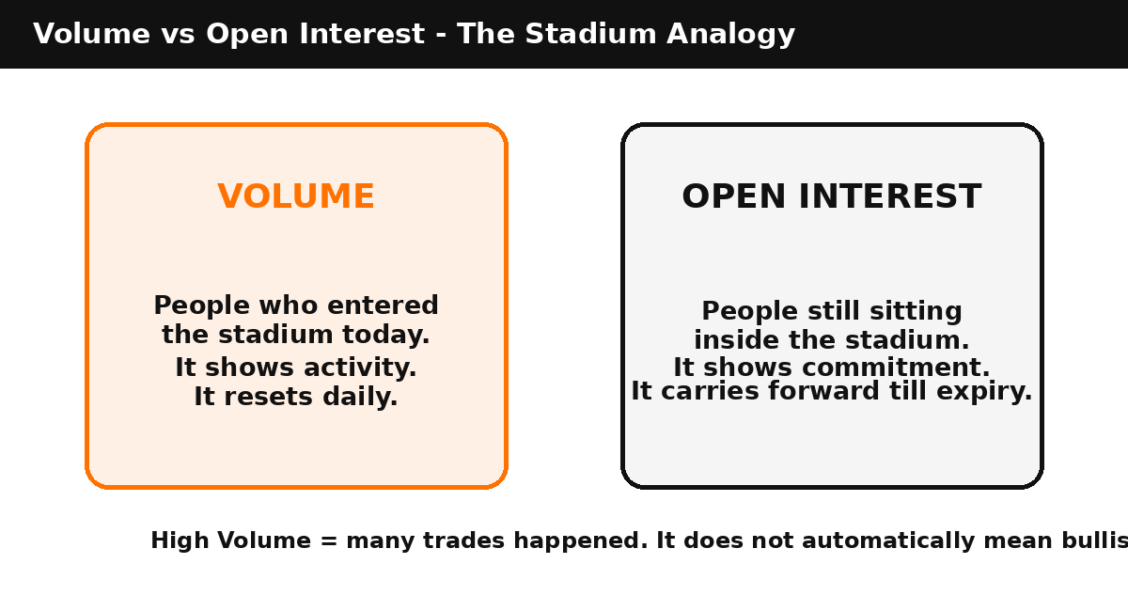
Volume is like the number of people who entered a stadium today. Open Interest is like the number of people still sitting inside the stadium. Volume resets daily. Open Interest carries forward until positions are closed or the contract expires.
Feature | Volume | Open Interest
Meaning | Total contracts traded today. | Total contracts still open.
Nature | Flow: how much trading happened. | Stock: how many positions remain alive.
Resets? | Usually starts fresh each trading day. | Carries forward until closed or expiry.
Can rise without OI rising? | Yes. Existing positions may change hands. | OI may remain unchanged if one old trader exits and one new trader enters.
Best use | Liquidity and activity check. | Support, resistance and positioning analysis.

7. Does Placing a Bid Create Open Interest?
No. A pending bid is only an intention to buy. Open Interest changes only after an actual trade is executed and the resulting position remains open.
Action | Trade executed? | Volume impact | OI impact
User places bid below market; no match | No | No change | No change
User buys at Ask and trade executes | Yes | Volume increases | OI may increase, decrease or remain same
User places bid and cancels it | No | No change | No change
Buyer and seller both open fresh positions | Yes | Volume increases | OI increases
Existing long and existing short both exit | Yes | Volume increases | OI decreases

Never Forget
Open Interest is not unmatched Bid value. It is not pending orders. OI represents completed trades that are still alive as open positions.

8. How Option Contracts Are Created, Transferred and Closed
This is the heart of the confusion. In the market, one person always transacts with another person. You do not physically return a contract to the exchange. Instead, the clearing system nets positions after opposite trades happen.
A contract is created when a new buyer and a new seller both open positions. It is transferred when one old trader exits and a new trader takes over the opposite side. It is closed only when an existing long and an existing short both exit against each other.
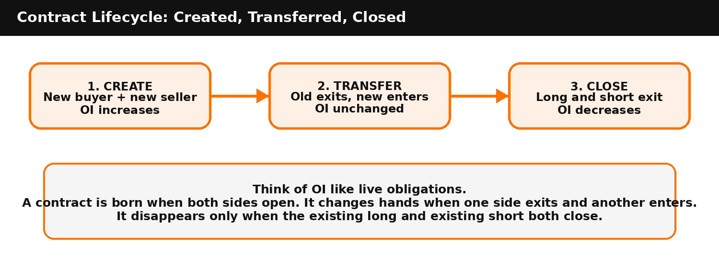

8.1 Corrected Scenario: A Buys 10 Lots; B and C Sell 6 and 4 Lots
At the start of the series, A buys 10 lots of NIFTY 24000 CE. B sells 6 lots and C sells 4 lots. The correct Volume is 10 lots and the correct Open Interest is also 10 lots. We do not count long plus short as 20. Open Interest is counted from one side only.
Stage | Transaction | A | B | C | B-prime | C-prime | Volume | OI | Meaning
1 | A buys 10; B sells 6; C sells 4 | +10 | -6 | -4 | 0 | 0 | 10 | 10 | Fresh contracts created
2 | B squares off by buying 6 from B-prime | +10 | 0 | -4 | -6 | 0 | 16 | 10 | B exits; B-prime becomes new short
3 | C squares off by buying 4 from C-prime | +10 | 0 | 0 | -6 | -4 | 20 | 10 | C exits; C-prime becomes new short
4 | A sells 6 to B-prime | +4 | 0 | 0 | 0 | -4 | 26 | 4 | Existing long and existing short close 6 lots
5 | A sells 4 to C-prime | 0 | 0 | 0 | 0 | 0 | 30 | 0 | Remaining contracts close

One-Line Rule
A contract is created when both sides open. It is transferred when one side exits and a new trader enters. It is closed only when an existing long and an existing short both exit against each other.

9. The Four OI Outcomes
Buyer Side | Seller Side | Volume | OI Effect | Plain English
New buyer opens long | New seller opens short | Increases | Increases | A new contract is born.
Existing short buys to close | New seller opens short | Increases | No change | Short position shifts from old trader to new trader.
New buyer opens long | Existing long sells to close | Increases | No change | Long position shifts from old trader to new trader.
Existing short buys to close | Existing long sells to close | Increases | Decreases | Contract disappears from OI.

10. The Upgraded Professional Scanning Sequence
The earlier sequence correctly started with spot price, ATM strike, OI, Change in OI, Volume and IV. The upgraded sequence adds two essential professional filters: PCR and classification of what kind of positions are being added through Change in OI.
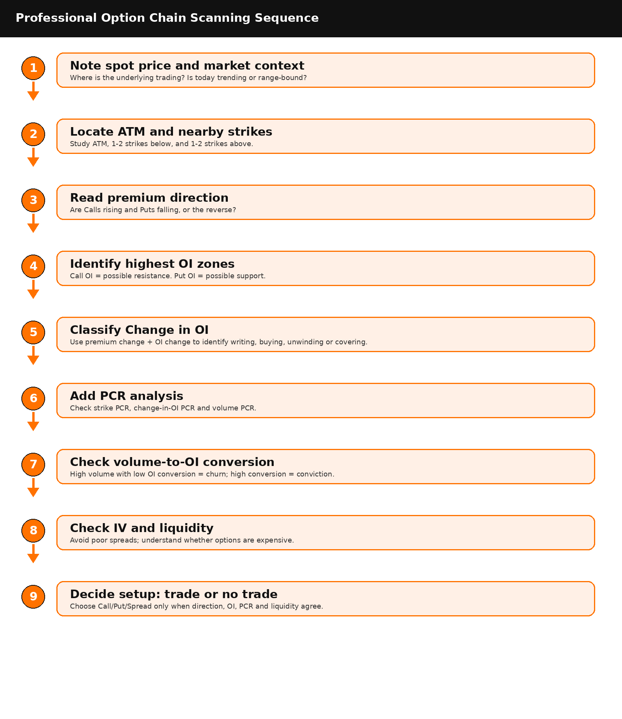

Book Reading Rule
Do not jump from high OI directly to support/resistance. First ask: Is the premium rising or falling? Is OI rising or falling? What does PCR say? Is volume converting into open positions?

11. Core Columns: What They Mean and How Professionals Use Them
Column | Plain Meaning | Professional Use
Strike Price | The contract level, such as 24,200 or 58,000. | Start from ATM and scan nearby strikes.
LTP | Last completed trade price. | History; useful but not a guaranteed next price.
Bid | Highest current buying offer. | Shows best visible demand, not every bid in the order book.
Ask | Lowest current selling offer. | Immediate buying usually happens at Ask.
Volume | Total contracts traded today. | Activity/churn. It resets daily.
Open Interest | Contracts still alive. | Commitment/positioning. It carries forward till exit or expiry.
Change in OI | Fresh increase or decrease in open positions. | Use with premium change to classify market behavior.
IV | Implied volatility in option price. | High IV means expensive options; low IV means cheaper options.
12. LTP, Bid and Ask: A Beginner-Friendly Clarification
Bid and Ask are offers. LTP is a completed transaction. A lower bid may sit inside the order book but not appear in the main option chain if it is not the best bid.
Situation | What Happens | Impact
User places bid at 130.20 while best bid is 137.20 | No immediate trade; main option chain still shows 137.20 as best bid. | LTP no change; Volume no change; OI no change.
User buys at Ask 139.80 | Order matches seller if quantity is available. | LTP may update; Volume increases; OI may increase/decrease/unchanged.
User cancels pending bid | No trade happened. | No effect on LTP, Volume or OI.
User places market buy order | Order consumes available sellers at Ask levels. | Execution can occur at multiple prices if depth is limited.

13. The Most Important Upgrade: Classify Change in OI
Change in OI only tells us that positions were added or removed. It does not by itself say whether buyers or sellers were dominant. To understand the type of positions being added, combine Change in OI with premium change.
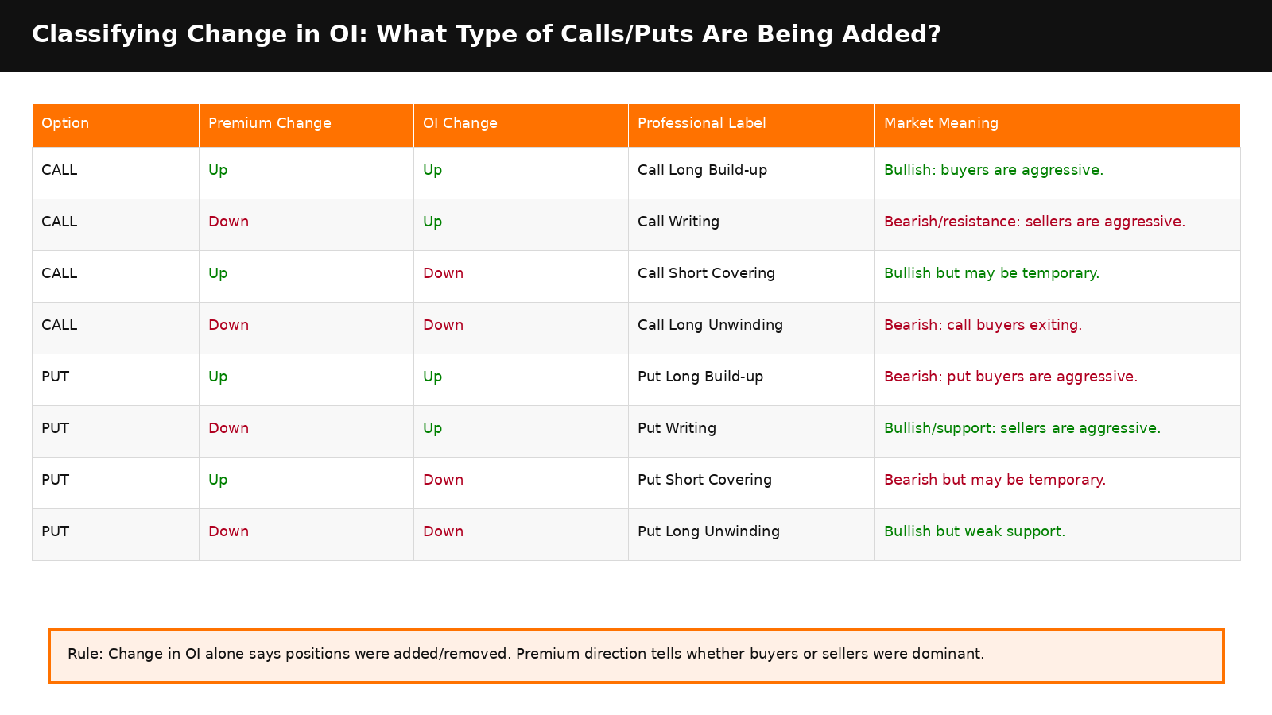
13.1 Practical Meaning of the Four Key Labels
Label | Condition | Meaning
Call Long Build-up | CE premium up + CE OI up | Bullish. Call buyers are aggressive enough to push premium up while fresh positions are added.
Call Writing | CE premium down + CE OI up | Bearish/resistance. Call sellers are aggressive; premium falls while fresh positions are added.
Put Long Build-up | PE premium up + PE OI up | Bearish. Put buyers are aggressive; downside protection/speculation increases.
Put Writing | PE premium down + PE OI up | Bullish/support. Put sellers are aggressive; premium falls while fresh positions are added.
Professional Warning
Every option trade has a buyer and a seller. Labels such as Call Writing or Put Writing are inferred from price movement plus OI movement. They are not directly printed in the option chain.

14. Integrating Put-Call Ratio into the Sequence
PCR is not one single number. For practical strike analysis, use three PCR scorecards: Total OI PCR, Change-in-OI PCR and Volume PCR. Total OI shows existing positioning. Change-in-OI PCR shows fresh conviction. Volume PCR shows intraday participation but may include churn.
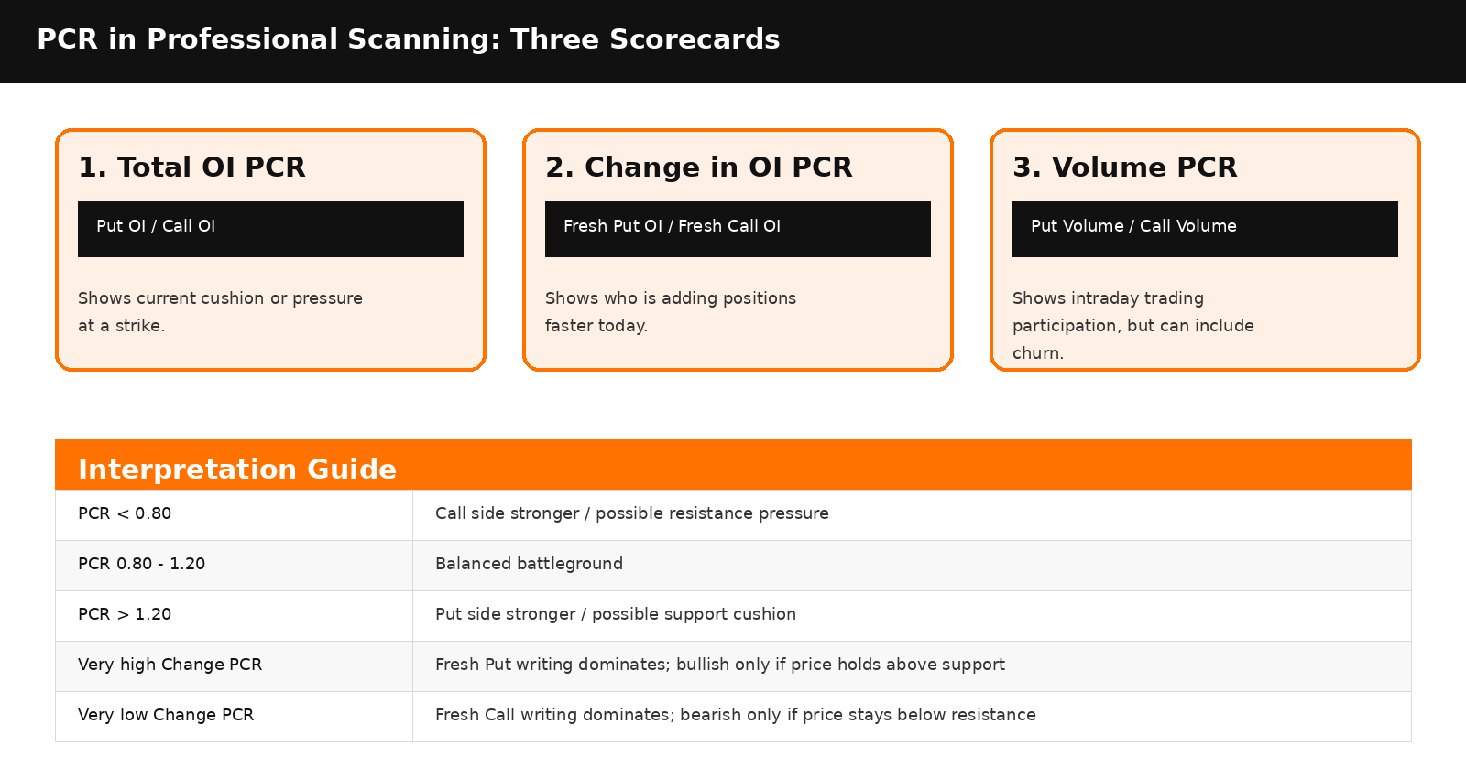
14.1 Formulas Used in This Chapter
Metric | Formula | Professional Question
Total OI PCR | Put OI / Call OI | Who has the larger existing position at a strike?
Change-in-OI PCR | Fresh Put OI Added / Fresh Call OI Added | Who is adding positions faster today?
Volume PCR | Put Volume / Call Volume | Which side has more intraday trading activity?
OI-to-Volume Conversion | Change in OI / Volume | How much traded volume is converting into positions that remain open?
Key Insight
A high Volume number can be noisy. If volume is high but Change in OI is low, activity may be churn. If Change in OI is high relative to volume, positions are sticking and conviction is stronger.

15. Case Study 1: NIFTY Option Chain Analysis
Live example from the screenshot used in the chapter: NIFTY at 24,201.90 around 11:01 AM on Friday. The nearest ATM strike is 24,200.
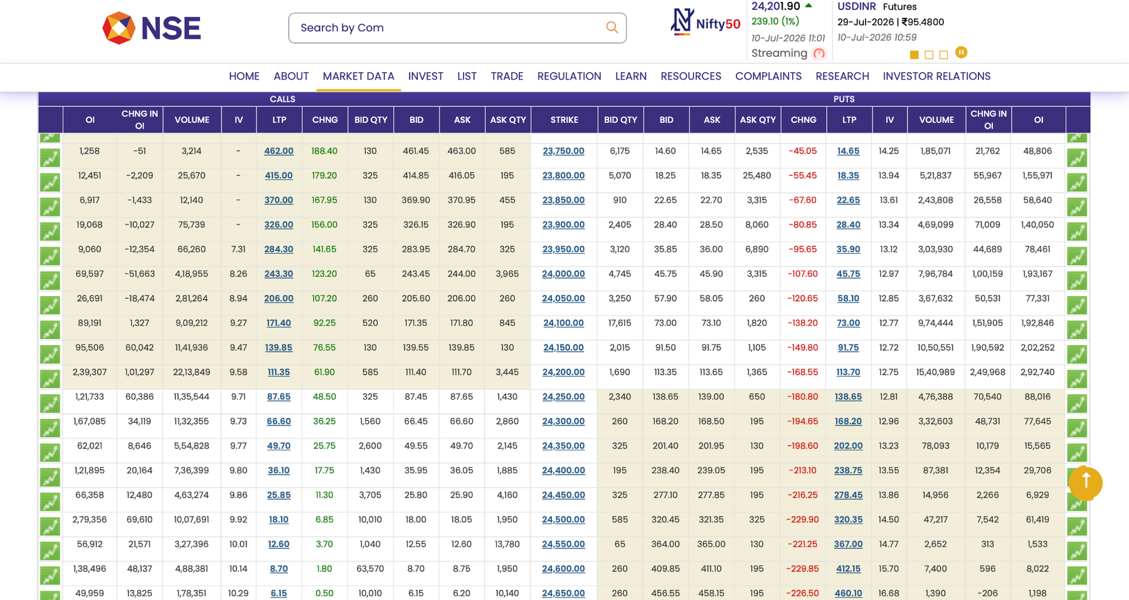
15.1 Current Market Snapshot
Item | Observation
Underlying | NIFTY
Spot | 24,201.90
Market move | +239.10 points / +1%
Time | 11:01 AM
Nearest ATM | 24,200
Initial read | Bullish movement; now verify with OI, PCR and conversion.
15.2 Premium Direction Around ATM
Strike | Premium Change | Interpretation
24,100 CE | +92.25 | Call rising: bullish participation
24,150 CE | +76.55 | Call rising: bullish participation
24,200 CE | +61.90 | ATM Call rising
24,200 PE | -168.55 | ATM Put falling sharply
24,150 PE | -149.80 | Put falling
24,100 PE | -138.20 | Put falling
Calls are rising and Puts are falling. This gives a bullish directional read, but the trade decision still needs OI classification and PCR confirmation.

15.3 Change in OI Classification
Strike | Observed Data | Position Type | Professional Meaning
24,200 CE | CE premium +61.90, CE OI +1,01,297 | Call long build-up / contested call activity | Bullish, but because Call OI is large at ATM, it is also a battleground.
24,250 CE | CE premium +48.50, CE OI +60,386 | Call long build-up above spot | Buyers are active above spot; needs price follow-through.
24,500 CE | CE premium +6.85, CE OI +69,610 | Likely far OTM call writing / resistance zone | Major upper wall; small premium rise warns not to blindly buy far OTM.
24,200 PE | PE premium -168.55, PE OI +2,49,968 | Put writing | Very strong support-building signal.
24,150 PE | PE premium -149.80, PE OI +1,90,592 | Put writing | Fresh support below spot.
24,100 PE | PE premium -138.20, PE OI +1,51,905 | Put writing | Support below ATM.

15.4 PCR and Conviction Tests at 24,200
Metric | Calculation | Result | Inference
Total OI PCR | 2,92,740 / 2,39,307 | 1.22 | Puts have a cushion over Calls at ATM.
Change-in-OI PCR | 2,49,968 / 1,01,297 | 2.47 | Fresh Put writing is almost 2.5 times fresh Call OI addition.
Volume PCR | 15,40,989 / 22,13,849 | 0.70 | Call volume is higher, but volume may be churn.
CE OI-to-Volume | 1,01,297 / 22,13,849 | 4.6% | Call volume converts weakly into lasting OI.
PE OI-to-Volume | 2,49,968 / 15,40,989 | 16.2% | Put volume converts strongly into lasting OI; stronger conviction.
NIFTY Inference
The fresh positioning at 24,200 is bullish because Put writing is much stronger than Call addition. The 24,150-24,200 zone behaves like support, provided price holds above it. If NIFTY sustains above 24,200 and moves above 24,250, call-side short covering or fresh call buying may push the move toward 24,300 and then 24,500.
7.5 Trade-Type Decision Framework
Trader Type | Preferred Action | Risk Note
Directional buyer | Prefer 24,150 CE or 24,200 CE after price sustains above 24,200/24,250 | Avoid buying far OTM 24,500 CE only because it is cheap.
Option seller | Bull Put Spread: sell 24,150 PE or 24,100 PE and buy lower PE hedge | Use defined risk; avoid naked selling without capital and risk controls.
No trade condition | If price stays stuck around 24,200 and both sides add OI | Possible short straddle/range; option buyer may suffer theta.
View invalidation | Break below 24,150 with PE OI unwinding and PE premium rising | Bullish structure weakens; reassess.

16. Case Study 2: BANKNIFTY Option Chain Analysis
Live example from the BANKNIFTY screenshot: underlying at 58,014.20 around 12:47 PM on 10-Jul-2026. The nearest ATM strike is 58,000.
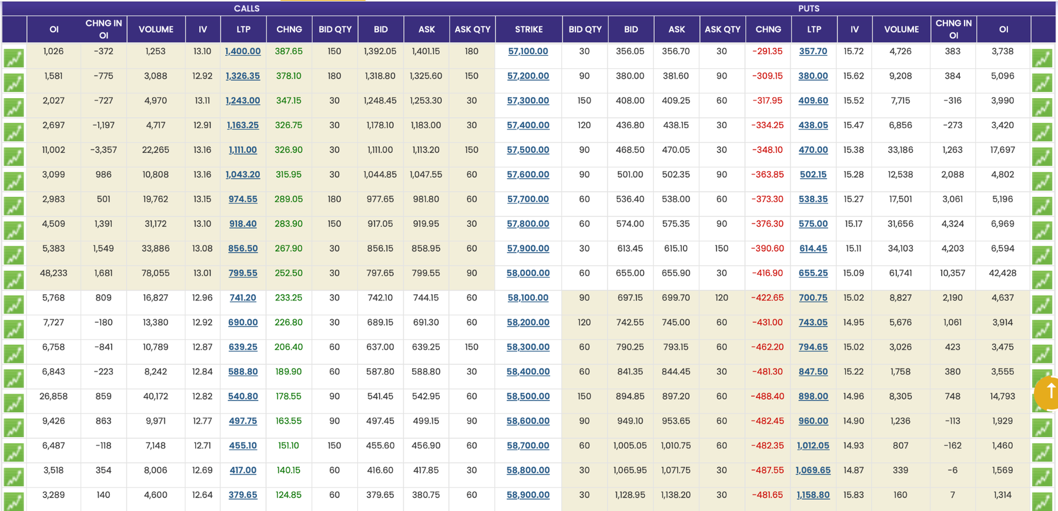
16.1 Current Market Snapshot
Item | Observation
Underlying | BANKNIFTY
Spot | 58,014.20
Time | 12:47 PM
Nearest ATM | 58,000
Initial read | Strong bullish movement; verify with OI, PCR and conversion.
16.2 Premium Direction Around ATM
Strike | Premium Change | Interpretation
57,800 CE | +283.90 | Call rising strongly
57,900 CE | +267.90 | Call rising strongly
58,000 CE | +252.50 | ATM Call rising strongly
58,100 CE | +233.25 | Call rising strongly
58,000 PE | -416.90 | ATM Put collapsing
58,100 PE | -422.65 | Put collapsing
Benchmark Reading
For BANKNIFTY near-ATM options, a +200 to +300 move in Calls together with a -300 to -450 move in Puts usually indicates a very strong intraday bullish phase. But it is still not a blind entry signal; OI and PCR must confirm.

16.3 Change in OI Classification
Strike | Observed Data | Position Type | Professional Meaning
58,000 CE | CE premium +252.50, CE OI +1,681 | Call long build-up, but low conversion | Bullish, but fresh OI is not very strong compared with volume.
58,100 CE | CE premium +233.25, CE OI +809 | Call long build-up | Bullish above ATM if price sustains.
58,200 CE | CE premium +226.80, CE OI -180 | Call short covering | Bullish but may be short-covering, not fresh conviction.
58,500 CE | CE premium +178.55, CE OI +859 | Call long build-up / resistance watch | Upper resistance zone; not the first strike for beginners.
58,000 PE | PE premium -416.90, PE OI +10,357 | Put writing | Strong support-building at 58,000.
57,900 PE | PE premium -390.60, PE OI +4,203 | Put writing | Support below ATM.
57,800 PE | PE premium -376.30, PE OI +4,324 | Put writing | Further support below ATM.

16.4 PCR and Conviction Tests at 58,000
Metric | Calculation | Result | Inference
Total OI PCR | 42,428 / 48,233 | 0.88 | Existing OI is slightly Call-heavy; 58,000 is a battlefield.
Change-in-OI PCR | 10,357 / 1,681 | 6.16 | Fresh Put writing dominates fresh Call OI addition.
Volume PCR | 61,741 / 78,055 | 0.79 | Call volume is higher, but not necessarily conviction.
CE OI-to-Volume | 1,681 / 78,055 | 2.2% | Call-side activity is mostly churn; little converts to OI.
PE OI-to-Volume | 10,357 / 61,741 | 16.8% | Put-side trades are converting into lasting positions.
BANKNIFTY Inference
The market is bullish above 58,000. The strongest fresh conviction is not in Call buying but in Put writing at 58,000. This means 58,000 is a make-or-break support zone. If BANKNIFTY sustains above 58,000 and starts crossing 58,100, ATM Call buying or a defined-risk Bull Put Spread becomes more logical than buying Puts.
16.5 Trade-Type Decision Framework
Trader Type | Preferred Action | Risk Note
Directional buyer | Prefer 58,000 CE or conservative 57,900 CE only after price sustains above 58,000/58,100 | Do not chase after a large move; wait for pullback or breakout confirmation.
Option seller | Bull Put Spread: sell 57,900 PE or 58,000 PE and buy lower PE hedge | Defined risk is essential in BANKNIFTY because reversals are sharp.
No trade condition | If price repeatedly fails above 58,000 and PE writing starts unwinding | The bullish floor is weakening.
View invalidation | Break below 58,000 with PE premium rising and PE OI falling | Avoid bullish Call buying; reassess for bearish setup.

17. Final Professional Decision Template
Step | Checkpoint | Action
1 | Spot and ATM | Write spot price and nearest ATM strike.
2 | Premium direction | Calls up + Puts down = bullish; Puts up + Calls down = bearish.
3 | Top OI zones | Highest Call OI = possible resistance; highest Put OI = possible support.
4 | Change-in-OI classification | Use premium change + OI change matrix to label writing, buying, unwinding, covering.
5 | PCR scorecards | Check total OI PCR, Change-in-OI PCR and Volume PCR at ATM and key strikes.
6 | Volume conversion | Change in OI / Volume tells whether activity is churn or conviction.
7 | Support/resistance | Accept support/resistance only when OI, Change OI, premium behavior and PCR agree.
8 | Strategy selection | Choose Call/Put/Spread/No Trade based on evidence and risk.
9 | Invalidation | Define the level where the view becomes wrong before entering.
18. Common Mistakes After Adding PCR
Mistake | Why It Is Dangerous | Professional Correction
Using only overall PCR | Overall market PCR can hide strike-level battles. | Calculate strike PCR around ATM and high OI zones.
Treating high Call OI as resistance blindly | If CE premium is rising with OI, it may be call long build-up, not simple resistance. | Classify using premium change + OI change.
Ignoring OI-to-volume conversion | High volume can be retail churn. | Check how much volume converts into Change in OI.
Buying far OTM options after strong move | Cheap premium may decay fast or fail to respond. | Prefer ATM or slight ITM for directional buying.
Selling naked options because support looks strong | Support can break suddenly. | Use defined-risk spreads and strict stop-loss.

19. Quiz: Professional Scanning Sequence
1. Which is the correct upgraded sequence after locating ATM?
A. LTP only | B. Premium direction, OI, Change-in-OI classification, PCR, volume conversion | C. Buy cheapest option | D. Ignore OI
2. CE premium rising and CE OI rising usually indicates:
A. Call writing | B. Call long build-up | C. Put writing | D. Put long unwinding
3. PE premium falling and PE OI rising usually indicates:
A. Put writing | B. Put long build-up | C. Call writing | D. Call covering
4. Total OI PCR is calculated as:
A. Call OI / Put OI | B. Put OI / Call OI | C. Volume / OI | D. LTP / IV
5. Change-in-OI PCR tells us:
A. Fresh Put OI compared with fresh Call OI | B. Last traded price | C. Expiry date | D. Bid-ask spread
6. If volume is very high but Change in OI is small, it may indicate:
A. Churn | B. Guaranteed breakout | C. Expiry | D. No trading
7. In the NIFTY example, Change-in-OI PCR at 24,200 was about:
A. 0.47 | B. 1.00 | C. 2.47 | D. 6.16
8. In the BANKNIFTY example, strongest fresh conviction at 58,000 was visible in:
A. Put writing | B. Put buying | C. Call writing only | D. No OI change
9. A bullish view weakens when:
A. Support PE OI unwinds and PE premium rises | B. Calls rise | C. Puts fall | D. Bid-ask spread tightens
10. Why should beginners prefer ATM/slight ITM options for directional buying?
A. Better liquidity and delta response | B. They are always free | C. They never lose | D. OI is irrelevant
20. Answer Key
Q | Answer | Reason
1 | B | Scanning must combine direction, OI behavior, PCR and volume conversion.
2 | B | Fresh Call positions with rising premium imply buyers are aggressive.
3 | A | Puts falling with rising OI indicates Put writers are aggressive.
4 | B | PCR = Put OI divided by Call OI.
5 | A | It compares fresh Put addition to fresh Call addition.
6 | A | High volume with low OI conversion often means intraday churn.
7 | C | 2,49,968 / 1,01,297 ≈ 2.47.
8 | A | PE OI addition was much stronger than CE addition.
9 | A | Support fails when Put writers exit and PE premium rises.
10 | A | ATM/slight ITM usually has better delta, liquidity and lower lottery risk.
21. Practical Assignment Template
For the next live option chain, fill this table for ATM and two strikes on each side. Then classify each row using the Change-in-OI matrix and calculate PCR.
Strike | CE Chg | CE Chg OI | CE Type | PE Chg | PE Chg OI | PE Type | Total PCR | Chg OI PCR | Conversion Note
ATM - 200
ATM - 100
ATM
ATM + 100
ATM + 200
Final Rule
A professional option-chain trade is taken only when premium direction, OI classification, PCR, volume conversion, liquidity and price level all tell the same story. When they disagree, the best trade may be no trade.

22. Practical Assignment
Open a live NIFTY option chain and record the following for five strikes around ATM: LTP, Best Bid, Best Ask, Volume, OI and Change in OI. Then answer: Which strikes are liquid? Where is OI concentrated? Which strikes have fresh Change in OI? Are you looking at activity, commitment, or only last traded price?
Strike | CE LTP | CE Bid | CE Ask | CE Volume | CE OI | PE LTP | PE Bid | PE Ask | PE Volume | PE OI
ATM - 100
ATM - 50
ATM
ATM + 50
ATM + 100

