

Phoneme HR Suite
Module 1 & 2 — Technical Design Document

TECHNICAL DESIGN (HLD/LLD)

PROJECT CODE: PHN-HR-2026-01-TDD-M1M2
September 2026
Submitted by: Phoneme Solutions Pvt. Ltd.
Security Classification: Confidential — Internal

Document Control
Field | Value
Document Description | Technical Design Document (HLD/LLD) — Phoneme HR Suite, Module 1 (JD Intake & Freezing) and Module 2 (Sourcing & Resume Aggregation)
Identification | PHN-HR-2026-01-TDD-M1M2, Version 2.0
Security Classification | Confidential — Internal
Location | HR Management project workspace

Authorization
 | Name of the Person | Date
Prepared by | Anuj (with drafting support) | 10-Sep-2026
Reviewed by | Pending | Pending
Approved by | Pending | Pending

Change Log
Version | Date | Section | A/M/D | Description | Reviewed By
1.0 | 10-Sep-2026 | All | A | Initial Technical Design for Module 1 and Module 2, following requirements lock in the BRD/PRD | Pending
1.1 | 15-Sep-2026 | 3, 4, 6.2, 10, 12 | A | Added AAA/Session Management, Key Management, consolidated Data Schema (ER diagram), Data Flow Diagram, and Object Flow Diagram (JobRequisition state machine) | Pending
2.0 | 15-Sep-2026 | 1, 4.2, 5–16 | A/M | Resolved critical/high review findings: replaced JDVersion.is_frozen with a full status/supersede lifecycle keyed to a new active_version_id pointer; rekeyed ScoringMatrix to jd_version_id and added draft-matrix generate/edit/freeze API sequence (Section 8); removed behavioral_proxy from screening-stage scoring per business decision (soft skills excluded entirely at screening); added Tenant & Organization Model (Section 5) with an explicit isolation enforcement matrix, reflecting the Release 1 in-scope staffing-agency/multi-client model; replaced DuplicateMatch.resolved boolean with a resolution/conflict_flag/reversal model (Section 7.1); separated KMS master-key rotation, DEK rotation, and re-encryption (Section 4.2); corrected resume-format scope to PDF/DOCX only (Section 10.4); labeled Naukri RMS and LinkedIn Talent Solutions integrations as proposed adapter contracts pending vendor confirmation (Section 10, 16); stated the Release 1 module boundary (Section 1.2); renumbered Sections 12–16 to resolve a duplicate section number and added new error-handling and open-decision entries | Pending

Client Sign Off
Stakeholder Name | Role | Sign Off Date | Communication

Confidentiality Agreement
This document is copyrighted, and all rights are reserved. This document may not, in whole or in part, be copied, photocopied, reproduced, translated, or reduced to any electronic medium or machine-readable form without prior consent, in writing. This document is for internal use only and may, in whole or in part, be provided to anyone outside of the Company, including customers, clients, or prospects after taking an approval from an authorized representative.

Table of Contents

1. Introduction
1.1 Purpose
1.2 Scope
1.3 References
1.4 Abbreviations
2. System Context & Architecture Overview
3. AAA — Authentication, Authorization & Session Management
4. Key Management
5. Tenant & Organization Model
6. Data Model — Module 1 (JD Intake & Freezing)
7. Data Model — Module 2 (Sourcing & Resume Aggregation)
8. API Contracts — Module 1
9. API Contracts — Module 2
10. Integration Specifications
11. Data Flow Diagrams
12. Sequence Flows
13. Object Flow Diagram — JobRequisition Lifecycle
14. Non-Functional / Technical Considerations
15. Error Handling & Edge Cases
16. Open Technical Decisions / Dependencies

1. Introduction

1.1 Purpose
This Technical Design Document (TDD) specifies the data model, API contracts, integration mechanics, and sequence flows for the two modules whose requirements are locked in the companion BRD/PRD (PHN-HR-2026-01-BRDPRD): Module 1 — Job Description (JD) Intake & Freezing, and Module 2 — Candidate Sourcing & Resume Aggregation. It is the engineering handoff artifact for these two modules; it does not restate business rationale, which lives in the BRD/PRD.

1.2 Scope
Release 1 boundary: this document covers Module 1 (JD Intake & Freezing) and Module 2 (Sourcing & Resume Aggregation) only — Modules 3–10 are explicitly out of scope for Release 1 and will be issued as their own Technical Design documents once each module's requirements are locked. Release 1 includes, as an in-scope (not deferred) requirement, the staffing-agency / multi-client tenant model described in Section 5: a Tenant may be either a direct employer or a staffing agency acting on behalf of one or more end-client companies, and this hierarchy is reflected throughout the Module 1 and Module 2 data model, APIs, and isolation rules below.
In scope: entity/field-level data model, REST API contracts, third-party integration specifications (Naukri RMS, LinkedIn Talent Solutions, email intake, resume/NLP parsing), sequence flows, and the technical non-functional considerations specific to these two modules. Out of scope: UI/screen design (a separate UX specification), and the data model/APIs for Modules 3–10.

1.3 References
- BRD/PRD — Phoneme HR Suite: Candidate Search to Onboarding Module (PHN-HR-2026-01-BRDPRD), Section 4.1 and 4.2 — the locked feature lists and locked decisions this design implements.
- Naukri RMS (Recruiter Management System) employer API documentation.
- LinkedIn Recruiter / Talent Solutions API documentation (OAuth2 authorization-code flow).

1.4 Abbreviations
Term | Meaning
TDD | Technical Design Document
NLP | Natural Language Processing
RMS | Recruiter Management System
SLA | Service Level Agreement
JD | Job Description
PII | Personally Identifiable Information

2. System Context & Architecture Overview
Both modules sit behind the tenant-aware API layer described in the BRD/PRD's solution overview. Module 1 owns the requisition and JD lifecycle; Module 2 owns candidate intake and dedupe. Module 1's freeze action is the trigger that hands a requisition to Module 2 (publish to sourcing channels); Module 2's unified candidate record is the entry point for Module 3 (Screening & Shortlisting, out of scope here).

Component Overview
Component | Owns | Consumes / Produces
Requisition Service | JobRequisition lifecycle, approval state | Produces requisition.frozen event consumed by Publish Service
JD Generation Service | NLP extraction, multi-variant JD generation | Consumes raw briefs; produces JDVersion records
Scoring Matrix Service | Weighted matrix generation and storage | Triggered by requisition freeze; produces ScoringMatrix + ScoringCriterion records
Publish Service | Fan-out of a frozen requisition to configured sourcing channels | Consumes requisition.frozen; calls channel adapters
Channel Adapters (Naukri RMS, LinkedIn, Email, Manual, Referral) | Per-channel ingestion/posting logic | Produce raw candidate/application payloads
Resume Parsing Service | Structured field extraction from resume files | Consumes raw resume files; produces parsed candidate JSON
Dedupe Service | Duplicate candidate detection | Consumes parsed candidate records; produces DuplicateMatch records
Candidate Store / Unified Inbox Index | Canonical Candidate and Application records | Serves search/filter queries for the unified resume inbox

Architecture Diagram
The diagram below shows the component layout for Module 1 and Module 2 within the wider platform: client layer, API gateway, the two modules' internal services, the cross-cutting platform services (Auth, Key/Secrets Management, Audit, Notification), and the shared per-tenant data layer.
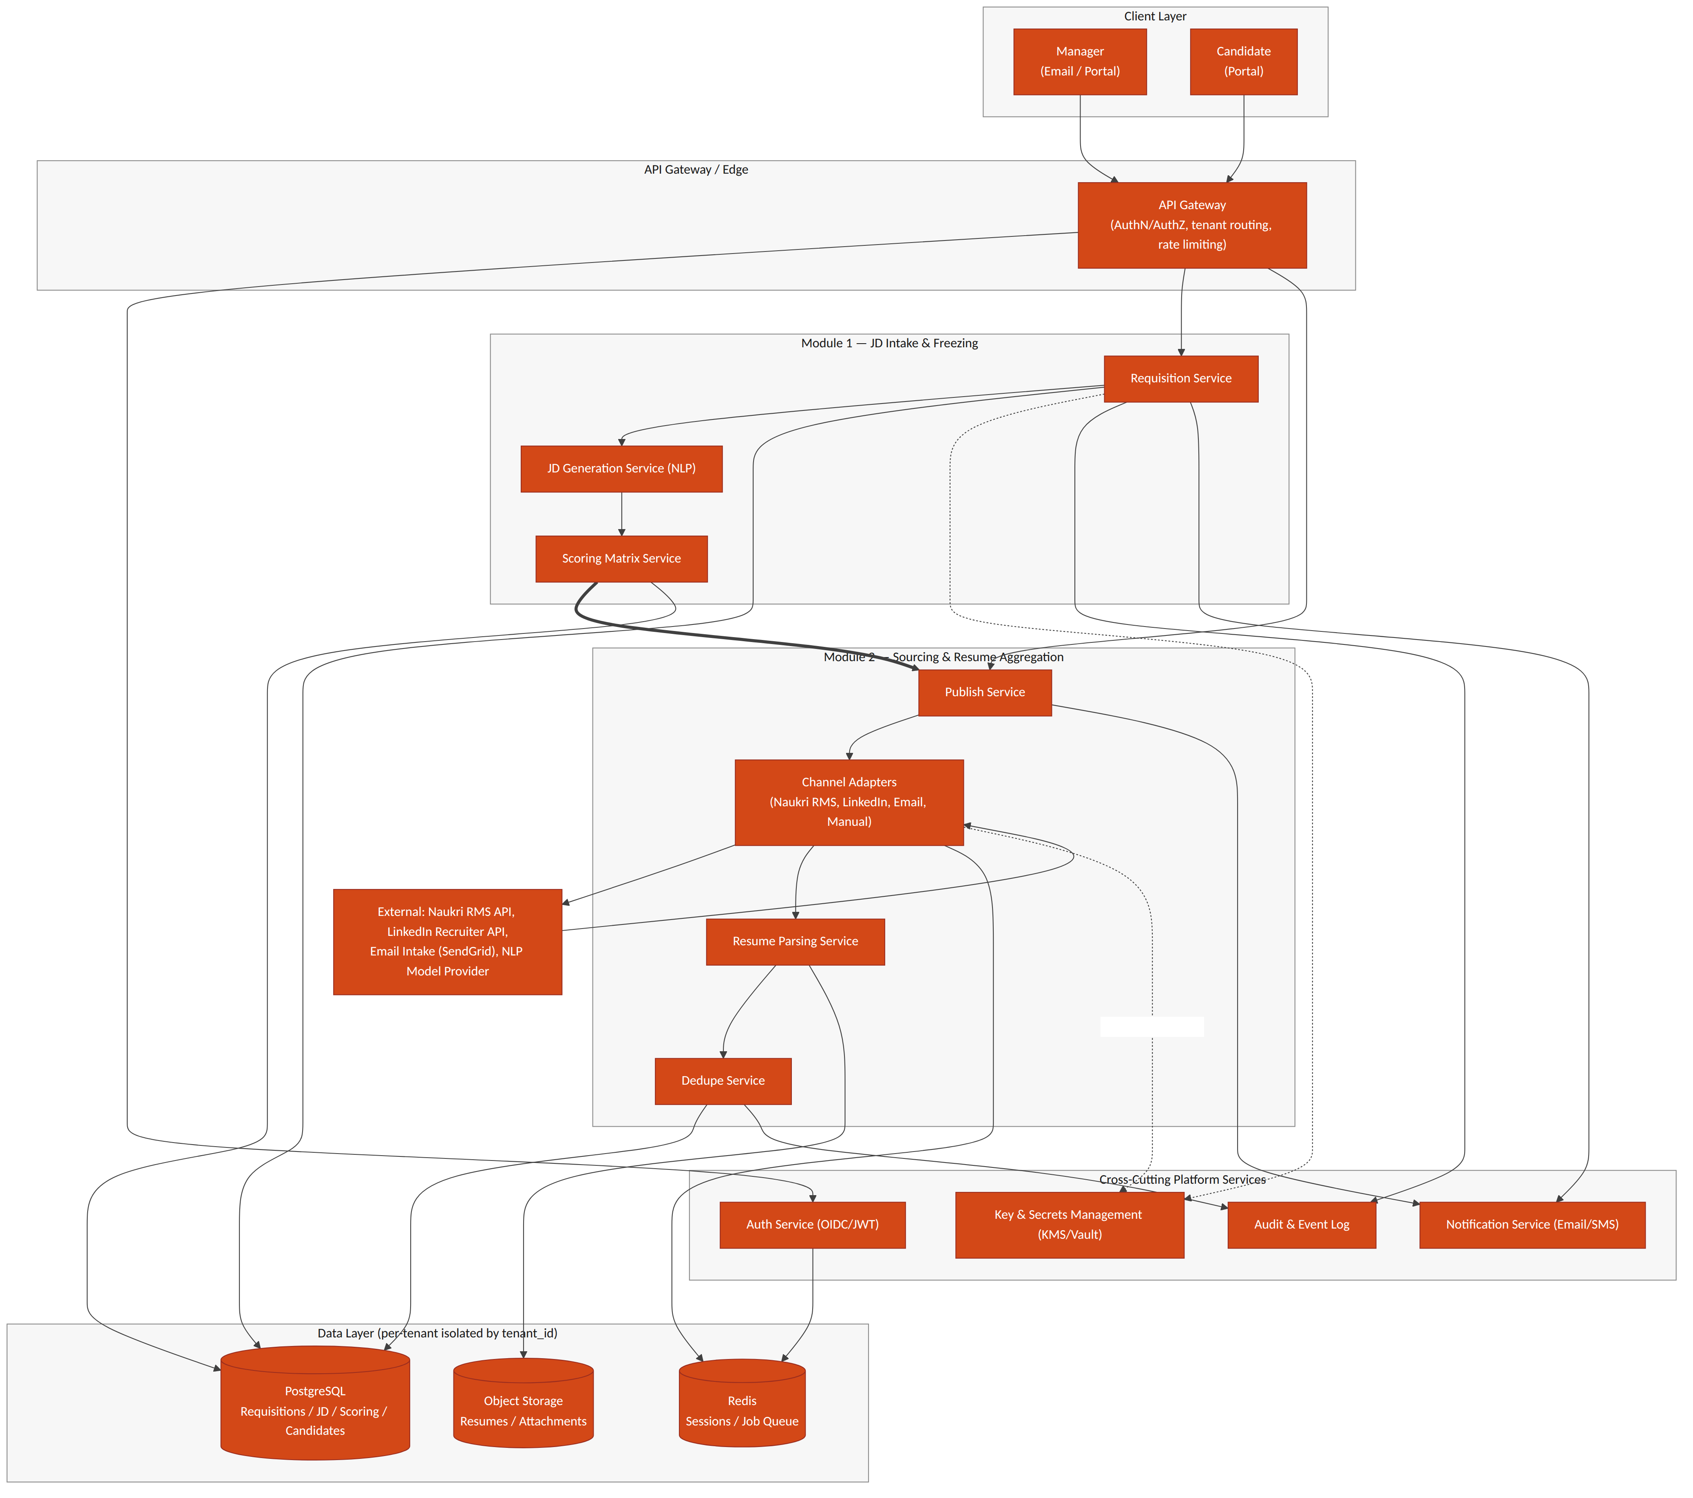
Figure 2.1 — System architecture: Module 1 & 2 components, cross-cutting services, and data layer

3. AAA — Authentication, Authorization & Session Management
Authentication, authorization, and session handling are platform-wide services consumed by every module, not module-specific logic. This section defines the pattern Module 1 and Module 2 build against; it becomes the standard for all subsequent modules.

3.1 Authentication
- OIDC-based login for managers/HR/recruiters via a tenant-scoped identity provider (supports tenant SSO where the customer has one, or a Phoneme-managed identity pool otherwise).
- Candidates authenticate separately via a magic-link / OTP flow tied to their application record — no password, no standing account.
- All tokens carry a tenant_id claim; the API Gateway rejects any request where the token's tenant_id does not match the tenant context of the resource being accessed.

3.2 Authorization
- Role-based access control (RBAC) at the API Gateway and service layer: roles at minimum include Manager, Recruiter/HR, Tenant Admin, Candidate, and Phoneme Platform Admin (break-glass, fully audited).
- Authorization is evaluated per-request against (tenant_id, role, resource) — a Manager can only freeze/edit requisitions in their own department unless granted a broader scope by the Tenant Admin.
- Field-level authorization: PII fields (e.g. candidate salary expectations, BGV data in later modules) are visible only to roles explicitly entitled to them, independent of general resource access.

3.3 Session Management
Session state is server-side (Redis-backed) so that revocation is immediate and centrally enforceable — a design choice over purely stateless JWT validation, which cannot be revoked before expiry.
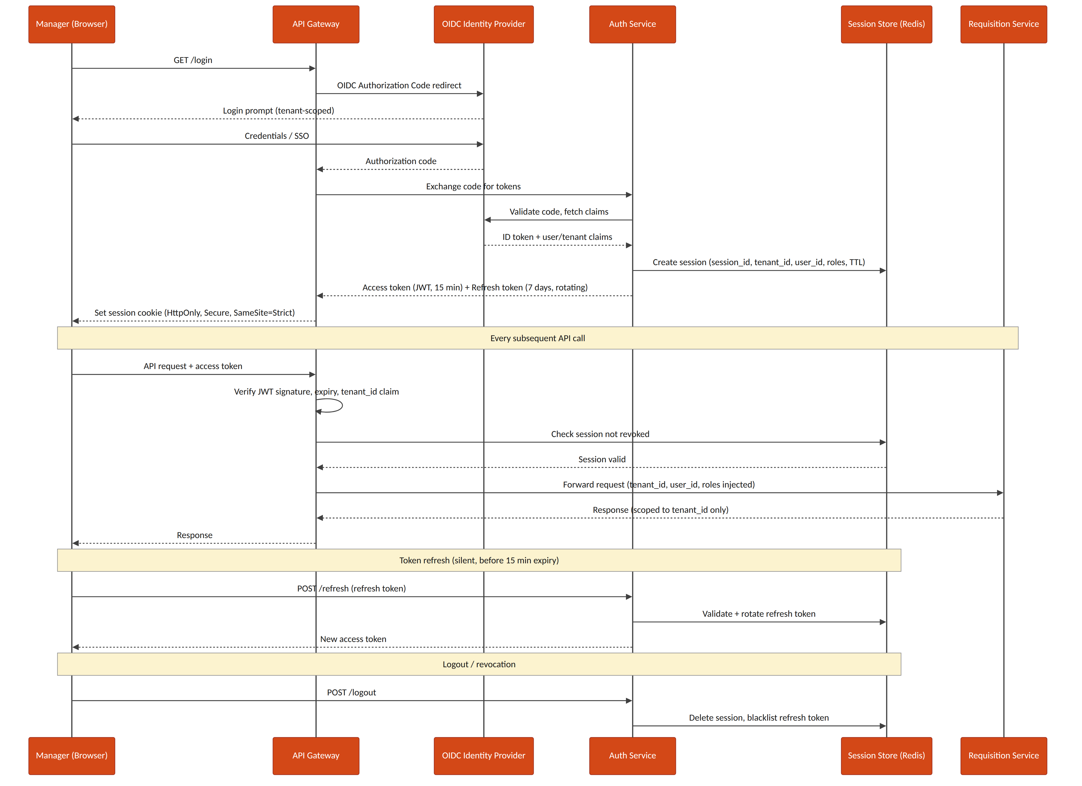
Figure 3.1 — Manager login, per-request AuthN/AuthZ check, token refresh, and logout/revocation sequence
- Access tokens: short-lived JWT (15 minutes), signature-verified at the gateway on every request.
- Refresh tokens: 7-day validity, rotating on each use (old refresh token invalidated the moment a new one is issued) to limit replay risk.
- Session cookie: HttpOnly, Secure, SameSite=Strict — never exposed to page JavaScript.
- Logout and administrative revocation both delete the Redis session record and blacklist the associated refresh token immediately.

4. Key Management
Every channel credential (Naukri RMS, LinkedIn Recruiter API keys), and every PII field stored at rest, is protected through a cloud KMS plus a secrets-manager layer rather than application-level static secrets.
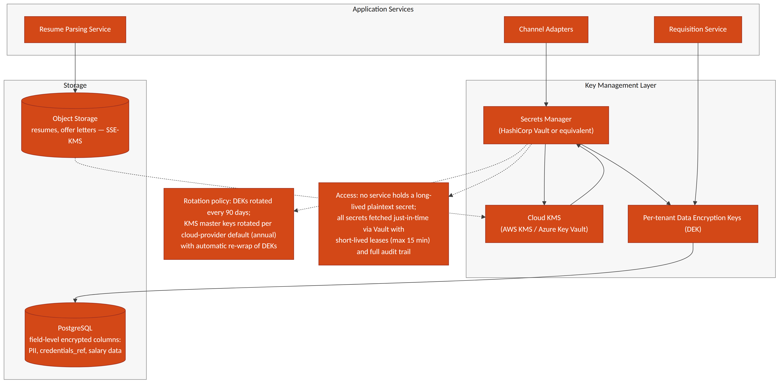
Figure 4.1 — Key management layer: KMS, secrets manager, per-tenant data-encryption keys, and encrypted storage

4.1 Principles
- No service ever holds a long-lived plaintext secret. Channel credentials are fetched just-in-time from the secrets manager (HashiCorp Vault or the cloud-native equivalent) with short-lived leases (max 15 minutes).
- Envelope encryption: a cloud KMS (AWS KMS / Azure Key Vault) holds the master key; per-tenant Data Encryption Keys (DEKs) are generated, wrapped by the master key, and used to encrypt tenant data — the master key itself never leaves the KMS.
- PII and sensitive fields (SourcingChannelConfig.credentials_ref, candidate salary/compensation data introduced in later modules) are encrypted at the column level in PostgreSQL using the tenant's DEK; resumes and offer documents in object storage use server-side encryption (SSE-KMS).

4.2 Rotation & Audit
- Three distinct operations are kept separate, per the cloud KMS provider's own distinction between key rotation and data re-encryption: (1) KMS master-key rotation, (2) per-tenant DEK rotation, and (3) re-encryption of already-stored data. Conflating these was flagged as a design error in the v1.1 draft and is corrected here.
- KMS master-key rotation: the cloud KMS rotates the master key on its default schedule (typically annual) or on-demand; because envelope encryption wraps each DEK rather than data directly, master-key rotation re-wraps DEKs only and requires no re-encryption of tenant data.
- Per-tenant DEK rotation: a new DEK version is generated every 90 days (or on-demand, e.g. after a suspected compromise). Each encrypted record/object stores a key_version reference alongside its ciphertext, so newly written data immediately uses the current DEK version while existing data remains readable under its original version — rotation does not require synchronous re-encryption of the whole tenant's data set.
- Re-encryption of existing data under a new DEK version is a separate, explicitly-scheduled background job (not an implicit side effect of rotation), run tenant-by-tenant with progress tracked per table/object-storage prefix; if a re-encryption job is interrupted, it resumes from the last completed batch using the recorded key_version watermark rather than restarting or leaving mixed-version data unaccounted for.
- Every secret access is logged to the Audit & Event Log with requester identity, tenant_id, and purpose — required both for SOC2-style controls and for DPDP Act accountability obligations.
- Credential rotation for a sourcing channel (e.g. a new Naukri RMS API key) is a Tenant Admin action that writes a new SourcingChannelConfig.credentials_ref without any service restart.

5. Tenant & Organization Model
Release 1 includes the staffing-agency multi-client tenant model as a locked requirement (not deferred): a single agency Tenant manages requisitions and candidates on behalf of multiple end-client companies, alongside the simpler direct-employer case where a Tenant has no clients at all. This section is written as a platform-wide concern — Module 1 and Module 2 both consume it rather than each defining their own isolation rules — and is a first candidate for extraction into a standalone Shared SaaS Platform Specification once that document exists.

5.1 Entities
Field | Type | Notes
Tenant.id | UUID (PK)
Tenant.org_type | enum | direct_employer | staffing_agency
Tenant.name | text
Client.id | UUID (PK) | Exists only for staffing_agency tenants
Client.agency_tenant_id | UUID (FK -> Tenant) | The agency that manages this end-client relationship
Client.name | text
Client.status | enum | active | offboarded

5.2 Scoping Rule
Every record that belongs to a requisition, candidate, or application carries both tenant_id (mandatory, always) and client_id (mandatory for staffing_agency tenants, forbidden/null for direct_employer tenants). A direct-employer tenant is modeled as the degenerate case of an agency with exactly zero clients — this keeps a single code path rather than branching application logic by org_type.

5.3 Isolation Enforcement Matrix
Tenant isolation is stated as a requirement in the BRD/PRD, but stating it is not the same as enforcing it at every layer data passes through. Enforcement is defined per layer, not assumed to follow from the database schema alone:
Layer | Enforcement Mechanism
Database (PostgreSQL) | Row-level filtering on (tenant_id, client_id) is applied by a mandatory query-builder middleware, never by convention in hand-written queries; a query missing both keys fails to compile rather than silently returning cross-tenant rows
Message queue / events | Every event envelope (e.g. requisition.frozen) carries tenant_id and client_id; consumers reject and dead-letter any message missing either
Search / candidate index | tenant_id + client_id are mandatory partition/filter keys set server-side from the authenticated session — never accepted as client-supplied query parameters
Object storage (resumes, offer documents) | Storage key is prefixed by tenant_id/client_id; bucket/IAM policy denies cross-prefix reads even if an application-layer bug leaked another tenant's file reference
Webhooks / external identity | Idempotency and identity matching are scoped to (tenant_id, integration_account_id, channel_type, external_id) — not channel_type + external_id alone, since two tenants (or two clients under one agency) may run independent integration accounts on the same channel with overlapping vendor-side IDs

6. Data Model — Module 1 (JD Intake & Freezing)

JobRequisition
Field | Type | Notes
id | UUID (PK)
tenant_id | UUID (FK) | Every query scoped by this field — see Section 5.3
client_id | UUID (FK -> Client, nullable) | Set for staffing_agency tenants; null and disallowed for direct_employer tenants
department_id | UUID (FK) | Nullable if not supplied in the brief; flagged for manager confirmation
status | enum | Draft | PendingApproval | Revising | Frozen_Open | OnHold | Closed
active_version_id | UUID (FK -> JDVersion, nullable) | The single currently-approved JD version; see Section 6's JDVersion notes for the immutable-history model this pointer enables
created_by | UUID (FK -> User) | The manager who submitted the brief
created_at / updated_at | timestamp

JDBrief (raw intake)
Field | Type | Notes
id | UUID (PK)
requisition_id | UUID (FK)
raw_text | text | Verbatim manager brief
source | enum | email | portal
received_at | timestamp

JDField (NLP-extracted structured fields)
Field | Type | Notes
id | UUID (PK)
requisition_id | UUID (FK)
field_name | enum | role_title | experience_range | education_pref | comp_band | job_role_tag | must_have_skills | domain_competencies | soft_skills | department | target_start_date
field_value | text / JSON
confidence_score | decimal (0–1) | Below tenant-configured threshold (default 0.75) → manager_confirmed forced false
manager_confirmed | boolean | Gate before this field can feed a frozen JD

JDVersion — immutable-history model
A JD revised after its initial approval must not overwrite history: any assessment, matrix, or downstream record that referenced an approved version has to keep resolving to the exact content that was approved at the time, even after a later revision supersedes it. JDVersion.status therefore replaces the earlier is_frozen boolean with a full lifecycle, and JobRequisition.active_version_id (Section 6) is the single pointer to "the current one" — approved versions themselves are never deleted or edited, only superseded.
Field | Type | Notes
id | UUID (PK)
requisition_id | UUID (FK)
version_no | integer | Monotonically increasing per requisition
variant_type | enum | formal | candidate_friendly | condensed | manager_edited
content | text
generated_by | enum | system | manager
status | enum | Draft | PendingApproval | Approved | Superseded | Rejected. Approved and Superseded rows are immutable — enforced by a DB-level trigger, not just application logic
superseded_by | UUID (FK -> JDVersion, nullable) | Set only when status transitions Approved → Superseded, pointing at the version that replaced it
created_at | timestamp
- A requisition can have at most one version with status = Approved at any moment, matching JobRequisition.active_version_id.
- Revising an already-approved JD does not touch that row: it creates a new Draft version that goes through the normal review loop; only when the new version is approved does the transaction (a) set the new version's status to Approved, (b) set the previous Approved version's status to Superseded and its superseded_by, and (c) repoint JobRequisition.active_version_id — all three in one atomic write.
- Any record that must remain accurate to "the JD as it was when X happened" (a ScoringMatrix, a candidate assessment, an audit log entry) stores a direct jd_version_id foreign key, never a lookup through the requisition — so it keeps resolving correctly regardless of later supersession.

ScoringMatrix / ScoringCriterion — versioned with the JD, not the requisition
A scoring matrix belongs to the JD version it was approved alongside, not to the requisition as a whole — otherwise revising a JD after freeze would silently rewrite the matrix that earlier assessments were scored against. Draft criteria are generated, retrieved, and edited before approval; see Section 8's draft-matrix endpoints for the API sequence this table supports.
Field | Type | Notes
ScoringMatrix.id | UUID (PK)
ScoringMatrix.jd_version_id | UUID (FK -> JDVersion) | One matrix per JD version, not per requisition — preserves a distinct matrix for every approved version in the requisition's history
ScoringMatrix.status | enum | Draft | Approved. Approved is immutable, set atomically with the JD version's Draft → Approved transition
ScoringMatrix.approved_at | timestamp | Set only when status becomes Approved
ScoringCriterion.id | UUID (PK)
ScoringCriterion.matrix_id | UUID (FK)
ScoringCriterion.category | enum | core_skills | experience_seniority | domain_competency | education_fit — screening-stage only, sums to 100. behavioral_proxy is deliberately excluded: soft-skill and behavioral evidence is never expressed as a numeric screening criterion (locked decision) and is assessed only at interview, out of scope of this document
ScoringCriterion.criterion_name | text | e.g. "Power BI proficiency"
ScoringCriterion.weight_percent | decimal | All Approved criteria for a matrix sum to exactly 100; a Draft matrix may be temporarily incomplete while a manager is still editing it
ScoringCriterion.source_field_ref | UUID (FK -> JDField) | Traceability back to the JD field that generated this criterion

7. Data Model — Module 2 (Sourcing & Resume Aggregation)

7.1 Entities

SourcingChannelConfig — now scoped as an integration account
A channel configuration is scoped to (tenant_id, client_id) rather than tenant_id alone, since an agency tenant commonly needs independent vendor credentials per client (each end-client has its own Naukri RMS employer account, for example). This is what Section 5.3's webhook idempotency rule scopes against.
Field | Type | Notes
id | UUID (PK) | Functions as the integration_account_id referenced throughout this document
tenant_id | UUID (FK)
client_id | UUID (FK -> Client, nullable) | Set for staffing_agency tenants; identifies which client this integration account posts/sources on behalf of
channel_type | enum | naukri_rms | linkedin_recruiter | niche_board | email_intake | manual_upload | referral
credentials_ref | UUID (FK -> Secret store) | Never stored in plaintext in this table
is_active | boolean

Candidate
Field | Type | Notes
id | UUID (PK)
tenant_id | UUID (FK) | Reusable across requisitions within a tenant
client_id | UUID (FK -> Client, nullable) | Agency tenants: the client this candidate was sourced for. A candidate applying to two different clients under the same agency gets two Candidate rows — deliberately not shared, so one client's view of a candidate never leaks to another
name / email / phone | text | Primary dedupe keys, scoped within (tenant_id, client_id) — see DuplicateMatch below
resume_file_ref | UUID (FK -> object storage)
parsed_json | JSONB | Structured output of the Resume Parsing Service
source_channel | enum | Matches SourcingChannelConfig.channel_type at first intake
created_at | timestamp

Application
Field | Type | Notes
id | UUID (PK)
candidate_id | UUID (FK)
requisition_id | UUID (FK)
client_id | UUID (FK -> Client, nullable) | Denormalized from the requisition for isolation-filter simplicity — see Section 5.3
status | enum | Feeds Module 3 pipeline stage — out of scope of this TDD beyond intake
applied_at | timestamp

DuplicateMatch — conflict, reversal, and audit
Matching is scoped within (tenant_id, client_id) — the same person applying through two different agency clients is not treated as a duplicate, by design (Candidate note above). Within that scope, an exact-key match (email or phone) is not always safe to auto-link: the same phone number can be reused by a different person, or two sources can disagree on the name attached to one email. Conflicting evidence is routed to a recruiter rather than silently auto-linked, and every resolution — link or reject — is recorded rather than only the current state.
Field | Type | Notes
id | UUID (PK)
candidate_id_primary / candidate_id_duplicate | UUID (FK)
match_type | enum | exact_email | exact_phone | content_similarity
confidence_score | decimal (0–1) | See Section 14 for thresholds
conflict_flag | boolean | True when exact-key evidence is accompanied by materially conflicting attributes (different name, different declared employer) — forces manual review even for an exact_email/exact_phone match_type
resolution | enum | pending | linked | rejected_not_duplicate | reversed. Replaces the earlier plain resolved boolean, which could not distinguish "confirmed duplicate" from "confirmed not a duplicate"
resolved_by / resolved_at | UUID (FK -> User) / timestamp
resolution_notes | text | Free-text rationale captured from the recruiter — required when resolution is rejected_not_duplicate or reversed
- Reversal: unlinking an earlier incorrect match never deletes or edits the original DuplicateMatch row — it writes a new row with resolution = reversed, referencing the same candidate pair, so the audit trail shows both the original decision and its correction.
- Application/source history is never destructively merged: when two Candidate rows are linked as duplicates, each retains its own Application and source_channel history; linking establishes a relationship between them, it does not collapse one record into the other.

7.2 Consolidated Data Schema (Module 1 & 2)
The entity-relationship diagram below consolidates every table introduced in Sections 5 and 6 into a single schema view, showing primary/foreign-key relationships across the two modules — including how a frozen ScoringMatrix traces back to the JDField it was derived from, and how Candidate/Application/DuplicateMatch tie together for the unified inbox.
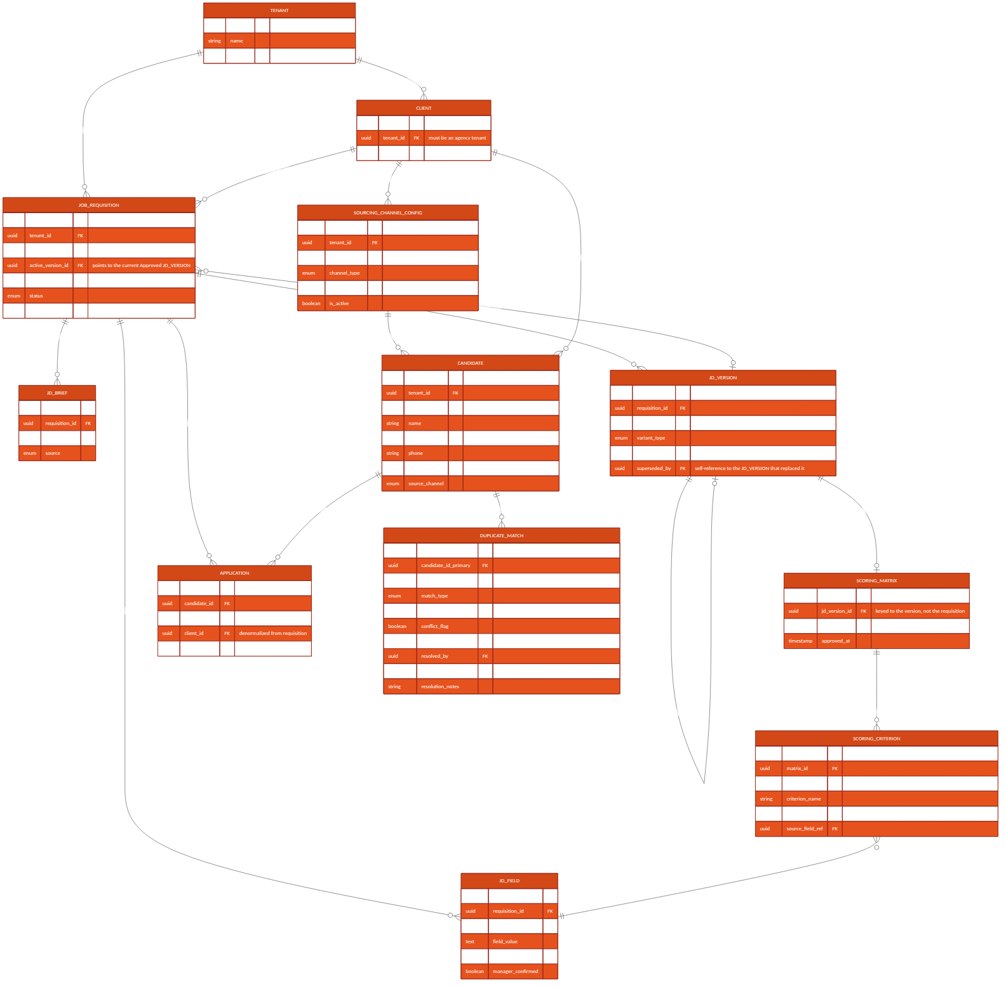
Figure 6.1 — Consolidated entity-relationship diagram, Module 1 & 2

8. API Contracts — Module 1

POST /api/v1/requisitions/intake
Creates a requisition from a manager's raw brief and kicks off NLP extraction.
Request: { "tenant_id": "uuid", "client_id": "uuid|null", "department_id": "uuid|null", "raw_brief_text": "string", "source": "email|portal" }
Response: 201 { "requisition_id": "uuid", "status": "Draft" }
Errors: 422 if client_id is missing for a staffing_agency tenant, or supplied for a direct_employer tenant

GET /api/v1/requisitions/{id}/jd-versions
Lists all JD versions for a requisition, in version order, including their status (Draft / PendingApproval / Approved / Superseded / Rejected) — the full immutable history, not only the current one.

POST /api/v1/requisitions/{id}/jd-versions/{versionId}/feedback
Submits manager feedback (email reply or portal form) for NLP parsing into a structured diff and a new draft version.
Request: { "feedback_text": "string", "source": "email|portal" }
Response: 202 { "new_version_id": "uuid", "status": "Revising", "low_confidence_fields": ["string", ...] }

GET /api/v1/requisitions/{id}/scoring-matrix/draft
Returns the in-progress draft ScoringCriterion set generated alongside the current PendingApproval JD version, for the manager to review before freezing. A draft matrix need not sum to 100 percent — it can be incomplete while under active editing.

PATCH /api/v1/requisitions/{id}/scoring-matrix/draft
Manager edits draft criterion weights (via the scoring-matrix slider UI) before freeze. Validated only against per-criterion bounds at this stage — the sum-to-100 rule is enforced at freeze, not on every intermediate edit, so a manager can save a partial adjustment mid-session.
Request: { "criteria": [ { "criterion_id": "uuid", "weight_percent": number }, ... ] }
Response: 200 { "status": "Draft", "current_total_percent": number }

POST /api/v1/requisitions/{id}/freeze
Approves a JD version and its draft scoring matrix in a single atomic transaction — the locked decision that freezing is a hard, immutable state change. If the requisition already has an Approved version, that version is superseded (not overwritten) and JobRequisition.active_version_id repoints to the newly approved one; the superseded version and its matrix remain queryable by their own ID for any assessment that already referenced them.
Request: { "approved_version_id": "uuid" }
Response: 200 { "status": "Frozen_Open", "active_version_id": "uuid", "scoring_matrix_id": "uuid", "superseded_version_id": "uuid|null" }
Errors: 409 if the draft matrix's criteria do not sum to exactly 100; 409 if approved_version_id is not in PendingApproval status

GET /api/v1/requisitions/{id}/scoring-matrix
Returns the Approved scoring matrix bound to the requisition's current active_version_id, for consumption by the Module 3 scoring engine. Callers needing the matrix behind a specific historical (superseded) JD version query it directly by jd_version_id instead.

9. API Contracts — Module 2

POST /api/v1/requisitions/{id}/publish
Triggered automatically on requisition freeze (or manually re-triggered by a recruiter); fans out to every active SourcingChannelConfig (integration account) scoped to the requisition's (tenant_id, client_id).

POST /webhooks/naukri-rms/applications
Inbound webhook (or polling result) from Naukri RMS carrying a new application/resume. Idempotency and identity resolution are keyed on (integration_account_id, external_application_id) — integration_account_id is the SourcingChannelConfig.id resolved from the webhook's registered endpoint, which already encodes tenant_id and client_id (Section 5.3).
Request (from Naukri RMS): { "external_application_id": "string", "requisition_external_ref": "string", "resume_url": "string", "applicant": { "name", "email", "phone" } }
Response: 202 { "candidate_id": "uuid", "application_id": "uuid", "duplicate_check": "queued" }

POST /webhooks/linkedin-recruiter/applications
Equivalent inbound contract for LinkedIn Talent Solutions, same idempotency scoping as above. Which specific LinkedIn Talent Solutions product (Recruiter System Connect, Apply Connect, or another) this integrates with is not yet confirmed — see Section 16.

POST /webhooks/email-intake/resume
Inbound-email-parse webhook: dedicated per-(tenant, client) intake address receives an email with a resume attachment; the email provider's inbound-parse service posts the parsed MIME payload here.

POST /api/v1/candidates/upload
Manual single/bulk upload path used by recruiters as the universal fallback for channels without an API.

GET /api/v1/candidates/search
Full-text and filtered search across the caller's (tenant_id, client_id)-scoped candidate pool — backs the unified resume inbox and Module 2's candidate database search feature. client_id is resolved server-side from the authenticated session, never accepted as a caller-supplied filter (Section 5.3).
Query params: q, skills[], experience_min, experience_max, source_channel[], requisition_id, page, page_size

10. Integration Specifications

10.1 Naukri RMS
- Status: proposed internal adapter contract — Naukri RMS partner-agreement terms and exact API capabilities are not yet confirmed; treat this section as the integration Phoneme intends to build against, pending vendor confirmation (Section 16).
- Auth: OAuth2 client-credentials, per-integration-account contracted employer account.
- Direction: confirm at vendor onboarding whether push (webhook) or poll is available under the contracted plan — Section 16 lists this as an open technical decision.
- Rate limits: respect vendor-published limits; Publish Service applies exponential backoff on 429 responses.

10.2 LinkedIn Talent Solutions
- Status: proposed internal adapter contract. LinkedIn documents multiple distinct Talent Solutions integration products (e.g. Recruiter System Connect, Apply Connect) with different capabilities; "LinkedIn Recruiter API" as used elsewhere in this document is a placeholder pending confirmation of which specific product Phoneme contracts for — this is a vendor-feasibility gate, not a detail to resolve during implementation (Section 16).
- Auth: OAuth2 authorization-code flow, requiring a per-integration-account recruiter to grant consent once during channel setup.
- Token refresh handled by the channel adapter; a failed refresh marks the channel Integration Error and alerts the tenant admin without blocking other channels.

10.3 Email Intake
- A dedicated per-(tenant, client) intake address, provisioned at integration-account setup, routed through a transactional-email provider's inbound-parse webhook (e.g. SendGrid Inbound Parse or equivalent).
- Attachment extraction feeds the Resume Parsing Service; the email body itself is retained for audit but is not parsed for structured fields.

10.4 Resume Parsing Service
- Release 1 supported formats: PDF and DOCX only, matching the BRD/PRD's scope statement (a broader "any resume format" claim in earlier drafts has been corrected — see BRD/PRD Change Log). Other formats (.doc, .rtf, .pages, images) are rejected at upload/intake with an explicit unsupported-format error, not silently dropped.
- Scanned/image-only PDFs (no extractable text layer) and password-protected files are detected and routed to the same manual structured-entry fallback used for NLP extraction failure (Section 15), rather than failing silently or producing an empty parse.
- Returns structured JSON (contact, work history, skills, education) with a per-field confidence score, consistent with the JDField confidence model in Module 1.
- Build-vs-buy is an open decision — see Section 16.

11. Data Flow Diagrams
The Level-1 data flow diagram below traces information from the manager's raw brief through JD generation, freezing, and scoring-matrix creation (Module 1), and from a published requisition through candidate sourcing, parsing and dedupe to the unified candidate store (Module 2) — ending at the handoff into Module 3 (Screening & Shortlisting).
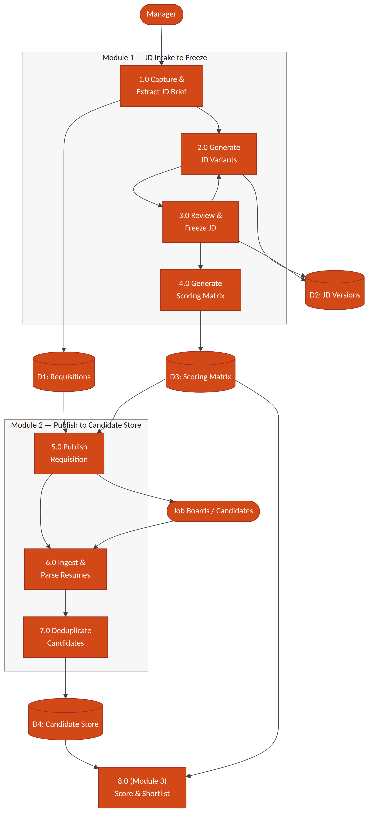
Figure 11.1 — Level-1 data flow diagram, JD Intake → Freeze → Publish → Sourcing → Candidate Store

12. Sequence Flows

12.1 Module 1 — JD Intake to Freeze
- Manager → Email/Portal: submits raw brief.
- Requisition Service: creates JobRequisition (status Draft) and JDBrief record.
- JD Generation Service: runs NLP extraction → JDField records; generates 2–3 JDVersion drafts plus a draft ScoringMatrix/ScoringCriterion set.
- Notification Service: emails manager, updates portal Pending JD Approval queue.
- Manager → Email reply or Portal edit: feedback submitted via POST .../feedback, and/or draft matrix weights adjusted via PATCH .../scoring-matrix/draft.
- JD Generation Service: parses feedback into a structured diff → new JDVersion (status Revising). Loop to step 4 until manager freezes.
- SLA Scheduler: if no manager response within the configured window, triggers a reminder, then an HR escalation notification.
- Manager → POST .../freeze: approves the PendingApproval version and its draft matrix in one atomic transaction.
- Scoring Matrix Service: sets the new JDVersion.status = Approved and its ScoringMatrix.status = Approved; if a previously Approved version existed, sets it to Superseded; repoints JobRequisition.active_version_id and sets status = Frozen_Open.
- Requisition Service: emits requisition.frozen event (carrying tenant_id, client_id, active_version_id), consumed by the Module 2 Publish Service.

12.2 Module 2 — Publish to Unified Candidate Record
- Publish Service: consumes requisition.frozen; calls each active channel adapter (integration account) scoped to the requisition's (tenant_id, client_id).
- Channel Adapter (Naukri RMS / LinkedIn / email / manual / referral): posts the requisition or begins listening/polling for applications.
- Inbound application/resume arrives via webhook, poll result, or manual upload, identified by (integration_account_id, external_application_id).
- Resume Parsing Service: extracts structured candidate fields; tags source_channel; routes unsupported/unparseable files to manual fallback (Section 15).
- Dedupe Service: checks against existing Candidate records scoped to (tenant_id, client_id) (see Section 14 for match logic and Section 7.1's DuplicateMatch conflict handling); links to an existing record, creates a new one, or routes to manual review on conflicting evidence.
- Candidate Store: persists/updates Candidate and Application; Unified Inbox Index makes the record searchable.

13. Object Flow Diagram — JobRequisition Lifecycle
The JobRequisition entity is the central object driving Module 1; its state machine gates every other action (JD editing, freeze, scoring-matrix generation, publish). The diagram below is the authoritative object-flow reference for implementation — every state transition must go through the guarded transitions shown, never a direct field update.
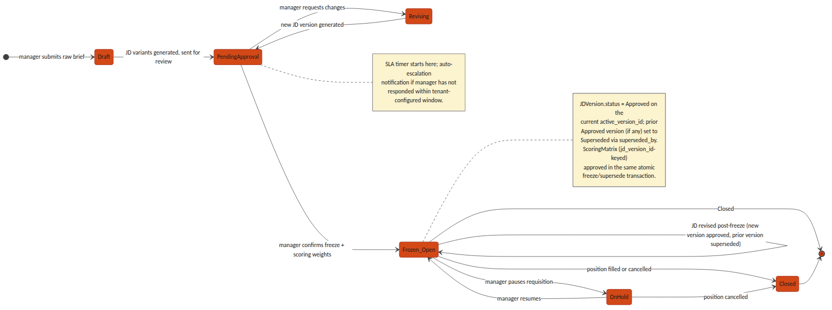
Figure 13.1 — JobRequisition object/state flow, Draft through Closed

14. Non-Functional / Technical Considerations
- Idempotency: every inbound webhook endpoint (Naukri RMS, LinkedIn, email intake) is keyed on (integration_account_id, external_application_id), which is itself scoped to a (tenant_id, client_id) integration account — so a vendor retry cannot create a duplicate Candidate/Application, and two different tenants' or clients' external IDs can never collide.
- JD immutability: an Approved or Superseded JDVersion is enforced read-only at both the application layer and a database-level constraint — not application-logic discipline alone; only a Draft/PendingApproval/Revising version may be mutated.
- NLP confidence threshold: tenant-configurable, default 0.75; any JDField below threshold forces manager_confirmed = false and blocks freeze until resolved.
- SLA escalation: implemented as a scheduled job (not a request-time check) polling PendingApproval requisitions against their configured SLA window.
- Dedupe matching order: exact match on email, then exact match on phone (both high-confidence, auto-link), then content-similarity scoring on parsed resume text (e.g. embedding cosine similarity) for a manual-review confidence band rather than an auto-link — routed to DuplicateMatch.resolution = pending with conflict_flag set on conflicting evidence, per the conflict-handling and reversal model in Section 7.1, rather than a silent auto-merge.
- Vendor rate limits: all channel adapters implement exponential backoff and surface a distinct Integration Error channel status so one vendor outage never blocks other channels or the unified inbox.

15. Error Handling & Edge Cases
Scenario | Handling
NLP extraction fails entirely on a brief | Requisition remains in Draft; manager is offered a manual structured-entry form as a fallback rather than a blocked pipeline
Job-board API authentication failure | Channel marked Integration Error; other channels continue publishing; tenant admin is alerted
Manager attempts to edit a frozen (Approved) JD | Rejected at the API layer (409); the correct path is a new version via the standard feedback/edit flow, which produces a new Draft/Revising version and reopens approval rather than mutating the Approved record
JD revised after initial freeze | A new JDVersion (status Draft → Revising → PendingApproval) is created against the same JobRequisition; on its own freeze, the previously Approved version is set Superseded (superseded_by = new version) and JobRequisition.active_version_id is repointed — history is retained, never overwritten
Conflicting identity evidence in dedupe | e.g. matching email but differing name/phone in a way that fails the similarity threshold — DuplicateMatch is created with resolution = pending and conflict_flag = true, routed to a recruiter queue rather than auto-linked or auto-rejected
Recruiter needs to reverse an incorrect auto-link | Recruiter sets DuplicateMatch.resolution = reversed with resolution_notes; the reversal is non-destructive (original link record retained for audit) and the two Candidate records are split back apart per the model in Section 7.1
Agency requisition raised without a client_id | Rejected at intake (422) for any Tenant with org_type = staffing_agency; client_id is mandatory whenever the owning tenant is an agency, per Section 5.2
Duplicate-detection false positive | Recruiter sets DuplicateMatch.resolution = rejected_not_duplicate with resolution_notes, which is retained for audit rather than deleting the match record
Matrix weights submitted not summing to 100 | Freeze request rejected (409) with the offending total returned, rather than silently normalizing

16. Open Technical Decisions / Dependencies
- Naukri RMS integration direction — confirm push (webhook) vs. poll availability under the contracted plan.
- Resume-parsing provider — build an in-house parser vs. license a third-party resume-parsing API.
- NLP model for brief-to-schema extraction — an in-house fine-tuned model vs. a third-party LLM API, and the associated per-tenant data-residency implications under the DPDP Act.
- Similarity-search infrastructure for duplicate detection — pgvector on the existing PostgreSQL instance vs. a dedicated vector-search service, driven by expected candidate-pool scale per tenant.
- Default and tenant-configurable bounds for the NLP confidence threshold and the SLA escalation window.
- Client Stakeholder read-only portal role — scope of what an agency's end-client contact may view (requisition status, candidate pipeline) is undefined; needs a decision before the agency model reaches implementation.
- Vendor/product-tier confirmation pending for both Naukri RMS (contracted plan capabilities, push vs. poll) and LinkedIn Talent Solutions (exact product — Recruiter System Connect vs. Apply Connect vs. other) — both integrations in Section 10 are proposed adapter contracts, not confirmed vendor capabilities, until this gate clears.

