HR MANAGEMENT MODULE

Table of Contents
1. Introduction
2. User Roles and Responsibilities
3. Access and Authentication
4. Vacancy & AI-Assisted JD Creation
5. JD Approval Workflow
6. Approved Vacancy Activation & Publishing
7. AI Resume Sourcing and Screening
8. Screening Results & Candidate Classification
9. Shortlisted Candidate Invitation & Portal Registration
10. Candidate Information Submission
11. Email and Notification Workflow
12. Status Lifecycle
13. End-to-End Recruitment Workflow
14. Role-Based Workflow Summary
16. Audit and Traceability
17. Current Process Completion Criteria
18. Quick Reference

1. Introduction

1.1 Purpose
This SOP defines the current operating workflow for the AI-enabled HR Recruitment Module. The process begins when HR creates a vacancy using natural-language input in an AI chatbox and continues through Manager approval, vacancy activation and publishing, AI-based candidate sourcing and resume screening, shortlisted-candidate onboarding into the portal, and interview scheduling.

1.2 Scope
The current scope covers the following stages:
- AI-assisted vacancy/JD creation
- Manager review and approval through email and portal
- Activation and publishing of approved vacancies to external recruitment platforms
- AI sourcing/fetching of resumes from configured recruitment sources
- AI skill-based screening against the approved JD
- Selected/shortlisted and rejected candidate classification by vacancy
- Candidate invitation, portal login and profile-data collection
- Candidate password setup/reset
- HR review of submitted candidate information
- Face-to-face or online interview scheduling and candidate notification

1.3 Core Principle
The approved Job Description is the controlling reference for candidate screening. AI assists in JD professionalization and resume matching; HR and the approving Manager remain responsible for recruitment decisions and process actions.

2. User Roles and Responsibilities
Role | Primary Responsibilities
HR | Create vacancies; use AI chatbox to generate professional JD; send JD for Manager approval; review highlighted Manager changes; activate/open approved vacancies; publish vacancies; run/review AI screening; manage shortlisted/rejected candidates; invite shortlisted candidates; review candidate details; schedule interviews.
Manager | Review JD approval email; approve directly or choose Review JD; authenticate using authorized Google account; edit JD where required; approve the revised JD.
Candidate | Access invitation email; log in using invited email identity; complete candidate profile details; submit information; set/reset portal password; receive recruitment and interview notifications.

3. Access and Authentication

3.1 HR Access
HR accesses the HR Recruitment Portal using authorized organizational credentials and works within vacancy, screening, candidate, and interview-management functions.
Figure 1. HR Management - Main Page / Dashboard
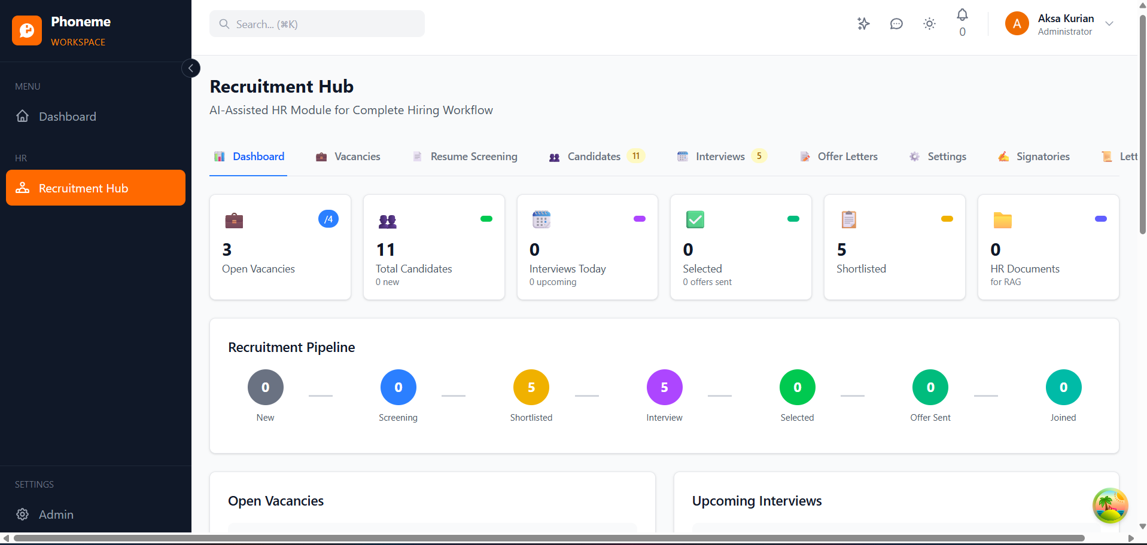
Expected result: Full HR Management page with navigation/menu, vacancy area, recruitment status summary, and the logged-in HR user context.

3.2 Manager Access
When a Manager selects Review JD or follows the approval link from email, the system navigates the Manager to the HR portal. The Manager authenticates using the authorized Google account before reviewing, editing, or approving the JD.

3.3 Candidate Access
A shortlisted Candidate receives an invitation email containing the applicable JD and a secure navigation link to the Candidate Module. The candidate accesses the portal using the same invited email identity. After profile submission, the candidate receives a confirmation email and is allowed to set/reset the portal password for subsequent access.

4. Vacancy & AI-Assisted JD Creation

4.1 Vacancy Creation Trigger
The workflow begins when a new vacancy is identified. HR selects Create Vacancy in the HR portal.

4.2 Natural-Language Input
HR enters the vacancy requirement in normal/manual language through the AI chatbox. The input may include job title, role objective, experience, key skills, qualifications, location, number of openings, employment type, compensation guidance, responsibilities, and any role-specific requirements.
Figure 2. Create Vacancy - HR Typing Requirement in AI Chatbox
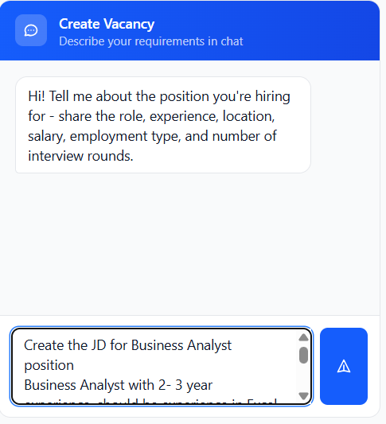
Expected result: AI chatbox with a realistic natural-language vacancy requirement being typed by HR before AI generation.

4.3 AI JD Professionalization
The AI converts HR’s input into a structured, professional Job Description format. HR reviews the generated JD and may correct or refine it before initiating approval.
Figure 3. AI-Generated Vacancy Card in Draft Status
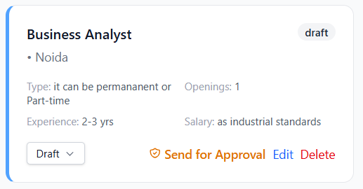

4.4 Draft Status
The vacancy/JD remains in Draft status until Manager approval is completed. A Draft JD is not open for recruitment and cannot be published externally.

5. JD Approval Workflow

5.1 Send for Approval
HR selects Send for Approval and identifies the approving Manager. The system sends an approval email to the Manager. Until approval is completed, the JD continues to be treated as a Draft/Pending Approval item.
Figure 4. Draft Vacancy - Send for Approval and Approver Details
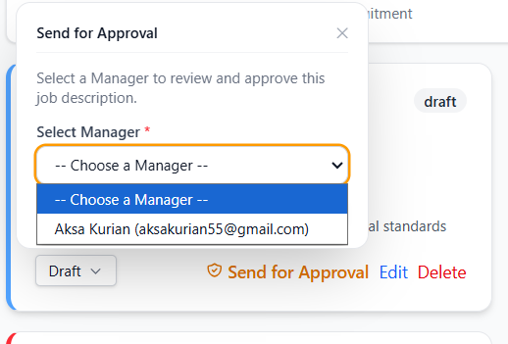
Expected result: Vacancy card showing Draft/Pending Approval status, Send for Approval button, and the selected/sent-to Manager name or email.

5.2 Manager Approval Email
The email should display the JD for review and provide two clear actions:
Figure 5. Manager Approval Email
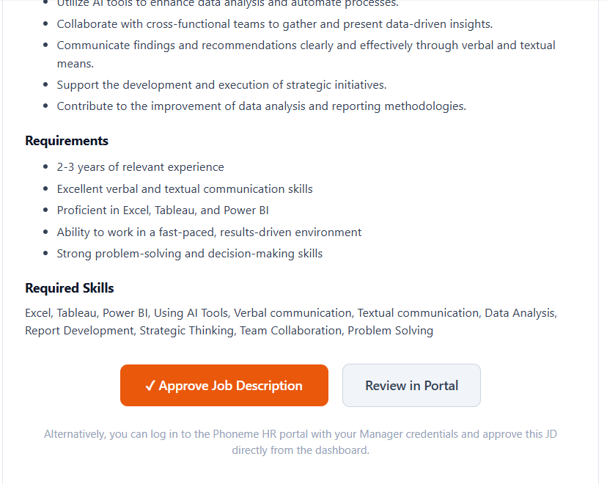
Expected result: Manager email showing vacancy/JD details and both actions: Approve JD and Review JD.
- Approve JD
- Review JD

5.3 Path A – Direct Approval
If the Manager agrees with the JD as received, the Manager selects Approve JD from the email. The system navigates the Manager to the portal, authenticates the Manager through the authorized Google account, displays the JD, and provides the final Approve JD action. The Manager confirms approval without editing.

5.4 Path B – Review, Edit and Approve
If the Manager wants to modify the JD, the Manager selects Review JD. The Manager is navigated to the portal, logs in through the authorized Google account, edits the required JD content, and then selects Approve JD.
Figure 6. Manager Review JD Screen
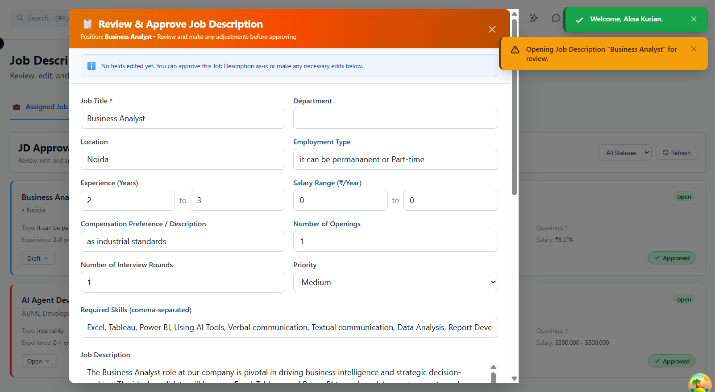
Expected result: Manager portal after Review JD: JD editing interface, editable fields/content, and Approve JD action visible.

5.5 HR Notification and Change Highlighting
After Manager approval, HR receives a notification. If the Manager changed any JD content, those changes are highlighted for HR so that HR can clearly identify what was modified during approval.
Figure 7. Manager Changes Highlighted for HR Review
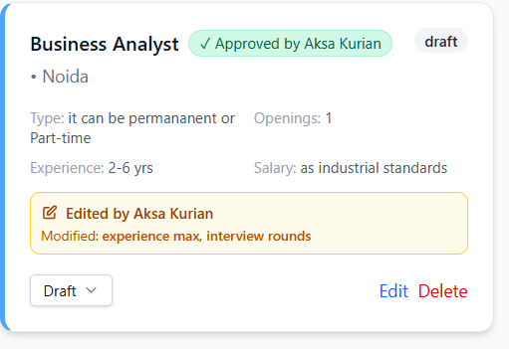
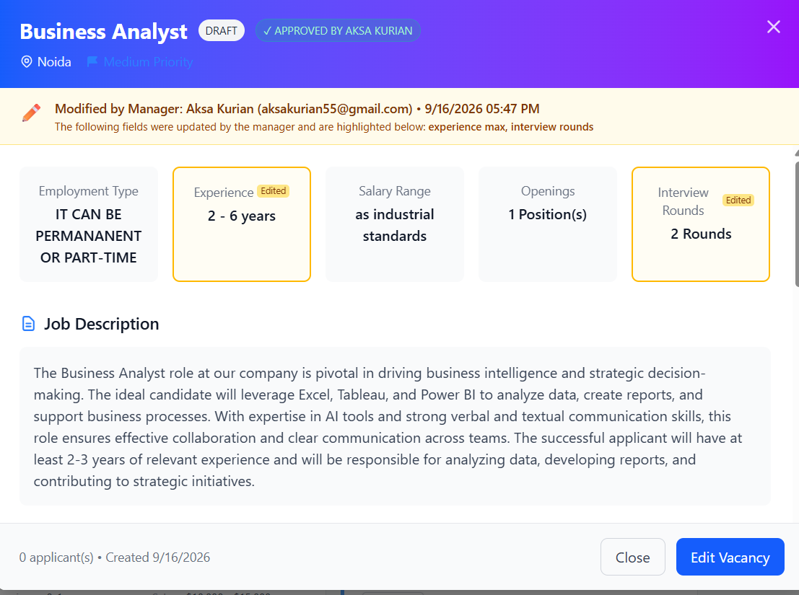
Expected result: HR view of the approved JD with Manager-modified text/fields clearly highlighted and the approval notification/context visible.

5.6 HR Final Review and Vacancy Finalization
After Manager approval, HR opens the vacancy and reviews any Manager changes highlighted by the system. HR may use Edit Vacancy to finalize the vacancy content. Once HR saves the finalized vacancy, the change highlighting is cleared, the Send for Approval action is no longer visible, and the Open action is enabled. The vacancy is then ready for activation and publishing.
Figure 8. HR Final Review - Approved Vacancy Card
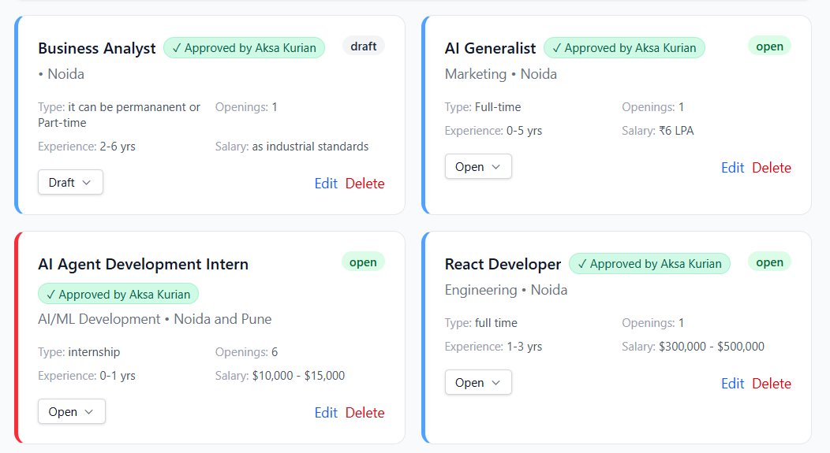
Expected result: After HR reviews/edits the vacancy: highlighted change markers no longer shown, Send for Approval button hidden, Approved status visible, and Open button enabled.

6. Approved Vacancy Activation & Publishing

6.1 Open Vacancy
HR reviews the approved vacancy card and selects Open. Only an approved JD can be opened.
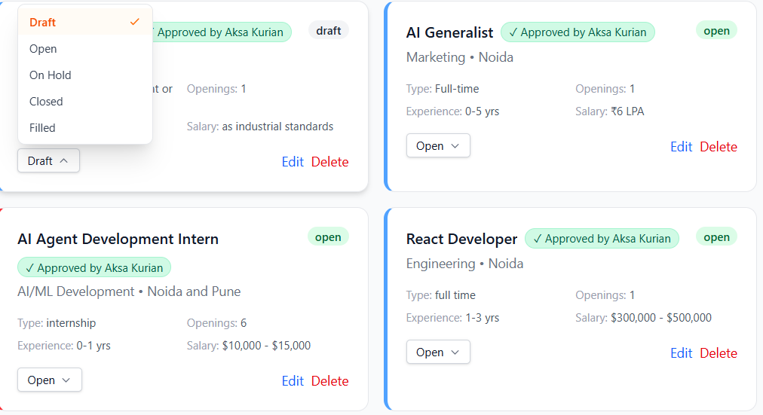

6.2 Publish to Recruitment Platforms
After opening the vacancy, HR may publish the approved JD to configured recruitment platforms such as LinkedIn, Naukri, Internshala, and other integrated channels.

6.3 Source Association
The system should retain the vacancy/JD association for every candidate or resume later sourced from external channels, so all screening results remain traceable to the correct vacancy.

7. AI Resume Sourcing and Screening

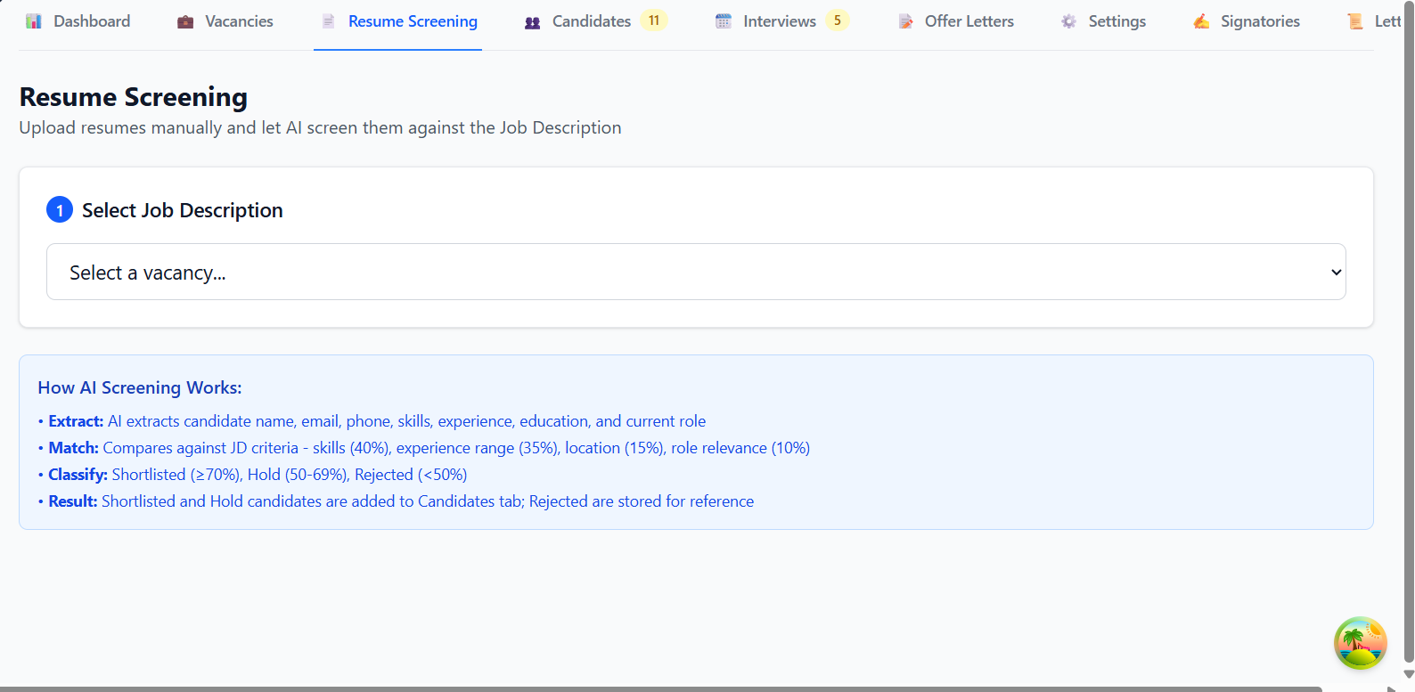

7.1 Candidate/Resume Sourcing
For an open vacancy, the system fetches or receives candidate resumes from configured sources such as Naukri, Internshala, LinkedIn, and other recruitment platforms/integrations.

7.2 Screening Reference
AI screening uses the skills and relevant requirements defined in the approved JD as the primary matching reference.
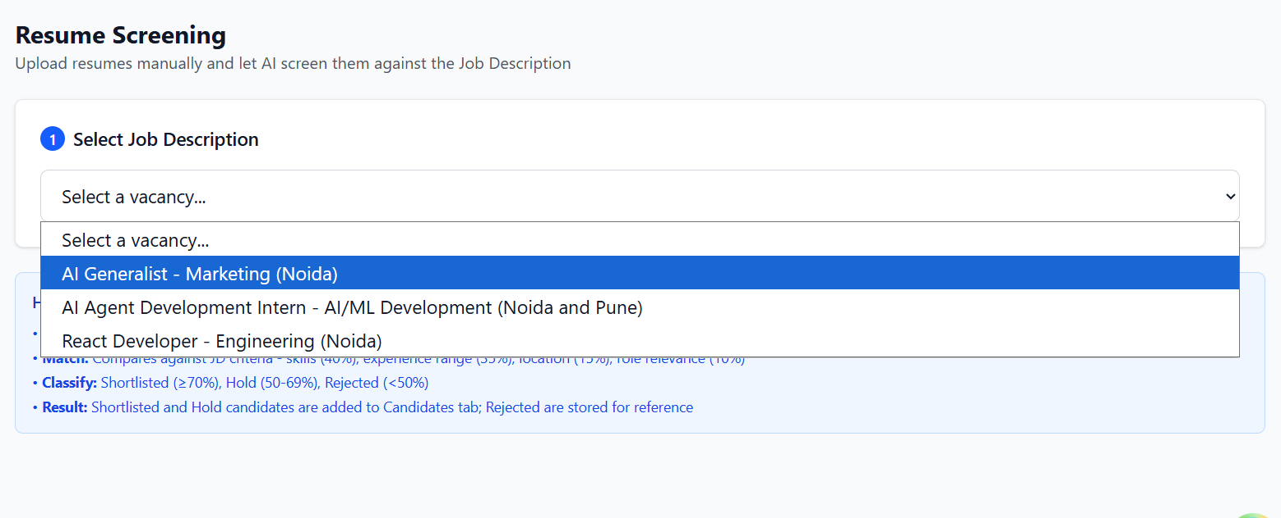

7.3 Skill-Match Analysis
The AI evaluates each resume against the vacancy and should identify the degree of match for required and relevant skills. The screening output should make the skill comparison understandable to HR rather than showing only a single unexplained score.

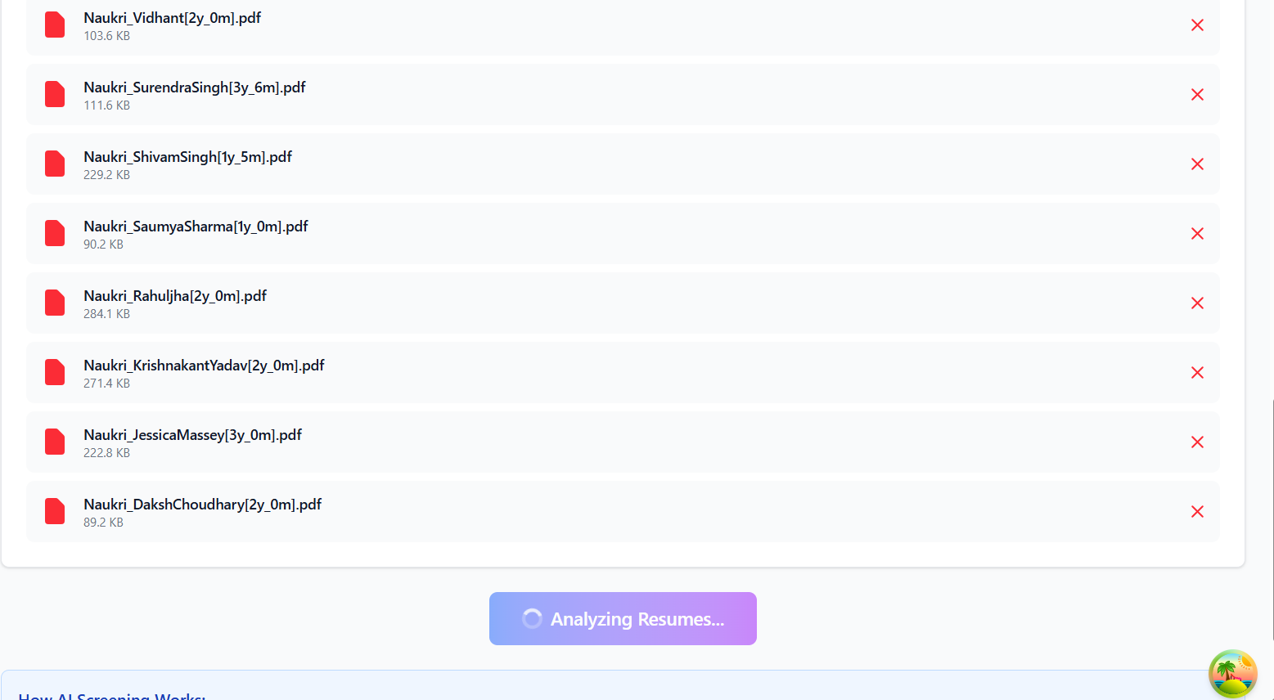

7.4 Candidate Ranking
The AI ranks candidates according to JD-to-resume match, with emphasis on relevant skill alignment and other configured screening criteria. The result supports HR review and shortlisting; it does not independently finalize employment decisions.
Figure 9. AI Resume Screening - Vacancy-wise Results
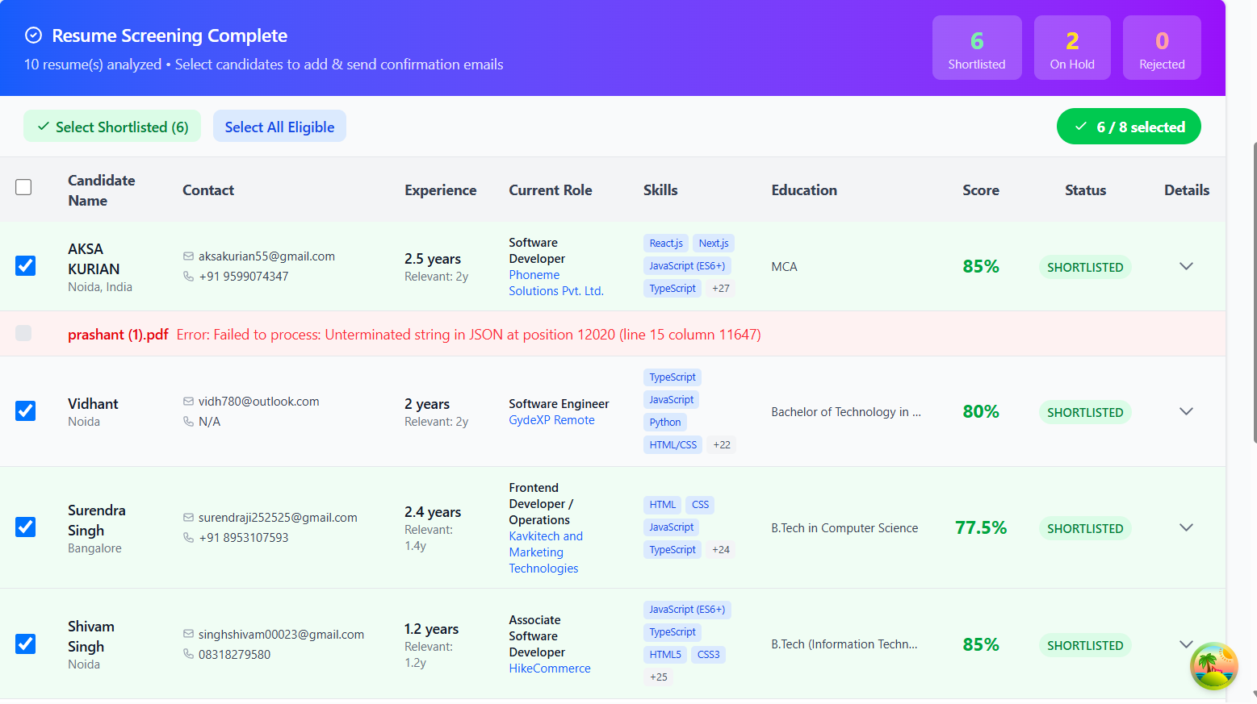
Expected result: Selected vacancy name/JD, resume list, skill-match indicators or scores, ranking/result columns, and screening status.

7.5 Minimum Screening Output
Screening Item | Expected Output
Vacancy Reference | Vacancy title / Vacancy ID / approved JD used for screening
Candidate | Candidate name and source profile/resume reference
Skill Match | Matched skills, partially matched skills, and missing/not-evident skills
Overall Match | Configured AI match score/rank or screening classification
Source | LinkedIn / Naukri / Internshala / other configured source
Status | Selected/Shortlisted or Rejected for the screening stage

8. Screening Results & Candidate Classification

8.1 Vacancy-Level Screening View
Screening results must always show which vacancy is being screened. HR should be able to view results vacancy-wise rather than as an unlinked candidate list.

8.2 Selected/Shortlisted Candidates
Candidates who meet the configured screening and HR review criteria are displayed under Selected/Shortlisted Candidates for the applicable vacancy.
Figure 10. Shortlisted and Rejected Candidate View
Expected result: Vacancy reference together with separate Selected/Shortlisted and Rejected candidate sections/tabs, including candidate names and screening outcome.

8.3 Rejected Candidates
Candidates who do not progress from screening are displayed under Rejected Candidates for the applicable vacancy.

8.4 HR Oversight
HR reviews AI output before acting on candidate progression. The interface should retain enough screening detail to understand why a candidate was placed in the selected/shortlisted or rejected list.

9. Shortlisted Candidate Invitation & Portal Registration

9.1 Invitation Trigger
After screening and HR confirmation, the shortlisted candidate is invited by email.
Figure 11. Shortlisted Candidate Invitation Email
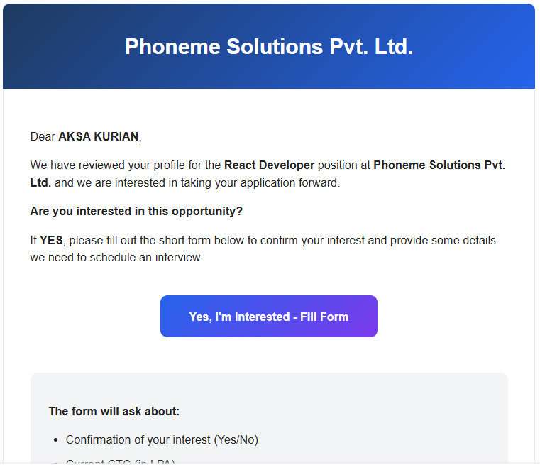.
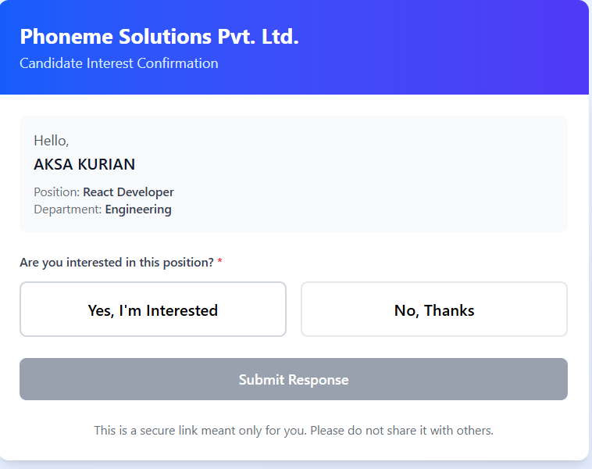

9.2 Invitation Email Content
The invitation email should include or clearly reference the relevant JD and provide a secure link to the Candidate Module in the recruitment portal.

9.3 Candidate Authentication
The candidate enters the portal using the email identity to which the invitation was sent. The system associates the candidate with the correct vacancy and shortlisted-candidate record.

10. Candidate Information Submission

10.1 Candidate Information Form
In the Candidate Module, the candidate completes the required recruitment profile. At minimum, the current workflow captures:
Figure 12. Candidate Portal - Recruitment Information Form
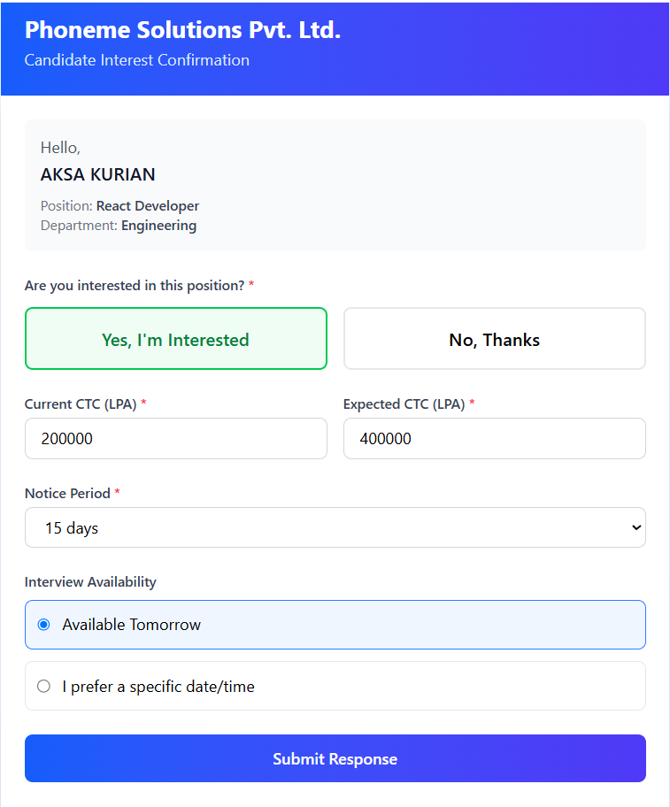

10.2 Submission
The candidate reviews the information and submits the profile. The submitted details become available to HR against the relevant vacancy and candidate record.

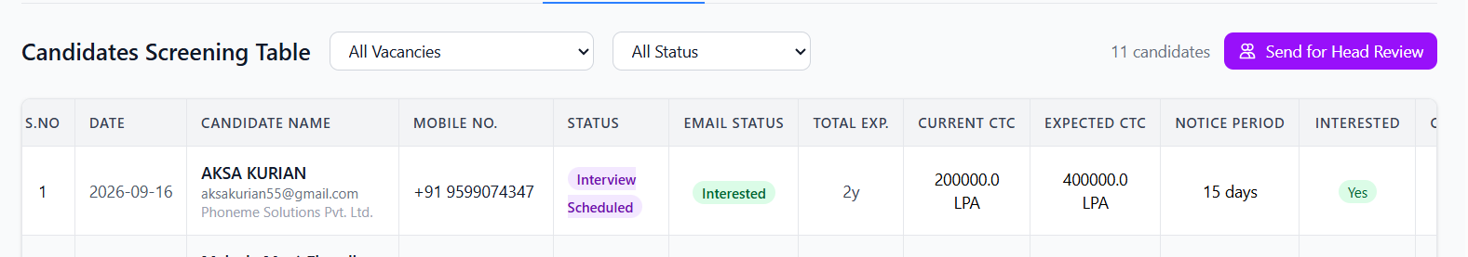

10.3 Interview Mode
HR may schedule the interview as either face-to-face or online, depending on the recruitment requirement.

10.4 Current Workflow End Point
For the present release, the documented workflow is considered operationally complete once the interview has been scheduled and the candidate has been notified. Later interview-evaluation and post-interview stages will be added separately.

11. Email and Notification Workflow
Event | Recipient | Required Notification / Action
JD sent for approval | Manager | Email displaying JD with Approve JD and Review JD actions.
Manager approves JD | HR | Approval notification; highlight Manager edits where applicable.
Candidate shortlisted | Candidate | Invitation email with JD reference and secure Candidate Module link.
Candidate submits details | Candidate | Thank-you / interest confirmation and password set/reset access.
Interview scheduled | Candidate | Interview schedule with date, time, mode, venue/link and instructions.

12. Status Lifecycle

12.1 Vacancy/JD Lifecycle
Draft → Pending Manager Approval → Manager Review (if applicable) → Approved → Open → Published / Active Recruitment → Screening in Progress → Candidate Shortlisting → Interview Scheduling

12.2 Candidate Lifecycle – Current Scope
Sourced / Resume Fetched → AI Screened → Selected/Shortlisted or Rejected → Candidate Invited → Candidate Profile Submitted → HR Review → Interview Scheduled

12.3 Status Controls
- Open must not be enabled until Manager approval is recorded.
- Send for Approval must not remain available after final approval unless a new revision cycle is initiated.
- Candidate records must remain linked to the vacancy used for screening.
- Selected/Shortlisted and Rejected lists must remain separately visible for each vacancy.

13. End-to-End Recruitment Workflow
Step | Actor | Activity
1 | HR | Vacancy identified; HR selects Create Vacancy.
2 | HR + AI | HR enters requirement in natural language; AI converts it into professional JD format.
3 | HR | HR reviews JD; JD remains Draft.
4 | HR | HR selects Send for Approval; Manager receives email with JD and Approve JD / Review JD actions.
5A | Manager | Direct approval path: open approval link, Google login, review and Approve JD.
5B | Manager | Review path: open Review JD, Google login, edit JD, then Approve JD.
6 | System / HR | HR is notified; Manager edits are highlighted; Send for Approval disappears and Open is enabled.
7 | HR | HR opens the approved vacancy and publishes it to configured recruitment platforms.
8 | System + AI | Resumes are fetched/received from recruitment sources and matched to the approved JD.
9 | AI + HR | AI ranks candidates by JD skill match; HR reviews results.
10 | System | Selected/Shortlisted and Rejected candidates are shown separately for the screened vacancy.
11 | HR / System | Shortlisted candidates receive invitation email with JD and Candidate Module link.
12 | Candidate | Candidate logs in using invited email identity and enters full name, experience, skills, projects, current CTC, expected CTC and notice period.
13 | Candidate / System | Candidate submits details and receives thank-you email plus password set/reset access.
14 | HR | HR reviews submitted candidate information and arranges interview.
15 | System | Candidate receives face-to-face or online interview notification.

14. Role-Based Workflow Summary
Process | HR | Manager | Candidate
Create vacancy / AI JD generation | ✓ | — | —
Send JD for approval | ✓ | — | —
Review / edit JD during approval | View highlighted edits | ✓ | —
Approve JD | — | ✓ | —
Open / publish approved vacancy | ✓ | — | —
Review AI screening | ✓ | — | —
View selected/rejected by vacancy | ✓ | — | —
Receive shortlisted-candidate invitation | — | — | ✓
Submit candidate profile details | Review | — | ✓
Set/reset portal password | — | — | ✓
Schedule interview | ✓ | — | —
Receive interview schedule | — | — | ✓

15. Audit and Traceability
The system should maintain traceability for the following key activities:
- Vacancy creation and creator identity
- AI-generated JD and HR edits
- Approval submission and selected Manager
- Manager review, edits, approver identity and approval timestamp
- Approved JD version
- Vacancy opening and external publication actions
- Resume source and vacancy association
- AI screening result, skill match and ranking output
- Selected/Shortlisted and Rejected screening status
- Candidate invitation and portal access event
- Candidate profile submission and key timestamps
- Password setup/reset event (without storing passwords in audit logs)
- Interview scheduling and notification delivery status

16. Current Process Completion Criteria
For the current implementation, a recruitment workflow is considered successfully progressed when:
- A vacancy is created and the JD is professionally generated/reviewed.
- The Manager approves the JD through the controlled approval flow.
- HR opens and, where required, publishes the approved vacancy.
- Candidate resumes are sourced and screened against the correct approved JD.
- Selected/Shortlisted and Rejected candidates are visible against the vacancy.
- A shortlisted candidate is invited into the portal.
- The candidate submits the required profile information and receives account/password setup access.
- HR reviews the candidate information and schedules an interview.
- The candidate receives the interview notification.

17. Quick Reference

17.1 HR
Create Vacancy → Enter Requirement in AI Chatbox → Review Professional JD → Send for Approval → Receive Approval/Highlighted Changes → Open Vacancy → Publish → Run/Review AI Screening → Review Selected & Rejected Candidates by Vacancy → Invite Shortlisted Candidate → Review Candidate Details → Schedule Interview

17.2 Manager
Receive Approval Email → Choose Approve JD or Review JD → Google Login → Review / Edit JD → Approve JD

17.3 Candidate
Receive Shortlist Invitation → Open Candidate Portal → Login with Invited Email → Enter Required Details → Submit → Receive Thank-You Email → Set/Reset Password → Receive Interview Schedule
End of SOP

