
Phoneme SDLC Operating Procedure
Development → Staging → QA Test Execution → CI/CD → Production Release Framework

STANDARD OPERATING PROCEDURE

PHN-SDLC-2026-01-SOP
September 2026
Submitted by: Phoneme Solutions Pvt. Ltd.
Security Classification: Confidential

Document Control
Field | Detail
Document Description | Standard Operating Procedure — Development, Staging, QA, and CI/CD Framework
Identification | PHN-SDLC-2026-01-SOP, Version 1.7 (Draft — pending Reviewed/Approved sign-off)
Security Classification | Confidential — Internal use
Location | Quality Assurance/ and Deployment/ folders, HR Management repository

Authorization
 | Name of the Person | Date
Prepared by
Reviewed by
Approved by

Change Log
Version | Date | Section | A/M/D | Description | Reviewed By
1.0 | Sep 2026 | All | A | Initial SOP — Dev/Staging/QA/CI-CD framework and monitoring tool recommendation
1.1 | Sep 2026 | Sec. 8 (new) | A | Added Environment Preparation Procedures — Machine A/B setup, Coolify self-hosted staging auto-deploy, production CI/CD pipeline, monitoring dashboard, and test-result versioning/sign-off convention. Renumbered Sections 8-10 to 9-11.
1.2 | Sep 2026 | Sec. 8.3, Appendix A (new) | A/M | Updated Sec. 8.3 with the as-built Coolify setup (GitHub App source instead of a plain deploy key; per-project “production”/“staging” Coolify environments; curl auto-install in the server setup script). Added Appendix A, a screenshot walkthrough of the live Teamora HRMS Coolify setup.
1.3 | Sep 2026 | Sec. 8.4, Appendix B (new) | A/M | Updated Sec. 8.4 with the as-built Project Monitoring Dashboard for Teamora HRMS — Section 7.2's lightweight alternative (GitHub Projects + self-hosted Kiwi TCMS) rather than Jira + Zephyr Scale. Added Appendix B, a screenshot walkthrough of the GitHub Projects board and the Kiwi TCMS Coolify deployment.
1.4 | Sep 2026 | Sec. 8.1, 8.2, 8.3, 10 | M | Updated Sec. 8.1/8.2 to reference the as-built, self-elevating/resumable Machine A & B setup scripts (Machine1_Env_Setup.ps1, MachineB_Env_Setup.ps1) and their companion process docs. Updated Sec. 8.3 for the per-service (polyglot microservices) Coolify setup per the finalized Technical Stack Charter, the NestJS/TypeScript vs. Python/FastAPI workflow split, and per-service webhook secret suffixing. Added a Key Risks row (Sec. 10) logging the tracked divergence between this interim Coolify pipeline and Tech Design §18–19's target-state K8s/GitOps architecture.
1.5 | Sep 2026 | Sec. 1.2, 5.0 (new), 8.4, Appendix B.3 (new) | A/M | Incorporated the BRD/PRD approval process into the Project Monitoring Dashboard so it is a genuine single window from requirement sign-off through release. Added Sec. 5.0 (Stage 0 — Requirement Approval) defining the Draft/Prepared/Reviewed/Approved/Rejected gate ahead of Stage 1. Updated Sec. 1.2 to bring approval-status tracking (not BRD/PRD content) in scope. Updated Sec. 8.4 for the as-built five-column board (new leftmost “Requirement Approval” column) and the new Approval Status table field. Added Appendix B.3, a screenshot walkthrough of both.
1.6 | Sep 2026 | Sec. 5.0, 8.7, Appendix C | A/M | Defined the actual mechanism behind the Reviewed step: the BRD/PRD's requirement content is published from the .docx of record to a live, commentable review page; the team lead comments against specific REQ-IDs; resolved comments are folded back into a re-versioned .docx; the Product Owner's final sign-off is recorded as a reply in the page's pinned sign-off thread, then transcribed into the .docx Authorization table as the permanent record. Added Sec. 8.7 (pipeline steps 1–5) and Appendix C (as-built run against Teamora BRD/PRD v2.4). Superseded by v1.7 after stakeholder review found this approach insufficiently rigorous.
1.7 | Sep 2026 | Sec. 5.0, 8.7, Appendix C | M | Replaced the v1.6 publish-for-review approach with docs-as-code: after evaluating self-hosted e-signature (DocuSeal/Documenso), docs-as-code (MkDocs/Docusaurus + Git PR review), and self-hosted wiki (Outline/AppFlowy) options, adopted MkDocs (Material) + GitHub Pull Request review. The BRD/PRD is authored in Markdown under docs-site/, a GitHub Actions workflow auto-publishes a PR preview for team-lead review (inline PR comments) and the signed-off copy to GitHub Pages on merge; the Product Owner's approve-and-merge action is the recorded sign-off. Rewrote Sec. 8.7 (pipeline steps 1–5) and Appendix C (as-built: docs-site/ layout, .github/workflows/docs-review.yml, first run against BRD/PRD v2.4).

Client Sign Off
Stakeholder Name | Role | Sign Off Date | Communication

Confidentiality Agreement
This document is copyrighted, and all rights are reserved. This document may not, in whole or in part, be copied, photocopied, reproduced, translated, or reduced to any electronic medium or machine-readable form without prior consent, in writing. This document is for internal use only and may, in whole or in part, be provided to anyone outside of the Company, including customers, clients, or prospects after taking an approval from an authorized representative.

Table of Contents

1. Introduction
1.1 Purpose
1.2 Scope
1.3 References
1.4 Abbreviations
2. Environment & Machine Topology
3. Roles & Responsibilities
4. Branching & Requirement-ID Traceability Convention
4.1 Branch naming
4.2 Requirement-ID discipline
5. Stage-by-Stage Operating Procedure
5.0 Stage 0 — Requirement Approval (Pre-Development Gate)
5.1 Stage 1 — Development (Machine A)
5.2 Stage 2 — Build & Deploy to Staging
5.3 Stage 3 — Test Execution (Machine B)
5.4 Stage 4 — Test Sign-off Gate (Exit Criteria)
5.5 Stage 5 — CI/CD Promotion to Production
5.6 Stage 6 — Post-Deployment Verification & Rollback
6. Traceability Matrix
7. Recommended Project & QA Monitoring Tooling
7.1 Primary recommendation — Jira Cloud (Standard) + Zephyr Scale
7.2 Lightweight alternative — GitHub Projects + Kiwi TCMS (self-hosted)
7.3 Recommendation
8. Environment Preparation Procedures
8.1 Machine A — Developer Environment Setup
8.2 Machine B — QA/Test Environment Setup
8.3 Staging Server — Auto-Deploy on Commit (Coolify)
8.4 Project Monitoring Dashboard
8.5 Production — CI/CD Pipeline
8.6 Test Result Versioning & Sign-off Record
8.7 Requirement Review Pipeline (Docs-as-Code: BRD/PRD Publish-for-Review)
9. Escalation Procedure
10. Key Risks
11. Conclusion & Road Ahead
Appendix A — Coolify Environment Setup (Screenshot Walkthrough)
A.1 Connecting the GitHub Source
A.2 Project and Environments
A.3 Creating the Applications
Appendix B — Project Monitoring Dashboard Setup (Screenshot Walkthrough)
B.1 GitHub Projects Board
B.2 Kiwi TCMS — Self-Hosted Test Case Management
B.3 Requirement Approval Stage — BRD/PRD Gate (v1.5)
Appendix C — Requirement Review Pipeline (As-Built)
C.1 Site and Pipeline
C.2 First Run — BRD/PRD v2.4

1. Introduction

1.1 Purpose
This document defines the Standard Operating Procedure and framework Phoneme follows to move a product from active development through staging, independent QA test execution, and finally into production via a CI/CD pipeline. It is written for a two-machine working pattern: one machine used for development and pushing builds to a shared staging server, and a second, independent machine used to execute test cases against that staging build, mapped one-to-one against the Requirement IDs frozen in the product's BRD/PRD.

1.2 Scope
In scope: the environment topology, roles, branching and Requirement-ID traceability convention, the stage-by-stage procedure from local development through production release, the test sign-off gate that decides when a release is allowed to proceed, rollback procedure, and a recommendation for the tool used to track progress across every Phoneme SaaS product in parallel.
Out of scope: the content of any single product's BRD/PRD, Technical Design, or UI/UX mockups — those are produced per-product using the phoneme-brd-prd, phoneme-techdesign, and phoneme-uiux-brand-theme skills respectively, before this SOP's Stage 1 begins. As of v1.5, the BRD/PRD's approval status itself (Prepared → Reviewed → Approved, per Stage 0 / Section 5.0) is in scope as a tracked gate in the unified Project Monitoring Dashboard (Section 8.4) — the document's content remains outside this SOP, but whether it has cleared sign-off, and therefore whether Stage 1 is allowed to start, is now visible from the same single window as every later stage.

1.3 References
- phoneme-brd-prd — produces the Requirement IDs this SOP's traceability model is built around.
- phoneme-techdesign — produces the module numbering this SOP's branch-naming convention aligns to.
- phoneme-technical-stack — the per-product Technical Stack Charter that determines the actual CI/CD tooling (e.g. GitHub Actions vs. another runner) for a given product.

1.4 Abbreviations
Term | Meaning
SOP | Standard Operating Procedure
REQ-ID | Requirement ID, as assigned in the product's BRD/PRD
TC-ID | Test Case ID
CI/CD | Continuous Integration / Continuous Deployment
UAT | User Acceptance Testing
RC | Release Candidate

2. Environment & Machine Topology
The framework assumes four distinct environments, physically or logically separated so that no single machine is both writing code and independently verifying it:
Environment | Machine / Host | Purpose | Who works here
Development | Developer's machine (“Machine A”) | Feature branch work, local build, local unit tests | Developer(s)
Staging | Shared staging server | Integration build the whole team and QA test against; mirrors production configuration at smaller scale | Auto-deployed by CI; read-only to humans
Test / QA | Independent QA machine (“Machine B”) | Executes test cases against the staging build, records pass/fail per Requirement ID, logs defects | QA engineer(s)
Production | Production infrastructure (per the product's Technical Stack Charter) | Live customer-facing environment | Deployed only by the CI/CD pipeline, never manually

Machine A and Machine B are kept separate deliberately: a developer verifying their own change against their own understanding of the requirement is not independent verification. QA on Machine B works only from the staging build and the frozen Requirement ID text — never from the developer's local branch — so a requirement that was misread during development has a real chance of being caught.

3. Roles & Responsibilities
Role | Responsibility
Developer (Machine A) | Implements a Requirement ID on a feature branch, runs local build/unit tests, opens a pull request tagged with the Requirement ID, merges to the staging branch once reviewed
Reviewer | Reviews the pull request for correctness against the linked Requirement ID before approving the merge to staging
QA Engineer (Machine B) | Pulls the deployed staging build, executes every test case mapped to the Requirement IDs in this release, logs pass/fail and any defects, and either signs off or bounces the release back to development
Release Owner | Confirms the test sign-off gate has been met, approves promotion of the staging branch to production, and owns the go/no-go and rollback decision
Product Owner (Anuj / designate) | Confirms the Requirement IDs in a release match what was actually approved in the BRD/PRD before sign-off

4. Branching & Requirement-ID Traceability Convention

4.1 Branch naming
- Feature branch: feature/REQ-<product>-<id>-<short-slug> (e.g. feature/REQ-TMR-14-jd-scoring-matrix)
- Staging branch: staging (or develop) — the always-deployable integration branch that the staging server auto-deploys from
- Production branch: main — only ever updated by the CI/CD pipeline promoting a signed-off staging build, never by a direct developer merge

4.2 Requirement-ID discipline
- Every Requirement ID (REQ-ID) originates in the product's BRD/PRD (see phoneme-brd-prd) and is never renumbered once assigned — a changed requirement gets a new ID with a note referencing the old one.
- Every commit and pull request references the REQ-ID(s) it implements in its title (e.g. “[REQ-TMR-14] Add weighted scoring matrix to JD freeze step”).
- Every test case carries a TC-ID and is mapped to exactly one REQ-ID (a requirement with several acceptance criteria gets several test cases, not one test case with several loosely related checks).
- This REQ-ID → commit/PR → TC-ID chain is what makes the Traceability Matrix in Section 6 possible — it cannot be reconstructed after the fact, so it has to be kept live from the first commit.

5. Stage-by-Stage Operating Procedure

5.0 Stage 0 — Requirement Approval (Pre-Development Gate)
- The BRD/PRD is authored per-product using the phoneme-brd-prd skill (Section 1.2/1.3) — that authoring work is out of this SOP's scope. What is in scope, starting at v1.5, is the sign-off gate that decides whether any REQ-ID in that document is allowed to move into Stage 1.
- Every REQ-ID begins in the Requirement Approval stage carrying an Approval Status of Draft, and progresses Draft → Prepared → Reviewed → Approved, mirroring the same Prepared-by/Reviewed-by/Approved-by pattern used in this SOP's own Document Control page — a document (or an individual requirement within it) is not implementation-ready until it carries all three sign-offs.
- An item may instead be marked Rejected — sent back to the BRD/PRD author for rework, not silently dropped; a rejected REQ-ID is re-submitted as Draft once revised, not reinstated at its prior status.
- Only a REQ-ID whose Approval Status is Approved is eligible to be pulled into Backlog and assigned to a feature branch under Section 4.1 — this is a hard gate: Stage 1 does not begin work against an un-approved requirement, however minor the change looks.
- As-built for Teamora HRMS: this gate is tracked as the leftmost "Requirement Approval" column on the Project Monitoring Dashboard's board view, and as an Approval Status field on its table view — see Section 8.4 and Appendix B.3 for the as-built setup.
- As of v1.7, the Reviewed step runs as a docs-as-code pipeline rather than a document passed around by email attachment or a hand-copied web page: the BRD/PRD is authored in Markdown, published automatically as a browsable site, and reviewed as a GitHub pull request — the team lead comments against specific REQ-IDs directly on the PR diff, and the Product Owner's approve-and-merge action is itself the recorded sign-off — see Section 8.7 and Appendix C for the as-built pipeline and the exact fold-back/sign-off procedure.

5.1 Stage 1 — Development (Machine A)
- Pull the latest staging branch; cut a feature branch named per Section 4.1 for the specific REQ-ID(s) being implemented.
- Implement against the Technical Design's module/API contract for that REQ-ID; write/extend unit tests alongside the change, not afterward.
- Run the full local build and unit test suite before opening a pull request — a red local build is never pushed for review.
- Open the pull request into staging, title tagged with the REQ-ID(s), description listing exactly which acceptance criteria (from the BRD/PRD) this change satisfies.
- A Reviewer approves against the linked requirement, not just code style, before the merge is allowed.

5.2 Stage 2 — Build & Deploy to Staging
- Merging a pull request into the staging branch triggers the CI pipeline: install, build, run the automated unit/integration suite, and — only if that suite is fully green — auto-deploy the build to the shared staging server.
- A failed staging build blocks further merges into staging until fixed; staging must always reflect a build that at least passed automated checks.
- The CI run tags the deployed staging build with the list of REQ-IDs it now contains, so QA always knows exactly what to test in this cycle.

5.3 Stage 3 — Test Execution (Machine B)
- QA, working independently on Machine B, pulls up the staging URL (never the developer's local environment) and executes every TC-ID mapped to the REQ-IDs newly present in this staging build.
- Each test case execution is recorded with a pass/fail result, the build/commit hash it was run against, and, on failure, a defect log entry that references both the TC-ID and its REQ-ID.
- A failed test case sends its REQ-ID back to Stage 1 as a new fix task — the same REQ-ID, not a new one, since the requirement itself has not changed, only the implementation.
- Regression: test cases from previously signed-off REQ-IDs that touch the same module are re-run, not just the new ones, whenever a change lands in a shared component.

5.4 Stage 4 — Test Sign-off Gate (Exit Criteria)
A staging build may be promoted to production only when ALL of the following hold:
- 100% of test cases mapped to Critical and High priority Requirement IDs in this release have passed.
- Zero open Severity-1 (blocking) or Severity-2 (major) defects against any REQ-ID in this release.
- Any open Severity-3/4 (minor/cosmetic) defects are explicitly accepted in writing by the Release Owner and Product Owner, with a target fix release noted.
- The Release Owner has reconciled the release's REQ-ID list against the BRD/PRD and confirmed nothing out-of-scope has been included.
Only once these are met does the Release Owner mark the staging build a Release Candidate (RC) and authorize Stage 5.

5.5 Stage 5 — CI/CD Promotion to Production
- The Release Owner merges the signed-off staging branch into main (or triggers the pipeline's promote step directly on the RC build — no new code is written at this stage).
- The CI/CD pipeline rebuilds from the exact RC commit (never a re-build from a moving branch tip), runs the full automated regression suite again, and deploys to production only if that run is green.
- Deployment to production is always pipeline-driven — no manual file copy or manual server login ever ships a change to production.
- The pipeline tags the production release with the same REQ-ID list carried since Stage 2, so production always has a traceable record of exactly which requirements are live.

5.6 Stage 6 — Post-Deployment Verification & Rollback
- Immediately after a production deploy, run an automated smoke test against a small set of critical-path REQ-IDs (login, core workflow entry point, payment/critical integration if applicable).
- If the smoke test fails, or a Severity-1 defect is reported within the initial monitoring window, the Release Owner triggers an immediate rollback to the last known-good production build via the pipeline — never a manual hotfix under pressure.
- A rollback is followed by a written incident note: which REQ-ID/build was rolled back, why, and whether it returns to Stage 1 (code fix) or Stage 4 (a sign-off gap).

6. Traceability Matrix
Maintained live (in the chosen project-tracking tool from Section 7, not as a static document) for every release, so any Requirement ID can be traced end-to-end from the BRD/PRD to its production release:
REQ-ID | BRD/PRD Module | TC-ID(s) | Build / Release | Status
REQ-TMR-14 | 3.2 JD Management | TC-14-01, TC-14-02, TC-14-03 | staging build #482 | Passed — RC
REQ-TMR-15 | 3.3 Publishing | TC-15-01 | staging build #482 | Failed — returned to dev
REQ-TMR-16 | 3.6 Screening | TC-16-01, TC-16-02 | prod release v2.4.0 | Live in production

7. Recommended Project & QA Monitoring Tooling
Phoneme runs several SaaS products in parallel, so the tracking tool needs to show per-product progress cleanly, support the REQ-ID ↔ TC-ID traceability this SOP depends on, and connect to the existing GitHub-based CI/CD pipeline without heavy custom glue.

7.1 Primary recommendation — Jira Cloud (Standard) + Zephyr Scale
- Jira Cloud Standard runs roughly $7.91/user/month (about $79/month for a 10-person team); Zephyr Scale is free up to 10 users and roughly $4.55/user/month beyond that.
- Zephyr Scale adds native, purpose-built requirement-to-test traceability — REQ-IDs as Jira issues link directly to TC-IDs as Zephyr test cases, with execution results and coverage reports out of the box, rather than being hand-built with labels.
- Zephyr Scale and Jira both integrate with GitHub Actions via webhooks/REST API, so a CI pipeline run can update a test execution's status automatically.
- Each Phoneme SaaS product (Teamora, and future products) runs as its own Jira project, with a shared cross-project traceability/portfolio view for Anuj to see progress across all of them at once.

7.2 Lightweight alternative — GitHub Projects + Kiwi TCMS (self-hosted)
- GitHub Projects is free/included at every GitHub tier and sits natively alongside the repos and Actions pipelines Phoneme already uses — no new vendor relationship.
- It has no native test-case management, so it is paired with Kiwi TCMS, an open-source test case management tool that can be self-hosted on Phoneme's own infrastructure (a natural fit given Phoneme's existing data-center/private-cloud capability), linked to GitHub issues manually per REQ-ID.
- This path costs less and stays fully within infrastructure Phoneme already controls, at the cost of more manual linking discipline than Jira + Zephyr Scale's native traceability.

7.3 Recommendation
Start with Jira Cloud Standard + Zephyr Scale for the first product this SOP is rolled out on (Teamora): the cost difference at Phoneme's current team size is small, and native traceability removes an entire category of manual bookkeeping error at exactly the REQ-ID ↔ TC-ID link this SOP is built around. Revisit the self-hosted GitHub Projects + Kiwi TCMS path if the number of paid seats grows enough for cost to become the deciding factor.

8. Environment Preparation Procedures
Hosting decision on record: staging and production run self-hosted on Phoneme's own infrastructure behind Coolify (open-source, self-hosted deployment platform) rather than a managed PaaS — consistent with Phoneme's existing data-center/private-cloud capability. This section is the checklist for standing up each environment in Sections 1–2 of this SOP for a new product.

8.1 Machine A — Developer Environment Setup
- Install the language runtime/package manager version pinned in the product's Technical Stack Charter (phoneme-technical-stack) — never “whatever is newest.”
- Configure git identity and add the developer's SSH key to GitHub; clone the product repository.
- Install project dependencies from the committed lockfile (never a fresh, unpinned install).
- Copy .env.example to a local .env with dev-safe placeholder values — real staging/production secrets are never copied onto a developer machine.
- Install and enable the repo's pre-commit hooks (lint/format) so style issues are caught before a PR, not in review.
- Run the full local build and unit test suite once, clean, before starting any feature work — confirms the environment itself is sound before blaming code.
- Confirm the branch-naming convention (Section 4.1) and the REQ-ID this session's work will implement before the first commit.
- As-built for Teamora HRMS: this checklist runs as a single, idempotent, resumable script (Deployment/Machine1_Env_Setup.ps1) rather than by hand — it self-elevates for the admin-only steps (WSL2, Docker Desktop, GitHub CLI, PostgreSQL client), resumes automatically across the reboot WSL2 requires via a Windows RunOnce entry, and pins Node.js to the repo's committed .nvmrc/.node-version. Git identity/SSH key registration and the application scaffold itself stay deliberately manual — see Deployment/MACHINE_A_SETUP_PROCESS.md for the full as-built writeup and Deployment/MACHINE1_READINESS.md for the first workstation's recorded baseline/blockers.

8.2 Machine B — QA/Test Environment Setup
- Install the test framework/runner specified in the Technical Stack Charter (e.g. Playwright) and its browser binaries — kept independent of whatever Machine A has installed.
- Configure network access to the staging URL only — Machine B never needs, and should never be given, production credentials or a route to the production database.
- Set up dedicated QA test accounts (never real customer/candidate data) for exercising the staging build.
- Connect to the test-management tool (Zephyr Scale, under the product's Jira project — or Kiwi TCMS under the Section 7.2 lightweight alternative, as adopted for Teamora HRMS per Section 8.4) with QA's own login — test executions are always recorded under the QA engineer's identity, not the developer's.
- Confirm the local path/convention for exporting a signed-off test cycle's results, per Section 8.6 below, before the first execution of a release.
- As-built for Teamora HRMS: this checklist likewise runs as a companion script (Deployment/MachineB_Env_Setup.ps1) — lighter than Machine A's since Machine B tests the deployed staging build over the network rather than running the application locally, so it needs only a baseline Node.js install and Playwright (once a pinned version lands in the repo's Phase 2 QA scaffold), plus an optional -StagingUrl reachability check. Network isolation to staging-only, QA account provisioning, and the Section 8.6 sign-off export itself all stay manual/owner-actioned by design — see Deployment/MACHINE_B_SETUP_PROCESS.md.

8.3 Staging Server — Auto-Deploy on Commit (Coolify)
- Provision a server/VM on Phoneme's own infrastructure and install Coolify on it (single install script; Coolify then manages its own reverse proxy, SSL, and deployment runtime). Note: the install script detects the OS's package manager (apt-get/dnf/yum/apk/zypper) and installs curl automatically if the base image doesn't ship it — this was needed in practice on the first server provisioned.
- Create one Coolify project per product (e.g. “Teamora HRMS”); within it, Coolify's own “production” environment is used for the production application and a second “staging” environment is added for the staging application — this environment split is Coolify's native mechanism for keeping the two deployments, their domains, and their variables completely separate within one project.
- Connect the product's GitHub repository as a Source using a GitHub App (Sources → New Source → GitHub App), not a plain deploy key — the App is scoped to “Only select repositories” (just the one product repo, least privilege) and is registered directly against the org/account that owns the repo. This is a one-time, per-Coolify-instance step; every product's applications thereafter reuse the same connected Source.
- In the “staging” environment, add the application as a “Git Repository (with GitHub App)” resource, pick the connected repo, and set its Branch to staging with Auto Deploy left on “Deploy on push (webhooks)” — every merge into staging (Section 5.2) then redeploys automatically with no manual step, no separate webhook secret to configure.
- In the “production” environment, add the same repo as a second application resource, Branch set to main, but with Auto Deploy switched to “Manual deployments only” — production is never redeployed by a raw push; Section 8.5's gated pipeline is what triggers it.
- Confirm the server's reverse proxy (Traefik, under Server → Proxy) shows a Running/healthy status before creating any application — a freshly installed server can come up with the proxy stopped, in which case no deployed app is reachable over HTTP/HTTPS until it's started (Actions → Start Proxy).
- Set each environment's variables once in Coolify (never committed to the repo) and expose a health-check endpoint the product returns 200 OK from, so Coolify (and later, the monitoring dashboard) can tell a deploy actually succeeded, not just that it ran.
- Point QA (Machine B, Section 8.2) at the staging application's Coolify-issued URL as the one and only target for test execution.
A full screenshot walkthrough of this exact setup — connecting the GitHub App source, creating the project/environments, and creating both applications — is in Appendix A.
- As-built refinement: Teamora HRMS is a polyglot microservices product per the Technical Stack Charter (Technical/Teamora_Technical_Stack_Charter_v1.0.md) — NestJS/TypeScript services (Auth, Notification, Requisition, Scoring Matrix) and Python/FastAPI services (JD Generation, Resume Parsing, Dedupe), plus the React frontend. Steps 4–7 above (application resource, Branch, Auto Deploy, secrets) therefore happen once per service, not once for the whole product — each service gets its own staging and production Coolify application.
- The GitHub Actions workflow used per service depends on its stack: staging-deploy.yml/production-release.yml for NestJS/TypeScript and the React frontend; staging-deploy-python.yml/production-release-python.yml for Python/FastAPI services. Both pairs now carry real install/lint/build/test commands drawn from the Technical Stack Charter's conventions (ESLint+Prettier / ruff+black) rather than placeholders — confirm a service's actual package.json scripts or requirements.txt/pytest markers match before relying on either workflow against real committed code.
- Once a repository hosts more than one service, suffix each service's Coolify webhook secrets with its service name (e.g. COOLIFY_STAGING_WEBHOOK_AUTH, COOLIFY_STAGING_WEBHOOK_JD_GEN) and update that service's workflow file to match — see Deployment/ci-cd/COOLIFY_SETUP.md.
- Known, tracked divergence: the product's Technical Design (Sections 18–19) specifies a target-state self-managed Kubernetes + GitOps (ArgoCD) architecture with signed images and canary rollout; the interim Coolify + GitHub Actions pipeline actually adopted (2026-09-18 decision, recorded in the Technical Stack Charter) has none of that — no GitOps, no canary, no image signing or container vulnerability scanning, and rollback is Coolify's redeploy-previous-build webhook rather than a GitOps revert. This is a deliberate, logged interim decision, not a silent substitution — see the Charter's “Known divergence” section and Section 10's Key Risks below.

8.4 Project Monitoring Dashboard
- Infra/release layer: Coolify's own dashboard shows, per product, which commit/build is currently running in staging vs. production side-by-side, plus deploy history and health-check status — this is the “what's live where” view.
- Requirement-progress layer, as-built for Teamora HRMS: Section 7.3 recommended Jira + Zephyr Scale as the default path, but Teamora HRMS was stood up on the Section 7.2 lightweight alternative instead — GitHub Projects for requirement/stage tracking, paired with a self-hosted Kiwi TCMS for test case management — to avoid a paid-seat commitment before the product has proven out its release cadence. This is the “how much is actually done” view.
- The GitHub Projects board (“Teamora HRMS - SDLC Tracker”, project #5 under the myphoneme account) mirrors Section 5's Stage 0–6 workflow as five columns — Requirement Approval, Backlog, In Development, QA on Staging, Released to Production — each carrying a description that cites the exact SOP stage/section it corresponds to, so an item's column alone tells you which gate it's sitting behind. This makes the board a genuine single window: a REQ-ID's entire lifecycle, from BRD/PRD sign-off through production release, is one board rather than a dashboard for development stages plus a separate, untracked approval process.
- As of v1.5, Requirement Approval is the leftmost column — positioned before Backlog because no REQ-ID is meant to sit in Backlog, let alone be picked up in Stage 1, before it clears Stage 0's sign-off gate (Section 5.0).
- A second view on the same board (“REQ-ID TraceabilityView”, table layout) adds four custom fields — REQ-ID (text), TC-ID(s) (text), Priority (single select: Critical/High/Medium/Low), and, as of v1.5, Approval Status (single select: Draft/Prepared/Reviewed/Approved/Rejected) — so every tracked item carries both the Requirement-ID ↔ Test-Case-ID linkage Section 4.2/6 requires and the Stage 0 sign-off status, without needing Zephyr Scale's native linking or a separate approval tracker.
- Approval Status is updated by hand as the BRD/PRD's own Prepared-by/Reviewed-by/Approved-by sign-offs happen (Section 5.0) — it is a status mirror of that document-level sign-off, not a substitute for it; the authoritative record of who approved a requirement and when remains the BRD/PRD document itself.
- Kiwi TCMS (open-source, self-hosted) is deployed on the same Coolify server as staging/production, but in its own “tools” Coolify environment — kept separate from the app-deploy environments in Section 8.3 so a Kiwi TCMS redeploy/restart can never accidentally touch the Teamora application containers. It runs as a Docker Compose resource (web + MariaDB), with Coolify's auto-generated secret variables (${SERVICE_PASSWORD_MYSQLROOT} / ${SERVICE_PASSWORD_MYSQL}) used for the database credentials rather than hand-set passwords.
- QA records test-case execution results directly in Kiwi TCMS under the REQ-ID it's exercising, then references that Kiwi TC-ID in the GitHub Projects item's TC-ID(s) field — this manual cross-link is the acknowledged trade-off of the lightweight path noted in Section 7.2.
- Read the infra and requirement-progress layers together for a release decision, exactly as in the Jira/Zephyr case: Coolify confirms staging is running the exact build QA tested; the GitHub Projects board + Kiwi TCMS confirm every Critical/High REQ-ID in that build has a passing, recorded test execution.
A full screenshot walkthrough of the as-built GitHub Projects board and the Kiwi TCMS Coolify deployment is in Appendix B.

8.5 Production — CI/CD Pipeline
- A GitHub Actions workflow triggers only on a merge into main, and that merge is itself blocked by a required GitHub Environment approval (the Release Owner's go/no-go from Section 5.4/5.5) — never a free merge.
- Pipeline stages: install → build → full automated regression suite → (only if green) call the Coolify API/webhook to redeploy the Production application from the exact approved commit → automated post-deploy smoke test (Section 5.6).
- A failed smoke test triggers Coolify's redeploy of the last known-good build automatically — the rollback path is itself part of the pipeline, not a manual afterthought.

8.6 Test Result Versioning & Sign-off Record
- At the Test Sign-off Gate (Section 5.4), export the release's test cycle results from Zephyr Scale and generate a dated sign-off report (e.g. TestReport_<product>_<release>_<date>.docx) saved into the repository's Quality Assurance/ folder.
- Commit that report and tag the exact commit it certifies (e.g. git tag release-v2.4.0-qa-signoff) — the sign-off record and the code it certifies are then permanently and immutably linked in git history.
- A superseding release gets its own dated report and tag; an existing sign-off report is never edited or overwritten after the fact.

8.7 Requirement Review Pipeline (Docs-as-Code: BRD/PRD Publish-for-Review)
- Purpose: Stage 0 (Section 5.0) requires a Reviewed step, but a .docx passed around by email has no inline commenting a team lead can act on, no diff between drafts, and no single, tamper-evident place a Product Owner's final sign-off is recorded against specific REQ-IDs. This pipeline replaces that with docs-as-code: the requirement document is treated like source code — written in Markdown, reviewed as a pull request, published automatically — so the review tooling Phoneme already runs (Section 8.3/8.5's GitHub + Actions pipeline) is reused rather than a new system stood up for one document type.
- Step 1 — Prepare: the .docx of record produced by the phoneme-brd-prd skill is converted to Markdown and placed under docs-site/docs/ in the product repository, on a review branch (e.g. review/brd-prd-v2.4) opened as a pull request into main. Its Approval Status on the Project Monitoring Dashboard (Section 8.4) is set to Prepared.
- Step 2 — Publish: opening (or updating) the pull request triggers a GitHub Actions workflow that builds the Markdown with MkDocs (Material theme) and deploys a preview copy to GitHub Pages, then posts the preview URL back onto the PR as a comment — this is the "publish as a web page" step, fully automatic and requiring no manual export or upload. The same link is added to the Requirement Approval card on the dashboard (Appendix C).
- Step 3 — Team-lead review: the team lead reads the published preview for readability, then leaves review feedback as inline comments directly on the pull request's Files Changed diff, anchored to the exact REQ-ID/line in question — this is GitHub's native review-comment mechanism, not a separate markup document, and every comment is permanently timestamped and attributed by GitHub itself.
- Step 4 — Fold-back: the author pushes further commits to the same branch/PR addressing review comments; each fold-back is a visible, diffable commit rather than a silently replaced file. Once the team lead resolves every review thread, the Approval Status on the dashboard moves to Reviewed. GitHub's PR is the record of both the requirement content and its full review history — no separate copy can drift from it.
- Step 5 — Product Owner sign-off: the Product Owner reviews the final diff and gives formal Approved sign-off by approving and merging the pull request into main — the merge is the recorded approval act, with GitHub permanently recording who merged it and when. Merging also re-triggers the same workflow to deploy the signed-off copy to the root of GitHub Pages, and re-versions the .docx of record (e.g. v2.4 → v2.5) per the phoneme-brd-prd skill's Change Log convention, transcribing the same names/dates into its Authorization table so the permanent sign-off record exists in both git history and the document itself. The dashboard's Approval Status field is set to Approved, and the REQ-ID(s) become eligible to move into Backlog (Section 5.0).
- A Rejected outcome at Step 3 or Step 5 (review comments requesting a fundamental rework, or the PO declining to merge) sends the item back to Step 1 as a revised Draft on a new branch/PR, per Section 5.0 — the rejected PR is closed without merging, never force-merged or silently edited.

9. Escalation Procedure
- A test case failing twice against the same REQ-ID escalates from Developer/Reviewer to the Release Owner before a third attempt — repeated failure on the same requirement usually means the requirement itself needs re-reading with the Product Owner, not another quick patch.
- Any Severity-1 defect found in staging halts further merges into staging until resolved.
- Any Severity-1 defect found in production triggers the rollback procedure in Section 5.6 immediately, before root-causing — restoring service comes first.

10. Key Risks
Risk | Mitigation
Developer tests their own change on staging, defeating independent QA | Machine B is a physically/logically separate environment QA alone operates; developers do not have a standing reason to sign off their own test cases
REQ-ID drift — a requirement is reworded after implementation without a new ID | Section 4.2's discipline: a changed requirement always gets a new REQ-ID referencing the old one, never a silent edit
Manual production deploys bypass the pipeline under time pressure | Section 5.5: production is only ever pipeline-driven; this is a hard rule, not a guideline, enforced by restricting direct push/deploy access to main
Interim Coolify + GitHub Actions pipeline diverges from Tech Design §18–19's target-state K8s/GitOps architecture (no canary rollout, no image signing/SCA scanning) — Section 8.3 | Divergence is logged, not silent: Technical Stack Charter's “Known divergence” section flags it explicitly for revisit before Release 1 scales past early traffic or before the Tech Design's compliance posture is actually required

11. Conclusion & Road Ahead
This SOP closes the loop from the BRD/PRD's Requirement IDs (phoneme-brd-prd) and the Technical Design's module contracts (phoneme-techdesign, phoneme-technical-stack) through independent test execution and pipeline-driven production release. As each new Phoneme SaaS product goes through Concept-to-Launch, it adopts this same SOP with its own Jira project (or the lightweight alternative) rather than a bespoke process per product, so progress across every product stays visible from one place.

Appendix A — Coolify Environment Setup (Screenshot Walkthrough)
This appendix records the exact, as-performed walkthrough for standing up Coolify for the Teamora HRMS product (Section 8.3), captured directly from the live setup so Section 8.3's checklist can be followed step-by-step against real screens rather than description alone. Screenshots are grouped into three phases: connecting the GitHub source, creating the project/environments, and creating the two applications.

A.1 Connecting the GitHub Source
Sources → New Source → GitHub App. Name the App and set the Organization to the account that owns the repository (here, myphoneme) — leave HTML/API URL at their github.com defaults unless the repository lives on a self-hosted GitHub Enterprise instance.
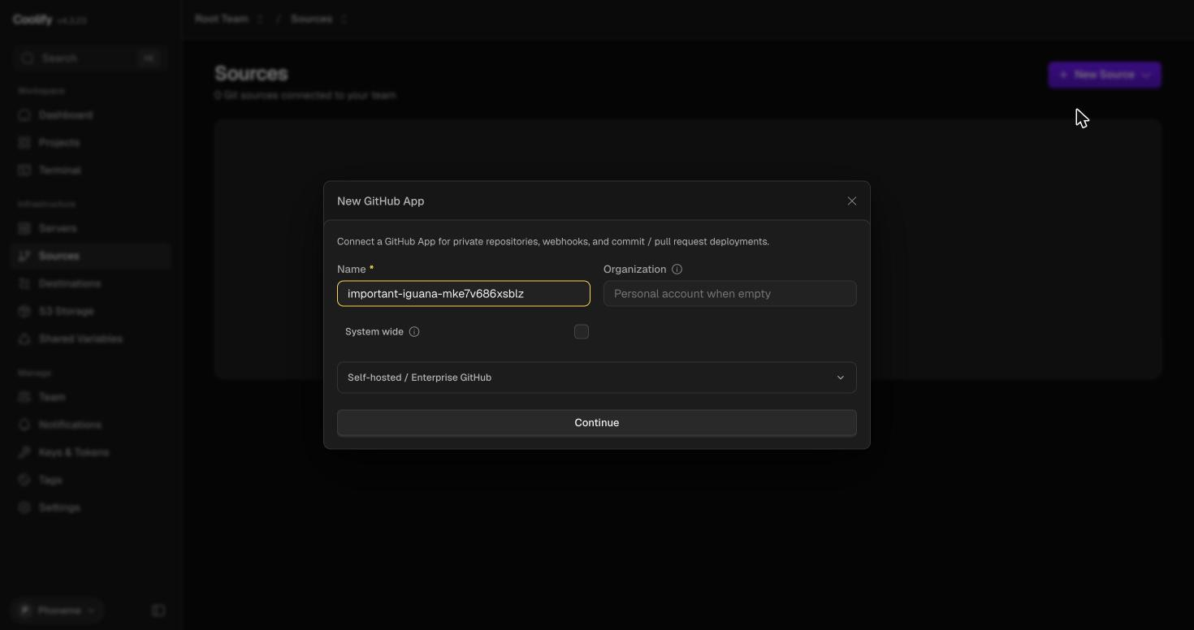
Figure A.1 — New GitHub App dialog, default state.
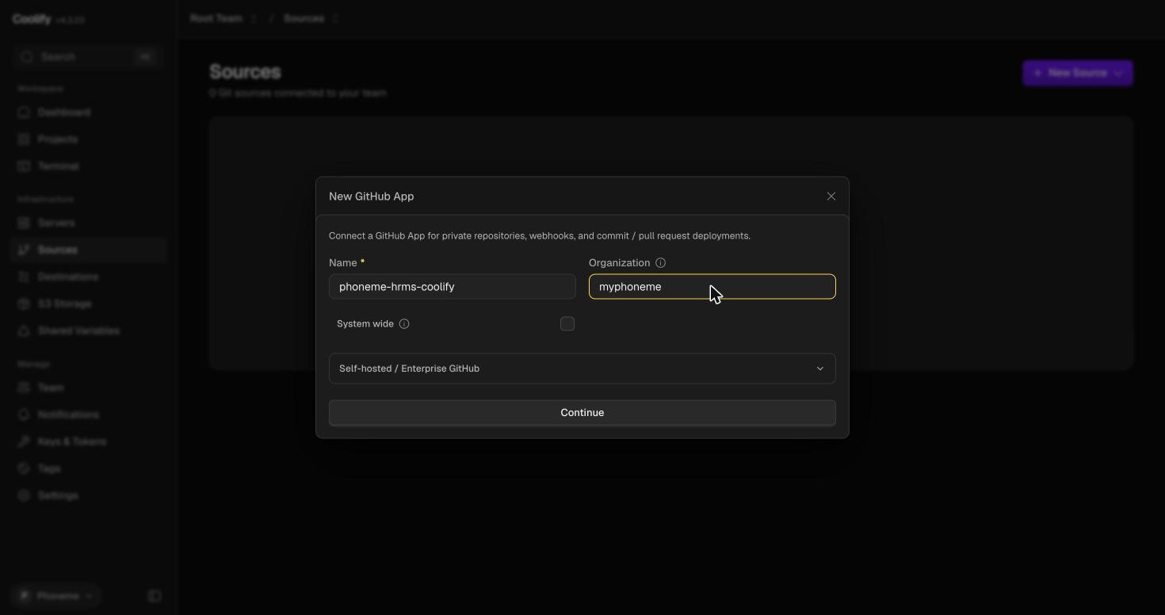
Figure A.2 — Name and Organization filled in (phoneme-hrms-coolify / myphoneme).
Coolify shows the App's mandatory permissions and its own webhook endpoint before handing off to GitHub to actually register it.
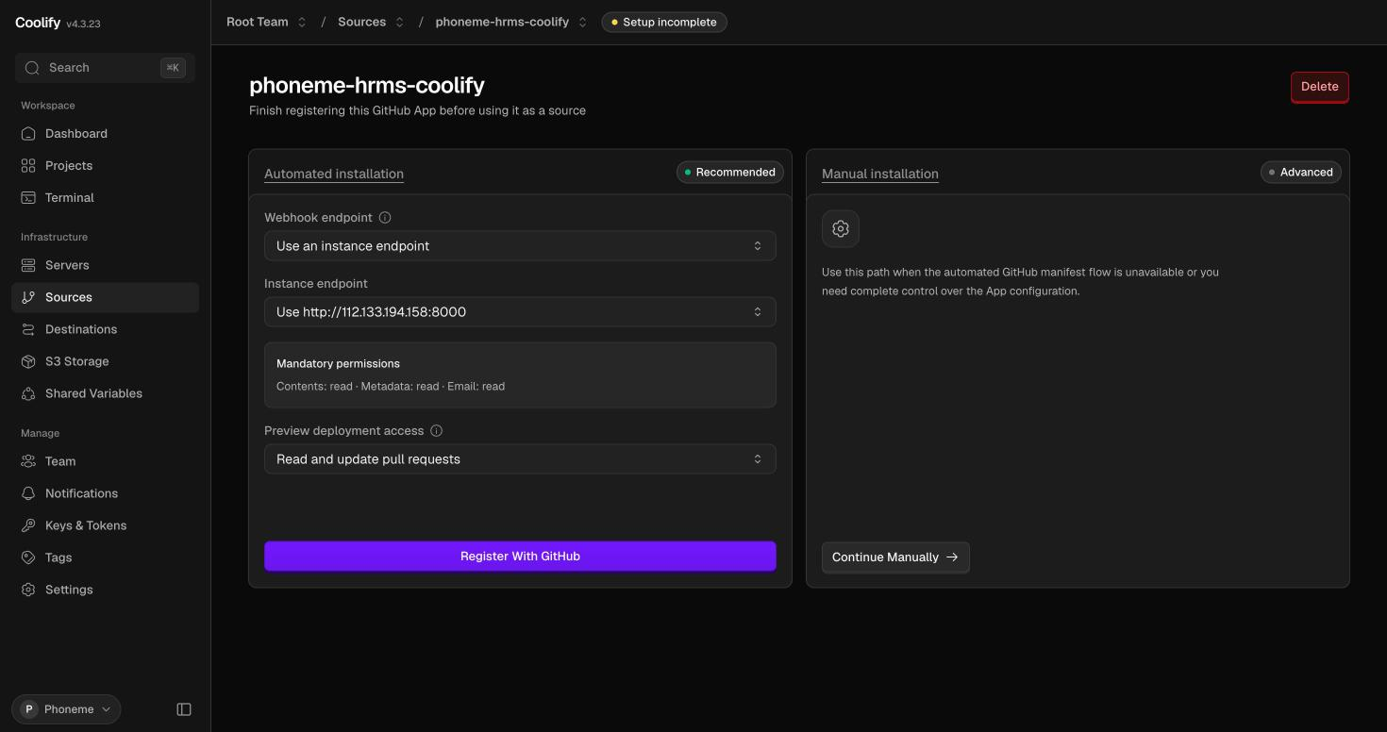
Figure A.3 — Automated installation screen: webhook endpoint and mandatory permissions, before “Register With GitHub.”
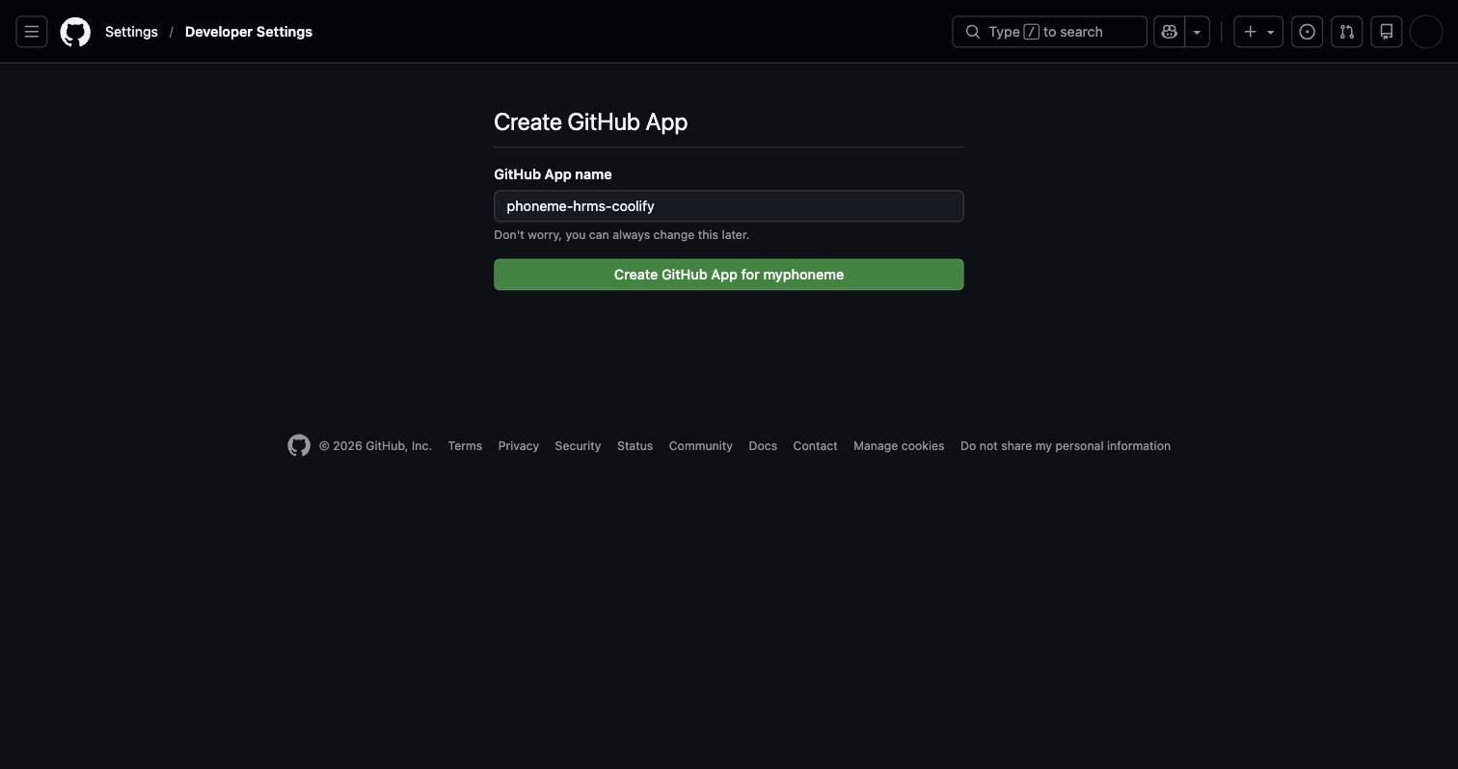
Figure A.4 — GitHub's own confirmation page: “Create GitHub App for <org>.”
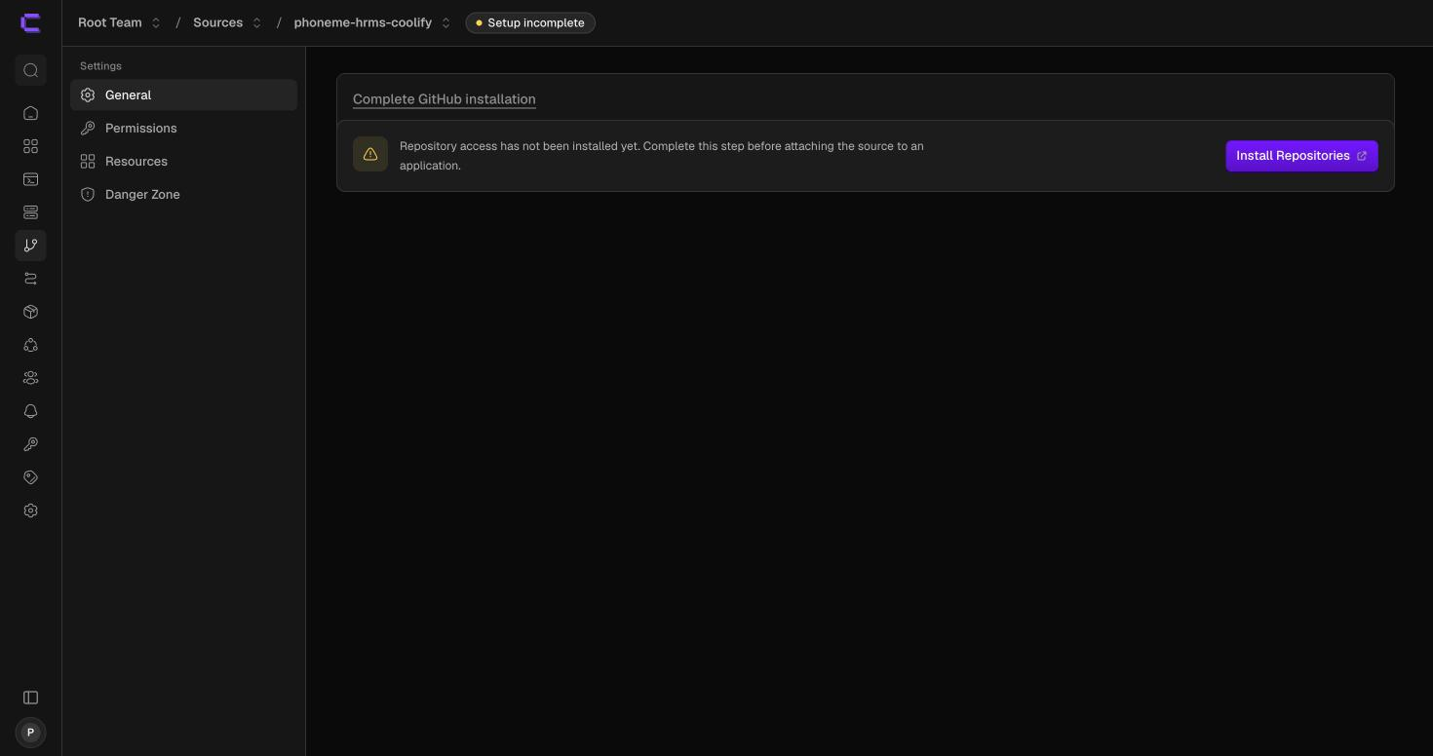
Figure A.5 — Back in Coolify: the App is registered but repository access isn't installed yet.
On GitHub's install screen, choose “Only select repositories” and pick just the one product repository — least-privilege access, rather than granting the App every repository in the account.
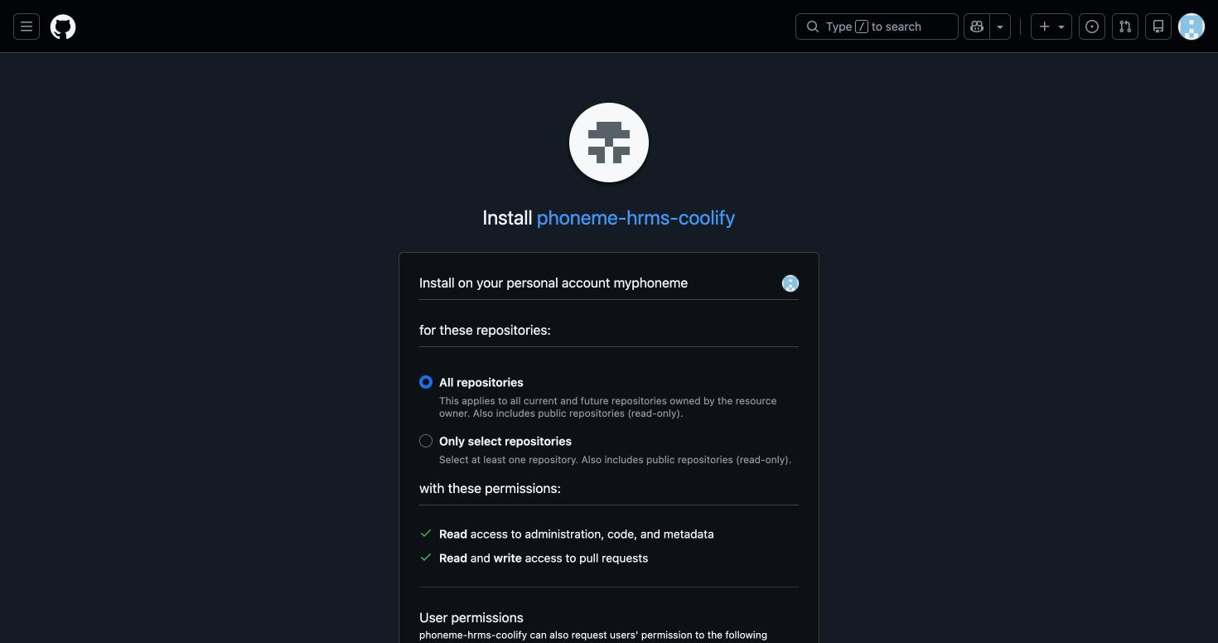
Figure A.6 — Repository selection: “Only select repositories”, myphoneme/hrms chosen.
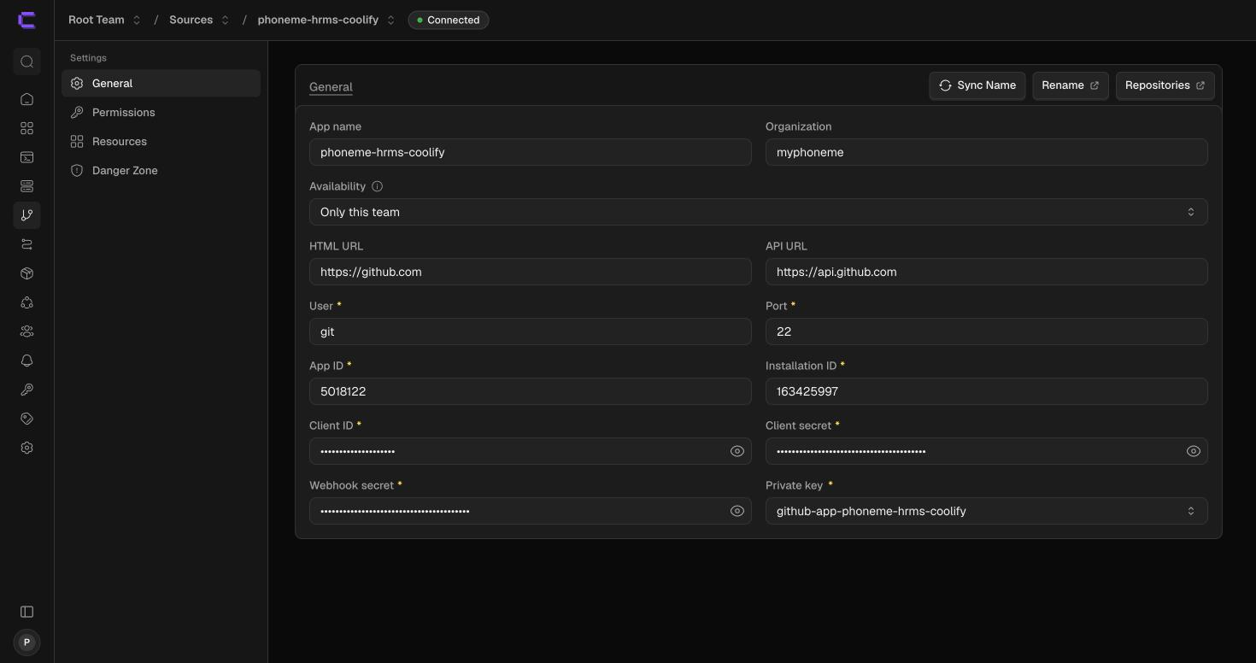
Figure A.7 — Source shows “Connected” with App ID, Installation ID, and credentials populated.
- Field note: GitHub's own redirect after registering the App and after installing repositories both point back at Coolify's public-IP webhook endpoint. If that public IP isn't reachable from the browser doing the setup (firewalled, or the browser has no outbound route to it), swap the IP in the redirect URL for the server's private/LAN IP before loading it — the same Coolify instance answers on both, and the setup continues normally from there.

A.2 Project and Environments
Projects → New Project creates a project shell; rename it to the product name. Every project starts with one “production” environment — add a second “staging” environment alongside it.
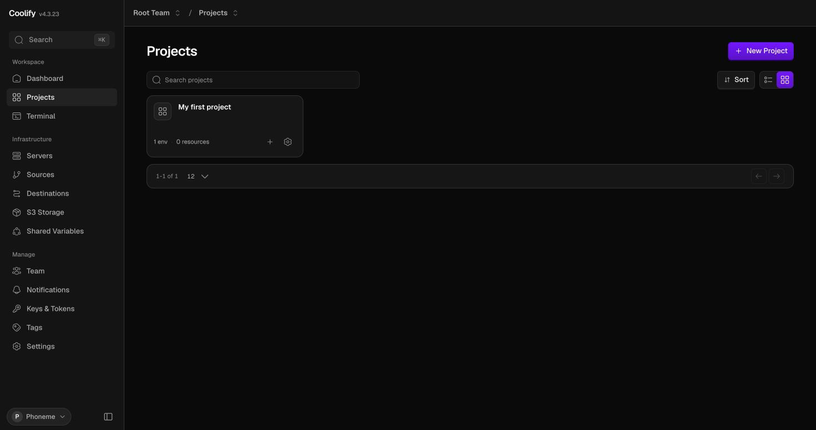
Figure A.8 — Projects list, default-named project before renaming.
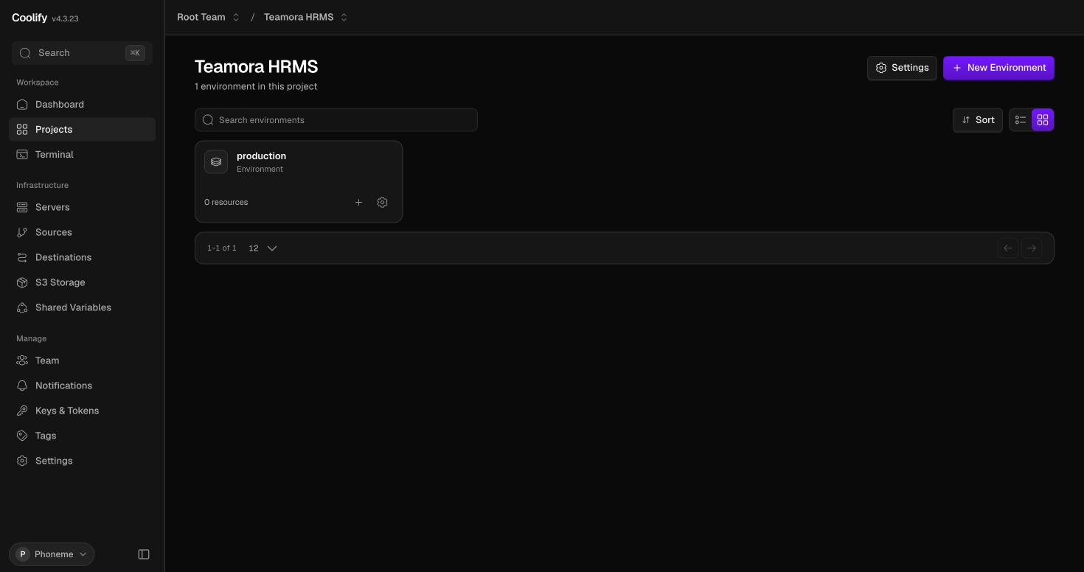
Figure A.9 — Project renamed to “Teamora HRMS”, showing its “production” environment.
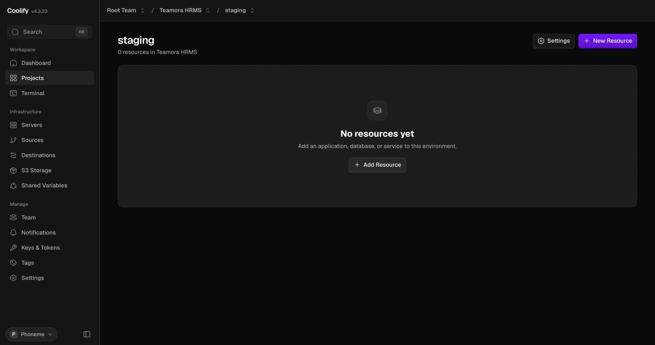
Figure A.10 — “staging” environment added, no resources yet.

A.3 Creating the Applications
Within each environment, Add Resource → Applications offers several source types; for a GitHub-App-connected repository, “Git Repository (with GitHub App)” is the correct choice for both the staging and production application.
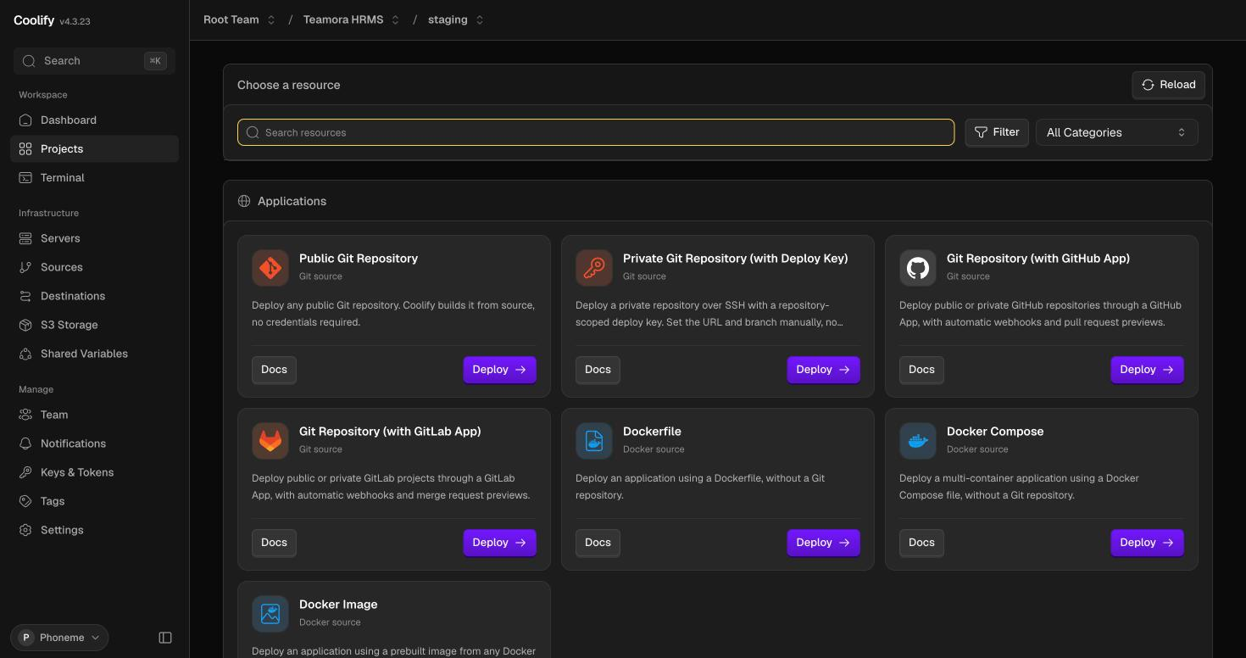
Figure A.11 — Resource catalog: Public/Private Git, GitHub App, GitLab App, Dockerfile, Docker Compose, Docker Image.
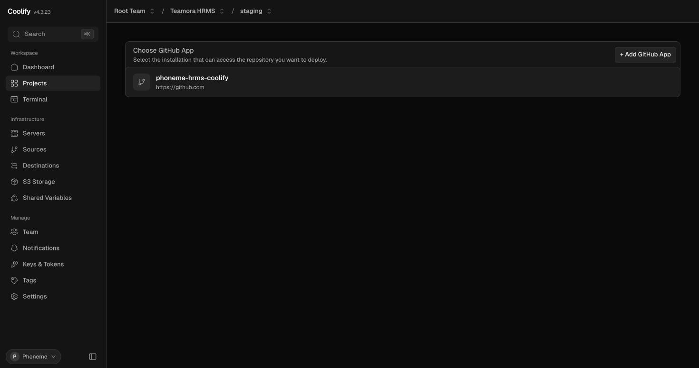
Figure A.12 — Selecting the connected GitHub App as the source.
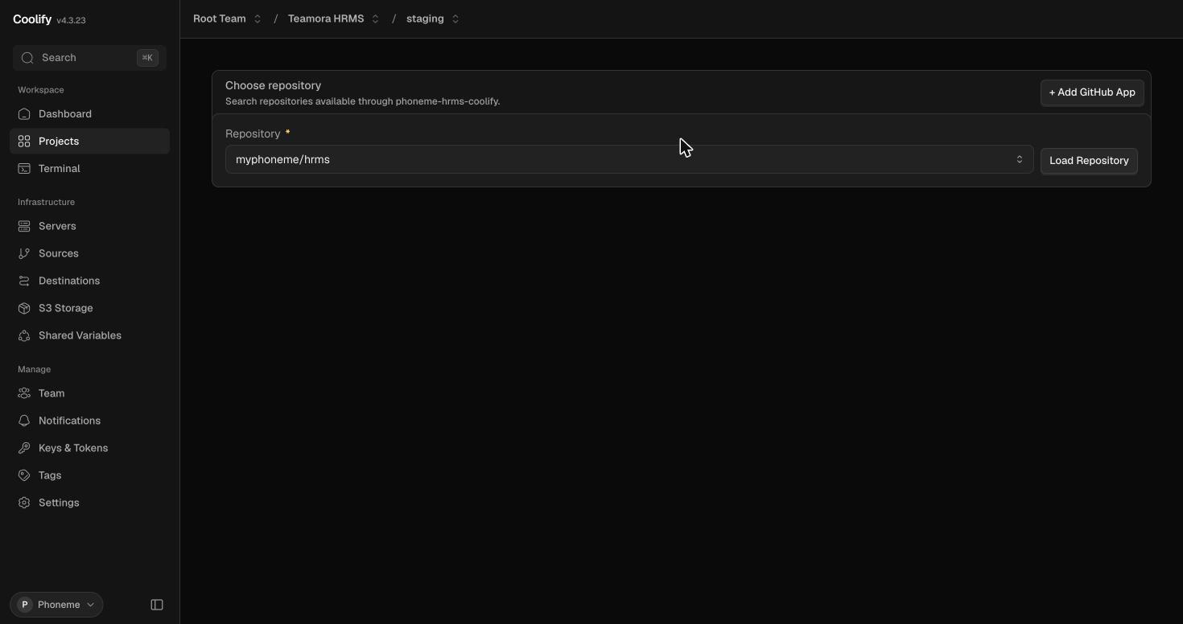
Figure A.13 — Repository picker, scoped to only the repositories the App was installed against.
Set the Branch field explicitly — it defaults to the repository's default branch (main), which is correct for the production application but must be switched to staging for the staging application once that branch exists on GitHub.
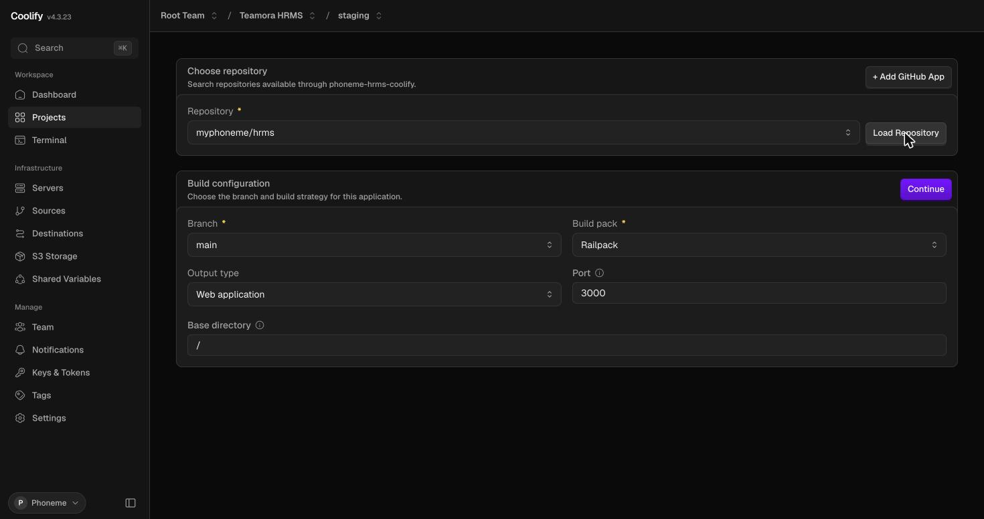
Figure A.14 — Build configuration for the staging application. Branch shown as main because the staging branch had not yet been pushed to GitHub at setup time — switch this to staging once it exists.
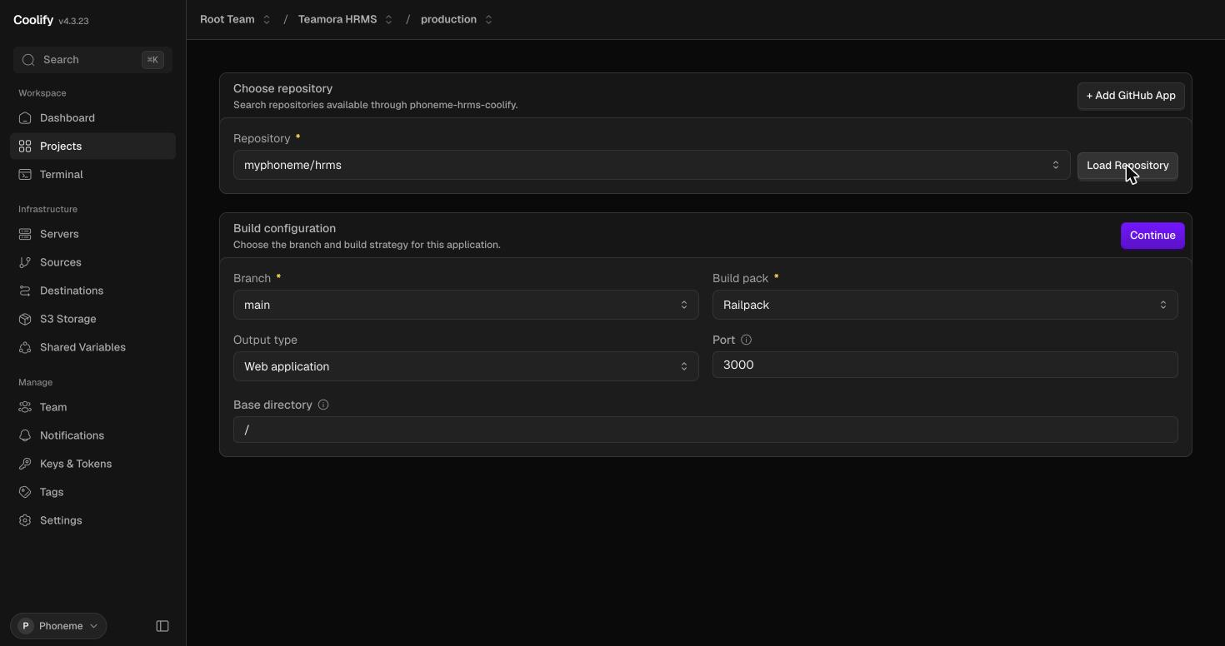
Figure A.15 — Build configuration for the production application, Branch correctly set to main.
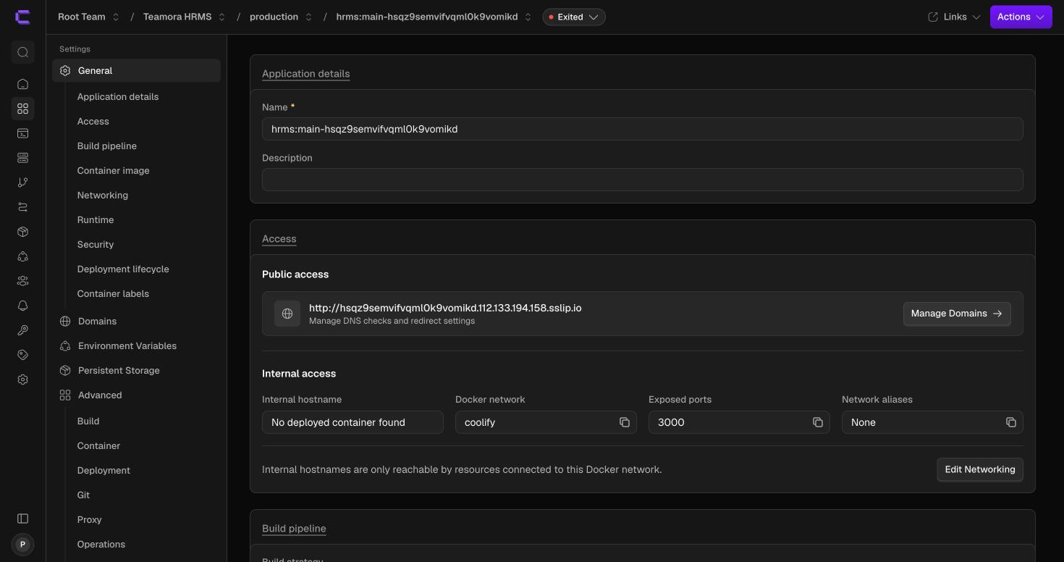
Figure A.16 — Application created: General/Access tab, showing the auto-generated public URL and internal Docker networking details.
Two settings are then changed away from their defaults on every application: the auto-generated resource name is replaced with a clear one (e.g. hrms-production / hrms-staging), and Auto Deploy (Advanced → Git) is set per Section 8.3 — “Deploy on push (webhooks)” for staging, “Manual deployments only” for production.
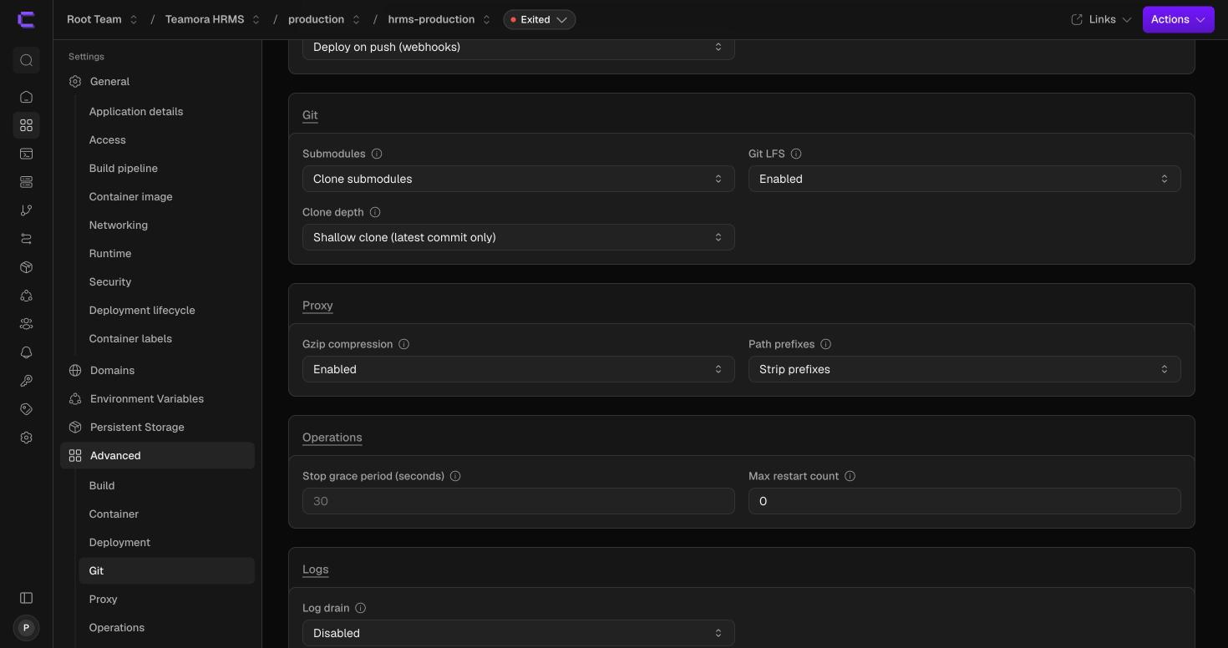
Figure A.17 — Advanced settings: Deployment / Git sections, showing the Auto deploy field.
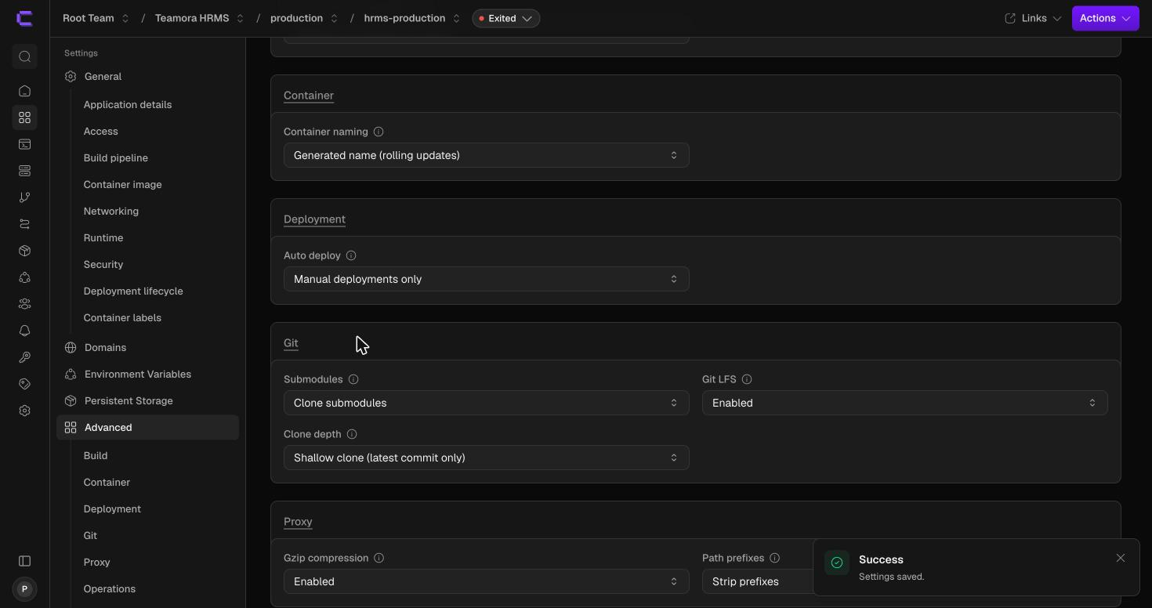
Figure A.18 — Production application: Auto deploy switched to “Manual deployments only” and saved.
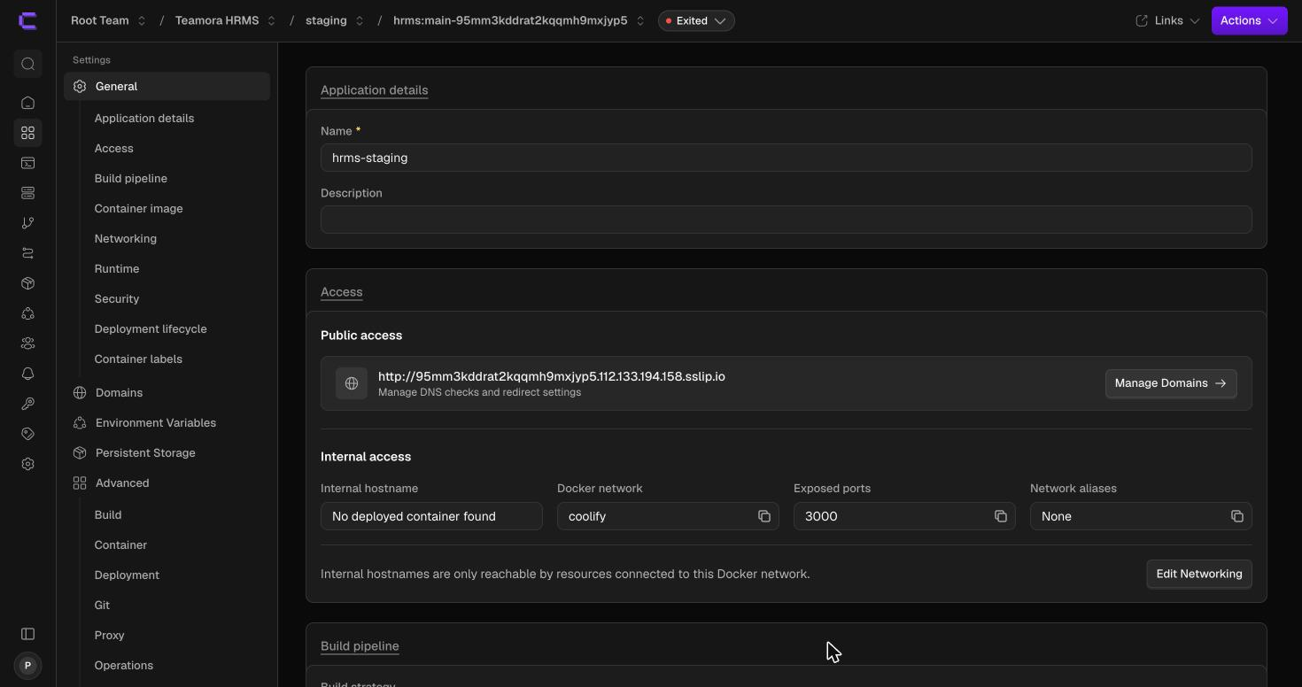
Figure A.19 — Staging application renamed to hrms-staging and saved.

Appendix B — Project Monitoring Dashboard Setup (Screenshot Walkthrough)
This appendix records the as-built setup of Section 8.4's Project Monitoring Dashboard for Teamora HRMS: the GitHub Projects board used for requirement/stage tracking, the self-hosted Kiwi TCMS deployment used for test case management — the Section 7.2 lightweight alternative, chosen over Jira + Zephyr Scale for this product's rollout — and, as of v1.5, the Requirement Approval stage that brings the BRD/PRD sign-off gate (Section 5.0) into the same board.

B.1 GitHub Projects Board
Projects → New Project, named “Teamora HRMS - SDLC Tracker”. The board view's columns were renamed and reordered to mirror Section 5's Stage 0–6 workflow, and each column was given a description citing the exact SOP section it represents — Requirement Approval (Stage 0 / Sec. 5.0), Backlog (awaiting a REQ-ID assignment, post-approval), In Development (Stage 1 / Sec. 5.1), QA on Staging (Stages 2–4 / Sec. 5.2–5.4), Released to Production (Stages 5–6 / Sec. 5.5–5.6).
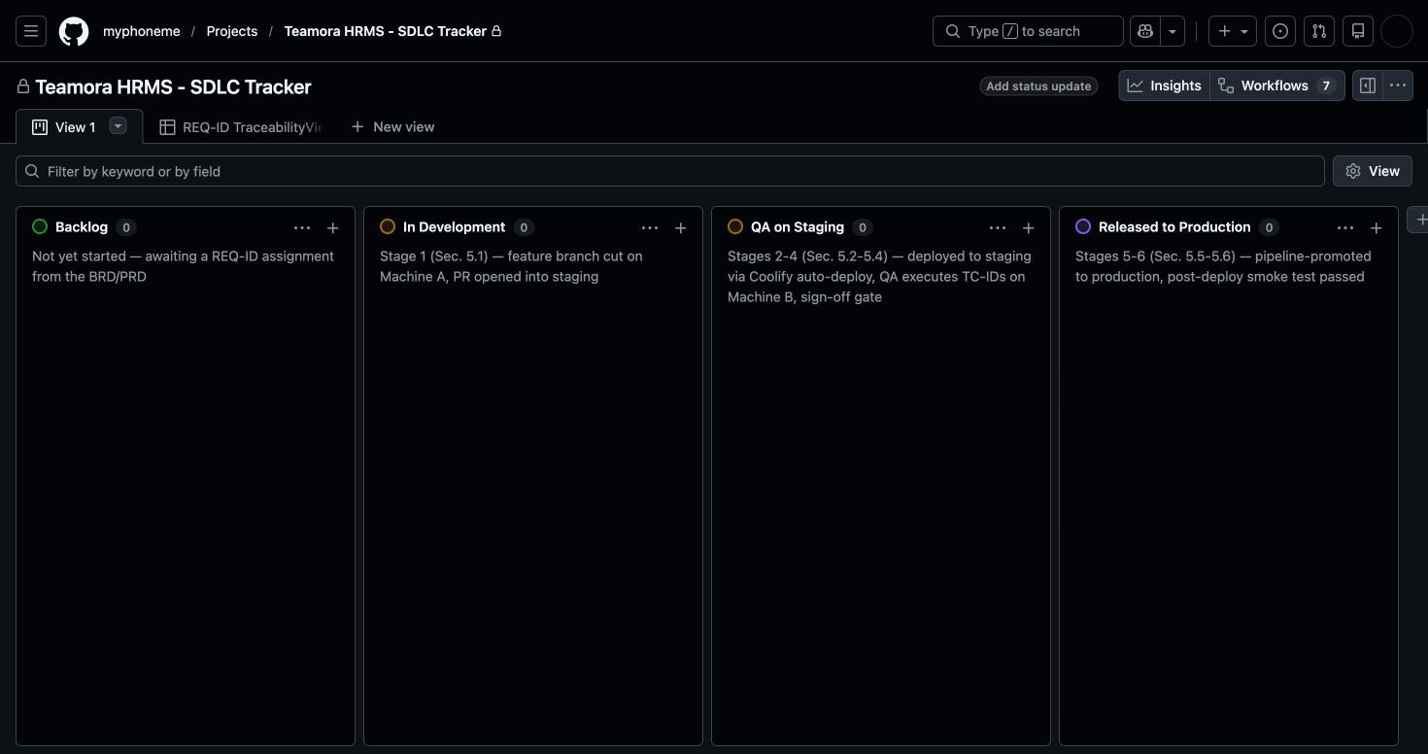
Figure B.1 — Board view: Backlog → In Development → QA on Staging → Released to Production, each column's description citing its SOP stage/section.
A second view (table layout) adds three custom Project fields so every tracked item carries the same REQ-ID ↔ TC-ID linkage Section 4.2/6 requires: REQ-ID (text), TC-ID(s) (text), and Priority (single select — Critical/High/Medium/Low).
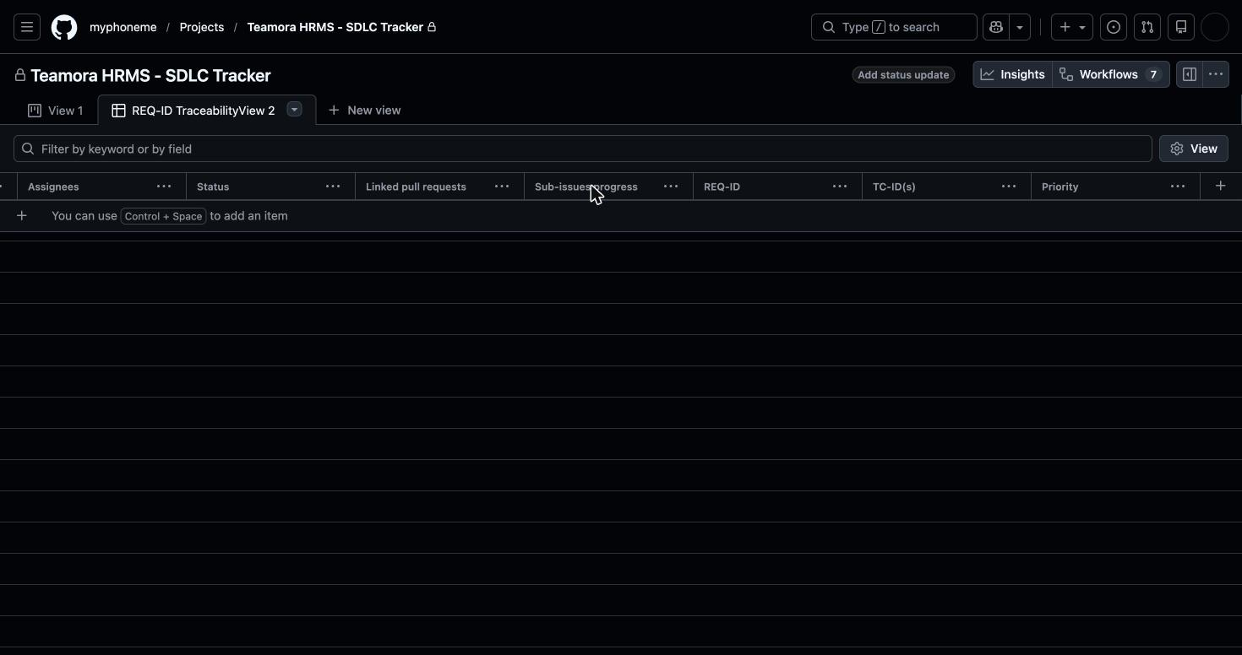
Figure B.2 — Table view, scrolled to show the custom REQ-ID, TC-ID(s), and Priority fields alongside GitHub's built-in Status/Assignees/Linked-pull-requests columns.

B.2 Kiwi TCMS — Self-Hosted Test Case Management
A new “tools” Coolify environment was added under the same “Teamora HRMS” project used for staging/production (Section 8.3) — kept separate so operations on Kiwi TCMS never touch the application environments. Within it, Add Resource → Docker Compose was used to deploy Kiwi TCMS directly from a compose file (web + MariaDB services), rather than as a Git-connected application, since Kiwi TCMS is a third-party tool with no Phoneme source to track.
- The compose file's database credentials use Coolify's auto-generated secret syntax (${SERVICE_PASSWORD_MYSQLROOT} for the MariaDB root password, ${SERVICE_PASSWORD_MYSQL} for the application user) rather than hand-set values — Coolify generates and persists these once, on first deploy.
- The upstream project's own test-only nginx proxy and its direct host port bindings (80/443) were both removed from the compose file before deploying — the host ports would collide with Traefik, Coolify's own reverse proxy, which already owns 80/443 on this server. The web service's container port 8080 is instead routed through Coolify's proxy via a normal domain assignment, the same mechanism used for the hrms-staging/hrms-production applications in Appendix A.
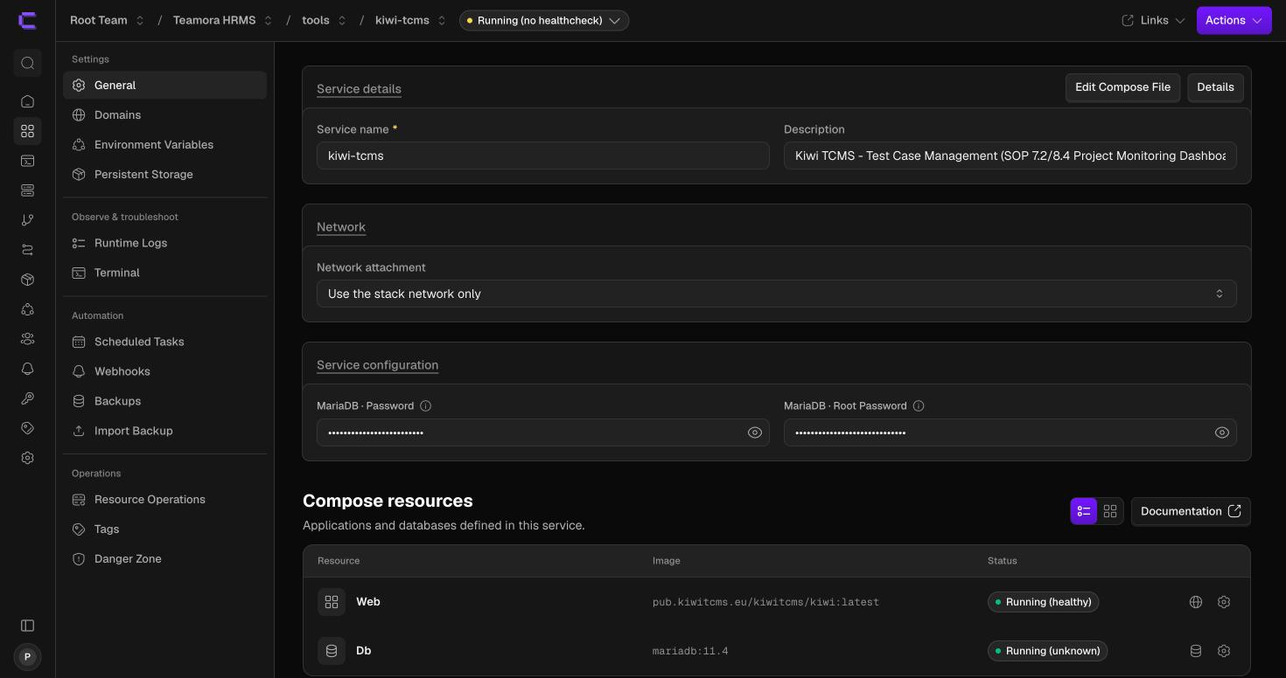
Figure B.3 — Kiwi TCMS service in the “tools” environment: web container Running (healthy), db (MariaDB) container Running (no built-in healthcheck, expected).
- Field note: the domain Coolify auto-generates for a new resource uses the server's public IP as Coolify detects it, which may not always be the address actually reachable from outside the server's own network — the same class of private/public-IP mismatch already noted for the Coolify dashboard itself in Appendix A.1's field note. Verify a freshly assigned domain loads before relying on it, and fall back to the server's LAN address/port if it doesn't.

B.3 Requirement Approval Stage — BRD/PRD Gate (v1.5)
Added to the board so Stage 0 (Section 5.0) is tracked in the same single window as every later stage, rather than the BRD/PRD approval process living entirely outside the dashboard as it did through v1.4.
- Board view: a new “Requirement Approval” column was created (purple label) and moved to the leftmost position via the column's “...” menu → Move left, repeated until it sits before Backlog. Its description reads: “Sec. 1.2/8.4 — BRD/PRD Prepared/Reviewed/Approved gate (phoneme-brd-prd), before any REQ-ID moves to Backlog” — naming both the skill that produces the document and the SOP sections that govern the gate.
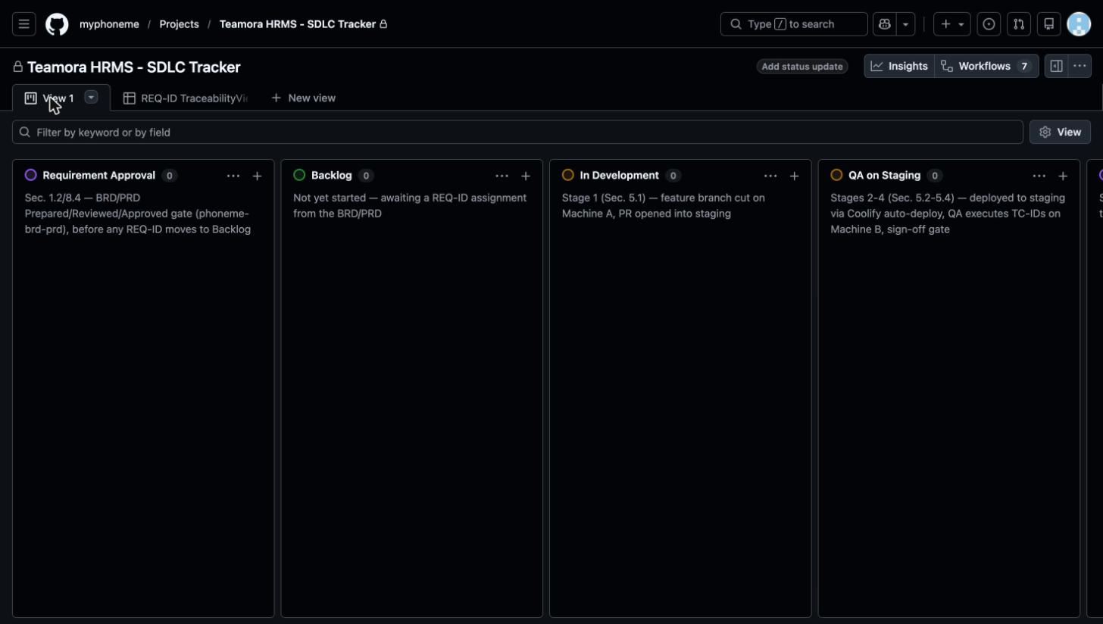
Figure B.4 — Board view with the five reordered columns: Requirement Approval → Backlog → In Development → QA on Staging → Released to Production.
- Table view: a new project field, Approval Status, was created via the table's “+ Add field” → “Create a project field” path (not the “Add issue fields” modal, which only surfaces org-level Issue Fields and does not apply here) — Field type Single select, with five options: Draft, Prepared, Reviewed, Approved, Rejected, matching Section 5.0's status progression.
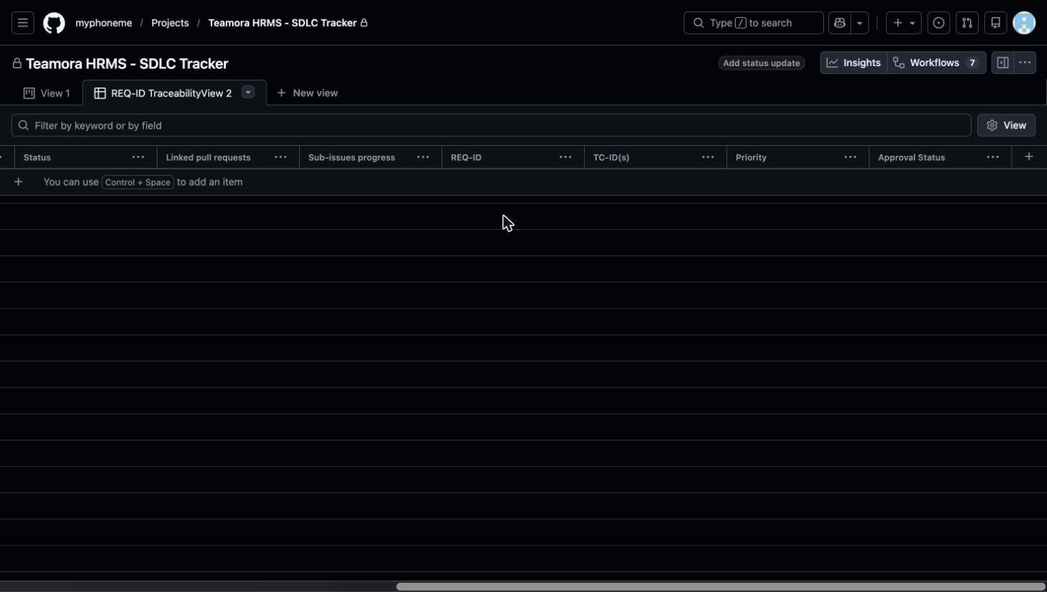
Figure B.5 — Table view (REQ-ID TraceabilityView) with the new Approval Status field alongside the existing REQ-ID, TC-ID(s), and Priority fields.
- Working convention: a REQ-ID's card sits in the Requirement Approval column with Approval Status advancing Draft → Prepared → Reviewed → Approved (or Rejected) as the BRD/PRD's own sign-off proceeds; only once it reaches Approved is the card moved into Backlog for Stage 1 pickup. The GitHub Projects status is a mirror of that sign-off, not the record of it — the BRD/PRD document itself remains the authoritative approval record, per Section 8.4.

Appendix C — Requirement Review Pipeline (As-Built)
This appendix records the as-built docs-as-code setup of Section 8.7's publish-for-review pipeline, first run against Teamora HRMS's BRD/PRD v2.4 (PHN-HR-2026-01-BRDPRD). Two earlier approaches were evaluated and rejected before this one: a manually-copied live document had no diffable history and no native reviewer-attribution, and a self-hosted e-signature tool (DocuSeal/Documenso) fit a one-shot final signature but not an iterative, in-progress review-and-revise cycle — see the Change Log's v1.7 entry.

C.1 Site and Pipeline
- A docs-site/ folder was added to the myphoneme/hrms repository: docs-site/mkdocs.yml (MkDocs, Material theme — tables, admonitions, and a permalinked table of contents enabled) and docs-site/docs/, containing docs/index.md (the review portal's landing page, explaining the 5-step review/sign-off flow and listing every published document with its current status and REQ-ID range) and docs/brd-prd/teamora-v2.4.md (the BRD/PRD's full content, converted from the .docx of record to GitHub-Flavored Markdown, tables and all).
- A GitHub Actions workflow (.github/workflows/docs-review.yml) drives publishing: on any pull request touching docs-site/, it builds the MkDocs site and deploys it to the gh-pages branch under a per-PR path (gh-pages/pr-<number>/), then comments the preview URL onto the PR automatically. On a push/merge to main, the same build deploys to the root of gh-pages — the signed-off, published copy at https://myphoneme.github.io/hrms/.
- GitHub Pages was left on its default per-repository configuration (Settings → Pages → Deploy from a branch → gh-pages), which is enough to serve both the PR-preview subpaths and the root published copy from the one branch, with no separate hosting account or Coolify container to provision or secure for this step.

C.2 First Run — BRD/PRD v2.4
- Branch review/brd-prd-v2.4 was opened as a pull request into main, carrying the converted Markdown, the MkDocs config, and the workflow itself. The Requirement Approval card's Review Link field on the dashboard (Section 8.4/Appendix B) points at this pull request rather than a static document link, since the PR is both the review surface and the sign-off record.
- Team-lead review happens as inline comments on the PR's Files Changed diff, anchored to the exact REQ-ID/line in question — GitHub's own review-comment mechanism, permanently attributed and timestamped without any custom tooling.
- Fold-back is a further commit to the same branch addressing each comment; once every review thread is marked resolved, the Approval Status field (Section 8.4/Appendix B.3) is moved from Prepared to Reviewed.
- The Product Owner's final sign-off is the Approve review + Merge pull request action on GitHub — the merge event itself, which GitHub records against the PO's account and a timestamp. Immediately after, the .docx of record is re-versioned (v2.4 → v2.5) per the phoneme-brd-prd skill's Change Log convention with the same name/date transcribed into its Authorization table, and the dashboard's Approval Status is set to Approved, releasing the REQ-ID(s) into Backlog per Section 5.0.
- Field note: the published site is a read/review surface, not an independent system of record — the pull request's merged diff is. If the .docx of record and the published Markdown ever disagree, the merged PR history is authoritative, and the next .docx revision is what gets re-converted and re-published, never a hand-edit to the live site.

