

Phoneme HR Suite
Module 1 & 2 — Technical Design Document

TECHNICAL DESIGN (HLD/LLD)

PROJECT CODE: PHN-HR-2026-01-TDD-M1M2
September 2026
Submitted by: Phoneme Solutions Pvt. Ltd.
Security Classification: Confidential — Internal

Document Control
Field | Value
Document Description | Technical Design Document (HLD/LLD) — Phoneme HR Suite, Module 1 (JD Intake & Freezing) and Module 2 (Sourcing & Resume Aggregation)
Identification | PHN-HR-2026-01-TDD-M1M2, Version 1.1
Security Classification | Confidential — Internal
Location | HR Management project workspace

Authorization
 | Name of the Person | Date
Prepared by | Anuj (with drafting support) | 10-Sep-2026
Reviewed by | Pending | Pending
Approved by | Pending | Pending

Change Log
Version | Date | Section | A/M/D | Description | Reviewed By
1.0 | 10-Sep-2026 | All | A | Initial Technical Design for Module 1 and Module 2, following requirements lock in the BRD/PRD | Pending
1.1 | 15-Sep-2026 | 3, 4, 6.2, 10, 12 | A | Added AAA/Session Management, Key Management, consolidated Data Schema (ER diagram), Data Flow Diagram, and Object Flow Diagram (JobRequisition state machine) | Pending

Client Sign Off
Stakeholder Name | Role | Sign Off Date | Communication

Confidentiality Agreement
This document is copyrighted, and all rights are reserved. This document may not, in whole or in part, be copied, photocopied, reproduced, translated, or reduced to any electronic medium or machine-readable form without prior consent, in writing. This document is for internal use only and may, in whole or in part, be provided to anyone outside of the Company, including customers, clients, or prospects after taking an approval from an authorized representative.

Table of Contents

1. Introduction
1.1 Purpose
1.2 Scope
1.3 References
1.4 Abbreviations
2. System Context & Architecture Overview
3. AAA — Authentication, Authorization & Session Management
4. Key Management
5. Data Model — Module 1 (JD Intake & Freezing)
6. Data Model — Module 2 (Sourcing & Resume Aggregation)
7. API Contracts — Module 1
8. API Contracts — Module 2
9. Integration Specifications
10. Data Flow Diagrams
11. Sequence Flows
12. Object Flow Diagram — JobRequisition Lifecycle
13. Non-Functional / Technical Considerations
14. Error Handling & Edge Cases
15. Open Technical Decisions / Dependencies

1. Introduction

1.1 Purpose
This Technical Design Document (TDD) specifies the data model, API contracts, integration mechanics, and sequence flows for the two modules whose requirements are locked in the companion BRD/PRD (PHN-HR-2026-01-BRDPRD): Module 1 — Job Description (JD) Intake & Freezing, and Module 2 — Candidate Sourcing & Resume Aggregation. It is the engineering handoff artifact for these two modules; it does not restate business rationale, which lives in the BRD/PRD.

1.2 Scope
In scope: entity/field-level data model, REST API contracts, third-party integration specifications (Naukri RMS, LinkedIn Recruiter API, email intake, resume/NLP parsing), sequence flows, and the technical non-functional considerations specific to these two modules. Out of scope: UI/screen design (a separate UX specification), and the data model/APIs for Modules 3–10, which will be issued as their own Technical Design documents once each module's requirements are locked.

1.3 References
- BRD/PRD — Phoneme HR Suite: Candidate Search to Onboarding Module (PHN-HR-2026-01-BRDPRD), Section 4.1 and 4.2 — the locked feature lists and locked decisions this design implements.
- Naukri RMS (Recruiter Management System) employer API documentation.
- LinkedIn Recruiter / Talent Solutions API documentation (OAuth2 authorization-code flow).

1.4 Abbreviations
Term | Meaning
TDD | Technical Design Document
NLP | Natural Language Processing
RMS | Recruiter Management System
SLA | Service Level Agreement
JD | Job Description
PII | Personally Identifiable Information

2. System Context & Architecture Overview
Both modules sit behind the tenant-aware API layer described in the BRD/PRD's solution overview. Module 1 owns the requisition and JD lifecycle; Module 2 owns candidate intake and dedupe. Module 1's freeze action is the trigger that hands a requisition to Module 2 (publish to sourcing channels); Module 2's unified candidate record is the entry point for Module 3 (Screening & Shortlisting, out of scope here).

Component Overview
Component | Owns | Consumes / Produces
Requisition Service | JobRequisition lifecycle, approval state | Produces requisition.frozen event consumed by Publish Service
JD Generation Service | NLP extraction, multi-variant JD generation | Consumes raw briefs; produces JDVersion records
Scoring Matrix Service | Weighted matrix generation and storage | Triggered by requisition freeze; produces ScoringMatrix + ScoringCriterion records
Publish Service | Fan-out of a frozen requisition to configured sourcing channels | Consumes requisition.frozen; calls channel adapters
Channel Adapters (Naukri RMS, LinkedIn, Email, Manual, Referral) | Per-channel ingestion/posting logic | Produce raw candidate/application payloads
Resume Parsing Service | Structured field extraction from resume files | Consumes raw resume files; produces parsed candidate JSON
Dedupe Service | Duplicate candidate detection | Consumes parsed candidate records; produces DuplicateMatch records
Candidate Store / Unified Inbox Index | Canonical Candidate and Application records | Serves search/filter queries for the unified resume inbox

Architecture Diagram
The diagram below shows the component layout for Module 1 and Module 2 within the wider platform: client layer, API gateway, the two modules' internal services, the cross-cutting platform services (Auth, Key/Secrets Management, Audit, Notification), and the shared per-tenant data layer.
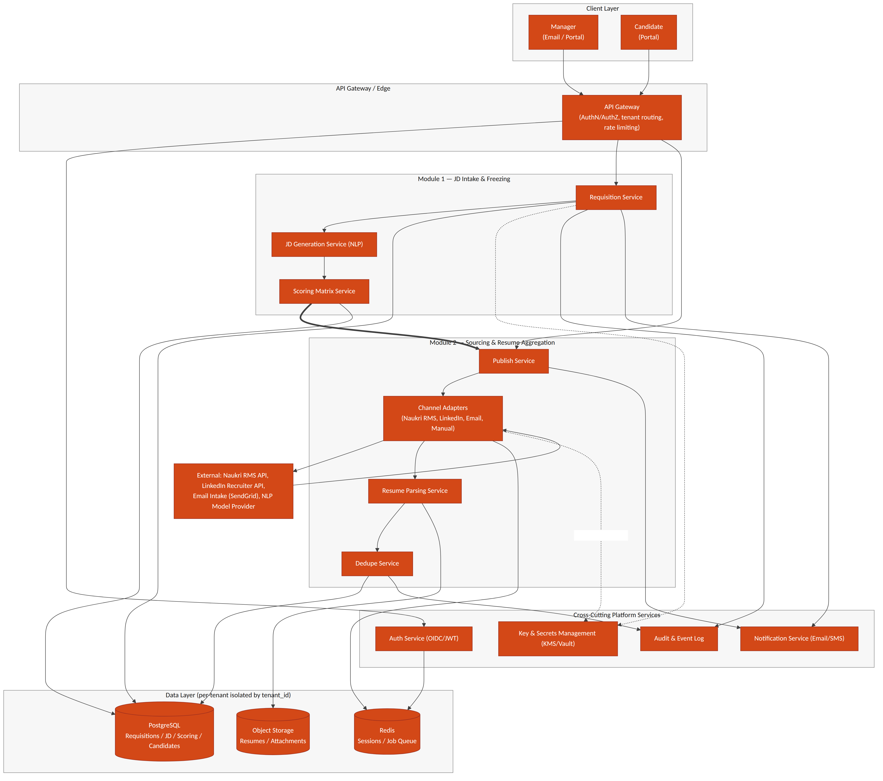
Figure 2.1 — System architecture: Module 1 & 2 components, cross-cutting services, and data layer

3. AAA — Authentication, Authorization & Session Management
Authentication, authorization, and session handling are platform-wide services consumed by every module, not module-specific logic. This section defines the pattern Module 1 and Module 2 build against; it becomes the standard for all subsequent modules.

3.1 Authentication
- OIDC-based login for managers/HR/recruiters via a tenant-scoped identity provider (supports tenant SSO where the customer has one, or a Phoneme-managed identity pool otherwise).
- Candidates authenticate separately via a magic-link / OTP flow tied to their application record — no password, no standing account.
- All tokens carry a tenant_id claim; the API Gateway rejects any request where the token's tenant_id does not match the tenant context of the resource being accessed.

3.2 Authorization
- Role-based access control (RBAC) at the API Gateway and service layer: roles at minimum include Manager, Recruiter/HR, Tenant Admin, Candidate, and Phoneme Platform Admin (break-glass, fully audited).
- Authorization is evaluated per-request against (tenant_id, role, resource) — a Manager can only freeze/edit requisitions in their own department unless granted a broader scope by the Tenant Admin.
- Field-level authorization: PII fields (e.g. candidate salary expectations, BGV data in later modules) are visible only to roles explicitly entitled to them, independent of general resource access.

3.3 Session Management
Session state is server-side (Redis-backed) so that revocation is immediate and centrally enforceable — a design choice over purely stateless JWT validation, which cannot be revoked before expiry.
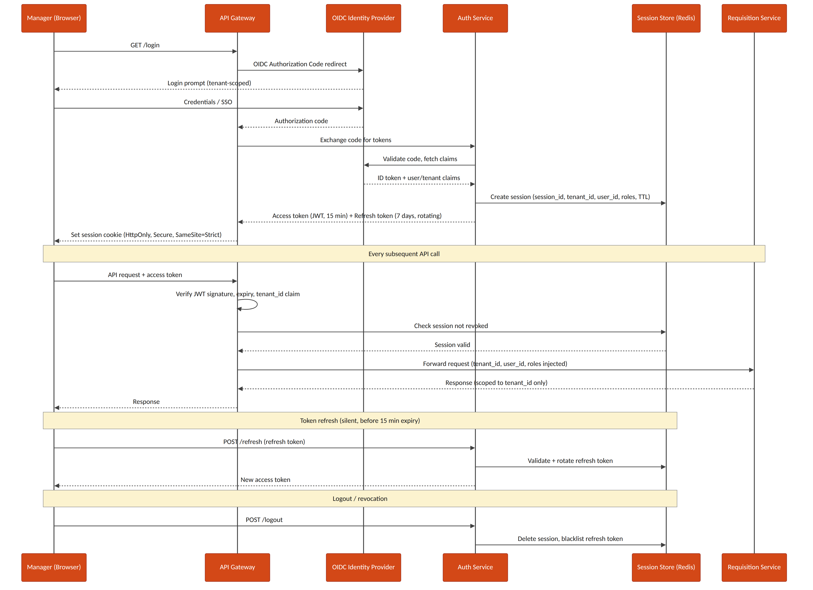
Figure 3.1 — Manager login, per-request AuthN/AuthZ check, token refresh, and logout/revocation sequence
- Access tokens: short-lived JWT (15 minutes), signature-verified at the gateway on every request.
- Refresh tokens: 7-day validity, rotating on each use (old refresh token invalidated the moment a new one is issued) to limit replay risk.
- Session cookie: HttpOnly, Secure, SameSite=Strict — never exposed to page JavaScript.
- Logout and administrative revocation both delete the Redis session record and blacklist the associated refresh token immediately.

4. Key Management
Every channel credential (Naukri RMS, LinkedIn Recruiter API keys), and every PII field stored at rest, is protected through a cloud KMS plus a secrets-manager layer rather than application-level static secrets.
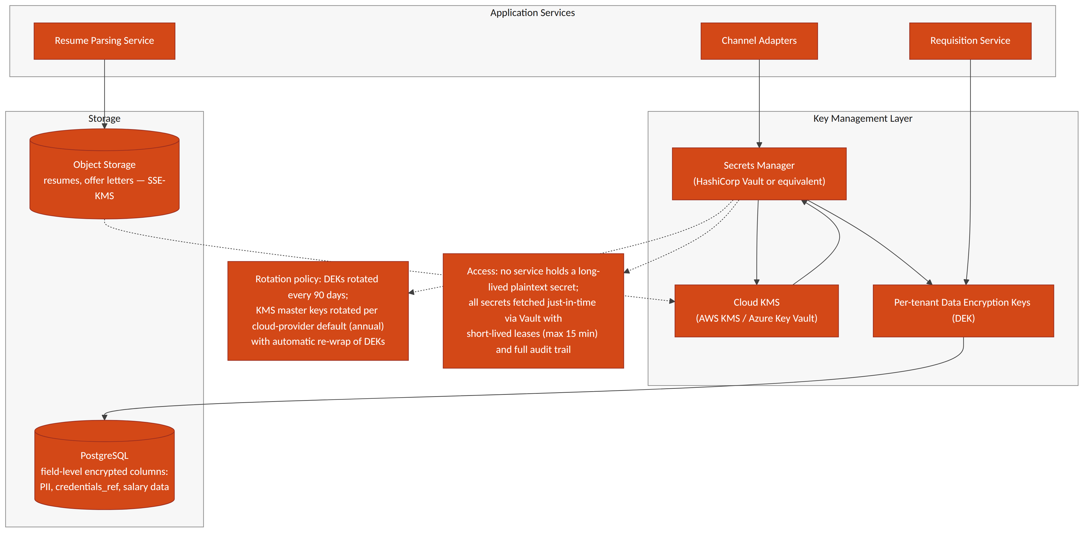
Figure 4.1 — Key management layer: KMS, secrets manager, per-tenant data-encryption keys, and encrypted storage

4.1 Principles
- No service ever holds a long-lived plaintext secret. Channel credentials are fetched just-in-time from the secrets manager (HashiCorp Vault or the cloud-native equivalent) with short-lived leases (max 15 minutes).
- Envelope encryption: a cloud KMS (AWS KMS / Azure Key Vault) holds the master key; per-tenant Data Encryption Keys (DEKs) are generated, wrapped by the master key, and used to encrypt tenant data — the master key itself never leaves the KMS.
- PII and sensitive fields (SourcingChannelConfig.credentials_ref, candidate salary/compensation data introduced in later modules) are encrypted at the column level in PostgreSQL using the tenant's DEK; resumes and offer documents in object storage use server-side encryption (SSE-KMS).

4.2 Rotation & Audit
- Per-tenant DEKs are rotated every 90 days with automatic re-wrap of existing encrypted data; KMS master keys rotate on the cloud provider's default schedule (typically annual).
- Every secret access is logged to the Audit & Event Log with requester identity, tenant_id, and purpose — required both for SOC2-style controls and for DPDP Act accountability obligations.
- Credential rotation for a sourcing channel (e.g. a new Naukri RMS API key) is a Tenant Admin action that writes a new SourcingChannelConfig.credentials_ref without any service restart.

5. Data Model — Module 1 (JD Intake & Freezing)

JobRequisition
Field | Type | Notes
id | UUID (PK)
tenant_id | UUID (FK) | Every query scoped by this field — see BRD/PRD architecture note
department_id | UUID (FK) | Nullable if not supplied in the brief; flagged for manager confirmation
status | enum | Draft | PendingApproval | Revising | Frozen_Open | OnHold | Closed
created_by | UUID (FK -> User) | The manager who submitted the brief
created_at / updated_at | timestamp

JDBrief (raw intake)
Field | Type | Notes
id | UUID (PK)
requisition_id | UUID (FK)
raw_text | text | Verbatim manager brief
source | enum | email | portal
received_at | timestamp

JDField (NLP-extracted structured fields)
Field | Type | Notes
id | UUID (PK)
requisition_id | UUID (FK)
field_name | enum | role_title | experience_range | education_pref | comp_band | job_role_tag | must_have_skills | domain_competencies | soft_skills | department | target_start_date
field_value | text / JSON
confidence_score | decimal (0–1) | Below tenant-configured threshold (default 0.75) → manager_confirmed forced false
manager_confirmed | boolean | Gate before this field can feed a frozen JD

JDVersion
Field | Type | Notes
id | UUID (PK)
requisition_id | UUID (FK)
version_no | integer | Monotonically increasing per requisition
variant_type | enum | formal | candidate_friendly | condensed | manager_edited
content | text
generated_by | enum | system | manager
is_frozen | boolean | True on exactly one version per requisition, and immutable once set
created_at | timestamp

ScoringMatrix / ScoringCriterion
Field | Type | Notes
ScoringMatrix.id | UUID (PK)
ScoringMatrix.requisition_id | UUID (FK) | One matrix per frozen requisition
ScoringMatrix.frozen_at | timestamp | Set only after manager confirms weights
ScoringCriterion.id | UUID (PK)
ScoringCriterion.matrix_id | UUID (FK)
ScoringCriterion.category | enum | core_skills | experience_seniority | domain_competency | behavioral_proxy | education_fit
ScoringCriterion.criterion_name | text | e.g. "Power BI proficiency"
ScoringCriterion.weight_percent | decimal | All criteria for a matrix sum to 100
ScoringCriterion.source_field_ref | UUID (FK -> JDField) | Traceability back to the JD field that generated this criterion

6. Data Model — Module 2 (Sourcing & Resume Aggregation)

6.1 Entities

SourcingChannelConfig
Field | Type | Notes
id | UUID (PK)
tenant_id | UUID (FK)
channel_type | enum | naukri_rms | linkedin_recruiter | niche_board | email_intake | manual_upload | referral
credentials_ref | UUID (FK -> Secret store) | Never stored in plaintext in this table
is_active | boolean

Candidate
Field | Type | Notes
id | UUID (PK)
tenant_id | UUID (FK) | Reusable across requisitions within a tenant
name / email / phone | text | Primary dedupe keys
resume_file_ref | UUID (FK -> object storage)
parsed_json | JSONB | Structured output of the Resume Parsing Service
source_channel | enum | Matches SourcingChannelConfig.channel_type at first intake
created_at | timestamp

Application
Field | Type | Notes
id | UUID (PK)
candidate_id | UUID (FK)
requisition_id | UUID (FK)
status | enum | Feeds Module 3 pipeline stage — out of scope of this TDD beyond intake
applied_at | timestamp

DuplicateMatch
Field | Type | Notes
id | UUID (PK)
candidate_id_primary / candidate_id_duplicate | UUID (FK)
match_type | enum | exact_email | exact_phone | content_similarity
confidence_score | decimal (0–1) | See Section 13 for thresholds
resolved | boolean | True once a recruiter confirms or overrides the match

6.2 Consolidated Data Schema (Module 1 & 2)
The entity-relationship diagram below consolidates every table introduced in Sections 5 and 6 into a single schema view, showing primary/foreign-key relationships across the two modules — including how a frozen ScoringMatrix traces back to the JDField it was derived from, and how Candidate/Application/DuplicateMatch tie together for the unified inbox.
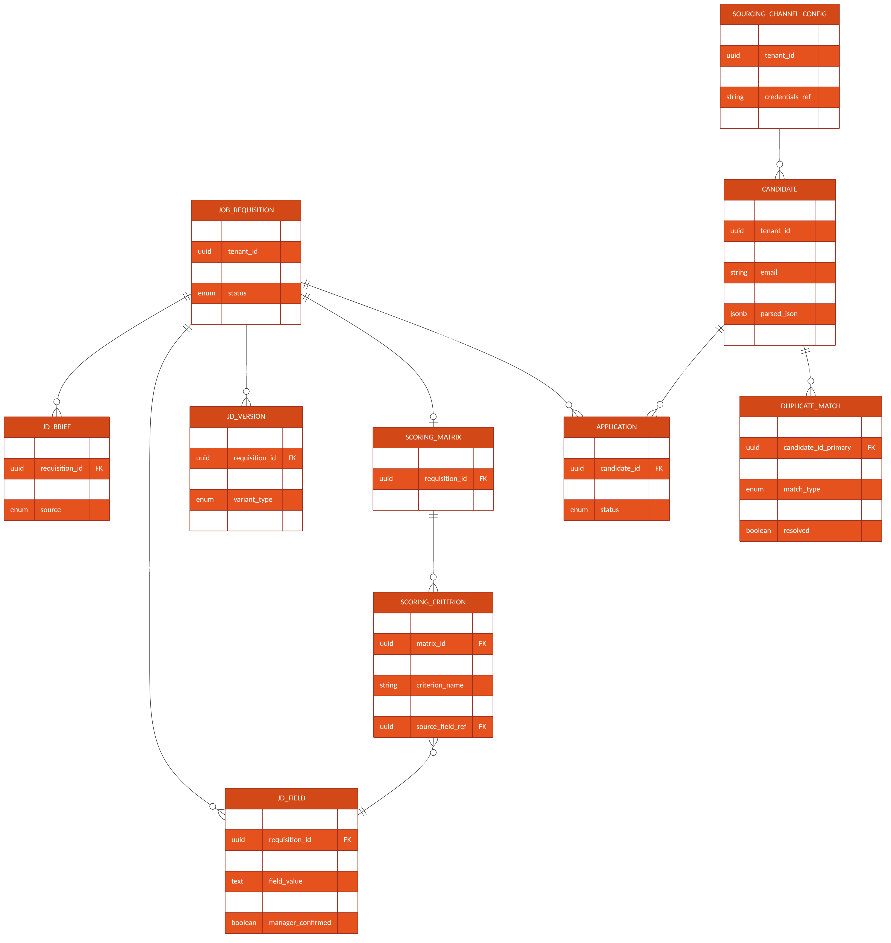
Figure 6.1 — Consolidated entity-relationship diagram, Module 1 & 2

7. API Contracts — Module 1

POST /api/v1/requisitions/intake
Creates a requisition from a manager's raw brief and kicks off NLP extraction.
Request: { "tenant_id": "uuid", "department_id": "uuid|null", "raw_brief_text": "string", "source": "email|portal" }
Response: 201 { "requisition_id": "uuid", "status": "Draft" }

GET /api/v1/requisitions/{id}/jd-versions
Lists all generated JD variants for a requisition, in version order.

POST /api/v1/requisitions/{id}/jd-versions/{versionId}/feedback
Submits manager feedback (email reply or portal form) for NLP parsing into a structured diff and a new draft version.
Request: { "feedback_text": "string", "source": "email|portal" }
Response: 202 { "new_version_id": "uuid", "status": "Revising", "low_confidence_fields": ["string", ...] }

POST /api/v1/requisitions/{id}/freeze
Freezes a JD version and confirms scoring-matrix weights in a single atomic action — matches the locked decision that freezing is a hard, immutable state change.
Request: { "approved_version_id": "uuid", "matrix_weights": [ { "criterion_id": "uuid", "weight_percent": number }, ... ] }
Response: 200 { "status": "Frozen_Open", "frozen_jd_version_id": "uuid", "scoring_matrix_id": "uuid" }
Errors: 409 if weights do not sum to 100; 409 if requisition is already frozen

GET /api/v1/requisitions/{id}/scoring-matrix
Returns the frozen scoring matrix for consumption by the Module 3 scoring engine.

8. API Contracts — Module 2

POST /api/v1/requisitions/{id}/publish
Triggered automatically on requisition freeze (or manually re-triggered by a recruiter); fans out to every active SourcingChannelConfig for the tenant.

POST /webhooks/naukri-rms/applications
Inbound webhook (or polling result) from Naukri RMS carrying a new application/resume.
Request (from Naukri RMS): { "external_application_id": "string", "requisition_external_ref": "string", "resume_url": "string", "applicant": { "name", "email", "phone" } }
Response: 202 { "candidate_id": "uuid", "application_id": "uuid", "duplicate_check": "queued" }

POST /webhooks/linkedin-recruiter/applications
Equivalent inbound contract for LinkedIn Recruiter/Talent Solutions.

POST /webhooks/email-intake/resume
Inbound-email-parse webhook: dedicated tenant intake address receives an email with a resume attachment; the email provider's inbound-parse service posts the parsed MIME payload here.

POST /api/v1/candidates/upload
Manual single/bulk upload path used by recruiters as the universal fallback for channels without an API.

GET /api/v1/candidates/search
Full-text and filtered search across the tenant's candidate pool — backs the unified resume inbox and Module 2's candidate database search feature.
Query params: q, skills[], experience_min, experience_max, source_channel[], requisition_id, page, page_size

9. Integration Specifications

9.1 Naukri RMS
- Auth: OAuth2 client-credentials, per-tenant contracted employer account.
- Direction: confirm at vendor onboarding whether push (webhook) or poll is available under the contracted plan — Section 15 lists this as an open technical decision.
- Rate limits: respect vendor-published limits; Publish Service applies exponential backoff on 429 responses.

9.2 LinkedIn Recruiter / Talent Solutions API
- Auth: OAuth2 authorization-code flow, requiring a per-tenant recruiter to grant consent once during channel setup.
- Token refresh handled by the channel adapter; a failed refresh marks the channel Integration Error and alerts the tenant admin without blocking other channels.

9.3 Email Intake
- A dedicated per-tenant intake address, provisioned at tenant setup, routed through a transactional-email provider's inbound-parse webhook (e.g. SendGrid Inbound Parse or equivalent).
- Attachment extraction feeds the Resume Parsing Service; the email body itself is retained for audit but is not parsed for structured fields.

9.4 Resume Parsing Service
- Accepts PDF/DOCX; returns structured JSON (contact, work history, skills, education) with a per-field confidence score, consistent with the JDField confidence model in Module 1.
- Build-vs-buy is an open decision — see Section 15.

10. Data Flow Diagrams
The Level-1 data flow diagram below traces information from the manager's raw brief through JD generation, freezing, and scoring-matrix creation (Module 1), and from a published requisition through candidate sourcing, parsing and dedupe to the unified candidate store (Module 2) — ending at the handoff into Module 3 (Screening & Shortlisting).
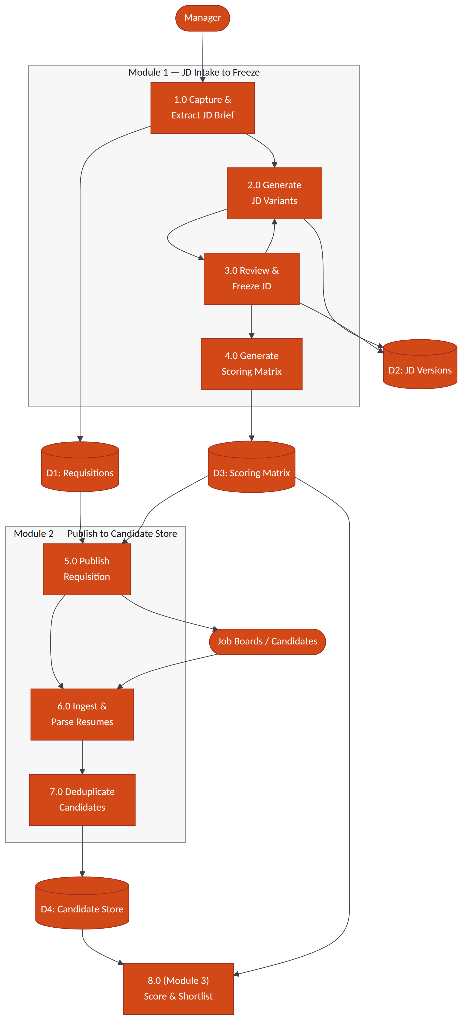
Figure 10.1 — Level-1 data flow diagram, JD Intake → Freeze → Publish → Sourcing → Candidate Store

11. Sequence Flows

11.1 Module 1 — JD Intake to Freeze
- Manager → Email/Portal: submits raw brief.
- Requisition Service: creates JobRequisition (status Draft) and JDBrief record.
- JD Generation Service: runs NLP extraction → JDField records; generates 2–3 JDVersion drafts.
- Notification Service: emails manager, updates portal Pending JD Approval queue.
- Manager → Email reply or Portal edit: feedback submitted via POST .../feedback.
- JD Generation Service: parses feedback into a structured diff → new JDVersion (status Revising). Loop to step 4 until manager freezes.
- SLA Scheduler: if no manager response within the configured window, triggers a reminder, then an HR escalation notification.
- Manager → POST .../freeze: approves final version and confirms matrix weights.
- Scoring Matrix Service: persists ScoringMatrix + ScoringCriterion, marks JDVersion is_frozen = true, sets JobRequisition.status = Frozen_Open.
- Requisition Service: emits requisition.frozen event, consumed by the Module 2 Publish Service.

11.2 Module 2 — Publish to Unified Candidate Record
- Publish Service: consumes requisition.frozen; calls each active channel adapter for the tenant.
- Channel Adapter (Naukri RMS / LinkedIn / email / manual / referral): posts the requisition or begins listening/polling for applications.
- Inbound application/resume arrives via webhook, poll result, or manual upload.
- Resume Parsing Service: extracts structured candidate fields; tags source_channel.
- Dedupe Service: checks against existing Candidate records for the tenant (see Section 13 for match logic); links to an existing record or creates a new one.
- Candidate Store: persists/updates Candidate and Application; Unified Inbox Index makes the record searchable.

12. Object Flow Diagram — JobRequisition Lifecycle
The JobRequisition entity is the central object driving Module 1; its state machine gates every other action (JD editing, freeze, scoring-matrix generation, publish). The diagram below is the authoritative object-flow reference for implementation — every state transition must go through the guarded transitions shown, never a direct field update.
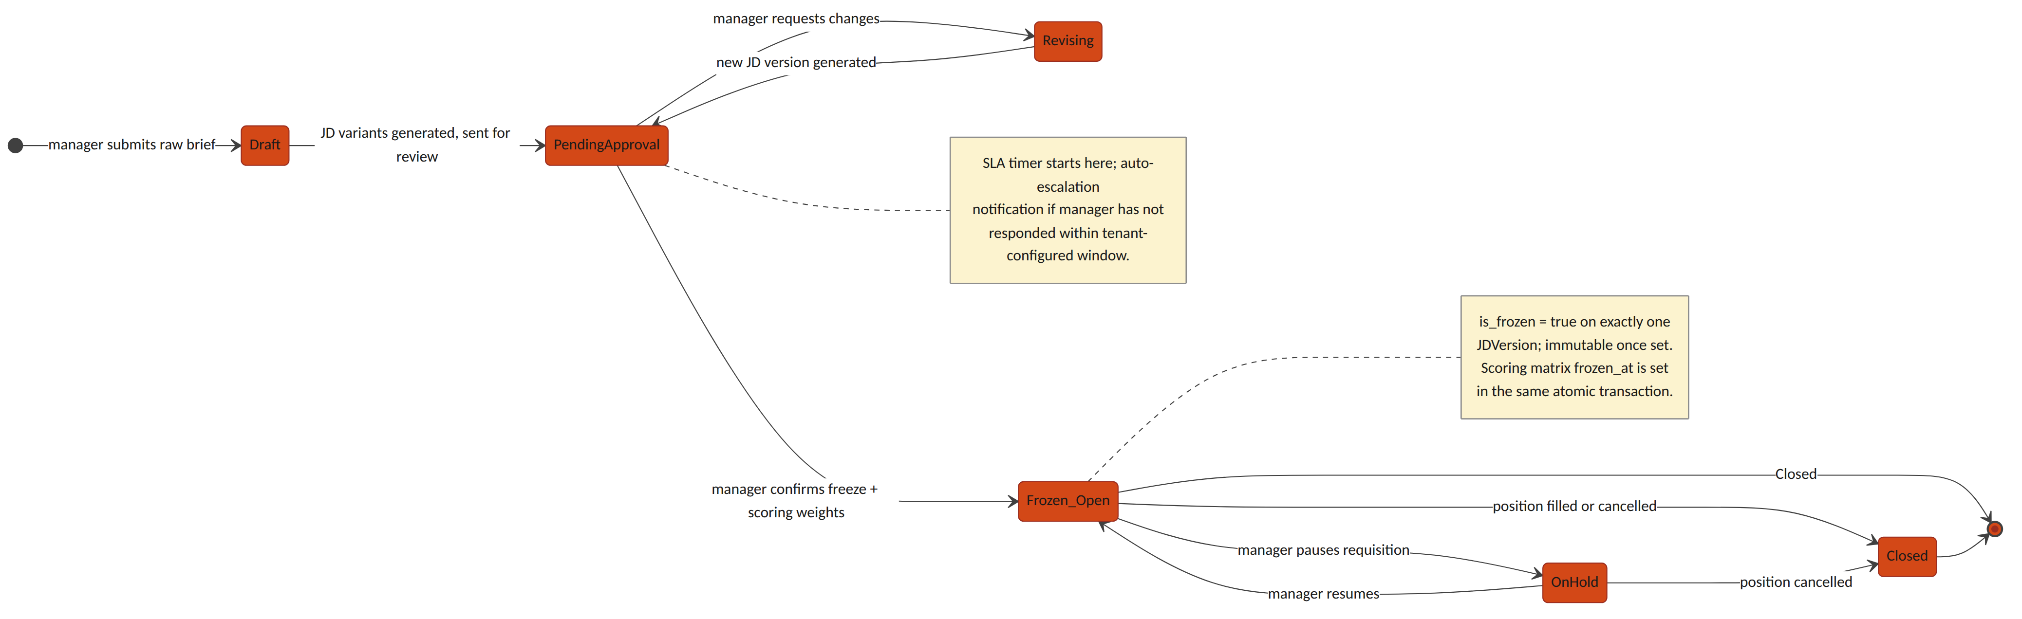
Figure 12.1 — JobRequisition object/state flow, Draft through Closed

13. Non-Functional / Technical Considerations
- Idempotency: every inbound webhook endpoint (Naukri RMS, LinkedIn, email intake) is keyed on (channel_type, external_id) so a vendor retry does not create a duplicate Candidate/Application.
- JD immutability: a frozen JDVersion is enforced read-only at both the application layer and a database-level constraint — not application-logic discipline alone.
- NLP confidence threshold: tenant-configurable, default 0.75; any JDField below threshold forces manager_confirmed = false and blocks freeze until resolved.
- SLA escalation: implemented as a scheduled job (not a request-time check) polling PendingApproval requisitions against their configured SLA window.
- Dedupe matching order: exact match on email, then exact match on phone (both high-confidence, auto-link), then content-similarity scoring on parsed resume text (e.g. embedding cosine similarity) for a manual-review confidence band rather than an auto-link — false positives here would silently merge two different candidates.
- Vendor rate limits: all channel adapters implement exponential backoff and surface a distinct Integration Error channel status so one vendor outage never blocks other channels or the unified inbox.

14. Error Handling & Edge Cases
Scenario | Handling
NLP extraction fails entirely on a brief | Requisition remains in Draft; manager is offered a manual structured-entry form as a fallback rather than a blocked pipeline
Job-board API authentication failure | Channel marked Integration Error; other channels continue publishing; tenant admin is alerted
Manager attempts to edit a frozen JD | Rejected at the API layer (409); the correct path is a new version via the standard feedback/edit flow, which reopens approval rather than mutating the frozen record
Duplicate-detection false positive | Recruiter can mark a DuplicateMatch as resolved=true with an explicit "not a duplicate" override, which is retained for audit
Matrix weights submitted not summing to 100 | Freeze request rejected (409) with the offending total returned, rather than silently normalizing

15. Open Technical Decisions / Dependencies
- Naukri RMS integration direction — confirm push (webhook) vs. poll availability under the contracted plan.
- Resume-parsing provider — build an in-house parser vs. license a third-party resume-parsing API.
- NLP model for brief-to-schema extraction — an in-house fine-tuned model vs. a third-party LLM API, and the associated per-tenant data-residency implications under the DPDP Act.
- Similarity-search infrastructure for duplicate detection — pgvector on the existing PostgreSQL instance vs. a dedicated vector-search service, driven by expected candidate-pool scale per tenant.
- Default and tenant-configurable bounds for the NLP confidence threshold and the SLA escalation window.

