LAB # 7
Generics in Java
OBJECTIVE:
Implementing generic classes and methods for ensuring compile time type safety of data.
Generics:
Generics is a type of specified data type in the related context of class, method or object. In order to restrict any class, method or object with specified type then generics should be introduced in the code. Generics means parameterized types. The idea is to allow type (Integer, String etc., and user-defined types) to be a parameter to methods, classes, and interfaces. Using Generics, it is possible to create classes that work with different data types. An entity such as class, interface, or method that operates on a parameterized type is called generic entity.
Importance of generics:
Object is the superclass of all other classes and Object reference can refer to any type object. These features lack type safety. Generics adds that type safety feature.
Generics Parameters name:
- E – Element (used extensively by the Java Collections Framework, for example ArrayList, Set etc.)
- K – Key (Used in Map)
- N – Number
- T – Type
- V – Value (Used in Map)
- S,U,V etc. – 2nd, 3rd, 4th types

Types of generics:
1. Generic Class
we use <> to specify parameter types in generic class creation. To create objects of generic class, we use following syntax.
class Test<T>
{
// An object of type T is declared
T obj;
Test(T obj)
{
this.obj = obj;
} // constructor
public T getObject()
{
return this.obj;
}
}

// Driver class to test above
class Main
{
public static void main (String[] args)
{
// instance of Integer type
Test <Integer> iObj = new Test<Integer>(84);
System.out.println(iObj.getObject());

// instance of String type
Test <String> sObj = new Test<String>("Hiba Fatima");
System.out.println(sObj.getObject());
}
}

We can also pass multiple Type parameters in Generic classes:
class Test<T, U>
{
T obj1; // An object of type T
U obj2; // An object of type U

// constructor
Test(T obj1, U obj2)
{
this.obj1 = obj1;
this.obj2 = obj2;
}

// To print objects of T and U
public void print()
{
System.out.println(obj1);
System.out.println(obj2);
}
}

// Driver class to test above
class Main
{
public static void main (String[] args)
{
Test <String, Integer> obj =
new Test<String, Integer>("Hiba Fatima", 84);

obj.print();
}
}

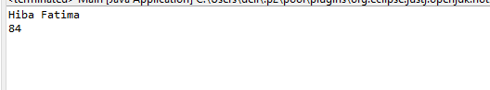
2. Generic Functions:
We can also write generic functions that can be called with different types of arguments based on the type of arguments passed to generic method, the compiler handles each method.
class Main
{
// A Generic method example
static <T> void genericDisplay (T element)
{
System.out.println("Value is" +
" = " + element);
}

// Driver method
public static void main(String[] args)
{
// Calling generic method with Integer argument
genericDisplay(11);

// Calling generic method with String argument
genericDisplay("Software Construction and Development");

// Calling generic method with double argument
genericDisplay(1.0);
}
}

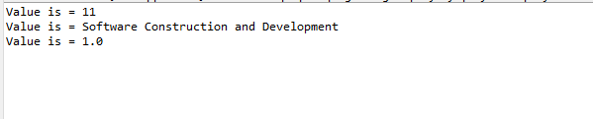

Example of a program without generic method and classes:
public class Main
{
public static void main(String[] args) {
// create arrays of Integer, Double and Character
Integer[] integerArray = {1, 2, 3, 4, 5, 6};
Double[] doubleArray = {1.1, 2.2, 3.3, 4.4, 5.5, 6.6, 7.7};
Character[] characterArray = {'H', 'E', 'L', 'L', 'O'};

System.out.printf("Array integerArray contains:%n");
printArray(integerArray);
System.out.printf("%nArray doubleArray contains:%n");
printArray(doubleArray);
System.out.print("Array characterArray contains:\n");
printArray(characterArray);
}
public static void printArray(Integer[] inputArray)
{
for (int element : inputArray)
System.out.printf("%s ", element);

}
public static void printArray(Double[] inputArray)
{
for ( double element : inputArray)
System.out.printf("%s ", element);
System.out.println();
}
public static void printArray(Character[] inputArray)
{
for ( char element : inputArray)
System.out.printf("%s ", element);
System.out.println();
}
}

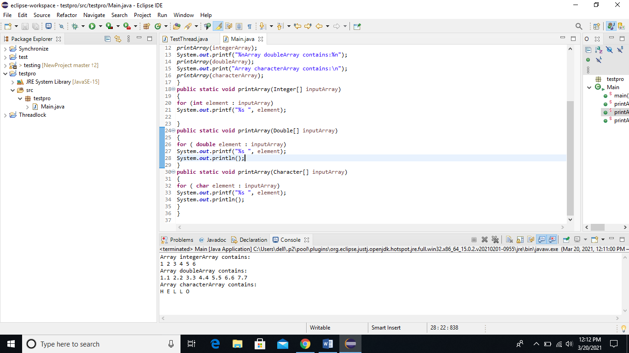
In the above code, three overloaded methods are implemented for getting integer, double or character type input. This long described pattern can be transformed into a single method by simply adding generic data type as below:
public static void printArray(E[] inputArray)
{
// display array elements
for (E element : inputArray)
System.out.printf("%s ", element);
System.out.println();
}

Solution with Generics:
public class Main {
// generic method printArray
public static < E > void printArray( E[] inputArray ) {
// Display array elements
for(E element : inputArray) {
System.out.printf("%s ", element);
}
System.out.println();
}

public static void main(String args[]) {
// Create arrays of Integer, Double and Character
Integer[] intArray = { 1, 2, 3, 4, 5 };
Double[] doubleArray = { 1.1, 2.2, 3.3, 4.4 };
Character[] charArray = { 'H', 'E', 'L', 'L', 'O' };

System.out.println("Array integerArray contains:");
printArray(intArray); // pass an Integer array

System.out.println("\nArray doubleArray contains:");
printArray(doubleArray); // pass a Double array

System.out.println("\nArray characterArray contains:");
printArray(charArray); // pass a Character array
}
}

Output:
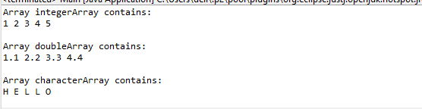

Lab Task:
Write a program that takes integer array, double array and float array. Make a generic function that performs subtraction on array element:
Example: input intArray = [5, 7, 3, 9, 19]
Output intArray = [2, -4, 6, 10]

