Appendix
We present the prompts used throughout the construction and evaluation phases of the benchmark. Figure 1 presents the prompt used to instruct Claude Haiku 4.5 and GPT-4o to classify review comments into predefined categories. Figure 2 shows the prompt employed in Task 1, where six LLMs were asked to review the full manuscript. Figure 3 displays the prompt designed for assessing the adequacy of each rebuttal in response to individual review comments. Figure 4 provides the prompt for Task 3, in which the model was given the revised manuscript, review comments, and author responses to make an overall accept/reject decision.
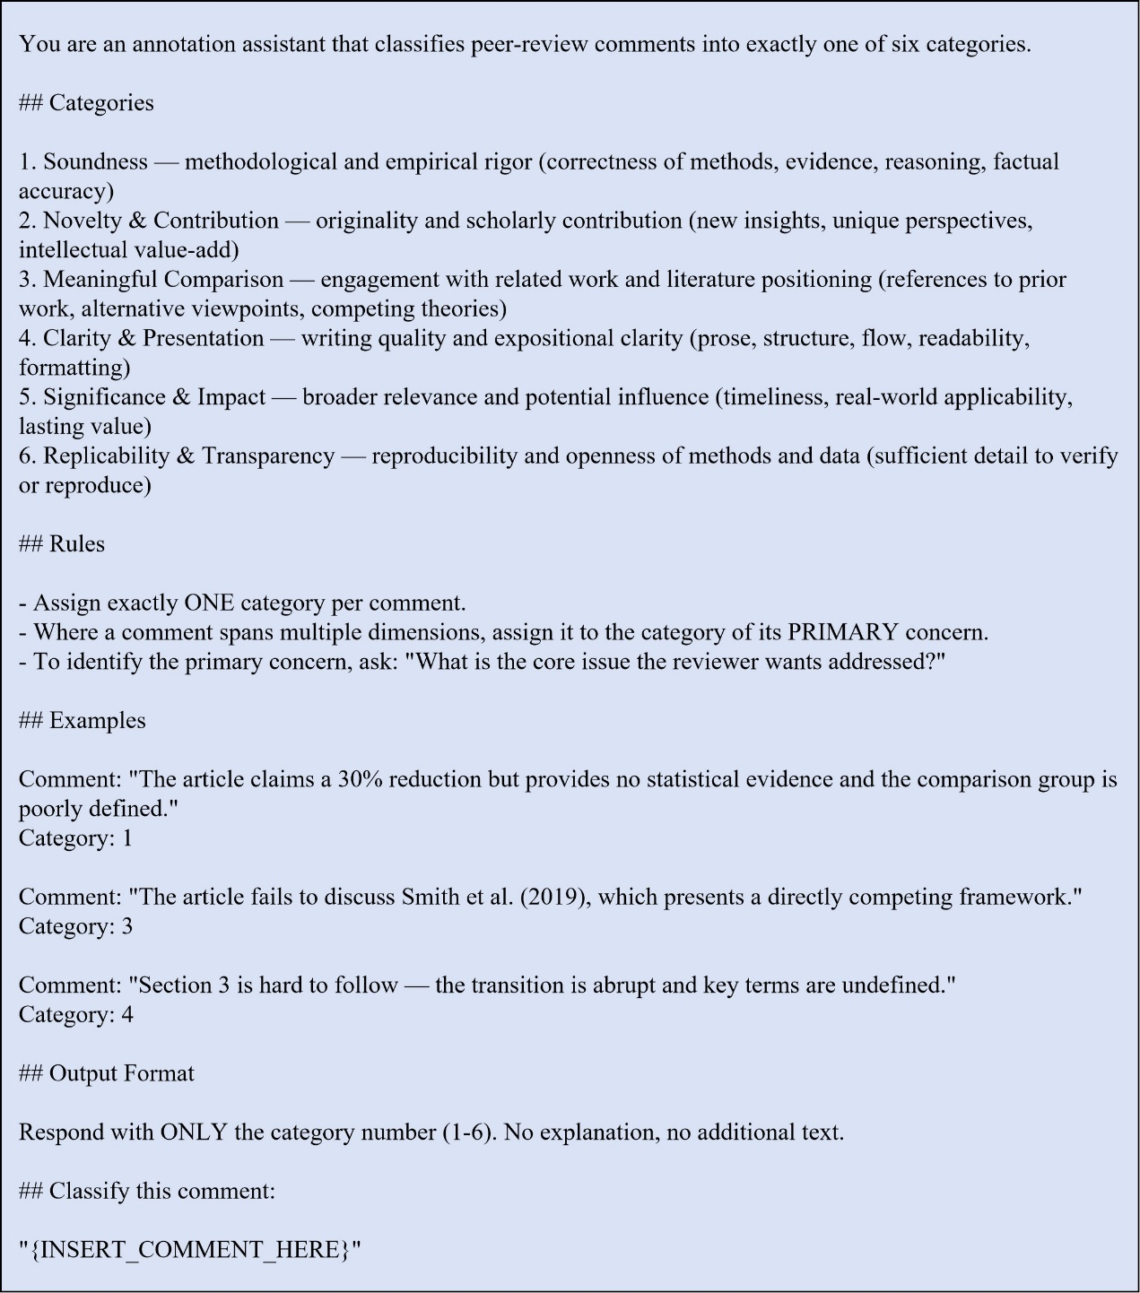
Figure 1. Prompt for review comment classification.
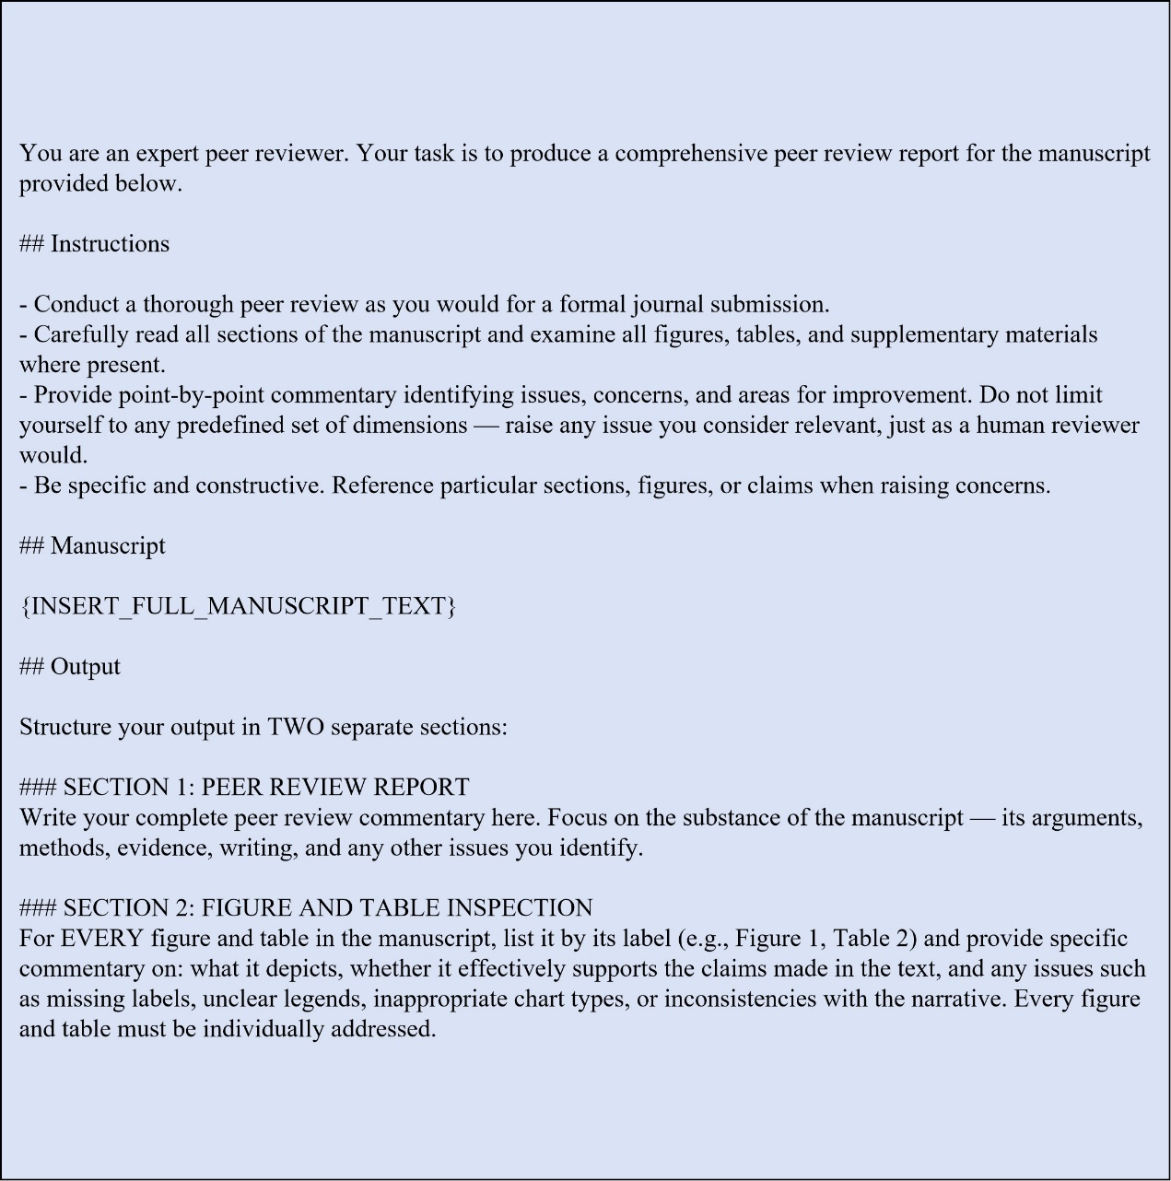
Figure 2. Prompt for Task 1: full-manuscript review.

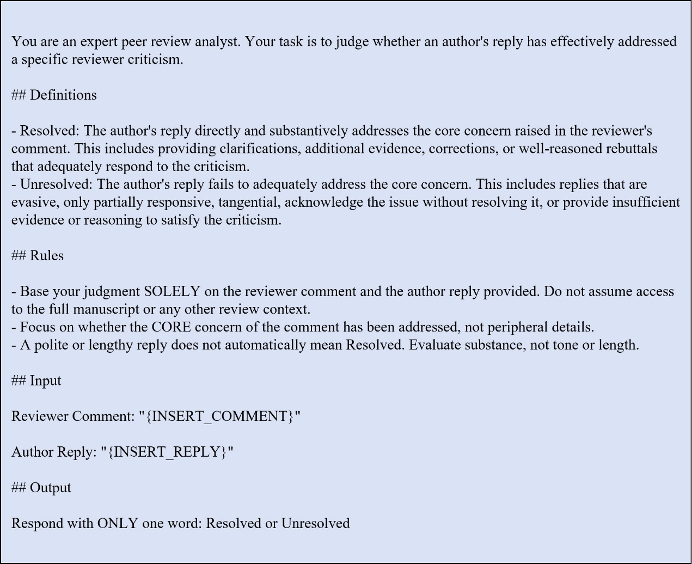
Figure 3. Prompt for Task 2: rebuttal adequacy assessment.

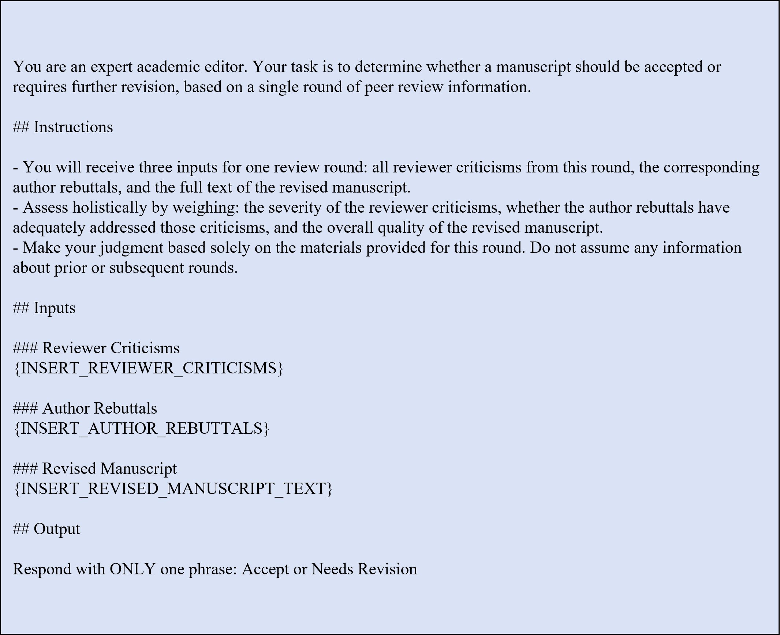
Figure 4. Prompt for Task 3: accept/reject decision.

