A Multi-Task Benchmark for Evaluating LLMs on Peer Review in Interdisciplinary Social Sciences
Kai Qiao ª ，Xiaoping Sheng ^{ab*} , Zhenyu Li ª
ª School of Cultural Heritage and Information Management, Shanghai University, Shanghai, China,
^{b} Research Academy of Cultural Heritage and Technology, Shanghai University, Shanghai, China,
Email: { qiaokai1996@shu.edu.cn; Shengxp68@126.com; sometimesrains@shu.edu.cn}
ORCID: { 0009-0000-0187-9190; 0000-0002-9310-6028; 0000-0002-6043-3479}

Abstract
As academic publishing continues to expand, peer review faces growing challenges in efficiency and consistency. Large language models (LLMs) offer new possibilities for review assistance, yet existing evaluations have largely focused on isolated tasks and rarely assess multiple stages and perspectives of peer review within a unified benchmark, especially across diverse disciplines. We construct a multi-task benchmark for interdisciplinary social sciences using open peer review data from PeerJ, Nature, PLOS, and ICLR, spanning fields including social science, data science, and psychology. The benchmark comprises 2,769 papers, 7,432 review reports, and 24,632 review–response dialogue pairs. We design three progressive tasks to evaluate LLM performance in review dimension coverage, reply resolution judgment, and round-level acceptability judgment, thereby providing a more process-aware benchmark framework. Experiments on six frontier LLMs show that the models can reasonably reproduce human reviewers’ attention to core dimensions such as methodological rigor in the coverage task. However, their performance degrades markedly when judging whether reviewer concerns are reflected as resolved in author responses and when making round-level acceptability judgments, revealing clear limitations in higher-order evaluative reasoning and judgment calibration. Different models also exhibit stable, distinctive biases: some overemphasize impact or judge concerns as resolved too optimistically, while others tend toward more negative assessments. These findings indicate that single-task frameworks may overestimate broader peer-review capabilities, and that deploying these models without task-specific calibration may introduce systematic, model-dependent biases. The proposed benchmark provides a more process-aware and diagnostically informative framework for the standardized evaluation of LLMs in open peer review.
Keywords: Open peer review; Large language models; Evaluation benchmark; Interdisciplinary social sciences; Multi-task evaluation

Introduction
In recent years, the rapid advancement of large language models (LLMs) has profoundly transformed the field of AI, achieving breakthrough performance in natural language processing, reasoning, and generative tasks. Leading models such as ChatGPT, Claude, Grok, and Gemini have significantly advanced the state of the art, showing strong performance across text understanding, reasoning, and content generation^{[1]}. These capabilities have been progressively extended into the domain of scientific research, fundamentally transforming traditional research paradigms and accelerating the advancement of scientific disciplines. In particular, LLMs have evolved from conventional text generation tools into autonomous agents capable of conducting end-to-end scientific inquiry, including literature review, hypothesis generation, experimental design, data analysis, and result interpretation^{[2]}. Zhang et al. (2024) conducted a comprehensive survey of over 260 scientific LLMs, examining their commonalities and differences, and summarizing pre-training datasets and evaluation tasks across various fields and modalities, highlighting the significant potential of LLMs in scientific research^{[3]}. As LLMs continue to evolve, their growing capabilities and autonomy are transforming their role in scientific research, redefining how humans and AI collaborate in the discovery process^{[4]}. This trend has also extended to key stages of academic publishing, particularly peer review.
Peer review is the cornerstone of academic publishing, serving as the primary mechanism for quality control and scholarly gatekeeping. However, the rapid growth of global research output and increasing interdisciplinary complexity have placed the traditional peer review system under significant strain. This has motivated growing interest in integrating AI into the review process^{[5]}. LLMs, with their strong text understanding and generation capabilities, are well suited to support review-related tasks. Recent surveys have systematically examined automated scholarly paper review in the LLMs era, revealing both transformative potential and persistent challenges such as limited review depth, over-positivity, and hallucination^{[6]}. As these models continue to improve, developing robust benchmark frameworks with well-constructed datasets and comprehensive evaluation protocols becomes essential for tracking progress and aligning model capabilities with the practical demands of peer review.
In prior work, Kang et al. (2018) introduced PeerRead, the first large-scale peer review dataset, comprising 14.7K paper drafts and 10.7K expert reviews from ACL, NeurIPS, and ICLR, which has since served as a foundational resource for subsequent research^{[7]}. Building on this, Li et al. (2025) constructed a large-scale benchmark of 1,683 papers and 6,495 expert reviews from ICLR and NeurIPS, and employed five LLMs to generate reviews for comparison with human counterparts. Using semantic similarity analysis and structured knowledge graph metrics, they found that LLMs perform well on descriptive content but exhibit notable deficiencies in critical reasoning^{[8]}. Taechoyotin and Acuna (2025) proposed the REMOR framework, which incorporates explicit reasoning and multi-objective reinforcement learning. Through experiments on the PeerRT dataset, they systematically evaluated fine-tuned models on peer review tasks along two dimensions: review content quality and review-manuscript relevance^{[9]}. Gao et al. (2025) introduced MMReview, a multidisciplinary and multimodal benchmark spanning 17 research domains, with 13 tasks designed to assess LLM capabilities in stepwise review generation, outcome prediction, and adversarial robustness. While MMReview provides a comprehensive and fine-grained evaluation of LLM-based reviewing, it still lacks assessment of author rebuttal evaluation^{[10]}.
Despite these advances, notable gaps remain. Most existing benchmarks cover only a few disciplines, leaving model generalizability largely untested. Current work also centers on reviewer-side tasks, paying limited attention to other important aspects of peer review such as author rebuttals, which remain relatively underexplored. Moreover, existing benchmarks tend to break peer review into fine-grained, isolated subtasks. While this approach has diagnostic value, when LLMs have yet to be integrated into peer review practice, a unified framework evaluating model performance across broader tasks may be more valuable than increasingly narrow task decomposition. Addressing these gaps is essential for advancing the real-world application of LLMs in scholarly evaluation. To this end, this study first constructs a new dataset based on open peer review data drawn from interdisciplinary fields related to the social sciences. We then propose a benchmark framework covering three core tasks: review dimension coverage, reply resolution judgment, and round-level acceptability judgment. Finally, we systematically evaluate six state-of-the-art LLMs on these tasks to examine cross-model differences and reveal their strengths and limitations in peer review settings.

Related work

LLMs for scientific tasks
The capabilities of LLMs are primarily determined by parameter scale, architecture, and training strategy. Beyond a certain size threshold, emergent abilities such as complex reasoning, instruction following, and few-shot learning arise that smaller models lack^{[11]}. Peer review requires simultaneous comprehension of lengthy academic texts, multidimensional critique generation, argumentative rigor assessment, and integrative decision-making, placing stringent demands on deep language understanding and reasoning. As academic papers also contain multimodal content (figures, equations, visualizations), models with mixed text-image processing capabilities hold an inherent advantage. Smaller open-source models (e.g., 7B–13B) often fall short of these demands and require elaborate fine-tuning^{[12][13]}.This study therefore focuses on frontier models to establish a more informative capability benchmark.
GPT-4 is OpenAI’s multimodal model supporting text and image inputs, consistently leading on benchmarks such as MMLU and HumanEval^{[14]}. GPT-4o is its efficiency-optimized variant, maintaining comparable reasoning at substantially lower latency and cost^{[15]}. Claude Opus and Claude Sonnet, developed by Anthropic, represent the highest-capability and balanced-efficiency tiers respectively^{[16]}. Notably, the Claude series exhibits a conservative, consistent judgment style that may benefit peer review scenarios requiring precise rather than sycophantic assessment. DeepSeek R1 employs a Mixture-of-Experts architecture with reinforcement learning–enhanced reasoning. Gao et al. (2025) found its classification accuracy second only to Claude, though with notably slower inference^{[17]}. Gemini 3 Pro, by Google DeepMind, natively supports text, image, audio, and video processing and maintains frontier performance on graduate-level reasoning benchmarks such as GPQA Diamond^{[18]}.The Grok series by xAI has also demonstrated competitive performance^{[19]}, but was excluded due to our limited access during the study period.
In total, six models—GPT-4, GPT-4o, Claude Opus 4.6, Claude Sonnet 4.6, DeepSeek R1, and Gemini 3 Pro—were selected, spanning four providers and encompassing dense Transformer, MoE, and natively multimodal architectures. All consistently rank within the frontier tier on independent leaderboards such as Chatbot Arena^{[20]} and Artificial Analysis, enabling meaningful cross-paradigm comparison on peer review tasks.

Taxonomy of peer review comments
A central challenge in AI-assisted peer review research lies in evaluating the quality of AI-generated review comments. Some scholars have employed computational semantic similarity to measure the alignment between AI and human reviews^{[8][21]}. However, this approach has fundamental limitations: peer review is not a summary or paraphrase of the original manuscript, but rather a multidimensional critical analysis encompassing methodological rigor, novelty of contribution, appropriateness of literature positioning, and quality of exposition. Establishing a dimensional taxonomy of review comments therefore represents a more principled approach to assessing the reviewing capabilities of LLMs at the cognitive level.
Several classification frameworks have been proposed for the dimensional analysis of review comments. Ortega (2022) categorized comments on the PubPeer platform into seven severity levels, ranging from positive appraisal to data manipulation, revealing the functional and evaluative diversity inherent in peer review^{[22]}. Sizo et al. (2025) identified six key categories through a scoping review, including structural elements, research methodology, and writing style, thereby delineating the multifaceted composition of review quality at a macro level^{[23]}. In terms of annotated dataset construction, Ghosal et al. (2022) developed the first multi-layered annotation scheme based on 1,199 reviews from ICLR 2018, comprising four hierarchical levels: paper section correspondence, aspect category, review functionality, and review significance, providing a standardized reference for subsequent studies^{[24]}. A growing consensus has emerged regarding specific dimensional frameworks. Yuan et al. (2022), in a pioneering study on automated scientific reviewing, proposed a taxonomy comprising Clarity, Soundness & Correctness, Originality, and related dimensions, closely aligned with the practical criteria used in peer review. This framework has been widely adopted in subsequent research^{[25]}. Shin et al. (2025) employed GPT-4o for unsupervised aspect identification of review comments, and their coarse-grained label set closely mirrors that of Yuan et al., further corroborating the cross-study robustness of this framework^{[26]}. Beyond review comment classification, the interaction between reviewer comments and author rebuttals has also attracted scholarly attention. Wu et al. (2022) modeled review–reply pairs as argumentative structures^{[27]} , while Kennard et al. (2022) annotated the discourse structure of review discussions^{[28]}. These efforts provide a data foundation for investigating reply resolution and response evaluation.
Nevertheless, no unified standard has yet been established for the dimensional classification of review comments, and disciplinary emphases vary considerably—experimental sciences prioritize methodological reproducibility, whereas the social sciences place greater weight on the appropriateness of theoretical frameworks.

2.3 Benchmarking LLMs for peer review
Leveraging LLMs to assist or automate peer review has emerged as a prominent research direction in recent years, accompanied by rapid progress in benchmark construction. Benchmarks are essential for assessing the practical capabilities of novel technologies^{[29]}. Zhuang et al. (2025) provided a systematic survey of automated scholarly reviewing in the LLMs era, identifying both the transformative potential and persistent challenges of LLMs in this domain, including limited review depth, positivity bias, and hallucination^{[6]}.
At the dataset level, Kang et al. (2018) introduced PeerRead, the first large-scale peer review dataset comprising 14,700 papers and 10,700 expert reviews from ACL, NeurIPS, and ICLR, laying the groundwork for subsequent research^{[7]}. Since then, datasets have expanded considerably in both scale and disciplinary coverage. Lin et al. (2023) constructed MOPRD, a multidisciplinary dataset spanning biology, computer science, and environmental science, capturing the full review workflow—including multiple manuscript versions, review reports, meta-reviews, author rebuttals, and editorial decisions^{[30]}；Dycke et al. (2023) further broadened the scope with NLPeer, incorporating data from multidisciplinary journals such as PLOS and eLife, with particular attention to ethical data acquisition. Their systematic survey of 53 existing datasets revealed that 37 originated from ML/NLP conferences hosted on OpenReview, while social science domains remained virtually unrepresented^{[31].}
At the benchmark framework level, early efforts focused on single-task exploration. Liu and Shah (2023) evaluated GPT-4 on tasks such as error detection and checklist verification, finding it promising as an assistive tool but insufficient for conducting independent, end-to-end reviews^{[32]}. Subsequent work has progressed toward multi-task, multi-dimensional evaluation. Lou et al. (2024) proposed AAAR-1.0, a comprehensive research-oriented benchmark featuring four expert-level tasks: equation inference, experiment design, weakness identification, and review quality assessment^{[33]}. Li et al. (2025) compared LLM and human reviews using semantic similarity and knowledge graph metrics, finding that LLMs performed well on descriptive content but fell short in critical reasoning^{[8]}. Gao et al. (2025) introduced MMReview, spanning 17 disciplines and 13 evaluation tasks, representing the most extensive multidisciplinary, multimodal review benchmark to date^{[10]} . Garg et al. (2025) proposed ReviewEval, which incorporates retrieval-augmented factual correctness verification to assess AI review quality across multiple dimensions^{[21]}. Additionally, multi-agent collaborative approaches (e.g., MARG^{[34]}、ReviewAgents^{[35]}) and iterative review frameworks (e.g., CycleReviewer^{[36]} ) have been introduced to enhance the comprehensiveness and reliability of generated reviews. A summary of recent benchmark tasks is presented in Table 1.
Table 1. Benchmarks and Representative Evaluation Studies for LLM-based Peer Review
Benchmark | Year | Dataset Scale | Disciplines | Evaluated Models | Core Evaluation Tasks
ReviewerGPT^{[32]} | 2023 | 13 synthetic papers; 15 NeurIPS papers; 119 checklist-paper pairs; 10 abstract pairs | Computer Science (ML/AI) | GPT-4, Bard, Vicuna, Koala, Alpaca, LLaMA, Dolly, OpenAssistant, StableLM | Error identification; checklist verification; paper comparison
AAAR-1.0^{[33]} | 2024 | 4-task benchmark; 1,049 EquationInference instances; 993 PaperWeakness instances; plus ExperimentDesign and ReviewCritique subsets | AI, Machine Learning, NLP | Gemma 2-27B, Falcon-40B, OLMo-7B, Mistral-7B, Mixtral-8x22B, Llama 3.1-70B, Qwen2.5-72B, Gemini 1.5 Pro, Claude 3.5 Sonnet, GPT-4, GPT-4o, o1-preview | Equation correctness inference; experiment design; weakness identification; review critique
Li et al.^{[8]} | 2025 | 1,683 papers; 6,495 expert reviews | Computer Science | GPT-4o, Claude-3.5-Sonnet, Gemini-2.0-Flash, Llama-3.3-70B, Qwen-2.5-72B | Review generation; semantic similarity assessment; knowledge-graph-based evaluation; review quality comparison
Zhou et al.^{[37]} | 2024 | 14 ICLR papers; 55 reviews; 196 RR-MCQ instances | Computer Science (ML/NLP) | GPT-3.5, GPT-4 | Review generation; score prediction; review-revision QA; critical feedback evaluation
MMReview^{[10]} | 2025 | 240 papers; 17 research domains; 4 major disciplines; 13 tasks | Artificial Intelligence, Natural Sciences, Engineering Sciences, Social Sciences | 16 open-source models + 5 closed-source models | review generation; outcome formulation; preference alignment; adversarial robustness
ReviewEval^{[21]} | 2025 | 120 papers; 30-paper expert preference subset | Computer Science (AI+X) | MARG variants, ReviewAgent variants, GPT-4o, GPT-4o-mini, Claude models, DeepSeek, Qwen | Semantic similarity; topical coverage; factual consistency; analytical depth; actionability; guideline adherence
ReviewAgents^{[35]} | 2025 | 37,403 papers; 142,324 review comments; 100 benchmark papers; 8 domains | Computer Science | Llama-3.1, Qwen2.5, GPT-4o, Claude-3.5, DeepSeek | review generation; reasoning consistency; semantic alignment; sentiment alignment; diversity evaluation
Yu et al.^{[38]} | 2025 | 788,984 peer reviews; 8 years of ICLR and NeurIPS | Computer Science / AI peer review | 18 detection methods; GPT-4o, Claude Sonnet 3.5, Gemini 1.5 Pro, Qwen 2.5 72B, Llama 3.1 70B | AI review detection; detector benchmarking; context-aware detection; review analysis
Despite significant progress, several limitations persist. First, existing datasets and benchmarks are predominantly concentrated in computer science, lacking adequate validation across disciplines such as the social sciences. Second, evaluation tasks largely focus on review generation, neglecting critical stages such as author rebuttal assessment and final decision-making. Third, the multi-round review process remains underexplored, making it difficult to capture the dynamic interaction and decision-making inherent in real-world peer review.

Methodology

3.1 Data Collection and Processing
Data Sources and Scope. To evaluate the cross-disciplinary generalizability of LLMs in peer review, we constructed a multi-source dataset drawn from PeerJ, Nature, PLOS, and ICLR proceedings. The dataset encompasses a diverse range of disciplines, including the social sciences, data science, computer and information sciences, computer science, science policy and psychology. These fields were included because the corpus centers on socially embedded, interdisciplinary research domains in which evaluation often combines methodological, interpretive, and policy-relevant criteria. In total, the dataset comprises 2,769 papers, 7,432 review reports. Each paper contains at least two rounds of review, with a subset involving three or more rounds.
Structured Field Extraction. Individual review reports were segmented into discrete comment units and aligned with the corresponding author rebuttals, resulting in the 24,632 review–reply dialogue pairs described. For each interaction, we extracted five structured fields: paper identifier (paper_id), reviewer identifier (reviewer_id), review comment text (comment), author replies (author_reply), and review round (review_round).
Comment Type Taxonomy. Each comment unit was classified into one of six categories derived from two established frameworks: the multi-layered annotation schema of Ghosal et al. (2022), developed across 1,199 open peer review texts^{[24]}, and the aspect taxonomy of Yuan et al. (2022), validated on 1,000 human-annotated instances drawn from ACL reviewing guidelines^{[25]}. Both have been widely adopted in computational studies of review quality^{[39][40]}. The taxonomy is intentionally domain-agnostic to enable consistent annotation across the heterogeneous disciplinary mix in our corpus. When a comment spanned multiple dimensions, it was assigned to the category that best reflected its primary concern. (1) Soundness — methodological and empirical rigor; (2) Novelty & Contribution — originality and scholarly contribution; (3) Meaningful Comparison — engagement with related work and literature positioning; (4) Clarity & Presentation — writing quality and expositional clarity; (5) Significance & Impact — broader relevance and potential influence; (6) Replicability & Transparency — reproducibility and openness of methods and data All annotations were generated by Claude Haiku 4.5 and GPT-4o using aligned annotation procedures^{[41]}. The resulting labels were assigned to the comment type (comment_type) field and subsequently validated through manual spot-checking. To assess annotation reliability, a random sample of 1,000 instances was manually annotated by the researcher and compared with the final labels assigned through the LLM-based annotation pipeline. The resulting agreement rate was 72.3%, indicating moderate annotation noise in the large-scale automatically labeled corpus.
Reply Resolution Annotation. To construct labels for reply resolution judgment, we selected a subset of 384 papers characterized by relatively rich review content and multiple review rounds. Three trained annotators independently labeled each comment–reply pair for resolution status using a binary scheme: Resolved or Unresolved. The labeling criterion was defined as follows: a comment was marked Unresolved if the same core issue was raised again in a subsequent round — regardless of changes in wording, reviewer identity, or category label — and Resolved if the issue did not recur. All final-round comment–reply pairs were operationally labeled as Resolved, because no subsequent review round was available in which the issue could recur. Inter-annotator agreement for this task was Cohen’s κ = 0.83. The initial annotation yielded a substantial imbalance favoring Resolved labels, partly due to the default labeling of final-round comments. Since these final-round pairs often exhibit distinctive surface-level features (e.g., brief acknowledgments rather than substantive responses), their overrepresentation risked introducing systematic bias. To mitigate this, we removed a portion of final-round pairs, resulting in a balanced baseline subset of 2,674 instances: 1,640 Resolved (61.3%) and 1,034 Unresolved (38.7%).

3.2 Benchmark Design
This study designs three progressive tasks to evaluate the scope and limitations of LLM capabilities in scientific peer review. The tasks correspond to three interconnected stages of the review process and increase in complexity, moving from the distribution of review comment dimensions, to the judgment of issue resolution in individual review–reply pairs, and further to round-level acceptability judgment based on complete review information. In this way, the benchmark provides a more process-aware evaluation framework spanning review generation, author response assessment, and round-level outcome judgment. The three tasks are defined as follows.
Task 1, review dimension coverage. This task evaluates whether LLM-generated review comments cover a range of critical dimensions similar to those emphasized by human reviewers. For each paper, the model is given the full manuscript and is asked to generate a free-form review report without predefined categories or structural constraints. The generated comments are then classified according to the six-dimensional taxonomy described in Section 3.1, and the resulting category distribution is compared with that of human reviewers to assess the extent to which model-generated critiques align with the human baseline in review focus.
Task 2, reply resolution judgment. This task evaluates whether an LLM can judge, on the basis of a single reviewer comment and its corresponding author reply, whether the underlying issue is reflected as resolved in the subsequent review process. For each comment–reply pair, the model receives the reviewer comment and the corresponding author response and outputs a binary label: Resolved or Unresolved. To isolate the model’s ability to reason over the local semantic relationship between the critique and the reply, the full manuscript and cross-round context are not provided. Model predictions are compared against the human-annotated labels described in Section 3.1 and evaluated using Accuracy, Precision, Recall, and F1 score.
Task 3, round-level acceptability judgment. This task evaluates whether an LLM can judge whether a manuscript has reached an acceptable state at a given review round on the basis of the complete round-level review information. For each review round, the model is given all reviewer comments from that round, the corresponding author replies, and the revised manuscript, and is asked to output a binary judgment: Accept or Needs Revision. The gold labels are derived from the observed review trajectory: a round is labeled Needs Revision if the paper proceeded to a subsequent revision round, and Accept if it was the final round before publication. Rather than directly predicting the editor’s real-world decision, this task evaluates the model’s ability to identify round-level acceptability status within the review process. The evaluation metrics are the same as those used in Task 2.
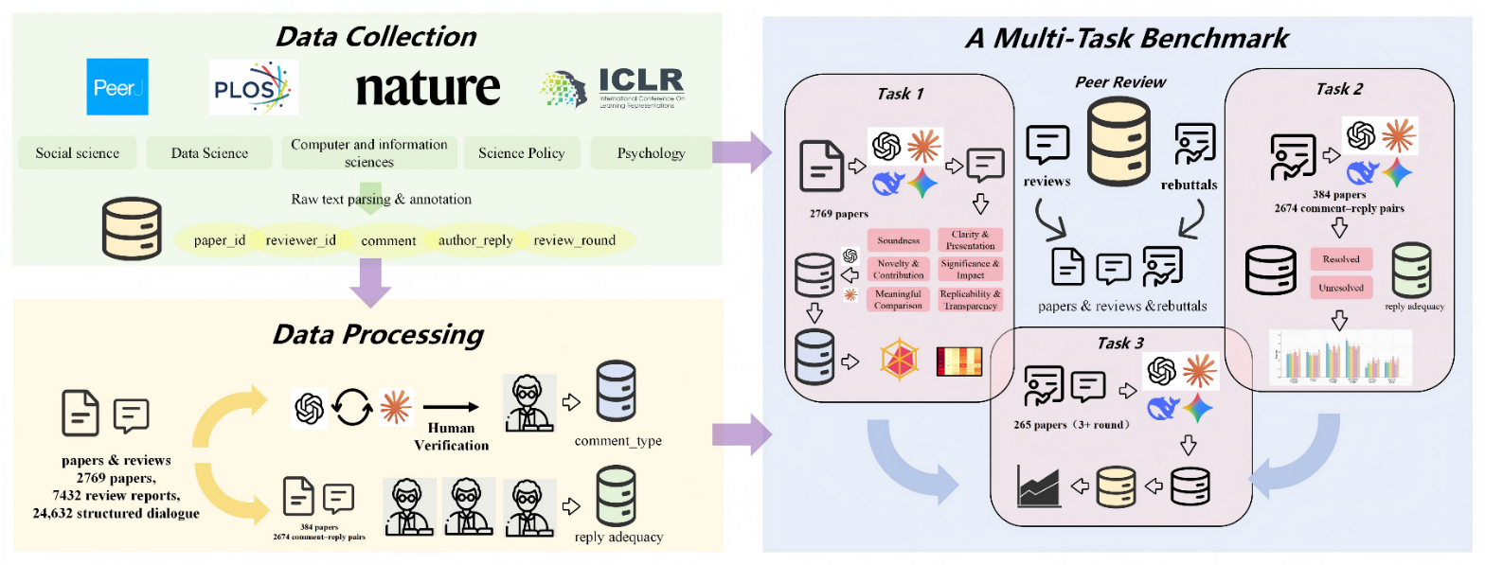
All three tasks were conducted with the same six LLMs: GPT-4, GPT-4o, Claude Opus 4.6, Claude Sonnet 4.6, DeepSeek R1, and Gemini 3 Pro. All models were evaluated in a zero-shot setting. Prompt templates were developed by multiple researchers. Five candidate templates were first drafted and tested on 20 papers per model, and the final template was selected based on output consistency and completeness to ensure fair comparison across models. Full prompts for each task are provided in the Appendix. Figure 1 shows the overall data processing and benchmark pipeline. To maintain the zero-shot setting, each query was run in a new conversation session to prevent context carryover. The temperature was set to 0 to reduce randomness and make model outputs more stable.
Figure 1. Overview of the Multi-Task Benchmark Framework for LLM-based Peer Review

3.3 Evaluation Metrics
To comprehensively evaluate model performance, this study adopts multiple metrics. Coverage rate and round-level accept prediction rate assess the distributional coverage of review dimensions and the model's sensitivity to round-wise review progression, respectively. For binary decision tasks, Accuracy, Precision, Recall, F1 score, and Cohen’s kappa are used to evaluate predictive performance and agreement with the reference labels beyond chance.

3.3.1 Coverage rate.
In Task 1, coverage rate is used to measure whether the distribution of LLM-generated comments across the six categories approximates the human review baseline. This metric captures how the model allocates attention across different review dimensions. For category $c$, coverage rate is defined as:
 | $$Coverage_{c}=\frac{n_{c}}{N}$$ | (1)
where $n_{c}$ is the number of comments assigned to category c and $N$ is the total number of comments generated by the model. A coverage rate closer to the corresponding human proportion indicates that the model exhibits a review focus more similar to that of human reviewers.

3.3.2 Performance metrics for binary decision tasks
For Task 2 and related binary classification tasks, this study employs Accuracy, Precision, Recall, F1 score, and Cohen’s kappa for evaluation.
Accuracy measures the proportion of correctly classified instances and reflects the overall classification performance of the model:
 | $$Accuracy=\frac{TP+TN}{TP+TN+FP+FN}$$ | (2)
where $TP$, $TN$, $FP$, and $FN$denote true positives, true negatives, false positives, and false negatives, respectively.
Precision measures the proportion of predicted positive instances that are truly positive, reflecting the reliability of positive predictions:
 | $$Precision=\frac{TP}{TP+FP}$$ | (3)
Recall measures the proportion of actual positive instances that are correctly identified, reflecting the model’s ability to detect positive cases:
 | $$Recall=\frac{TP}{TP+FN}$$ | (4)
F1 score is the harmonic mean of Precision and Recall, and provides a balanced measure of positive-class identification performance:
 | $$F1=\frac{2×Precision×Recall}{Precision+Recall}$$ | (5)
Because Accuracy may overestimate model performance under class imbalance, this study further adopts Cohen’s kappa to assess agreement between predicted and true labels while correcting for chance agreement. It is defined as:
 | $$κ=\frac{P_{o}−P_{e}}{1−P_{e}}$$ | (6)
where $p_{o}$is the observed agreement rate and $p_{e}$is the expected agreement rate computed from the marginal distributions of predicted and true labels. A value of $κ=0$ indicates performance equivalent to random guessing, while $κ=1$ indicates perfect agreement.

3.3.3 Round-level accept prediction rate.
To assess whether the model captures the progression of the peer review process, building on prior work on acceptance decision prediction in peer review^{[42]}, we define the round-level accept prediction rate to quantify the proportion of Accept predictions at each relative round position. To align trajectories across papers with different total rounds, rounds are indexed by distance from the final round: Last, Round −2, and so forth. For relative position r:
 | $$APR_{r}=\frac{\sum_{i=1}^{M_{r}}{1[}{\hat{y}}_{i}=\text{Accept}]}{M_{r}}$$ | (7)
where $M_{r}$ denotes the number of instances at relative round position $r$, and ${\hat{y}}_{i}$ denotes the predicted label for instance $i$. This metric is used to characterize whether the model produces an acceptance trajectory consistent with the underlying review process. Ideally, the model should maintain a low Accept prediction rate in non-final rounds and a substantially higher rate in the final round.

Task 1：Review dimension coverage

4.1 Experimental setup
Each large language model was prompted to produce a free-form peer review report for every paper in the 2,769-paper corpus, taking only the full manuscript text as input. No predefined category labels, scoring rubrics, or structural constraints were imposed on the output, so as to approximate the open-ended conditions under which human reviewers typically operate. The prompt instructed each model to adopt the role of an expert peer reviewer, adhere to the standard review format of the target journal, examine all figures and tables, and provide point-by-point commentary. This prompt was applied uniformly across all six models—GPT-4, GPT-4o, Claude Opus 4.6, Claude Sonnet 4.6, DeepSeek R1, and Gemini 3 Pro—to ensure cross-model comparability.
All generated comments were subsequently classified according to the Comment Type Taxonomy defined in Section 3.1, following the same annotation protocol described earlier, with Claude Haiku 4.5 and GPT-4o serving as alignment annotators. The proportion of comments falling into each category was computed as the coverage rate for that category and used as the primary comparison metric, thereby providing a measure of each model's ability to identify and address distinct comment types in the peer review task.

4.2 Results

4.2.1 Overall Distribution of Critique Types
Table 2 reports the full distribution of critiques across six categories for the six LLMs and human reviewers. Soundness dominates across all sources: human reviewers devote 42.70% of their critiques to this category, while the six models range from 37.30% to 46.60%, generally falling within a five-percentage-point margin. This close alignment suggests that LLMs and human reviewers converge in their attention to core methodological issues. Clarity & Presentation, the second-largest category among human reviewers (29.20%), receives model coverage between 19.70% and 30.40%—broadly comparable overall, though with notable inter-model variation. Replicability & Transparency accounts for 14.60% in the human baseline, with similarly varied patterns across models.
The remaining three categories occur less frequently but reveal distinctive tendencies. Novelty & Contribution remains uniformly low for both humans and models (≤2.20%). This pattern may partly reflect the nature of the corpus, which is drawn from open review rounds associated with author response and revision. In such settings, contribution-level concerns may often have been addressed in earlier rounds, leading to the underrepresentation of this category. Even so, LLMs fall below the human baseline on this dimension, suggesting a relative under-attention to novelty-related concerns in this benchmark setting. Significance & Impact constitutes only 2.20% of human critiques, yet several models allocate disproportionately high attention to this category (up to 11.20%), suggesting a tendency to overemphasize impact-related concerns relative to human reviewers. As for Meaningful Comparison, humans devote 9.00% of their critiques to situating papers within the broader literature, whereas model coverage ranges from 3.50% to 11.90%, with four of the six models falling below the human level.
Table 2. Distribution of peer review comment types across six LLMs and human reviewers
Model | Total  Comments | Soundness |  | Novelty  &Contribution |  | Meaningful  Comparison |  | Clarity &  Presentation |  | Significance &  Impact |  | Replicability &  Transparency
 |  | n | % | n | % | n | % | n | % | n | % | n | %
Human (baseline) | 24632 | 10517 | 42.70% | 554 | 2.25% | 2214 | 8.99% | 7196 | 29.21% | 554 | 2.25% | 3597 | 14.60%
Claude Opus 4.6 | 25186 | 11347 | 45.05% | 446 | 1.77% | 1689 | 6.71% | 6945 | 27.57% | 513 | 2.04% | 4246 | 16.86%
Claude Sonnet 4.6 | 28507 | 13285 | 46.60% | 401 | 1.41% | 1546 | 5.42% | 7165 | 25.13% | 721 | 2.53% | 5389 | 18.90%
DeepSeek R1 | 18543 | 8580 | 46.27% | 277 | 1.49% | 645 | 3.48% | 3978 | 21.45% | 397 | 2.14% | 4666 | 25.16%
Gemini 3 Pro | 14945 | 6642 | 44.44% | 304 | 2.03% | 950 | 6.36% | 4536 | 30.35% | 1107 | 7.41% | 1406 | 9.41%
GPT-4 | 19843 | 7731 | 38.96% | 345 | 1.74% | 1125 | 5.67% | 4312 | 21.73% | 1398 | 7.05% | 4932 | 24.86%
GPT-4o | 16329 | 6089 | 37.29% | 289 | 1.77% | 1937 | 11.86% | 3216 | 19.70% | 1821 | 11.15% | 2977 | 18.23%

4.2.2 Differences Across Models
Figure 2 presents the critique-type profiles of the six models in a 2×3 radar-chart panel, with the human baseline overlaid as a gray dashed reference. In terms of polygon overlap, Claude Opus 4.6 and Claude Sonnet 4.6 exhibit the closest alignment with the human baseline, deviating by fewer than five percentage points on the three dominant dimensions—Soundness, Clarity & Presentation, and Replicability & Transparency. DeepSeek R1 expands markedly along the Replicability & Transparency axis (25.16% vs. 14.60% for humans) while contracting on Meaningful Comparison (3.48% vs. 8.99%), reflecting a disproportionate focus on reproducibility at the expense of scholarly positioning. Gemini 3 Pro shows slightly elevated Clarity & Presentation coverage (30.35% vs. 29.21%) but records the lowest Replicability & Transparency among all models (9.41% vs. 14.60%), with its polygon visibly contracting along the transparency axis. Both GPT-4 and GPT-4o deviate substantially on Significance & Impact (7.05% and 11.15%, respectively, well above the human baseline of 2.25%). GPT-4o diverges further on Meaningful Comparison (11.86% vs. 8.99%) and registers the lowest Soundness (37.29%) and Clarity & Presentation (19.70%) among all models. This distributional profile suggests relatively greater emphasis on macro-level impact and literature comparison, accompanied by less sustained attention to methodological detail and writing quality.
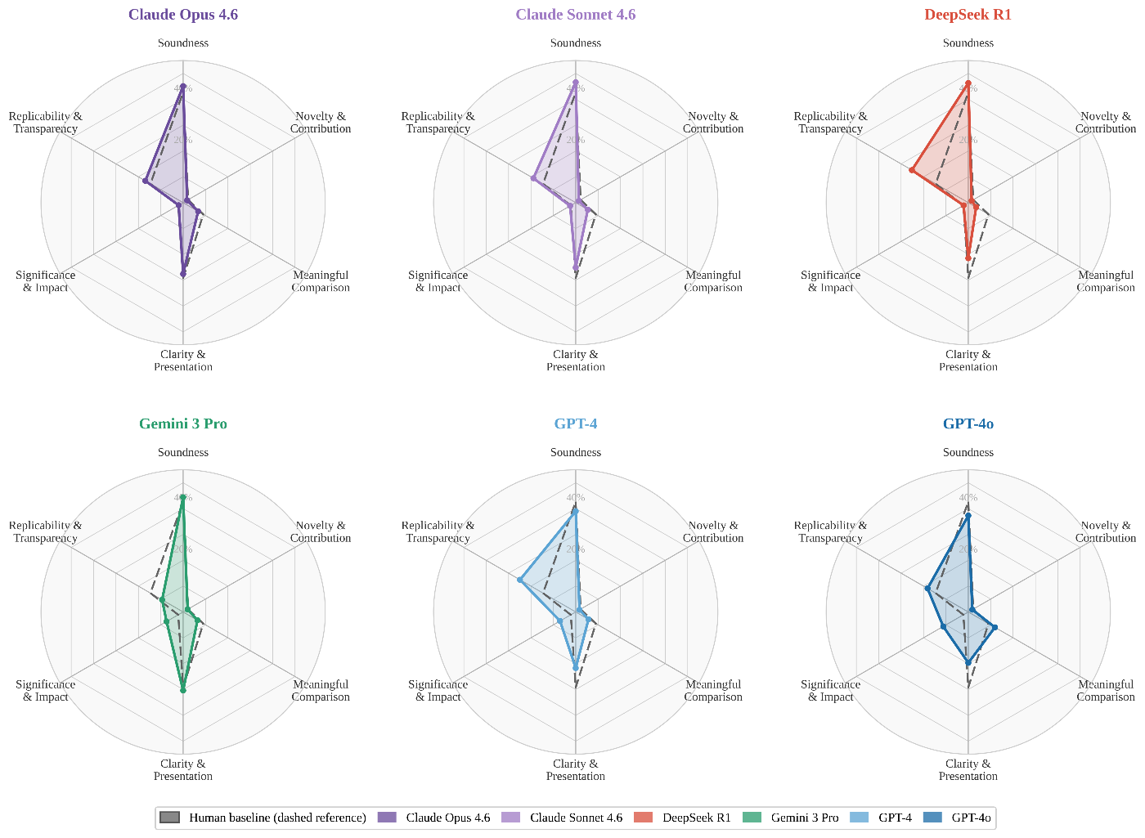
Figure 2. Radar chart comparison of comment category coverage between each LLM model and the human reviewer baseline across six evaluation dimensions
Figure 3 presents a heatmap of the model-by-category coverage matrix, with color intensity ranging from light yellow (low coverage) to deep red (high coverage) and the human baseline row positioned at the top for reference. The Soundness column displays uniformly deep tones across all rows, confirming its dominance as the primary critique category regardless of source. Novelty & Contribution remains consistently pale, reflecting its systematic scarcity at the rebuttal stage. The most pronounced inter-model variation is concentrated in three dimensions. In Replicability & Transparency, DeepSeek R1 (25.16%) and Gemini 3 Pro (9.41%) diverge by over 15 percentage points, deviating from the human baseline (14.60%) in opposite directions. In Significance & Impact, GPT-4o (11.15%) appears as a distinctly darker cell against an otherwise pale column, representing nearly five times the human proportion (2.25%). In Meaningful Comparison, GPT-4o (11.86%) and DeepSeek R1 (3.48%) form a sharp contrast on the color scale, flanking the human baseline (8.99%) from above and below. These chromatic disparities visually encapsulate the systematic differences in review emphasis across models.
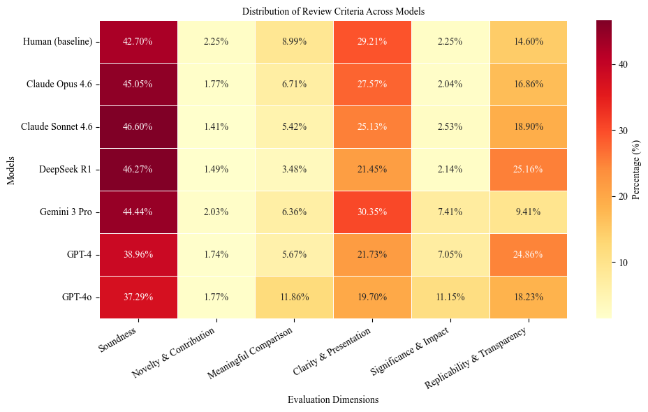
Figure 3. Heatmap of comment category coverage rates (%) by model and category; the human baseline row is highlighted with a bold border

Task 2：Reply resolution judgment

5.1 Experimental setup
This task evaluates whether LLMs can judge whether a reviewer concern is reflected as resolved on the basis of a comment–reply pair. The evaluation is based on the reply resolution annotations described in Section 3, using the balanced subset of 2,674 comment–reply pairs (1,640 Resolved and 1,034 Unresolved) drawn from 384 papers.
The experimental procedure was as follows. For each comment–reply pair, the original reviewer comment and the corresponding author reply were used as input to construct a standardized prompt. The prompt instructed the model to act as a peer review expert, assess whether the reviewer concern was reflected as resolved on the basis of the author’s reply, and return a binary label: Resolved or Unresolved. The input included no access to the full manuscript text or review information from other rounds; the model's judgment relied entirely on the textual exchange between a single criticism and its corresponding reply. All 2,674 pairs were submitted to six models—GPT-4, GPT-4o, Claude Opus, Claude Sonnet, DeepSeek R1, and Gemini 3 Pro—and the resulting judgments were compared against human-annotated ground truth for evaluation.

5.2 Results
Table 3 reports the performance of each model on the reply resolution judgment task. Accuracy ranges from 0.506 (DeepSeek R1) to 0.839 (Gemini 3 Pro). However, Cohen's κ values across all models remain below 0.1, indicating negligible agreement with the ground truth beyond chance. Gemini 3 Pro achieves the highest accuracy but the lowest κ (0.002), as its predictions are overwhelmingly dominated by the Resolved label. GPT-4 obtains the highest κ (0.093), while GPT-4o yields the highest Recall (0.533) and F1 (0.268) for the Unresolved class. Claude Opus ranks second in accuracy (0.735) and highest in Precision (0.187), though with comparatively lower Recall (0.311). Taken together, these results suggest that current LLMs have limited ability to align with trajectory-based reply resolution labels in this benchmark setting.
Table 3: Performance of LLMs on the reply resolution judgment task.
Model | Accuracy | Cohen's κ | Precision (U) | Recall (U) | F1 (U)
Gemini 3 Pro | 0.839 | 0.002 | 0.133 | 0.044 | 0.067
GPT-4 | 0.695 | 0.093 | 0.186 | 0.400 | 0.254
GPT-4o | 0.622 | 0.092 | 0.179 | 0.533 | 0.268
Claude Sonnet | 0.640 | 0.066 | 0.167 | 0.444 | 0.242
DeepSeek R1 | 0.506 | 0.032 | 0.146 | 0.578 | 0.233
Claude Opus | 0.735 | 0.085 | 0.187 | 0.311 | 0.233
Figure 4 presents model accuracy disaggregated by review category. All models achieve their highest accuracy on Replicability & Transparency (0.667–0.867) and Meaningful Comparison (0.573–0.792). Accuracy declines markedly for Novelty & Contribution (0.231–0.421) and Significance & Impact (0.317–0.438), remaining below 0.45 across all models in both categories. The two largest categories—Clarity & Presentation (n = 1,073) and Soundness (n = 860)—fall in an intermediate range, with accuracy between 0.495 and 0.613. Notably, Claude Sonnet and Claude Opus exhibit relatively consistent performance across categories, including the two in which other models struggle most.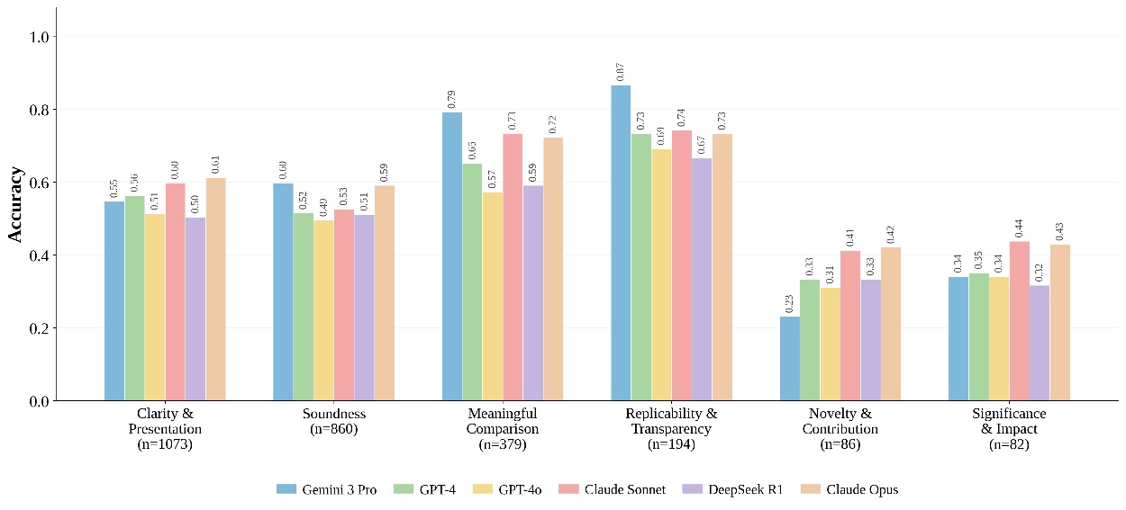
Figure 4: Model accuracy on reply resolution judgment disaggregated by review category.
Figure 5 illustrates the judgment composition and error directionality of each model. Claude Opus achieves the highest correct rate (62.5%) but also exhibits the largest proportion of over-optimistic errors (27.3%), suggesting a tendency to classify unresolved issues as resolved. DeepSeek R1 displays the opposite pattern, producing the highest proportion of over-pessimistic errors (34.1%) by frequently classifying resolved issues as unresolved. GPT-4o exhibits a similar tendency, with 32.8% over-pessimistic errors. By contrast, GPT-4 and Claude Sonnet show the most balanced error distributions, with neither error type exceeding 23.4%. These findings reveal systematic directional biases: Gemini 3 Pro and Claude Opus tend toward leniency, whereas DeepSeek R1 and GPT-4o lean toward excessive skepticism.
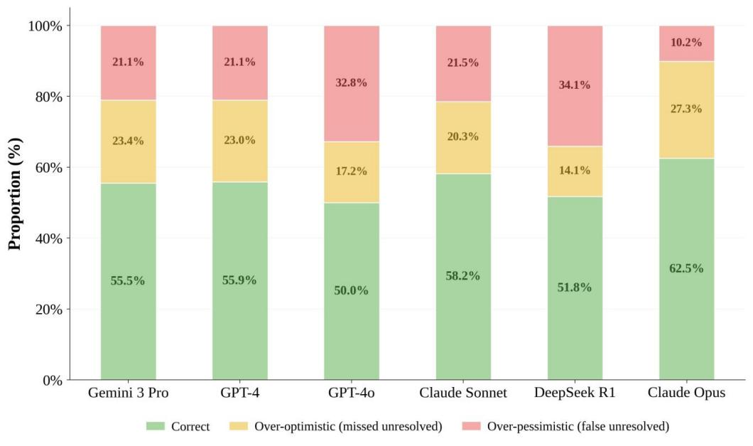
Figure 5: Judgment composition and error directionality of each model on the reply resolution judgment task.

Task 3：Round-level acceptability judgment

6.1 Experimental setup
Task 3 further examines whether LLMs can make round-level acceptability judgments given complete review information. This task requires models to simultaneously weigh the severity of reviewer criticisms, the extent to which author replies address those concerns, and the overall quality of the revised manuscript, thereby producing a holistic round-level judgment.
We selected all 265 papers containing three or more complete review rounds from the dataset. For each review round, the model receives three inputs: (1) all reviewer criticisms from that round, (2) the corresponding author rebuttals, and (3) the full text of the revised manuscript. The model is then required to produce a binary classification: Accept or Needs Revision. Each round is evaluated independently, with no information about subsequent rounds provided.
The gold standard is derived from each paper's actual editorial trajectory. For all non-final rounds, the ground-truth label is Needs Revision; for the final round, the label is Accept. This operationalization approximates round-level acceptance status as reflected in the observed review trajectory. Notably, the resulting label distribution is inherently imbalanced, as only the final round of each paper carries an Accept label while all preceding rounds are labeled Needs Revision.
To enable meaningful aggregation across papers with varying numbers of review rounds, we index rounds by their relative distance from the final round: the last round is designated Last Round, the penultimate round Round −2, the antepenultimate round Round −3, and so forth. Six models—GPT-4, GPT-4o, Claude Opus 4.6, Claude Sonnet 4.6, DeepSeek R1, and Gemini 3 Pro—are evaluated under identical conditions.

6.2 Results
Table 5 reports the binary classification performance of each model across all rounds. All six models achieved accuracy above 0.70, with Claude Opus attaining the highest (0.789) and GPT-4o the lowest (0.702). However, Cohen's κ ranged from only 0.218 (GPT-4o) to 0.432 (Claude Opus), indicating that agreement beyond chance remains limited despite ostensibly reasonable accuracy. Even the best-performing model falls within the "moderate agreement" range, suggesting that round-level acceptability judgment remains challenging for current LLMs under this benchmark setting. Precision and recall, computed with Accept as the positive class, follow a consistent ranking: Claude Opus leads on both metrics (Precision = 0.714, Recall = 0.658), while GPT-4o scores lowest (Precision = 0.548, Recall = 0.526). Claude Sonnet, GPT-4, and DeepSeek R1 occupy the middle tier, with F1 scores between 0.605 and 0.642.
Notably, these accuracy figures are partly inflated by the label imbalance inherent in the task design. Because non-final rounds (labeled Needs Revision) substantially outnumber final rounds (labeled Accept), a naïve classifier that uniformly predicts Needs Revision would achieve non-trivial accuracy. The modest κ values confirm that much of the observed accuracy reflects this baseline bias rather than genuine predictive capability.
Table 5: Overall performance on accept/revise decision (Accept as positive class)
Model | Accuracy | Cohen's κ | Precision | Recall | F1
Claude Opus 4.6 | 0.789 | 0.432 | 0.714 | 0.658 | 0.685
Claude Sonnet 4.6 | 0.754 | 0.371 | 0.652 | 0.632 | 0.642
GPT-4 | 0.737 | 0.348 | 0.636 | 0.605 | 0.62
DeepSeek R1 | 0.728 | 0.322 | 0.618 | 0.592 | 0.605
Gemini 3 Pro | 0.726 | 0.274 | 0.583 | 0.553 | 0.567
GPT-4o | 0.702 | 0.218 | 0.548 | 0.526 | 0.537
Figure 6 presents the proportion of Accept predictions at each relative round position. An ideal model would predict Needs Revision at all non-final rounds (0% accept rate) and switch to Accept only at the last round (100% accept rate). None of the six models approximated this pattern.
At Round −3, all models already exhibited non-trivial accept rates, ranging from 10.5% (Claude Opus) to 24.9% (DeepSeek R1), indicating a tendency to judge manuscripts as acceptable prematurely despite multiple revision rounds remaining. Claude Opus was the most conservative, predicting Accept in roughly one out of ten cases at this early stage, while the remaining models ranged between 18% and 25%. GPT-4o represented a notable exception: its Round −3 rate (21.8%) was moderate, but escalated sharply in subsequent rounds.
At Round −2, accept rates rose across all models, ranging from 22.4% (Claude Opus) to 42.1% (GPT-4o), with inter-model divergence widening considerably. Claude Opus and Claude Sonnet maintained relatively restrained rates (22.4% and 28.9%), whereas GPT-4o and DeepSeek R1 exceeded 39%, predicting Accept in nearly two out of five cases despite at least one further revision round remaining.
At the last round, where the gold standard is Accept, prediction rates ranged from 62.5% (GPT-4o) to 84.2% (Claude Opus). No model exceeded 85%, meaning that even at the point of eventual publication, a substantial fraction of cases were misclassified. Claude Opus exhibited the steepest trajectory—from 10.5% at Round −3 to 84.2% at the last round—suggesting the strongest sensitivity to revision progress. GPT-4o displayed the flattest curve, rising only from 21.8% to 62.5%, indicating a limited ability to discriminate between rounds requiring further revision and those warranting acceptance.
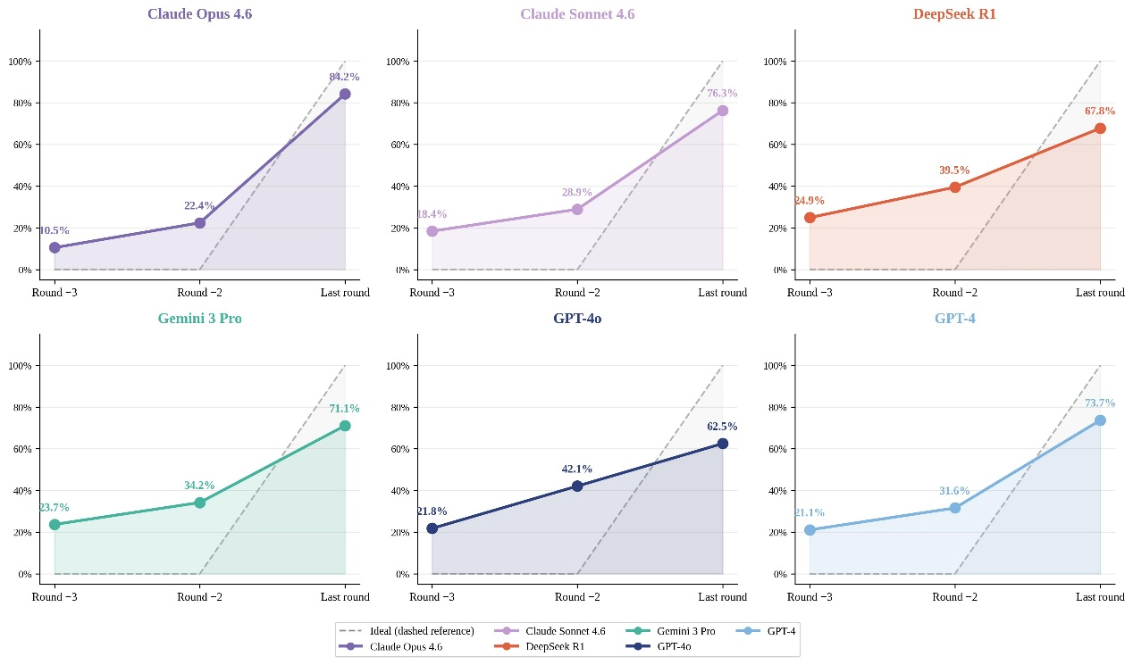
Figure 6: Accept prediction rate by relative round position for each model. The dashed gray line represents the ideal pattern (0% at non-final rounds, 100% at the last round).

Discussion
Evaluating six frontier LLMs across three open peer review tasks on our benchmark yields critical insights into their reasoning patterns, evaluative judgment, and task-specific limitations within the peer review process. This section examines two interrelated dimensions: (1) how model performance varies across tasks and what this reveals about the compound nature of peer review competence (Section 7.1), and (2) how models differ from one another in their evaluative tendencies, systematic biases, and task-specific suitability (Section 7.2).

7.1 Performance Variation Across Tasks
Our multi-task evaluation reveals a clear and consistent performance gradient across the three peer review tasks: models show comparatively closer alignment with human distributions in review dimension coverage than in the other two tasks (Task 1), show marked degradation on author reply resolution judgment (Task 2), and exhibit systematic deficiencies in round-level acceptability judgment (Task 3).
In Task 1, most models approximate the macro-level dimensional distribution of human review comments, demonstrating particularly high alignment with human baselines on the Soundness dimension. This finding is consistent with Shin et al. (2025), whose focus-level evaluation framework at EMNLP 2025 showed that both LLMs and human reviewers converge on technical validity as a primary review focus^{[26]}. However, our results also reveal two notable deviations from human baselines. First, all models exhibit systematically lower coverage on Novelty & Contribution relative to human reviewers, an observation consistent with a growing body of evidence documenting LLMs' deficiencies in novelty assessment^{[43][44]}. Second, and more distinctive to the present study, models—with the exception of GPT-4o—also perform significantly below human baselines on Meaningful Comparison, a dimension that requires situating a paper within its broader scholarly community rather than evaluating it in isolation. The anomalously high coverage by GPT-4o on this dimension likely reflects a model-specific systematic bias rather than genuine competence^{[45]}, whereas the widespread under-coverage across other models points to a recurring limitation in the current benchmark setting: current LLMs can critique internal methodological rigor, but they struggle to situate papers within the broader scholarly context in the way expert reviewers do. We further observe that models consistently exceed human coverage rates on Replicability & Transparency, indicating a pronounced orientation toward technical reproducibility and data transparency—dimensions defined by explicit, rule-based criteria well suited to pattern matching in textual evidence.
In Task 2, although some models achieve ostensibly acceptable accuracy scores, the uniformly low Cohen's κ values across all models indicate limited stable agreement with the human-annotated reference labels. More critically, model performance exhibits pronounced dimensional asymmetry: models perform substantially better on concrete, rule-governed dimensions such as Replicability and Transparency, where resolution status can be inferred more directly from the presence or absence of explicit textual supplements (e.g., code links, methodological details), yet perform markedly worse on abstract dimensions such as Novelty and Contribution and Significance and Impact, where judgment requires evaluating whether a response has meaningfully altered the scholarly standing of the paper. This pattern suggests that current models are better equipped to detect whether specific evidentiary supplements have been provided than to assess whether those supplements constitute a resolution of the underlying concern as reflected in subsequent review progression. Du et al. (2024) similarly observed that LLMs tend to accept authors' claims at face value without adequate verification^{[46]}; our dimensional analysis provides a finer-grained structural explanation for this tendency, demonstrating that it is concentrated in dimensions requiring higher-order evaluative inference rather than representing a uniform deficit across all review criteria.
Task 3 requires models to synthesize review criticisms, author rebuttals, and manuscript revisions within complete review rounds to judge whether the manuscript has reached round-level acceptability in the current review round. To assess model sensitivity to the temporal dynamics of the review process, we introduce a novel evaluation metric: the round-level accept prediction rate. Under this operationalization, ideal performance would imply a monotonically increasing accept prediction rate across successive rounds, reaching its maximum in the final round as accumulated revisions progressively resolve outstanding concerns. Our results, however, reveal that all models generate non-trivial proportions of Accept predictions in early, non-terminal rounds while simultaneously failing to achieve reliably high acceptance rates in final rounds. This indicates that models show limited ability to align round-level acceptability judgments with the observed review trajectory—a finding consistent with Tan et al. (2024), whose ReviewMT framework demonstrated that LLMs achieve notably low decision hit rates under zero-shot conditions^{[47]}.

7.2 Performance Variation Across Models
Beyond the cross-task capability stratification discussed above, our benchmark also reveals substantial inter-model differences. These differences cannot be reduced to a simple overall performance ranking; rather, they manifest as distinct and stable patterns in review focus, judgment bias directionality, and temporal sensitivity.
In Task 1, the six models exhibited divergent distributions of review dimensions. Claude Opus 4.6 and Claude Sonnet 4.6 most closely approximated the human baseline overall, particularly on Soundness, Clarity & Presentation, and Replicability & Transparency, indicating that their review focus structures best mirror those of human reviewers. DeepSeek R1 showed disproportionately high coverage of Replicability & Transparency but markedly low coverage of Meaningful Comparison, suggesting an emphasis on technical reproducibility at the expense of scholarly positioning. GPT-4o displayed the inverse pattern—elevated coverage of Significance & Impact and Meaningful Comparison alongside reduced attention to Soundness and Clarity & Presentation—favoring macro-level value judgments. Gemini 3 Pro was characterized by higher Clarity & Presentation coverage coupled with lower Replicability & Transparency, prioritizing expository quality over methodological detail. These findings extend the conclusions of Shin et al. (2025), who reported aggregate directional biases of LLMs relative to humans in focus distribution^{[26]}. Our results further demonstrate that such aggregate biases mask considerable inter-model heterogeneity, with individual models deviating from the human baseline in qualitatively distinct directions.
In Task 2, inter-model differences shifted from distributional focus to judgment directionality, as models diverged in producing lenient versus strict verdicts. Gemini 3 Pro achieved relatively high surface-level accuracy yet an extremely low κ, indicating that its performance was driven primarily by majority-class label bias rather than genuine discriminative ability. Claude Opus exhibited generally higher judgment quality but with a tendency toward leniency, whereas DeepSeek R1 and GPT-4o displayed more pronounced over-rejection tendencies. The directionality of such biases carries direct implications for peer review applications. Latona et al. (2024) confirmed through a large-scale study that LLM-assisted reviewing systematically inflates scores and increases acceptance probability, establishing positive bias as a general LLM tendency^{[48]}. Our findings further show that both the magnitude and direction of this bias vary substantially across models, with some exhibiting the opposite tendency toward excessive skepticism. This bidirectional distribution connects to the broader literature on LLM sycophancy, which may originate from agreement-laden pretraining corpora and post-training reward mechanisms that reinforce user affirmation, encompassing multiple independently modulable sub-behaviors^{[49][50]}. Our study contributes domain-specific evidence from peer review: different alignment strategies and post-training regimes can produce qualitatively distinct judgment tendencies rather than merely scalar variations of a single underlying bias.
In Task 3, inter-model differences were most clearly reflected in the shape of round-level accept prediction rate curves. Claude Opus exhibited the steepest trajectory, indicating a stronger capacity to differentiate between early and final rounds and, to some extent, approximating the expected pattern of progressively increasing round-level acceptability judgment as revisions accumulate. GPT-4o produced a comparatively flat curve, suggesting weaker sensitivity to the stage-wise evolution of the review process—despite not necessarily exhibiting lower per-round judgment accuracy.

Conclusion
This study proposes a multi-task evaluation benchmark for open peer review, systematically examining six frontier LLMs across three tasks: review dimension coverage, reply resolution judgment, and round-level acceptability judgment. The results reveal significant inter-model differences in reasoning stability, evaluative bias directionality, and process-awareness. Within this benchmark, Claude Opus 4.6 and Claude Sonnet 4.6 show the most balanced performance profile across the three tasks, exhibiting the highest alignment with human baselines in review dimension coverage, maintaining a favorable trade-off between accuracy and κ in reply resolution judgment, and demonstrating the strongest round-sensitivity in round-level acceptability judgment. By contrast, GPT-4o shows relatively strong performance on macro-level significance dimensions but pays comparatively less attention to core technical dimensions such as Soundness, while also displaying weaker sensitivity to the sequential evolution of the review process. DeepSeek R1 places disproportionate emphasis on reproducibility-related dimensions but performs less well on scholarly positioning and literature comparison, while also showing a pronounced tendency toward negative judgments in rebuttal evaluation. Although Gemini 3 Pro achieves nominally high accuracy in the rebuttal judgment task, its extremely low κ indicates that this performance is largely attributable to majority-class bias rather than genuine discriminative capacity. These findings suggest that neither model scale nor ranking on general-purpose benchmarks reliably predicts performance in the high-judgment setting of peer review. These findings also suggest that using LLMs as reviewing aids without task-specific calibration may introduce systematic, model-dependent biases into round-level acceptability judgment, highlighting the need for bias-aware integration before large-scale adoption.
More importantly, this study suggests that prevailing models may appear stronger under evaluation paradigms centered on a single task—particularly review generation—because such paradigms fail to capture the judgmental depth and procedural complexity inherent in peer review. The discrepancy between models’ comparatively closer alignment in review dimension coverage and their marked degradation in rebuttal judgment and round-level acceptability judgment suggests that existing evaluations may overestimate broader reviewing capability. By introducing a multi-task, multi-round evaluation design, the proposed benchmark effects a methodological shift: from assessing generation quality in isolation to conducting diagnostic analysis across multiple linked stages of the review process. Specifically, the round-level accept prediction rate metric proposed herein provides a novel analytical tool for quantifying temporal consistency throughout iterative review processes, while cross-task dimensional comparison reveals a capability gap between surface-level evidence matching and higher-order scholarly judgment. By exposing systematic inter-model differences in dimensional preference, judgment directionality, and process tracking, this benchmark moves beyond aggregate accuracy reporting to offer a more diagnostic, failure-aware evaluation framework.
Several limitations remain. First, the large-scale corpus includes non-negligible annotation noise, as manual validation of a 1,000-instance sample yielded 72.3% agreement with the LLM-assisted labels. This may have introduced uncertainty into the fine-grained distributional analyses, although the overall comparative trends remain informative. Second, rigorous cross-domain generalization testing has not yet been conducted; as the dataset spans multiple interdisciplinary fields without strict domain delineation, future work will preliminarily investigate inter-domain performance variation through topic- or discipline-based stratification and pursue more systematic cross-domain evaluation. Subsequent research will leverage the findings of this benchmark to guide the optimization of peer review assistance systems, with particular emphasis on enhancing model capabilities in issue-resolution status judgment and process-oriented integrative decision-making. Future work should also extend the evaluation scope to incorporate computational efficiency, assessing the trade-off between accuracy and inference cost. The findings of this study reveal not only where models fail but how they fail, charting a path toward targeted improvements in evaluative consistency and judgment calibration. As LLMs continue to expand into domains demanding rigorous reasoning reliability—including scholarly publishing and research administration—evaluation benchmarks must evolve accordingly. By providing diagnostic instruments that transcend summary scores, this study lays the groundwork for developing peer review assistance systems capable of reliable reasoning, judicious evaluation, and safe generalization.
CRediT authorship contribution statement
Kai Qiao: Writing – review & editing, Writing – original draft, Visualization, Methodology, Formal analysis, Data curation, Conceptualization; Xiaoping Sheng: Writing – review & editing, Validation,
Supervision, Methodology; Zhenyu Li: Writing – review & editing, Methodology, Validation, Supervision, Conceptualization.
Declarations & ethics
This manuscript is not under consideration elsewhere and has not been previously published in any form other than those allowed by the journal, such as a preprint or thesis, if applicable.
Data availability
The data will be made publicly available at https://github.com/myppqk88/A-Multi-Task-Benchmark-for-Evaluating-LLMs-on-Peer-Review.
Acknowledgement
The authors gratefully acknowledge the financial support of the Key Project of the National Social Science Fund of China (Grant No. 22ATQ005).
Declaration of generative AI and AI-assisted technologies in the manuscript preparation process
During the preparation of this work, the authors used Claude Opus 4.6 and ChatGPT 5.3 to improve the language and assist with the processing of images and tables. After using these tools/services, the authors reviewed and edited the content as needed and take full responsibility for the content of the published article.

Reference
- Li, J., Gao, Y., Yang, Y., Bai, Y., Zhou, X., Li, Y., ... & Huang, H. (2025). Fundamental capabilities and applications of large language models: A survey. ACM Computing Surveys, 58(2), 1-42.
- So, R. (2025). Scientific Discoveries by LLM Agents. Nature.
- Zhang, Y., Chen, X., Jin, B., Wang, S., Ji, S., Wang, W., & Han, J. (2024, November). A comprehensive survey of scientific large language models and their applications in scientific discovery. In Proceedings of the 2024 Conference on Empirical Methods in Natural Language Processing (pp. 8783-8817).
- Zheng, T., Deng, Z., Tsang, H. T., Wang, W., Bai, J., Wang, Z., & Song, Y. (2025, November). From automation to autonomy: A survey on large language models in scientific discovery. In Proceedings of the 2025 Conference on Empirical Methods in Natural Language Processing (pp. 17744-17761).
- Nath, K. A., Conway, M., & Fonseca, R. (2024, January). AI in peer review: publishing’s panacea or a Pandora’s box of problems?. In Mayo Clinic Proceedings (Vol. 99, No. 1, pp. 10-12). Elsevier.
- Zhuang, Z., Chen, J., Xu, H., Jiang, Y., & Lin, J. (2025). Large language models for automated scholarly paper review: A survey. Information Fusion, 124, 103332.
- Kang, D., Ammar, W., Dalvi, B., Van Zuylen, M., Kohlmeier, S., Hovy, E., & Schwartz, R. (2018, June). A dataset of peer reviews (PeerRead): Collection, insights and NLP applications. In Proceedings of the 2018 conference of the North American chapter of the Association for Computational Linguistics: Human language technologies, volume 1 (long papers) (pp. 1647-1661).
- Li, R., Zhang, H., Gehringer, E., Xiao, T., Ding, J., & Chen, H. (2025, November). Unveiling the merits and defects of llms in automatic review generation for scientific papers. In 2025 IEEE International Conference on Data Mining (ICDM) (pp. 1370-1379). IEEE.
- Taechoyotin, P., & Acuna, D. (2025). Remor: Automated peer review generation with llm reasoning and multi-objective reinforcement learning. arXiv preprint arXiv:2505.11718.
- Gao, X., Ruan, J., Zhang, Z., Gao, J., Liu, T., & Fu, Y. (2025). MMReview: A Multidisciplinary and Multimodal Benchmark for LLM-Based Peer Review Automation. arXiv preprint arXiv:2508.14146.
- Zhao, W. X., Zhou, K., Li, J., Tang, T., Wang, X., Hou, Y., ... & Wen, J. R. (2023). A survey of large language models. arXiv preprint arXiv:2303.18223, 1(2), 1-124.
- Shen, S. M., Wang, Z., Paul, K., Li, M. H., Huang, X., & Koizumi, N. (2026). Evaluation of Large Language Models for Peer Review in Transplantation Research: Algorithm Validation Study. JMIR AI, 5, e84322.
- Jegham, N., Abdelatti, M., & Hendawi, A. (2025). Visual reasoning consistency and robustness analysis of multimodal llms. Pattern Recognition, 112765.
- OpenAI. (2023). GPT-4 technical report. arXiv:2303.08774.
- OpenAI. (2024). GPT-4o system card. https://openai.com/index/gpt-4o-system-card/
- Anthropic. (2025). Claude Opus 4 & Sonnet 4 system card. https://www.anthropic.com/claude-4-system-card
- Gao, T., Jin, J., Ke, Z. T., & Moryoussef, G. (2026). A comparison of DeepSeek and other LLMs. The American Statistician, 80(1), 164-176.
- Google DeepMind. (2024). Gemini: A family of highly capable multimodal models. arXiv:2312.11805.
- Xie, J., Song, W., & Hu, Y. (2026). Analysis of AI Multi-model Responses and Evaluations for PEP Guidelines. American Journal of Preventive Medicine.
- Zheng, L., Chiang, W. L., Sheng, Y., Zhuang, S., Wu, Z., Zhuang, Y., ... & Stoica, I. (2023). Judging llm-as-a-judge with mt-bench and chatbot arena. Advances in neural information processing systems, 36, 46595-46623.
- Garg, M. K., Prasad, T., Singhal, T., Kirtani, C., Mandal, M., & Kumar, D. (2025). Revieweval: An evaluation framework for ai-generated reviews. arXiv preprint arXiv:2502.11736.
- Ortega, J.L. (2022). Classification and analysis of PubPeer comments: How a web journal club is used. Journal of the Association for Information Science and Technology, 73(5), 655–670.
- Sizo, A., Lino, A., Rocha, Á., & Reis, L.P. (2025). Defining quality in peer review reports: A scoping review. Knowledge and Information Systems, 67(8), 6413–6460.
- Ghosal, T., Kumar, S., Bharti, P. K., & Ekbal, A. (2022). Peer review analyze: A novel benchmark resource for computational analysis of peer reviews. Plos one, 17(1), e0259238.
- Yuan, W., Liu, P., & Neubig, G. (2022). Can we automate scientific reviewing?. Journal of Artificial Intelligence Research, 75, 171-212.
- Shin, H., Tang, J., Lee, Y., et al. (2025). Mind the blind spots: A focus-level evaluation framework for LLM reviews. In Proceedings of EMNLP 2025, pp. 35630–35656.
- Wu, P. C., Yen, A. Z., Huang, H. H., & Chen, H. H. (2022, October). Incorporating peer reviews and rebuttal counter-arguments for meta-review generation. In Proceedings of the 31st ACM International Conference on Information & Knowledge Management (pp. 2189-2198).
- Kennard, N. N., O’Gorman, T., Das, R., Sharma, A., Bagchi, C., Clinton, M., ... & McCallum, A. (2022, July). DISAPERE: A dataset for discourse structure in peer review discussions. In Proceedings of the 2022 conference of the North American chapter of the Association for Computational Linguistics: Human language technologies (pp. 1234-1249).
- Koohestani, R., de Bekker, P., Koç, B., & Izadi, M. (2025). Benchmarking AI Models in Software Engineering: A Review, Search Tool, and Unified Approach for Elevating Benchmark Quality. IEEE Transactions on Software Engineering.
- Lin, J., Song, J., Zhou, Z., Chen, Y., & Shi, X. (2023). Moprd: A multidisciplinary open peer review dataset. Neural Computing and Applications, 35(34), 24191-24206.
- Dycke, N., Kuznetsov, I., & Gurevych, I. (2023, July). NLPeer: A unified resource for the computational study of peer review. In Proceedings of the 61st annual meeting of the Association for Computational Linguistics (volume 1: Long papers) (pp. 5049-5073).
- Liu, R., & Shah, N. B. (2023). Reviewergpt? an exploratory study on using large language models for paper reviewing. arXiv preprint arXiv:2306.00622.
- Lou, R., Xu, H., Wang, S., Du, J., Kamoi, R., Lu, X., ... & Yin, W. (2024). AAAR-1.0: Assessing AI's Potential to Assist Research. arXiv preprint arXiv:2410.22394.
- D'Arcy, M., Hope, T., Birnbaum, L., & Downey, D. (2024). Marg: Multi-agent review generation for scientific papers. arXiv preprint arXiv:2401.04259.
- Gao, X., Ruan, J., Zhang, Z., Gao, J., Liu, T., & Fu, Y. (2025). Reviewagents: Bridging the gap between human and ai-generated paper reviews. arXiv preprint arXiv:2503.08506.
- Weng, Y., Zhu, M., Bao, G., Zhang, H., Wang, J., Zhang, Y., & Yang, L. (2024). Cycleresearcher: Improving automated research via automated review. arXiv preprint arXiv:2411.00816.
- Zhou, R., Chen, L., & Yu, K. (2024, May). Is LLM a reliable reviewer? A comprehensive evaluation of LLM on automatic paper reviewing tasks. In Proceedings of the 2024 joint international conference on computational linguistics, language resources and evaluation (LREC-COLING 2024) (pp. 9340-9351).
- Yu, S., Luo, M., Madusu, A., Lal, V., & Howard, P. (2025). Is your paper being reviewed by an LLM? A new benchmark dataset and approach for detecting AI text in peer review. arXiv e-prints, arXiv-2502.
- Bharti, P., Ghosal, T., Agarwal, M., & Ekbal, A. (2022, December). A method for automatically estimating the informativeness of peer reviews. In Proceedings of the 19th international conference on natural language processing (icon) (pp. 280-289).
- Sun, L., Chan, A., Chang, Y. S., & Dow, S. P. (2024, March). ReviewFlow: Intelligent scaffolding to support academic peer reviewing. In Proceedings of the 29th International Conference on Intelligent User Interfaces (pp. 120-137).
- Qiao, K., Sheng, X., & Li, Z. (2025). AI-Avatars Versus Human-Avatars: A Comparative Study of User Interaction Behaviors in Live Streaming. International Journal of Human–Computer Interaction, 1-26.
- Ribeiro, A. C., Sizo, A., Lopes Cardoso, H., & Reis, L. P. (2021, September). Acceptance decision prediction in peer-review through sentiment analysis. In EPIA Conference on Artificial Intelligence (pp. 766-777). Cham: Springer International Publishing.
- Liang, W., Zhang, Y., Cao, H., Wang, B., Ding, D. Y., Yang, X., ... & Zou, J. (2024). Can large language models provide useful feedback on research papers? A large-scale empirical analysis. NEJM AI, 1(8), AIoa2400196.
- Lin, E., Peng, Z., & Fang, Y. (2025, May). Evaluating and enhancing large language models for novelty assessment in scholarly publications. In Proceedings of the 1st Workshop on AI and Scientific Discovery: Directions and Opportunities (pp. 46-57).
- OpenAI. (2025, April 29). Sycophancy in GPT-4o: What happened and what we’re doing about it. OpenAI. https://openai.com/index/sycophancy-in-gpt-4o/
- Du, J., Wang, Y., Zhao, W., Deng, Z., Liu, S., Lou, R., ... & Yin, W. (2024, November). LLMs assist NLP researchers: Critique paper (meta-) reviewing. In Proceedings of the 2024 conference on empirical methods in natural language processing (pp. 5081-5099).
- Tan, C., Lyu, D., Li, S., Gao, Z., Wei, J., Ma, S., ... & Li, S. Z. (2024). Peer review as a multi-turn and long-context dialogue with role-based interactions. arXiv preprint arXiv:2406.05688.
- Latona, G. R., Ribeiro, M. H., Davidson, T. R., et al. (2024). The AI review lottery: Widespread AI-assisted peer reviews boost paper scores and acceptance rates. arXiv preprint arXiv:2405.02150.
- Malmqvist, L. (2025, June). Sycophancy in large language models: Causes and mitigations. In Intelligent Computing-Proceedings of the Computing Conference (pp. 61-74). Cham: Springer Nature Switzerland.
- Sharma, M., Tong, M., Korbak, T., Duvenaud, D., Askell, A., Bowman, S. R., ... & Perez, E. (2023). Towards understanding sycophancy in language models. arXiv preprint arXiv:2310.13548.

