CUSTOMER REQUIREMENTS SPECIFICATION

Integrated College
Management System
  - Online admissions learning academic results and lecturer attendance
Prepared for Brima Conteh
Version 1.0 | 26 September 2026
Status Proposed requirements for customer review
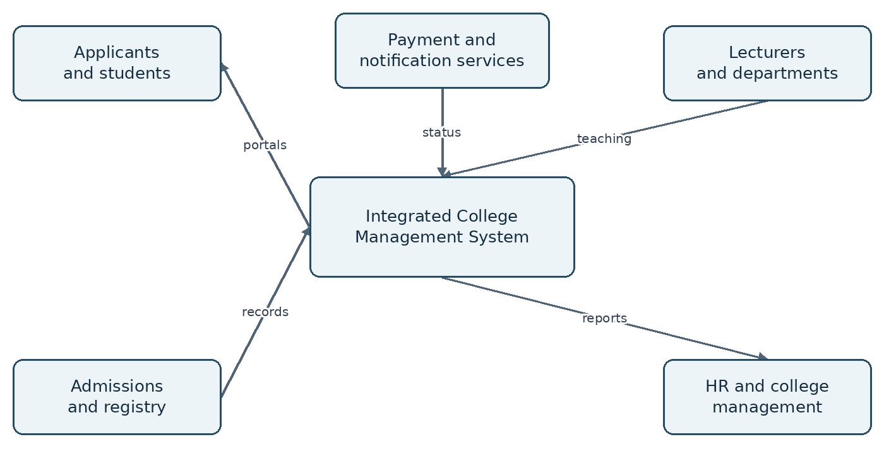
Figure 1 The proposed system connects college users and supporting services.
This specification defines the customer outcomes, operating rules, functional requirements and acceptance conditions for a unified college platform. It provides a reviewable basis for scope agreement, solution design, implementation and user acceptance testing.
Institution name, governance policies, delivery budget and hosting arrangements remain to be confirmed. Approval of this document establishes a requirements baseline; it does not certify that the software has been implemented.

Document control and reading guide
Field | Value
Document identifier | ICMS CRS 001
Document owner | Project sponsor to nominate
Project initiator | Brima Conteh
Audience | College leadership, admissions, registry, lecturers, HR, students and development team
Baseline | Version 1.0 proposed for review
Change authority | College sponsor with the relevant process owner

Purpose and interpretation
CRS means Customer Requirements Specification in this document. It describes what the college needs and how success will be checked. Detailed technical design, procurement terms and institution-specific regulations require separate approval. Google Classroom and openSIS are functional reference points named in the project concept; this scope does not promise product parity, software reuse or integration with either service.

Requirement language
“Shall” identifies a proposed mandatory capability within an approved release. “Should” identifies a desirable capability. All requirements remain proposed until the customer approves the baseline. Priority M means Must, S means Should and C means Could. Unless explicitly marked S or C, numbered requirements have priority M. A phased Must is mandatory for its allocated release, not necessarily for the first pilot.

How to review
Process owners should check the rules and exceptions in their module, then examine acceptance evidence and unresolved decisions. Reviewers should record the requirement identifier, requested change, reason and operational impact. The sponsor resolves conflicts between departments before the development team estimates the approved scope.
Version | Date | Change
1.0 | 26 September 2026 | Initial complete customer specification with workflows, conceptual screens and acceptance requirements.

Contents
Document control and reading guide 2
Business purpose and success measures 4
Scope and delivery boundaries 5
Stakeholders and access responsibilities 6
Student lifecycle and admission workflow 7
Online application requirements 8
Admission and student record requirements 9
Academic structure and registration 10
Learning management requirements 11
Assessment and result publication 12
Grading rules and academic exceptions 13
Lecturer attendance and teaching records 14
Supporting administration and reporting 15
Student and lecturer interface illustrations 16
Data requirements and information ownership 17
System boundaries and integration requirements 18
Security privacy and accountability 19
Service quality and operating targets 20
Acceptance scenarios and traceability 21
Delivery migration and operational readiness 22
Risks dependencies and decisions 23
Approval glossary and baseline checklist 24
Figures include a system context illustration, admission workflow, result approval workflow, lecturer attendance workflow, two conceptual portal screens, a conceptual data model and a logical architecture diagram. Page references apply to this edition.

Business purpose and success measures

Business need
The proposed platform gives the college one coordinated way to receive applications, establish student records, deliver learning activities, publish approved academic results and monitor lecturer attendance. Each process should reuse authoritative information rather than requiring separate accounts and repeated manual transcription. A student accepted through admissions should progress into registration and learning without staff re-entering the same identity details.
The business problems below are planning hypotheses to validate during discovery. No institution-specific operational audit has yet been supplied. The customer should confirm current processing times, volumes and error rates before using improvement targets in a contract.
Objective | Proposed success measure | Evidence owner
Reduce duplicate records | No duplicate student record in the agreed conversion and retry tests | Registry
Control result publication | Every released result has approval and a version history | Examinations
Connect learning access | Every active registration grants only the correct course access | Academic office
Make teaching visible | Every scheduled pilot session has a recorded outcome or unresolved exception | Department and HR
Support independent use | At least 90% of pilot participants complete their role tasks without staff intervention | UAT coordinator

Expected value
Applicants gain a clear view of their next action. Students find coursework and results in one place. Lecturers manage assigned courses and teaching records from a common workspace. Admissions, registry and HR retain distinct approval responsibilities while management receives consistent summaries. The value depends on agreed policies and timely staff participation as well as software functionality.

Evaluation boundary
The pilot should measure completion rate, task time, support requests and record reconciliation. The project shall not claim improved academic performance or reduced absenteeism solely because the platform is installed. Such outcomes require a separately designed evaluation and an adequate observation period.

Scope and delivery boundaries

Core scope
The first implementation is provisionally designed for one college, with configurable departments, programmes and academic periods. Multiple campuses may be represented within that institution if approved. Operating several independent colleges as isolated customers is a separate architecture and commercial decision. It must be resolved before production deployment.
Included capability | Boundary
Online admissions | Application drafts, document uploads, review, decisions and admission conversion
Student information | Identity, academic status, enrolment history and authorised record changes
Learning management | Materials, announcements, assignments, basic quizzes, submissions and feedback
Results | Marks, validation, approval, publication, GPA and authorised corrections
Lecturer attendance | Staff presence where required, teaching sessions, exceptions and reviewed reports
Common services | Role access, audit trails, notifications, exports, configuration and backup

Desirable extensions
Student attendance, official transcript request processing, discussion forums and additional notification channels are Should requirements. Native Android and iOS applications, biometric attendance, live video teaching and advanced analytics are Could items requiring separate estimates and approval. A responsive web application is the baseline access channel.

Outside the initial baseline
Full payroll, library circulation, hostel allocation, transport, procurement, accounting ledgers, remote examination proctoring and automatic admission decisions are excluded. Fees are limited to the agreed application-payment verification workflow. Full tuition billing and debt management require an approved extension. No automated disciplinary sanction shall result solely from an attendance signal.

Assumptions and constraints
The college supplies programme data, grading policies, authorised signatories and representative users. Staff have supported devices and intermittent internet access. The platform should accommodate lower bandwidth through compact pages and recoverable drafts. Dates, currency and institution branding are configuration values, not hard-coded assumptions about a particular college.

Stakeholders and access responsibilities
Access shall combine role, institutional scope and record ownership. A lecturer with an additional administrative responsibility receives an explicit additional grant. Hiding a button is insufficient: every protected operation must be authorised on the server. Role changes must take effect without relying on a user voluntarily logging out.
Role | Permitted responsibility | Important restriction
Applicant | Own application, uploads and decision | Cannot inspect other applicants
Student | Own courses, submissions and released results | Cannot see draft marks or another student record
Lecturer | Assigned courses, feedback, marks and own attendance | Cannot publish own marks without required approvals
Admissions officer | Applications within assigned intake or programme | Cannot alter published academic results
Head of department | Scoped allocations and academic review | Cannot approve outside delegated scope
Registry or examinations | Student records and authorised result release | Must preserve approval and revision history
HR or attendance officer | Staff attendance and exception handling | No automatic access to student grades
Finance verifier | Payment reconciliation and fee evidence | Cannot decide academic eligibility
System administrator | Accounts, configuration and operations | No inherent academic approval power
College management | Authorised summary reports | Detailed personal data only where justified

Customer governance
The sponsor owns scope, funding and final acceptance. Admissions owns entry requirements; registry owns student identifiers and records; the academic authority owns grading and publication rules; HR owns staff attendance policy. IT owns service operation. The development team proposes implementation details but shall not invent college policy.
IAM-01 Scoped permissions. The system shall maintain explicit role grants with scope, grantor and effective dates, and deny access unless a matching permission applies.
IAM-02 Account lifecycle. The system shall support invitation, activation, suspension and deactivation while retaining records and preventing suspended accounts from accessing protected services.

Student lifecycle and admission workflow
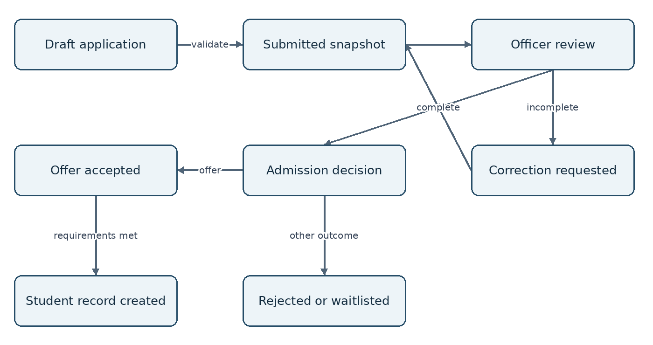
Figure 2 Application review includes correction, alternative outcomes and controlled conversion.

State ownership
Applicants control drafts and responses to correction requests. Admissions officers control review status and decisions. The system records the actor, time and reason for each transition. Submitted information must remain available as a snapshot even when the applicant later corrects it. A rejected or withdrawn application must not silently become a student record.

Offer and conversion
An offer identifies the programme, intake, response deadline and any conditions. Acceptance records the applicant’s response. Student creation occurs only after the configured conditions are met and an authorised conversion is approved. The conversion must be atomic and safe to retry, so a network interruption cannot create a second student identity.

Exceptions and continuity
A waitlisted applicant remains separate from an admitted student. Deferral, transfer of an offer or reopening a rejected application requires a recorded administrative decision. Applicants must see a plain-language status and the next required action without receiving internal reviewer comments. A person with an existing student identity may submit a later application, but registry must reconcile the identity before any new student record is created.

Online application requirements
APP-01 Account and draft. The system shall let an applicant establish a verified contact channel, save an application draft and resume it after signing in. Draft recovery must not expose personal data on a shared device.
APP-02 Programme eligibility information. The system shall display active programmes, intake deadlines, entry requirements, required documents and fee instructions before submission. Each application shall retain the version of the rules under which it was submitted.
APP-03 Form validation. The system shall validate mandatory fields, document requirements, date formats and programme choices on the server. Errors shall identify the affected field without deleting valid entries. College-approved declarations shall be explicitly acknowledged.
APP-04 Document handling. The system shall allow approved document types within configured size limits, quarantine unsafe uploads, restrict document access and show upload status. A failed or interrupted upload shall not appear as a completed document.
APP-05 Submission and receipt. The system shall issue a unique application reference and timestamp only after successful submission. Repeat clicks or retried requests shall return the existing submission outcome. The applicant shall be able to download or print a submission acknowledgement.
APP-06 Payment verification. Where a fee is required, the system shall distinguish pending, confirmed, failed, waived and refunded payment states. Only a verified provider response or authorised reconciliation shall confirm payment; an uploaded receipt alone is evidence for review.
APP-07 Tracking and corrections. The system shall show status, outstanding actions and deadlines, and allow requested corrections while preserving earlier submissions. Applicants shall not alter a submitted record outside the permitted correction process.

Acceptance evidence
An applicant saves a draft, resumes it on another device, receives field-level validation, replaces a rejected document and submits successfully. A double submission produces one reference. An unpaid application follows the configured fee rule. A forged payment message does not confirm payment, and another applicant cannot open the uploaded files even with a copied link.

Operational rule
Admissions shall configure whether an application can enter review before payment confirmation. Deadline checks shall use the college timezone and an authoritative server timestamp. Staff extensions must state the beneficiary, reason and expiry and appear in the audit history.

Admission and student record requirements
ADM-01 Review queues. The system shall provide scoped queues filtered by intake, programme, completeness and status. An officer shall be able to assign or claim a review without losing another reviewer’s changes.
ADM-02 Recorded decisions. The system shall record reviewer findings, correction requests and admission decisions with reasons. Decision authority and any required second approval shall follow configurable college policy.
ADM-03 Offer documents. The system shall generate an offer or decision document from an approved template, using the correct applicant and intake. Public messages and internal deliberations shall remain separate.
ADM-04 Controlled conversion. The system shall convert an eligible accepted application into an active student record exactly once, link it to the application and assign a unique student ID. The applicant account shall retain continuity where identity is verified.
STU-01 Student master record. The system shall maintain identity details, verified contact information, programme, admission year, academic status and authorised history. Student identifiers shall be immutable except through a controlled correction procedure.
STU-02 Record changes. The system shall distinguish student-editable contact fields from controlled identity and academic fields. Controlled changes shall retain previous values, reason, actor and approval where required.
STU-03 Status transitions. The system shall support active, deferred, suspended, withdrawn and completed statuses with effective dates. Access and registration consequences shall follow an approved policy without deleting historic grades or submissions.
STU-04 Duplicate resolution. The system shall flag potential duplicate identities for registry review. Name similarity alone shall never merge people automatically. Approved merges shall preserve linked records and a reversible reconciliation record.

Acceptance evidence
Two concurrent conversion attempts produce one student ID. Registry can trace the student back to the accepted application and identify the conditions checked. A student can update permitted contact details but cannot change programme or admission status. A deferred student retains historical results while new registration follows the configured restriction.

Academic structure and registration
ACA-01 Academic configuration. The system shall maintain faculties where applicable, departments, programmes, courses, credits, academic years, semesters and intakes. Referenced items shall be retired rather than deleted. Policy changes shall not silently recalculate prior approved records.
ACA-02 Course offerings. The system shall distinguish a course definition from its offering in a specific semester. Each offering shall identify its department, assigned lecturer or lecturers, timetable and enrolment rules.
ACA-03 Registration controls. The system shall validate eligibility, prerequisites, registration windows, credit limits and holds according to approved rules. Overrides shall require an authorised actor and a reason. Registration outcomes shall be visible to the student.
ACA-04 Course access synchronisation. An approved registration shall grant the appropriate classroom access. Withdrawal shall stop new participation according to policy while preserving previous submissions and assessment history. Retried synchronisation shall not create duplicate enrolments.
ACA-05 Timetable and assignment. The system shall maintain lecturer assignments, rooms, session dates and permitted substitutions. It shall identify overlapping room and lecturer allocations before approval and preserve rescheduling history.
ACA-06 Registration amendments. The system shall support add, drop, repeat and deferred registration workflows within approved windows. The academic record shall distinguish a repeated course attempt from the original attempt.

Operational example
A student registers for a course offered in Semester One. The system checks the prerequisite and approved credit limit, creates an enrolment and grants access to that semester’s classroom. A later repeat uses a new offering and enrolment, leaving the original attempt available for transcript and GPA policy evaluation.

Acceptance evidence
Test eligible and ineligible registration, an approved override, two timetable clashes and an add/drop request at the deadline boundary. Compare the official enrolment list with classroom membership after each action. A removed lecturer must lose course management rights, while the replacement receives only the assigned scope.

Learning management requirements
LMS-01 Course workspace. The system shall provide one workspace per course offering with announcements, topics, resources and assignments. Only assigned lecturers and authorised academic staff may manage its content.
LMS-02 Materials and announcements. Lecturers shall upload or link learning materials, organise them by topic and control release dates. Students shall see only released material for their enrolled courses. Links to externally hosted material shall be clearly identified.
LMS-03 Assignments. Lecturers shall define instructions, due dates, allowed submission types, mark limits and late-submission rules before release. Changes after publication shall be recorded and communicated to affected students.
LMS-04 Submission receipt. Students shall submit work and receive a server timestamp and submission reference. The system shall distinguish a saved draft from a submitted attempt and retain allowed resubmission versions. Interrupted transfers shall not be reported as successful.
LMS-05 Feedback and marking. Lecturers shall record marks and private feedback for each submission. Students shall see feedback only after release. A classroom mark shall not automatically become an official published academic result.
LMS-06 Basic quizzes. The system shall support objective and manually marked questions with configured attempts and availability windows. Scoring shall use the question version delivered to the learner, and incomplete or interrupted attempts shall follow a published recovery policy.
LMS-07 Course archive. The system shall archive completed offerings according to retention policy, preserving evidence and preventing unintended content changes. Reusing materials in a new semester shall not copy student submissions or personal feedback.
LMS-08 Discussion support. The system should support course discussions with moderation, reporting and clear visibility rules. Private feedback shall not be posted to a class discussion. Priority S.

Acceptance evidence
A registered student opens a released resource, uploads an assignment, sees a receipt, resubmits where allowed and receives feedback. A withdrawn student follows the approved access rule. A late attempt receives the correct status using server time. A lecturer cannot retrieve submissions from an unassigned course by changing a record identifier.

Assessment and result publication
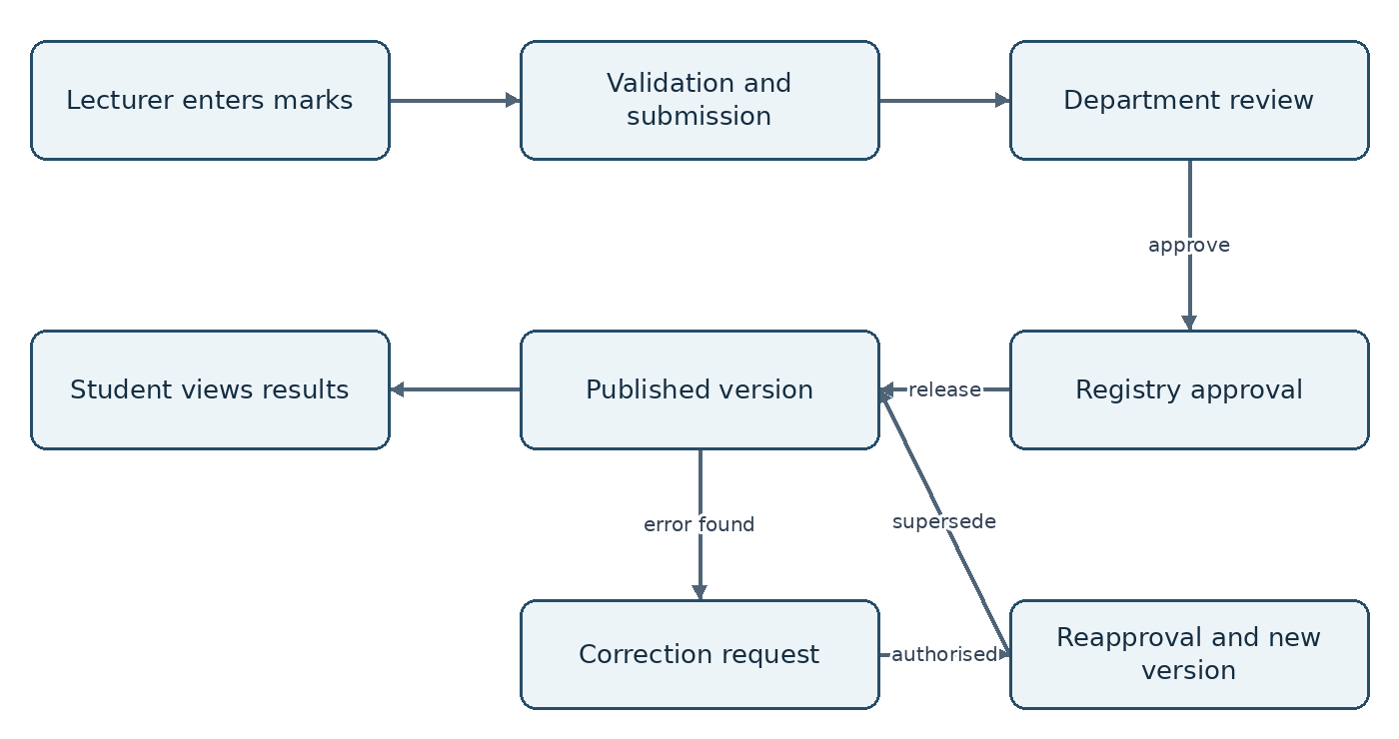
Figure 3 Official results pass through review and release; later corrections create a new approved version.
RES-01 Marks and validation. The system shall accept marks only for eligible enrolments and configured components. It shall reject out-of-range values, duplicate entries and incomplete mark sheets unless an approved exception code applies.
RES-02 Review and approval. Lecturers shall submit a mark sheet for review. Required reviewers shall approve or return it with reasons. Submitted marks shall be locked against ordinary editing until returned or formally reopened.
RES-03 Authorised publication. The system shall release results only after all configured approvals, publishing a consistent version for the selected cohort. Students shall see only their own released results and downloadable result slips.
RES-04 Corrections and supersession. A correction shall retain the original published values, reason, supporting evidence and new approvals. The replacement shall identify the superseded version and notify affected users without disclosing their marks publicly.

Acceptance evidence
A lecturer submits a complete sheet; a reviewer returns one error; the lecturer corrects it; authorised staff approve and release it. A student sees no official results before release. A post-release correction creates a second version while the original remains available to authorised auditors. Concurrent publication requests must not create inconsistent cohort versions.

Grading rules and academic exceptions
GRD-01 Versioned policy. The system shall store approved assessment weights, grade boundaries, grade points, rounding rules and effective cohorts as versioned policies. A course offering shall reference the correct policy version.
GRD-02 GPA calculation. The system shall calculate GPA and CGPA from eligible credits and grade points using the approved inclusion policy. The displayed result shall be traceable to course attempts, credits and policy version.
GRD-03 Exception codes. The system shall distinguish absent, incomplete, withheld, exempted, withdrawn and deferred outcomes where adopted by the college. Missing data shall not silently become a numerical zero or a pass.
GRD-04 Repeat and appeal handling. The system shall retain repeated attempts and support the college’s approved treatment of repeats in GPA and transcripts. Appeals shall have a reference, status, assigned reviewer and outcome without bypassing result correction approvals.

Illustrative calculation only
For demonstration, suppose a college uses a 4-point scale and includes all three courses below. Weighted points equal course credits multiplied by grade points. GPA equals total weighted points divided by total eligible credits. This is an example for validation and is not the grading policy of any named college.
Course | Credits | Grade points | Weighted points
Course A | 3 | 4.0 | 12.0
Course B | 3 | 3.0 | 9.0
Course C | 2 | 2.0 | 4.0
Total | 8 | Not applicable | 25.0

Illustrative GPA = 25 ÷ 8 = 3.125. It would display as 3.13 only if the approved policy rounds to two decimal places using the corresponding rounding method. CGPA must use eligible weighted points and credits across applicable attempts; averaging semester GPAs without accounting for credits is insufficient.

Acceptance evidence
Use independently prepared expected results for grade-boundary values, rounding boundaries, zero eligible credits, missing marks, exemptions and repeated attempts. Registry and the academic authority must sign off the expected results before implementation testing. Policy changes must leave previously approved cohorts unchanged unless a separately authorised recalculation is performed.

Lecturer attendance and teaching records
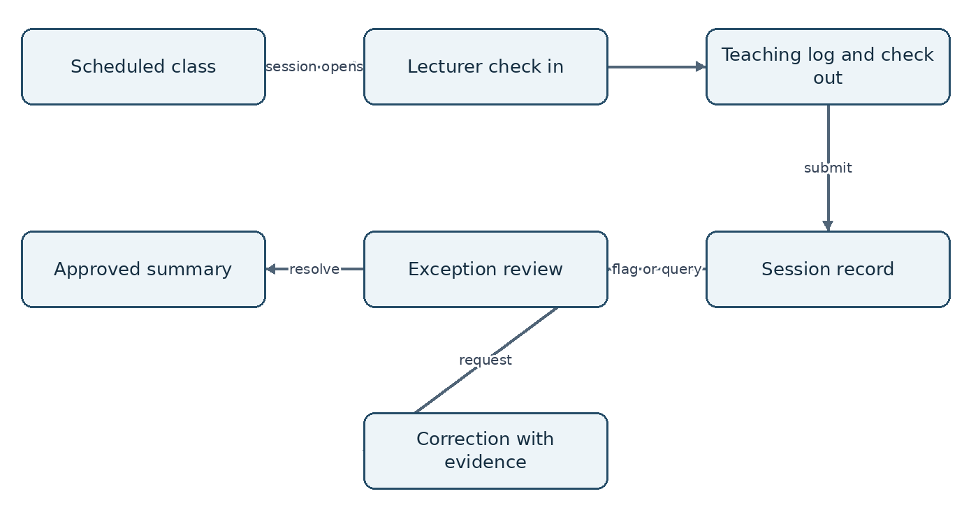
Figure 4 Teaching attendance connects scheduled sessions, lecturer evidence and reviewed exceptions.
ATT-01 Separate attendance concepts. The system shall distinguish reporting for work from delivering a scheduled class. Reports shall not infer that a class occurred solely because a lecturer checked in at the workplace.
ATT-02 Session attendance. Assigned lecturers shall record check-in, check-out, delivery mode, topic covered and session outcome. Records shall link to a scheduled or authorised replacement session and use authoritative timestamps.
ATT-03 Exceptions and review. The system shall flag missing check-outs, late entries, overlaps and unscheduled claims using approved rules. Authorised staff shall review corrections and supporting evidence, retaining original and corrected values.
ATT-04 Verification and privacy. Where approved, time-limited QR or location checks shall provide supporting evidence, with a fallback for device or network failure. The system shall not continuously track staff or treat location evidence as conclusive proof of teaching.
ATT-05 Approved reports. Reports shall distinguish scheduled, delivered, cancelled, substituted and unresolved sessions. Approved leave and timetable changes shall be accounted for before lateness or absence summaries are finalised.
Acceptance evidence: record a normal session, approved substitution, cancelled class and failed device check. Attempt a duplicate record and expired QR use. Confirm exceptions receive review and that an unverified claim does not silently become a confirmed absence or a payroll deduction.

Supporting administration and reporting
SUP-01 Notifications. The system shall issue in-portal notices for required actions, admission decisions, assignment updates and result availability. Delivery retries shall not create repeated business actions. External messages shall avoid including private grades or sensitive documents.
SUP-02 Payment reconciliation. Finance staff shall reconcile application payments using unique references, amount, currency and provider status. Duplicate callbacks, late confirmations, waivers and refunds shall retain a traceable history and require appropriate permissions.
SUP-03 Operational reports. Authorised staff shall filter admissions, enrolment, submission, result approval and attendance reports by relevant periods and organisational scope. Reports shall state applied filters, generation time and status definitions.
SUP-04 Safe exports. The system shall apply the same permissions to exports as to on-screen records, log sensitive exports and prevent untrusted spreadsheet values from being interpreted as executable formulas. Export downloads shall expire and require authorisation.
SUP-05 Student attendance. The system should let lecturers record student attendance for their assigned sessions, submit corrections and distinguish justified absence from unrecorded attendance. Students should see only their own attendance. Priority S.
SUP-06 Transcript requests. The system should support a controlled request and issue process for official transcripts using released results, approved templates and authorised signatories. A result slip shall not be labelled as an official transcript. Priority S.

Report interpretation
Attendance percentages need an approved denominator, including how cancelled classes, leave and substitutions are treated. Admissions counts must distinguish people, applications and offers. Academic reports must distinguish draft marks from published results. Dashboards shall identify delayed data so management does not mistake a stale figure for current activity.

Acceptance evidence
Compare each pilot report with its underlying approved records. Verify totals after filtering, payment retry handling, export scope and notification deduplication. A user without access to detailed grades must not obtain them through a report, download, notification preview or cached response.

Student and lecturer interface illustrations
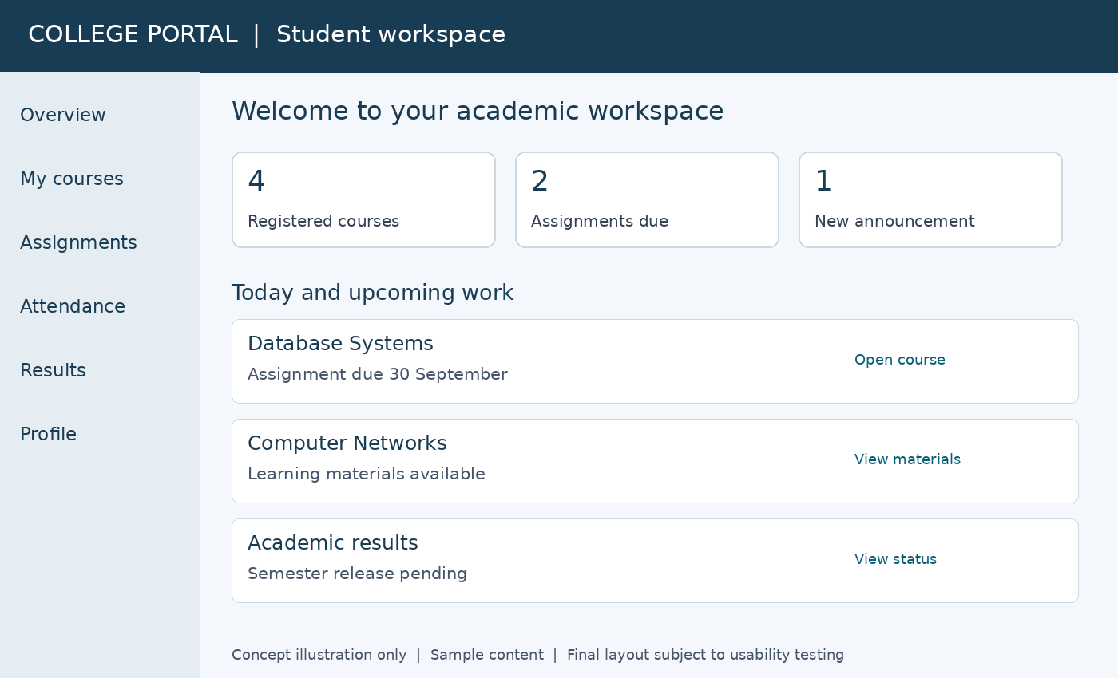
Figure 5 Conceptual student portal with coursework, deadlines and result status.
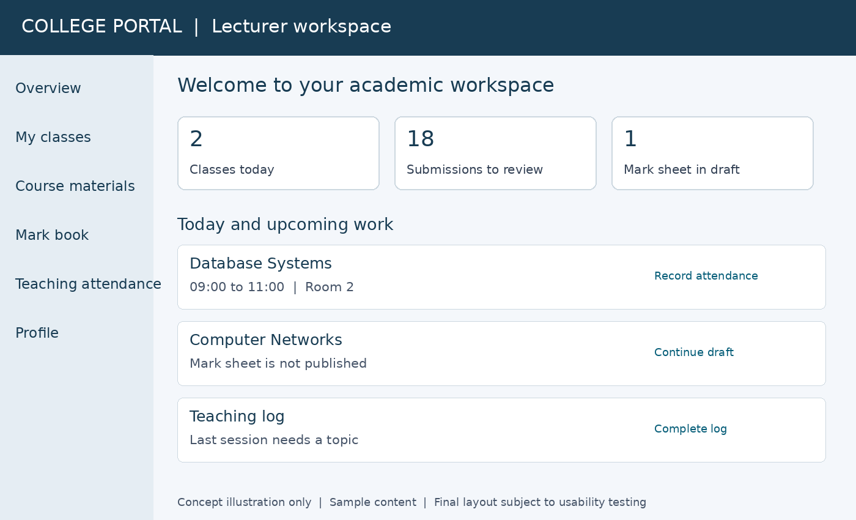
Figure 6 Conceptual lecturer portal with teaching sessions and assessment work.
These are proposed interface images using sample content, not screenshots of implemented software. Shared navigation provides a consistent experience, while role-specific tasks and permissions remain distinct. Final mobile layouts shall stack content, retain clear action labels and support keyboard and assistive-technology use.

Data requirements and information ownership
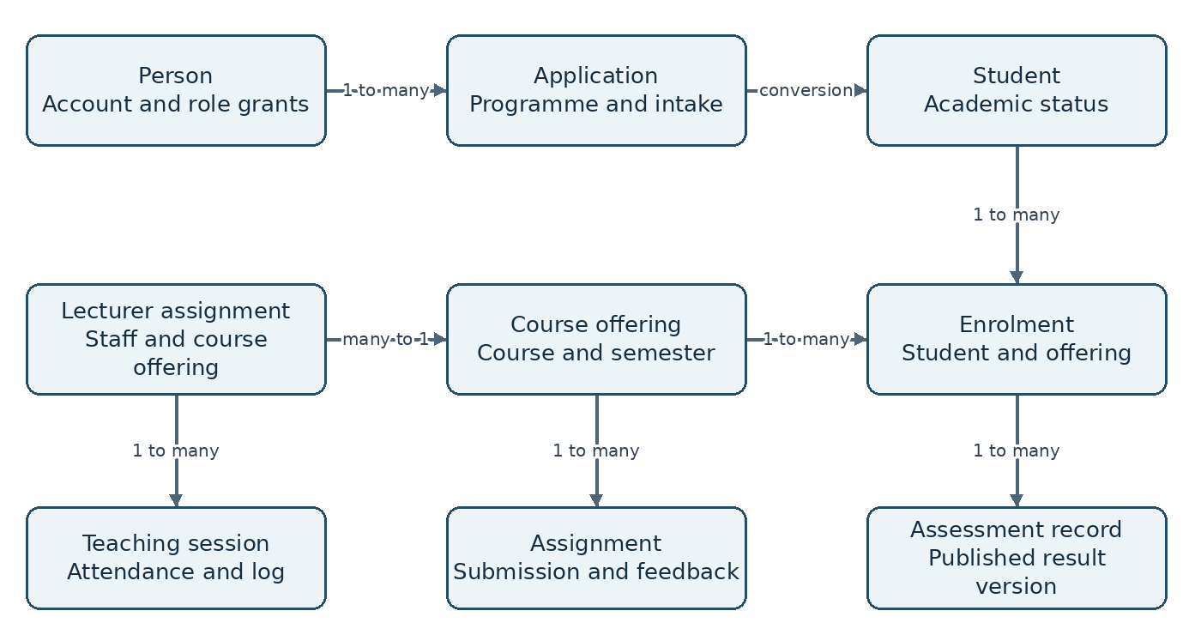
Figure 7 Conceptual relationships showing identity continuity and course-centred academic records.
DAT-01 Referential integrity. The system shall maintain unique identifiers and valid links between applications, students, offerings, enrolments, submissions, results and attendance. Business records shall not be identified solely by names or email addresses.
DAT-02 History and ownership. Each controlled record shall carry creation and modification metadata. Admissions owns applications; registry owns student identity and enrolment; academic authorities own approved results; HR and departments own attendance decisions.
DAT-03 Retention and deletion. The system shall implement a customer-approved retention schedule by record class, including uploaded documents, unsuccessful applications, academic records and logs. Legal holds and approved archival rules shall suspend ordinary disposal where applicable.

Model interpretation
One person may have several applications and role grants. Each course offering belongs to a specific academic period and can have many enrolments. A student may have many enrolments, and each enrolment can carry multiple assessment components and result versions. The illustration is conceptual; final keys, cardinalities and integrity constraints belong in the detailed data design.

Quality controls
Imports shall report invalid references, duplicates and missing mandatory fields before commitment. Controlled vocabularies shall be used for statuses and periods. Date and timezone handling must be consistent across records, and corrected identity details must not erase the historical evidence attached to prior decisions.

System boundaries and integration requirements
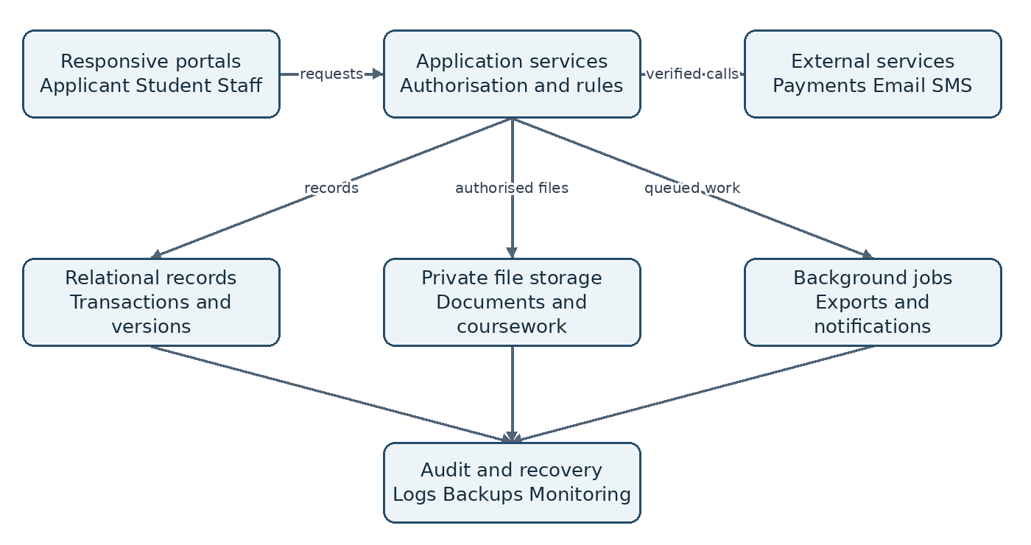
Figure 8 Logical architecture separates user access, business rules, files, background work and recovery.
INT-01 Server authority. The system shall enforce business rules and permissions through application services. Client-side values shall not determine payment confirmation, academic approval or attendance status without server validation.
INT-02 External interfaces. Each approved integration shall document its data fields, authentication, timeout, retry, failure handling and ownership. Payment callbacks shall be authenticated and processed idempotently before financial status changes.
INT-03 Import and portability. The system shall support documented imports and exports for approved student, course and enrolment records. Preview and validation shall precede import, and partial failures shall be recoverable without duplicate records.

Technology neutrality
This CRS does not mandate a programming language, cloud provider or database product. A relational record store, controlled file storage and background processing are logical capabilities, not procurement commitments. The implementation proposal shall justify maintainability, support cost, local skills and recovery arrangements.

Integration boundary
Google Classroom and openSIS integration is not part of the baseline. If the customer later requests migration or live synchronisation, a separate interface specification must identify authorised access, field mappings, conflict resolution and licensing conditions. Failure of email or payment services must not make valid internal academic records disappear.

Security privacy and accountability
SEC-01 Authentication. The system shall protect passwords using a suitable adaptive password hash, never readable database storage. Privileged accounts shall use multi-factor authentication. Recovery shall use expiring single-use proof and shall not disclose whether another person has an account.
SEC-02 Session and access security. The system shall enforce scoped authorisation on every protected request, expire sessions, support revocation and limit abusive authentication attempts. Sensitive actions shall require renewed verification where risk warrants it.
SEC-03 Data protection. The system shall encrypt network traffic, protect stored sensitive records and backups, and keep secrets outside source code and ordinary logs. Uploaded files shall use private access controls and validated download paths.
SEC-04 Audit evidence. The system shall log authentication events, role changes, decisions, marks, publication, attendance corrections and sensitive exports with actor, time, action and record reference. Ordinary users shall not alter audit records; tampering shall be detectable.
SEC-05 Privacy controls. The system shall collect only approved necessary fields, show appropriate privacy notices and support authorised correction and disposal workflows. Personal information shall not be reused for unrelated purposes without an approved basis.
SEC-06 Operational protection. The system shall separate production from test environments, restrict operational access and record emergency access. Test data shall be anonymised or purpose-created unless a controlled exception is approved.

Threat-focused acceptance
Tests shall attempt cross-student access, cross-department mark changes, stolen or expired links, replayed payment messages, unsafe uploads and privilege escalation. The customer shall receive remediation evidence for material findings before release. Logging must capture useful evidence without storing passwords, reset secrets or full payment credentials.

Policy responsibility
The college shall approve applicable privacy, employment and education obligations, retention periods and incident contacts before launch. This specification makes no claim of legal certification. Any proposed biometric processing requires a separate privacy and operational assessment and is outside the initial scope.

Service quality and operating targets
The following are proposed acceptance targets, not measured performance or guaranteed service commitments. The customer must approve the workload, network conditions and support coverage before they become a baseline. Test results shall report actual conditions and limitations.
ID | Quality target | Measurement
NFR-01 | 95% of ordinary record requests complete within 2 seconds at the server under 200 concurrent active users | 30-minute representative load test; exclude file transfer and long exports
NFR-02 | Pilot reference volume of 5,000 students, 300 staff and 3 academic years | Load representative records and report response times and error rates
NFR-03 | 99.5% monthly service availability excluding agreed maintenance | Monitor production service and document the availability calculation
NFR-04 | Recovery point within 24 hours and service restoration within 8 hours | Timed recovery drill using protected backups and dependency checks
NFR-05 | No lost or duplicated confirmed submissions during retry tests | Interrupt requests before and after commitment and reconcile records
NFR-06 | Core tasks usable at 360-pixel width, by keyboard and at 200% zoom | Manual accessibility and responsive-layout checks
NFR-07 | Core portal remains usable on a 1 Mbps test connection | Test login, draft save, course navigation and result viewing; exclude large media
NFR-08 | At least 90% pilot task completion without facilitator intervention | Observe representative users on defined tasks and record failures

Usability and accessibility
Forms shall have explicit labels, meaningful errors, visible focus, adequate contrast and alternatives to colour-only status. Upload limits and progress shall be visible before users commit time or data. Pages shall avoid unnecessary media and allow safe resumption of interrupted work. Full offline assessment or attendance synchronisation is not promised in the initial release.

Maintainability and support
Configuration changes, deployments and background failures shall be observable. The operator shall have documented restore, incident and escalation procedures. Long exports shall run as tracked jobs with a completion status, rather than blocking ordinary academic workflows.

Acceptance scenarios and traceability
Each scenario below is a minimum test family. Detailed cases shall include setup, inputs, expected outputs, actual outputs, evidence and defect references. Every numbered requirement must be linked to at least one executed case before the relevant release is accepted.
Test | Requirement coverage | Required outcome
UAT-01 | APP-01 to APP-07; SUP-02 | Draft, validation, upload, payment and retry paths produce one valid application
UAT-02 | ADM-01 to ADM-04; STU-01 to STU-04 | Review, offer and concurrent conversion preserve one identity and history
UAT-03 | ACA-01 to ACA-06; IAM-01 | Registration, timetable changes and overrides grant correct course access
UAT-04 | LMS-01 to LMS-08 | Release, submission, feedback, quiz recovery and archive follow policy
UAT-05 | RES-01 to RES-04; GRD-01 to GRD-04 | Expected grades match; publication and correction require approval
UAT-06 | ATT-01 to ATT-05; SUP-05 | Attendance exceptions and substitutions produce a reviewed summary
UAT-07 | SUP-01; SUP-03 to SUP-06 | Scoped reports, exports, notices and optional transcript process agree with source records
UAT-08 | IAM-01 to IAM-02; SEC-01 to SEC-06 | Access abuse is denied and relevant events appear in protected audit evidence
UAT-09 | DAT-01 to DAT-03; INT-01 to INT-03 | Imports, integrations, retention and retries preserve integrity
UAT-10 | NFR-01 to NFR-08 | Approved load, recovery, accessibility and usability targets are demonstrated

Exit criteria
All Must requirements in the release shall pass. No unresolved critical or high-severity defect may expose records, corrupt results, lose confirmed submissions or bypass approvals. Lower-severity defects require an owner, due date and explicit customer acceptance. Deferred Should or Could items shall be recorded, not treated as silently complete.

Evidence and sign off
Admissions, registry, academic staff, HR, IT and representative students shall review their workflows. Evidence shall include screenshots, reconciliation outputs, relevant audit records and observed task outcomes, using non-production data where possible. The sponsor signs release acceptance after process owners confirm their evidence and operational readiness.

Delivery migration and operational readiness
Phase | Deliverable boundary | Exit gate
1 Foundation and admissions | IAM, APP, ADM, STU and supporting security | One programme completes application-to-student pilot
2 Academic learning | ACA and LMS with enrolment synchronisation | Registered students and assigned lecturers complete teaching tasks
3 Results | RES and GRD with approved grading policy | Independent calculations and publication controls pass
4 Attendance and rollout | ATT, agreed SUP features and institution rollout | Attendance policy, reporting and operating targets accepted

Security, data integrity, audit, integration controls and applicable service-quality requirements run through every phase. The phases define delivery order, not permission to omit foundational controls. Dates and costs shall be estimated after college volumes, policies and priorities are confirmed.

Migration procedure
The customer shall nominate authoritative source files and owners. The team shall profile records, map fields, identify duplicates and run a trial import. Owners shall compare record counts, enrolments, credit values and published results against the sources. A signed reconciliation is required before cutover. Historical results may be imported as locked records where reconstruction of old workflows is inappropriate.

Cutover and rollback
A release plan shall name the cutover window, temporary freeze, backup, final import and validation owners. Rollback triggers include unreconciled academic records, failed access controls and unusable core workflows. Restoring a prior version must account for new transactions received after cutover; those transactions must be preserved or reconciled rather than discarded.

Training and handover
The supplier shall provide role-based guides, an administrator manual, deployment and restore instructions, a configuration register and known-issue list. Training shall use realistic tasks for applicants, lecturers and office staff. The customer shall appoint first-line support and escalation contacts, approve incident priorities and verify that operational credentials and service ownership are transferred securely.

Risks dependencies and decisions
Risk | Impact | Response and owner
Unclear grading rules | Incorrect academic outcomes | Academic authority approves versioned rules and independent examples
Scope growth | Budget and schedule become unreliable | Sponsor controls changes and confirms release priorities
Weak connectivity | Failed uploads and missed deadlines | IT tests interrupted workflows; college approves fallback procedure
Poor source data | Duplicate identities and invalid history | Registry reconciles trial imports before cutover
Misleading attendance evidence | Unfair absence decisions | HR distinguishes signals from reviewed outcomes
Service or payment outage | Delayed confirmation and communication | IT and finance use retries, reconciliation and visible status
Overprivileged accounts | Unauthorised disclosure or changes | IT reviews scopes and privileged grants regularly

Decisions required before design approval
D-01: Confirm the college name, campuses and whether this is one institution or a product for multiple independent colleges. D-02: Confirm expected user volumes, available budget, delivery dates and hosting ownership. D-03: Approve admissions eligibility, required documents, fees, payment method and authorised decision makers.
D-04: Approve assessment weights, grading scale, rounding, repeat treatment, appeal workflow and result signatories. D-05: Confirm whether lecturer attendance means staff presence, teaching delivery or both, including leave, verification and correction rules. D-06: Approve retention, privacy notices, access scopes and support arrangements.
D-07: Identify source records and external integrations. D-08: Confirm the Should and Could capabilities to fund. D-09: Confirm recovery and performance targets against operational resources. The relevant process owner shall resolve each decision; the sponsor approves any change to scope or cost.

Change control
A change request shall identify affected requirements, business reason, proposed behaviour, data and security impact, cost, schedule and acceptance updates. Approval shall precede implementation of a changed baseline. Urgent fixes may use an emergency process, but their authorisation and retrospective review must still be recorded.

Approval glossary and baseline checklist

Customer approval
Approval confirms that the requirements accurately express the agreed release scope and responsibilities. It does not waive testing, operational readiness or unresolved decisions. Any conditions of approval shall identify their owner and due date. Blank fields below are deliberately reserved for the college’s authorised representatives.
Approver | Name and signature | Date
Project sponsor | ____________________________ | ____________
Admissions representative | ____________________________ | ____________
Registry and academic authority | ____________________________ | ____________
HR or attendance representative | ____________________________ | ____________
IT and service owner | ____________________________ | ____________

Glossary
Term | Meaning
CRS | Customer Requirements Specification
LMS | Learning Management System
Course offering | A course delivered in a particular academic period
Enrolment | A student’s registration in a course offering
GPA and CGPA | Grade Point Average and Cumulative Grade Point Average
Idempotent action | An action that remains safe when the same request is retried
RPO and RTO | Recovery point objective and recovery time objective
UAT | User Acceptance Testing

Baseline checklist
Confirm institutional scope; assign process owners; approve grading and attendance rules; resolve release priorities; agree measurable operating targets; map all requirements to tests; approve migration sources; establish support and recovery ownership; record outstanding decisions; obtain authorised signatures.

