SOFTWARE REQUIREMENTS SPECIFICATION

Integrated College
Management System
  - Detailed software behaviour data interfaces and verification
Prepared for Brima Conteh
Version 1.0 | 26 September 2026
Status Proposed software requirements for review
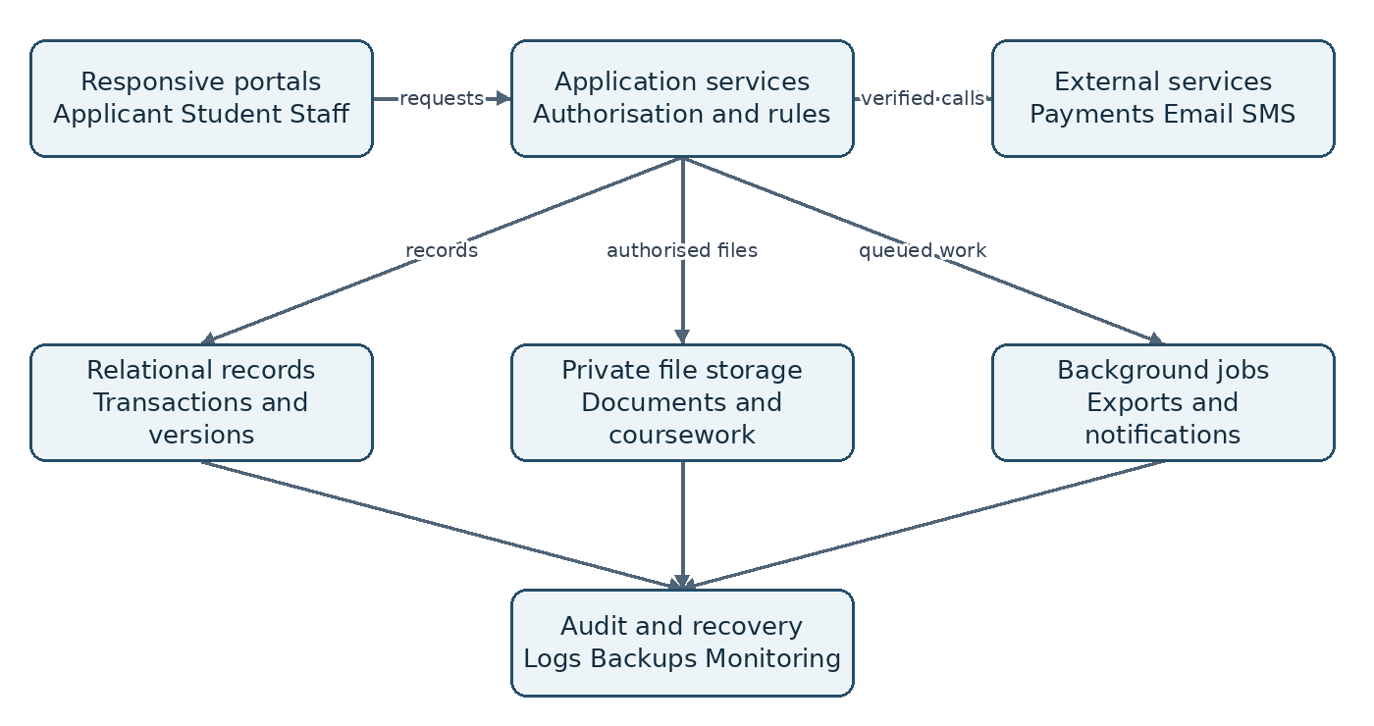
Figure 1 Logical system boundary and supporting services.
This SRS defines the observable behaviour and engineering acceptance conditions for the proposed college platform. It refines the Customer Requirements Specification into requirements that developers can implement and testers can verify across admissions, learning, academic results and lecturer attendance.
The baseline remains subject to college approval. Institutional policies, operational targets and external providers that have not been selected are tracked as explicit decisions rather than assumed facts.

1 Document control and conventions
Item | Specification
Document ID | ICMS SRS 001
Version and date | 1.0 dated 26 September 2026
Source baseline | College Management CRS version 1.0 dated 26 September 2026
Source status | Proposed customer requirements; no signed approval recorded
Primary audience | Developers, testers, architects, college process owners and service operators
Accountable owner | College sponsor to appoint a requirements owner
Change authority | Sponsor with registry, academic, admissions, HR and IT owners

Purpose and precedence
The CRS describes customer needs; this SRS refines software behaviour without replacing college policy. If a requirement conflicts with an approved policy or the CRS, the discrepancy must be resolved through change control before implementation. Logical entities and interface operations specify required semantics, not a mandated database product, programming language or deployment vendor.

Normative language
“Shall” is mandatory for the approved release. Priority M means Must, S means Should and C means Could. Should items require an explicit inclusion decision. Each SRS identifier is stable and unique. The source field references CRS identifiers; “derived” indicates additional detail needed to implement a source requirement. A verification label identifies a test family, not evidence that testing has already passed.

Document basis
Reference B-01 is College_Management_CRS.docx, version 1.0, 24 pages. Reference B-02 is the project brief requesting one platform for online college applications, classroom-style learning, academic result publication and lecturer attendance. Illustrations are conceptual. This document does not claim certification against an external standard or parity with Google Classroom or openSIS.

Review procedure
Review comments shall identify the SRS ID, proposed correction, rationale and affected test. Approved changes require a version increment and an updated traceability record. Policies and configurable limits must be signed off by their process owner before release acceptance.

2 Contents and navigation
1 Document control and conventions 2
2 Contents and navigation 3
3 Product scope and operating context 4
4 Actors and permission model 5
5 Identity and account lifecycle 6
6 Application capture and submission 7
7 Admissions decisions and student records 8
8 Academic configuration and enrolment 9
9 Learning content and classroom membership 10
10 Assignments quizzes and feedback 11
11 Academic marks and result release 12
12 Grading calculations and academic exceptions 13
13 Lecturer attendance and teaching evidence 14
14 Supporting services and reporting 15
15 State transition rules 16
16 Critical use cases and failure paths 17
17 Logical data model 18
18 Data dictionary and integrity constraints 19
19 External and internal interface contracts 20
20 User interface and accessibility 21
21 Security and privacy requirements 22
22 Performance reliability and recovery 23
23 Deployment migration and operation 24
24 Verification plan and test scenarios 25
25 Requirements traceability 26
26 Decisions dependencies and approval 27
The document contains 26 numbered sections plus the cover. The contents refer to the rendered edition. Requirements SRS-001 to SRS-078 and the referenced state, data and interface rules form the proposed software baseline.

3 Product scope and operating context
The product shall provide responsive browser access for applicants, students, lecturers and authorised staff. One institutional identity links the person’s application history, student profile and permitted staff roles. Business responsibilities remain separated: managing user accounts does not confer academic approval authority.
Boundary | Required interpretation
Institution | One college provisionally; independent multi-college tenancy requires a separate approved design
Academic lifecycle | Application, review, admission, enrolment, teaching, assessment, publication and retained records
Attendance | Separate workplace presence and scheduled teaching delivery; neither automatically proves the other
Finance | Application fee status and reconciliation only; full tuition accounting and payroll excluded
Reference products | Classroom and student-information concepts only; no baseline external product synchronisation
Channels | Responsive web baseline; native mobile applications and full offline operation are extensions

Operating environment
The service must support college-managed and personal devices over variable internet connections. Private records and uploaded coursework require authenticated access. Large uploads, exports and external notifications are separable from ordinary record requests so that a slow provider does not hold an academic transaction open.

Dependencies
The college supplies active programmes, intake rules, grading policies, lecturer assignments, source records and authorised signatories. Payment, email and optional SMS providers require selection and credentials. The sponsor must confirm volumes and service ownership. No production workflow shall depend on a developer inventing unresolved academic policy.

Release sequence
Release 1 covers identity, admissions and student records. Release 2 adds academic registration and learning. Release 3 adds official results and grading. Release 4 adds lecturer attendance and approved supporting features. Security, data integrity, audit, operational readiness and relevant performance requirements apply to every release.

4 Actors and permission model
Actor | Record scope | Authorised actions
Applicant | Own applications | Save, upload, submit, correct and respond to offers
Student | Own enrolments and released records | Read resources, submit coursework and view released results
Lecturer | Assigned course offerings and own sessions | Manage learning, assess work, submit marks and record teaching
Admissions officer | Assigned programme or intake | Review, request corrections and recommend or issue authorised decisions
Academic reviewer | Delegated department and period | Review mark sheets and return or approve them
Registry publisher | Delegated cohort and academic period | Maintain student records and release approved result batches
HR or attendance officer | Delegated staff scope | Review leave, attendance evidence and corrections
Finance verifier | Assigned payment records | Reconcile, waive or record refund confirmation
System administrator | Explicit technical scope | Manage accounts and system configuration
Management | Authorised reporting scope | Read approved aggregates and separately authorised detail

Permission evaluation
The authorisation decision is the intersection of action permission, active role grant, organisational scope and ownership or assignment. An account can hold multiple grants, but the system must enforce separation-of-duty rules for sensitive operations. A user who enters a mark sheet shall not be its sole final approver or publisher. A separately authorised emergency workflow must record justification and independent review.

Visibility and delegation
The interface shall show permitted tasks, but the API independently evaluates every request. Temporary delegations have start and end times and a named grantor. Revocation applies to subsequent protected requests, including file downloads and queued exports. Aggregated reports must not provide a route around detail-level restrictions.

Acceptance boundary
Authorisation testing shall include users with several roles, expired grants, revoked assignments and direct object-ID manipulation. The expected outcome is denial without disclosing the target record. Privilege tests shall cover read, create, change, export and download paths rather than only visible navigation.

5 Identity and account lifecycle
SRS-001 Identity continuity. The system shall assign immutable internal person and account identifiers, link role-specific profiles to the verified person, and permit more than one application without duplicating that person. Email changes shall not change ownership of prior records.
Source: IAM-01, STU-01 | Priority: M | Verify: T01 identity reconciliation
SRS-002 Scoped role grants. The system shall store role, organisational scope, effective dates, grantor and grant status. It shall reject a protected operation unless an active grant permits the action and record scope. Revocation shall apply to the next protected request.
Source: IAM-01 | Priority: M | Verify: T01 scope and revocation
SRS-003 Account states. The system shall support invited, active, suspended and deactivated accounts. Only active accounts may start or continue protected sessions. Suspension and deactivation shall retain owned academic records and immediately revoke active sessions.
Source: IAM-02 | Priority: M | Verify: T01 account transitions
SRS-004 Verification and recovery. The system shall verify the selected contact channel before account activation. Recovery proof shall be single-use, expiring and stored in non-recoverable form. Successful recovery shall invalidate the proof and existing sessions and notify the account owner.
Source: APP-01, SEC-01 | Priority: M | Verify: T01 recovery replay
SRS-005 Authentication protection. The system shall use adaptive password hashing with unique salts, multi-factor authentication for privileged roles and configurable abuse throttling. Authentication and recovery responses shall not reveal whether an unknown account exists. Secrets shall not appear in logs.
Source: SEC-01, SEC-02 | Priority: M | Verify: T01 authentication abuse
SRS-006 Session control. The system shall enforce idle and absolute session expiry, explicit logout and server-side revocation. A sensitive action shall reject expired verification and preserve safe draft input while requesting renewed verification. Proposed expiry values require security-owner approval.
Source: SEC-02 | Priority: M | Verify: T01 session expiry

Implementation boundary
Internal IDs are not authentication secrets. Human-readable student numbers may follow college policy, but knowledge of a student number must never permit a reset, grade change or private download. A person’s verified identity and access grants remain distinct from their current academic status.

6 Application capture and submission
SRS-007 Draft persistence. The system shall persist each successful draft save with a revision number and saved timestamp. A stale update shall return a conflict instead of overwriting a newer save. A draft shall be readable only by its owner and authorised admissions staff.
Source: APP-01 | Priority: M | Verify: T02 interrupted draft save
SRS-008 Versioned intake rules. The system shall publish active programme and intake rules, including deadlines, document types and fee conditions. A submitted application shall reference an immutable rule version and retain a snapshot of the submitted values.
Source: APP-02 | Priority: M | Verify: T02 policy version
SRS-009 Validation and declarations. The system shall validate required fields, allowable programme choices, dates and required declarations before submission. It shall return field-specific errors, retain valid draft values and reject submission outside the permitted window unless an authorised extension exists.
Source: APP-03 | Priority: M | Verify: T02 invalid and boundary inputs
SRS-010 Upload lifecycle. The system shall track initiated, uploaded, scanning, available and rejected file states. Only available files may satisfy a required document. It shall verify permitted content types and size, restrict private downloads and refuse unsafe or incomplete files.
Source: APP-04 | Priority: M | Verify: T02 rejected and interrupted uploads
SRS-011 Submission transaction. The system shall create one application reference, submission snapshot and timestamp in one successful transaction. A repeated request with the same idempotency key and payload shall return the original result; a reused key with different content shall fail.
Source: APP-05 | Priority: M | Verify: T02 concurrent submission
SRS-012 Status and correction. The system shall expose applicant-visible status and next actions separately from internal notes. A correction request shall identify editable fields and a deadline; resubmission shall create a new snapshot without removing prior submissions.
Source: APP-07 | Priority: M | Verify: T02 restricted correction

Fees and deadlines
Payment eligibility is governed by SRS-048. Submission and review eligibility may use different fee rules if the college approves that configuration. All deadline checks use server time and the configured institutional timezone. The API shall return an explicit payment-pending or deadline-closed condition, not an unexplained generic failure.

7 Admissions decisions and student records
SRS-013 Review assignment. The system shall offer scoped queues by intake, programme, status and completeness. Claiming or reassigning a review shall check the current assignment revision and reject conflicting claims without overwriting another officer’s work.
Source: ADM-01 | Priority: M | Verify: T03 concurrent review claim
SRS-014 Decision authority. The system shall record recommended and final admission outcomes separately where multiple approvals apply. Final decisions shall require an active delegated permission and all configured prerequisites, with actor, reason and time.
Source: ADM-02 | Priority: M | Verify: T03 unauthorised decision
SRS-015 Decision documents. The system shall generate offer and decision documents from an approved template version and immutable decision data. Offer conditions, response deadline and programme shall match the record. Internal review comments shall not appear in applicant documents.
Source: ADM-03 | Priority: M | Verify: T03 document reconciliation
SRS-016 Admission conversion. The system shall convert an accepted eligible offer exactly once in an atomic operation that links the existing person, creates or reconciles the student profile, assigns a unique student number and records the conversion. Retrying shall return the same student.
Source: ADM-04 | Priority: M | Verify: T03 conversion race
SRS-017 Controlled profile changes. The system shall maintain programme, admission year, status and identity history. Contact edits may be self-service; legal identity and academic fields shall require delegated staff authority and a reason. Prior values shall remain auditable.
Source: STU-01, STU-02 | Priority: M | Verify: T03 field permissions
SRS-018 Status and duplicate handling. The system shall record effective-dated student status transitions and enforce their registration consequences. Suspected duplicates shall enter a registry review queue. An approved merge shall preserve links and a reversible mapping; name similarity shall not automatically merge people.
Source: STU-03, STU-04 | Priority: M | Verify: T03 status and merge reversal

Conversion exception
If a verified person already has a student profile, the conversion shall stop for registry reconciliation or attach the authorised new programme admission to that profile. It shall not silently issue a competing identity. A failed conversion shall leave the offer and financial evidence intact for correction and retry.

8 Academic configuration and enrolment
SRS-019 Academic master data. The system shall maintain versioned programmes, courses, credits, academic periods and policy references. Referenced records shall be retired rather than physically removed. Previously approved results shall continue to reference their original versions.
Source: ACA-01 | Priority: M | Verify: T04 configuration history
SRS-020 Course offerings. The system shall create a unique offering for the approved course, period and section combination. It shall record lecturers, department, delivery mode and schedule. Reassigning lecturers shall change access without changing historic authorship.
Source: ACA-02 | Priority: M | Verify: T04 offering uniqueness
SRS-021 Registration eligibility. The system shall evaluate student status, prerequisites, credit limits, holds and registration windows on the server before enrolling. A delegated override shall record the rule bypassed, actor, reason and effective scope.
Source: ACA-03 | Priority: M | Verify: T04 eligibility and override
SRS-022 Membership consistency. An approved enrolment shall grant classroom access within 60 seconds under normal operation, a proposed derived target. Withdrawals shall immediately prevent new submissions unless policy allows them; a delayed synchronisation job shall not preserve prohibited access.
Source: ACA-04 | Priority: M | Verify: T04 enrolment and access reconciliation
SRS-023 Timetable integrity. The system shall detect lecturer and room overlaps before schedule approval. A permitted override shall require reason and authority. Rescheduling and substitution shall retain the original session and link the replacement, rather than erasing attendance evidence.
Source: ACA-05 | Priority: M | Verify: T04 schedule conflicts
SRS-024 Add drop and repeats. The system shall record add, drop, deferral and repeat actions with effective time and rule version. Each repeated course attempt shall have its own enrolment. Closed registration periods shall reject amendments unless an approved exception is supplied.
Source: ACA-06 | Priority: M | Verify: T04 repeated course attempts

Concurrency rule
Enrolment uniqueness and credit-limit evaluation must remain correct when several registration requests arrive together. The system shall either commit all valid requested registrations under an agreed batch policy or return per-item outcomes clearly. It must not report a whole batch as successful when some items failed.

9 Learning content and classroom membership
SRS-025 Workspace isolation. The system shall maintain a classroom for each offering. Reads shall require current enrolment or delegated staff access; changes shall require a current lecturer assignment or authorised academic grant. A guessed URL shall not bypass this control.
Source: LMS-01 | Priority: M | Verify: T05 cross-course access
SRS-026 Content publication. The system shall support draft, scheduled, published and archived learning resources with topic ordering, release time and author. Students shall not access draft or future resources through lists, search, direct file URLs or notifications.
Source: LMS-02 | Priority: M | Verify: T05 scheduled release
SRS-027 Announcements. The system shall publish announcements to the selected offering and authorised audience only. Editing a published announcement shall retain its revision history and record whether recipients need an update. External links shall be labelled as external.
Source: LMS-02, SUP-01 | Priority: M | Verify: T05 announcement audience
SRS-028 Course archive and reuse. The system shall archive completed offerings using the retention policy. Copying material to a new offering shall include reusable content and instructions only, excluding submissions, marks, private feedback and student discussion identities.
Source: LMS-07 | Priority: M | Verify: T05 archive and copy
SRS-029 Moderated discussion. The system should provide offering-scoped threads, moderation, reporting and a record of moderation actions. Private feedback shall not be published as discussion content. The feature shall be disabled if it is not included in the release.
Source: LMS-08 | Priority: S | Verify: T05 moderation and privacy

Resource and access errors
A removed resource shall display a clear unavailable state to previously authorised users without exposing its storage location. Suspended accounts cannot retrieve cached protected content through the application. Where archived student read access is permitted, its policy must distinguish viewing historic resources from submitting new work.

Learning and academic authority
Learning activities support teaching but do not independently determine official academic standing. Released feedback, provisional course totals and approved semester results must have distinct labels. Any transfer of learning marks into an official assessment component requires the controls on the result workflow page.

10 Assignments quizzes and feedback
SRS-030 Assignment definition. The system shall store instructions, allowed file types, maximum mark, availability, due time, late policy and permitted attempts before release. Post-release changes shall be versioned and produce an affected-student notification event.
Source: LMS-03 | Priority: M | Verify: T06 assignment changes
SRS-031 Submission commitment. The system shall issue a receipt only after the submission manifest and its accepted files are committed. The receipt shall identify assignment, enrolment, attempt and server time. Failed transfers remain drafts and cannot be counted as submitted work.
Source: LMS-04 | Priority: M | Verify: T06 lost-response retry
SRS-032 Resubmission and lateness. The system shall retain each permitted submitted attempt, identify the effective marking attempt and compute lateness from authoritative submission time. Retried requests shall not create another attempt. Disallowed attempts shall return a policy-specific error.
Source: LMS-04 | Priority: M | Verify: T06 due-time and attempt limits
SRS-033 Feedback release. The system shall store marks and private feedback per submitted attempt, validate mark ranges and distinguish draft from released feedback. Released classroom marks shall not appear as official results until explicitly transferred and approved.
Source: LMS-05 | Priority: M | Verify: T06 private feedback release
SRS-034 Quiz attempts. The system shall bind each quiz attempt to the delivered question and scoring versions, enforce availability and attempt limits, and save acknowledged responses. Only objective questions with approved answer rules shall be automatically scored; other answers await manual marking.
Source: LMS-06 | Priority: M | Verify: T06 versioned quiz scoring
SRS-035 Quiz interruption. The system shall resume an interrupted attempt only within its server-enforced deadline and configured recovery policy. It shall disclose whether the attempt is active, submitted, expired or awaiting review. Reopening a closed attempt requires authority and a reason.
Source: LMS-06 | Priority: M | Verify: T06 interruption and expiry

Shared-device behaviour
Submission confirmations must be visible in the student’s account after reconnection. The browser must not imply success based solely on local upload progress. Logout shall remove protected application state from the active interface; sensitive local caching requires an approved design.

11 Academic marks and result release
SRS-036 Assessment component validation. The system shall accept marks only for valid enrolments and configured components. Each mark shall be decimal-valued within the component range or an approved exception code. Duplicate components, conflicting codes and incomplete sheets shall block submission.
Source: RES-01 | Priority: M | Verify: T07 mark validation
SRS-037 Controlled mark import. The system shall preview learning-mark transfers and file imports before commitment, identify unmatched enrolments and reject inconsistent rows. A committed transfer shall record source attempt and source revision without automatically publishing academic results.
Source: RES-01, INT-03 derived | Priority: M | Verify: T07 mark import reconciliation
SRS-038 Approval workflow. The system shall lock a submitted mark-sheet revision. Each approval shall bind to that exact revision; a return shall include reasons. Editing returned marks creates a new revision and invalidates approvals on superseded content.
Source: RES-02 | Priority: M | Verify: T07 stale approval
SRS-039 Atomic publication. The system shall publish only a complete authorised batch whose required approvals remain valid. Publication shall create immutable result versions and change the visible batch pointer atomically, preventing students from seeing a partly released cohort.
Source: RES-03 | Priority: M | Verify: T07 interrupted publication
SRS-040 Student result access. The system shall return only the requesting student’s published results, with period, course, credit, grade, status and result version. Downloaded slips shall identify their issue time and version and shall not imply official transcript status.
Source: RES-03, SUP-06 | Priority: M | Verify: T07 result ownership
SRS-041 Corrections and supersession. The system shall preserve a published result while an authorised correction is reviewed. Approval shall create a new result version linked to its predecessor, update the current visible version and record the reason and affected-student notice.
Source: RES-04 | Priority: M | Verify: T07 correction chain

Publication failure guarantee
Notifications are dispatched after publication commits. If dispatch fails, the published results remain valid and notification delivery is retried. A stale approval, unresolved validation error or unauthorised actor shall prevent publication without changing student-visible results. The application shall expose a clear batch status to authorised staff.

12 Grading calculations and academic exceptions
SRS-042 Policy version binding. The system shall bind each offering and result version to approved weights, grade intervals, grade points, credit inclusion and rounding policy. An unapproved or incomplete grading configuration shall block calculation and publication.
Source: GRD-01 | Priority: M | Verify: T08 policy completeness
SRS-043 Deterministic calculation. The system shall calculate weighted totals and GPA using decimal arithmetic and the approved rounding stages. It shall store enough component, credit and policy evidence to reproduce each published result. Display rounding shall not silently change stored calculation inputs.
Source: GRD-02 | Priority: M | Verify: T08 golden calculation set
SRS-044 Special outcomes. The system shall represent absent, incomplete, withheld, exempted, withdrawn and deferred outcomes as distinct approved codes. Each code shall define whether credits and points enter GPA. Missing marks shall remain unresolved unless policy explicitly assigns an outcome.
Source: GRD-03 | Priority: M | Verify: T08 exception matrix
SRS-045 Repeated attempts and appeals. The system shall preserve all attempts, select eligible attempts by the approved repeat policy and keep appeal tracking separate from mark editing. An accepted appeal shall trigger the controlled correction workflow, never a direct overwrite.
Source: GRD-04 | Priority: M | Verify: T08 repeat and appeal

Calculation contract
For eligible attempts i, GPA = sum of credit_i multiplied by grade_point_i divided by the sum of credit_i. A zero denominator shall display Not applicable, not zero or a software error. CGPA shall aggregate the eligible weighted points and credits across periods using the same approved attempt-selection policy. It shall not be an unweighted mean of semester GPAs.
Validation example | Expected behaviour
Boundary total equals a grade cutoff | Exactly one interval applies under the configured inclusive and exclusive bounds
Weights do not total the required whole | Configuration rejected before use
Credits 3, 3, 2 and points 4, 3, 2 | Weighted points 25; eligible credits 8; unrounded GPA 3.125
Repeat policy changes for a later cohort | Earlier published versions retain their original calculation policy

The example is illustrative only. The college must approve the actual grading scale, repeat rules, grade intervals and rounding method. Independent expected calculations shall be prepared by the academic authority before acceptance testing.

13 Lecturer attendance and teaching evidence
SRS-046 Attendance record separation. The system shall keep workplace-presence records separate from teaching-session records. Teaching records shall reference an assigned or authorised replacement session, lecturer, topic, delivery mode, check-in, check-out and outcome.
Source: ATT-01, ATT-02 | Priority: M | Verify: T09 presence versus teaching
SRS-047 Attendance review and reports. The system shall flag missing check-outs, overlaps, late records and unsupported sessions. Corrections shall retain original values, evidence, reviewer and reason. Reports shall separate delivered, cancelled, substituted and unresolved sessions and apply approved leave and denominator rules.
Source: ATT-03, ATT-05 | Priority: M | Verify: T09 exception resolution
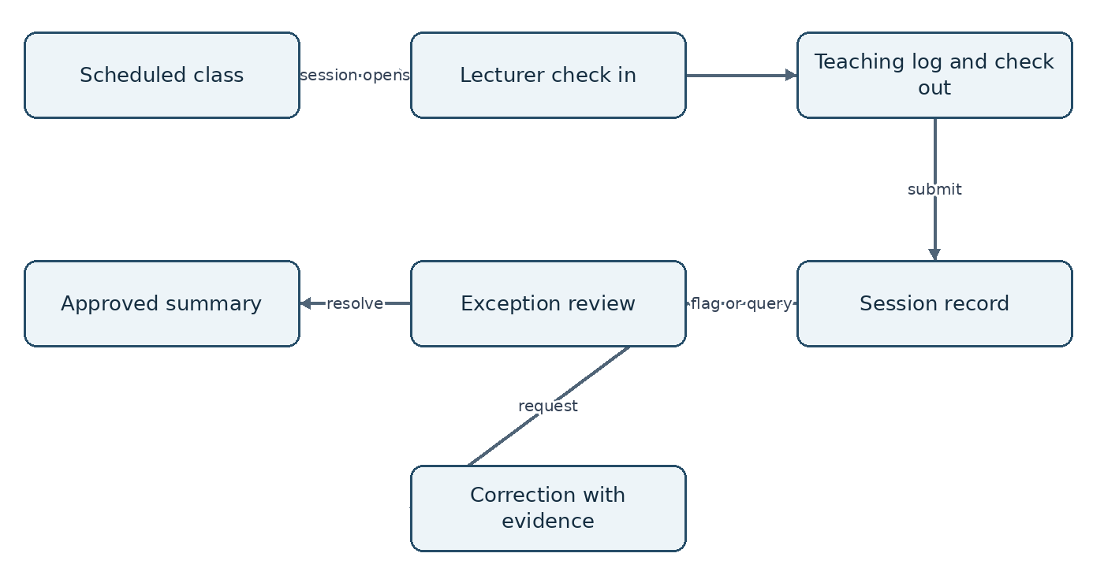
Figure 2 Teaching evidence is reviewed before attendance summaries are finalised.

Verification contract
Where selected, a QR check shall be scoped to session, expiry and intended account action. Replaying the same accepted check shall not create another record. Location evidence shall record capture time and accuracy where available, but shall not independently establish class delivery. The system shall provide a staff-reviewed fallback when a device or connection prevents verification. These controls refine CRS ATT-04 and are tested in T09.

Fair operational interpretation
An unresolved session is not automatically an absence. A cancelled class shall not count as a missed teaching obligation. A substitution shall credit the authorised delivery record without claiming both lecturers taught the same session. No attendance operation shall automatically deduct salary or issue a disciplinary sanction.

14 Supporting services and reporting
SRS-048 Payment states and reconciliation. The system shall separate a payment attempt from verified fee satisfaction. It shall authenticate provider events, match reference, amount and currency, deduplicate event IDs and record pending, confirmed, failed, waived and refunded states. Conflicts shall enter finance review.
Source: APP-06, SUP-02 | Priority: M | Verify: T10 payment replay and mismatch
SRS-049 Notification delivery. The system shall commit an event with the business transaction and queue delivery afterward. It shall deduplicate by event, recipient and channel, track retries and failures, and keep private marks and document contents out of external message bodies.
Source: SUP-01 | Priority: M | Verify: T10 provider outage
SRS-050 Scoped reports and exports. The system shall apply record permissions to report queries and exports, include filters and generation time, neutralise spreadsheet formula inputs and log sensitive exports. Queued jobs shall recheck access at execution and download.
Source: SUP-03, SUP-04 | Priority: M | Verify: T10 export revocation
SRS-051 Student attendance extension. The system should let assigned lecturers submit session attendance for enrolled students and request corrections. It should distinguish present, justified absence, absence and not recorded, and expose only the student’s own history.
Source: SUP-05 | Priority: S | Verify: T09 student attendance
SRS-052 Transcript extension. The system should track transcript requests, approval, issue and revocation where required. Issued transcripts should use approved published result versions and authorised signatories, retain their source version references and avoid public disclosure through verification links.
Source: SUP-06 | Priority: S | Verify: T10 transcript source version

Refund and timing exceptions
A browser redirect shall not prove payment. A provider-confirmed late payment shall be recorded even if the intake closed, then routed to finance and admissions policy resolution. Refunding an application fee shall not automatically revoke admission or erase the application. Waivers require the permitted finance role and a recorded reason.

Reporting denominators
Application counts, person counts and offer counts are separate metrics. Attendance percentages shall identify eligible scheduled sessions and excluded cancellations or leave. Draft and published academic aggregates shall be labelled distinctly. Failed or stale refreshes shall display their last successful update time.

15 State transition rules
The following transition rules are normative refinements of SRS-003, SRS-012 to SRS-016 and SRS-036 to SRS-041. All unlisted transitions shall be denied unless an approved administrative exception workflow explicitly defines them. Every transition records actor, timestamp and reason where required.
Object and current state | Action and guard | Next state
Application Draft | Owner submits valid snapshot within window | Submitted
Application Submitted | Scoped officer claims review | Under review
Application Under review | Officer requests specified corrections | Correction requested
Application Correction requested | Owner resubmits valid revision | Submitted
Application Under review | Final authorised decision | Offered, Waitlisted or Rejected
Application Waitlisted | Authorised review reopened | Under review
Application Offered | Owner accepts before offer expiry | Accepted
Application Offered | Owner declines or deadline expires | Declined or Expired
Application Accepted | Registry verifies conditions and converts | Converted
Application Draft to Accepted | Owner withdrawal where permitted | Withdrawn
Mark sheet Draft or Returned | Lecturer submits valid revision | Submitted
Mark sheet Submitted | Reviewer returns with reason | Returned
Mark sheet Submitted | All required approvals bind to revision | Approved
Mark sheet Approved | Publisher commits authorised batch | Published
Published result Current | Approved correction creates successor | Superseded; successor becomes Current

State invariants
Converted applications cannot be converted twice. Terminal decisions cannot be reopened by an applicant. A reopened staff decision preserves the old decision and records an exception reason. Published versions are immutable; correction creates successors. Student status and account status remain independent, so an academic deferral does not itself imply account deactivation.

Related asynchronous states
Uploads use Initiated, Uploaded, Scanning, Available and Rejected. Export jobs use Queued, Running, Succeeded, Failed and Expired. A technical job failure shall not reverse an already committed admission, submission or publication. Retry semantics shall return the business operation’s committed state.

16 Critical use cases and failure paths

UC01 Submit an application
Actor: verified applicant. Preconditions: an open intake, owned draft and required available documents. Trigger: Submit. The service checks ownership, revision, rule version, fee policy and deadline; commits the snapshot and reference; records an audit event and notification event; then returns a receipt. If validation fails, no submitted record is created and field errors are returned. If the response is lost after commit, a retry with the same key returns the original receipt.

UC02 Convert an admitted applicant
Actor: authorised registry officer. Preconditions: accepted offer, verified conditions and resolved identity. The service locks or otherwise serialises conversion for the application, checks for a prior conversion, allocates or reuses the authorised student identity and commits the profile link and audit event. A duplicate request returns the established link. Conflicting identity evidence stops conversion for review. No partial student record may remain visible after transaction failure.

UC03 Publish academic results
Actor: delegated publisher distinct from the mark originator. Preconditions: complete approved batch, current policy and unchanged approved revisions. The service verifies permissions and approvals, generates immutable result records, atomically activates the batch version and queues notices. A failed approval check causes no release. A notification outage affects delivery status only. A later correction repeats approval and publication for successor versions.

UC04 Record and correct a teaching session
Actor: assigned lecturer, then attendance reviewer. The lecturer opens a permitted session, records check-in, topic and check-out, and submits the teaching log. Missing or inconsistent evidence creates an exception. The lecturer supplies a correction reason; the reviewer accepts or rejects it with a reason. The report retains both the original evidence and final reviewed outcome. Network failure before commit must not display a confirmed attendance record.

Common postconditions
Successful use cases shall produce a stable reference, actor and authoritative timestamp. Failed validation shall preserve permissible draft input. Unauthorised requests shall not disclose private record existence. Lost responses shall be recoverable without duplicate business actions. Tests T02, T03, T07 and T09 cover the successful, denied, conflicting and interrupted paths above.

17 Logical data model
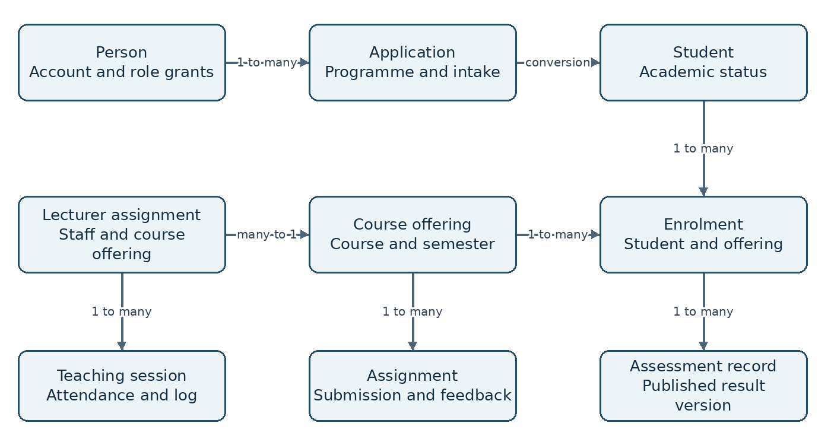
Figure 3 Principal academic entities and relationships inherited from the customer baseline.
SRS-053 Record identity and relationships. The system shall enforce immutable internal primary identifiers, required parent references and uniqueness constraints. It shall prohibit orphaned enrolments, submissions, results and teaching records. Human-readable identifiers shall be unique within the approved institutional scope.
Source: DAT-01 | Priority: M | Verify: T11 referential integrity
SRS-054 History and lineage. The system shall preserve creation, modification and decision metadata and the policy versions used by controlled records. Published result evidence shall link to enrolment, component marks, credits, approvals and superseded versions where applicable.
Source: DAT-02 | Priority: M | Verify: T11 lineage reconstruction
SRS-055 Retention and holds. The system shall execute an approved record-class retention schedule, respect active holds and record disposal outcomes. Disposal shall cover associated private files and replicas according to approved policy without breaking retained academic evidence.
Source: DAT-03 | Priority: M | Verify: T11 retention and hold

Relationship constraints
A person can hold zero or more role grants and applications and at most one canonical student identity per approved institutional scope. An offering has many enrolments and assignments. Each assignment submission belongs to an enrolment in that same offering. A mark belongs to an enrolment and assessment component; those parents must agree on offering. A teaching record belongs to a scheduled session and an authorised lecturer assignment.

18 Data dictionary and integrity constraints
Entity | Essential fields | Integrity rule
Person and Account | person_id, account_id, contact, verification, status | Account links to one canonical person; contacts do not act as primary keys
RoleGrant | account_id, role, scope, valid_from, valid_to, grantor | No permission outside active scope or effective time
Application | application_id, person_id, intake_id, programme_id, state, revision | Unique submission reference; immutable submitted snapshots
FileAsset | file_id, owner_id, storage_key, type, bytes, scan_state | Only available assets can be attached to a completed submission
Student | student_id, person_id, student_number, status | Unique student number and canonical person link
Offering and Enrolment | offering_id, course_id, period_id, section; enrolment_id, student_id | Unique student and offering enrolment; repeats use distinct offerings
Assignment and Submission | assignment_id, offering_id, due_at; attempt_id, enrolment_id, receipt | Attempt enrolment belongs to assignment offering
Mark and ResultVersion | component_id, enrolment_id, decimal_mark or outcome; result_version_id | Mark or approved code; result versions cannot be overwritten
Approval | target_id, target_revision, approver_id, decision, time | Approval invalid if the target content changes
Session and TeachingRecord | session_id, assignment_id, start_at, end_at; lecturer_id, outcome | End after start; one effective record per lecturer and session
PaymentEvent | provider_id, event_id, reference, amount, currency, state | Unique provider and event pair; exact reference and value matching
AuditEvent | event_id, actor_id, action, object_id, time, correlation_id | Append-only application access and protected integrity evidence

Data representation rules
Instants shall be stored with unambiguous timezone semantics and displayed in the approved institutional timezone. Amounts and marks shall use fixed-precision decimal representations. Calendar dates such as birth dates shall not shift across timezones. Null means missing or inapplicable only where the field definition permits it; it shall not be substituted for an unexplained zero.

Consistency enforcement
Database or equivalent transactional constraints shall enforce uniqueness and parent integrity under concurrent requests. API validation provides user-friendly errors but does not replace persistence constraints. Imports and background jobs shall obey the same invariants as interactive actions.

19 External and internal interface contracts
SRS-056 Authoritative service boundary. Every mutation shall validate actor, scope, object state, input schema and relevant policy on the server. Client-calculated totals and status fields shall be treated as untrusted input and independently checked.
Source: INT-01 | Priority: M | Verify: T12 manipulated request
SRS-057 Provider interaction. The system shall authenticate callbacks, validate their schema and replay status, enforce timeouts and retry only safe operations. Provider outages shall expose a pending or failed delivery state without corrupting committed internal records.
Source: INT-02 | Priority: M | Verify: T12 callback and timeout
SRS-058 Import and export contract. The system shall require an approved field mapping, preview invalid rows and deduplicate import keys before commitment. It shall produce per-row outcomes and a reconciliation summary, with a safe retry or rollback strategy documented for each import type.
Source: INT-03 | Priority: M | Verify: T12 import replay
Logical operation | Minimum input | Required result
Submit application | Owned ID, revision, idempotency key | Receipt or field/state/conflict errors
Register offering | Student, offering, policy context | Enrolment ID or eligibility reasons
Submit coursework | Assignment, attempt, available file IDs, key | Committed receipt and lateness state
Approve mark sheet | Sheet ID, exact revision, decision | Approval bound to revision
Publish batch | Batch ID, revision, key | Published version or unchanged failure
Provider payment event | Signed event ID, reference, value, currency | Accepted, duplicate or rejected outcome

Transport and error semantics
For an HTTP implementation, the proposed contract uses versioned JSON resources, opaque identifiers and correlation IDs. Responses distinguish unauthenticated, forbidden or concealed-not-found, validation failure, stale revision, throttling and temporary unavailability. Error bodies contain code, safe message and optional field errors, never stack traces or secrets. Route names and full schemas belong in the interface design deliverable.
List operations shall use bounded pagination and stable ordering. File bodies use a dedicated upload flow. Retrying an action after an unknown outcome shall consult its stable operation reference or idempotency key before creating a new business transaction.

20 User interface and accessibility
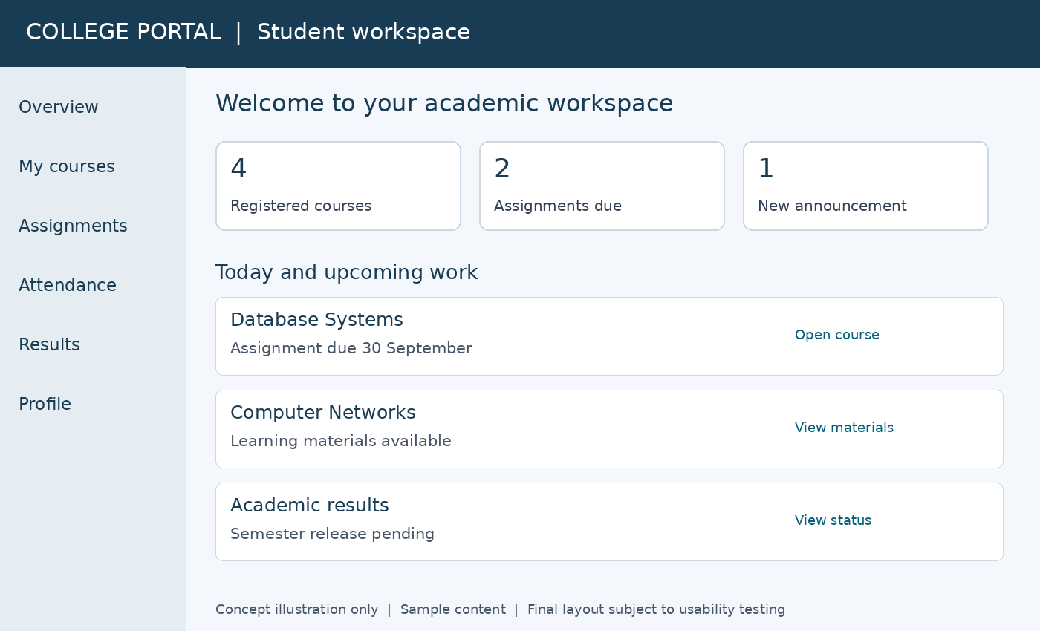
Figure 4 Conceptual student portal showing course work and result status rather than unapproved marks.
SRS-059 Task and status clarity. The interface shall distinguish Saved draft, Submitted, Awaiting review and Published outcomes, show authoritative receipts and indicate the next required action. A browser progress indicator shall not substitute for server confirmation.
Source: APP-05, LMS-04, RES-03 derived | Priority: M | Verify: T13 status comprehension
SRS-060 Responsive and accessible tasks. Core tasks shall work at a 360-pixel viewport, 200% zoom and by keyboard alone. Inputs shall have labels, errors shall identify fields, focus shall remain visible and status shall not rely on colour alone.
Source: NFR-06 | Priority: M | Verify: T13 accessibility tasks
SRS-061 Connection-aware interaction. The interface shall show save and upload state, preserve recoverable drafts and explain retry outcomes. It shall avoid unnecessary media and show file limits before upload. Full offline quiz or attendance completion is excluded from the initial baseline.
Source: NFR-07 | Priority: M | Verify: T13 constrained network

Role-specific navigation
Applicants see applications and offers; students see registered learning and published results; lecturers see assigned offerings, mark sheets and teaching records. Staff portals shall show scoped queues. Shared branding shall not imply shared permissions. Concept images are illustrative and subject to user testing.

21 Security and privacy requirements
SRS-062 Transport and storage protection. The system shall protect network traffic, sensitive stored data and backups, restrict private file access and maintain secrets outside source code. Rotating secrets shall not require exposing their values in ordinary user interfaces or logs.
Source: SEC-03 | Priority: M | Verify: T14 transport and secret inspection
SRS-063 Audit integrity. The system shall record authentication, role changes, controlled edits, admissions decisions, marks, publication, attendance corrections and sensitive exports with actor and correlation ID. Ordinary application roles shall not update or delete audit entries; integrity checks shall detect tampering.
Source: SEC-04 | Priority: M | Verify: T14 audit completeness and tamper
SRS-064 Privacy and minimisation. The system shall collect only approved fields, present appropriate notices and support authorised correction and disposal. Private grades, identity documents and staff location evidence shall not appear in public URLs, analytics payloads or external notification previews.
Source: SEC-05 | Priority: M | Verify: T14 disclosure review
SRS-065 Environment isolation. The system shall separate production and test access and data, limit operational privileges and record emergency access. Production data shall not be copied to testing unless a specifically approved protected process applies.
Source: SEC-06 | Priority: M | Verify: T14 environment isolation

Security test obligations
The verification plan shall test object-level access, forged role and scope inputs, malicious upload content, injection, session fixation or theft scenarios, replayed actions and exported spreadsheet content. Material vulnerabilities affecting confidentiality, integrity or availability block release until remediated or the affected capability is removed under an approved scope change.

Incident and privacy handling
The operating procedure shall identify who can revoke sessions, disable compromised integrations, preserve evidence and notify the appropriate college authority. Retention and disclosure decisions require institutional approval. No legal compliance certification is asserted by this SRS. Biometrics, continuous location tracking and automated disciplinary decisions are outside the baseline.

Security ownership
The IT owner approves security configuration and operational access. Academic and admissions owners approve business permissions. Testers shall verify that these responsibilities remain separated, including emergency recovery and administrator support workflows.

22 Performance reliability and recovery
The following inherited targets are proposed and require approval of workload and operational resources. They are not measured claims. Performance tests shall state the software build, dataset, concurrency model, hardware, network conditions and exclusion list.
SRS-066 Response time. At 200 concurrent active users, at least 95% of ordinary record requests shall complete server processing within 2 seconds during a 30-minute representative test. Large file transfers and asynchronous exports are excluded and shall be reported separately.
Source: NFR-01 | Priority: M | Verify: T15 load test
SRS-067 Reference volume. The performance dataset shall represent 5,000 students, 300 staff and three academic years, including realistic enrolments, marks and submissions. Results shall report error rate as well as latency; rejecting valid work is not a performance success.
Source: NFR-02 | Priority: M | Verify: T15 volume validation
SRS-068 Availability. The service shall target 99.5% monthly availability excluding pre-agreed maintenance. Availability shall equal successful service minutes divided by eligible minutes, using agreed core transaction probes and documented incident intervals.
Source: NFR-03 | Priority: M | Verify: T15 monitoring review
SRS-069 Recovery objectives. The service shall restore to a recovery point no older than 24 hours and restore core service within 8 hours in an approved drill. The drill shall verify database, file and configuration consistency and log the actual loss and restoration interval.
Source: NFR-04 | Priority: M | Verify: T15 recovery drill
SRS-070 Retry integrity. Confirmed admissions conversions, applications, coursework submissions and publications shall not be lost or duplicated during request-interruption tests. A confirmed operation is one committed by the service, regardless of whether the caller received its response.
Source: NFR-05 | Priority: M | Verify: T15 failure injection
SRS-071 Usability threshold. At least 90% of representative pilot participants shall complete their assigned core tasks without facilitator intervention. Recruitment, tasks and scoring shall be agreed before testing, and failures shall be recorded by role and task.
Source: NFR-08 | Priority: M | Verify: T13 observed pilot
The zero-loss retry requirement applies to transaction and connection failures. Disaster recovery remains bounded by the approved recovery point objective; it does not promise zero data loss after catastrophic failure. Core portal tasks shall also be tested on the 1 Mbps connection specified by the CRS.

23 Deployment migration and operation
SRS-072 Migration reconciliation. The system shall support trial imports with record counts, exception reports and comparison of enrolments, credits and released results to approved sources. Cutover shall require source-owner sign off and a plan for reconciling new transactions during rollback.
Source: INT-03; CRS delivery section | Priority: M | Verify: T16 migration rehearsal
SRS-073 Configuration control. The operator shall be able to manage approved institution, academic-period, upload, session and notification settings without source-code edits. Security-sensitive and policy changes shall be permission-controlled, versioned and auditable.
Source: ACA-01, SEC-06 derived | Priority: M | Verify: T16 configuration change
SRS-074 Operational visibility. The service shall expose health, job backlog, provider failures and protected audit events to authorised operators. Alerts shall identify actionable failures without including private academic content or credentials.
Source: NFR-03, SEC-06 derived | Priority: M | Verify: T16 fault alert
SRS-075 Deployment safety. The release process shall provide environment separation, schema-change validation, a backup checkpoint and a documented rollback or forward-recovery plan. It shall preserve committed transactions and avoid incompatible code and data versions.
Source: SEC-06; CRS delivery section | Priority: M | Verify: T16 deployment rehearsal
SRS-076 Handover deliverables. Release handover shall include deployment instructions, configuration register, restore procedure, role guides, interface schemas, data dictionary, test evidence and known issues. College operators shall demonstrate restore and account-administration tasks before service acceptance.
Source: CRS delivery section derived | Priority: M | Verify: T16 operator demonstration

Operational readiness gate
The customer shall name first-line support, technical escalation and incident decision makers. Monitoring and backup ownership must be assigned, and provider accounts must be controlled by the approved service owner. Production access shall not depend on a developer’s personal account. Support hours and commercial service terms require a separate agreement.

Change safety
A migration rehearsal must use a representative copy or approved anonymised dataset. Any upgrade that changes calculation or permission behaviour requires targeted regression evidence. Rolling back code alone is not acceptable if a schema change or newly committed data would make that rollback inconsistent.

24 Verification plan and test scenarios
SRS-077 Verification coverage. Every approved SRS requirement shall have an executed test or inspection record with build, setup, inputs, expected outcome, actual outcome and evidence. Conditional requirements shall be marked included or explicitly deferred before release.
Source: CRS acceptance section derived | Priority: M | Verify: T17 coverage audit
SRS-078 Release acceptance. A release shall pass all applicable Must requirements and contain no unresolved critical or high-severity defect affecting access, record integrity or core workflows. Lower defects require explicit owner acceptance, mitigation and a due date.
Source: CRS acceptance section derived | Priority: M | Verify: T17 release review
Test | Setup and action | Expected result
T02 A | Lose submission response; retry identical request | One application and same receipt
T03 A | Two officers convert the same accepted offer | One linked student identity
T04 A | Revoke lecturer assignment during active session | Next protected course mutation denied
T06 A | File transfer stops before manifest commit | No submitted receipt; recoverable draft
T07 A | Approve revision 4; attempt to publish revision 5 | Publication denied; prior visible results unchanged
T07 B | Stop notification provider after release commit | Results remain published; notices queued for retry
T08 A | Calculate boundary grades, exceptions and repeats | Exact match to signed independent examples
T09 A | Submit correction for a cancelled class | Reviewed outcome; no automatic absence penalty
T10 A | Replay valid payment event with same provider ID | No duplicate fee satisfaction or finance event
T11 A | Delete held records through disposal job | Held records retained; decision recorded
T15 A | Restore backup with database and attached files | Core service restored within agreed objectives

Test completion
T01 to T17 are test families used throughout the document. Each family shall include positive, negative, permission, boundary and interruption cases where applicable. Independent expected grade calculations, finance reconciliation and source-data comparison require process-owner approval. Test records are deliverables; this specification is not a test execution report.

25 Requirements traceability
This matrix maps the complete numbered CRS baseline to the proposed software requirements and primary test families. Detailed requirements carry their own source and verification tags. The prose state, data and interface constraints are part of the associated requirements, not optional design notes.
CRS source | SRS coverage | Tests
IAM-01 to IAM-02 | 001 to 003; permission model | T01
APP-01 to APP-05, APP-07 | 004, 007 to 012, 059 | T01, T02, T13
APP-06 | 048 | T10
ADM-01 to ADM-04 | 013 to 016 | T03
STU-01 to STU-04 | 001, 017 to 018 | T03
ACA-01 to ACA-06 | 019 to 024, 073 | T04, T16
LMS-01 to LMS-08 | 025 to 035 | T05, T06
RES-01 to RES-04 | 036 to 041 | T07
GRD-01 to GRD-04 | 042 to 045 | T08
ATT-01 to ATT-05 | 046 to 047; section 13 verification contract | T09
SUP-01 to SUP-06 | 027, 040, 048 to 052 | T05, T07, T09, T10
DAT-01 to DAT-03 | 053 to 055; section 18 constraints | T11
INT-01 to INT-03 | 037, 056 to 058, 072 | T07, T12, T16
SEC-01 to SEC-06 | 004 to 006, 062 to 065, 073 to 075 | T01, T14, T16
NFR-01 to NFR-08 | 060 to 061, 066 to 071, 074 | T13, T15, T16
CRS delivery and acceptance | 072, 075 to 078 | T16, T17

Derived detail and change impact
SRS-022 proposes a 60-second normal-operation membership propagation target while requiring immediate denial of prohibited actions. Other added details include optimistic conflict handling, idempotency, exact-revision approvals, protected job execution and reproducible calculation evidence. These refine the customer intent and require review with this SRS; they are not claimed as previously approved decisions.

Conditional scope
SRS-029, SRS-051 and SRS-052 are Should items. QR or location verification is conditional on the attendance policy. Native mobile, biometric processing, live video, payroll and full accounting remain outside the baseline. Deferring an item must not weaken mandatory privacy and access controls.

26 Decisions dependencies and approval
Decision | Required owner | Needed before
Single institution or independent multi-college tenancy | Sponsor and architect | Data and access design approval
College identity, campuses, volumes and hosting owner | Sponsor and IT | Sizing and deployment plan
Admission rules, fees, deadlines and document limits | Admissions and finance | Admission configuration acceptance
Grading scale, rounding, repeats and approval stages | Registry and academic authority | Calculation and publication design
Presence versus teaching, leave and verification rules | HR and academic departments | Attendance implementation
Contact verification, session limits and recovery settings | IT security owner | Identity release
Retention schedule and permitted personal fields | Institutional data owner | Production data collection
Providers, support hours, recovery and workload targets | IT and sponsor | Integration and service acceptance
Should features and 60-second access propagation target | Sponsor and academic owner | Release scope approval

Open policy safeguards
Unresolved rules shall not be filled with invented college policy. The team may build configurable structures and test with labelled example data, but production activation of grading, admission or attendance decisions requires the corresponding signed configuration. Budget, delivery dates and stack selection remain outside this specification until approved.

Glossary
SRS: Software Requirements Specification. CRS: Customer Requirements Specification. Offering: delivery of a course in a specific period and section. Idempotency: repeat requests preserve one business outcome. Optimistic concurrency: reject stale writes using a revision check. RPO: maximum recoverable data-loss interval. RTO: target service-restoration duration. UAT: User Acceptance Testing.

Approval record
Role | Name and signature | Date
Sponsor | ________________________ | ___________
Academic and registry owner | ________________________ | ___________
Admissions and HR owners | ________________________ | ___________
Technical and test leads | ________________________ | ___________

Approval establishes the software baseline and any recorded conditions. Release acceptance remains a separate decision supported by executed tests and operational evidence.

