Integrated College Management System
  - Illustrated Operation Guide
Prepared for Brima Conteh and Alhaji MW Bah
Version 1.1 | 26 September 2026

Purpose of the system
The system brings student applications, admissions, student records, course registration, online learning, academic results and lecturer attendance into one connected platform. A person’s records remain linked as they move from applicant to student, while each staff member works within their assigned responsibilities.
This guide explains the intended day-to-day operation for applicants, students, lecturers and college staff. It is an operational overview for development and training. Production use begins only after the relevant modules, college policies and user permissions have been approved and tested.

How the information connects
An applicant submits an application for review. An accepted, eligible offer is converted into a linked student record. Approved course registration gives the student access to the relevant digital classrooms. Lecturers teach, assess work and submit marks. Authorised academic staff review those marks, and the registry publishes approved results for students to view.
Lecturer attendance runs alongside teaching. Workplace presence and delivery of a scheduled class are recorded separately. Both rely on verified staff identities and authorised assignments; checking in at the college does not by itself prove that a class was delivered.

Using this guide
Read each operational section together with its following illustrated explanation. The diagrams show the main record flows, decision points and handovers. Examples explain typical situations; exact deadlines, grading rules and approval stages follow the approved college policy.
The baseline is a responsive web application used through an internet-connected browser. Google Classroom and openSIS describe familiar capability areas; synchronisation with those products is not assumed. The CRS and SRS govern detailed requirements, and approved institutional rules govern decisions such as grading, deadlines and attendance corrections.

How the modules share records
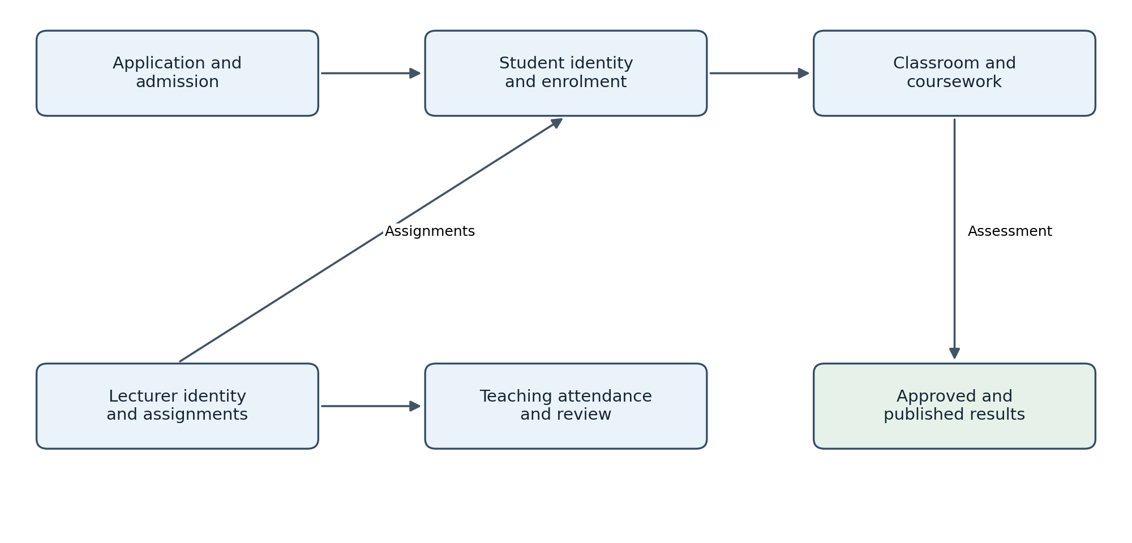
Figure 1 Shared records connect the modules while attendance and academic results retain separate controls.

One record with several uses
A student’s verified identity connects the original application, current programme, registered courses and published results. Departments work with these linked records instead of entering a new student independently in every module. A change to a contact address should not create another identity or detach earlier academic history.

Follow the arrows
The upper path shows how admission leads to enrolment and learning. Lecturer assignments determine who can teach and assess an offering. Attendance uses those assignments to identify scheduled teaching, but attendance records do not calculate student grades. The result path requires academic review before student publication.

An everyday example
An applicant accepts an eligible offer, receives a linked student record and registers for a course. That enrolment provides the correct classroom membership. When marks are approved and published, the same student account displays the result. Each transition has its own confirmation and permission checks.

Access and user responsibilities

Signing in and starting work
Open the official college system address and sign in with your own authorised account. Complete any required contact verification or additional security check. Check that your displayed role and academic period are correct before working. The dashboard should show only the tasks and records that your account is permitted to use.
Use the account recovery process if you cannot sign in. Do not share passwords or use another person’s account to complete a task. A student number or staff identifier is a record reference, not sufficient proof for resetting a password. Sign out when finished, especially on a shared computer.

Applicants and students
Applicants manage their own applications, upload required documents, respond to correction requests and view admission decisions. Students access their own registration, enrolled classrooms, submissions, released feedback and published academic results. Admission and course registration are separate steps; an offer alone does not provide access to every classroom.

Lecturers and academic staff
Lecturers manage learning resources, assignments and assessment for their assigned course offerings. They also record their own teaching sessions and attendance as authorised. Academic reviewers check submitted mark sheets within their delegated department and period. Registry staff maintain controlled student records and publish approved result batches.

Admissions and attendance staff
Admissions officers review assigned applications and make recommendations or decisions according to their delegated authority. HR or attendance officers review staff attendance evidence, approved leave and correction requests. Finance staff verify application-fee records where the approved admission process requires them; full accounting and payroll are outside the baseline.

Administrators and management
System administrators manage technical settings, accounts and approved access grants. Technical administration does not automatically confer authority to approve admissions or change academic results. Management users view reports within their authorised scope. Sensitive exports and record changes must remain traceable to the responsible user.
Before each intake or term, authorised staff must configure approved programmes, courses, academic periods, lecturer assignments, registration windows and applicable policies. Incomplete or unapproved configuration must be resolved before affected workflows are activated.

How access is decided
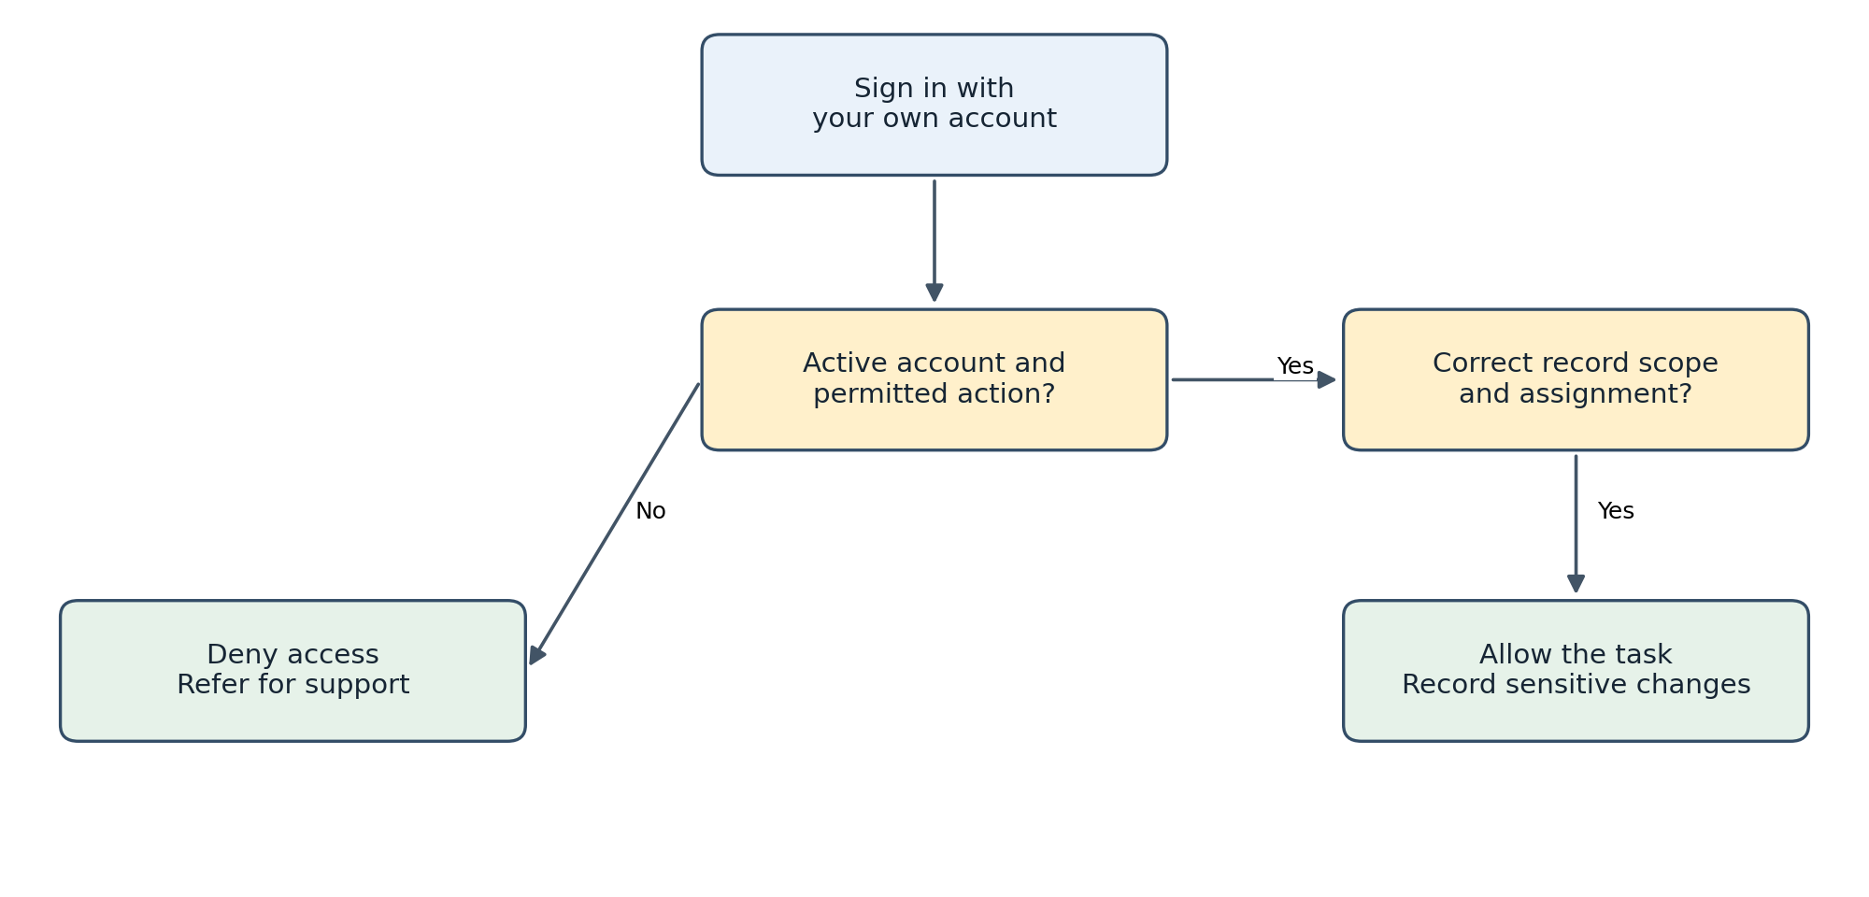
Figure 2 Permission requires an active account, an allowed action and the correct record scope. A failed scope check also denies access.

Why a role is not enough
A lecturer may be allowed to enter marks but only for currently assigned offerings. A student may be allowed to download results but only their own published records. Knowing a record number or obtaining its link does not grant permission to view or change it.

Account changes and recovery
An authorised administrator can grant or revoke access according to approved responsibilities. Suspension or deactivation blocks protected access while retaining historical academic records. Account recovery must verify the user through the approved recovery process; staff must never ask the user to disclose a current password.

What to do when access is denied
Confirm the selected role, academic period and assignment. Send the support office the affected module and safe record reference. The office should correct an erroneous grant or explain the restriction. Technical administrators must not grant themselves academic approval authority simply to complete a blocked task.

Applications admissions and registration

Submitting an application
The applicant selects an available programme and intake, completes the required personal and academic information, and saves the application as a draft. Required documents must finish uploading and pass the configured checks. The applicant reviews the entries and declarations before submitting. Where fees apply, the approved payment condition must also be satisfied.
A saved draft is not a submitted application. Submission is complete only when the system confirms it and provides an application reference and timestamp. The applicant should retain that reference and check the account for status updates. If the connection fails, check whether a submission already exists before trying again.

Reviewing and deciding
The admissions officer opens the assigned review queue and checks completeness and eligibility against the approved intake rules. If corrections are needed, the officer identifies the permitted changes and deadline. The applicant updates the requested information and resubmits, while earlier versions remain available to authorised staff.
The authorised decision maker records the outcome and required reasons. Where several approvals are required, a recommendation must not be treated as the final decision. The applicant receives the applicable decision or offer information, including any conditions and response deadline. Internal review notes remain restricted.

Creating the student record
Once an offer has been accepted and its conversion conditions are met, authorised staff convert it into a student record linked to the existing person. The system assigns or reconciles the student number and retains the application history. A suspected duplicate is referred to registry staff; users should not create a second identity merely to bypass a failed conversion.

Registering for courses
The student or authorised registry officer selects the appropriate academic period and permitted course offerings. The system checks the approved registration rules, including student status, prerequisites, credit limits and registration windows. Successful registration records the enrolment and enables the corresponding classroom access.
If registration is refused, review the reason and contact the responsible office. A permitted override requires delegated authority and a recorded justification. Additions, withdrawals, deferrals and repeated attempts must follow their approved workflows so that classroom membership, assessments and historical records stay consistent.

From application to classroom access
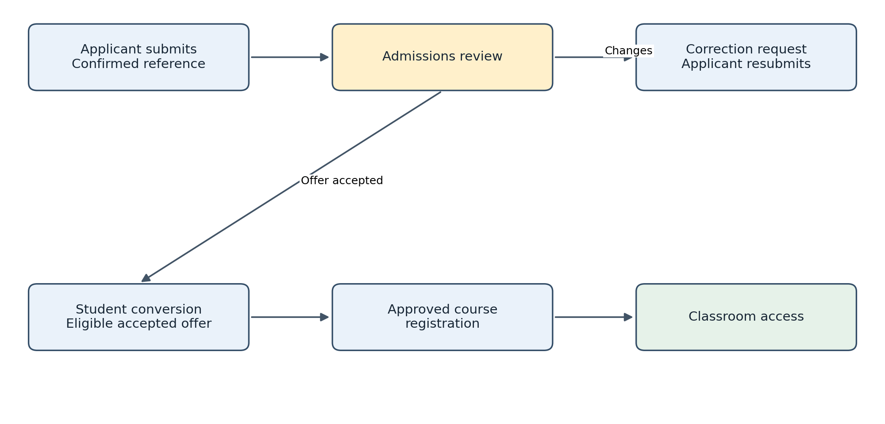
Figure 3 The successful admission path. Corrected applications return to review; unsuccessful decisions do not create student enrolments.

The review loop
A correction request tells the applicant which fields need attention and the response deadline. Resubmission returns the application to review and retains earlier versions. The officer must distinguish an internal recommendation from a final authorised decision. An offer may contain conditions that must be satisfied before conversion.

The conversion boundary
Accepting an offer does not automatically satisfy every conversion condition. The system checks the configured eligibility and links the person to one student identity. If an existing identity is found, registry staff reconcile it. Repeated conversion attempts must return the existing outcome rather than create competing student numbers.

Registration is another decision
The student’s period, programme, prerequisites and permitted workload determine the available course registrations. A successful registration provides the classroom membership; a failed one provides a reason to resolve. Admission does not mean unrestricted access to all courses. Changes and withdrawals must update access without erasing earlier work.

Learning and classroom activities

Preparing a classroom
An authorised course offering connects a course, academic period, class section and assigned lecturer. The lecturer prepares learning resources and announcements, then publishes or schedules them for the enrolled audience. Draft resources must remain private. Students should confirm they are viewing the correct course and period before downloading materials or submitting work.

Creating and completing assignments
The lecturer defines the assignment instructions, maximum mark, release time, deadline, accepted file types and permitted attempts. Late-submission rules must follow the approved configuration. Students read these instructions, prepare their work and upload the required files. An upload progress bar alone does not confirm submission.
The student submits the completed work and checks for a receipt containing the assignment, attempt and submission time. If a file is rejected or a transfer stops, the student corrects the issue and checks the final submission state. Where resubmission is allowed, the system retains earlier attempts and identifies which attempt will be marked.

Quizzes and feedback
Students complete quizzes within their availability and attempt limits. Following a connection interruption, the student checks whether the attempt is still active, submitted, expired or awaiting review. Resuming or reopening an attempt depends on the configured rules; the device clock does not override the server deadline.
The lecturer reviews the submitted attempt, records a valid mark and prepares private feedback. Students can see feedback only after it is released to them. Classroom marks are learning feedback or provisional assessment information until they pass the separate academic approval and result-publication process.

Membership and completed courses
Access depends on current enrolment or an authorised staff assignment. When a student withdraws or a lecturer is reassigned, permissions must reflect that change. Users must not share private resource links to give access to someone outside the class. Discussion tools are used only if included in the approved release.
At the end of the teaching period, staff archive the offering according to the retention policy. Reusing teaching materials for a new class must not copy previous students’ submissions, private feedback or marks into the new classroom. Historical access follows the college’s approved rules.

Understanding submission confirmation
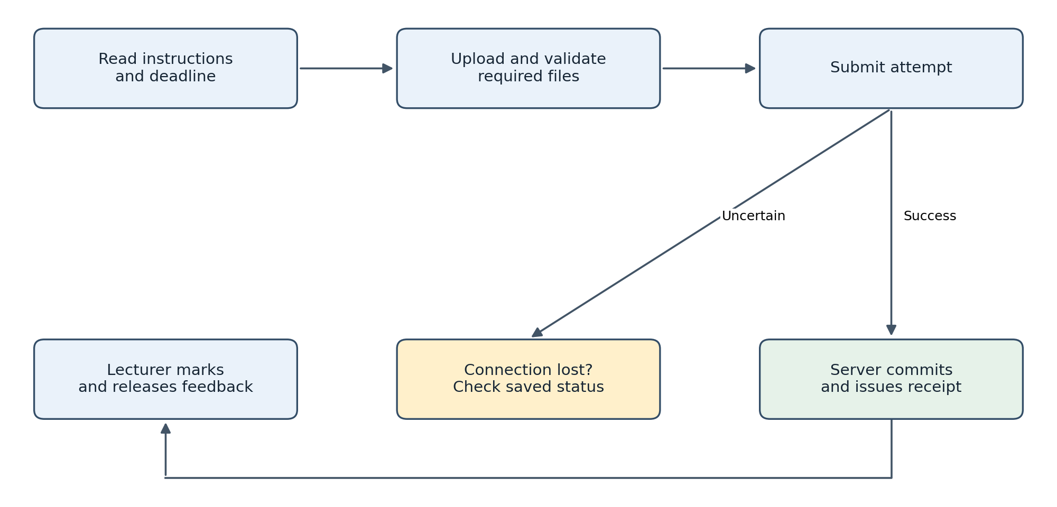
Figure 4 Uploading a file and committing an assignment submission are different events. Check the recorded outcome after an interruption.

Before submission
The student verifies the course, assignment, accepted file types and deadline. A file may still be uploading, scanning or rejected, even when it appears in the browser. Only accepted, available files can form part of a confirmed submission. The student should preserve their original work locally until submission is verified.

When the connection drops
Suppose the browser stops responding immediately after Submit is selected. The server may already have committed the attempt. After reconnecting, open the assignment and look for the receipt and attempt status. If a receipt exists, do not create another attempt merely because the earlier page did not refresh. If the work remains a draft, follow the allowed retry process.

After marking
The lecturer marks the effective permitted attempt and releases feedback privately. Late status comes from the authoritative submission time and approved policy. A classroom mark remains distinct from a published semester result. Quiz recovery similarly depends on the server deadline and approved attempt policy.

Academic results and lecturer attendance

Preparing and approving results
The lecturer enters or imports marks for valid enrolments and configured assessment components. Imported learning marks must be previewed and reconciled before commitment. Missing marks, invalid values and unresolved exceptions must be addressed. The system calculates totals and grade points using the approved grading policy; it must not invent a grade scale or treat every missing mark as zero.
Submitting the mark sheet locks its revision for review. The authorised reviewer either approves that exact revision or returns it with reasons. Corrections create a new revision requiring the relevant approvals again. The person entering marks must not be the sole final approver or publisher.

Publishing and correcting results
The authorised registry publisher checks that the complete result batch has valid approvals and no blocking errors before release. Students then view only their own published results for the selected period. A downloadable result slip identifies its issue time and version; it must not be described as an official transcript unless a separate approved transcript service provides that status.
A student who disputes a result follows the college’s approved appeal or correction process. Authorised staff review the request and supporting evidence. An approved correction creates a new result version with its reason and history; the previously published record must not be silently overwritten. Failed notification delivery does not cancel a successfully published result.

Recording lecturer attendance
The lecturer records workplace presence through the approved attendance method. For a teaching session, the lecturer separately records the assigned or authorised replacement class, topic, delivery mode, check-in, check-out and outcome. The college must approve the timing and verification rules before these records are used operationally.
Missing check-outs, overlaps and disputed entries are referred for review. The lecturer submits a correction request with a reason and any required evidence. The authorised attendance officer records a decision while preserving the original values. Cancelled, substituted, delivered and unresolved sessions must remain distinguishable.
An unresolved session must not automatically become an absence. QR or location verification is used only if approved and must have a staff-reviewed fallback for device or connection failure. Attendance records do not automatically trigger salary deductions or disciplinary action.

How results become official
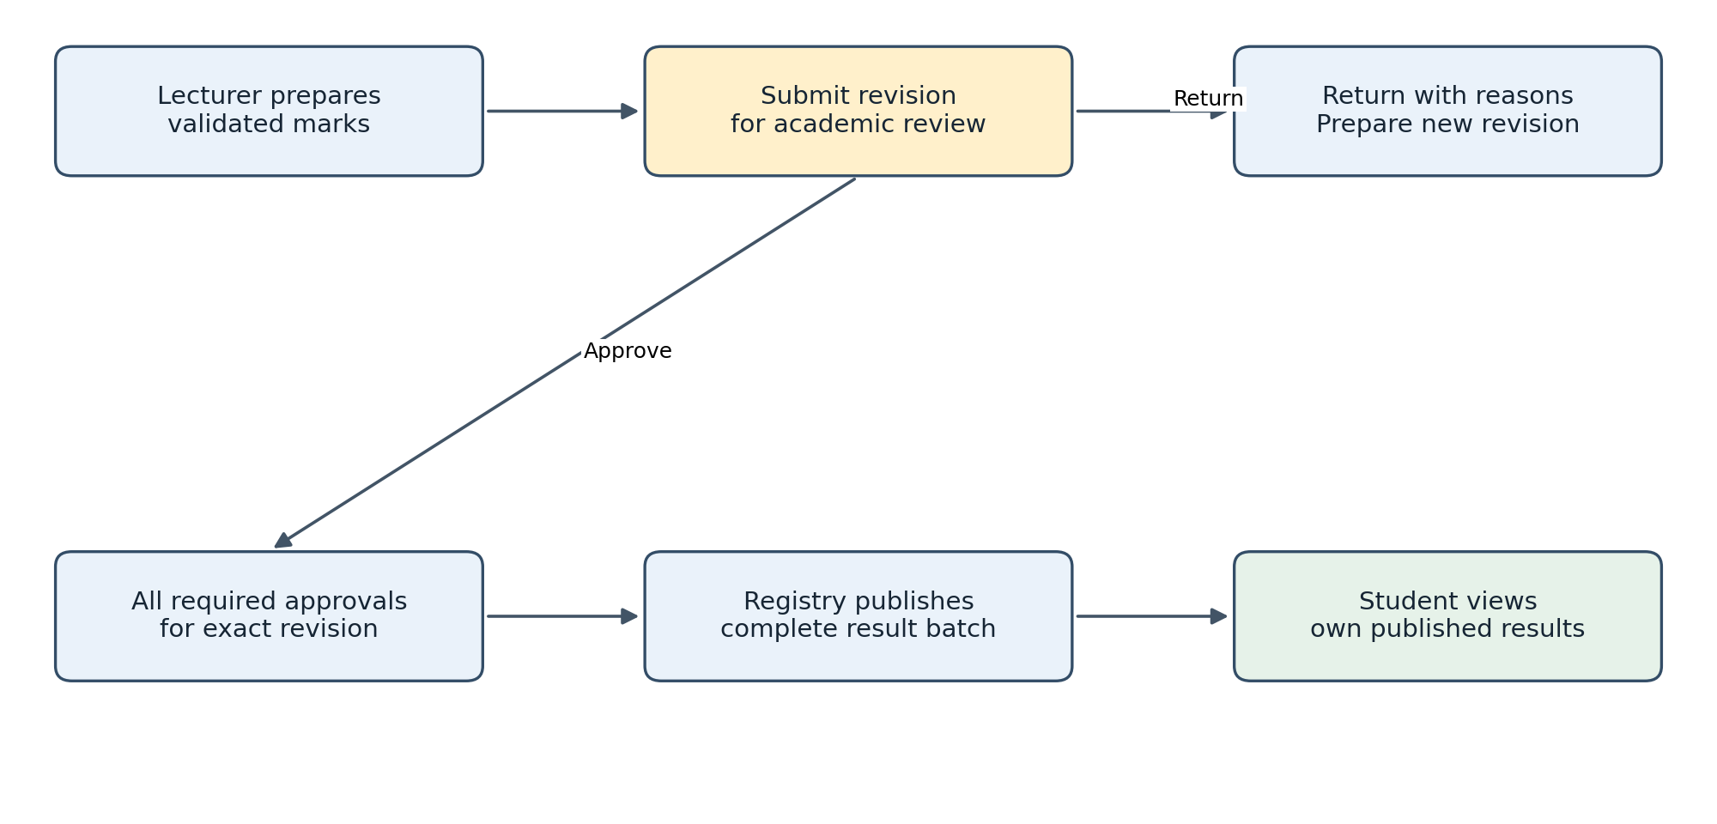
Figure 5 Academic review and publication separate lecturer-entered marks from student-visible official results.

Approval belongs to a version
An approval applies to the mark-sheet revision the reviewer examined. If a returned sheet is edited, the new version must be reviewed again. This prevents a lecturer or operator from changing values after approval while retaining the old approval. The final publisher must have independent delegated authority.

Publication and notification
The registry checks completeness, valid approvals and the intended cohort and period. Publication changes the visible result batch as one controlled operation, so students do not receive a partly published cohort. Notifications follow that commitment. A failed email must be retried without republishing or reversing valid results.

Correcting a published result
A disputed score enters the approved appeal or correction process. The existing result remains identifiable while the request is reviewed. Once approved, the correction creates a successor version linked to the previous result. Staff record the reason and notify the affected student. A downloaded slip should show its version and issue time.

Understanding lecturer attendance evidence
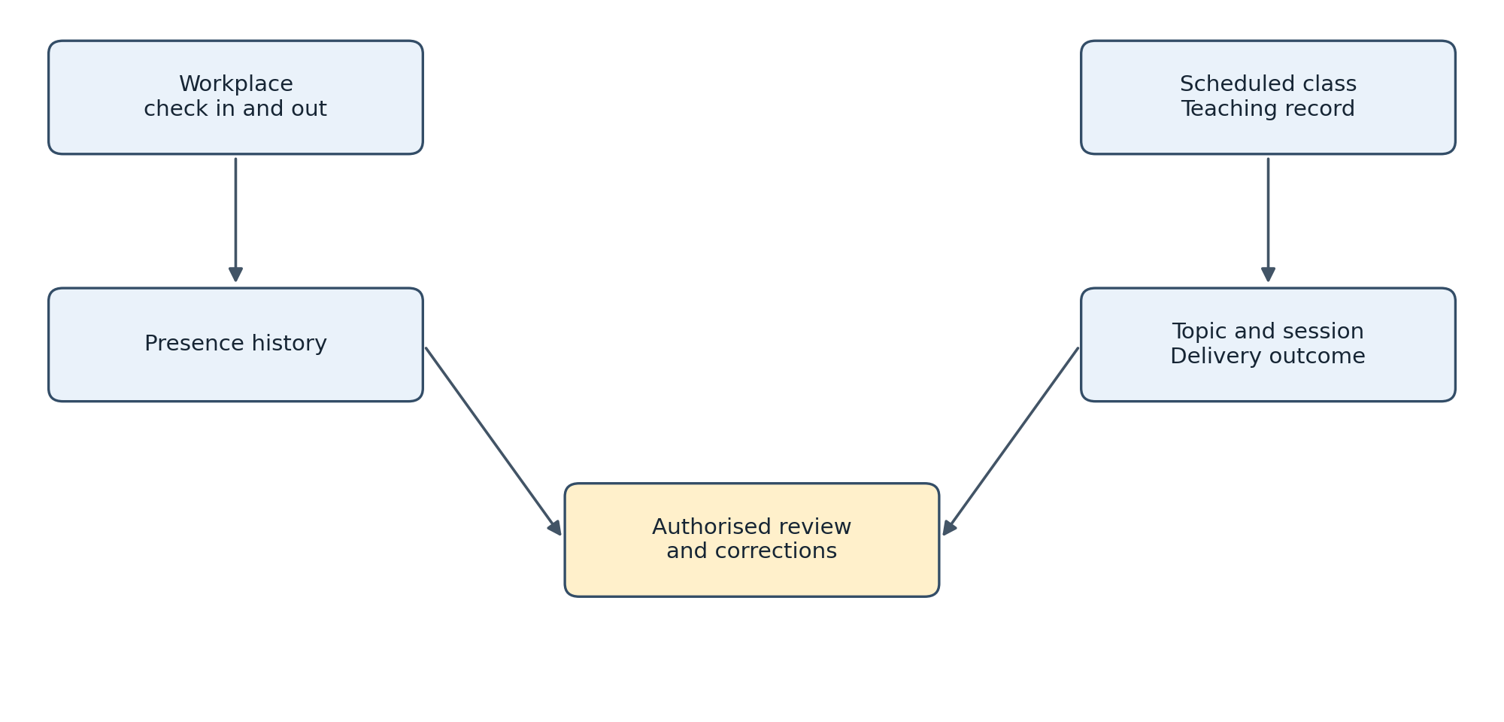
Figure 6 Presence and teaching are separate evidence streams. Review resolves exceptions before authorised reports are finalised.

Two different questions
A presence record asks whether the lecturer checked in at the workplace under the approved rules. A teaching record asks what happened to a particular assigned class. The lecturer can be present while a class is cancelled, or deliver an authorised session through another approved delivery mode. Reports must not treat these situations as identical.

Reviewing an exception
For a missing check-out or disputed teaching record, the lecturer requests a correction and supplies the required reason and evidence. The reviewer checks the schedule, assignment, leave or substitution information before deciding. The original entry, corrected value, reviewer and decision remain traceable. An unresolved record stays unresolved until reviewed.

A cancellation example
If the college cancels a class, the session is recorded as cancelled rather than automatically counted as a missed teaching obligation. A substitute lecturer receives the authorised delivery record without crediting both lecturers for the same session. Attendance does not automatically impose payroll deductions or disciplinary sanctions. QR or location checks remain conditional on approved policy.

Daily operation and support

Routine checks
At the start of work, users check the correct role, period, pending tasks and relevant notices. Admissions staff review outstanding applications; lecturers check scheduled sessions and assessment deadlines; registry staff review registration and result queues. Before signing out, users confirm that important saves, submissions and decisions have a recorded successful outcome.
Authorised operators monitor service health, failed background jobs, notification delivery and backup results. They investigate failures and retain an incident record. Sensitive report exports should be limited to the intended purpose, stored securely and shared only with authorised recipients.

Common problems
If a course is missing, check the student’s approved enrolment or lecturer assignment and the selected academic period. Refer unresolved membership issues to registry or academic support. Do not create a duplicate class or account as a workaround.
If an upload fails, check the permitted file type and size, connection and displayed rejection reason. Confirm whether the file is still a draft or whether a submission receipt exists before retrying. If results are unavailable, first check the selected period and publication status; classroom feedback does not prove that official results have been released.
If access is denied, ask the responsible office to check the account status and scoped permission. If a record appears incorrect, request the controlled correction process. Do not use another person’s credentials or direct database edits to bypass the workflow.

Reporting an issue and recovering service
A useful support report includes the user’s role, affected module, record reference, time, expected outcome, actual message and a screenshot with unrelated private information removed. Never include a password or secret key. The college must name its first-line support contact, technical escalation contact and incident decision maker before launch.
Operators must follow the approved backup and recovery procedure and verify that restored records, files and configuration agree. Recovery should be rehearsed before acceptance. During an outage, users follow the institution’s approved contingency procedure; full offline operation is not assumed. After restoration, staff reconcile pending transactions before asking users to repeat them.

Keeping the guide current
Brima Conteh and Alhaji MW Bah develop the application through one shared GitHub repository and reviewed changes. Their development access is separate from college business authority. Each authorised phase must update the relevant operating instructions and provide test evidence before release. The deployed edition of this guide should include verified screen instructions, support contacts and the approved policy settings.
Reference: College Management SRS version 1.0, particularly sections 3 to 14 and 20 to 23. The approved CRS, SRS and subsequent authorised changes remain the governing requirements.

Handling errors and service interruptions
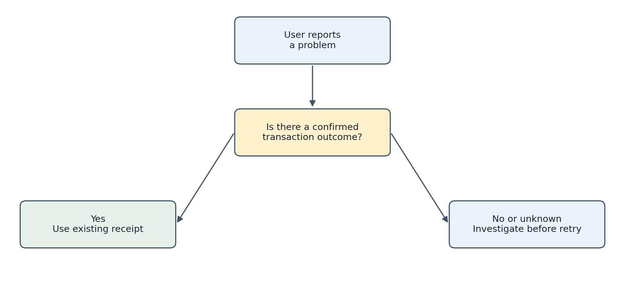
Figure 7 Check the recorded outcome before repeating a sensitive action after a timeout or interruption.

Record enough to investigate
A support report should identify the time, affected module, role, safe record reference and displayed error. Describe the expected outcome and what actually happened. Include a screenshot only after removing unrelated personal information. Never put credentials, secret keys or full private records into a public issue or shared chat.

Separate business and technical problems
An unapproved result belongs with the registry or academic reviewer; a missing course may require an enrolment correction. A widespread sign-in failure or unavailable service belongs with technical support. Support staff should use approved permissions and retain a record of any sensitive action rather than bypass controls to make the screen appear successful.

Restore and reconcile
Operators verify database, uploaded-file and configuration consistency after recovery. They then reconcile pending applications, submissions, publications and notifications before normal activity resumes. Brima and Alhaji should include these checks in release handovers, keep changes in reviewed GitHub branches and update operating instructions for every accepted phase.

