Gesture_Media_Controller Documentation

# Introduction

This program allows you to control your computer using hand gestures through a webcam. By detecting how many fingers you raise, the program triggers specific actions on your keyboard, such as moving the cursor or pressing keys like 'space'. This is made possible by using a powerful technology called MediaPipe for detecting hand landmarks and OpenCV for handling video processing.

# Hand Landmark Image

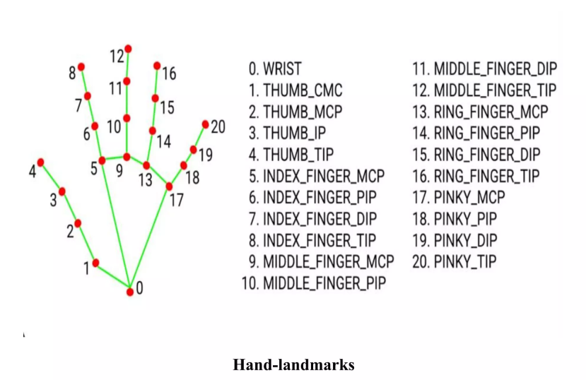

# Modules Used

This program uses several tools and libraries to achieve its functionality:  
- **OpenCV (cv2)**: Used for capturing video from the webcam and displaying the video feed on the screen.  
- **MediaPipe**: This library helps detect and track key points (landmarks) on your hand in real-time.  
- **pyautogui**: A library that allows the program to simulate keyboard presses when certain gestures are made.  
- **time**: This module is used to control how often the program reacts to a gesture, ensuring it doesn't respond too quickly.

# How It Works

The program works in the following steps:  
1. **Webcam Capture**: The program first captures a live video stream from your webcam.  
2. **Hand Gesture Detection**: Using MediaPipe, the program detects the key points (landmarks) on your hand.  
3. **Counting Raised Fingers**: The program counts how many fingers are raised by analyzing the distance between these landmarks.  
4. **Triggering Key Presses**: Based on the number of fingers raised, the program sends a corresponding keyboard command, such as moving the cursor or pressing 'space'.  
5. **Real-time Feedback**: The program continuously processes video frames, updating the actions in real-time.

# Functions

### count_fingers(lst)  
This function checks how many fingers you have raised by analyzing the position of the key points on your hand. It calculates the distance between certain points on the hand to determine if each finger is raised. If a finger is raised, it counts it.

# Main Code Workflow

The main steps the program follows are as follows:  
1. **Initialize the Webcam**: The program starts by capturing video from your webcam. This allows it to detect your hand gestures in real time.  
  
2. **Setup MediaPipe for Hand Detection**: The program sets up the MediaPipe library to detect the landmarks on your hand. These landmarks are specific points on your hand that help identify where the fingers are.  
  
3. **Processing Each Frame**: For every frame (image) captured from the webcam, the program processes it to detect any hand landmarks. Once it detects a hand, it counts how many fingers are raised.  
  
4. **Simulating Key Presses**: Depending on how many fingers are raised, the program simulates a key press. For example:  
 - 1 Finger -> Right Arrow  
 - 2 Fingers -> Left Arrow  
 - 3 Fingers -> Up Arrow  
 - 4 Fingers -> Down Arrow  
 - 5 Fingers -> Space  
  
5. **Exit the Program**: Press the 'Esc' key to stop the program and close the webcam feed.

# Key Variables

1. **prev**: This variable keeps track of the previous number of fingers raised. It helps avoid sending multiple commands for the same gesture.  
2. **start_init**: A flag that helps control the timing of when the program sends a key press.  
3. **start_time** and **end_time**: These variables track the time between gestures to avoid sending too many key presses in quick succession.

# Dependencies

In order to run this program, you need to have the following software installed:  
- **OpenCV (opencv-python)**: Used for video processing and displaying the webcam feed.  
- **MediaPipe**: Detects and tracks the landmarks on your hand.  
- **pyautogui**: Allows the program to simulate keyboard actions.  
- **time**: Helps manage the timing of gestures.  
  
To install the required libraries, you can use the following command:  
```bash  
pip install opencv-python mediapipe pyautogui  
```

# Potential Enhancements

While this program is functional, there are a few ways it could be improved:  
1. **Multi-Hand Detection**: Currently, the program only detects one hand at a time. It could be expanded to detect multiple hands.  
2. **Dynamic Thresholds**: Instead of using fixed values, the program could adjust the thresholds for detecting fingers based on individual hand sizes.  
3. **Custom Gestures**: New gestures could be added for additional controls, such as opening apps or switching tabs.  
4. **Graphical User Interface (GUI)**: Adding a GUI would allow users to easily configure the program's behavior without needing to modify the code directly.

# Conclusion

This program offers a unique and intuitive way to control your computer using hand gestures. By combining computer vision techniques and real-time processing, it demonstrates how gesture-based interactions can be used for practical automation tasks.