BÀI 1: CHUYỂN ĐỔI GIÁ TRỊ TIỀN TỆ
Bước 1: Khai báo chuỗi String và tải ảnh lá cờ về máy
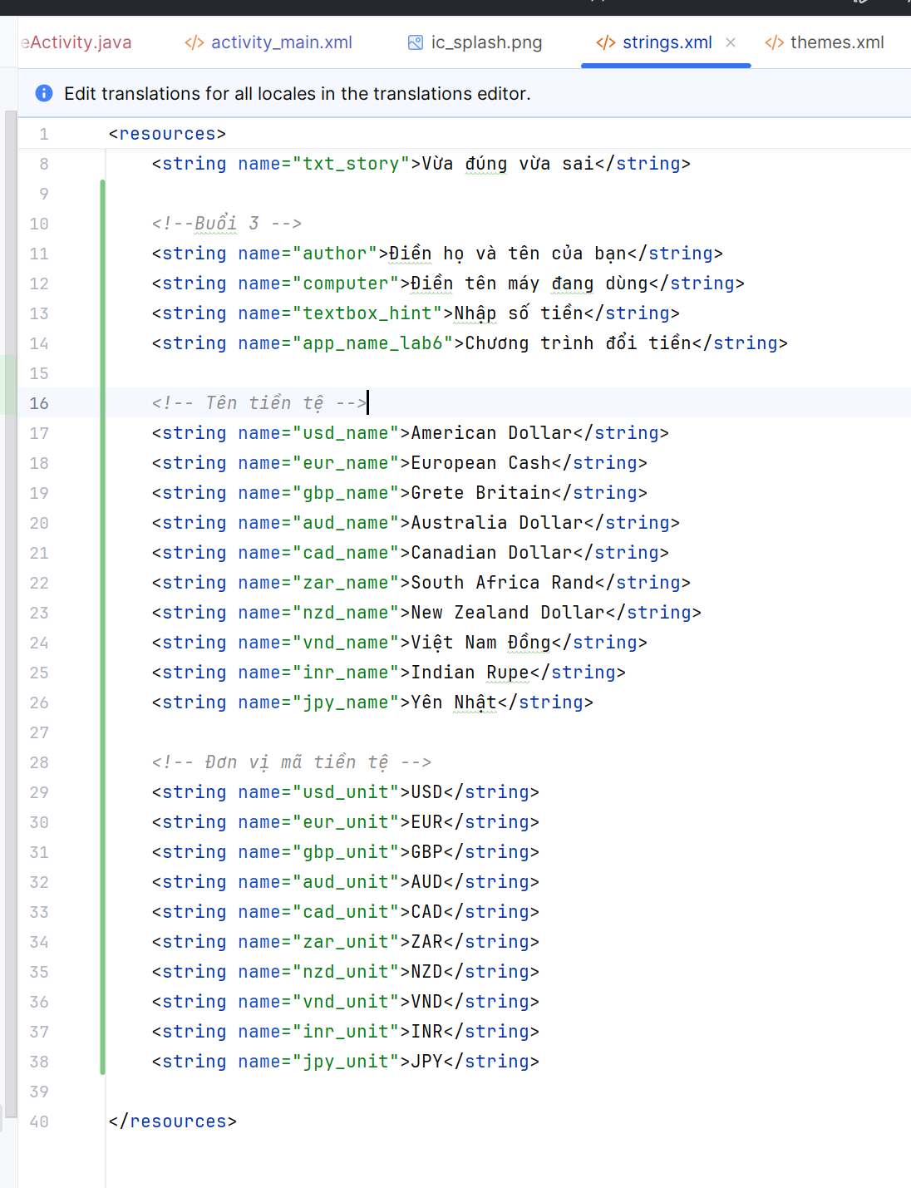
Bước 2: Code giao diện
<?xml version="1.0" encoding="utf-8"?>
<ScrollView xmlns:android="http://schemas.android.com/apk/res/android"
android:layout_width="match_parent"
android:layout_height="match_parent"
xmlns:app="http://schemas.android.com/apk/res-auto"
android:padding="8dp">
<LinearLayout
android:layout_width="match_parent"
android:layout_height="wrap_content"
android:orientation="vertical"
android:background="@color/white"
android:layout_marginTop="20dp">
<LinearLayout
android:layout_width="match_parent"
android:layout_height="56dp"
android:orientation="horizontal"
android:gravity="center_vertical"
android:background="@color/teal_700"
android:paddingStart="8dp"
android:paddingEnd="8dp"
android:elevation="4dp">
<ImageView
android:id="@+id/imgBack"
android:layout_width="32dp"
android:layout_height="32dp"
android:src="@drawable/ic_back"
app:tint="@color/white"/>
<TextView
android:id="@+id/tvHeader"
android:layout_width="0dp"
android:layout_height="wrap_content"
android:layout_weight="1"
android:text="Quay lại"
android:textColor="@color/white"
android:textSize="20sp"
android:textStyle="bold"
android:gravity="left"/>
</LinearLayout>
<TextView
android:id="@+id/tvTitle"
android:layout_width="wrap_content"
android:layout_height="wrap_content"
android:text="@string/app_name_lab6"
android:textSize="22sp"
android:textStyle="bold"
android:layout_gravity="center"
android:padding="12dp"
android:textColor="#000000" />
<!-- Input + Spinner -->
<LinearLayout
android:layout_width="match_parent"
android:layout_height="wrap_content"
android:orientation="horizontal">
<EditText
android:id="@+id/txtNumber"
android:layout_width="0dp"
android:layout_height="wrap_content"
android:layout_weight="1"
android:hint="@string/textbox_hint"
android:inputType="numberDecimal"/>
<Spinner
android:id="@+id/spnUnit"
android:layout_width="100dp"
android:layout_height="wrap_content"
android:layout_marginLeft="8dp"/>
</LinearLayout>
<TableLayout
android:layout_width="match_parent"
android:layout_height="wrap_content"
android:stretchColumns="1">
<!-- USD -->
<TableRow
android:layout_width="match_parent"
android:layout_height="wrap_content"
android:padding="3dp"
android:gravity="center">
<ImageView
android:layout_width="40dp"
android:layout_height="40dp"
android:src="@drawable/usd"
android:contentDescription="@string/usd_name" />
<TextView
android:layout_width="wrap_content"
android:layout_height="wrap_content"
android:text="@string/usd_unit"
android:paddingLeft="10dp" />
<TextView
android:id="@+id/lblUsd"
android:layout_width="wrap_content"
android:layout_height="wrap_content"
android:paddingLeft="10dp" />
</TableRow>
<!--eur-->
<TableRow
android:layout_width="match_parent"
android:layout_height="wrap_content"
android:padding="3dp"
android:gravity="center">
<ImageView
android:layout_width="40dp"
android:layout_height="40dp"
android:src="@drawable/eur"
android:contentDescription="@string/usd_name" />
<TextView
android:layout_width="wrap_content"
android:layout_height="wrap_content"
android:text="@string/eur_unit"
android:paddingLeft="10dp" />
<TextView
android:id="@+id/lblEur"
android:layout_width="wrap_content"
android:layout_height="wrap_content"
android:paddingLeft="10dp" />
</TableRow>
<!-- GBP-->
<TableRow
android:layout_width="match_parent"
android:layout_height="wrap_content"
android:padding="3dp"
android:gravity="center">
<ImageView
android:layout_width="40dp"
android:layout_height="40dp"
android:src="@drawable/gbp"
android:contentDescription="@string/gbp_name" />
<TextView
android:layout_width="wrap_content"
android:layout_height="wrap_content"
android:text="@string/eur_unit"
android:paddingLeft="10dp" />
<TextView
android:id="@+id/lblGbp"
android:layout_width="wrap_content"
android:layout_height="wrap_content"
android:paddingLeft="10dp" />
</TableRow>
<!-- AUD-->
<TableRow
android:layout_width="match_parent"
android:layout_height="wrap_content"
android:padding="3dp"
android:gravity="center">
<ImageView
android:layout_width="40dp"
android:layout_height="40dp"
android:src="@drawable/aud"
android:contentDescription="@string/aud_name" />
<TextView
android:layout_width="wrap_content"
android:layout_height="wrap_content"
android:text="@string/aud_unit"
android:paddingLeft="10dp" />
<TextView
android:id="@+id/lblAud"
android:layout_width="wrap_content"
android:layout_height="wrap_content"
android:paddingLeft="10dp" />
</TableRow>
<!-- CAD-->
<TableRow
android:layout_width="match_parent"
android:layout_height="wrap_content"
android:padding="3dp"
android:gravity="center">
<ImageView
android:layout_width="40dp"
android:layout_height="40dp"
android:src="@drawable/cad"
android:contentDescription="@string/cad_name" />
<TextView
android:layout_width="wrap_content"
android:layout_height="wrap_content"
android:text="@string/cad_unit"
android:paddingLeft="10dp" />
<TextView
android:id="@+id/lblCad"
android:layout_width="wrap_content"
android:layout_height="wrap_content"
android:paddingLeft="10dp" />
</TableRow>
<!-- ZAR-->
<TableRow
android:layout_width="match_parent"
android:layout_height="wrap_content"
android:padding="3dp"
android:gravity="center">
<ImageView
android:layout_width="40dp"
android:layout_height="40dp"
android:src="@drawable/zar"
android:contentDescription="@string/zar_name" />
<TextView
android:layout_width="wrap_content"
android:layout_height="wrap_content"
android:text="@string/zar_unit"
android:paddingLeft="10dp" />
<TextView
android:id="@+id/lblZar"
android:layout_width="wrap_content"
android:layout_height="wrap_content"
android:paddingLeft="10dp" />
</TableRow>
<!-- NZD-->
<TableRow
android:layout_width="match_parent"
android:layout_height="wrap_content"
android:padding="3dp"
android:gravity="center">
<ImageView
android:layout_width="40dp"
android:layout_height="40dp"
android:src="@drawable/nzd"
android:contentDescription="@string/nzd_name" />
<TextView
android:layout_width="wrap_content"
android:layout_height="wrap_content"
android:text="@string/nzd_unit"
android:paddingLeft="10dp" />
<TextView
android:id="@+id/lblNzd"
android:layout_width="wrap_content"
android:layout_height="wrap_content"
android:paddingLeft="10dp" />
</TableRow>
<!-- VND-->
<TableRow
android:layout_width="match_parent"
android:layout_height="wrap_content"
android:padding="3dp"
android:gravity="center">
<ImageView
android:layout_width="40dp"
android:layout_height="40dp"
android:src="@drawable/vnd"
android:contentDescription="@string/vnd_name" />
<TextView
android:layout_width="wrap_content"
android:layout_height="wrap_content"
android:text="@string/vnd_unit"
android:paddingLeft="10dp" />
<TextView
android:id="@+id/lblVnd"
android:layout_width="wrap_content"
android:layout_height="wrap_content"
android:paddingLeft="10dp" />
</TableRow>
<!-- INR-->
<TableRow
android:layout_width="match_parent"
android:layout_height="wrap_content"
android:padding="3dp"
android:gravity="center">
<ImageView
android:layout_width="40dp"
android:layout_height="40dp"
android:src="@drawable/inr"
android:contentDescription="@string/inr_name" />
<TextView
android:layout_width="wrap_content"
android:layout_height="wrap_content"
android:text="@string/inr_unit"
android:paddingLeft="10dp" />
<TextView
android:id="@+id/lblInr"
android:layout_width="wrap_content"
android:layout_height="wrap_content"
android:paddingLeft="10dp" />
</TableRow>
<!-- JPY-->
<TableRow
android:layout_width="match_parent"
android:layout_height="wrap_content"
android:padding="3dp"
android:gravity="center">
<ImageView
android:layout_width="40dp"
android:layout_height="40dp"
android:src="@drawable/jpy"
android:contentDescription="@string/jpy_name" />
<TextView
android:layout_width="wrap_content"
android:layout_height="wrap_content"
android:text="@string/jpy_unit"
android:paddingLeft="10dp" />
<TextView
android:id="@+id/lblJpy"
android:layout_width="wrap_content"
android:layout_height="wrap_content"
android:paddingLeft="10dp" />
</TableRow>
</TableLayout>
</LinearLayout>
</ScrollView>

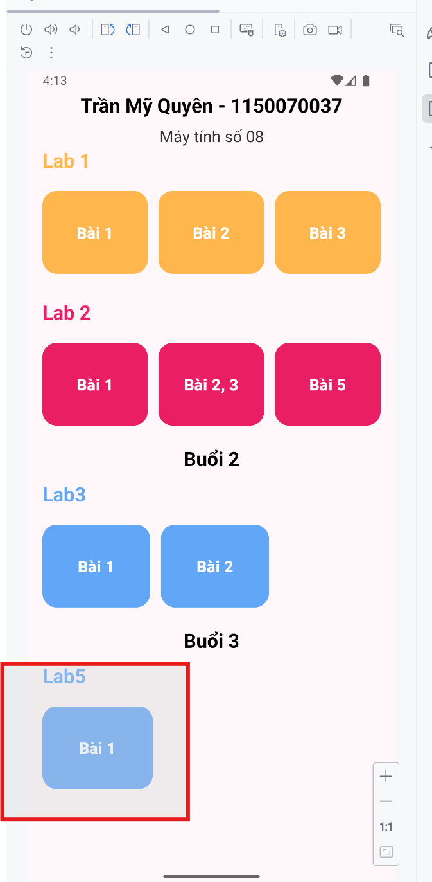 | 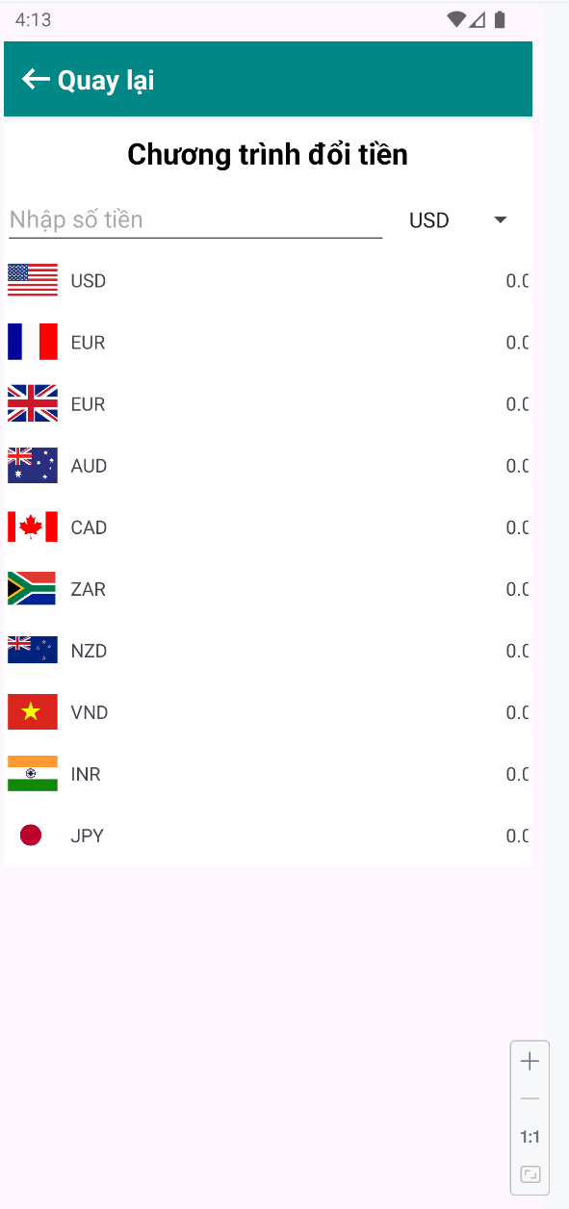

Bước 3: Báo trong Activity
3.1 Khai báo mảng chứa danh sách các loại tiền tệ
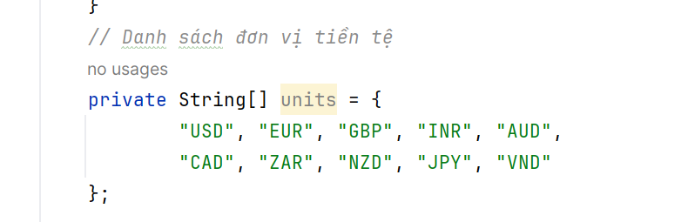

3.2Khai báo ma trận lưu tỉ giá giữa các loại tiền tệ
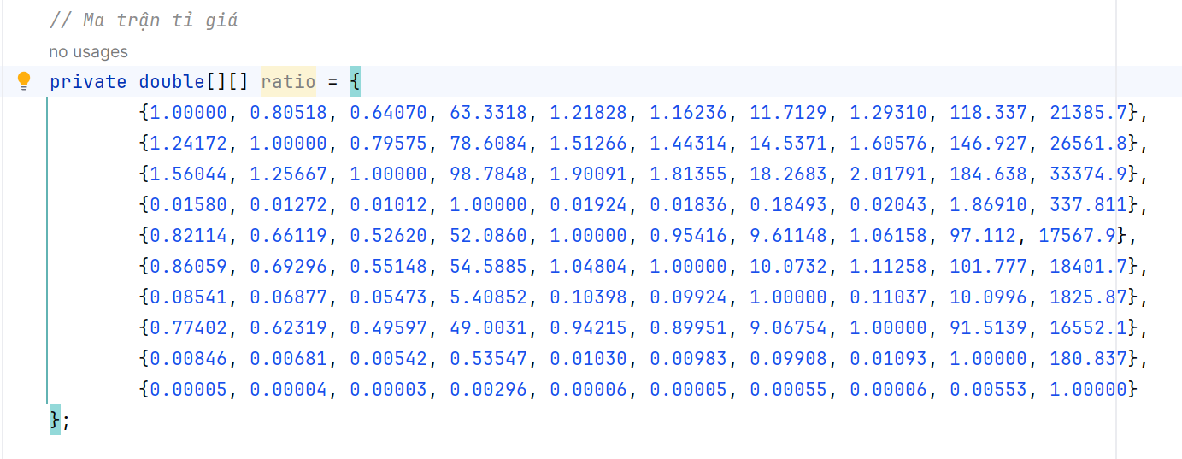
3.3Khai báo các đối tượng view
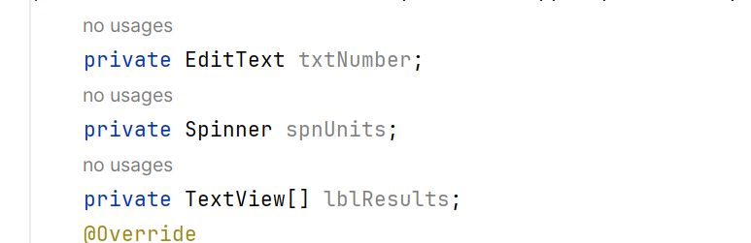
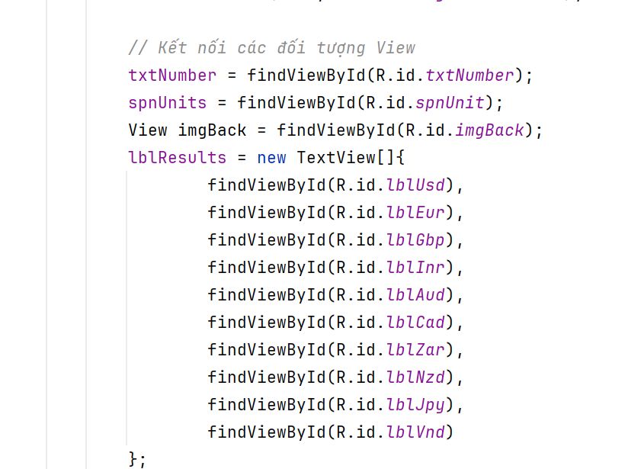
3.4 Cài đặt hàm đổi tiền
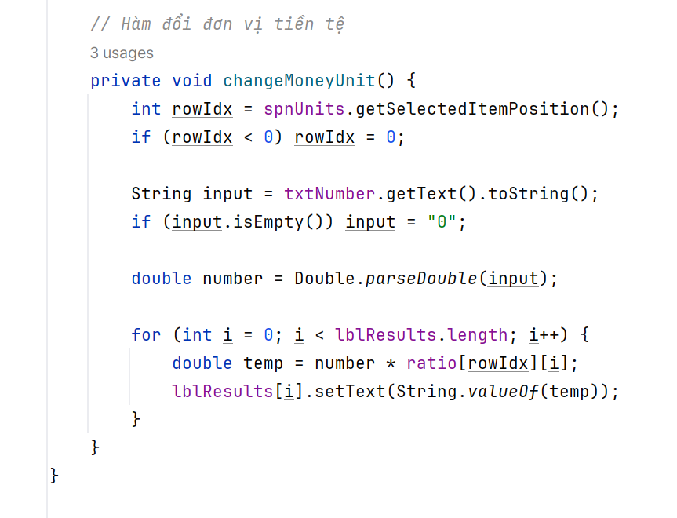
3.5 Đưa dữ liẹu vào Spinner
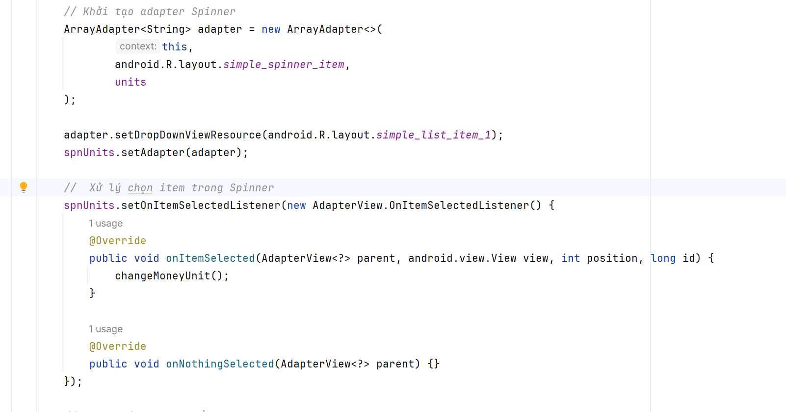
3.5 xử lý giá trị nhập
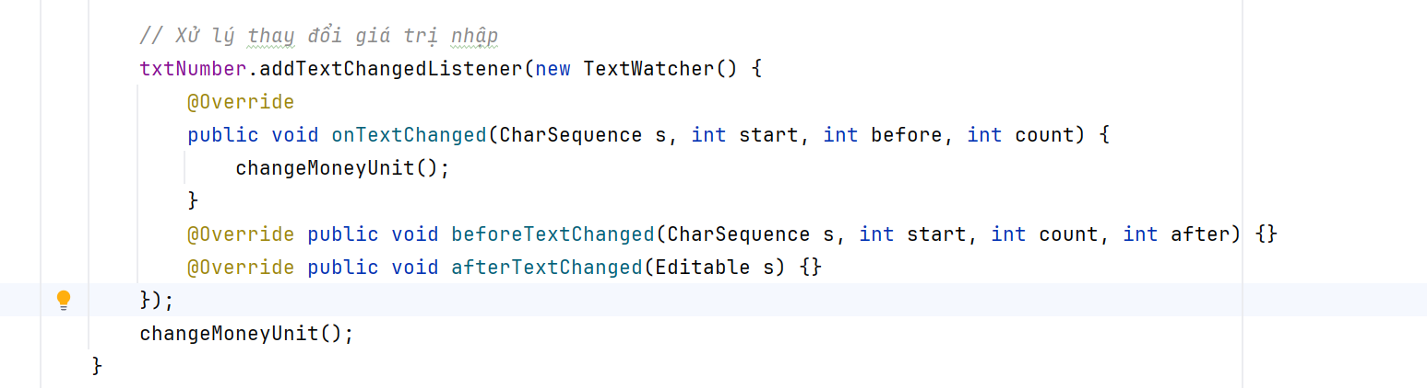
3.6 Xử lý nút thoát
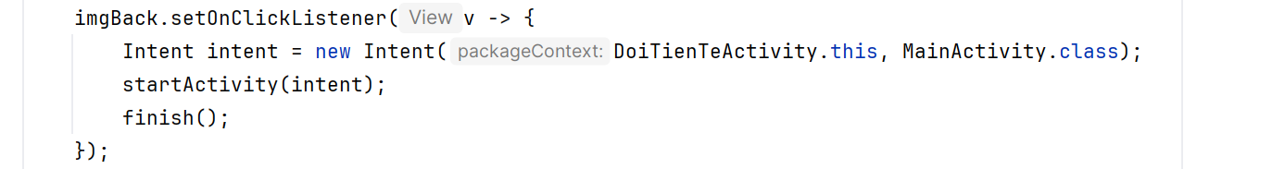

BÀI 2: CHUYỂN ĐỔI ĐỘ DÀI
Bước 1: Khai báo tên độ dài trong String.xml
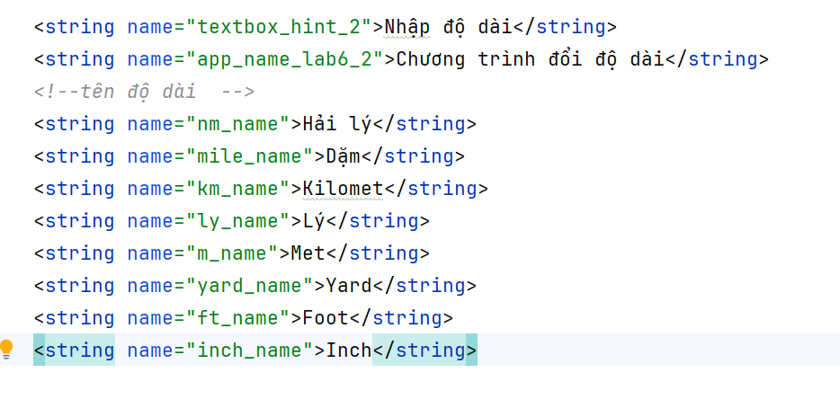
Bước 2: viết giao diện
<?xml version="1.0" encoding="utf-8"?>
<ScrollView xmlns:android="http://schemas.android.com/apk/res/android"
xmlns:app="http://schemas.android.com/apk/res-auto"
android:layout_width="match_parent"
android:layout_height="match_parent"
android:padding="8dp">
<LinearLayout
android:layout_width="match_parent"
android:layout_height="wrap_content"
android:orientation="vertical">
<LinearLayout
android:layout_width="match_parent"
android:layout_height="56dp"
android:orientation="horizontal"
android:gravity="center_vertical"
android:background="@color/teal_700"
android:paddingStart="8dp"
android:paddingEnd="8dp">
<ImageView
android:id="@+id/imgBack"
android:layout_width="32dp"
android:layout_height="32dp"
android:src="@drawable/ic_back"
app:tint="@color/white"/>
<TextView
android:id="@+id/tvHeader"
android:layout_width="0dp"
android:layout_height="wrap_content"
android:layout_weight="1"
android:text="@string/app_name_lab6_2"
android:textColor="@color/white"
android:textSize="20sp"
android:textStyle="bold"
android:gravity="center"/>
</LinearLayout>
<LinearLayout
android:layout_width="match_parent"
android:layout_height="wrap_content"
android:orientation="horizontal"
android:padding="6dp">
<EditText
android:id="@+id/txtNumber"
android:layout_width="0dp"
android:layout_height="wrap_content"
android:layout_weight="1"
android:hint="@string/textbox_hint_2"
android:inputType="numberDecimal"/>
<Spinner
android:id="@+id/spnUnit"
android:layout_width="120dp"
android:layout_height="wrap_content"
android:layout_marginLeft="6dp"/>
</LinearLayout>
<TextView
android:layout_width="match_parent"
android:layout_height="wrap_content"
android:background="@color/teal_700"
android:text="Tương đương với"
android:textColor="@color/white"
android:textStyle="bold"
android:padding="6dp"/>
<TableLayout
android:layout_width="match_parent"
android:layout_height="wrap_content"
android:stretchColumns="0,1">
<!-- hải lý-->
<TableRow android:padding="3dp">
<TextView
android:id="@+id/lblHaiLy"
android:layout_width="wrap_content"
android:padding="6dp"/>
<TextView
android:layout_width="wrap_content"
android:text="@string/nm_name"
android:padding="6dp"/>
</TableRow>
<!-- Dặm-->
<TableRow android:padding="3dp">
<TextView
android:id="@+id/lblDam"
android:padding="6dp"/>
<TextView
android:layout_width="wrap_content"
android:text="@string/mile_name"
android:padding="6dp"/>
</TableRow>
<!-- Kilomet -->
<TableRow android:padding="3dp">
<TextView
android:id="@+id/lblKilomet"
android:padding="6dp"/>
<TextView
android:text="@string/km_name"
android:padding="6dp"/>
</TableRow>
<!-- Lý -->
<TableRow android:padding="3dp">
<TextView
android:id="@+id/lblLy"
android:padding="6dp"/>
<TextView
android:text="@string/ly_name"
android:padding="6dp"/>
</TableRow>
<!-- met -->
<TableRow android:padding="3dp">
<TextView
android:id="@+id/lblMet"
android:padding="6dp"/>
<TextView
android:text="@string/m_name"
android:padding="6dp"/>
</TableRow>
<!-- yard -->
<TableRow android:padding="3dp">
<TextView
android:id="@+id/lblYard"
android:padding="6dp"/>
<TextView
android:text="@string/yard_name"
android:padding="6dp"/>
</TableRow>
<!-- Foot -->
<TableRow android:padding="3dp">
<TextView
android:id="@+id/lblFoot"
android:padding="6dp"/>
<TextView
android:text="@string/ft_name"
android:padding="6dp"/>
</TableRow>
<!-- Inch -->
<TableRow android:padding="3dp">
<TextView
android:id="@+id/lblInch"
android:padding="6dp"/>
<TextView
android:text="@string/inch_name"
android:padding="6dp"/>
</TableRow>
</TableLayout>
</LinearLayout>
</ScrollView>

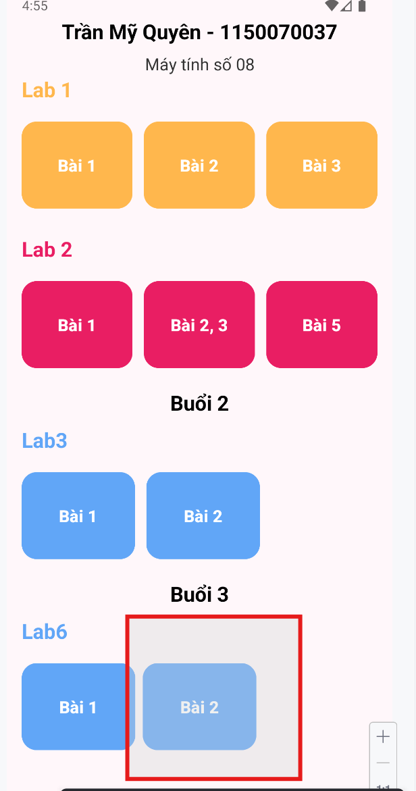 | 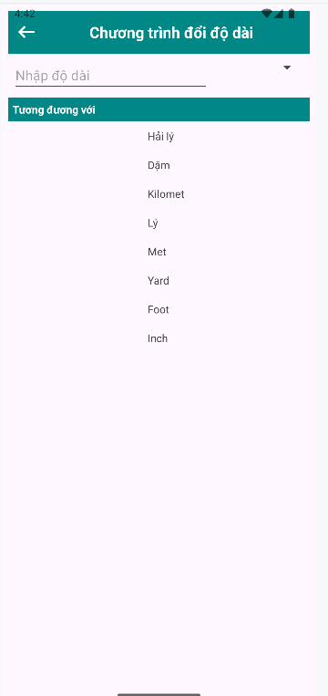

Bước 3: Xử lý Activity
3.1 Ánh xạ view
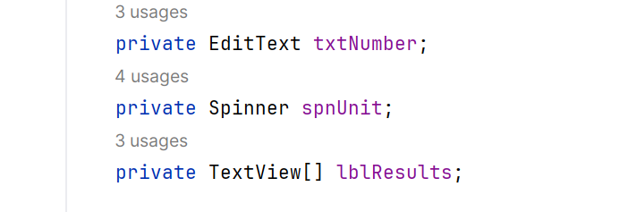
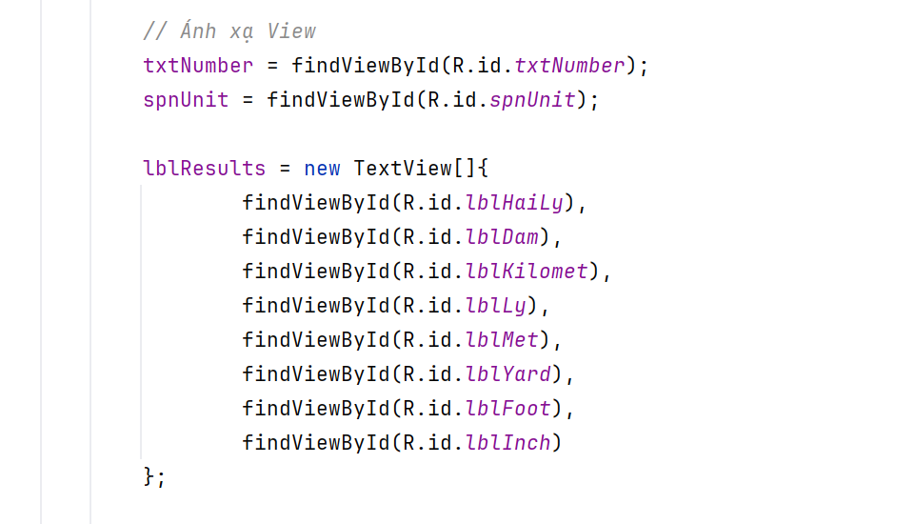
3.2 Khai báo mảng chứa danh sách đơn vị độ dài
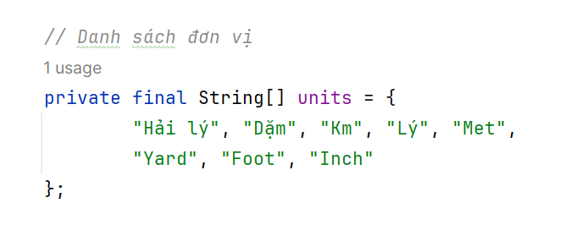
3.3 Khai báo ma trận lưu tỷ giá chuyển đổi độ dài
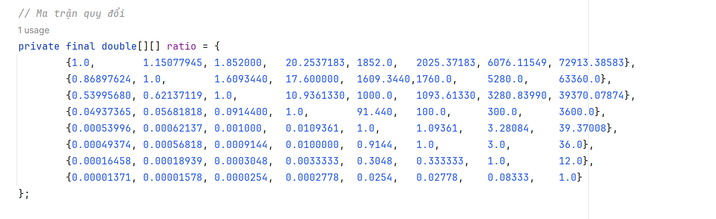
3.4 Đưa dữ liệu vào Spinner
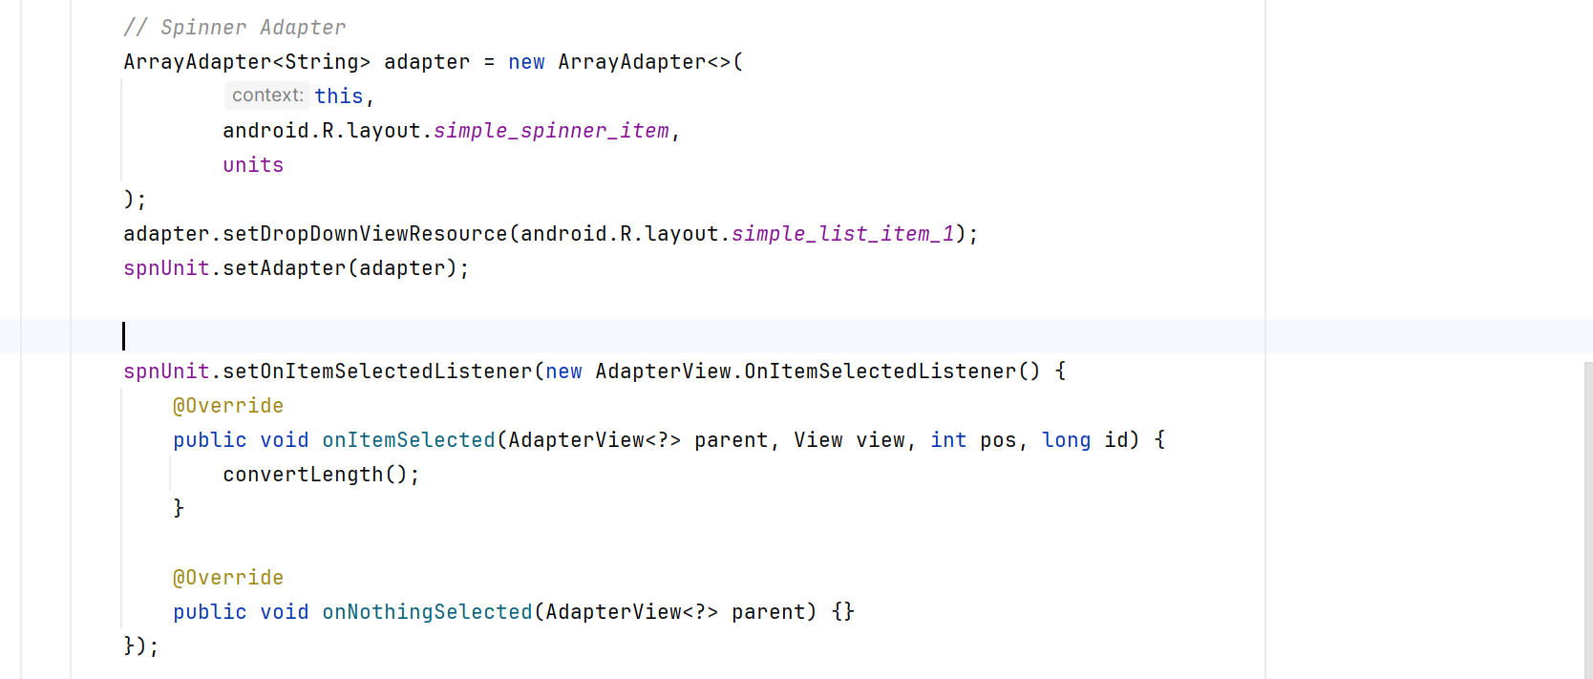
3.5 Xử lý chuyển đổi đơn vị độ dài
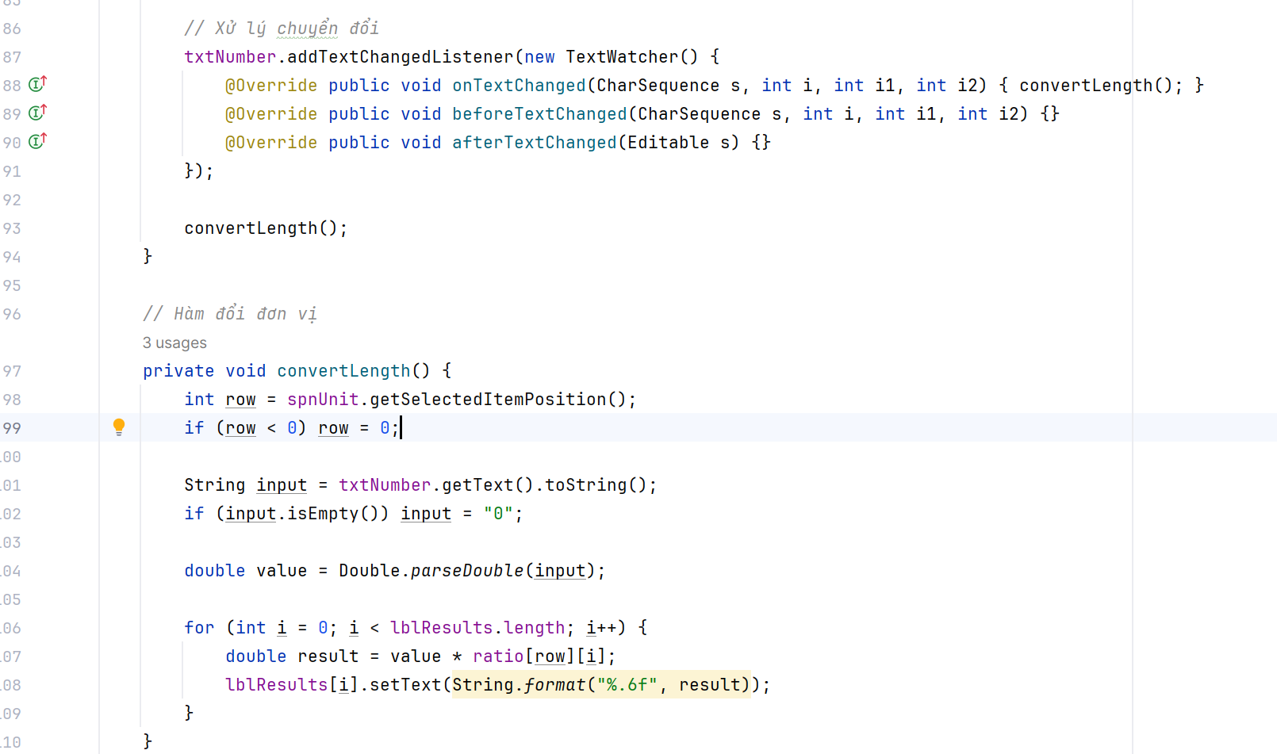
3.6 xử lý nút thoát
