BÀI THỰC HÀNH BUỔI 1
Câu trúc file: MainActivity chưa menu chuyển sang các bài tập
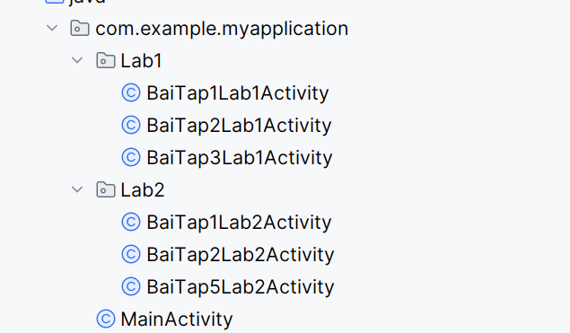
Giao diện MainActivity
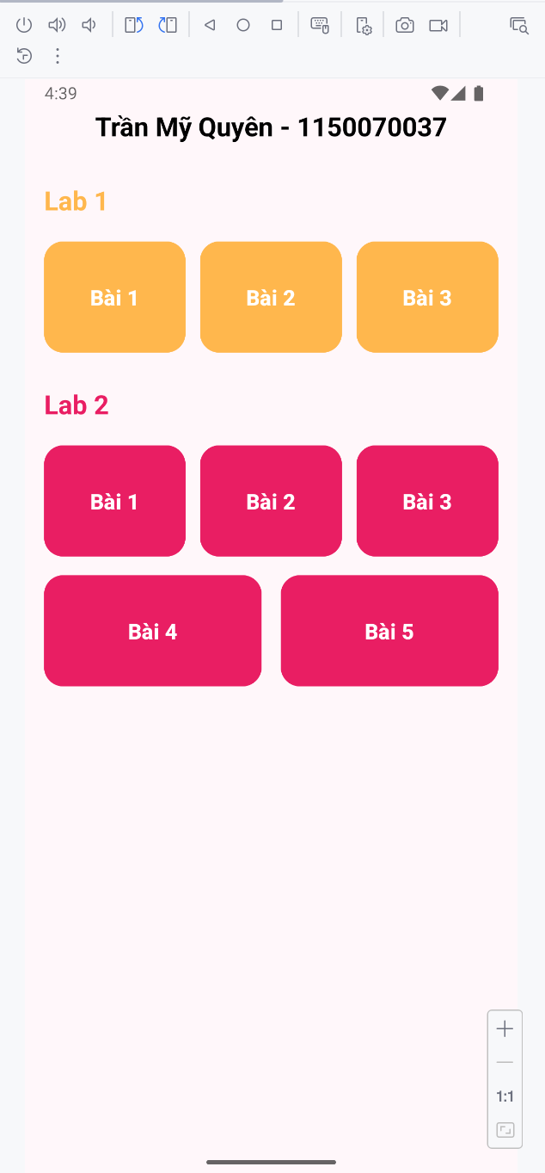

Code giao activity_main.xml
package com.example.myapplication;
import android.content.Intent;
import android.os.Bundle;
import android.view.View;
import androidx.activity.EdgeToEdge;
import androidx.appcompat.app.AppCompatActivity;
import androidx.core.graphics.Insets;
import androidx.core.view.ViewCompat;
import androidx.core.view.WindowInsetsCompat;
import com.example.myapplication.Lab1.BaiTap1Lab1Activity;
import com.example.myapplication.Lab1.BaiTap2Lab1Activity;
import com.example.myapplication.Lab1.BaiTap3Lab1Activity;
import com.example.myapplication.Lab2.BaiTap1Lab2Activity;
import com.example.myapplication.Lab2.BaiTap2Lab2Activity;
import com.example.myapplication.Lab2.BaiTap5Lab2Activity;
public class MainActivity extends AppCompatActivity {
@Override
protected void onCreate(Bundle savedInstanceState) {
super.onCreate(savedInstanceState);
EdgeToEdge.enable(this);
setContentView(R.layout.activity_main);
View btnLab1 = findViewById(R.id.btnLab1);
View btnLab2 = findViewById(R.id.btnLab2);
View btnLab3 = findViewById(R.id.btnLab3);
View btnLab4 = findViewById(R.id.btnLab4);
View btnLab5 = findViewById(R.id.btnLab5);
View btnLab6 = findViewById(R.id.btnLab6);
btnLab1.setOnClickListener(v -> {
Intent intent = new Intent(MainActivity.this, BaiTap1Lab1Activity.class);
startActivity(intent);
});
btnLab2.setOnClickListener(v -> {
Intent intent = new Intent(MainActivity.this, BaiTap2Lab1Activity.class);
startActivity(intent);
});
btnLab3.setOnClickListener(v -> {
Intent intent = new Intent(MainActivity.this, BaiTap3Lab1Activity.class);
startActivity(intent);
});
btnLab4.setOnClickListener(v -> {
Intent intent = new Intent(MainActivity.this, BaiTap1Lab2Activity.class);
startActivity(intent);
});
btnLab5.setOnClickListener(v -> {
Intent intent = new Intent(MainActivity.this, BaiTap2Lab2Activity.class);
startActivity(intent);
});
btnLab6.setOnClickListener(v -> {
Intent intent = new Intent(MainActivity.this, BaiTap5Lab2Activity.class);
startActivity(intent);
});
}
}

Xử lý chức trong MainActivity
package com.example.myapplication;
import android.content.Intent;
import android.os.Bundle;
import android.view.View;
import androidx.activity.EdgeToEdge;
import androidx.appcompat.app.AppCompatActivity;
import androidx.core.graphics.Insets;
import androidx.core.view.ViewCompat;
import androidx.core.view.WindowInsetsCompat;
import com.example.myapplication.Lab1.BaiTap1Lab1Activity;
import com.example.myapplication.Lab1.BaiTap2Lab1Activity;
import com.example.myapplication.Lab1.BaiTap3Lab1Activity;
import com.example.myapplication.Lab2.BaiTap1Lab2Activity;
import com.example.myapplication.Lab2.BaiTap2Lab2Activity;
import com.example.myapplication.Lab2.BaiTap5Lab2Activity;
public class MainActivity extends AppCompatActivity {
@Override
protected void onCreate(Bundle savedInstanceState) {
super.onCreate(savedInstanceState);
EdgeToEdge.enable(this);
setContentView(R.layout.activity_main);
View btnLab1 = findViewById(R.id.btnLab1);
View btnLab2 = findViewById(R.id.btnLab2);
View btnLab3 = findViewById(R.id.btnLab3);
View btnLab4 = findViewById(R.id.btnLab4);
View btnLab5 = findViewById(R.id.btnLab5);
View btnLab6 = findViewById(R.id.btnLab6);
btnLab1.setOnClickListener(v -> {
Intent intent = new Intent(MainActivity.this, BaiTap1Lab1Activity.class);
startActivity(intent);
});
btnLab2.setOnClickListener(v -> {
Intent intent = new Intent(MainActivity.this, BaiTap2Lab1Activity.class);
startActivity(intent);
});
btnLab3.setOnClickListener(v -> {
Intent intent = new Intent(MainActivity.this, BaiTap3Lab1Activity.class);
startActivity(intent);
});
btnLab4.setOnClickListener(v -> {
Intent intent = new Intent(MainActivity.this, BaiTap1Lab2Activity.class);
startActivity(intent);
});
btnLab5.setOnClickListener(v -> {
Intent intent = new Intent(MainActivity.this, BaiTap2Lab2Activity.class);
startActivity(intent);
});
btnLab6.setOnClickListener(v -> {
Intent intent = new Intent(MainActivity.this, BaiTap5Lab2Activity.class);
startActivity(intent);
});
}
}

Lab1
Bài Tập 1
Giao diện
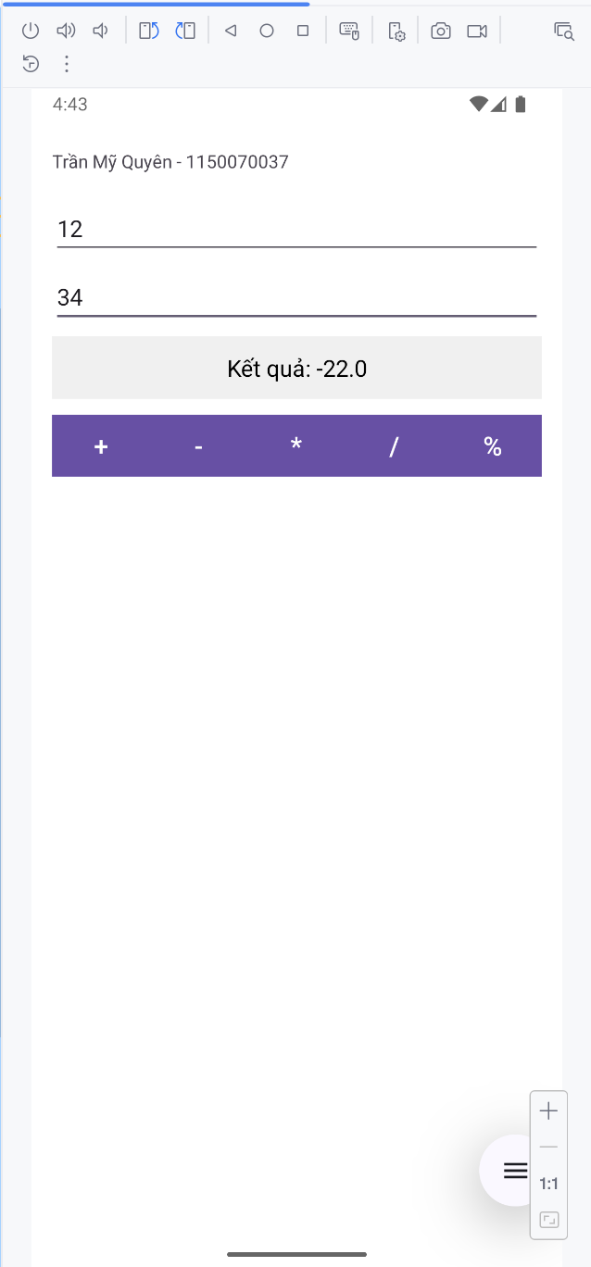
Activity_bai_tap1_lab1.xml
<?xml version="1.0" encoding="utf-8"?>
<LinearLayout xmlns:android="http://schemas.android.com/apk/res/android"
xmlns:tools="http://schemas.android.com/tools"
android:layout_width="match_parent"
android:layout_height="match_parent"
android:orientation="vertical"
android:padding="16dp"
android:background="#FFFFFF"
tools:context=".Lab1.BaiTap1Lab1Activity">
<TextView
android:layout_width="wrap_content"
android:layout_height="wrap_content"
android:text="Trần Mỹ Quyên - 1150070037"
android:layout_marginTop="30dp"/>
<!-- Ô nhập số thứ nhất -->
<EditText
android:id="@+id/edtSo1"
android:layout_width="match_parent"
android:layout_height="wrap_content"
android:hint="Nhập số thứ nhất"
android:inputType="numberDecimal"
android:layout_marginTop="20dp"
android:layout_marginBottom="8dp" />
<!-- Ô nhập số thứ hai -->
<EditText
android:id="@+id/edtSo2"
android:layout_width="match_parent"
android:layout_height="wrap_content"
android:hint="Nhập số thứ hai"
android:inputType="numberDecimal"
android:layout_marginBottom="8dp" />
<!-- Nút xem kết quả -->
<TextView
android:id="@+id/tvKetQua"
android:layout_width="match_parent"
android:layout_height="wrap_content"
android:text="Kết quả"
android:textAlignment="center"
android:textColor="#000000"
android:textSize="18sp"
android:padding="12dp"
android:background="#F0F0F0"
android:layout_marginBottom="12dp" />
<!-- Hàng chứa các nút phép toán -->
<LinearLayout
android:layout_width="match_parent"
android:layout_height="wrap_content"
android:orientation="horizontal"
android:weightSum="5">
<Button
android:id="@+id/btnCong"
android:layout_width="0dp"
android:layout_height="wrap_content"
android:layout_weight="1"
android:text="+"
android:textSize="20sp"
android:textColor="#FFFFFF"
android:background="#6200EE" />
<Button
android:id="@+id/btnTru"
android:layout_width="0dp"
android:layout_height="wrap_content"
android:layout_weight="1"
android:text="-"
android:textSize="20sp"
android:textColor="#FFFFFF"
android:background="#6200EE" />
<Button
android:id="@+id/btnNhan"
android:layout_width="0dp"
android:layout_height="wrap_content"
android:layout_weight="1"
android:text="*"
android:textSize="20sp"
android:textColor="#FFFFFF"
android:background="#6200EE" />
<Button
android:id="@+id/btnChia"
android:layout_width="0dp"
android:layout_height="wrap_content"
android:layout_weight="1"
android:text="/"
android:textSize="20sp"
android:textColor="#FFFFFF"
android:background="#6200EE" />
<Button
android:id="@+id/btnChiaDu"
android:layout_width="0dp"
android:layout_height="wrap_content"
android:layout_weight="1"
android:text="%"
android:textSize="20sp"
android:textColor="#FFFFFF"
android:background="#6200EE" />
</LinearLayout>
</LinearLayout>

BaiTap1Lab1Activity
package com.example.myapplication.Lab1;
import android.os.Bundle;
import android.view.View;
import android.widget.Button;
import android.widget.EditText;
import android.widget.TextView;
import androidx.activity.EdgeToEdge;
import androidx.appcompat.app.AppCompatActivity;
import androidx.core.graphics.Insets;
import androidx.core.view.ViewCompat;
import androidx.core.view.WindowInsetsCompat;
import com.example.myapplication.R;
public class BaiTap1Lab1Activity extends AppCompatActivity {
@Override
protected void onCreate(Bundle savedInstanceState) {
super.onCreate(savedInstanceState);
EdgeToEdge.enable(this);
setContentView(R.layout.activity_bai_tap1_lab1);
EditText edtSo1, edtSo2;
TextView tvKetQua;
Button btnCong, btnTru, btnNhan, btnChia, btnChiaDu;
edtSo1 = findViewById(R.id.edtSo1);
edtSo2 = findViewById(R.id.edtSo2);
tvKetQua = findViewById(R.id.tvKetQua);
btnCong = findViewById(R.id.btnCong);
btnTru = findViewById(R.id.btnTru);
btnNhan = findViewById(R.id.btnNhan);
btnChia = findViewById(R.id.btnChia);
btnChiaDu = findViewById(R.id.btnChiaDu);
View.OnClickListener phepToan = v -> {
// kiểm tra nhập rỗng
if (edtSo1.getText().toString().isEmpty() || edtSo2.getText().toString().isEmpty()) {
tvKetQua.setText("Vui lòng nhập đủ hai số!");
return;
}
double a = Double.parseDouble(edtSo1.getText().toString());
double b = Double.parseDouble(edtSo2.getText().toString());
double kq = 0;
if (v.getId() == R.id.btnCong) {
kq = a + b;
}
else if (v.getId() == R.id.btnTru) {
kq = a - b;
}
else if (v.getId() == R.id.btnNhan) {
kq = a * b;
}
else if (v.getId() == R.id.btnChia) {
if (b != 0)
kq = a / b;
else {
tvKetQua.setText("Không thể chia cho 0!");
return;
}
}
else if (v.getId() == R.id.btnChiaDu) {
if (b != 0)
kq = a % b;
else {
tvKetQua.setText("Không thể chia cho 0!");
return;
}
}
tvKetQua.setText("Kết quả: " + kq);
};
btnCong.setOnClickListener(phepToan);
btnTru.setOnClickListener(phepToan);
btnNhan.setOnClickListener(phepToan);
btnChia.setOnClickListener(phepToan);
btnChiaDu.setOnClickListener(phepToan);
}
}

Bài tập 2
Giao diện
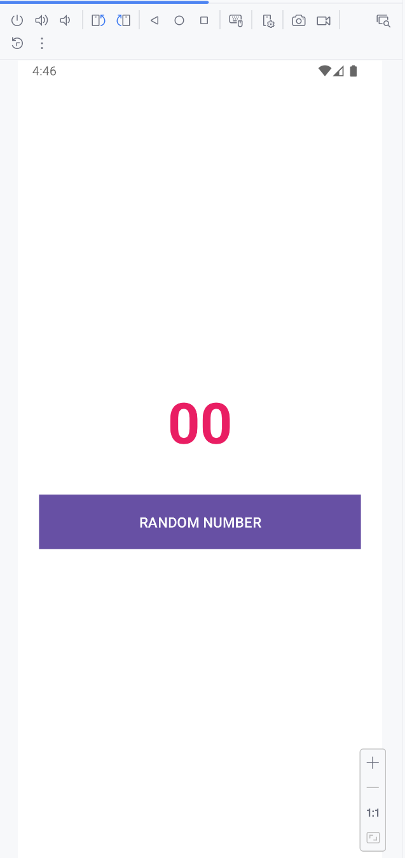

Activity_bai_tap2_lab2.xml
<?xml version="1.0" encoding="utf-8"?>
<LinearLayout xmlns:android="http://schemas.android.com/apk/res/android"
xmlns:tools="http://schemas.android.com/tools"
android:layout_width="match_parent"
android:layout_height="match_parent"
android:orientation="vertical"
android:gravity="center"
android:padding="24dp"
android:background="#FFFFFF"
tools:context="Lab1.BaiTap2Lab1Activity">
<!-- Hiển thị số ngẫu nhiên -->
<TextView
android:id="@+id/tvNumber"
android:layout_width="wrap_content"
android:layout_height="wrap_content"
android:text="00"
android:textSize="64sp"
android:textStyle="bold"
android:textColor="#E91E63"
android:layout_marginBottom="40dp" />
<!-- Nút Random -->
<Button
android:id="@+id/btnRandom"
android:layout_width="match_parent"
android:layout_height="wrap_content"
android:text="RANDOM NUMBER"
android:textAllCaps="true"
android:textSize="16sp"
android:textColor="#FFFFFF"
android:background="#6200EE"
android:padding="16dp" />
</LinearLayout>

BaiTap2Lab1Activity
package com.example.myapplication.Lab1;
import android.os.Bundle;
import android.widget.Button;
import android.widget.TextView;
import androidx.activity.EdgeToEdge;
import androidx.appcompat.app.AppCompatActivity;
import com.example.myapplication.R;
import java.util.Random;
public class BaiTap2Lab1Activity extends AppCompatActivity {
TextView tvNumber;
Button btnRandom;
@Override
protected void onCreate(Bundle savedInstanceState) {
super.onCreate(savedInstanceState);
EdgeToEdge.enable(this);
setContentView(R.layout.activity_bai_tap2_lab1);
tvNumber = findViewById(R.id.tvNumber);
btnRandom = findViewById(R.id.btnRandom);
Random random = new Random();
btnRandom.setOnClickListener(v -> {
// Tạo số ngẫu nhiên từ 0 đến 99
int soNgauNhien = random.nextInt(100);
tvNumber.setText(String.format("%02d", soNgauNhien));
});
}
}

Bài tập 3
Giao diện khi điện thoại và nhắn tin
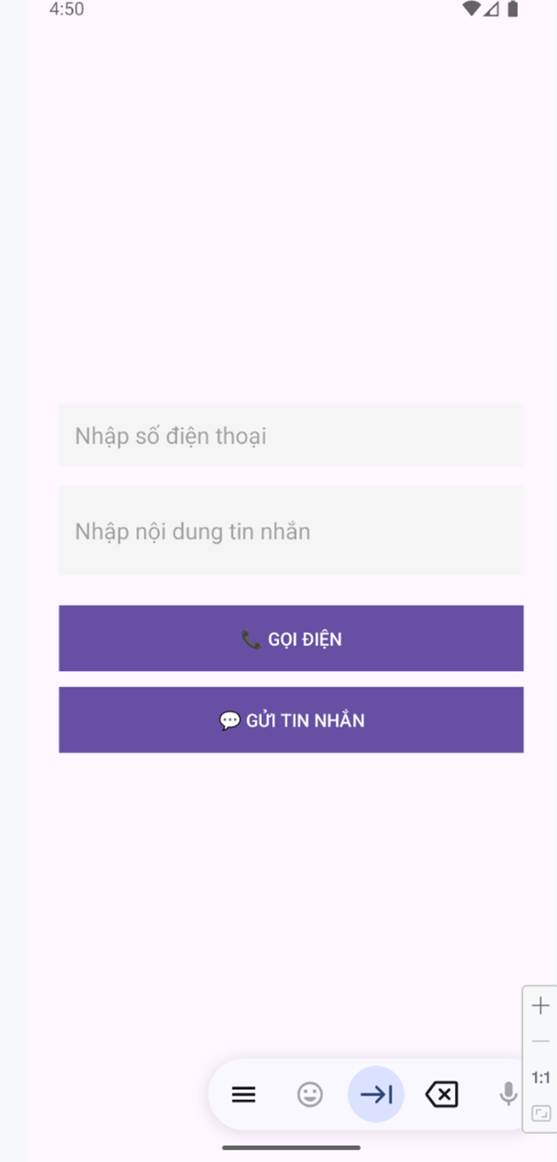 | 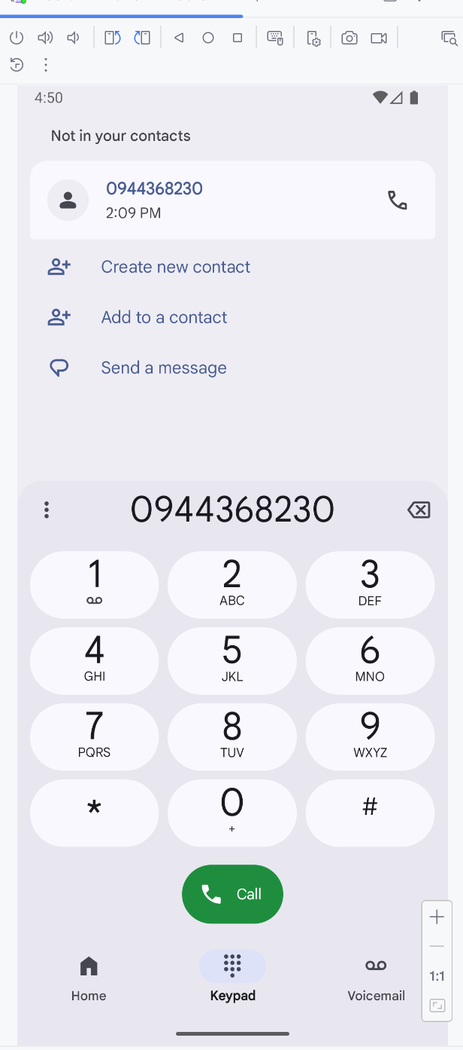
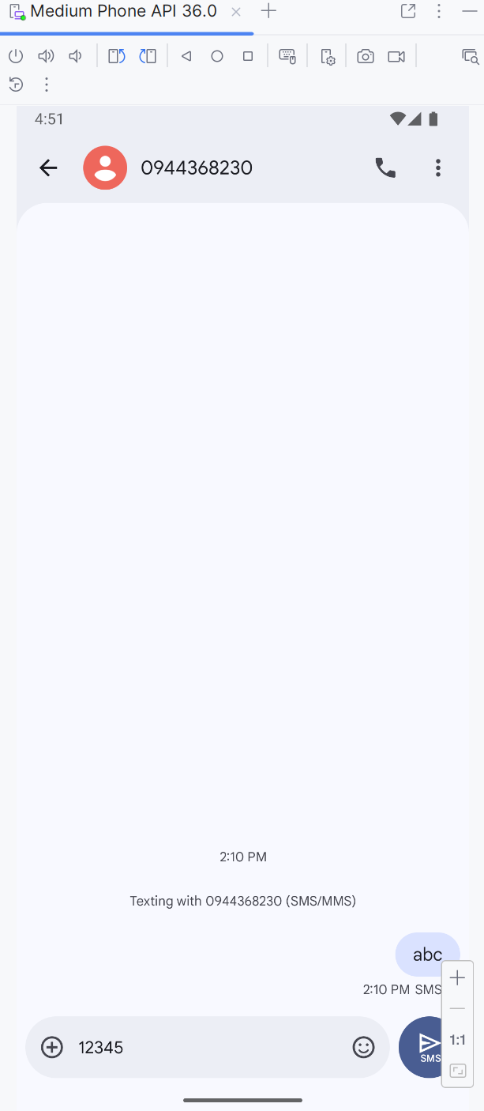

Activity_bai_tap3_lab1.xml
<?xml version="1.0" encoding="utf-8"?>
<LinearLayout xmlns:android="http://schemas.android.com/apk/res/android"
xmlns:tools="http://schemas.android.com/tools"
android:layout_width="match_parent"
android:layout_height="match_parent"
android:orientation="vertical"
android:gravity="center"
android:padding="24dp"
tools:context=".Lab1.BaiTap3Lab1Activity">
<EditText
android:id="@+id/edtPhone"
android:layout_width="match_parent"
android:layout_height="wrap_content"
android:hint="Nhập số điện thoại"
android:inputType="phone"
android:layout_marginBottom="16dp"
android:padding="12dp"
android:background="#F5F5F5" />
<EditText
android:id="@+id/edtMessage"
android:layout_width="match_parent"
android:layout_height="wrap_content"
android:hint="Nhập nội dung tin nhắn"
android:inputType="textMultiLine"
android:minLines="2"
android:layout_marginBottom="24dp"
android:padding="12dp"
android:background="#F5F5F5" />
<Button
android:id="@+id/btnCall"
android:layout_width="match_parent"
android:layout_height="wrap_content"
android:text="📞 GỌI ĐIỆN"
android:textColor="#FFFFFF"
android:background="#4CAF50"
android:padding="12dp"
android:layout_marginBottom="12dp" />
<Button
android:id="@+id/btnSms"
android:layout_width="match_parent"
android:layout_height="wrap_content"
android:text="💬 GỬI TIN NHẮN"
android:textColor="#FFFFFF"
android:background="#2196F3"
android:padding="12dp" />
</LinearLayout>

BaiTap3Lab1Activity
package com.example.myapplication.Lab1;
import android.content.Intent;
import android.net.Uri;
import android.os.Bundle;
import android.widget.Button;
import android.widget.EditText;
import android.widget.Toast;
import androidx.activity.EdgeToEdge;
import androidx.appcompat.app.AppCompatActivity;
import androidx.core.graphics.Insets;
import androidx.core.view.ViewCompat;
import androidx.core.view.WindowInsetsCompat;
import com.example.myapplication.R;
public class BaiTap3Lab1Activity extends AppCompatActivity {
EditText edtPhone, edtMessage;
Button btnCall, btnSms;
@Override
protected void onCreate(Bundle savedInstanceState) {
super.onCreate(savedInstanceState);
EdgeToEdge.enable(this);
setContentView(R.layout.activity_bai_tap3_lab1);
edtPhone = findViewById(R.id.edtPhone);
edtMessage = findViewById(R.id.edtMessage);
btnCall = findViewById(R.id.btnCall);
btnSms = findViewById(R.id.btnSms);
// GỌI ĐIỆN
btnCall.setOnClickListener(v -> {
String phone = edtPhone.getText().toString().trim();
if (phone.isEmpty()) {
Toast.makeText(this, "Vui lòng nhập số điện thoại!", Toast.LENGTH_SHORT).show();
return;
}
// Sử dụng ACTION_DIAL để mở app gọi (không cần quyền CALL_PHONE)
Intent intent = new Intent(Intent.ACTION_DIAL, Uri.parse("tel:" + phone));
startActivity(intent);
});
// GỬI TIN NHẮN
btnSms.setOnClickListener(v -> {
String phone = edtPhone.getText().toString().trim();
String message = edtMessage.getText().toString().trim();
if (phone.isEmpty() || message.isEmpty()) {
Toast.makeText(this, "Vui lòng nhập số điện thoại và nội dung!", Toast.LENGTH_SHORT).show();
return;
}
// ACTION_SENDTO với Uri "smsto:"
Intent intent = new Intent(Intent.ACTION_SENDTO);
intent.setData(Uri.parse("smsto:" + phone));
intent.putExtra("sms_body", message);
startActivity(intent);
});
}
}

Lab 2
Bài tập 1
Giao diện
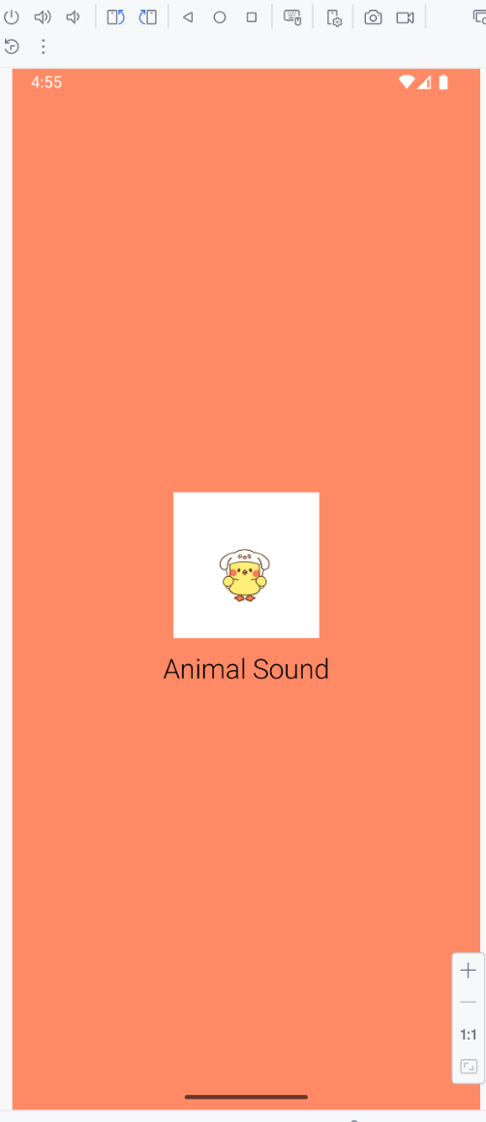 | 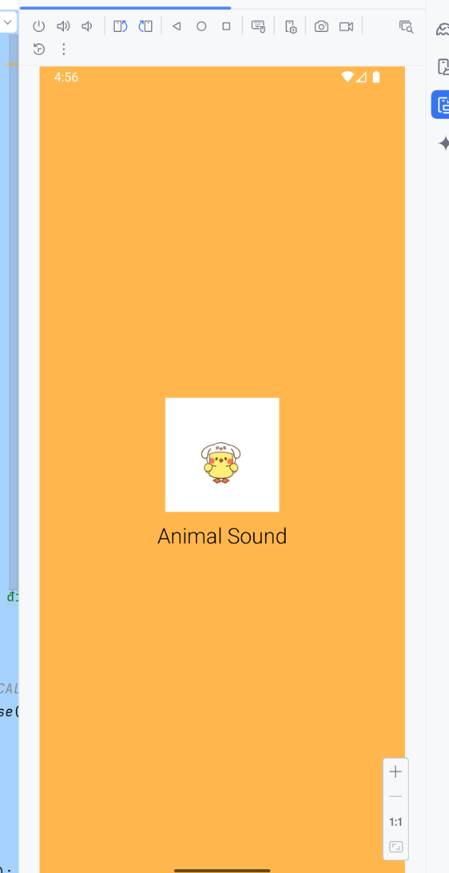
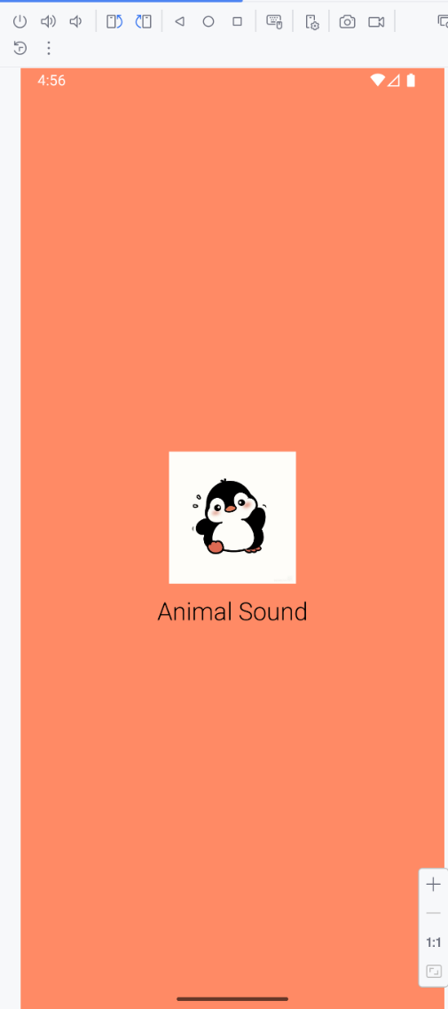 | 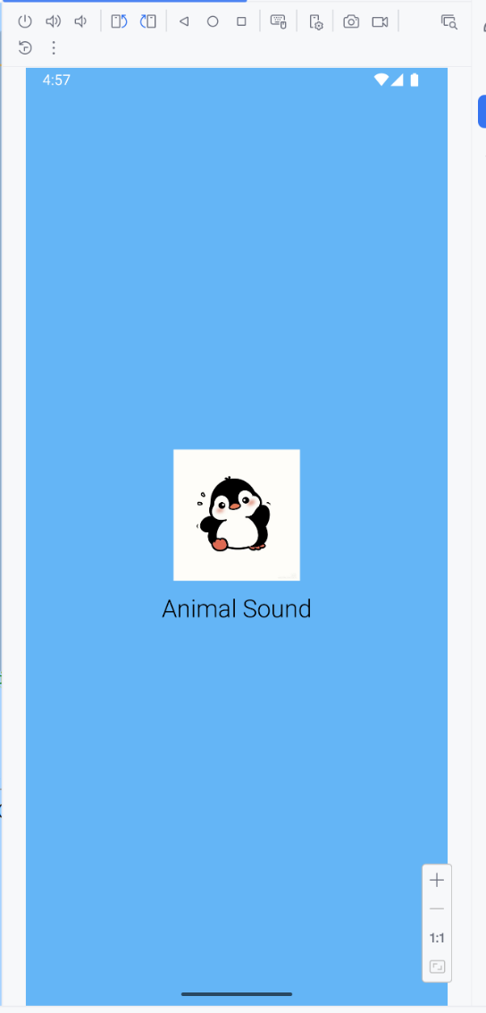
Activity_bai_tap1_lab2.xml
<?xml version="1.0" encoding="utf-8"?>
<LinearLayout xmlns:android="http://schemas.android.com/apk/res/android"
xmlns:tools="http://schemas.android.com/tools"
android:layout_width="match_parent"
android:layout_height="match_parent"
android:background="@color/white"
android:id="@+id/mainLayout"
android:gravity="center"
android:orientation="vertical"
tools:context=".Lab2.BaiTap1Lab2Activity">
<ImageView
android:id="@+id/imgIcon"
android:layout_width="128dp"
android:layout_height="128dp"
android:src="@drawable/img_canh_cut"
tools:ignore="ContentDescription" />
<TextView
android:layout_width="wrap_content"
android:layout_height="wrap_content"
android:layout_marginTop="10dp"
android:fontFamily="sans-serif-light"
android:text="@string/app_name"
android:textColor="@color/black"
android:textSize="24sp" />
</LinearLayout>

Vị trí ảnh sử dụng
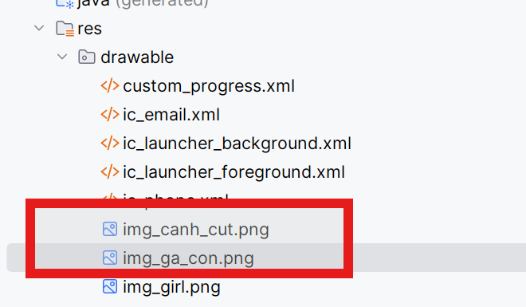
BaiTap1Lab2Activity
package com.example.myapplication.Lab2;
import android.os.Bundle;
import android.widget.ImageView;
import android.widget.LinearLayout;
import androidx.appcompat.app.AppCompatActivity;
import com.example.myapplication.R;
import java.util.Random;
public class BaiTap1Lab2Activity extends AppCompatActivity {
LinearLayout mainLayout;
ImageView imgIcon;
@Override
protected void onCreate(Bundle savedInstanceState) {
super.onCreate(savedInstanceState);
setContentView(R.layout.activity_bai_tap1_lab2);
mainLayout = findViewById(R.id.mainLayout);
imgIcon = findViewById(R.id.imgIcon);
// Mảng màu nền
int[] colors = {
0xFFE57373, // đỏ nhạt
0xFF81C784, // xanh lá
0xFF64B5F6, // xanh dương
0xFFFFB74D, // cam
0xFFBA68C8, // tím
0xFFFF8A65 // cam đất
};
// Mảng icon (đặt ảnh trong res/drawable)
int[] icons = {
R.drawable.img_ga_con,
R.drawable.img_canh_cut,
};
Random random = new Random();
int colorIndex = random.nextInt(colors.length);
int iconIndex = random.nextInt(icons.length);
// Đổi màu nền & icon
mainLayout.setBackgroundColor(colors[colorIndex]);
imgIcon.setImageResource(icons[iconIndex]);
}
}

Bài tập 2 + Bài tập 3
Giao diện
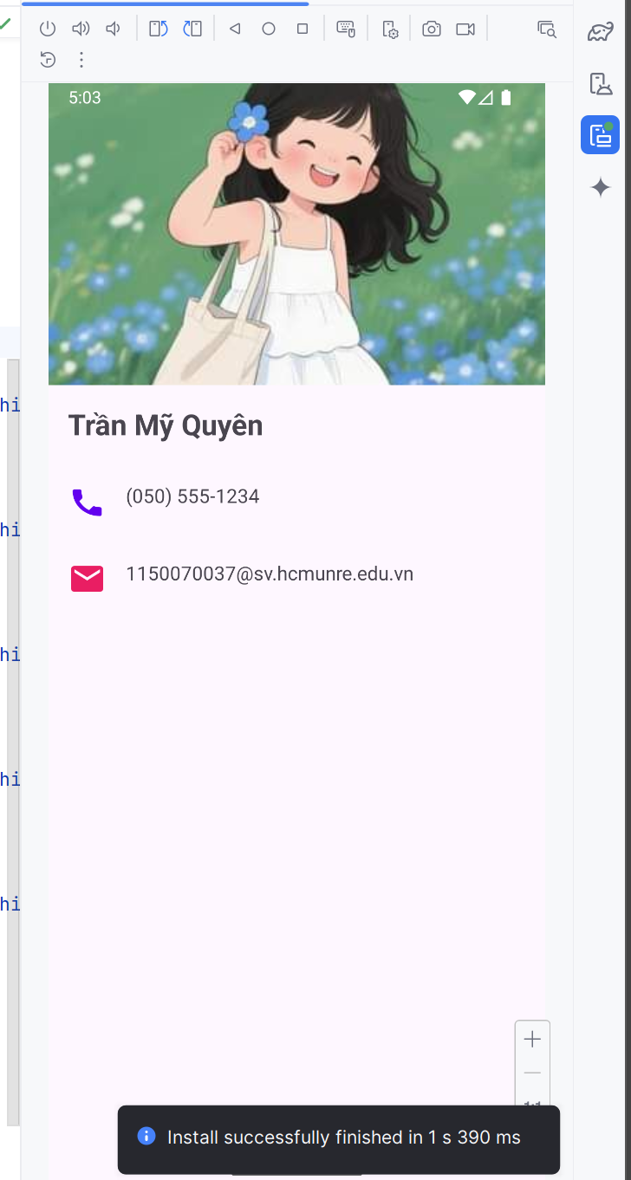 | 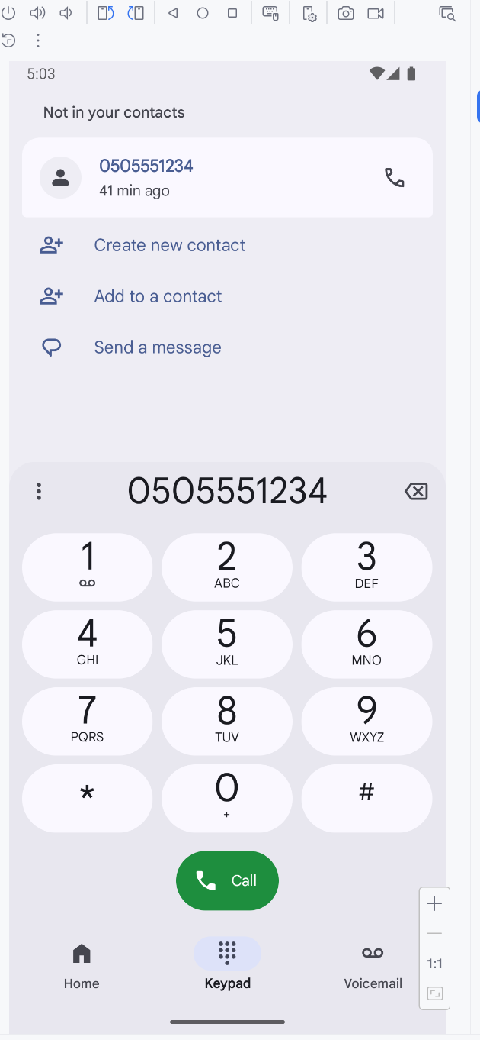

Activity_bai_tap2_lab2.xml
<?xml version="1.0" encoding="utf-8"?>
<FrameLayout xmlns:android="http://schemas.android.com/apk/res/android"
xmlns:app="http://schemas.android.com/apk/res-auto"
xmlns:tools="http://schemas.android.com/tools"
android:layout_width="match_parent"
android:layout_height="match_parent"
tools:context=".Lab2.BaiTap2Lab2Activity">
<!-- Custom ProgressBar (hiển thị khi đang tải) -->
<ProgressBar
android:id="@+id/progressBar"
style="?android:attr/progressBarStyleLarge"
android:layout_width="100dp"
android:layout_height="100dp"
android:layout_gravity="center"
android:indeterminateDrawable="@drawable/custom_progress"
android:visibility="visible" />
<!-- Nội dung chính -->
<ScrollView
android:id="@+id/contentLayout"
android:layout_width="match_parent"
android:layout_height="match_parent"
android:visibility="gone">
<LinearLayout
android:layout_width="match_parent"
android:layout_height="wrap_content"
android:orientation="vertical">
<ImageView
android:id="@+id/profileImage"
android:layout_width="match_parent"
android:layout_height="250dp"
android:scaleType="centerCrop"
android:src="@drawable/img_girl" />
<TextView
android:id="@+id/profileName"
android:layout_width="wrap_content"
android:layout_height="wrap_content"
android:text="Trần Mỹ Quyên"
android:textSize="24sp"
android:textStyle="bold"
android:layout_margin="16dp" />
<!-- Thông tin liên hệ -->
<LinearLayout
android:layout_width="match_parent"
android:layout_height="wrap_content"
android:orientation="horizontal"
android:padding="16dp">
<ImageView
android:id="@+id/imgPhone"
android:layout_width="32dp"
android:layout_height="32dp"
android:src="@drawable/ic_phone"
android:layout_marginEnd="16dp"
app:tint="#6200EE" />
<TextView
android:layout_width="wrap_content"
android:layout_height="wrap_content"
android:text="(050) 555-1234"
android:textSize="16sp" />
</LinearLayout>
<LinearLayout
android:layout_width="match_parent"
android:layout_height="wrap_content"
android:orientation="horizontal"
android:padding="16dp">
<ImageView
android:layout_width="32dp"
android:layout_height="32dp"
android:src="@drawable/ic_email"
android:layout_marginEnd="16dp"
app:tint="#E91E63" />
<TextView
android:layout_width="wrap_content"
android:layout_height="wrap_content"
android:text="1150070037@sv.hcmunre.edu.vn"
android:textSize="16sp" />
</LinearLayout>
</LinearLayout>
</ScrollView>
</FrameLayout>

Các file xml đã sử dụng
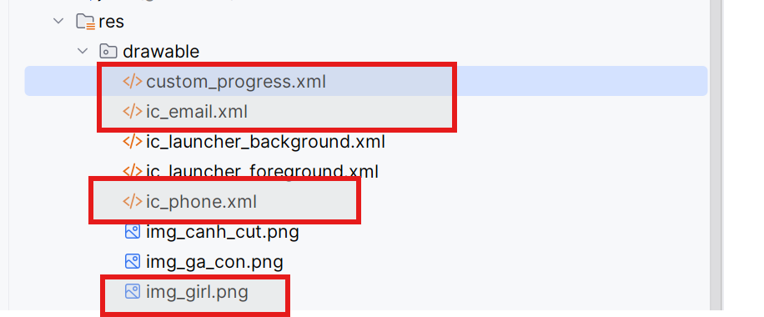
BaiTap2Lab2Activity
package com.example.myapplication.Lab2;
import androidx.appcompat.app.AppCompatActivity;
import android.os.Bundle;
import android.content.Intent;
import android.net.Uri;
import android.view.View;
import android.widget.ImageView;
import android.widget.ProgressBar;
import android.widget.ScrollView;
import android.os.Handler;
import com.example.myapplication.R;
public class BaiTap2Lab2Activity extends AppCompatActivity {
private ProgressBar progressBar;
private ScrollView contentLayout;
private ImageView imgPhone;
@Override
protected void onCreate(Bundle savedInstanceState) {
super.onCreate(savedInstanceState);
setContentView(R.layout.activity_bai_tap2_lab2);
// Ánh xạ view
progressBar = findViewById(R.id.progressBar);
contentLayout = findViewById(R.id.contentLayout);
imgPhone = findViewById(R.id.imgPhone);
// Hiển thị hiệu ứng tải
new Handler().postDelayed(() -> {
progressBar.setVisibility(View.GONE);
contentLayout.setVisibility(View.VISIBLE);
}, 2000);
// Khi bấm vào icon điện thoại → mở ứng dụng gọi
imgPhone.setOnClickListener(v -> {
String phoneNumber = "(050)5551234"; // bạn có thể đổi số này tùy ý
Intent intent = new Intent(Intent.ACTION_DIAL);
intent.setData(Uri.parse("tel:" + phoneNumber));
// chạy Intent gọi điện
startActivity(intent);
});
}
}

