Số máy: 08

Bước 1: Tạo thêm nút chuyển cho buổi 2 trong MainActivity
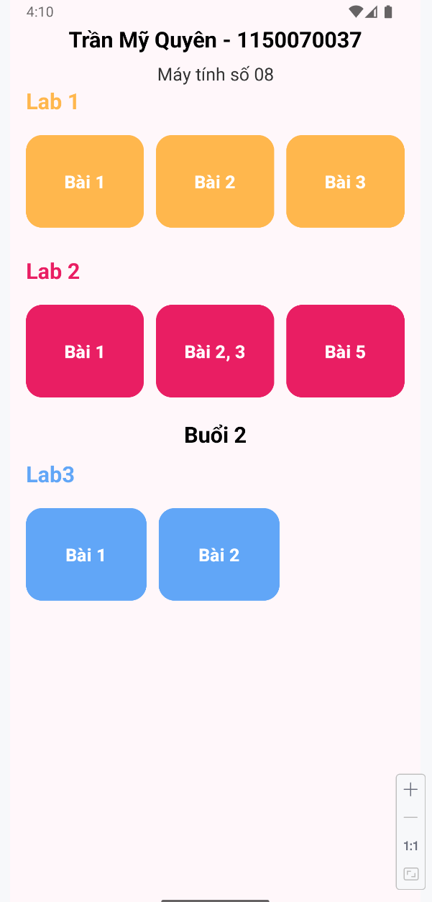
Code MainActivity.java
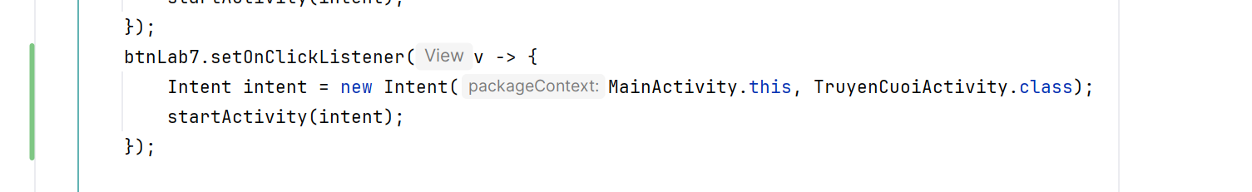
Code bổ sung trong activity_main.xml
<!-- Lab 3 -->
<TextView
android:layout_width="match_parent"
android:layout_height="wrap_content"
android:text="Buổi 2"
android:gravity="center"
android:textSize="22sp"
android:textStyle="bold"
android:textColor="@color/black"
android:layout_marginTop="10dp"
android:layout_marginBottom="10dp" />
<TextView
android:layout_width="wrap_content"
android:layout_height="wrap_content"
android:text="Lab3"
android:textSize="22sp"
android:textStyle="bold"
android:textColor="#61A6F7"
android:layout_marginBottom="16dp" />
<LinearLayout
android:layout_width="match_parent"
android:layout_height="wrap_content"
android:orientation="horizontal"
android:weightSum="3"
android:layout_marginBottom="8dp">
<Button
android:id="@+id/btnLab7"
android:layout_width="0dp"
android:layout_height="100dp"
android:layout_weight="1"
android:layout_marginEnd="8dp"
android:text="Bài 1"
android:textSize="18sp"
android:textStyle="bold"
android:backgroundTint="#61A6F7"
app:cornerRadius="16dp" />
<Button
android:id="@+id/btnLab8"
android:layout_width="0dp"
android:layout_height="100dp"
android:layout_weight="1"
android:layout_marginHorizontal="4dp"
android:text="Bài 2"
android:textSize="18sp"
android:textStyle="bold"
android:backgroundTint="#61A6F7"
app:cornerRadius="16dp" />
</LinearLayout>
</LinearLayout>

Bước 2: Chuẩn bị tài nguyên drawable, string, themes, colors
- Drawable bao gồm:
- ic_splash: ảnh giao diện màn hình
- Ic_back: kí hiệu quay lại
- 3 hình ảnh đại diện cho 3 chủ đề truyện: cachcach.png, chuchovuinhon.png, meorauria.png
- String
<resources>
<!-- Buổi 1-->
<string name="app_name">Animal Sound</string>
<string name="loading">Loading</string>
<!-- Buổi 2-->
<string name="app_name_lap3">TruyenCuoi</string>
<string name="txt_congai">Con gái</string>
<string name="txt_story">Vừa đúng vừa sai</string>
</resources>

- Themes
<resources xmlns:tools="http://schemas.android.com/tools">
<!-- Base theme -->
<style name="Base.Theme.MyApplication" parent="Theme.Material3.DayNight.NoActionBar">
<!-- Primary brand color -->
<item name="colorPrimary">@color/purple_500</item>
<item name="colorPrimaryVariant">@color/purple_700</item>
<item name="colorOnPrimary">@color/white</item>
<!-- Secondary brand color -->
<item name="colorSecondary">@color/teal_200</item>
<item name="colorSecondaryVariant">@color/teal_700</item>
<item name="colorOnSecondary">@color/black</item>
<!-- Status bar color -->
<item name="android:statusBarColor" tools:targetApi="l">?attr/colorPrimaryVariant</item>
<!-- Customize your theme here -->
</style>
<style name="Theme.MyApplication" parent="Base.Theme.MyApplication" />
<style name="Full_Screen" parent="Theme.MaterialComponents.DayNight.NoActionBar" />
</resources>

- Colors
<?xml version="1.0" encoding="utf-8"?>
<resources>
<color name="black">#FF000000</color>
<color name="white">#FFFFFFFF</color>
<color name="purple_200">#FFBB86FC</color>
<color name="purple_500">#FF6200EE</color>
<color name="purple_700">#FF3700B3</color>
<color name="teal_200">#FF03DAC5</color>
<color name="teal_700">#FF018786</color>
<color name="greenMid">#478942</color>
<color name="greenLight">#62BC5B</color>
<color name="greenSuperLight">#EFFFEE</color>
</resources>

Bước 3: Tạo file res/layout/m000_frg_splash.xml
<?xml version="1.0" encoding="utf-8"?>
<FrameLayout xmlns:android="http://schemas.android.com/apk/res/android"
xmlns:tools="http://schemas.android.com/tools"
android:layout_width="match_parent"
android:layout_height="match_parent"
android:background="@color/greenMid">
<ImageView
android:layout_width="200dp"
android:layout_height="100dp"
android:layout_gravity="center"
android:src="@drawable/ic_splash"
tools:ignore="ContentDescription"/>
</FrameLayout>

Bước 4 Tạo file res/layout/activity_truyen_cuoi.xml
<?xml version="1.0" encoding="utf-8"?>
<LinearLayout xmlns:android="http://schemas.android.com/apk/res/android"
xmlns:tools="http://schemas.android.com/tools"
android:layout_width="match_parent"
android:layout_height="match_parent"
android:id="@+id/ln_main"
tools:context=".Lab3.TruyenCuoiActivity"
android:orientation="horizontal">
</LinearLayout>

Bước 5: Xây dựng giao diện màn hình m000_frg_splash được quản lý bởi M000SplashFrg
package com.example.myapplication.Lab3;
import android.os.Bundle;
import android.os.Handler;
import android.view.LayoutInflater;
import android.view.View;
import android.view.ViewGroup;
import androidx.fragment.app.Fragment;
import com.example.myapplication.MainActivity;
import com.example.myapplication.R;
public class M000SplashFrg extends Fragment {
@Override
public View onCreateView(LayoutInflater inflater, ViewGroup container, Bundle savedInstanceState) {
initViews();
return inflater.inflate(R.layout.m000_frg_splash, container, false);
}
private void initViews() {
new Handler().postDelayed(this::gotoM001Screen, 2000);
}
private void gotoM001Screen() {
((TruyenCuoiActivity) getActivity()).gotoM001Screen();
}
}

Bước 6: Xây dựng giao diện màn hình activity_truyen_cuoi được quản lý bởi TruyenCuoiActivity
package com.example.myapplication.Lab3;
import android.os.Bundle;
import androidx.activity.EdgeToEdge;
import androidx.appcompat.app.AppCompatActivity;
import androidx.fragment.app.Fragment;
import com.example.myapplication.R;
public class TruyenCuoiActivity extends AppCompatActivity {
private String topicName;
@Override
protected void onCreate(Bundle savedInstanceState) {
super.onCreate(savedInstanceState);
EdgeToEdge.enable(this);
setContentView(R.layout.activity_truyen_cuoi);
showFrg(new M000SplashFrg());
}
void showFrg(Fragment frg) {
getSupportFragmentManager()
.beginTransaction()
.replace(R.id.ln_main, frg, null)
.commit();
}
public void gotoM001Screen() {
showFrg(new M001ScreenChuDe());
}
public void gotoM002Screen(String topicName) {
this.topicName = topicName;
Bundle bundle = new Bundle();
bundle.putString("TOPIC_NAME", topicName);
M002ScreenDanhSachTruyen frg = new M002ScreenDanhSachTruyen();
frg.setArguments(bundle);
showFrg(frg);
}
public void gotoM003Screen(Bundle bundle) {
M003ScreenDocTruyen frg = new M003ScreenDocTruyen();
frg.setArguments(bundle);
showFrg(frg);
}
public void backToM001Screen() {
gotoM001Screen();
}
public void backToM002Screen() {
if (topicName != null) {
gotoM002Screen(topicName);
} else {
gotoM001Screen();
}
}
}

Kết quả:
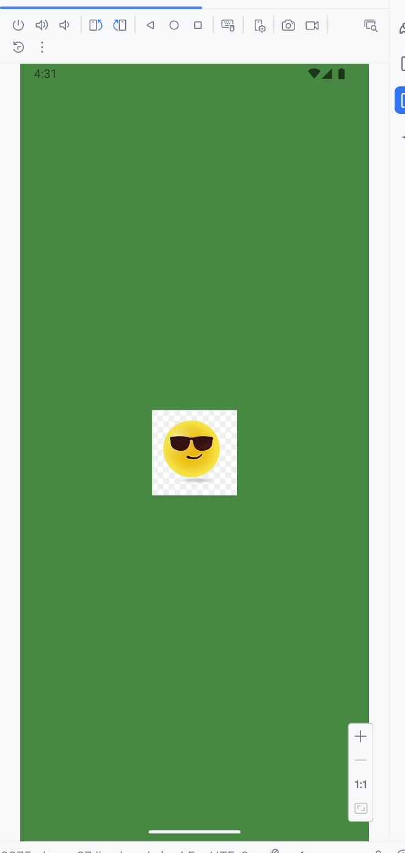
Bước 7: Xây dựng giao diện Chủ đề truyện cười và xử lý cho phép xoay màn hình
activity_m001_screen_chu_de.xml
<?xml version="1.0" encoding="utf-8"?>
<LinearLayout xmlns:android="http://schemas.android.com/apk/res/android"
xmlns:app="http://schemas.android.com/apk/res-auto"
xmlns:tools="http://schemas.android.com/tools"
android:layout_width="match_parent"
android:layout_height="match_parent"
android:orientation="vertical"
android:background="@color/greenSuperLight"
tools:context=".Lab3.M001ScreenChuDe">
<LinearLayout
android:layout_width="match_parent"
android:layout_height="56dp"
android:orientation="horizontal"
android:gravity="center_vertical"
android:background="@color/greenMid"
android:paddingStart="8dp"
android:layout_marginTop="20dp"
android:paddingEnd="8dp"
android:elevation="4dp">
<ImageView
android:id="@+id/imgBack"
android:layout_width="32dp"
android:layout_height="32dp"
android:src="@drawable/ic_back"
app:tint="@color/white" />
<TextView
android:id="@+id/tvTitle"
android:layout_width="0dp"
android:layout_height="wrap_content"
android:layout_weight="1"
android:text="Truyện cười 😁😜😋😍"
android:textColor="@color/white"
android:textSize="20sp"
android:textStyle="bold"
android:gravity="center" />
<Switch
android:id="@+id/switchRotate"
android:layout_width="wrap_content"
android:layout_height="wrap_content"
android:text="Xoay"
android:textColor="@color/white"
android:checked="true" />
</LinearLayout>
<androidx.recyclerview.widget.RecyclerView
android:id="@+id/rvTopics"
android:layout_width="match_parent"
android:layout_height="match_parent"
android:padding="8dp"
android:scrollbars="vertical" />
</LinearLayout>

Item_chu_de.xml
<?xml version="1.0" encoding="utf-8"?>
<LinearLayout xmlns:android="http://schemas.android.com/apk/res/android"
android:layout_width="match_parent"
android:layout_height="wrap_content"
android:orientation="horizontal"
android:padding="8dp"
android:background="@color/white"
android:layout_marginVertical="4dp"
android:layout_marginHorizontal="8dp"
android:elevation="2dp"
android:gravity="center_vertical"
android:clipToOutline="true"
android:backgroundTint="@color/greenMid"
android:foreground="?attr/selectableItemBackground">
<ImageView
android:id="@+id/imgTopic"
android:layout_width="90dp"
android:layout_height="70dp"
android:layout_marginEnd="10dp"
android:scaleType="centerCrop"
android:src="@drawable/ic_launcher_background"
android:background="@android:color/white"
android:contentDescription="@string/app_name" />
<TextView
android:id="@+id/tvTopicName"
android:layout_width="0dp"
android:layout_height="wrap_content"
android:layout_weight="1"
android:text="Công sở"
android:textSize="20sp"
android:textColor="@color/black"
android:textStyle="bold" />
</LinearLayout>

Bước 8: Tạo Adapter cho chủ đề
ChuDeAdapter.xml
package com.example.myapplication.Lab3;
import android.view.LayoutInflater;
import android.view.View;
import android.view.ViewGroup;
import android.widget.ImageView;
import android.widget.TextView;
import androidx.annotation.NonNull;
import androidx.recyclerview.widget.RecyclerView;
import com.example.myapplication.R;
public class ChuDeAdapter extends RecyclerView.Adapter<ChuDeAdapter.ChuDeViewHolder> {
private String[] topicNames;
private int[] topicImages;
private OnTopicClickListener listener;
public interface OnTopicClickListener {
void onTopicClick(int position);
}
public ChuDeAdapter(String[] topicNames, int[] topicImages, OnTopicClickListener listener) {
this.topicNames = topicNames;
this.topicImages = topicImages;
this.listener = listener;
}
@NonNull
@Override
public ChuDeViewHolder onCreateViewHolder(@NonNull ViewGroup parent, int viewType) {
View view = LayoutInflater.from(parent.getContext())
.inflate(R.layout.item_chu_de, parent, false);
return new ChuDeViewHolder(view);
}
@Override
public void onBindViewHolder(@NonNull ChuDeViewHolder holder, int position) {
holder.tvTopicName.setText(topicNames[position]);
holder.imgTopic.setImageResource(topicImages[position]);
holder.itemView.setOnClickListener(v -> {
if (listener != null) listener.onTopicClick(position);
});
}
@Override
public int getItemCount() {
return topicNames.length;
}
static class ChuDeViewHolder extends RecyclerView.ViewHolder {
ImageView imgTopic;
TextView tvTopicName;
ChuDeViewHolder(@NonNull View itemView) {
super(itemView);
imgTopic = itemView.findViewById(R.id.imgTopic);
tvTopicName = itemView.findViewById(R.id.tvTopicName);
}
}
}

Bước 9: Xử lý M001ScreenChuDe.java
package com.example.myapplication.Lab3;
import android.content.Intent;
import android.content.pm.ActivityInfo;
import android.os.Bundle;
import android.view.LayoutInflater;
import android.view.View;
import android.view.ViewGroup;
import android.widget.ImageView;
import android.widget.Switch;
import androidx.annotation.NonNull;
import androidx.annotation.Nullable;
import androidx.fragment.app.Fragment;
import androidx.recyclerview.widget.LinearLayoutManager;
import androidx.recyclerview.widget.RecyclerView;
import com.example.myapplication.MainActivity;
import com.example.myapplication.R;
public class M001ScreenChuDe extends Fragment {
@Nullable
@Override
public View onCreateView(@NonNull LayoutInflater inflater,
@Nullable ViewGroup container,
@Nullable Bundle savedInstanceState) {
View view = inflater.inflate(R.layout.activity_m001_screen_chu_de, container, false);
ImageView imgBack = view.findViewById(R.id.imgBack);
Switch switchRotate = view.findViewById(R.id.switchRotate);
RecyclerView rvTopics = view.findViewById(R.id.rvTopics);
rvTopics.setLayoutManager(new LinearLayoutManager(getContext()));
imgBack.setOnClickListener(v -> {
Intent intent = new Intent(getActivity(), MainActivity.class);
startActivity(intent);
getActivity().finish();
});
switchRotate.setOnCheckedChangeListener((buttonView, isChecked) -> {
if (isChecked) {
getActivity().setRequestedOrientation(ActivityInfo.SCREEN_ORIENTATION_UNSPECIFIED);
} else {
getActivity().setRequestedOrientation(ActivityInfo.SCREEN_ORIENTATION_PORTRAIT);
}
});
String[] topicNames = {"Chú chó vui nhộn", "Cách cách", "Mèo râu ria"};
int[] topicImages = {R.drawable.chuchovuinhon, R.drawable.cachcach, R.drawable.meorauria};
ChuDeAdapter adapter = new ChuDeAdapter(topicNames, topicImages, position -> {
String selectedTopic = topicNames[position];
((TruyenCuoiActivity) getActivity()).gotoM002Screen(selectedTopic);
});
rvTopics.setAdapter(adapter);
return view;
}
}

Kêt quả:
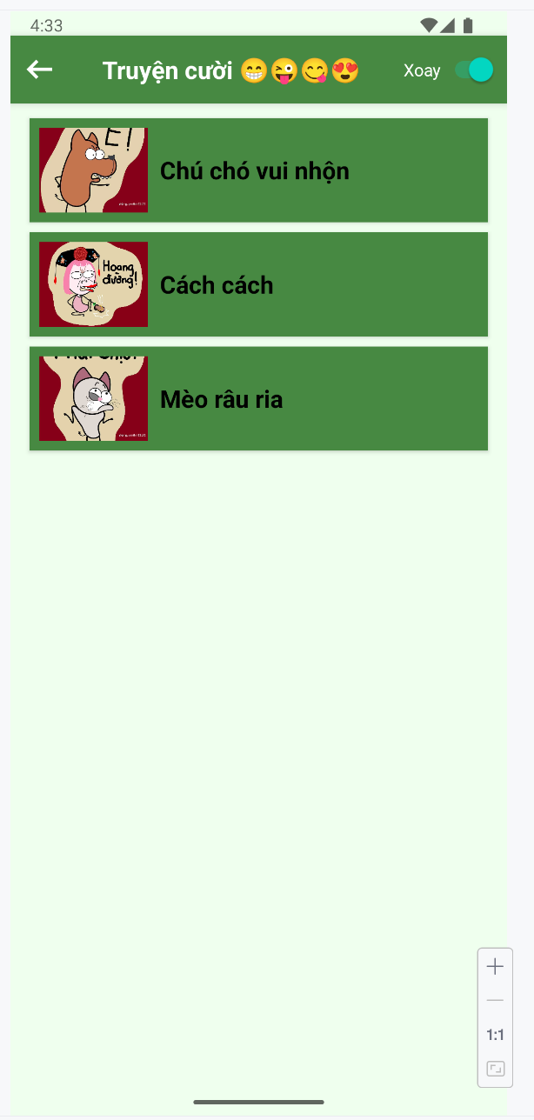

Bước 10: Tạo truyện theo chủ đề
TẠO GIAO DIỆN
activity_m002_screen_danh_sach_truyen.xml
<?xml version="1.0" encoding="utf-8"?>
<LinearLayout xmlns:android="http://schemas.android.com/apk/res/android"
xmlns:app="http://schemas.android.com/apk/res-auto"
xmlns:tools="http://schemas.android.com/tools"
android:layout_width="match_parent"
android:layout_height="match_parent"
android:orientation="vertical"
android:background="@color/greenSuperLight"
tools:context=".Lab3.M002ScreenDanhSachTruyen">
<LinearLayout
android:layout_width="match_parent"
android:layout_height="56dp"
android:orientation="horizontal"
android:gravity="center_vertical"
android:layout_marginTop="20dp"
android:background="@color/greenMid"
android:elevation="4dp">
<ImageView
android:id="@+id/imgBack"
android:layout_width="24dp"
android:layout_height="24dp"
android:layout_marginStart="16dp"
android:src="@drawable/ic_back"
android:contentDescription="@string/app_name"
app:tint="@color/white" />
<TextView
android:id="@+id/tvTopicTitle"
android:layout_width="wrap_content"
android:layout_height="wrap_content"
android:layout_marginStart="12dp"
android:text="Tên chủ đề"
android:textColor="@color/white"
android:textSize="22sp"
android:textStyle="bold" />
</LinearLayout>
<androidx.recyclerview.widget.RecyclerView
android:id="@+id/rvStories"
android:layout_width="match_parent"
android:layout_height="match_parent"
android:padding="8dp"
android:scrollbars="vertical"
tools:listitem="@layout/item_danh_sach_truyen" />
</LinearLayout>

item_danh_sach_truyen.xml
<?xml version="1.0" encoding="utf-8"?>
<LinearLayout xmlns:android="http://schemas.android.com/apk/res/android"
xmlns:app="http://schemas.android.com/apk/res-auto"
android:layout_width="match_parent"
android:layout_height="wrap_content"
android:orientation="horizontal"
android:paddingVertical="10dp"
android:paddingHorizontal="16dp"
android:gravity="center_vertical"
android:background="?attr/selectableItemBackground">
<ImageView
android:id="@+id/imgStoryIcon"
android:layout_width="24dp"
android:layout_height="24dp"
android:layout_marginEnd="16dp"
android:src="@drawable/ic_smile"
android:contentDescription="@string/app_name"
app:tint="@color/greenMid" />
<TextView
android:id="@+id/tvStoryTitle"
android:layout_width="0dp"
android:layout_height="wrap_content"
android:layout_weight="1"
android:text="Tên truyện"
android:textColor="@color/black"
android:textSize="18sp" />
</LinearLayout>

Bước 11 :Tạo StoryAdapter
package com.example.myapplication.Lab3;
import android.view.LayoutInflater;
import android.view.View;
import android.view.ViewGroup;
import android.widget.ImageView;
import android.widget.TextView;
import androidx.annotation.NonNull;
import androidx.recyclerview.widget.RecyclerView;
import com.example.myapplication.R;
public class StoryAdapter extends RecyclerView.Adapter<StoryAdapter.StoryViewHolder> {
private String[] stories;
private OnItemClickListener listener;
public interface OnItemClickListener {
void onItemClick(int position);
}
public StoryAdapter(String[] stories, OnItemClickListener listener) {
this.stories = stories;
this.listener = listener;
}
@NonNull
@Override
public StoryViewHolder onCreateViewHolder(@NonNull ViewGroup parent, int viewType) {
View view = LayoutInflater.from(parent.getContext())
.inflate(R.layout.item_danh_sach_truyen, parent, false);
return new StoryViewHolder(view);
}
@Override
public void onBindViewHolder(@NonNull StoryViewHolder holder, int position) {
holder.tvStoryTitle.setText(stories[position]);
holder.itemView.setOnClickListener(v -> listener.onItemClick(position));
}
@Override
public int getItemCount() {
return stories.length;
}
static class StoryViewHolder extends RecyclerView.ViewHolder {
TextView tvStoryTitle;
ImageView imgStoryIcon;
StoryViewHolder(@NonNull View itemView) {
super(itemView);
tvStoryTitle = itemView.findViewById(R.id.tvStoryTitle);
imgStoryIcon = itemView.findViewById(R.id.imgStoryIcon);
}
}
}

Bước 12: Xử lý trong M002ScreenDanhSachTruyen.java
package com.example.myapplication.Lab3;
import android.os.Bundle;
import android.view.LayoutInflater;
import android.view.View;
import android.view.ViewGroup;
import android.widget.ImageView;
import android.widget.TextView;
import androidx.annotation.NonNull;
import androidx.annotation.Nullable;
import androidx.fragment.app.Fragment;
import androidx.recyclerview.widget.LinearLayoutManager;
import androidx.recyclerview.widget.RecyclerView;
import com.example.myapplication.R;
public class M002ScreenDanhSachTruyen extends Fragment {
@Nullable
@Override
public View onCreateView(@NonNull LayoutInflater inflater,
@Nullable ViewGroup container,
@Nullable Bundle savedInstanceState) {
View view = inflater.inflate(R.layout.activity_m002_screen_danh_sach_truyen, container, false);
RecyclerView rvStories = view.findViewById(R.id.rvStories);
ImageView imgBack = view.findViewById(R.id.imgBack);
TextView tvTopicTitle = view.findViewById(R.id.tvTopicTitle);
rvStories.setLayoutManager(new LinearLayoutManager(getContext()));
String topicName = getArguments() != null ? getArguments().getString("TOPIC_NAME") : "";
tvTopicTitle.setText(topicName);
imgBack.setOnClickListener(v -> {
((TruyenCuoiActivity) getActivity()).backToM001Screen();
});
String[] stories;
String[] storyContents;
switch (topicName) {
case "Chú chó vui nhộn":
stories = new String[]{"Cún con thông minh", "Cún lười học", "Cún và mèo"};
storyContents = new String[]{
"Lúc bé, nghĩ học là chuyện lạ. Lớn lên mới biết, học là cực hình.",
"Cún lười học nên bị mèo trêu suốt, cuối cùng lại giỏi nhất lớp.",
"Cún và mèo luôn cãi nhau, nhưng cuối cùng lại là bạn tốt."
};
break;
case "Cách cách":
stories = new String[]{"Cách cư xử lạ", "Bí mật Cách cách", "Cách cách đi học"};
storyContents = new String[]{
"Cách cách cư xử khiến ai cũng bất ngờ.",
"Bí mật của Cách cách là gì? Hãy cùng khám phá.",
"Cách cách đi học, cả lớp cười nghiêng ngả."
};
break;
case "Mèo râu ria":
stories = new String[]{"Mèo bắt cá", "Mèo nghịch ngợm", "Râu ria dài"};
storyContents = new String[]{
"Mèo bắt cá nhưng lại sợ ướt chân.",
"Mèo nghịch ngợm khiến cả nhà rối tung.",
"Râu ria dài giúp mèo luôn tự tin!"
};
break;
default:
stories = new String[]{"Không có truyện nào"};
storyContents = new String[]{"Không có nội dung"};
}
// Khởi tạo Adapter và xử lý khi click vào 1 truyện
StoryAdapter adapter = new StoryAdapter(stories, position -> {
Bundle bundle = new Bundle();
bundle.putString("TOPIC_NAME", topicName);
bundle.putInt("STORY_INDEX", position);
bundle.putStringArray("STORY_TITLES", stories);
bundle.putStringArray("STORY_CONTENTS", storyContents);
M003ScreenDocTruyen frg = new M003ScreenDocTruyen();
frg.setArguments(bundle);
((TruyenCuoiActivity) getActivity()).showFrg(frg);
});
rvStories.setAdapter(adapter);
return view;
}
}

Kết quả:
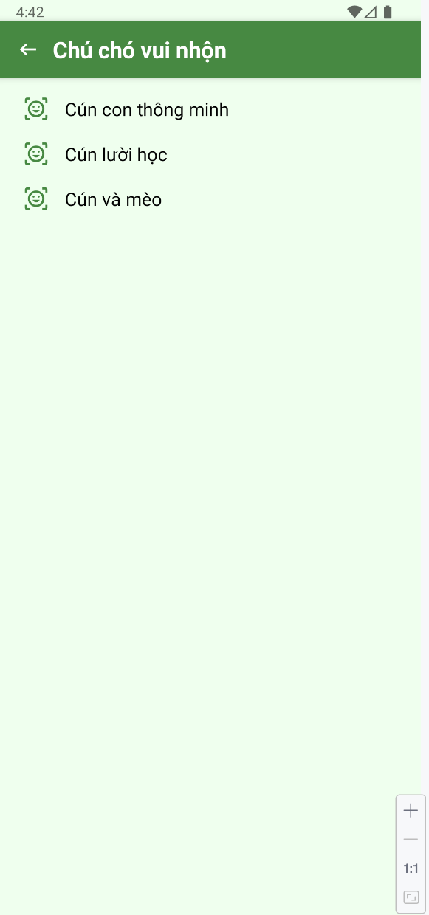 | 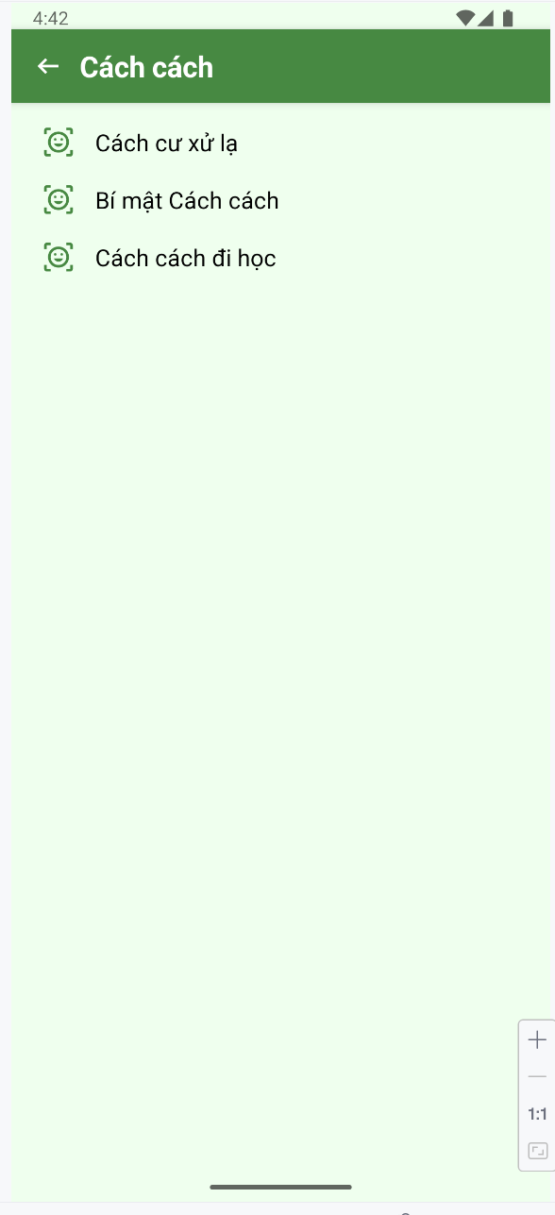

Bước 13: Xử lý khi bấm vào truyện hiện nội dung và kéo sang trái phải để chuyển truyện
TẠO GIAO DIỆN
activity_m003_screen_doc_truyen.xml
<?xml version="1.0" encoding="utf-8"?>
<LinearLayout xmlns:android="http://schemas.android.com/apk/res/android"
xmlns:app="http://schemas.android.com/apk/res-auto"
xmlns:tools="http://schemas.android.com/tools"
android:layout_width="match_parent"
android:layout_height="match_parent"
android:orientation="vertical"
android:background="@color/white"
tools:context=".Lab3.M003ScreenDocTruyen">
<LinearLayout
android:layout_width="match_parent"
android:layout_height="56dp"
android:orientation="horizontal"
android:gravity="center_vertical"
android:background="@color/greenMid"
android:layout_marginTop="20dp"
android:elevation="4dp">
<ImageView
android:id="@+id/imgBack"
android:layout_width="24dp"
android:layout_height="24dp"
android:layout_marginStart="16dp"
android:src="@drawable/ic_back"
android:contentDescription="@string/app_name"
app:tint="@color/white" />
<TextView
android:id="@+id/tvTopicTitle"
android:layout_width="wrap_content"
android:layout_height="wrap_content"
android:layout_marginStart="12dp"
android:text="Con gái"
android:textColor="@color/white"
android:textSize="20sp"
android:textStyle="bold" />
</LinearLayout>
<androidx.viewpager2.widget.ViewPager2
android:id="@+id/viewPager"
android:layout_width="match_parent"
android:layout_height="match_parent" />
</LinearLayout>

Item_doc_truyen.xml
<?xml version="1.0" encoding="utf-8"?>
<ScrollView xmlns:android="http://schemas.android.com/apk/res/android"
android:layout_width="match_parent"
android:layout_height="match_parent"
android:padding="16dp">
<LinearLayout
android:layout_width="match_parent"
android:layout_height="wrap_content"
android:orientation="vertical">
<TextView
android:id="@+id/tvStoryTitle"
android:layout_width="match_parent"
android:layout_height="wrap_content"
android:text="Việc học"
android:textSize="22sp"
android:textStyle="bold"
android:textColor="@color/greenMid"
android:gravity="center"
android:layout_marginBottom="16dp" />
<TextView
android:id="@+id/tvStoryContent"
android:layout_width="match_parent"
android:layout_height="wrap_content"
android:text="..."
android:textSize="16sp"
android:lineSpacingExtra="4dp"
android:textColor="@color/black" />
</LinearLayout>
</ScrollView>

Bước 13: Tạo DocTruyenAdapter
package com.example.myapplication.Lab3;
import android.view.LayoutInflater;
import android.view.View;
import android.view.ViewGroup;
import android.widget.TextView;
import androidx.annotation.NonNull;
import androidx.recyclerview.widget.RecyclerView;
import com.example.myapplication.R;
public class DocTruyenAdapter extends RecyclerView.Adapter<DocTruyenAdapter.DocTruyenViewHolder> {
private String[] storyTitles;
private String[] storyContents;
public DocTruyenAdapter(String[] storyTitles, String[] storyContents) {
this.storyTitles = storyTitles;
this.storyContents = storyContents;
}
@NonNull
@Override
public DocTruyenViewHolder onCreateViewHolder(@NonNull ViewGroup parent, int viewType) {
View view = LayoutInflater.from(parent.getContext())
.inflate(R.layout.item_doc_truyen, parent, false);
return new DocTruyenViewHolder(view);
}
@Override
public void onBindViewHolder(@NonNull DocTruyenViewHolder holder, int position) {
holder.tvTitle.setText(storyTitles[position]);
holder.tvContent.setText(storyContents[position]);
}
@Override
public int getItemCount() {
return storyTitles.length;
}
static class DocTruyenViewHolder extends RecyclerView.ViewHolder {
TextView tvTitle, tvContent;
DocTruyenViewHolder(@NonNull View itemView) {
super(itemView);
tvTitle = itemView.findViewById(R.id.tvStoryTitle);
tvContent = itemView.findViewById(R.id.tvStoryContent);
}
}
}

Bước 14: Cấu hình M003ScreenDocTruyen.java
package com.example.myapplication.Lab3;
import android.os.Bundle;
import android.view.LayoutInflater;
import android.view.View;
import android.view.ViewGroup;
import android.widget.ImageView;
import android.widget.TextView;
import androidx.annotation.NonNull;
import androidx.annotation.Nullable;
import androidx.fragment.app.Fragment;
import androidx.viewpager2.widget.ViewPager2;
import com.example.myapplication.R;
public class M003ScreenDocTruyen extends Fragment {
@Nullable
@Override
public View onCreateView(@NonNull LayoutInflater inflater,
@Nullable ViewGroup container,
@Nullable Bundle savedInstanceState) {
View view = inflater.inflate(R.layout.activity_m003_screen_doc_truyen, container, false);
ImageView imgBack = view.findViewById(R.id.imgBack);
TextView tvTopicTitle = view.findViewById(R.id.tvTopicTitle);
ViewPager2 viewPager = view.findViewById(R.id.viewPager);
Bundle bundle = getArguments();
if (bundle == null) return view;
String topicName = bundle.getString("TOPIC_NAME", "Chủ đề");
int currentIndex = bundle.getInt("STORY_INDEX", 0);
String[] storyTitles = bundle.getStringArray("STORY_TITLES");
String[] storyContents = bundle.getStringArray("STORY_CONTENTS");
tvTopicTitle.setText(topicName);
DocTruyenAdapter adapter = new DocTruyenAdapter(storyTitles, storyContents);
viewPager.setAdapter(adapter);
viewPager.setCurrentItem(currentIndex, false);
imgBack.setOnClickListener(v -> {
((TruyenCuoiActivity) getActivity()).backToM002Screen();
});
return view;
}
}

Kết quả:
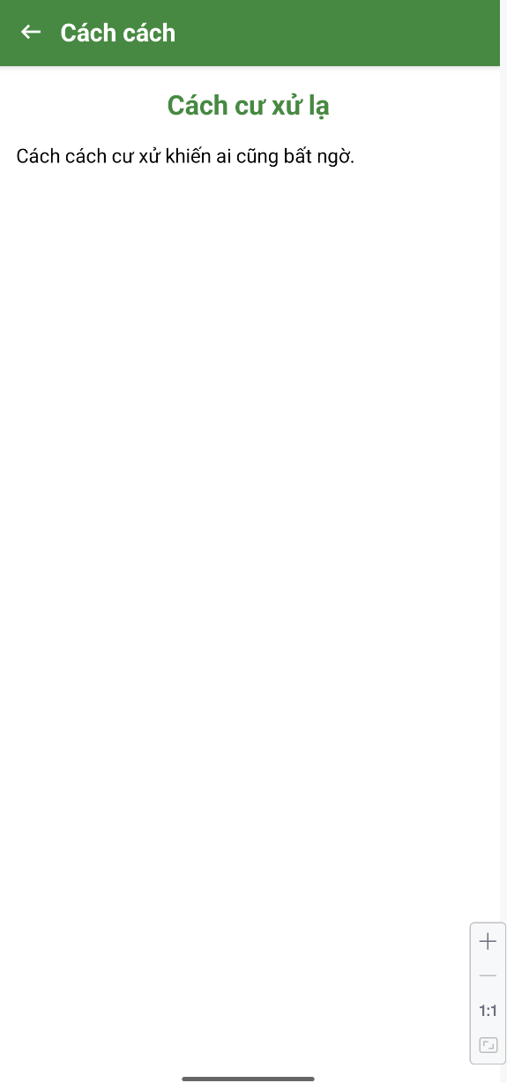 | 