Thực hành lab 7
Bước 1: Tạo file giao diện chính
<?xml version="1.0" encoding="utf-8"?>
<LinearLayout xmlns:android="http://schemas.android.com/apk/res/android"
xmlns:app="http://schemas.android.com/apk/res-auto"
xmlns:tools="http://schemas.android.com/tools"
android:orientation="vertical"
android:layout_width="match_parent"
android:layout_height="match_parent"
android:background="@drawable/img_1"
tools:context=".MainActivity">
<!-- Thanh tiêu đề -->
<androidx.appcompat.widget.Toolbar
android:id="@+id/toolbar"
android:layout_width="match_parent"
android:layout_height="?attr/actionBarSize"
android:background="@color/purple_500"
app:title="Download Manager"
app:titleTextColor="@android:color/white"
app:navigationIcon="@drawable/ic_download"
android:elevation="6dp"
android:paddingStart="16dp"
android:paddingEnd="16dp" />
<!-- Nội dung chính -->
<ScrollView
android:id="@+id/scrollView"
android:layout_width="match_parent"
android:layout_height="match_parent"
android:fillViewport="true">
<LinearLayout
android:id="@+id/mainLayout"
android:orientation="vertical"
android:gravity="center"
android:padding="24dp"
android:layout_width="match_parent"
android:layout_height="wrap_content">
<!-- Khung chứa EditText -->
<androidx.cardview.widget.CardView
android:layout_width="match_parent"
android:layout_height="wrap_content"
app:cardCornerRadius="12dp"
app:cardElevation="8dp"
android:backgroundTint="@color/white"
android:layout_marginBottom="20dp">
<EditText
android:id="@+id/edtUrl"
android:hint="@string/download_link_hint"
android:autofillHints="url"
android:inputType="textUri"
android:textColor="@android:color/black"
android:padding="16dp"
android:background="@android:color/transparent"
android:textSize="16sp"
android:layout_width="match_parent"
android:layout_height="wrap_content" />
</androidx.cardview.widget.CardView>
<!-- Nút tải xuống -->
<Button
android:id="@+id/btnDownload"
android:text="@string/download_button_text"
android:textAllCaps="true"
android:textStyle="bold"
android:textSize="16sp"
android:paddingHorizontal="24dp"
android:paddingVertical="12dp"
android:backgroundTint="@color/purple_500"
android:textColor="@android:color/white"
android:layout_gravity="center"
android:layout_width="wrap_content"
android:layout_height="wrap_content" />
</LinearLayout>
</ScrollView>
</LinearLayout>

Background nền
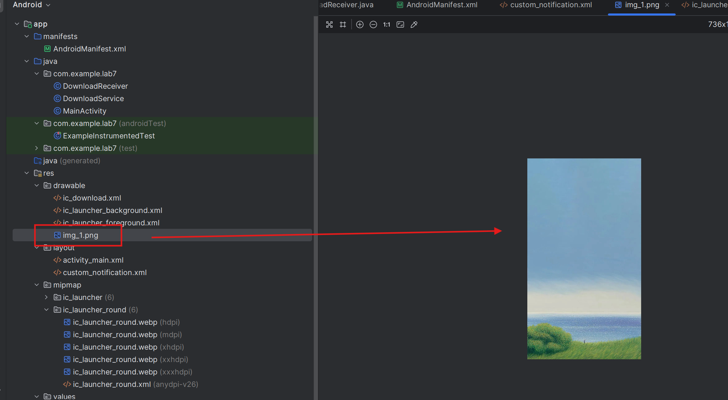
Ký hiệu tải
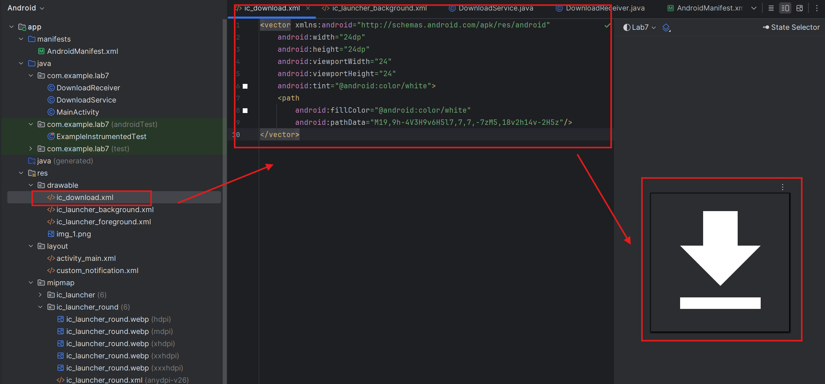
Kết quả:
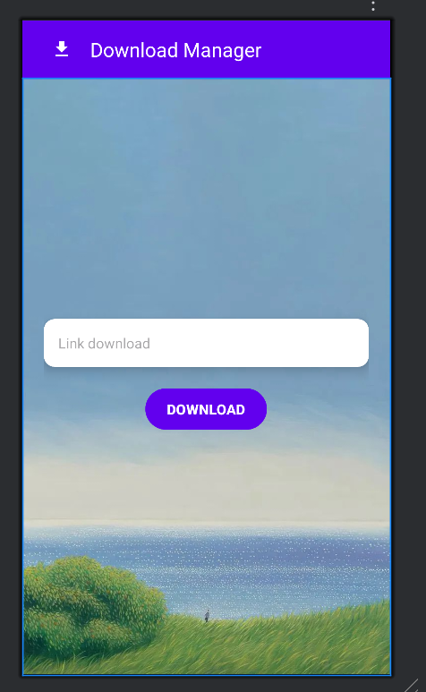
Bước 2: Tạo giao diện chạy tiến trình custom_notificaton.xml
<LinearLayout xmlns:android="http://schemas.android.com/apk/res/android"
android:orientation="vertical"
android:padding="10dp"
android:layout_width="match_parent"
android:layout_height="wrap_content"
android:background="@android:color/white">
<TextView
android:id="@+id/tv_title"
android:text="Download manager"
android:textStyle="bold"
android:textSize="16sp"
android:textColor="@android:color/black"
android:layout_width="wrap_content"
android:layout_height="wrap_content"/>
<TextView
android:id="@+id/tv_link"
android:text="Link: ..."
android:textSize="12sp"
android:textColor="@android:color/darker_gray"
android:layout_width="wrap_content"
android:layout_height="wrap_content"
android:layout_marginTop="2dp"/>
<TextView
android:id="@+id/tv_progress"
android:text="Complete: 0%"
android:textSize="14sp"
android:textColor="@android:color/black"
android:layout_width="wrap_content"
android:layout_height="wrap_content"
android:paddingTop="4dp"/>
<ProgressBar
android:id="@+id/progress_bar"
style="?android:attr/progressBarStyleHorizontal"
android:layout_width="match_parent"
android:layout_height="wrap_content"
android:progress="0"
android:max="100"
android:paddingVertical="6dp"/>
<LinearLayout
android:orientation="horizontal"
android:gravity="center"
android:layout_width="match_parent"
android:layout_height="wrap_content"
android:paddingTop="4dp">
<ImageButton
android:id="@+id/btn_pause"
android:src="@android:drawable/ic_media_pause"
android:contentDescription="Pause"
android:background="?android:attr/selectableItemBackground"
android:layout_width="48dp"
android:layout_height="48dp"
android:layout_marginEnd="8dp"/>
<ImageButton
android:id="@+id/btn_resume"
android:src="@android:drawable/ic_media_play"
android:contentDescription="Resume"
android:background="?android:attr/selectableItemBackground"
android:layout_width="48dp"
android:layout_height="48dp"
android:layout_marginEnd="8dp"/>
<ImageButton
android:id="@+id/btn_cancel"
android:src="@android:drawable/ic_delete"
android:contentDescription="Cancel"
android:background="?android:attr/selectableItemBackground"
android:layout_width="48dp"
android:layout_height="48dp"/>
</LinearLayout>
</LinearLayout>

Kết quả:
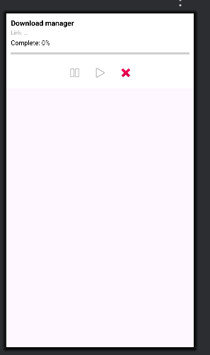

Bước 3: Trong java tạo file DowloadService.java để cấu hình tải file và xử lý Pause / Resume / Cancel
package com.example.lab7;
import android.app.*;
import android.content.*;
import android.os.*;
import android.util.Log;
import android.widget.RemoteViews;
import androidx.core.app.NotificationCompat;
import java.io.*;
import java.net.*;
public class DownloadService extends Service {
public static final String CHANNEL_ID = "download_channel";
private boolean isPaused = false, isCancelled = false;
private String fileUrl;
@Override
public int onStartCommand(Intent intent, int flags, int startId) {
Log.d("DownloadService", "Service started");
if (intent == null) return START_NOT_STICKY;
if (intent.hasExtra("action")) handleAction(intent.getStringExtra("action"));
else {
fileUrl = intent.getStringExtra("url");
createChannel();
updateNotification(0); // Show initial notification immediately
new Thread(this::downloadFile).start();
}
return START_STICKY;
}
private void handleAction(String action) {
switch (action) {
case "PAUSE": isPaused = true; break;
case "RESUME": isPaused = false; break;
case "CANCEL": isCancelled = true; stopSelf(); break;
}
}
private void downloadFile() {
try {
URL url = new URL(fileUrl);
HttpURLConnection conn = (HttpURLConnection) url.openConnection();
conn.connect();
int fileLength = conn.getContentLength();
InputStream input = new BufferedInputStream(conn.getInputStream());
String name = "file_" + System.currentTimeMillis() + ".bin";
File outFile = new File(getExternalFilesDir(null), name);
FileOutputStream output = new FileOutputStream(outFile);
byte[] data = new byte[4096];
long total = 0;
int count;
while ((count = input.read(data)) != -1) {
if (isCancelled) break;
while (isPaused) Thread.sleep(300);
total += count;
output.write(data, 0, count);
int progress = (int) (total * 100 / fileLength);
updateNotification(progress);
}
output.flush();
output.close();
input.close();
stopSelf();
} catch (Exception e) {
Log.e("DownloadService", e.getMessage());
}
}
private void updateNotification(int progress) {
Log.d("DownloadService", "updateNotification called, progress: " + progress);
// Tạo RemoteViews từ custom layout
RemoteViews notificationLayout = new RemoteViews(getPackageName(), R.layout.custom_notification);
// Cập nhật nội dung
notificationLayout.setTextViewText(R.id.tv_title, "Download manager");
notificationLayout.setTextViewText(R.id.tv_link, "Link: " + (fileUrl != null ? fileUrl : "..."));
notificationLayout.setTextViewText(R.id.tv_progress, "Complete: " + progress + "%");
notificationLayout.setProgressBar(R.id.progress_bar, 100, progress, false);
// Tạo PendingIntent cho các nút
Intent pause = new Intent(this, DownloadReceiver.class).setAction("PAUSE");
Intent resume = new Intent(this, DownloadReceiver.class).setAction("RESUME");
Intent cancel = new Intent(this, DownloadReceiver.class).setAction("CANCEL");
PendingIntent pPause = PendingIntent.getBroadcast(this, 0, pause, PendingIntent.FLAG_IMMUTABLE);
PendingIntent pResume = PendingIntent.getBroadcast(this, 1, resume, PendingIntent.FLAG_IMMUTABLE);
PendingIntent pCancel = PendingIntent.getBroadcast(this, 2, cancel, PendingIntent.FLAG_IMMUTABLE);
// Gắn PendingIntent vào các nút
notificationLayout.setOnClickPendingIntent(R.id.btn_pause, pPause);
notificationLayout.setOnClickPendingIntent(R.id.btn_resume, pResume);
notificationLayout.setOnClickPendingIntent(R.id.btn_cancel, pCancel);
// Tạo notification với custom layout
NotificationCompat.Builder builder = new NotificationCompat.Builder(this, CHANNEL_ID)
.setSmallIcon(android.R.drawable.stat_sys_download)
.setStyle(new NotificationCompat.DecoratedCustomViewStyle())
.setCustomContentView(notificationLayout)
.setCustomBigContentView(notificationLayout)
.addAction(android.R.drawable.ic_media_pause, "Pause", pPause)
.addAction(android.R.drawable.ic_media_play, "Resume", pResume)
.addAction(android.R.drawable.ic_delete, "Cancel", pCancel)
;
startForeground(1, builder.build());
}
private void createChannel() {
if (Build.VERSION.SDK_INT >= Build.VERSION_CODES.O) {
NotificationChannel ch = new NotificationChannel(CHANNEL_ID, "Download", NotificationManager.IMPORTANCE_DEFAULT); // Changed from IMPORTANCE_LOW to IMPORTANCE_DEFAULT
getSystemService(NotificationManager.class).createNotificationChannel(ch);
}
}
@Override
public IBinder onBind(Intent intent) { return null; }
}

Bước 4: Tiếp tục tạo file DownloadReceiver.java xử lý bấm nút Pause, Resume, hoặc Cancel trên notification
package com.example.lab7;
import android.content.*;
import android.os.Build;
import android.widget.Toast;
public class DownloadReceiver extends BroadcastReceiver {
@Override
public void onReceive(Context context, Intent intent) {
String action = intent.getAction();
Toast.makeText(context, "Action: " + action, Toast.LENGTH_SHORT).show();
Intent service = new Intent(context, DownloadService.class);
service.putExtra("action", action);
if (Build.VERSION.SDK_INT >= Build.VERSION_CODES.O) {
context.startForegroundService(service);
} else {
context.startService(service);
}
}
}

Bước 5: Câu hình MainActivity.java xử lý nhập URL và nút download
package com.example.lab7;
import androidx.appcompat.app.AppCompatActivity;
import androidx.appcompat.widget.Toolbar;
import android.os.Bundle;
import android.content.Intent;
import android.view.View;
import android.widget.Button;
import android.widget.EditText;
import android.widget.ScrollView;
import android.widget.Toast;
import android.Manifest;
import android.content.pm.PackageManager;
import androidx.core.app.ActivityCompat;
import androidx.core.content.ContextCompat;
import android.app.NotificationChannel;
import android.app.NotificationManager;
import androidx.core.app.NotificationCompat;
public class MainActivity extends AppCompatActivity {
EditText edtUrl;
Button btnDownload;
ScrollView scrollView;
@Override
protected void onCreate(Bundle savedInstanceState) {
super.onCreate(savedInstanceState);
setContentView(R.layout.activity_main);
// Tạo NotificationChannel với mô tả rõ ràng
if (android.os.Build.VERSION.SDK_INT >= android.os.Build.VERSION_CODES.O) {
NotificationManager nm = (NotificationManager) getSystemService(NOTIFICATION_SERVICE);
NotificationChannel ch = new NotificationChannel("test_channel", "Test", NotificationManager.IMPORTANCE_DEFAULT);
ch.setDescription("Kênh thông báo test cho Dowloadmanager");
nm.createNotificationChannel(ch);
}
// Request notification permission for Android 13+
if (android.os.Build.VERSION.SDK_INT >= 33) {
if (ContextCompat.checkSelfPermission(this, Manifest.permission.POST_NOTIFICATIONS) != PackageManager.PERMISSION_GRANTED) {
ActivityCompat.requestPermissions(this, new String[]{Manifest.permission.POST_NOTIFICATIONS}, 1);
}
}
// Thiết lập Toolbar làm AppBar
Toolbar toolbar = findViewById(R.id.toolbar);
setSupportActionBar(toolbar);
// Hiển thị nút back
if (getSupportActionBar() != null) {
getSupportActionBar().setDisplayHomeAsUpEnabled(true);
}
// Xử lý khi bấm vào nút back
toolbar.setNavigationOnClickListener(v -> finish());
// Liên kết view
edtUrl = findViewById(R.id.edtUrl);
btnDownload = findViewById(R.id.btnDownload);
scrollView = findViewById(R.id.scrollView);
btnDownload.setOnClickListener(v -> {
String url = edtUrl.getText().toString().trim();
if (url.isEmpty()) {
Toast.makeText(MainActivity.this, "Vui lòng nhập link download!", Toast.LENGTH_SHORT).show();
return;
}
Intent intent = new Intent(MainActivity.this, DownloadService.class);
intent.putExtra("url", url);
if (android.os.Build.VERSION.SDK_INT >= android.os.Build.VERSION_CODES.O) {
startForegroundService(intent);
} else {
startService(intent);
}
Toast.makeText(MainActivity.this, "Đang bắt đầu tải xuống...", Toast.LENGTH_SHORT).show();
scrollView.smoothScrollTo(0, 0); // Scroll to top when download is pressed
});
}
}
Bước 6: khai báo DowloadService.java và DowloadReceiver.java + quyền truy cập internet vào Mainifest
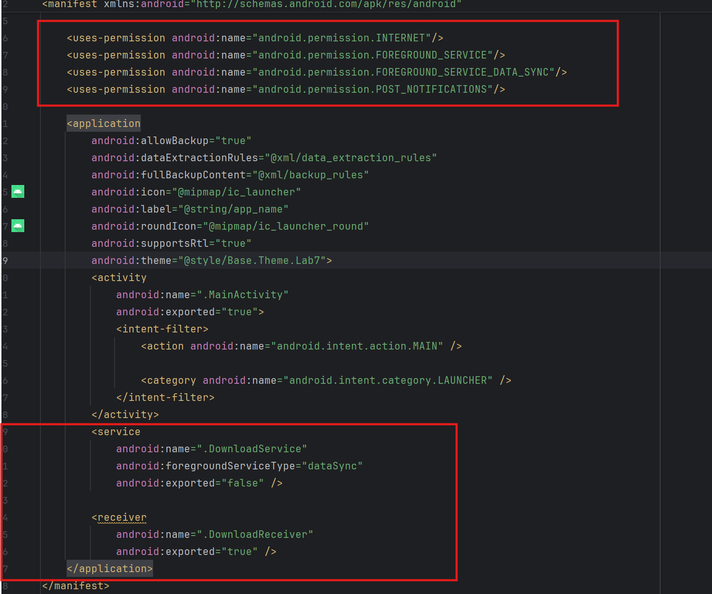

Bước 7: Kết quả
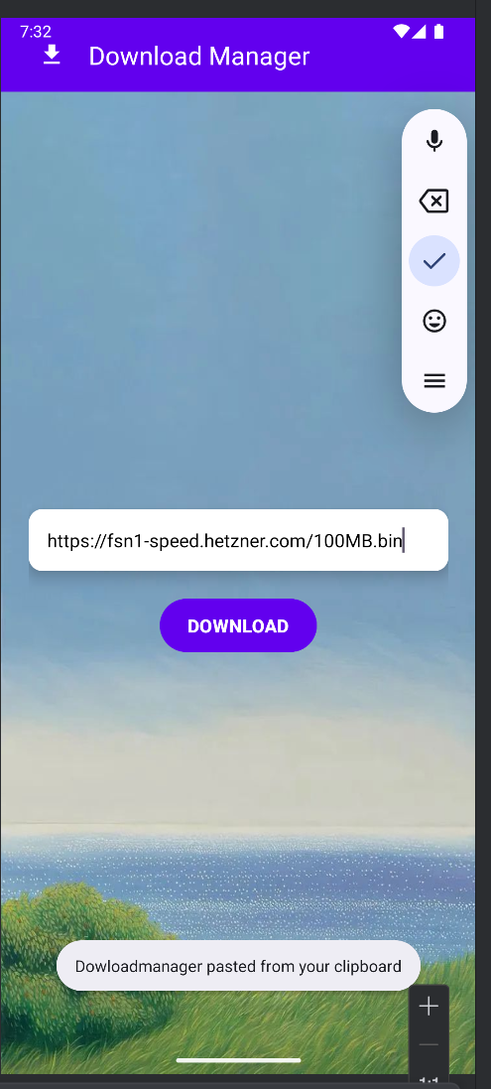 | 