

**Hello! Welcome to Hellosaurus.** This document serves as an overview of our content and production strategies as well as aspects of our product strategy. It also includes links to additional helpful documents, designs, videos, and more. The document is meant primarily for creative and/or brand partners potentially interested in working for/with Hellosaurus. Feel free to reach out to [james@hellosaurus.com](mailto:james@hellosaurus.com) with any questions or comments.

## About Hellosaurus

Hellosaurus is a mobile, interactive video platform for kids’ entertainment-based learning, initially targeting 3 to 8 year olds. Engaging with on-screen subjects has always been central to kids’ media, with characters turning to the viewers asking them to answer questions, sing along, and much more. We are building the technology and enabling the program development to transform kids’ media consumption into a true two-way, mobile-first experience. Put simply, Hellosaurus is TV you can play.

All content on Hellosaurus has been made specifically for our interactive format and mobile app distribution platform. Our interactive tools will ultimately empower a large curated set of creators to produce new shows on their own for the Hellosaurus app. Many of our shows are meant to be filmed live or live-to-tape, and all content will be available on-demand.

## The Hellosaurus Secret Sauce

There are multiple services that offer mobile videos for kids: Netflix, YouTube, Disney+...

And there are also services that offer mobile games for kids: Toca Boca, SagoMini, Kidomi…

We are inventing a new type of mobile format that requires neither heavily-produced video nor laborious game design. Instead, we focus on frequent, simple, and delightful user interactions paired perfectly with a video format that can be efficiently created without compromising quality.

Put differently, the secret to our success lies in the ways in which the video and the interactive are inextricably woven together. We are neither Pixar nor Nintendo, but we manage to combine good video and good interactions in such a way that the end result is greater than the sum of its parts. In a way, our special product is sort of like taking cheese (simple, good) and bread (simple, good) and making the perfect grilled cheese.



*It’s video, it’s interactivity. The raw ingredients have been around for a while, but we combine them in a unique, new, and delightful way.*

To reiterate, our videos augment the satisfaction of our interactive components and vice versa. That’s our secret sauce. For this formula to work, the experience in toto must be fantastic. So, let’s take a look at how that experience is crafted (or jump ahead to learn about the Hellosaurus Interactive Forms).

## The Hellosaurus Experience

The key is that the childfeels like an **active** and **important** part of the process: like they are pushing the show forward. In a sense, the experience could be similar to how a parent and cool older sibling will let you do all the things she knows that you are capable of while cooking, gardening, or fixing a bike. It should feel to the child like **they** helped move things along by doing **work**. The child should be using their hands a lot. And ideally as freely as possible.

It should be evident to the **parent** that this is an active experience. When the parent looks over at their child they should often see them **doing** something, not just watching. In many ways, the child should be participating as if the Hellosaurus show were a live performance (e.g. musician, magician, artist, animal expert), of the type seen at kids’ birthday parties or in kids’ classrooms.

### Feelings and Sensations

What should the child feel when they interact with the product? In a typical session, there are a few sensations we hope to elicit, listed in chronological order:

1. **I matter!** Self-importance, e.g. “My input is clearly necessary here”.
2. **I’m having fun helping/doing!** Pleasurable focus, e.g. “I am excited to participate and am having fun doing so.”
3. **Check out what I did!** Satisfaction, e.g. “Yes, the accomplishment was achieved because of me and/or with my help.”

These three sensations should be present in all sessions. In addition, each show’s original content should elicit its own set of feelings. These could be entirely different depending on whether the show is about animals, STEM, storytelling, or anything else.

Some emotions to consider as creators begin to create potential content: Excitement, Wonder, Captivation, Intellectual Stimulation, Liveliness, Delighted, Mysterious, Energetic, Engrossed, Entertained, Happiness, Playfulness, Silliness.

## Educational Philosophy

A little bit about the educational philosophy to which we subscribe. We believe that:

1. **The child is capable.** We often jump to do things for children when we see them struggle, but children can and want to do things for themselves. We simply need to show them the tools and give them the time they need. On our platform, the host is a conduit to the task, not the star. That being said, just like with your cool older sibling, it should be someone you feel friendly towards and that you want to play with.
2. **The child wants to do meaningful tasks.** Children want to feel competent and relevant. We all do. On our platform children are asked to help in crucial moments and, in the end get to say “I did it!”.
3. **The child needs freedom in their work.** No one likes being micromanaged. To learn a task the child should have the freedom to do it their way. Even if the goal is set, it should ideally be approachable and achievable in many ways.
4. **The child not only enjoys but also learns best from repetition.** The continuous practice of a previously learned skill and/or in a familiar environment provides the child with the cognitive and psychological benefits of reinforcement and mastery. Through frequent repetition, the child finds joy in achieving and develops the confidence to progress further.

Our philosophy is influenced by Montessori education. These four values fit well with the goals for our service of having children engaged in *doing*.

**So our entertainment based-learning formula is:**

* Give the child a person (or character) they can look up to, to work alongside with.
* Give them a reason to feel that what they will do will matter.
* Give the child minimal--if any--instructions on how the tools work.
* Give them plenty of time to execute the task.
* Give the child as many ways as possible to get to the end.
* Give them a sense that what they did was essential.
* Give them the ability to execute the task as many times as they would like.

*“Play is often talked about as if it were a relief from serious learning. But for children play is serious learning. Play is really the work of childhood.” - Fred Rogers*

### Active > Passive

We believe that active media engagement rather than passive media consumption is not only more fun for the child but also meaningfully better for the cognitive and social development of a child.

Because technology tends to progress faster than scientific research, there are only a few published academic papers that deeply explore kids' usage of different kinds of mobile, interactive media and how these experiences compare to more passive media experiences. However, early studies are very promising. For example, compared to simply watching video, the responsiveness of interactive media can provide children a feeling of accomplishment ([Christakis, 2014](https://jamanetwork.com/journals/jamapediatrics/fullarticle/1840251)), holds promise of better learning ([Kirkorian, Choi, & Pempek, 2015](https://srcd.onlinelibrary.wiley.com/doi/abs/10.1111/cdev.12508)), and helps children retain information better ([Kirkorian, 2018](https://www.researchgate.net/publication/325289711_When_and_How_Do_Interactive_Digital_Media_Help_Children_Connect_What_They_See_On_and_Off_the_Screen)), especially if the interaction is not so extensive that it becomes distracting ([Nussenbaum & Amso, 2015](http://research.clps.brown.edu/dcnl/wp-content/uploads/2014/08/Nussenbaum_Amso_2016.pdf)). Moreover, a 2017 report synthesizing nearly 600 entries of discussion, research, and practice around technology and media for young children found that “playing” and “creating” provided the basis for the children’s interactions with technology or media that furthered the children’s social and emotional development and learning readiness ([Paciga & Donohue, 2017](https://www.fredrogerscenter.org/wp-content/uploads/2017/07/Technology-and-Interactive-Media-for-Young-Children.pdf)).

### An Additional Note on Repetition

As mentioned above, we believe repetition is both fun and rewarding for a child. *Blue’s Clues* popularized a repetition-based content release cadence for kid’s media: while the show had a daily time slot, Blue’s Clues opted to release one new episode at the beginning of the week and then re-air that same episode in their daily time slot every day for the rest of the week. [This notable research study on *Blue’s Clues*](https://www.researchgate.net/profile/Daniel_Anderson7/publication/232578269_Effects_of_Repeated_Exposures_to_a_Single_Episode_of_the_Television_Program_Blue%27s_Clues_on_the_Viewing_Behaviors_and_Comprehension_of_Preschool_Children/links/00463530b6aff3bff6000000/Effects-of-Repeated-Exposures-to-a-Single-Episode-of-the-Television-Program-Blues-Clues-on-the-Viewing-Behaviors-and-Comprehension-of-Preschool-Children.pdf?origin=publication_detail) explores the effects of that approach, finding that each repeated exposure to a single episode of Blue’s Clues increased both the comprehension of the content as well as the active engagement with the content. In other words, repetition is not only beneficial for learning but also is more enjoyable for the child. In line with the results of this study, then, the Hellosaurus experience is designed to allow the child to repeat tasks as often as they would like.

Embracing repetition has an additional meaningful impact on our content creation strategy: because every episode we put on the platform will be played multiple times, Hellosaurus creators will need to develop far less content than what must exist on a platform meant for a grown-up audience (for whom frequent repetition of the same content is the exception rather than the rule). Moreover, unlike shows for grown-ups, the Hellosaurus kid’s media library is evergreen. Put differently, content aired today will be just as valuable to our users at any point in the future because the lessons and activities that appeal to our audience now will likely generally still hold their appeal for 3-8 year olds at any future moment.

### It’s Not About You

Yes, yes, you are charming and very telegenic, but this show is really not about you. It’s about creating that personal bond between you and the child in which they want to hang out with you and do something fun with you. You can do that!



*“There’s a world of difference between insisting on someone doing something and establishing an atmosphere in which that person can grow into wanting to do it.” - Fred Rogers*

When you write your script, think about what it is you want the child to do. Why does it matter to you, why should the child care about you, and why should the child care about the thing that is to be done?

Try to involve the child from the first second. Fred Rogers did this. Blues Clues does this. Talk to the child directly as if you knew them just a little. Work your hardest to create a bond and a feeling of presence between the two of you. You are here to do things together; something that matters to you and, hopefully, to them.

Don’t just talk to them. See them.

## The Hellosaurus Content Framework

### Initial Format Assumptions

The following format assumptions will be helpful to keep in mind as you explore potential show concepts:

1. Primary subjects are not animated. In other words, the main characters and hosts are live-action humans, puppets, or other objects. Animation may still play a role through the utilization of a green screen or built-in software components.
2. Video production setups are fairly simple: one or two cameras, likely stationary. Perhaps even filmed in a continuous shot. One set or green-screen studio. While creators with current studio setups are encouraged to produce their shows in their own space, Hellosaurus offices will have a staffed studio for any creator to use, if desired.
3. Video stream + interaction may happen LIVE at times, but every show also must have clear and interactive replay (encore) value as well as on-demand value. Content that is recorded should not require heavy post-production work. Put differently, shows that are not broadcast live should be filmed as close to live-to-tape as possible.
4. Avoid “Choose Your Own Adventure” style shows in which the viewer goes down a personal, narrative path with individualized video changes. In other words, the base layer video will be the same for every user.
5. Each show should be able to create a new episode at roughly a weekly rate, if required. Though that rate expectation could change to multiple times per week or even daily over time.
6. A Hellosaurus show should not be able to be just as enjoyable/beneficial if it were uploaded to YouTube and watched passively; if this is the case then the Hellosaurus show is not interactive enough and/or not interactive in the right ways.
7. Available user-input sources for interactions: multi-touch screen, microphone, front-facing camera (+ 3D sensors in newer mobile devices), rear-facing camera, motion sensors (e.g. gyroscope, accelerometer).

### Mobile First

The Hellosaurus app/platform is available exclusively on mobile devices (mobile phones and tablets). Unlike all other streaming services that essentially treat phones and tablets simply as smaller TV screens, Hellosaurus actually takes advantage of the amazing technology on these devices (e.g. multitouch screens, microphones, cameras, motion sensors) to offer a truly interactive experience for kids. Through these inputs/interactions, Hellosaurus puts the child in the show. Moreover, Hellosaurus focuses on a mobile experience because, unlike grownups, children under 8 are already using mobile phones and tablets as their primary media consumption devices.

### A Note on Content Distribution (LIVE + On-Demand)

As previously mentioned, all content will be distributed on the Hellosaurus mobile application; simply put, we must distribute exclusively on our own platform because the video player needs to have the interactive technology built-in (which, for example, YouTube does/will not). However, creative partners will be welcome to repost content onto their own channels (e.g. YouTube, social) with the proper attribution because, as mentioned above, the content is best experienced with the interactive abilities and thus we view partner channels as marketing, not distribution.

A selection of shows will be highlighted as part of a hosted broadcast, for free, on Saturday mornings. This content, as well as all other shows, will also be available on-demand at any time for paying subscribers.

### “Real-World” Content Analogy

As mentioned above, content on Hellosaurus should not be able to be just as enjoyable/beneficial if it were watched passively on a platform like YouTube. The “real world” analog of a passive viewing experience would be a performance with a very clear “fourth wall” between the stage/performers and the audience/viewers. On the other hand, a prototypical Hellosaurus show is akin to a live performance in a full kindergarten classroom or at a kid’s birthday party: back-and-forth between the children and the performer is a fundamental component of the experience.

By way of example: A musician is invited into a classroom or birthday party to perform “Old Macdonald Had a Farm”. The real-world version of a YouTube video performer would play the song from beginning to end without stopping, as many times as the audience would like, and then leave. Conversely, a Hellosaurus performer would sing only a few lines of the song at a time, pausing frequently to play an activity with the kids (e.g. “Hey, we just met a cow! Let’s all learn to moo together”; “Wow, we just sang a special type of letter called a vowel! Pull out your markers and let’s learn to draw these vowels”; “Pick up one of these tambourines and play along with me”; “Look! A pig! Everyone put on your pig masks and let’s pretend to be pigs”). The Hellosaurus version is ultimately the type of performer that a parent or teacher would much rather hire because the experience is not only more fun for the child but also is significantly more socially and cognitively stimulating.

Creators exploring what type of content to create on Hellosaurus, then, can start by thinking about how their show would function when performed live alongside a group of kids. What activities would the kids play? What tools/toys/objects would be in the room for kids to use? Hellosaurus will then digitize these tools and activities (e.g. a physical mirror → front-facing camera; marker+paper → finger+multitouch screen) and scale the “group” size to include any number of kids virtually tuning in.

### Show Themes

We’ve currently prioritized the following themes for potential show concepts:

### Food

* Arts & Crafts
* Variety
* STEM and STEAM
* Mindfulness
* Mystery Narrative
* Storytelling and/or Story Creation
* Caretaking
* Music
* Language

### Hellosaurus Interactive Forms

As previously mentioned, interactive moments on Hellosaurus are meant to make the child feel like an **active and important** part of the process: like they are pushing the show forward. User interactions generally fall into two categories: *Do Its* and *Always-on Actions.*

### Do Its

*Do Its* are the cornerstone of both the Hellosaurus player experience as well as the Hellosaurus proprietary set of software tools. They are the interactive moments in which the host explicitly seeks participation from the user and have start and end times determined by the host or producer.

We have compiled a long list of ready-made Do Its (called the “Do It Handbook”) that any creator can easily incorporate into their content. These Do Its are either triggered on-the-fly using the Hellosaurus CMS if a show is broadcast live (or filmed live-to-tape) or Do Its are added in post-production using the Hellosaurus CMS if a show is simply recorded. Please read [the Hellosaurus Do It Handbook](https://docs.google.com/document/d/1vjzxoyJRoDQA3EUtTHpAgHclFa5X5ofhSPm1ehfaGjw/edit#) *(note: please email* [*james@hellosaurus.com*](mailto:james@hellosaurus.com) *for access to the Do It Handbook)* to learn more about Do Its and how to use them. This list is ever-growing and there are many examples of Do Its in the Handbook, but a few are included below:

#### **Example #1: Trace It**

##### Description

Trace any object (e.g. letter, animal) with a choice of different colors and tools. Ideally the image shown after successful tracing is more complicated than the image before the tracing (or, the image being traced) to provide additional satisfaction.

##### Trace It Example(s)

In this example, the child is given the letter “E” on the right hand side and the host asks if they can draw an E. The child can pick a color and use the paintbrush to draw over the outline.

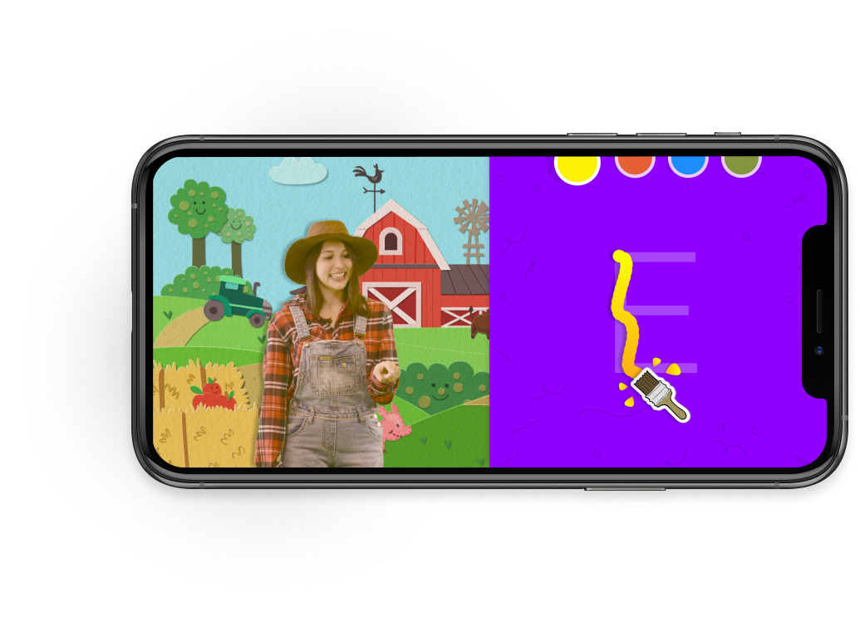

See this example brought to life in [this Hellosaurus Trace It video demo](https://drive.google.com/open?id=1lt8vU_fblQ5Z7XIVz4m7DuKXWISJgfwT).

##### Supported Layouts

Vertical Half - Left, Vertical Half - Right, Full Screen - No Video, Full Screen - Video Cutout, Full Screen - Video Overlay, Horizontal Third - Upper, Horizontal Third - Lower

##### Required Creator Input

Image of object to be traced both before and after tracing.

#### **Example #2 Say It**

##### Description

Child is read and shown a word and then asked to say the word aloud. The letters/syllables of the word light up as the child correctly says them.

##### Say It Example(s)

In this example, the word “Moo” is shown on the screen, along with a visual cue. The host reads the word and asks the child to “Say it with me!”. As the software recognizes the letters of the word, they light up, until the word is complete. The child can complete this multiple times. If the software recognizes the child saying a word that doesn’t match, there will be gentle negative feedback.

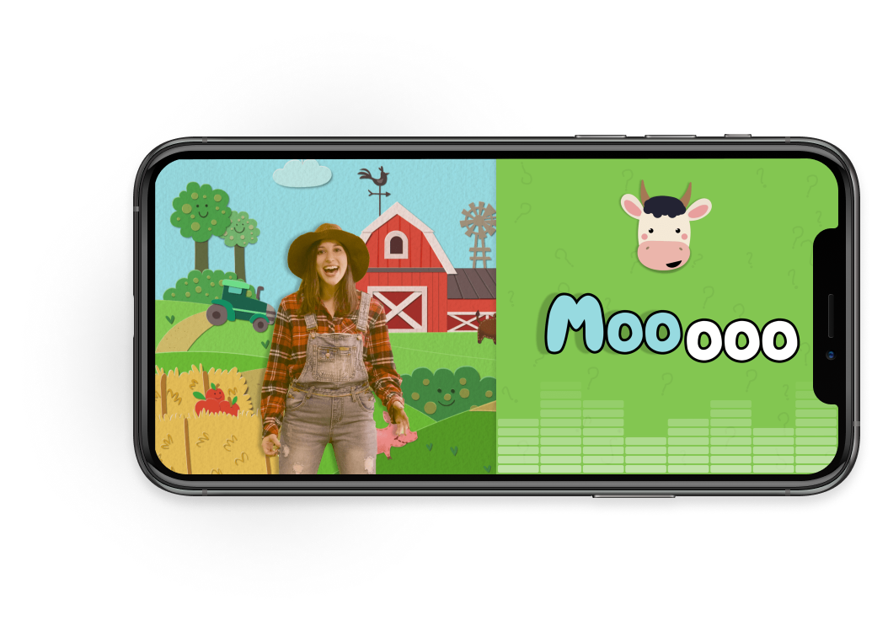

See this example brought to life in [this Hellosaurus Say It video demo](https://drive.google.com/open?id=1A5nDaRsnm3ahSvd8bxsqZ2R2xztJ2CRo).

##### Supported Layouts

Vertical Half - Left, Vertical Half - Right, Full Screen - No Video, Full Screen - Video Cutout, Full Screen - Video Overlay, Horizontal Third - Upper, Horizontal Third - Lower

##### Required Creator Input

Text of word to be read/spoken aloud. Optional image or looping video/GIF to be shown alongside word and optional recording of word being spoken. Optional background image or looping video.

#### **Example #3: Stack It**

##### Description

The child is given a set of items to vertically arrange on top of a base.

##### Stack It Example(s)

In this example, the child is given all the makings of a burger on the lower part of the screen, with a Bun in place to start. They can drag whichever parts they want onto the base and build their favorite burger!

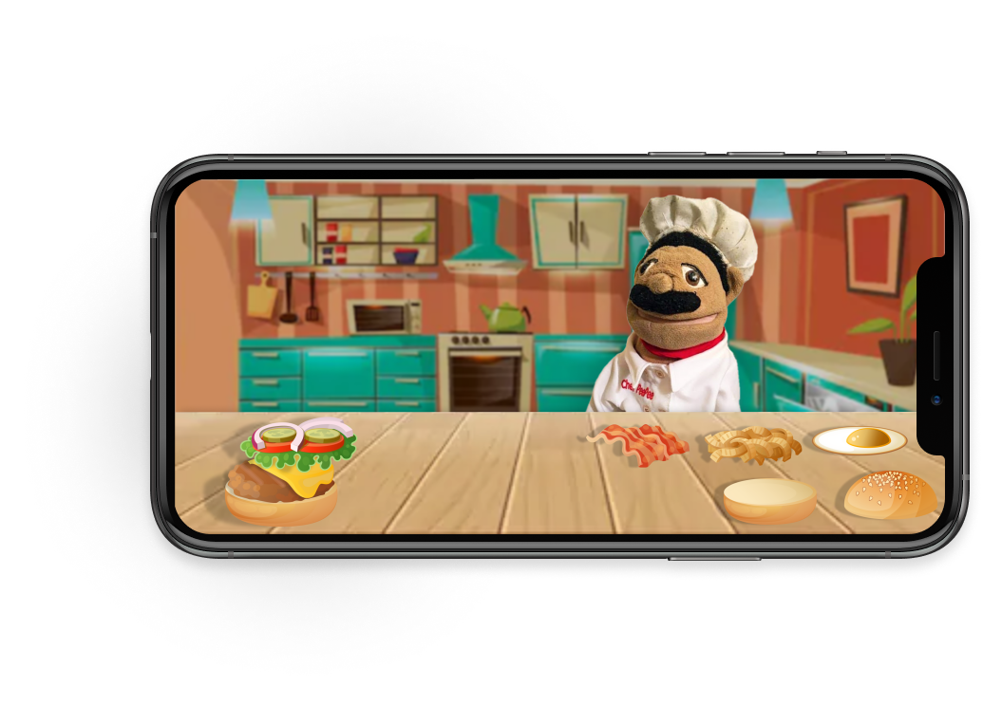

##### Supported Layouts

Vertical Half - Left, Vertical Half - Right, Full Screen - No Video, Full Screen - Video Cutout, Full Screen - Video Overlay, Horizontal Third - Upper, Horizontal Third - Lower

##### Required Creator Input

Images of items to be stacked. Optional sound effect for when each item is correctly stacked.

Other Do Its include: [Sequence It](https://docs.google.com/document/d/1vjzxoyJRoDQA3EUtTHpAgHclFa5X5ofhSPm1ehfaGjw/edit#heading=h.xzy953glmlru), [Wear It](https://docs.google.com/document/d/1vjzxoyJRoDQA3EUtTHpAgHclFa5X5ofhSPm1ehfaGjw/edit#heading=h.xx7scboy34fh), [Toggle It](https://docs.google.com/document/d/1vjzxoyJRoDQA3EUtTHpAgHclFa5X5ofhSPm1ehfaGjw/edit#heading=h.6p0d2bsm2b6b), [Puzzle It](https://docs.google.com/document/d/1vjzxoyJRoDQA3EUtTHpAgHclFa5X5ofhSPm1ehfaGjw/edit#heading=h.4pv3dvh5ndrm), [Pour It](https://docs.google.com/document/d/1vjzxoyJRoDQA3EUtTHpAgHclFa5X5ofhSPm1ehfaGjw/edit#heading=h.npdmae9l0gp2), [Order It](https://docs.google.com/document/d/1vjzxoyJRoDQA3EUtTHpAgHclFa5X5ofhSPm1ehfaGjw/edit#heading=h.dkmnfsgntiuq), [Find It](https://docs.google.com/document/d/1vjzxoyJRoDQA3EUtTHpAgHclFa5X5ofhSPm1ehfaGjw/edit#heading=h.4055xok6hqzl), [Draw It](https://docs.google.com/document/d/1vjzxoyJRoDQA3EUtTHpAgHclFa5X5ofhSPm1ehfaGjw/edit#heading=h.6kk0smbwjym7), and many more in [the Hellosaurus Do It Handbook](https://docs.google.com/document/d/1vjzxoyJRoDQA3EUtTHpAgHclFa5X5ofhSPm1ehfaGjw/edit#) (*note: please email* [*james@hellosaurus.com*](mailto:james@hellosaurus.com) *for access to the Do It Handbook)*.

The true magic of Do Its lies in the fact that they are extendable to any content type. For example, a creator could use “Trace It” in a very different way in an Art-themed show than in a Food-theme show, even though the underlying technology is the same. In other words, any given Do It software has to be built only once to power any number interactive moments across any number of shows.

#### Adding Do Its To A Video

As mentioned above, Do Its are either triggered on-the-fly using the Hellosaurus CMS if a show is broadcast live (or filmed live-to-tape) or Do Its are added in post-production using the Hellosaurus CMS if a show is simply recorded.

If a video has already been recorded, creators simply use the drag and drop interface on the Hellosaurus CMS (which will be available on the web) to add interactivity, as shown in the video timeline example below:

### Always-on Actions

Users can complete *Always-on Actions* at any time throughout the show except when a Do It is active. Whereas the characters in a show explicitly call out Do Its and guide users through them, characters do not even need to be aware that users are interacting with Always-on Actions during a broadcast. For example, an Always-on Action called “Voicechanger” allows a user to change the sound of on-screen subjects’ voice to sound like a robot, a chipmunk, and other variations. Characters in a show are neither aware of the change nor do they acknowledge it.

Additional Always-on actions include:

* “Soundmaker” -- Tap a button at any moment to make a show-specific sound! This sound can also be made by shaking the phone. For example, a tamborine to be played at any moment during a music show.
* “Stickerplacer” -- Place stickers from a show-specific sticker pack anywhere on the screen! Stickers disappear on a set timer and/or when the next Do It begins.

Always-on actions may be consistent across many shows. Other than selecting which (if any and at most three) Always-on actions they will want in a given episode, creators have no required inputs for Always-on actions. There will also be platform-wide UI interactions that are common across all shows (e.g. seeing list of other viewers currently in broadcast and sending a wave to someone).

Users can complete these at any time (akin to typing in or reading the chat in an HQ Trivia show; for example, an instrument on the screen that can always be played when tapped in a sing-along show).

### A Note on LIVE Interactions

As mentioned above, it is important that shows on Hellosaurus have significant on-demand replay value even when broadcast live.

In general, user interactions (both *Do Its* as well as *Always-on Actions*) on Hellosaurus are meant to be the same whether the user is playing the live version or an on-demand recording of the episode. In other words, the interactions do not create any meaningful narrative shifts to the underlying video. For example, [this “Trace It”](https://drive.google.com/open?id=1lt8vU_fblQ5Z7XIVz4m7DuKXWISJgfwT) or [this “Say It”](https://drive.google.com/open?id=1A5nDaRsnm3ahSvd8bxsqZ2R2xztJ2CRo) -- no matter if or how they are completed -- do not have any significant bearing on what the host does next. Still, the Do Its should be treated as essential parts of the story and user experience.

There are, however, a small set of user interactions (both *Do Its* as well as *Always-on Actions*) that must be performed live because of their narrative impact. For example, Alli’s Sandwich Shop -- a show in which the users learn about ingredients and vote on which to put on a sandwich that Alli then eats and reviews -- may require live audience decisions that may not translate well to an interactive recording. If creators were to want to make a show that includes an interaction of this type, they should make sure each episode also includes enough interactions that are the same whether live or on-demand. Creators could also use minimal post-production to more effectively transition these interactive moments from live to on-demand.

To reiterate, though: regardless of the interactions used, the majority of shows are meant to be filmed in the same way. In other words, most content should be either broadcast live or filmed live-to-tape (as if it were live), with little-to-no mandatory post-production.

## Benchmarks

The following table compares Hellosaurus to a variety of similar products and companies: 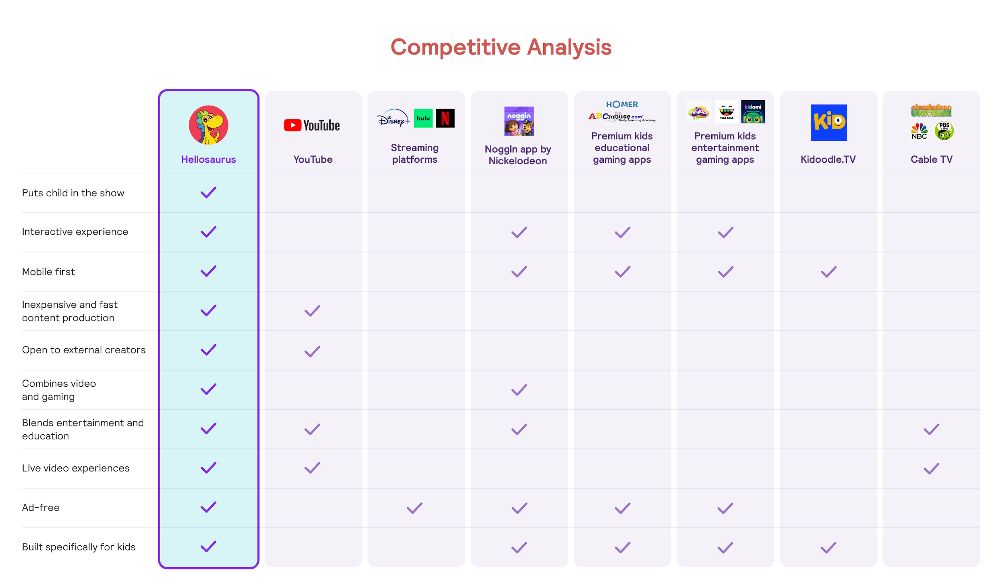

As shown above, Hellosaurus is much more comparable to YouTube/YouTube Kids than any SVOD service like Netflix because both Hellosaurus and YouTube leverage external creators to quickly and cheaply produce content using the provided software tools and platform (see the [Hellosaurus, The Company](https://docs.google.com/document/d/1Yq6bOfPlVPx5xxz1YyV0s-LPN6zppck-I473QyKO_-U/edit#heading=h.ic7fleulkngl) section above for more information).

While kids entertainment and/or educational gaming apps -- due to their mobile focus and interactive offerings -- perhaps encourage similar user behaviors to those found on Hellosaurus, their long, expensive, and rigid development processes prevent them from scaling content production as effectively as Hellosaurus.

By similar logic, while Hellosaurus shows use video as their fundamental building block to keep production costs low and release cycles fast, Hellosaurus is quite unlike any linear video service (YouTube, SVOD companies, cable TV) because the Hellosaurus user experience is fundamentally different from what is offered on these linear video services. This difference is perhaps best illustrated by examining what a kid can do on Hellosaurus: 