Assignment 1: Observability
Invoice Job Queue
Enterprise Software Development, Fall 2026
Myrah Hussain
Repository: github.com/myrahhussain/ESD-Assignment-1

Part A: The Project

What the project is
This project is a small job queue system for a shop that needs to generate invoices for customer orders. Instead of creating an invoice the instant an order comes in, which would make whoever is placing the order wait, the order is stored as a job with a status of pending. A background worker, running continuously inside the same application, checks for pending jobs and processes them one at a time, in the order they arrived (first come, first served). Processing a job means generating a real, itemized PDF invoice and saving it to disk. At any point, the status of a job can be checked: pending, in progress, or done, with a link to the finished file once it is ready.

Problem
Small shops need to generate invoices for customer orders, but doing this manually for each order wastes the owner's time and forces them to stop other work to create one. If many orders arrive at the same time, the owner would have to handle them one by one instead of running the shop.

Users
- Shop owners (primary user): save time by not manually creating each invoice themselves
- Customers (secondary/indirect user): receive their invoice without waiting on the owner to stop and create it

Solution
A job queue system where the shop owner submits order details through a simple API. Initially, the job is stored with a "pending" status. A background worker continuously checks for pending jobs and processes them in first-come-first-serve order, generating a real, itemized PDF invoice. The owner and customer can check a job's status at any time: pending, in progress, or done. The request is stored as a job and handled in the background, so the shop owner does not have to spend their time creating it manually.

Sample jobs
Three example dessert orders, submitted using Postman (a tool for sending test API requests):
{"customer": "Hira Naveed", "items": [{"name": "Chocolate Eclairs", "qty": 4, "price": 6}, {"name": "Blueberry Macarons", "qty": 6, "price": 3}, {"name": "Tiramisu Slice", "qty": 1, "price": 15}, {"name": "Red Velvet Cupcake", "qty": 4, "price": 4}]}
{"customer": "Zainab Farooqi", "items": [{"name": "Peach Tart", "qty": 2, "price": 11}, {"name": "Baklava", "qty": 4, "price": 5}]}
{"customer": "Sana Mehmood", "items": [{"name": "Chocolate Chip Cookie", "qty": 6, "price": 3}, {"name": "Cheesecake Slice", "qty": 1, "price": 12}, {"name": "Macaron Box", "qty": 8, "price": 2}]}

What works
- Submitting a new invoice job via the API, with one or more items per order
- Jobs are processed in the order they were received (first-come-first-serve)
- A background worker automatically picks up pending jobs and generates a real, itemized PDF invoice
- Job status can be checked at any time: pending, in_progress, or done
- Once done, the generated PDF file path is included in the response

Tools and technologies used
- Backend: Python, Flask
- PDF generation: fpdf2
- Metrics: prometheus_client, Prometheus, Grafana, Node Exporter, windows_exporter
- Logging: Python logging + python-json-logger, Filebeat, Elasticsearch, Kibana
- Infrastructure: Docker

Demonstration: submitting a job and receiving the invoice
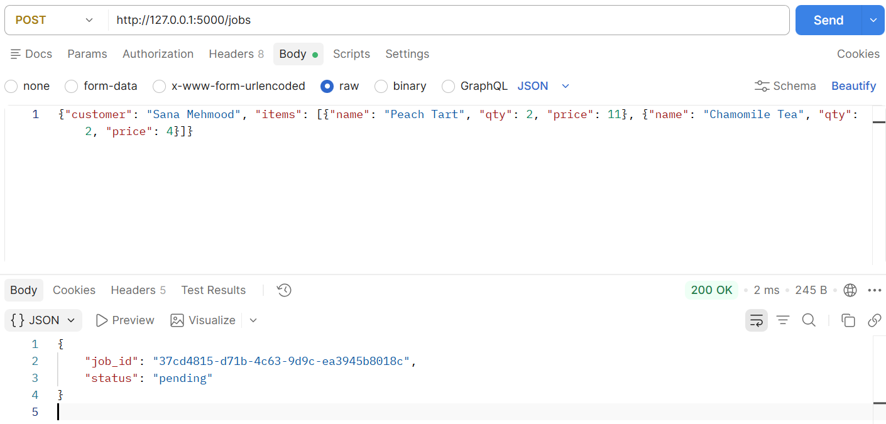
Submitting a job via POST /jobs in Postman — response returns a job_id with status pending
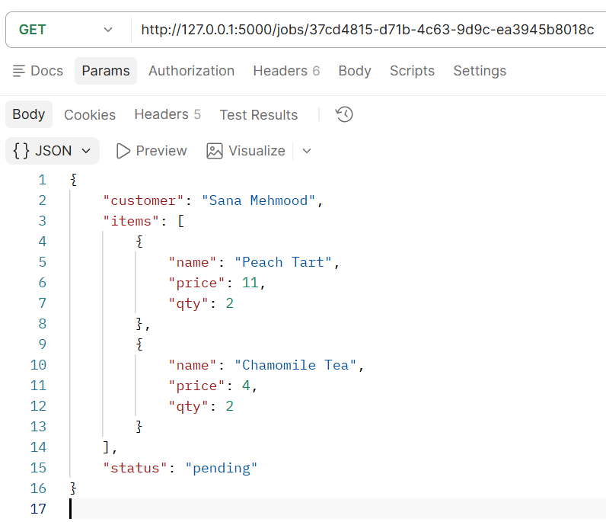
The request body sent for this job
What the request body means: "customer" is the name attached to the invoice. "items" is a list of what was ordered — each item has a "name", a "qty" (how many were ordered), and a "price" (cost per single unit, not the line total). The application calculates each item's line total (qty × price) and the invoice's grand total itself when the PDF is generated; the request body only needs to describe what was ordered, not the totals.
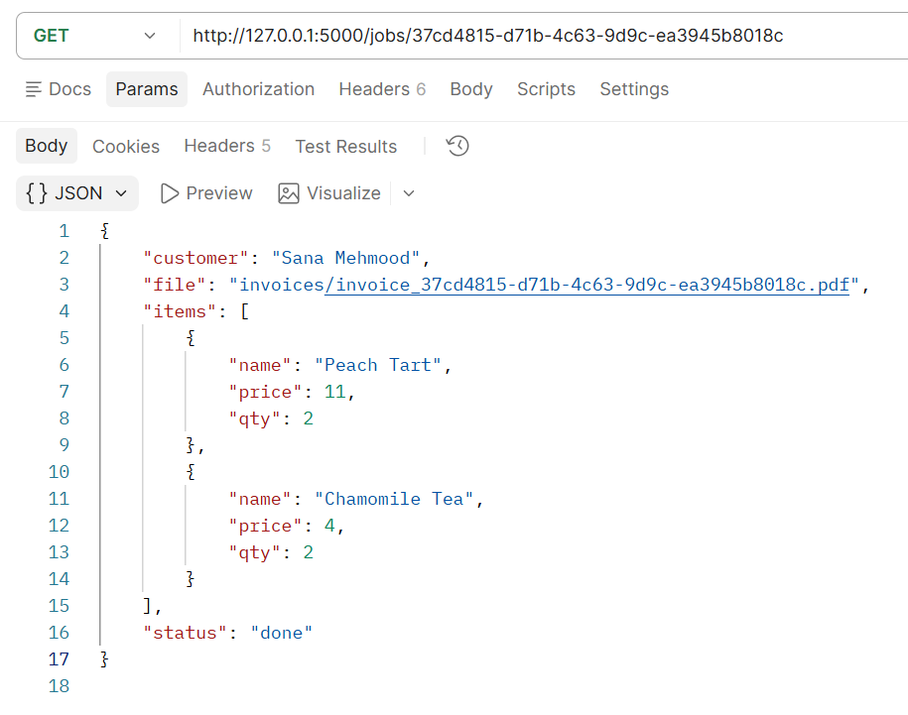
Checking the same job a short time later — status is now done, with a file path to the generated PDF
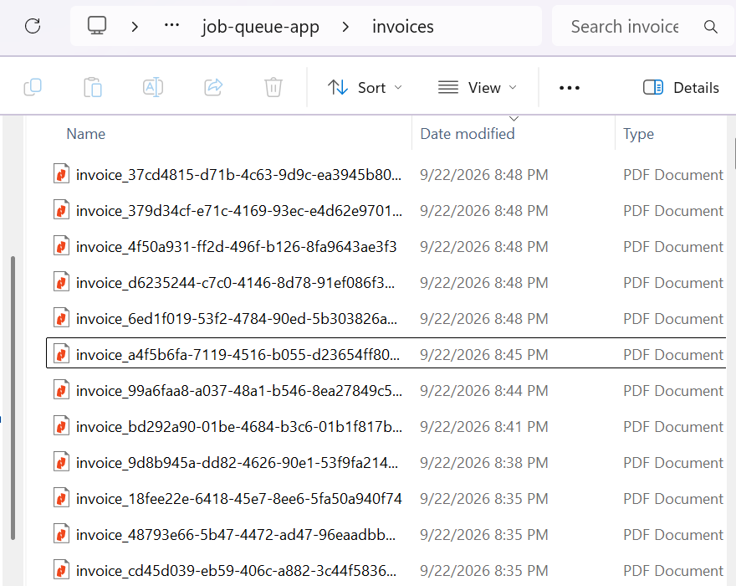
The invoices folder, showing multiple generated PDF files

The actual generated invoice, itemized with quantity, price and total

How Everything Works (Architecture Overview)

The core application flow
- A request hits POST /jobs, handled by create_job() in app.py.
- A unique job ID is generated, the job is stored in memory with status "pending", and the API replies immediately.
- A background thread runs worker_loop() continuously, checking for pending jobs roughly once a second.
- When it finds one, it marks it "in_progress", generates a real PDF invoice via generate_invoice(), then marks it "done".
- GET /jobs/<id> can be called at any time to see the current status.

The metrics pipeline
- The application records numbers using prometheus_client: counters, a gauge, histograms, and a summary.
- These are exposed as plain text at /metrics, in a format Prometheus understands.
- Prometheus, running in Docker, is configured to scrape /metrics, Node Exporter, and windows_exporter every 5 seconds, storing every value with a timestamp.
- Grafana queries Prometheus's stored history and renders it as charts on a dashboard.

The logging pipeline
- The application writes every significant event as structured JSON to logs/app.log.
- Filebeat, running in Docker with the logs/ folder mounted in, watches this file and forwards each new line to Elasticsearch.
- Elasticsearch stores these entries in a way built for fast text search.
- Kibana provides a search interface on top of Elasticsearch.
- A retention policy (Index Lifecycle Management) is configured so log data older than a defined age is automatically deleted.

The fault injection layer
A /chaos endpoint allows two independent settings to be toggled on and off at runtime, without restarting the server or losing in-progress data: an artificial processing delay every Nth job, and a random failure rate applied to each job.

What happens if a component stops working
- Worker thread stops: new jobs still queue as pending, but nothing is processed; jobs_in_progress climbs and never comes back down, visible immediately in Grafana.
- Prometheus stops: the application is unaffected, since it has no awareness of Prometheus; only historical metric collection pauses.
- Filebeat or Elasticsearch stop: logs keep being written to the local file exactly as before, and nothing is lost, but nothing new becomes searchable in Kibana until the pipeline is restored.
- The Flask application itself stops: everything in memory (the jobs dictionary, every metric's current value) is lost, since none of it is persisted to disk. This is a deliberate simplification, per the assignment's instruction not to build a database management system.

Part B: Metrics and Dashboards

Application metrics
All four required metric types are used across the project, alongside one custom, self-explored metric.
Metric Name | Type | Purpose | Unit | Labels | Where / How Recorded
jobs_submitted_total | Counter | Total number of invoice jobs ever submitted | count | none | app.py, create_job() - .inc() called each time a POST /jobs request is received
jobs_in_progress | Gauge | How many jobs are currently pending or being processed right now | count | none | app.py, create_job() (.inc()) and worker_loop() (.dec() once a job finishes)
job_processing_seconds | Histogram | How long each job takes to process, bucketed so percentiles can be derived | seconds | none | app.py, worker_loop() - .observe(duration) after generate_invoice() completes
invoice_file_size_kb | Summary | Average size of generated PDF invoice files | kilobytes | none | app.py, worker_loop() - .observe(file_size_kb) right after the PDF is written to disk
invoice_total_value | Histogram (custom) | Distribution of invoice dollar values, own explored business metric | dollars | custom buckets 10-10000 | app.py, worker_loop() - .observe(invoice_total) after the invoice total is calculated
jobs_failed_total | Counter | Total number of jobs that failed during processing (Part E) | count | none | app.py, worker_loop() - .inc() when a job is randomly failed under failure_rate

Why invoice_total_value was chosen as the custom metric
Every other metric in this project measures something technical: how fast the system runs, how big files are. invoice_total_value instead measures a genuinely business-relevant question: how much is each order actually worth? A shop owner does not just want to know that requests are fast; they want to know whether orders are typically small or large, and whether that is changing over time. Because this metric is a histogram rather than a plain average, it also reveals the spread of order values, not just a single midpoint, which is closer to how an owner would actually think about their business.

Machine metrics: virtualization vs. real host
Machine metrics were collected two separate ways, specifically to check whether Node Exporter's numbers actually represent the real laptop or something else. Node Exporter runs inside Docker, which on Windows means it runs inside a WSL2 Linux virtual machine, a lightweight virtualization layer. CPU and memory figures from Node Exporter are genuinely representative of the real machine, since WSL2 shares the actual hardware directly rather than emulating fake hardware. Disk figures from Node Exporter, however, do not represent the real machine at all: they reflect WSL2's own small internal virtual disk, not the real Windows C: drive, which is visible directly in the panel below (the mountpoints shown are internal container paths such as /etc/hostname, not real folders). windows_exporter, a separate service running natively on Windows rather than inside Docker, was added to measure the same four things directly on the real host, with no virtualization layer involved, so the two sets of panels below can be compared side by side.
Metric / Panel | Source | Purpose | Unit | Machine
CPU Usage % | Node Exporter (WSL2 virtualization) | CPU usage as seen from the WSL2 layer; representative of the real machine since WSL2 shares hardware directly | % | Myrah's Laptop
Memory Usage % | Node Exporter (WSL2 virtualization) | Memory usage as seen from the WSL2 layer; also representative of the real machine | % | Myrah's Laptop
Network Receive Bytes/sec | Node Exporter (WSL2 virtualization) | Network activity as seen from the container's own virtual interface | bytes/sec | Myrah's Laptop
Disk Usage (Container Filesystem) | Node Exporter (WSL2 virtualization) | Limitation: reflects WSL2's own internal virtual disk, not the real C: drive | % | Myrah's Laptop
CPU Usage % | windows_exporter (real host) | CPU usage measured directly on Windows, no virtualization layer | % | Myrah's Laptop
Memory Usage % | windows_exporter (real host) | Memory usage measured directly on Windows, no virtualization layer | % | Myrah's Laptop
Network Receive Bytes/sec | windows_exporter (real host) | Network activity measured directly on the real network adapter | bytes/sec | Myrah's Laptop
Disk Usage % (C: Drive) | windows_exporter (real host) | Accurate real disk usage for the actual C: drive | % | Myrah's Laptop

Grafana panel queries

Total Jobs Submitted
jobs_submitted_total

Jobs Currently In Progress
jobs_in_progress

Average Job Processing Time (seconds)
job_processing_seconds_sum / job_processing_seconds_count

Job Processing Time Distribution (Buckets)
job_processing_seconds_bucket

Average Invoice File Size (KB)
invoice_file_size_kb_sum / invoice_file_size_kb_count

Average Invoice Value ($)
invoice_total_value_sum / invoice_total_value_count

CPU Usage % (WSL2 Virtualization - Node Exporter) - Myrah's Laptop
100 - (avg(rate(node_cpu_seconds_total{mode="idle"}[1m])) * 100)

Memory Usage % (WSL2 Virtualization - Node Exporter) - Myrah's Laptop
100 - ((node_memory_MemAvailable_bytes / node_memory_MemTotal_bytes) * 100)

Network Receive Bytes/sec (WSL2 Virtualization - Node Exporter) - Myrah's Laptop
rate(node_network_receive_bytes_total{device!="lo"}[1m])

Disk Usage (Container Filesystem) - Limitation Noted
node_filesystem_avail_bytes

CPU Usage % (Real Host - windows_exporter) - Myrah's Laptop
100 - (avg(rate(windows_cpu_time_total{mode="idle"}[1m])) * 100)

Memory Usage % (Real Host - windows_exporter) - Myrah's Laptop
100 - (windows_memory_available_bytes / 16892956672 * 100)
Total physical memory (16,892,956,672 bytes) was obtained once via Get-CimInstance Win32_ComputerSystem in PowerShell and used as a fixed value, since this windows_exporter build does not expose total memory as its own metric with the default collectors enabled.

Network Receive Bytes/sec (Real Host - windows_exporter) - Myrah's Laptop
rate(windows_net_bytes_received_total[1m])

Disk Usage % (C: Drive) - Myrah's Laptop
100 - ((windows_logical_disk_free_bytes{volume="C:"} / windows_logical_disk_size_bytes{volume="C:"}) * 100)

Screenshots: application metrics and Prometheus
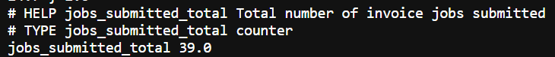
Raw output from /metrics, showing jobs_submitted_total
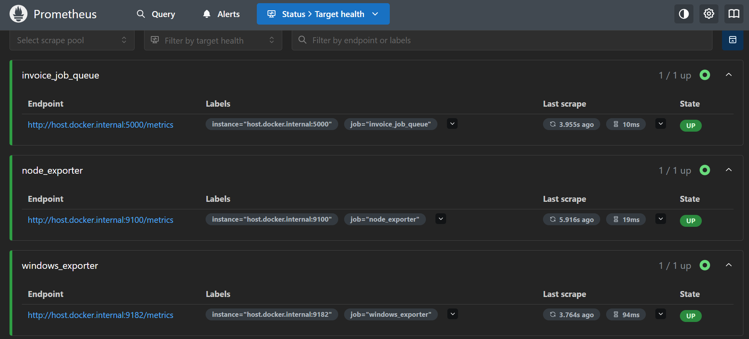
Prometheus Status > Target health, showing all three scrape targets (application, Node Exporter, windows_exporter) as UP

Screenshots: application metrics dashboard
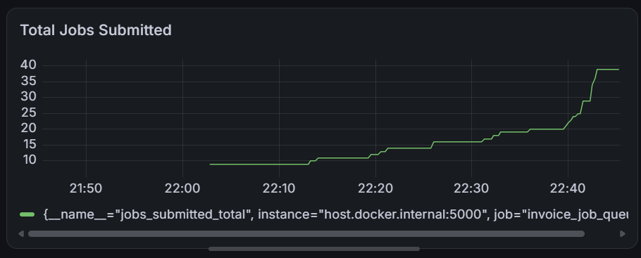
Total Jobs Submitted
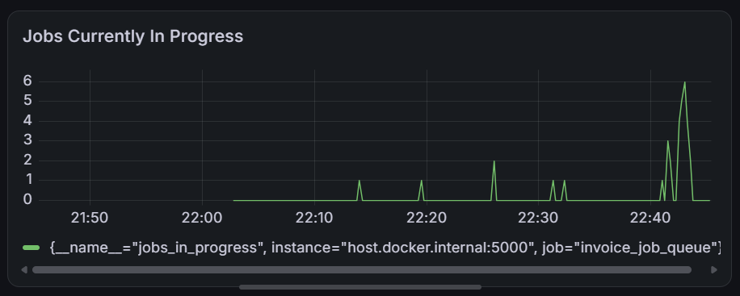
Jobs Currently In Progress
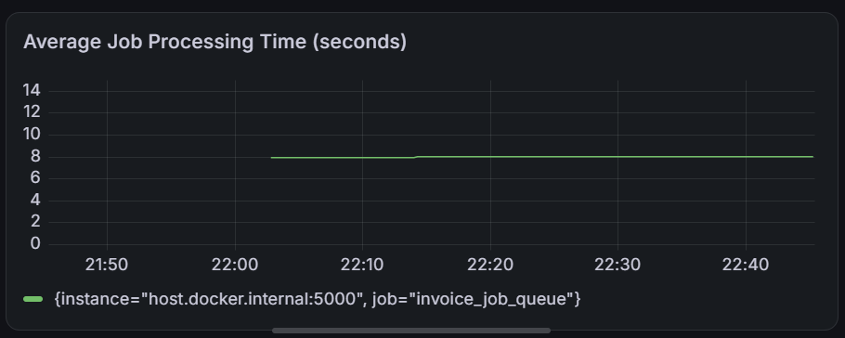
Average Job Processing Time
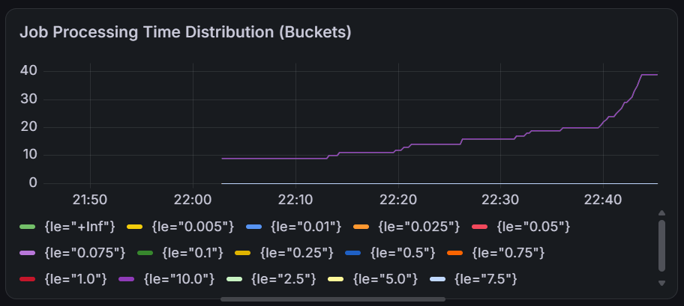
Job Processing Time Distribution (Buckets)
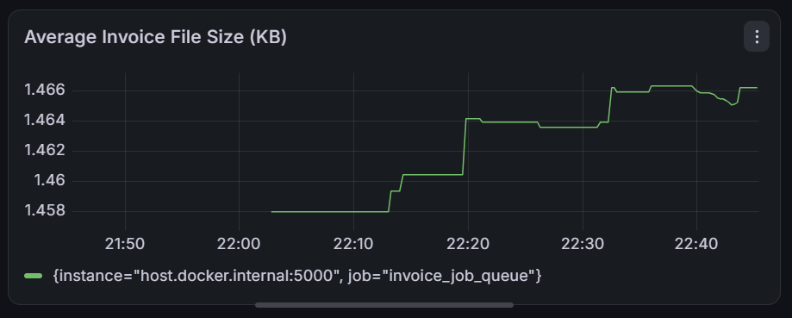
Average Invoice File Size
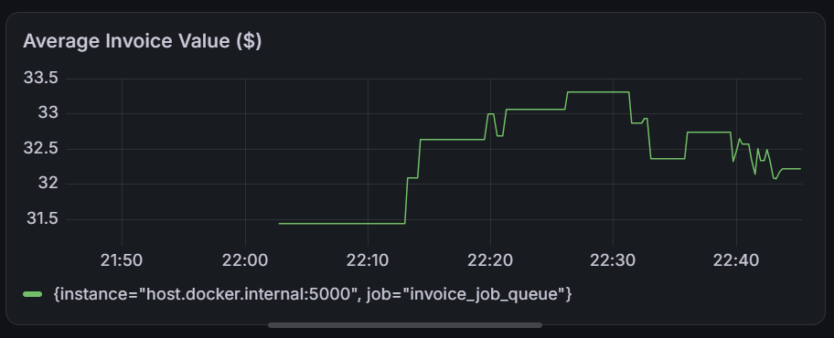
Average Invoice Value

Screenshots: machine metrics, last 24 hours (virtualization vs. real host)

WSL2 virtualization (Node Exporter)
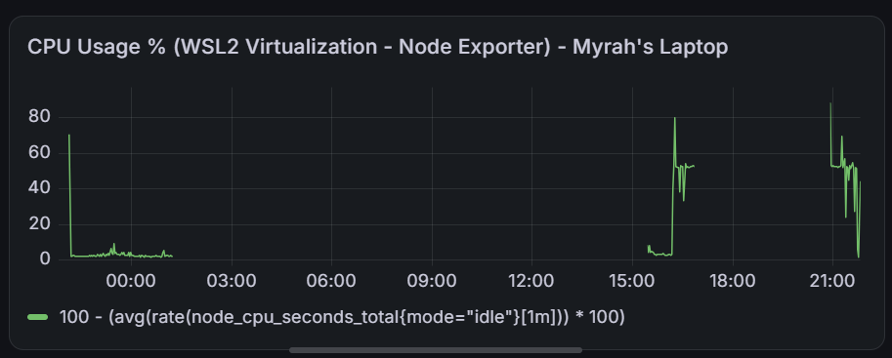
CPU Usage % (WSL2 Virtualization - Node Exporter) - Myrah's Laptop
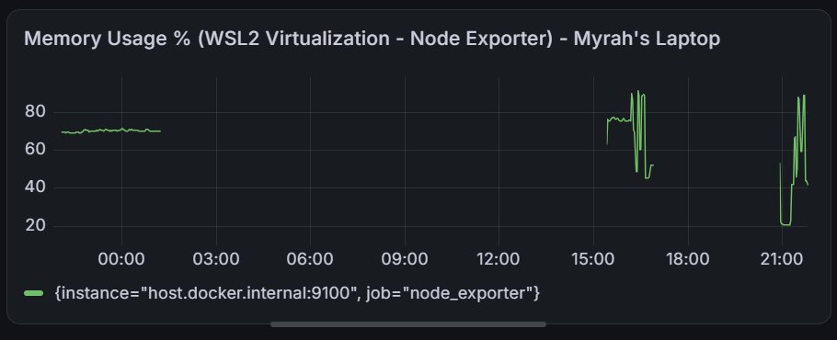
Memory Usage % (WSL2 Virtualization - Node Exporter) - Myrah's Laptop
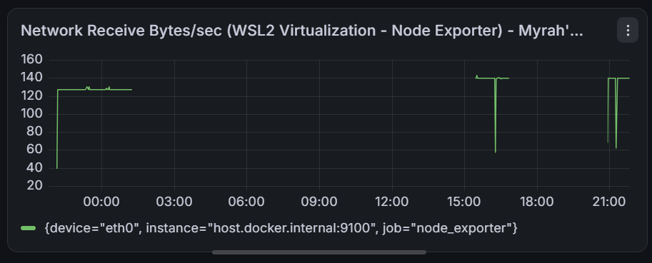
Network Receive Bytes/sec (WSL2 Virtualization - Node Exporter) - Myrah's Laptop
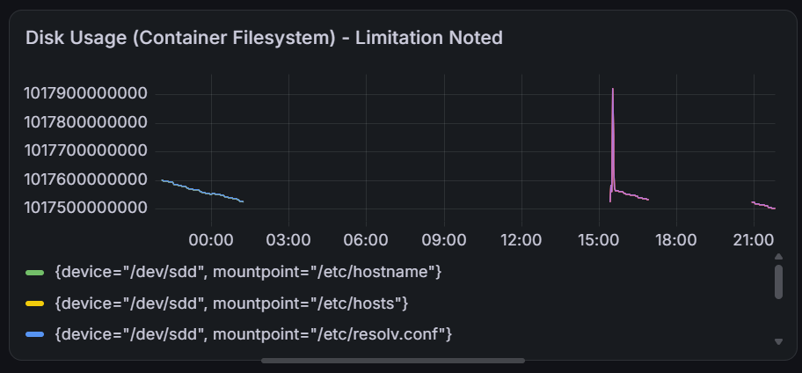
Disk Usage (Container Filesystem) - Limitation Noted: the labels shown (/etc/hostname, /etc/hosts, /etc/resolv.conf) are internal container paths, confirming this does not reflect the real C: drive

Real host (windows_exporter)
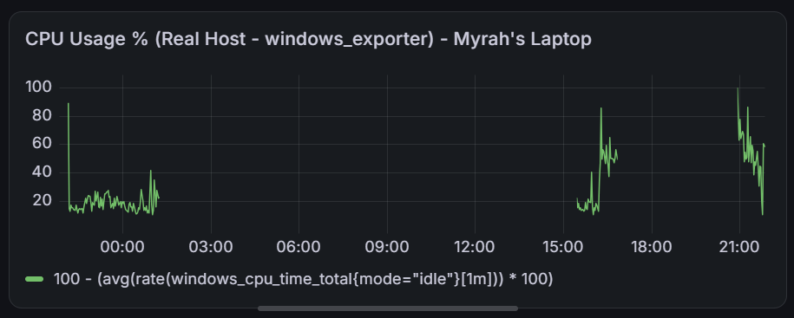
CPU Usage % (Real Host - windows_exporter) - Myrah's Laptop
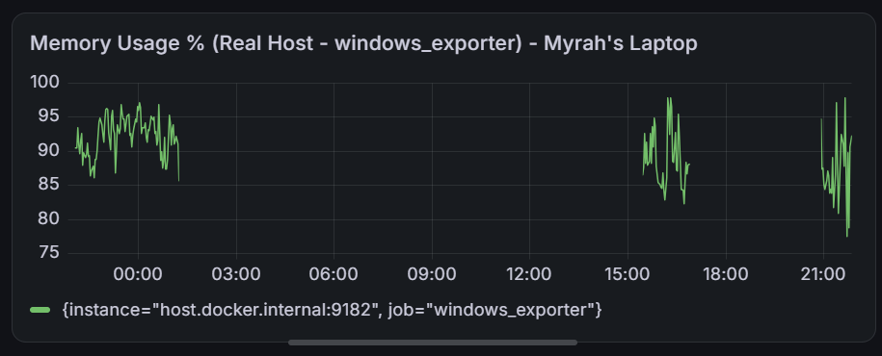
Memory Usage % (Real Host - windows_exporter) - Myrah's Laptop
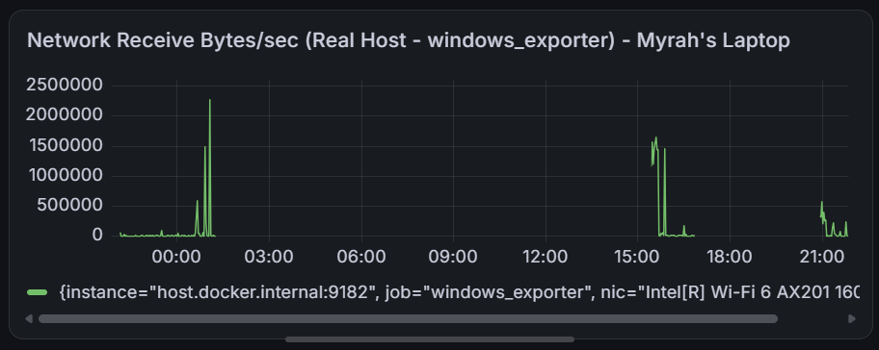
Network Receive Bytes/sec (Real Host - windows_exporter) - Myrah's Laptop
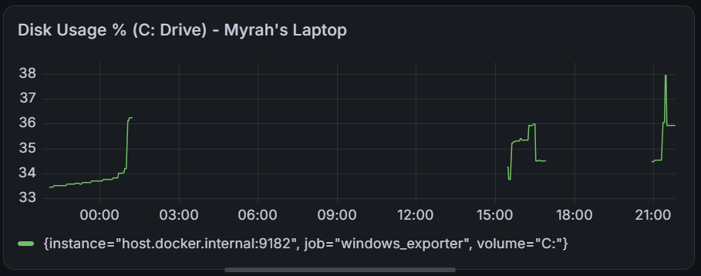
Disk Usage % (C: Drive) - Myrah's Laptop — the accurate figure for the real drive, in contrast to the container-filesystem panel above
The difference between the two sources is clearest on disk: the virtualized panel tracks a tiny, unrelated internal filesystem in the single-digit terabyte-of-bytes range with meaningless mountpoints, while the real-host panel shows a believable 33-38% usage figure for the actual C: drive. For CPU and memory, the two sources track each other reasonably closely in shape, supporting the explanation above that WSL2 shares real hardware for these two resources even though it virtualizes disk separately.

Part C: Logging

What is logged, and why
Every job's lifecycle produces structured JSON log entries at three points: when it is submitted, when the worker starts processing it, and when it completes (or fails, under fault injection). Each entry includes a timestamp, a severity level, a human-readable message, the service name, the job's unique ID (acting as the request ID), and event-specific details such as customer name, item list, processing duration, or invoice total.

Log fields used
- time — the asctime field
- service — the app_service field, identifying the invoice_job_queue service
- severity — the levelname field (INFO for normal events, ERROR for simulated failures)
- message — a short human-readable description of the event
- request ID — the job_id field, unique per job

Real bugs found and fixed
Three separate field-naming collisions were discovered and resolved over the course of this project, all of the same underlying kind: a custom log field happened to share a name with a field Elasticsearch's built-in schema (ECS) expects to be a structured object, causing every affected log line to be silently rejected.
- event renamed to event_type (collided with ECS's structured event field)
- file renamed to invoice_file (collided with ECS's structured file field)
- service renamed to app_service (collided with ECS's structured service field) — this field appears correctly in the screenshots below
Diagnosing each required reading Filebeat's container logs directly for the exact document_parsing_exception reason, rather than assuming the pipeline itself was broken.

How Filebeat collects and parses logs
Filebeat is configured (filebeat.yml) to watch logs/app.log directly. Because the log lines are already valid JSON, json.keys_under_root tells Filebeat to treat each JSON field as its own separate, searchable field, rather than one block of unstructured text. Filebeat then forwards each new line to Elasticsearch as it appears.

Where logs live, and what survives a restart
- logs/app.log lives on disk and is unaffected by restarting Flask or any Docker container — the permanent source of truth.
- Application metrics live only in the Flask process's memory and reset to zero on restart.
- Once ingested, data in Elasticsearch persists until removed by the retention policy below.

Log retention (Index Lifecycle Management)
An ILM policy named invoice-app-logs-policy was created in Elasticsearch and attached to Filebeat's data stream. For demonstration purposes the deletion window was set very short (10 minutes) so automatic deletion could actually be observed; it was later extended to a longer, more realistic window for ongoing use. A real production deployment of this system would likely use a longer window still, for example 90 days, to allow time for invoice disputes or accounting queries.

Example searches performed in Kibana
- event_type: "job_submitted" — finds every job submission event
- customer: "<name>" — finds all log entries relating to one specific customer
- items.qty >= 6 — finds bulk orders by per-item quantity
- event_type: "job_completed" and invoice_total > 40 — finds completed jobs above a business-relevant value threshold
- job_id: "<id>" — traces one job's full lifecycle across exactly three log entries

Screenshots
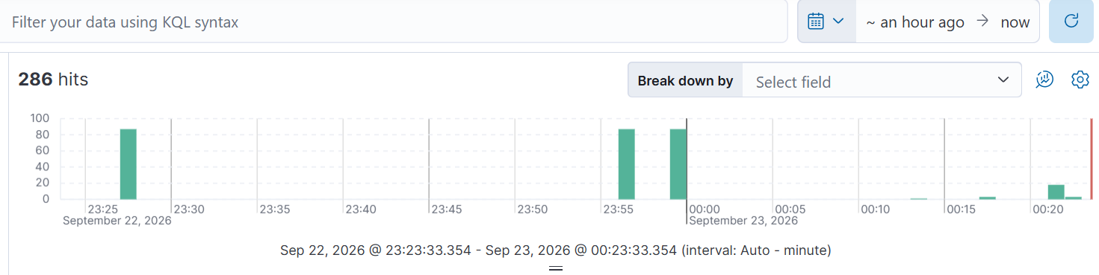
Kibana Discover, full set of ingested logs (286 hits)
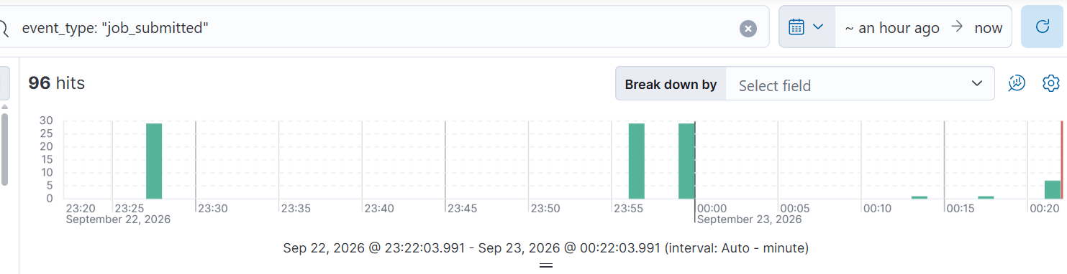
Search: event_type: "job_submitted" (96 hits)
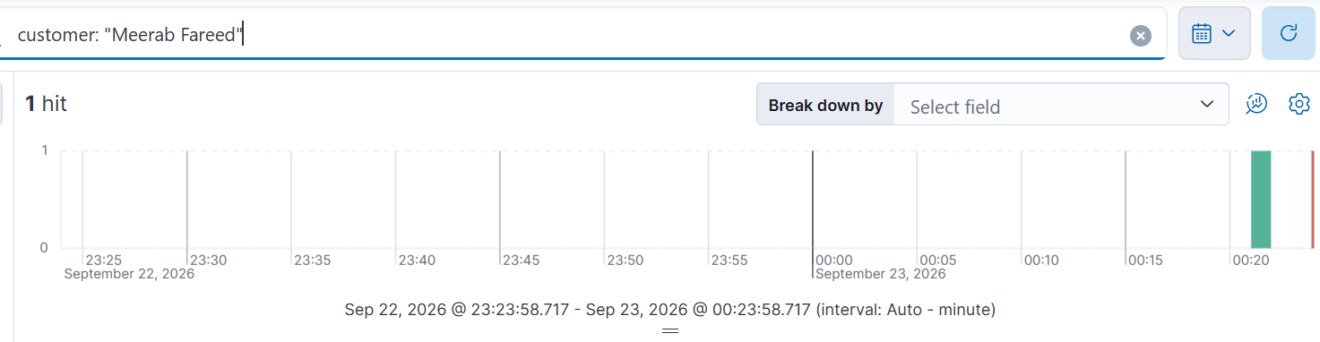
Search: customer: "Meerab Fareed" (1 hit)
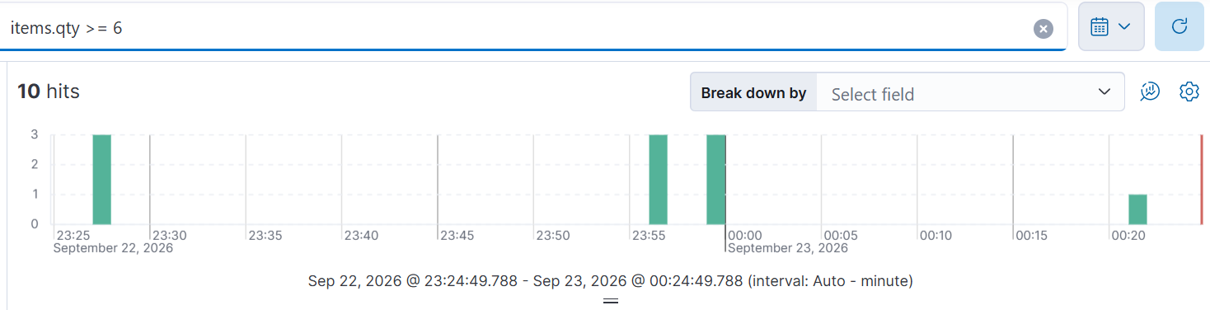
Search: items.qty >= 6 (10 hits)
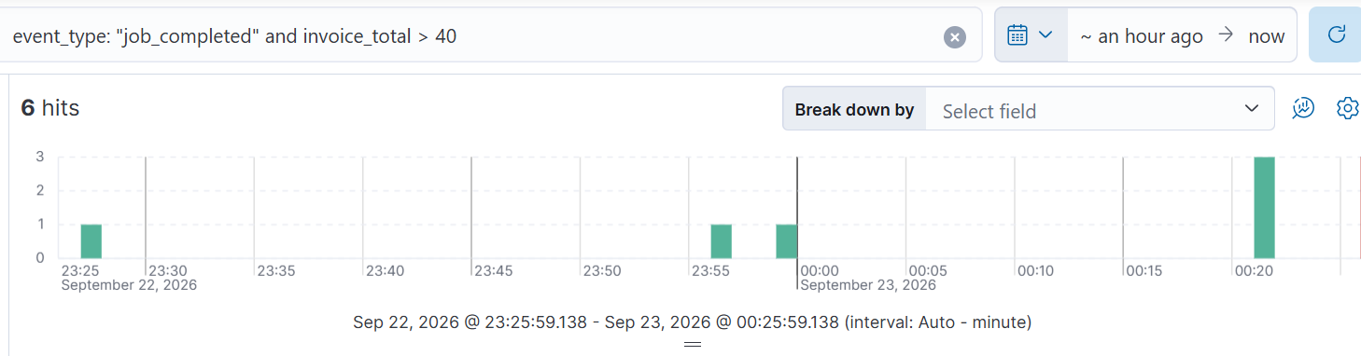
Search: event_type: "job_completed" and invoice_total > 40 (6 hits)
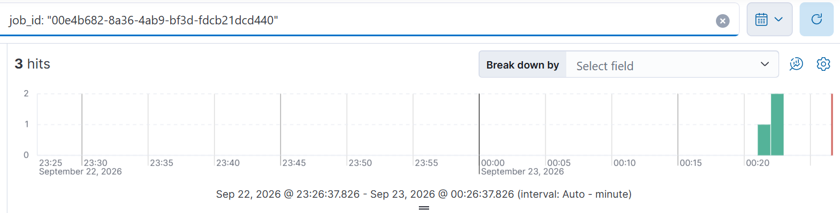
Search: job_id trace, returning exactly 3 hits (submitted, started, completed)
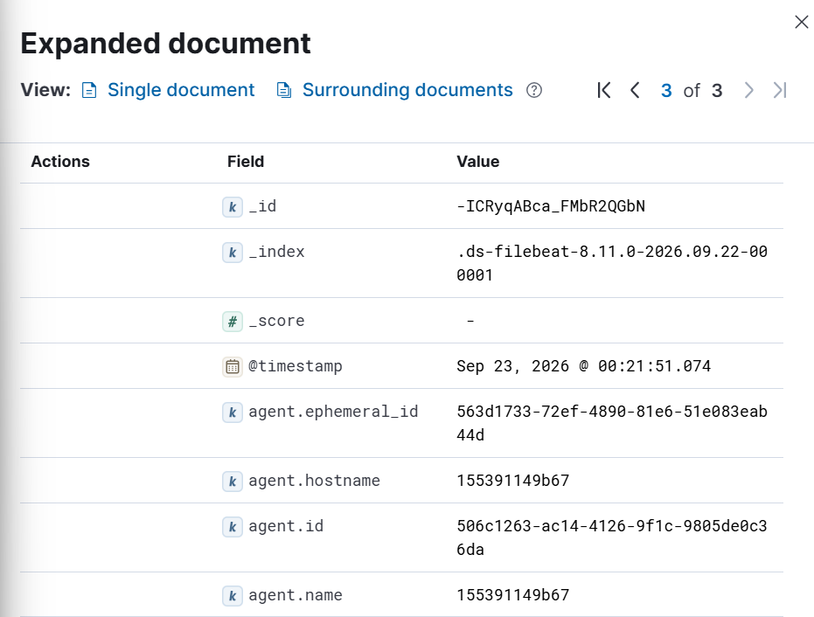
Expanded document view, page 1 of 3 — standard fields
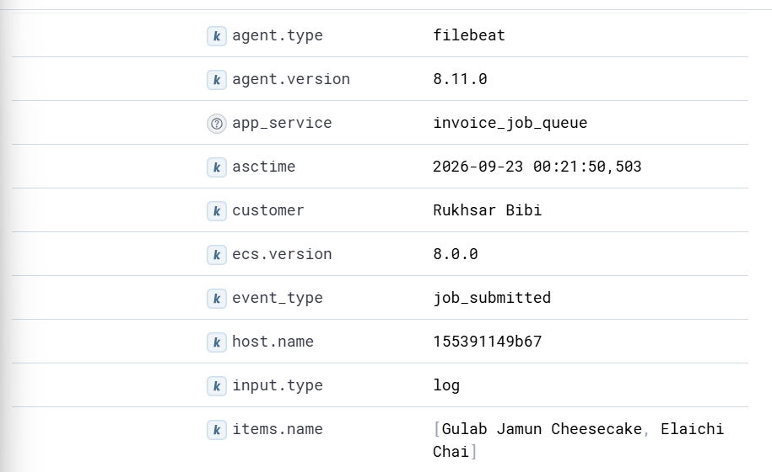
Expanded document view, page 2 of 3 — showing app_service, customer, event_type, items.name
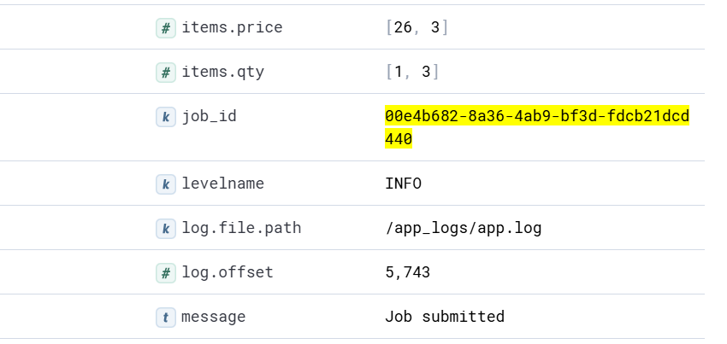
Expanded document view, page 3 of 3 — showing items.price, items.qty, job_id, message

Part D: System Design

1. Architecture diagram
The system consists of three logical groups. The client (Postman or a browser) sends HTTP requests to the Flask application, which contains the API endpoints and a background worker running on a separate thread. The application exposes metrics at /metrics, which Prometheus pulls every 5 seconds along with Node Exporter and windows_exporter; Grafana then queries Prometheus to render dashboards. Separately, the application writes structured JSON logs to a file, which Filebeat reads and forwards to Elasticsearch; Kibana provides the search interface on top of Elasticsearch.
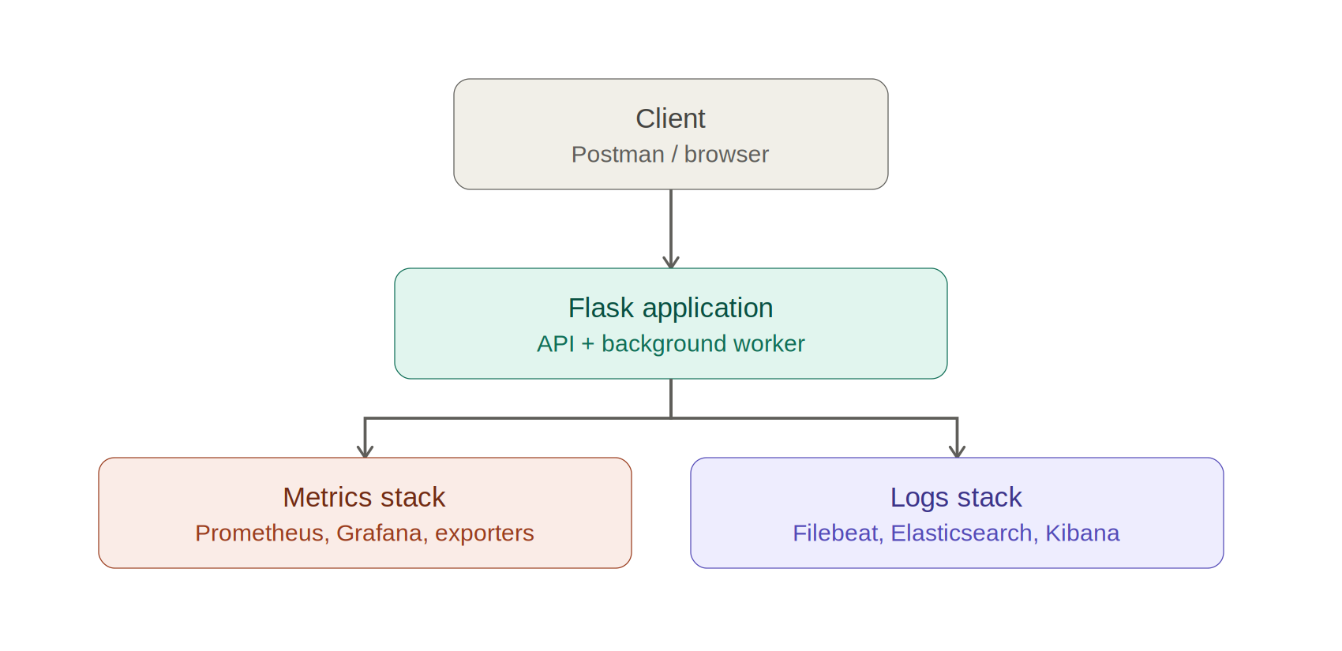
Overview: client, application, metrics stack, logs stack
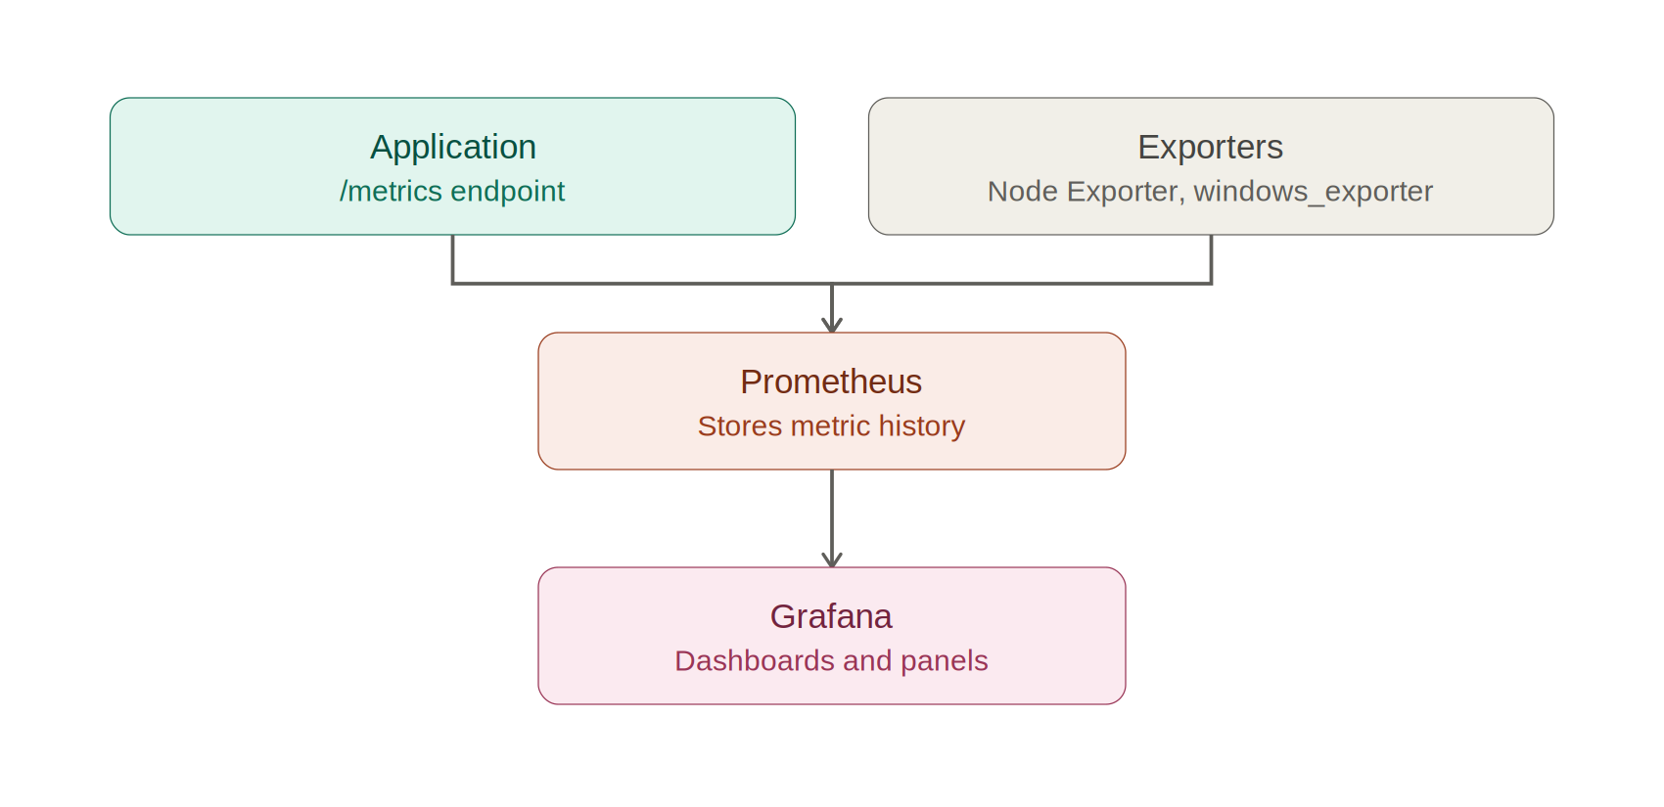
Metrics pipeline detail: application and exporters feed Prometheus, which Grafana queries
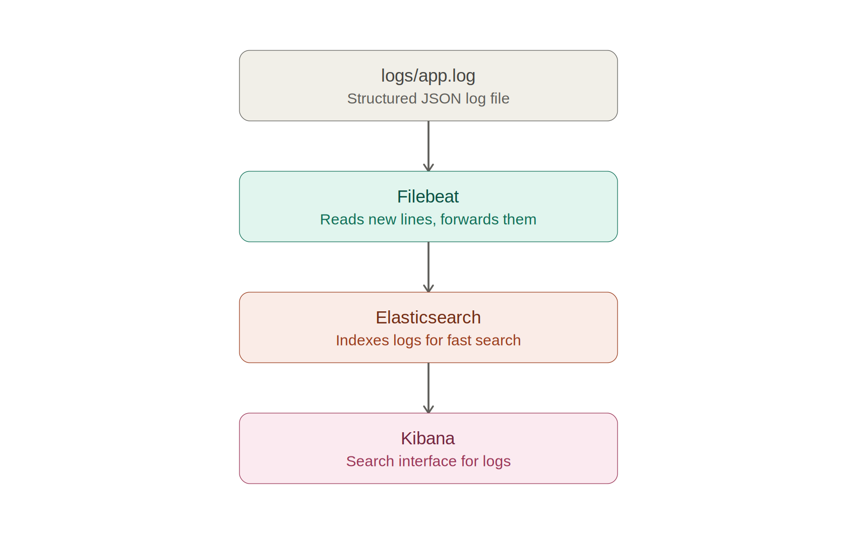
Logs pipeline detail: application writes a file, Filebeat forwards it, Elasticsearch indexes it, Kibana searches it
If the worker thread stops, new jobs can still be submitted and will queue as pending, but nothing will be processed; jobs_in_progress would climb and never come back down, visible immediately on the Grafana dashboard. If Prometheus stops, the application is unaffected, since it has no awareness of Prometheus; only historical metric collection pauses. If Filebeat or Elasticsearch stop, logs keep being written to the local file exactly as before, and nothing is lost, but nothing new becomes searchable in Kibana until the pipeline is restored.

2. Follow a metric, start to finish: jobs_submitted_total
A single job was submitted specifically to trace through this path: customer "Myrah Hussain", ordering a New York Cheesecake and Blueberry Macarons, given job_id 08c257bb-efa2-47ce-a184-edb47b52dfd9.

Step 1 — the code that updates it
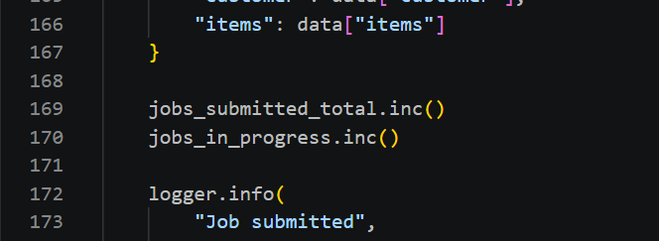
app.py, create_job() — jobs_submitted_total.inc() called immediately before the job is logged

Step 2 — the job that triggered it
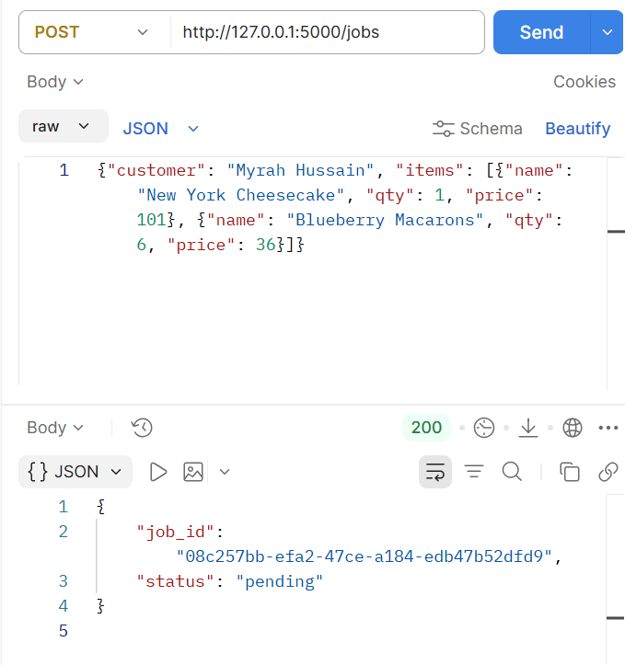
Submitting the traced job via POST /jobs
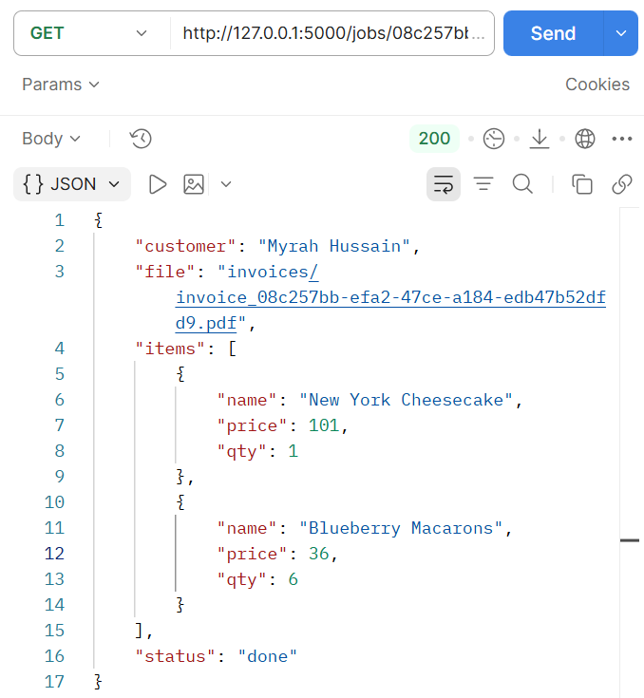
Confirming the job reached status done

Step 3 — the raw value at /metrics
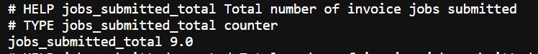
Raw /metrics output: jobs_submitted_total 9.0

Step 4 — Prometheus collecting and storing it
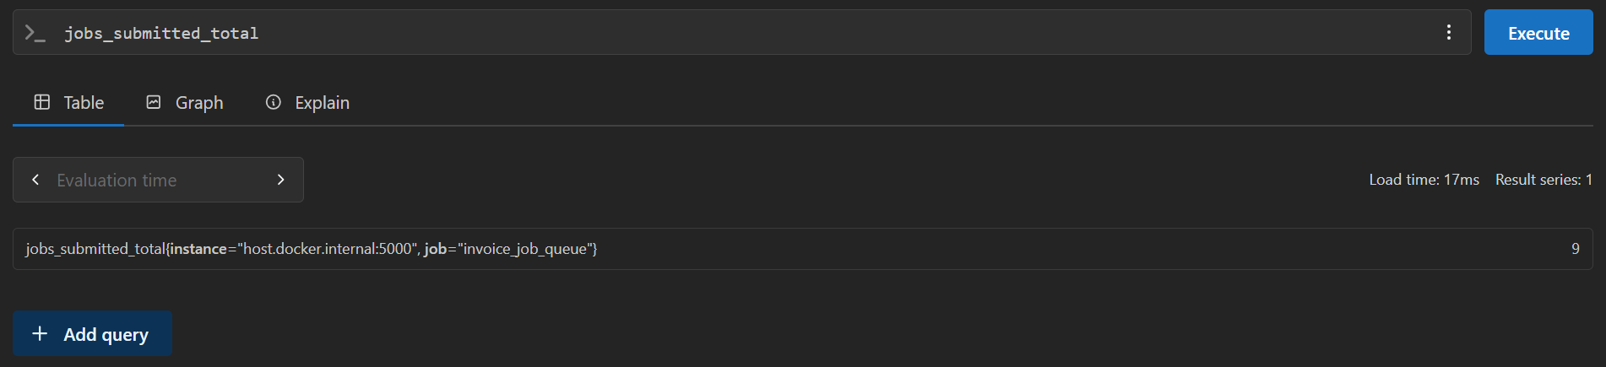
Prometheus query jobs_submitted_total, returning the same value: 9
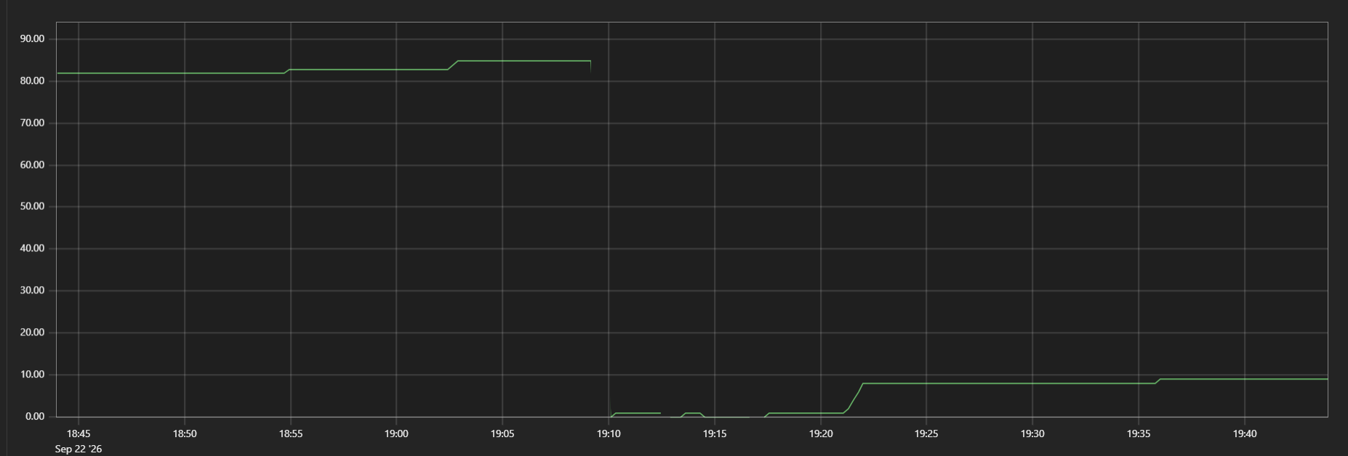
Prometheus Graph view, showing the metric's history over time, including a drop to near-zero at an earlier application restart and its climb back up since

Step 5 — Grafana querying and displaying it
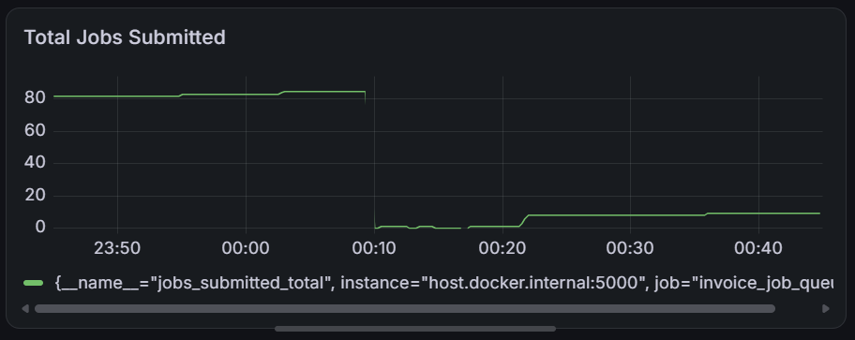
Total Jobs Submitted panel in Grafana, showing the same climb and the same current value
The value is consistent at every stage: the code increments the same in-memory counter each time a job is submitted, /metrics exposes its live value as plain text, Prometheus's own query returns the identical number after scraping it, and Grafana's panel — built from the same query — renders that same history as a chart. The dip visible in the Prometheus graph reflects an application restart during testing, after which the in-memory counter began climbing again from zero, exactly as expected for data that is not persisted to disk.

3. Follow a log, start to finish: job submission event

Step 1 — the code that writes it
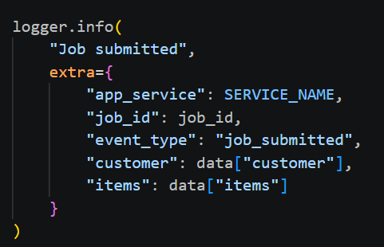
app.py, create_job() — logger.info() call that writes the job_submitted event

Step 2 — the raw line it produces
For a job with job_id 6c5c4689-b399-43fa-8409-66688d3fe7c5 (customer "Real Fix Test"), the three resulting log lines in logs/app.log:
{"asctime": "2026-09-23 00:17:21,861", "levelname": "INFO", "name": "invoice_app", "message": "Job submitted", "app_service": "invoice_job_queue", "job_id": "6c5c4689-b399-43fa-8409-66688d3fe7c5", "event_type": "job_submitted", "customer": "Real Fix Test", "items": [{"name": "Test Item", "qty": 1, "price": 5}]}
{"asctime": "2026-09-23 00:17:22,383", "levelname": "INFO", "name": "invoice_app", "message": "Job processing started", "app_service": "invoice_job_queue", "job_id": "6c5c4689-b399-43fa-8409-66688d3fe7c5", "event_type": "job_started"}
{"asctime": "2026-09-23 00:17:30,391", "levelname": "INFO", "name": "invoice_app", "message": "Job completed successfully", "app_service": "invoice_job_queue", "job_id": "6c5c4689-b399-43fa-8409-66688d3fe7c5", "event_type": "job_completed", "invoice_file": "invoices/invoice_6c5c4689-b399-43fa-8409-66688d3fe7c5.pdf", "duration_seconds": 8.008103370666504, "invoice_total": 5}
The same lines as they actually appear in VS Code, as raw text in the file

Step 3 — how Filebeat parses it
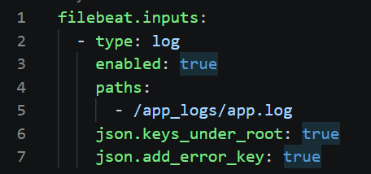
filebeat.yml — json.keys_under_root: true tells Filebeat to treat each JSON key as its own field rather than one block of text

Step 4 — the same event, now searchable in Kibana
Searching by job_id for the traced job (08c257bb-efa2-47ce-a184-edb47b52dfd9) returns exactly the three expected events:
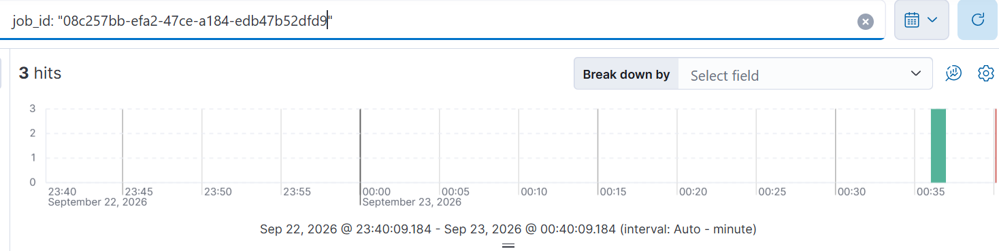
Kibana Discover search: job_id: "08c257bb-efa2-47ce-a184-edb47b52dfd9" — 3 hits (submitted, started, completed)
The raw JSON line written by the code and the document found in Kibana refer to the same underlying event. Filebeat's parsing step is what turns that one unstructured line into individually searchable fields — event_type, customer, and job_id each become their own field, rather than being buried inside one block of text, which is exactly what makes the job_id search above possible.

Part E: Experiments

The /chaos endpoint
A single endpoint was added that lets two independent fault settings be toggled on and off while the server keeps running, without needing a restart or losing in-memory job data: an artificial processing delay applied to every Nth job (slow_every_nth), and a random failure rate applied to each job (failure_rate).

E.1 Reproducing a Problem: Injected Processing Delay
Problem chosen: a simulated backend slowdown, where every Nth invoice job takes significantly longer to process than normal (30 seconds instead of the usual 8 seconds), modeling a real-world scenario such as a database or third-party service becoming temporarily slow under load.

Baseline
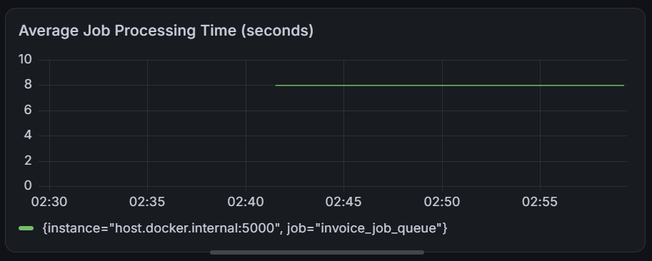
Baseline: flat processing time at 8 seconds, chaos off

Prediction
- The Average Job Processing Time panel would show a visible increase once slow jobs were mixed in with normal ones.
- The Job Processing Time Distribution panel would show a gap open between the "10 seconds or less" bucket and the "+Inf" bucket.
- No change was expected in job success or failure status, since this fault only affects timing.

Introduce the problem
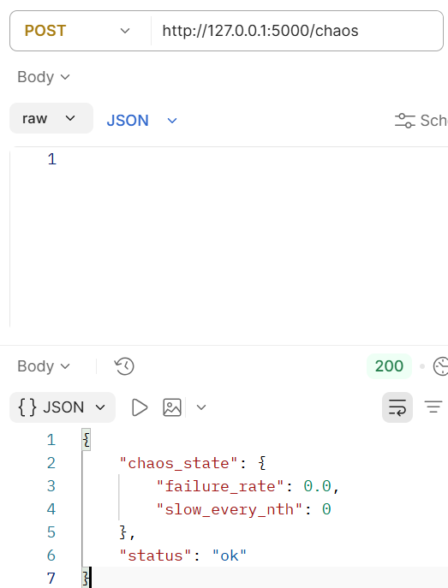
Chaos settings confirmed at baseline (both off) before the fault is introduced
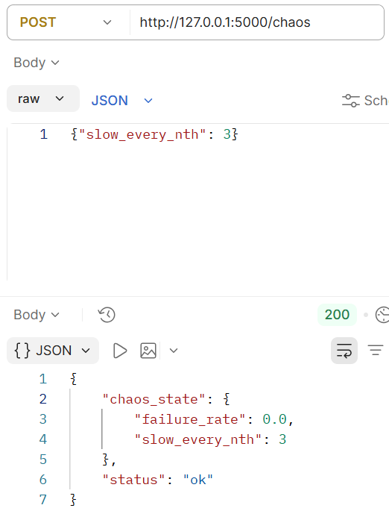
POST /chaos {"slow_every_nth": 3} — fault now active

Observe the change
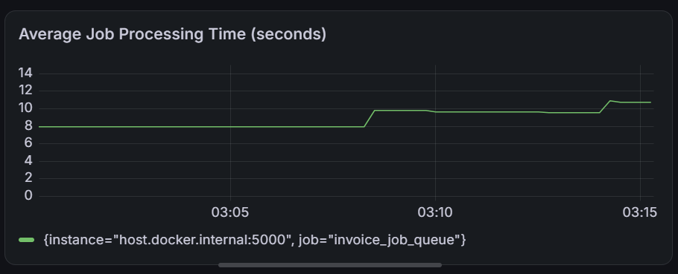
Average Job Processing Time climbing in steps as slow jobs mix in
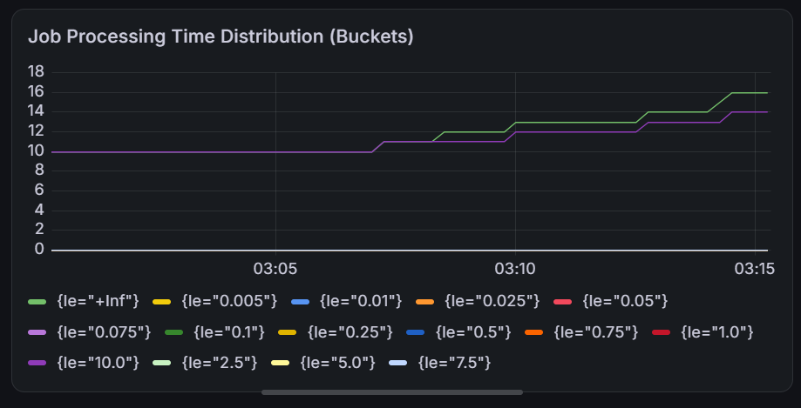
Job Processing Time Distribution (Buckets) — a gap opens between the ≤10s line and +Inf

Cause and effect
This simulates a slow dependency such as a database write or an external API call becoming temporarily unresponsive. The effect on users is a longer wait between submitting an order and receiving the finished invoice — exactly the kind of pattern a monitoring setup is meant to catch early.

Remove the problem and confirm recovery
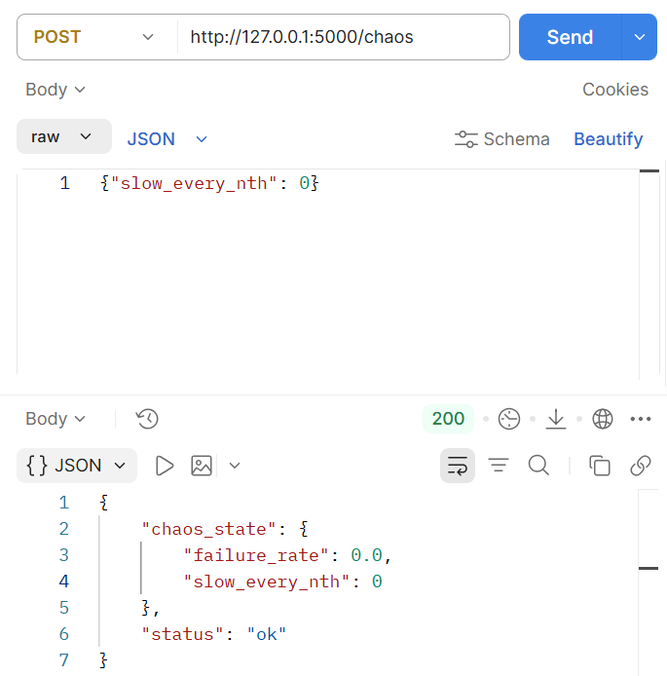
POST /chaos {"slow_every_nth": 0} — fault removed
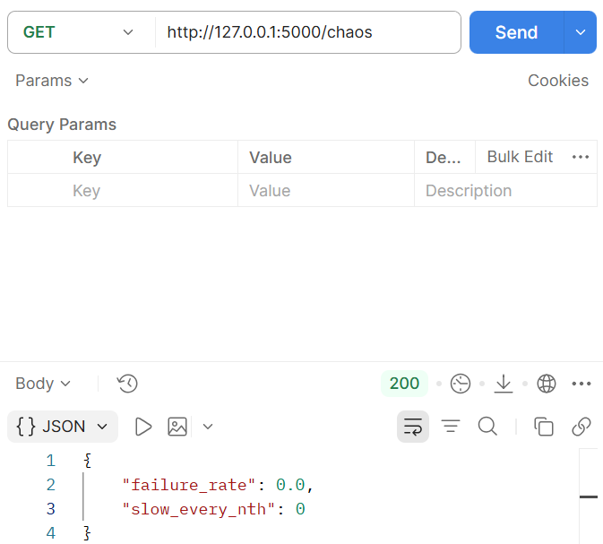
GET /chaos confirming both settings off
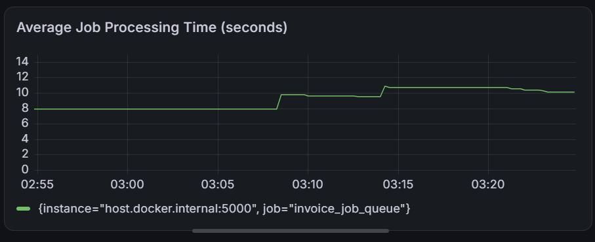
Average Job Processing Time drifting back down toward 8 seconds as new normal jobs dilute the earlier outliers
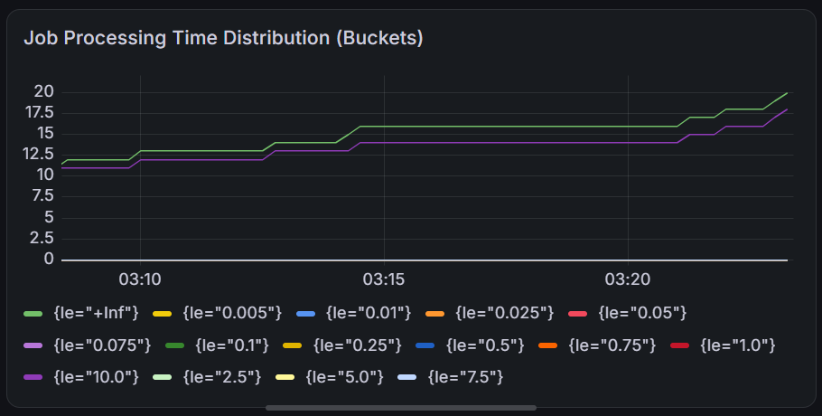
Job Processing Time Distribution — the two bucket lines resume climbing in parallel, confirming recovery

E.2 Reproducing a Problem: Injected Random Failures
Problem chosen: a percentage of jobs randomly fail during processing, simulating an intermittent downstream error such as a payment step or database write occasionally failing.

Introduce the fault
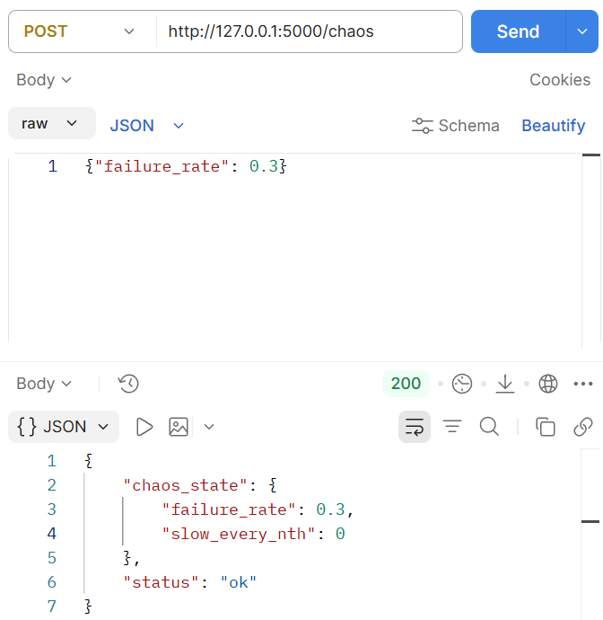
POST /chaos {"failure_rate": 0.3} confirmed active

Observe the change
jobs_failed_total metric climbing to 3.0
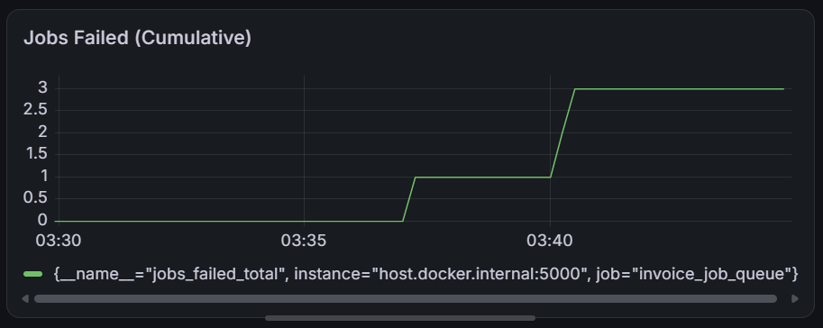
Jobs Failed (Cumulative) Grafana panel, showing the step increase from 0 to 3

Cause and effect
This fault represents an intermittent downstream failure unrelated to system load, unlike the slowdown experiment. The effect on users is that some fraction of orders never complete at all, requiring the customer or shop owner to notice and resubmit, rather than simply waiting longer.

Remove the problem and confirm recovery
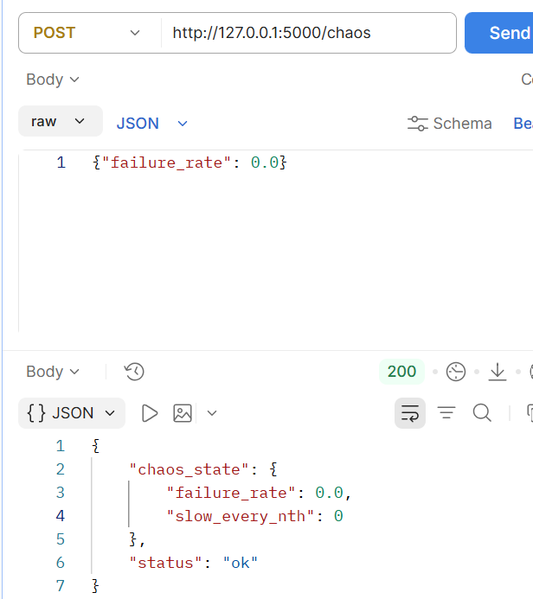
POST /chaos {"failure_rate": 0.0} — fault removed
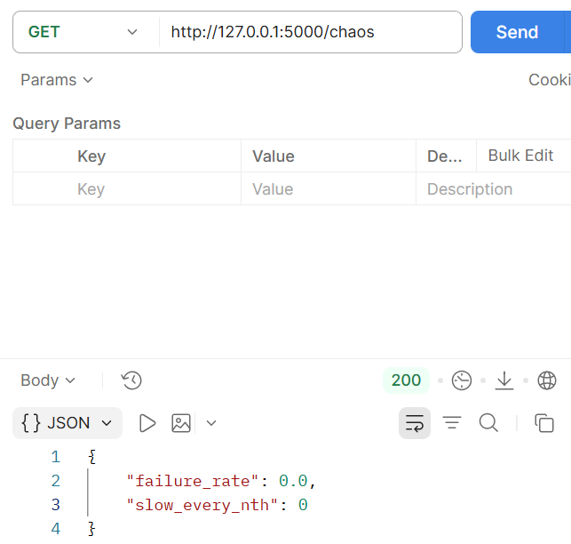
GET /chaos confirming both settings off
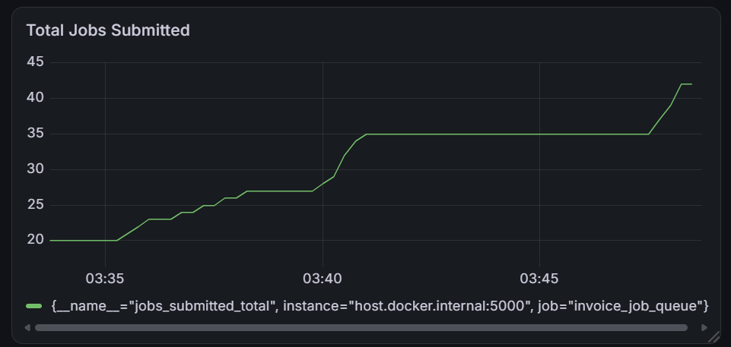
Total Jobs Submitted continuing to climb normally while the failure counter stays flat, confirming recovery

E.3 Cardinality Explosion
Setup: a test counter, cardinality_test_requests_total, labeled with a unique request_id generated on every call to /cardinality-test — deliberately mirroring a common real-world mistake, such as tagging a metric with a request ID or user ID.

Growing the series count
cardinality_test_requests_total showing a single series after the first call
PowerShell loop sending 100 requests
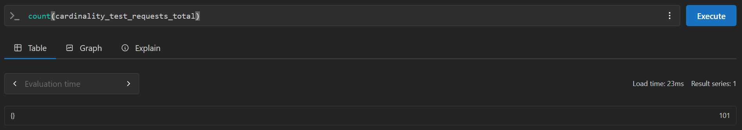
count(cardinality_test_requests_total) query, result: 101
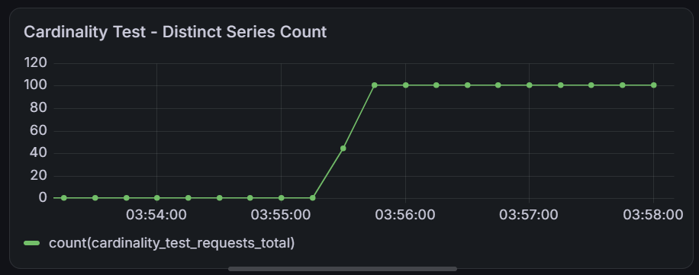
Grafana: distinct series count jumping from 0 to 100
A further 300-request loop pushing the total higher
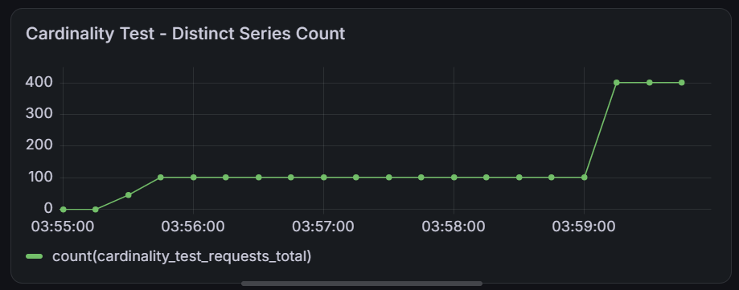
Grafana: distinct series count jumping further, from 100 to 400
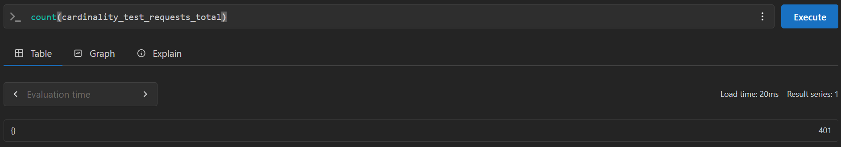
count() query result: 401

Note on an application restart
Partway through testing, the application was restarted to add a comparison endpoint, resetting all in-memory Prometheus metrics (including this one) back to zero, since metrics in this application are held in memory rather than persisted externally. Re-running the same load afterward reproduced the same growth pattern independently, confirming it was consistent and not a one-off artifact.
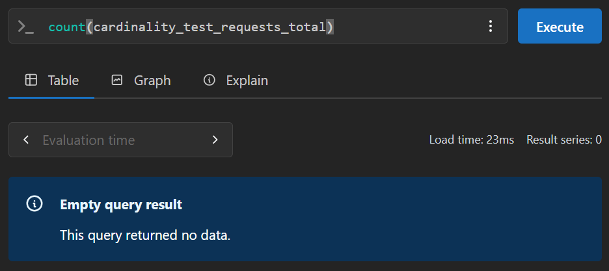
Empty query result immediately after the restart
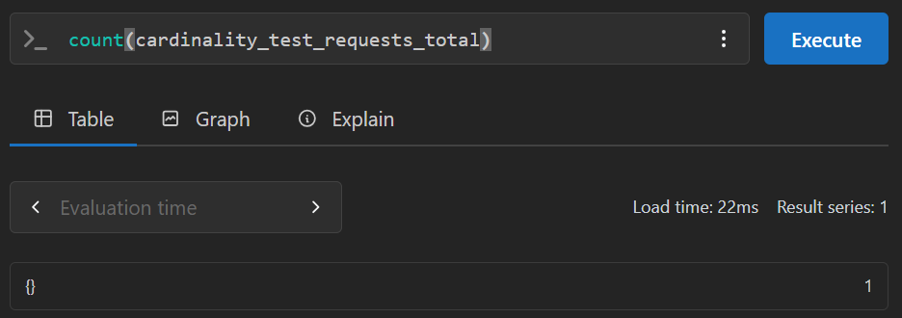
Series count back to 1 after a single fresh call
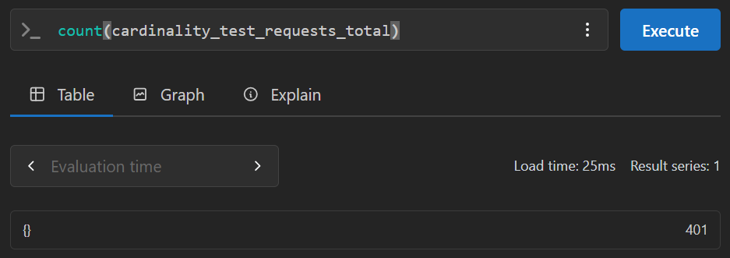
Series count back to 401 after repeating the load

Comparison: removing the unbounded label
A second endpoint, /cardinality-test-safe, was added using a counter with no per-call label at all:
cardinality_test_safe_counter = Counter(
"cardinality_test_safe_requests_total",
"Safe version, no per-request label"
)
Called 400 times using the same loop pattern, count(cardinality_test_safe_requests_total) returned exactly 1, since there is no label creating new series — the counter's actual value still correctly reached 400.
PowerShell loop calling the safe endpoint 400 times (an initial verification run)
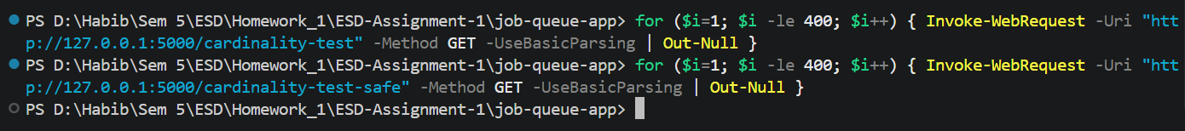
PowerShell loops calling both the unsafe and safe endpoints 400 times each — the final comparison run
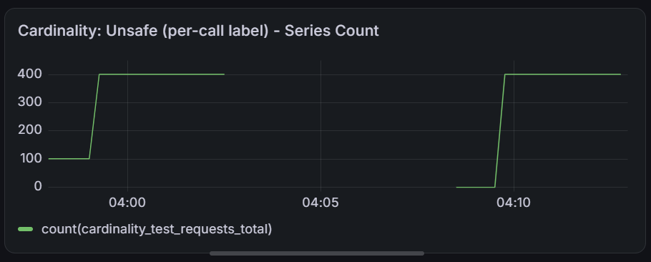
Cardinality: Unsafe (per-call label) — series count climbing to 400 across two separate loads, before and after an application restart
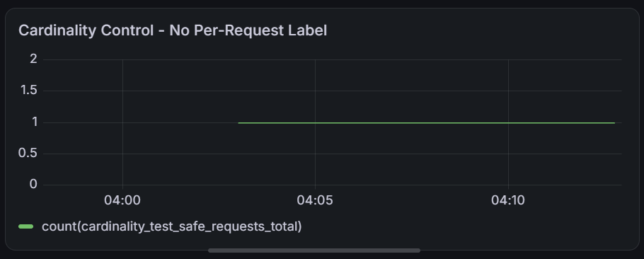
Cardinality Control (No Per-Request Label) — flat at exactly 1 throughout

Explaining the cost at scale
With only a few hundred calls, this experiment already created hundreds of permanent, unique time series from a single line of code. In a real production system handling thousands or millions of requests, an unbounded label like a user ID or request ID would create a proportionally massive number of series, consuming memory and degrading query performance in the metrics database. This is exactly why high-cardinality identifiers like request IDs belong in logs, where each entry is independently searchable, rather than in metric labels, where every unique value permanently expands the number of tracked series.

