Lab 1 - Getting Started with RISC-V (Assembly Language) in VS Code

Name: Myrah Hussain, Romaisa Shazad | Student ID: mh10074, rb10107

Task 3:

Code:
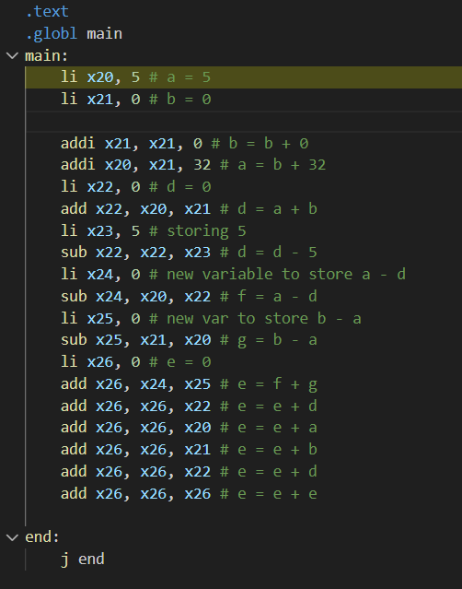

Results:
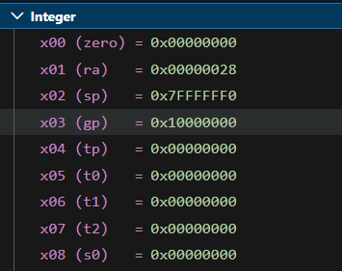
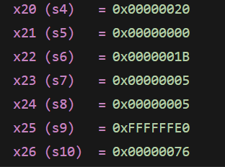

Task 4a:
- Store x10 as unsigned integer at address 0x100.
li x10, 0x78786464 # a = 0x78786464
li x11, 0xA8A81919 # b = 0xA8A81919

sw x10, 0x100(x0)

- Store x11 as unsigned integer at address 0x1F0.
sw x11, 0x1F0(x0)

- Load an unsigned short integer (two bytes) from address 0x100 in x12.
lhu x12, 0x100(x0)

- Load a short integer from address 0x1F0 in register x13.
lh x13, 0x1F0(x0)

- Load a singed character from address 0x1F0 in register x14.
lb x14, 0x1F0(x0)

Full code:
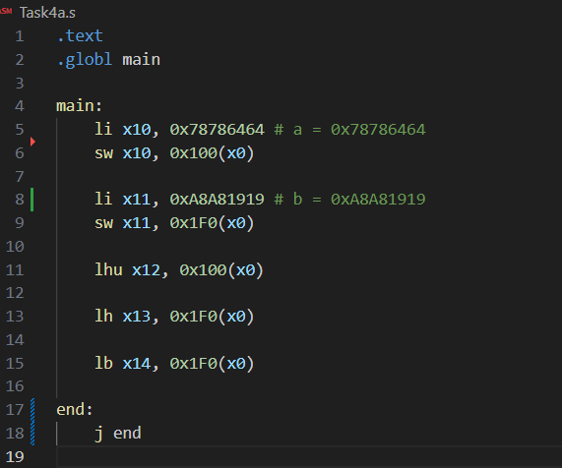
Results:
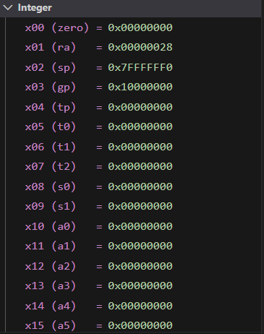

Task 4b:

Code:
// Array A
li x20, 1 // Value for A[0]
sb x20, 0x100(x0)

li x21, 2 // Value for A[1]
sb x21, 0x101(x0)

li x22, 3 // Value for A[2]
sb x22, 0x102(x0)

li x23, 4 // Value for A[3]
sb x23, 0x103(x0)

// Array B
li x24, 5 // Value for B[0]
sh x24, 0x200(x0)

li x25, 6 // Value for B[1]
sh x25, 0x202(x0)

li x26, 7 // Value for B[2]
sh x26, 0x204(x0)

li x27, 8 // Value for B[3]
sh x27, 0x206(x0)

// Array C

// i = 0 C[0] = A[0] + B[0]
// C[0] = 1 + 5 = 6
lb x28, 0x100(x0) // Loading A[0]
lh x29, 0x200(x0) // Loading B[0]
add x30, x28, x29
sw x30, 0x300(x0) // Storing C[0] as unsigned int

// i = 1 C[1] = A[1] + B[1]
// C[1] = 2 + 6 = 8
lb x28, 0x101(x0) // Loading A[1]
lh x29, 0x202(x0) // Loading B[1]
add x30, x28, x29
sw x30, 0x304(x0) // Storing C[1] as character array

// i = 2 C[2] = A[2] + B[2]
// C[2] =3 + 7 = 10
lb x28, 0x102(x0) // Loading A[2]
lh x29, 0x204(x0) // Loading B[2]
add x30, x28, x29
sw x30, 0x308(x0) // Storing C[2] as unsigned int

// i = 3 C[3] = A[3] + B[3]
// C[3] = 4 + 8 = 12
lb x28, 0x103(x0) // Loading A[3]
lh x29, 0x206(x0) // Loading B[3]
add x30, x28, x29
sw x30, 0x30C(x0) // Storing C[3] as unsigned int

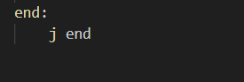

Results:
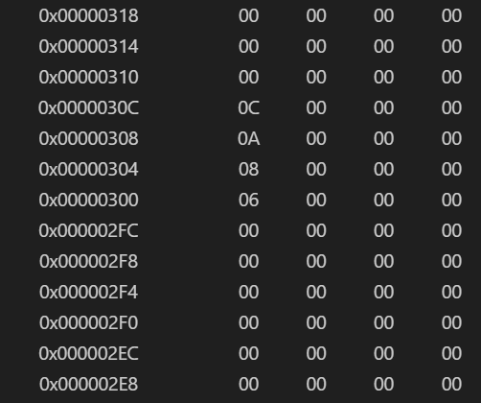
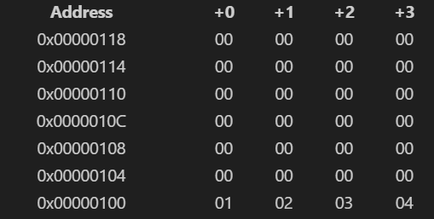
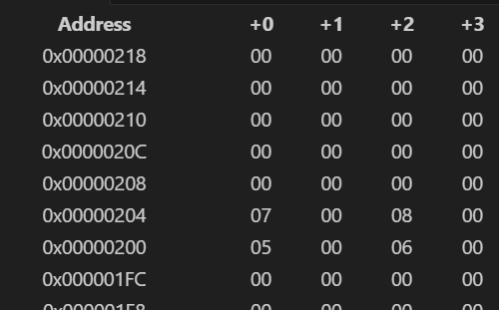

Assessment Rubric
Lab 1: Getting Started with RISC-V (Assembly Language) n VS Code

Name | Student ID: | Section:

Points Distribution:

 | Task No. | LR 2 (Code) | LR 5 (Results)
In-Lab | Task 1 | - | /15
In-Lab | Task 2 | - | /15
In-Lab | Task 3 | /10 | /5
In-Lab | Task 4a | /10 | /5
In-Lab | Task 4b | /10 | /10
Total Points: 100 |  | /30 | /50
CLO Mapped |  | CLO 2

Affective Domain Rubric |  | Points | CLO Mapped
AR7 | Report Submission & Git Upload | /10 & /10 | CLO 2

CLO | Total Points | Points Obtained
2 | 100
Total | 100

