**Ex No: 5 RSA Algorithm**

**Date:**

**Aim:**

To implement RSA (Rivest–Shamir–Adleman) algorithm by using HTML and JavaScript.

**Algorithm:**

1. Choose two prime number p and q
2. Compute the value of n and **p**
3. Find the value of ***e*** (public key)
4. Compute the value of ***d*** (private key) using gcd()
5. Do the encryption and decryption
   1. Encryption is given as,

***c = te mod n***

* 1. Decryption is given as,

***t = cd mod n***

**Program:**

<html>

<head>

<title>RSA Encryption</title>

<meta name="viewport" content="width=device-width, initial-scale=1.0">

</head>

<body>

<center>

<h1>RSA Algorithm</h1>

<h2>Implemented Using HTML & Javascript</h2>

<hr>

<table>

<tr>

<td>Enter First Prime Number:</td>

<td><input type="number" value="53" id="p"></td>

</tr>

<tr>

<td>Enter Second Prime Number:</td>

<td><input type="number" value="59" id="q"></p>

</td>

</tr>

<tr>

<td>Enter the Message(cipher text):<br>[A=1, B=2,...]</td>

<td><input type="number" value="89" id="msg"></p>

</td>

</tr>

<tr>

<td>Public Key:</td>

<td>

<p id="publickey"></p>

</td>

</tr>

<tr>

<td>Exponent:</td>

<td>

<p id="exponent"></p>

</td>

</tr>

<tr>

<td>Private Key:</td>

<td>

<p id="privatekey"></p>

</td>

</tr>

<tr>

<td>Cipher Text:</td>

<td>

<p id="ciphertext"></p>

</td>

</tr>

<tr>

<td><button onclick="RSA();">Apply RSA</button></td>

</tr>

</table>

</center>

</body>

<script type="text/javascript">

function RSA() {

var gcd, p, q, no, n, t, e, i, x;

gcd = function (a, b) { return (!b) ? a : gcd(b, a % b); };

p = document.getElementById('p').value;

q = document.getElementById('q').value;

no = document.getElementById('msg').value;

n = p * q;

t = (p - 1) * (q - 1);

for (e = 2; e < t; e++) {

if (gcd(e, t) == 1) {

break;

}

}

for (i = 0; i < 10; i++) {

x = 1 + i * t

if (x % e == 0) {

d = x / e;

break;

}

}

ctt = Math.pow(no, e).toFixed(0);

ct = ctt % n;

dtt = Math.pow(ct, d).toFixed(0);

dt = dtt % n;

document.getElementById('publickey').innerHTML = n;

document.getElementById('exponent').innerHTML = e;

document.getElementById('privatekey').innerHTML = d;

document.getElementById('ciphertext').innerHTML = ct;

}

</script>

</html>

**OUTPUT:**

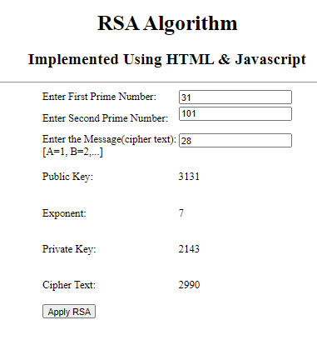

**RESULT:**

Thus the RSA algorithm has been implemented using HTML & CSS and the output has been verified successfully.