


LimeRFE 1v31

– Quick Starter Manual –

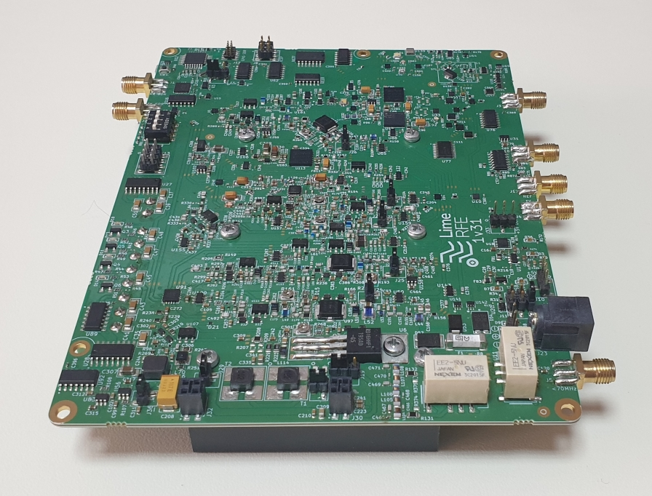

Document version: | 1.0
Document revision: | 10
Last modified: | 5-20-2021 05:53:22 PM

Contents

Table of Contents
Introduction 4
Absolute Maximum Ratings 5
Installing the Control Software 7
Getting Started with the Control Software 8
4.1 Required libraries and tools 8
4.2 Establishing Connection Through SDR 8
4.3 Establishing Direct USB Connection 10
4.4 Overview of the LimeRFE Control Module 11
LimeRFE Connectors and Options 15
5.1 Supply Options 15
5.2 Introduction to the LimeRFE Connectors 16
Block diagram 21
Setting up the LimeRFE board – An Example 27
Changing the bias of TX amplifiers 29
API Functions 33
9.1 Reference 33
RFE_Open 33
RFE_Close 33
RFE_GetInfo 34
RFE_LoadConfig 34
RFE_Reset 34
RFE_Configure 35
RFE_ConfigureState 35
RFE_Mode 36
RFE_ReadADC 36
RFE_ConfGPIO 36
RFE_SetGPIO 37
RFE_GetGPIO 37
RFE_AssignSDRChannels 37
RFE_Fan 37
9.2 Examples 38

Revision History

The following table shows the revision history of this document:

Date | Version | Description of Revisions
12/07/2019 | 1.0.0 | Initial version created.
15/07/2019 | 1.0.1 | Figure 6 and found text errors were corrected.
24/07/2019 | 1.0.2 | Descriptions for J3 and J5 are modified.
01/08/2019 | 1.0.3 | Chapters ‘Block Diagram’ and ‘Absolute Maximum Ratings’ added.
18/11/2019 | 1.0.4 | Hardware of the LimeRFE board has been updated and, accordingly, the whole document follows these changes:  Three RF channels are added:  50 – 70 MHz (6 and 4 m),  220 – 225 MHz (1.25 m) and  902 – 928 MHz (33 cm)
23/01/2020 | 1.0.5 | Four aditional filters added for Cellular Band 1, Band 2, Band 3 and Band 7, in receiver in GSM-LTE sub-block (Table 6).  One additional filter added for Cellular Band 38, in transmitter in GSM-LTE sub-block (Table 7).  U35, U44, U86, U126 changed from SKY13414 and SKY13415 to SKY13416 (Table 6 and Table 7).
20/02/2020 | 1.0.6 | Table 1 and Table 2 right borders updated.  Table 2 all comments deleted and cellular band Peak RF power set to 10 dBm.  Figure 4 cross-reference corrected in Chapter 4.2, in page 10.  Header on odd pages “LimeRFE 0v3 – Quick Starter Manual” changed to “LimeRFE 1v2 – Quick Starter Manual”.  Chapter cross-references added in Introduction.  Table 6 and Table 7 line style updated.
09/03/2020 | 1.0.7 | Figure 1, Figure 2 and Figure 3 inserted with SDR bus description.
24/03/2020 | 1.0.8 | Overall revision. Updated the GUI screenshots.
22/02/2021 | 1.0.9 | Minor GPIO related API functions update
11/03/2021 | 1.0.10 | LimeRFE_1v31 was produced and all images of it were changed accordingly: Front cover picture, Figure 6, Figure 7, Figure 8, Figure 10, Figure 11 and Figure 12.  LimeRFE_1v31 changed HAM3500 power amplifier device, now NXP’s MMZ38333B amplifier module is implemented, so this change is updated in Figure 9, Table 2 and Table 7.  LimeRFE GUI was updated and Figure 3, Figure 4 and Figure 5 are updated accordingly.  Errors in J13, J16 pin description, Table 5, were corrected.

Introduction
This document presents the LimeRFE board. The content of this document is as follows.
Absolute maximum rating are given in Chapter 2.
A link to download all necessary software is given in Chapter 3.
Chapter 4 describes how to run a control software and make a quick start with the LimeRFE board.
A list of all connectors and their brief description are given in Chapter 5.
LimeRFE block diagram is detailed in Chapter 6.
Chapter 7 gives a step-by-step procedure for quick and easy startup of the LimeRFE board, illustrated with an example.
Chapter 8 gives short description of how to adjust bias currents of amplifiers which have that option.
API functions for LimeRFE control are described in Chapter 9.

Absolute Maximum Ratings
Table 1 shows the maximum no damage input powers for RX mode (applied to connectors J3 or J5).
Table 1: Maximum input signals for RX
Channel | Channel Description | RF Input Power [dBm] | Comment
HAM 30 | HF | 10
HAM 50 and 70 | 6 and 4 m | 10
HAM 145 | 2 m | 10
HAM 220 | 1.25 m | 10
HAM 435 | 70 cm | 10
Wideband 1000 | 1 – 1000 MHz | 10
HAM 915 | 33 cm | 20
HAM 1280 | 23 cm | 20
HAM 2400 | 13 cm | 20
HAM 3400 | 9 cm | 20
Wideband 4000 | 1 – 4 GHz | 20
Cellular Band 1 | LTE Band 1 | 20
Cellular Band 2 | LTE Band 2 /  PCS – 1900 | 20
Cellular Band 3 | LTE Band 3 /  DCS – 1800 | 20
Cellular Band 7 | LTE Band 7 | 20
Cellular Band 38 | LTE Band 38 | 20

Note: The received signal will be amplified at the connector SDR RX (J1), care must be taken that the maximum input RF power of the SDR connected is not exceeded.

Table 2 shows the maximum no damage input powers for TX mode (applied to connectors J2).
Table 2: Maximum input signals for TX
Channel | Channel Description | Peak RF Input Power [dBm] | Comment
HAM 30 | HF | 13
HAM 50 and 70 | 6 and 4 m | 13
HAM 145 | 2 m | 15
HAM 435 | 70 cm | 13
Wideband 1000 | 1 – 1000 MHz | 0
HAM 1280 | 23 cm | 5
HAM 2400 | 13 cm | -10
HAM 3400 | 9 cm | -10
Wideband 4000 | 1 – 4 GHz | 5
Cellular Band 1 | LTE Band 1 | 10
Cellular Band 2 | LTE Band 2 /  PCS – 1900 | 10
Cellular Band 3 | LTE Band 3 /  DCS – 1800 | 10
Cellular Band 7 | LTE Band 7 | 10
Cellular Band 38 | LTE Band 38 | 10

Installing the Control Software
Software control of LimeRFE is integrated into the LimeSuite software.
Information on LimeSuite, as well as the installation instructions are available here:
https://wiki.myriadrf.org/Lime_Suite

Getting Started with the Control Software
In this chapter the basic information regarding the LimeRFE board and control software will be presented. The purpose is to get the LimeRFE up and running with as little effort as possible, emphasizing the essential information. Detailed information on the board and the control software will be provided in the following chapters.
  - Required libraries and tools
There are 2 possible ways to connect the software with the LimeRFE board:
- Through SDR board − Communication is established through any of the LimeSDR platforms.
- Directly, through USB − Direct communication via USB.

Basic setup using both connection types will be presented in the following.
  - Establishing Connection Through SDR
In order to connect to the LimeRFE board through SDR, an additional Lime SDR platform board is needed. Setup using LimeSDR-Mini is illustrated in Figure 1. SDR bus communication is achieved through 10-pin flat cable which is connected to two of 2x5 pin headers on both boards (“FPGA GPIO” header on LimeSDR-Mini and “GPIO SDR” header on the LimeRFE). The communication between the SDR board and LimeRFE is implemented utilizing I²C protocol.
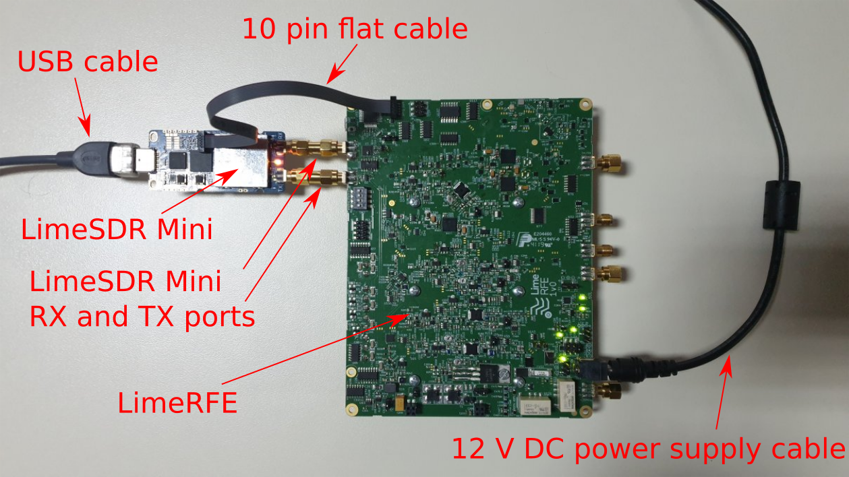
Figure 1: Connection between LimeSDR-Mini and LimeRFE.
(RF connection is achieved with two gender-changer SMA adapters.
Communication is through the 10-pin flat cable.)
The basic setup procedure is described bellow:
- Open Lime Suite GUI and then go to Options→Connection Settings (Figure 2).
- Mark available Lime SDR platform board and press Connect button, in Connection Settings window.
- After connection is established, go to Modules→LimeRFE
- After LimeRFE module is opened, LimeRFE Controls window is displayed (Figure 3).
- In Communication panel, choose SDR option.
Keep in mind that for SDR (I²C) communication, any of the additional Lime SDR platforms board must be connected. Communication is established with the Open Port button. Close Port button terminates the communication.
- After clicking Open Port button a confirmation message is displayed in Message Display panel (Figure 3).
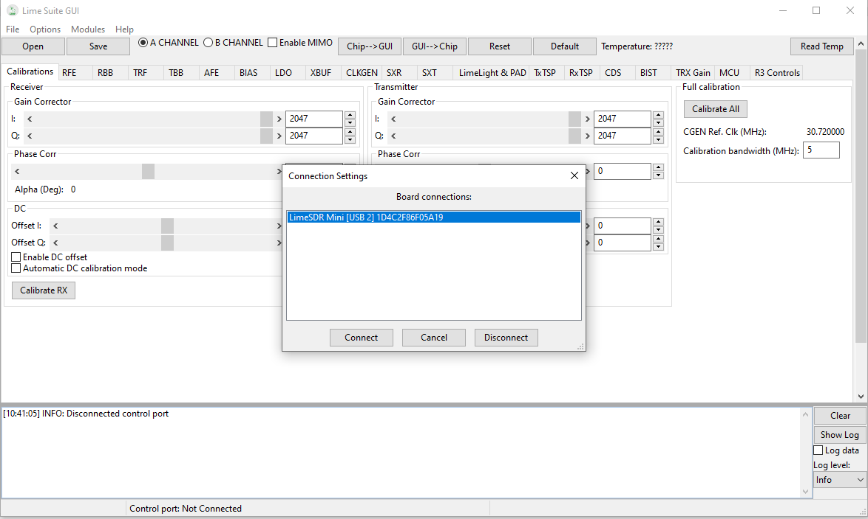
Figure 2: Lime Suite GUI window

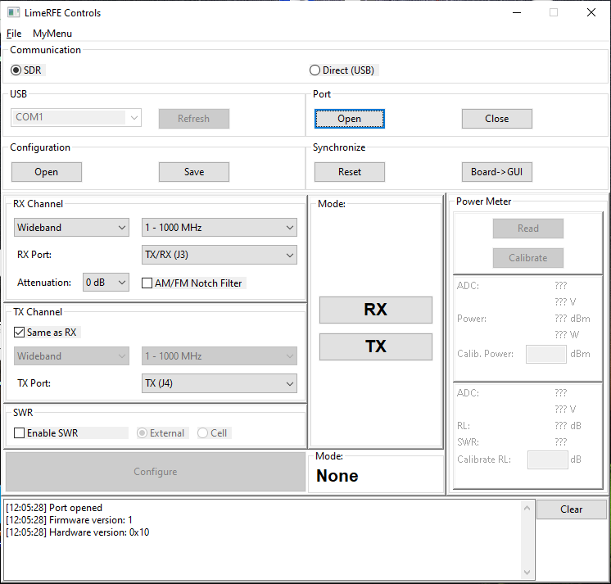
Figure 3: LimeRFE Controls window

  - Establishing Direct USB Connection
Basic procedure for establishing direct USB connections is as follows:
- Open Lime Suite GUI and then go to Modules→LimeRFE.
- LimeRFE Controls window appears.
- In Communication panel choose option Direct (USB).
- From a drop menu select appropriate COM port (Figure 4) and click Open Port button to open communication between the LimeRFE board and PC. Notification in Message Display panel will be shown after a successful port opening.
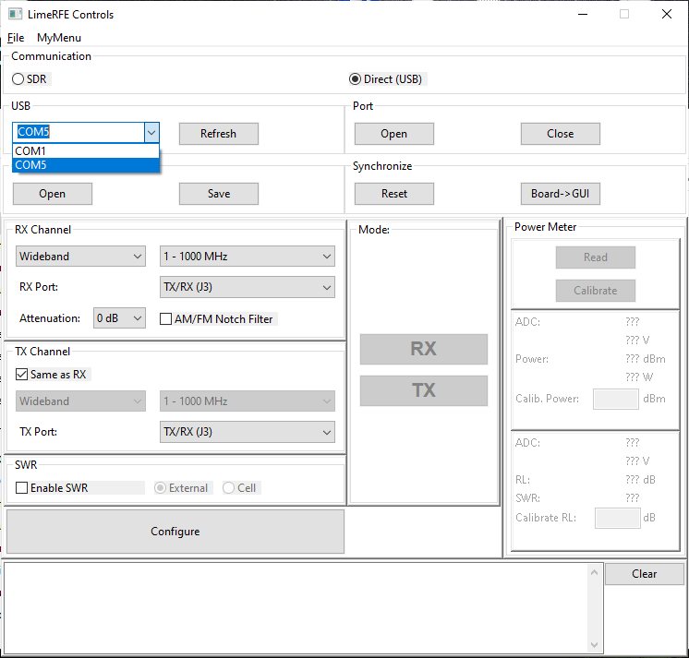
Figure 4: LimeRFE Controls window – Direct USB connection
  - Overview of the LimeRFE Control Module
In order to open the LimeRFE Control module, in LimeSuite main window choose Modules→LimeRFE. LimeRFE Controls window is shown in Figure 3. It consists of several panels: Communication, Configuration, Synchronize, RX Channel, TX Channel, SWR, Mode, and Message Display panel. Overview of this window will be given in the following.
- Configuration panel enables the current configuration to be saved into the *.ini file (Save button), and previously saved configuration to be loaded from the *.ini file (Open button).
- In Synchronize panel, any current configuration can be changed to default, by clicking Reset button. Button Board→GUI is used to synchronize the control windows with the current board configuration.
- RX Channel panel enables the user to choose RX channel, by first choosing the appropriate channel type (Wideband, HAM, or Cellular), and then choosing the desired channel.
It is then possible to choose the desired RX port.
Possible combinations are listed in Table 3 bellow.
In the same panel, the RX attenuation level can be set.
In the same panel, AM/FM Notch filter can be enabled or bypassed.
Note: After any change, button Configure must be pressed to apply new settings.
- In TX Channel panel a TX channel and port can be chosen.
Possible combinations are listed in Table 3 bellow.
- If SDR connection is established, and HAM is chosen, an additional item “Auto” is available in the selection of channels. This option enables automatic selection of channels to provide the best match to the SDR frequencies. For example, if LimeSDR receiver is set to operate at 145 MHz, then LimeRFE receiver will be set to type “HAM”, and channel “144 – 146 MHz (2m)”. However, the desired ports must be chosen by the user.
- Mode panel enables RX or TX mode control. Not all modes are available for all channels. Possible combinations are given in Table 3 bellow.

Table 3: All possible states of the LimeSDR board (Type, Band/Channel, Rx and Tx connectors, Modes)
Type | Channel/Band | RX Port | TX port | Mode
Wideband | 1 – 1000 MHz | TX/RX (J3) | TX/RX (J3) | None, RX, TX
 |  |  | TX (J4) | None, RX, TX, RX&TX
 |  | TX to 30 MHz TX/RX (J5) | TX/RX (J3) | None, RX, TX, RX&TX
 |  |  | TX (J4) | None, RX, TX, RX&TX
 | 1000 – 4000 MHz | TX/RX (J3) | TX/RX (J3) | None, RX, TX
 |  |  | TX (J4) | None, RX, TX, RX&TX
HAM | 30 MHz (HF) | TX/RX (J3) | TX to 30 MHz TX/RX (J5) | None, RX, TX, RX&TX
 |  | TX to 30 MHz TX/RX (J5) |  | None, RX, TX
 | 50 – 70 MHz (6 & 4 m) | TX/RX (J3) | TX to 30 MHz TX/RX (J5) | None, RX, TX, RX&TX
 |  | TX to 30 MHz TX/RX (J5) |  | None, RX, TX
 | 144 – 146 MHz (2 m) | TX/RX (J3) | TX/RX (J3) | None, RX, TX
 |  |  | TX (J4) | None, RX, TX, RX&TX
 |  | TX to 30 MHz TX/RX (J5) | TX/RX (J3) | None, RX, TX, RX&TX
 |  |  | TX (J4) | None, RX, TX, RX&TX
 | 220 – 225 MHz (1.25 m) | TX to 30 MHz TX/RX (J5) | TX/RX (J3) | None, RX, TX, RX&TX
 |  |  | TX (J4) | None, RX, TX, RX&TX
 |  | TX/RX (J3) | TX/RX (J3) | None, RX, TX
 |  |  | TX (J4) | None, RX, TX, RX&TX
 | 430 – 440 MHz (70 cm) | TX to 30 MHz TX/RX (J5) | TX/RX (J3) | None, RX, TX, RX&TX
 |  |  | TX (J4) | None, RX, TX, RX&TX
 |  | TX/RX (J3) | TX/RX (J3) | None, RX, TX
 |  |  | TX (J4) | None, RX, TX, RX&TX
 | 902 – 928 MHz (33 cm) | TX/RX (J3) | TX/RX (J3) | None, RX, TX
 |  |  | TX (J4) | None, RX, TX, RX&TX
 | 1240 – 1325 MHz (23 cm) | TX/RX (J3) | TX/RX (J3) | None, RX, TX
 |  |  | TX (J4) | None, RX, TX, RX&TX
 | 2300 – 2450 MHz (13 cm) | TX/RX (J3) | TX/RX (J3) | None, RX, TX
 |  |  | TX (J4) | None, RX, TX, RX&TX
 | 3300 – 3500 MHz (9 cm) | TX/RX (J3) | TX/RX (J3) | None, RX, TX
 |  |  | TX (J4) | None, RX, TX, RX&TX
 | Auto | RX/RX (J3) | RX/RX (J3) | None, RX, TX
 | *Only when using SDR |  | TX (J4) | None, RX, TX, RX&TX
 |  |  | TX to 30 MHz TX/RX (J5) | None, RX, TX, RX&TX
 |  | 30 MHz TX/RX (J5) | RX/RX (J3) | None, RX, TX, RX&TX
 |  |  | TX (J4) | None, RX, TX, RX&TX
 |  |  | TX to 30 MHz TX/RX (J5) | None, RX, TX
Cellular | Band 1 | TX/RX (J3) | TX/RX (J3) | RX&TX
 | Band 2 / PCS – 1900 | TX/RX (J3) | TX/RX (J3) | RX&TX
 | Band 3 / DCS – 1800 | TX/RX (J3) | TX/RX (J3) | RX&TX
 | Band 7 | TX/RX (J3) | TX/RX (J3) | RX&TX
 | Band 38 | TX/RX (J3) | TX/RX (J3) | RX, TX

- SWR subsystem of the LimeRFE is disabled by default. It can be enabled in the SWR panel. In the same panel it is possible to choose between the source of the SWR signals. SWR subsystem provides the means of measuring RF signal power. These signals can be direct and reflected power signals provided by an external directional coupler and connected to the J18 and J17 respectively. In that case the source of the SWR signals is denoted as External. In this case both direct power and reflection coefficient are calculated. Another source for power meter is denoted as Cellular. Here, the signal proportional to the transmitted RF signal for cellular channels is internally connected to the power meter. In this case only the transmitted power is available. Measurement results are available within the Power Meter panel which becomes available after pushing the Configure button, in case the SWR is enabled (Figure 5).
It is possible to correct the calculated values by a constant coefficient factor, by performing the calibration. Namely, if the exact value for the power and/or reflection coefficient (gamma) is known, it can be entered in the fields Calibration Power and Calibration Gamma. By clicking Calibrate button, coefficients are calculated, and will be used in subsequent calculations. These coefficients are included in the configuration file, and can be saved/loaded.
- Message Display panel provides all important information related to the LimeRFE board communication (displays info messages if port is opened, closed, if the board is configured for specific band, if there was an error in communication etc.)

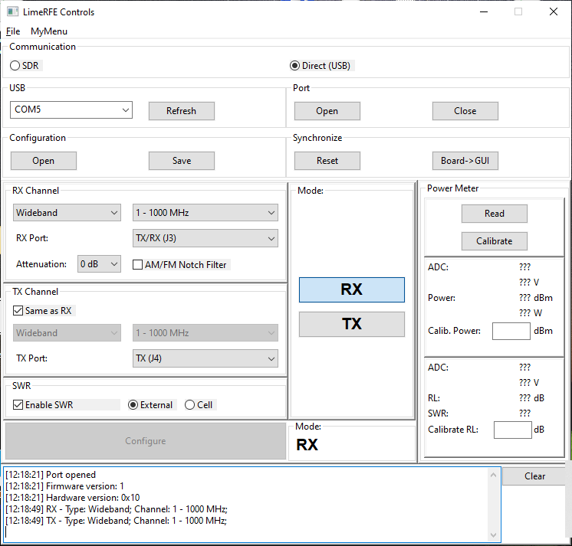
Figure 5: LimeRFE Controls window with enabled SWR panel and enabled SWR

Important note: It is important to keep the impedance controlled on all output connectors (J3, J4, and J5) Detailed description of the connectors is provided in the next section. In the very unlikely situations that the impedance on those ports is very reflective, the power amplifier oscillations might occur, which may damage the board. Hence, it is recommended to connect 50 Ω matched loads/sources and terminate the unused ports with 50 Ω terminations.

LimeRFE Connectors and Options
  - Supply Options
Supply option is chosen by properly configuring and connecting connectors J9, J10, J11, J23 and CON1 (this is micro USB type B connector). All of these connectors except CON1 are placed on the top side of the board, grouped, as shown in Figure 6. CON1 connector is on the bottom side.
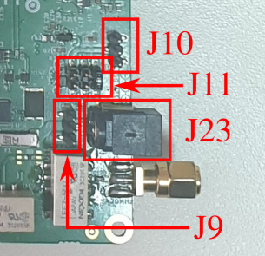
Figure 6: Photo of J9, J10, J11 and J23 connectors
There are three ways of providing 5 V supply to the board. It is possible to select one of these ways by placing a jumper at connector J11, Table 4.
Table 4: Power supply options with connector J11
Jumper position | Selected option | Comments
Left (Pins 5-6) | External 5 V power supply | 5 V is obtained from J10
Centre (Pins 3-4) | Internal 5 V from USB | 5 V is obtained from USB (CON1)
Right (Pins 1-2) | 5 V from  external 12 V power supply | 5 V is obtained from DC – DC convertor which is supplied from 12 V.  12 V is obtained from J9 or J23
Preferred configuration of J11 connector is at jumper position – right (Pins 1-2), where 5 V is obtained from the 12 V power supply. In this configuration either J9 or J23 are connected to external 12 V power supply. Only with 12 V supply all transmitters can operate!
  - Introduction to the LimeRFE Connectors
This section describes the various connectors available on the LimeRFE.
The top view of the LimeRFE board is shown in Figure 7. The bottom view of the LimeRFE board is shown in Figure 8.
Please note that connectors J1, J2, J3, J4 and J5 are terminated with 50 Ohm terminations and all jumpers are set in preferred positions.

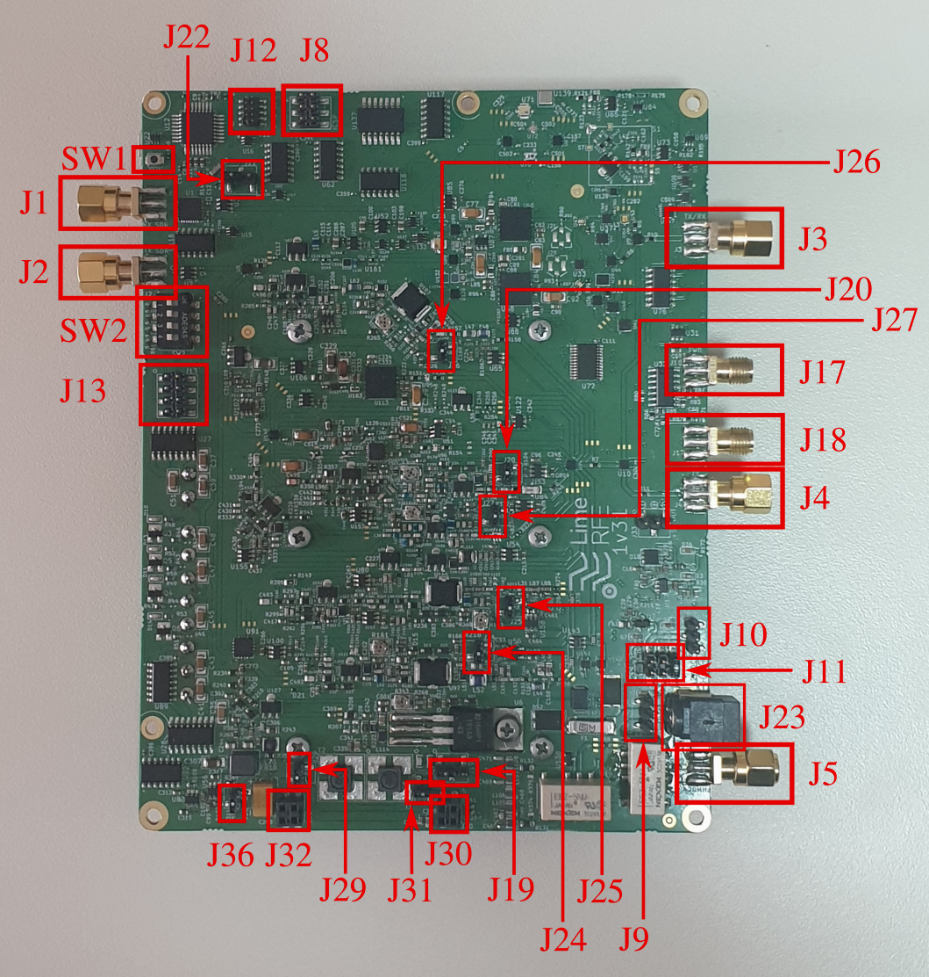
Figure 7: LimeRFE Connectors – Top View

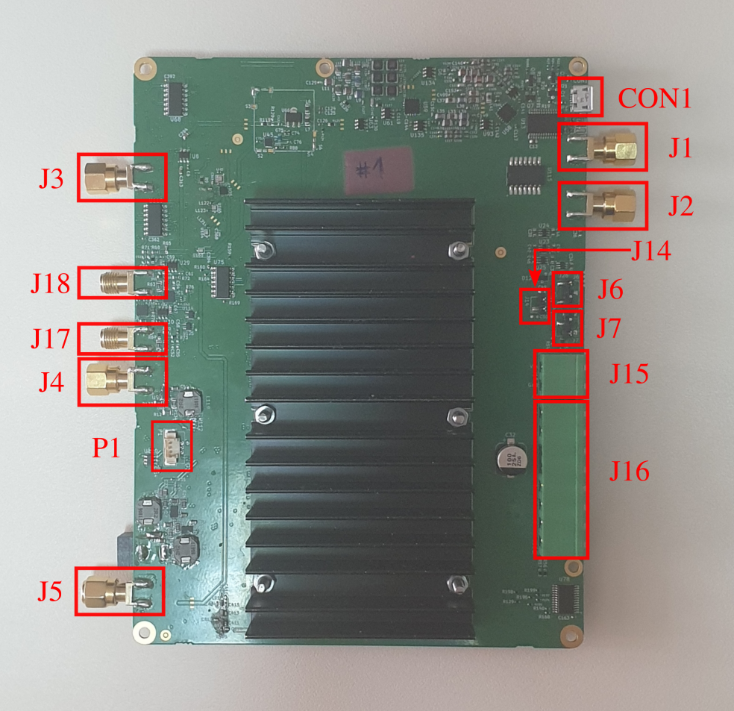
Figure 8: LimeRFE Connectors – Bottom view
Table 5 describes the pin assignment for each connector.
Table 5: Connectors and switches
Connector | Description
J1 | RF output – for RX mode (connect to SDR input)
J2 | RF input – for TX mode (connect to SDR output)
J3 | RF input – in RX mode, for all frequency bands  RF output – in TX mode, for all frequency bands except 30 MHz (HF) band and 50–70 MHz (6 & 4 m) band
J4 | RF output – in TX mode, for all frequency bands except 30 MHz (HF) band and 50–70 MHz (6 & 4 m) band and all Cellular bands (Band 1, 2, 3, 7 and 38)
J5 | RF input – in RX mode, for 30 MHz (HF), 50 – 70 MHz (6 & 4 m),  144 – 146 MHz (2 m), 220 – 225 MHz (1.25 m) and 430 – 440 MHz bands  RF output – in TX mode, only for 30 MHz (HF) band
J6 | To connect the output of the log detector to ADC7 input of the microcontroller, in order to measure forward power, place jumper between pins 1 and 2.  To connect the external signal (connected to J13-PIN3) to ADC7 input of the microcontroller, place jumper between pins 2 and 3.
J7 | To connect the output of the log detector to ADC6 input of the microcontroller, in order to measure forward power, place jumper between pins 1 and 2.  To connect the external signal (connected to J13-PIN6) to ADC6 input of the microcontroller, place jumper between pins 2 and 3.
J8 | ICSP bus – MISO (PIN1), SCK (PIN3), MOSI (PIN4), RESET (PIN5), PWR (PIN2), GND (PIN6)
J9 | External 12 V connection – GND (PINs 1, 3), 12 V (PIN 2)
J10 | External 5 V connection – GND (PINs 1, 3), 5 V (PIN 2)
J11 | 5 V source selection:  - 5 V is obtained from DC-DC connector supplied from external 12 V (PIN connection 1-2, jumper position – right);  - 5 V is obtained from USB (PIN connection 3-4, jumper position – center);  - 5 V is obtained from external 5 V supply unit (PIN connection 5-6, jumper position – left).
J12 | This 10-header enables the communication between the SDR and LimeRFE. Denoted as GPIO SDR.  Such 10-pin GPIO headers are available in all Lime Microsystems’ SDR platforms.  - GPIO – GPIO0 (PIN1), GPIO1 (PIN2), GPIO2 (PIN3), GPIO3 (PIN4),  These pins are connected to the GPIO sub-system of the LimeRFE. This sub-system provides level shifters and relay drivers, and enables communication/control between SDR and other hardware (e.g. additional PA). This sub-system enables the same functionality as the LimeSDR GPIO Board (https://wiki.myriadrf.org/LimeSDR_GPIO_Board), but with the number of GPIO pins reduced to 4.  - GPIO – GPIO4 (PIN5), GPIO5 (PIN6)  These 2 pins provide the 2-way communication between the SDR and the microcontroller on LimeRFE.  - SCL (PIN7), SDA (PIN8)  These pins enable I2C communication between SDR and LimeRFE.  - GND (PIN9), VDD_CON (PIN10)  These are supply pins.
J13 | - GPIO2_LS (PIN1), GPIO4_LS (PIN2), GPIO5_LS (PIN7), GPIO3_LS (PIN8)  These pins are part of the GPIO sub-system.  - ADC7 (PIN3), ADC6 (PIN6)  These pins can be connected to the ADC inputs of the LimeRFE microcontroller by properly setting jumpers on J6 and J7.  - VDDA (PIN5), GND (PIN4)  These are supply pins.
J14 | - VDDA (PIN1), VDD_CON (PIN2)  Jumper connection only in case that VDDA = VDDA_CONN (For use in relay only mode)
J15 | DC supply for RELAY signals – VCOM (PIN2), GND (PIN1)
J16 | RELAY signals – RELAY_0 (PIN7), RELAY_1 (PIN5), RELAY_2 (PIN3), RELAY_3 (PIN1), VCOM (PINs 2, 4, 6, 8)
J17 | Reverse power RF input (for SWR operation)
J18 | Forward power RF input (for SWR operation)
J19 | This connector connects drain of RD16HHF1 to the either the on-board baluns T1 and T2 or to the external balun (LimeRFE add-on balun board).  In default configuration (T1 and T2 are used), J29 should be shorted by jumper, as well as the J31 connector. Also, pins 1 and 2 of connector J19 should be shorted by jumper for this configuration (jumper in left position).  If external balun is used (LimeRFE add-on balun board), then connectors J29 and J31 should be left open and pins 2 and 3 of connector J19 should be shortened by jumper (jumper in right position). External balun is connected to the board through connector J30. Connector J32 is dummy and serves only for mechanical support. All four pins of J32 are connected to ground.
J20 | This connector enables the measurement of the bias current in power amplifier for 1240–1325 MHz (23 cm) band. Pins should be shorted by jumper for normal operation.
J22 | Connects GPIO3 to GPIO3_CONN (PIN connection 2-3) or to GPIO5 (PIN connection 1-2).  The intention is to enable one of the level-shifters/relay-drivers to be controlled directly from the LimeRFE microcontroller.
J23 | External 12 V connection
J24 | This connector enables the measurement of the bias current in power amplifier for 144–146 MHz (2 m) band. Pins should be shorted by jumper for normal operation.
J25 | This connector enables the measurement of the bias current in power amplifier for 220–225 MHz (1.25 m) band. Pins should be shorted by jumper for normal operation.
J26 | This connector enables the measurement of the bias current in power amplifier for 430–440 MHz (70 cm) band. Pins should be shorted by jumper for normal operation.
J27 | This connector enables the measurement of the bias current in power amplifier for 902–928 MHz (33 cm) band. Pins should be shorted by jumper for normal operation.
J29 | Please refer to the description of J19.
J30 | Please refer to the description of J19.
J31 | Please refer to the description of J19.
J32 | Please refer to the description of J19.
J36 | This connector enables the measurement of the bias current in power amplifier for 30 MHz (HF) band. Pins should be shorted by jumper for normal operation.
SW1 | LimeRFE microcontroller RESET push-switch
SW2 | GPIO to/from level shifted signals (GPIO_LS):  - When the switches are in position closer to PIN1 (marked with dot), direction signal is high, direction is GPIO → GPIO_LS;  - When the switches are in position away from PIN1 (marked with dot), direction signal is low, direction is GPIO_LS → GPIO.
CON1 | Micro USB type B connector
P1 | 3-pin fan connector for external fan

Block diagram
Block diagram of the LimeRFE board is shown in Figure 9. Please note that it depicts only the RF part of the board.

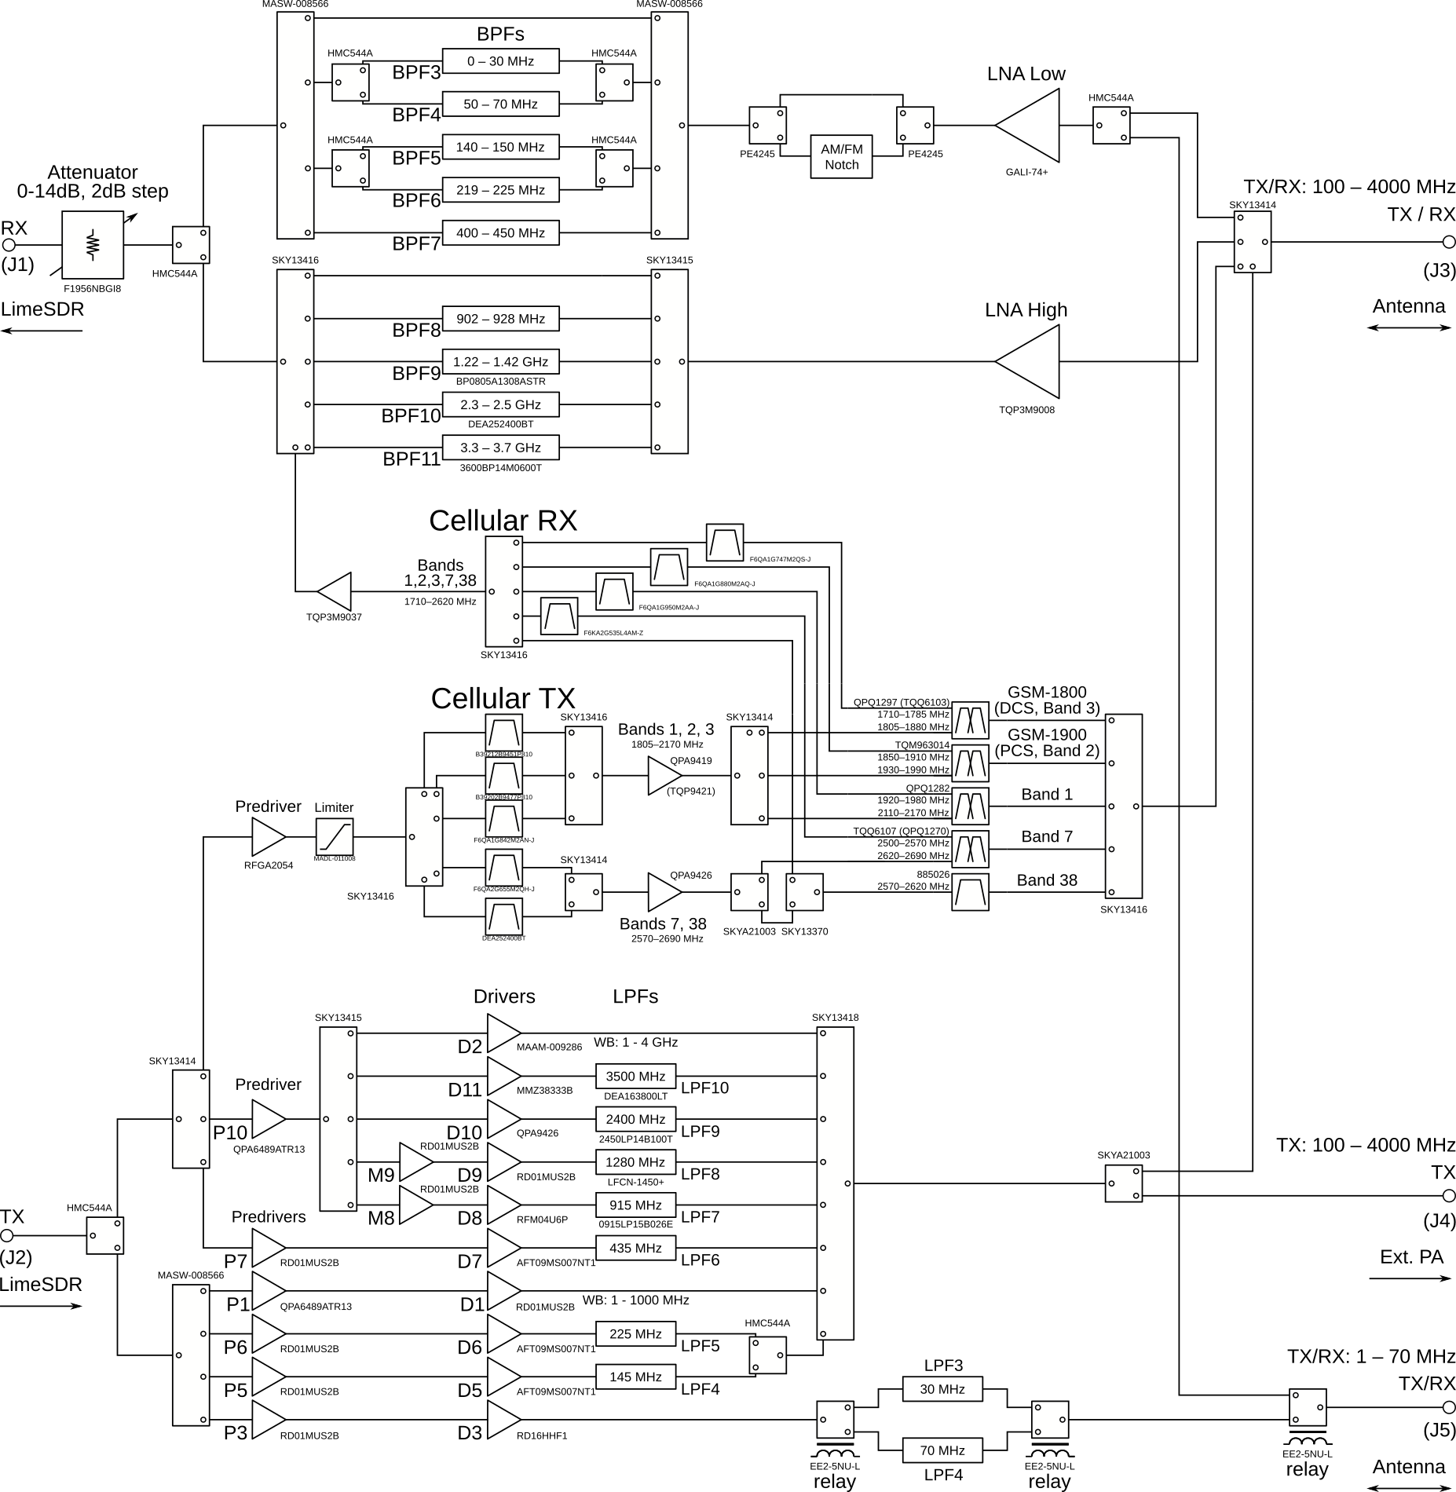
Figure 9: Lime RFE block diagram (RF part only)
Photos of the LimeRFE top and bottom side, with most important RF blocks marked, are shown in Figures 10 and 11.

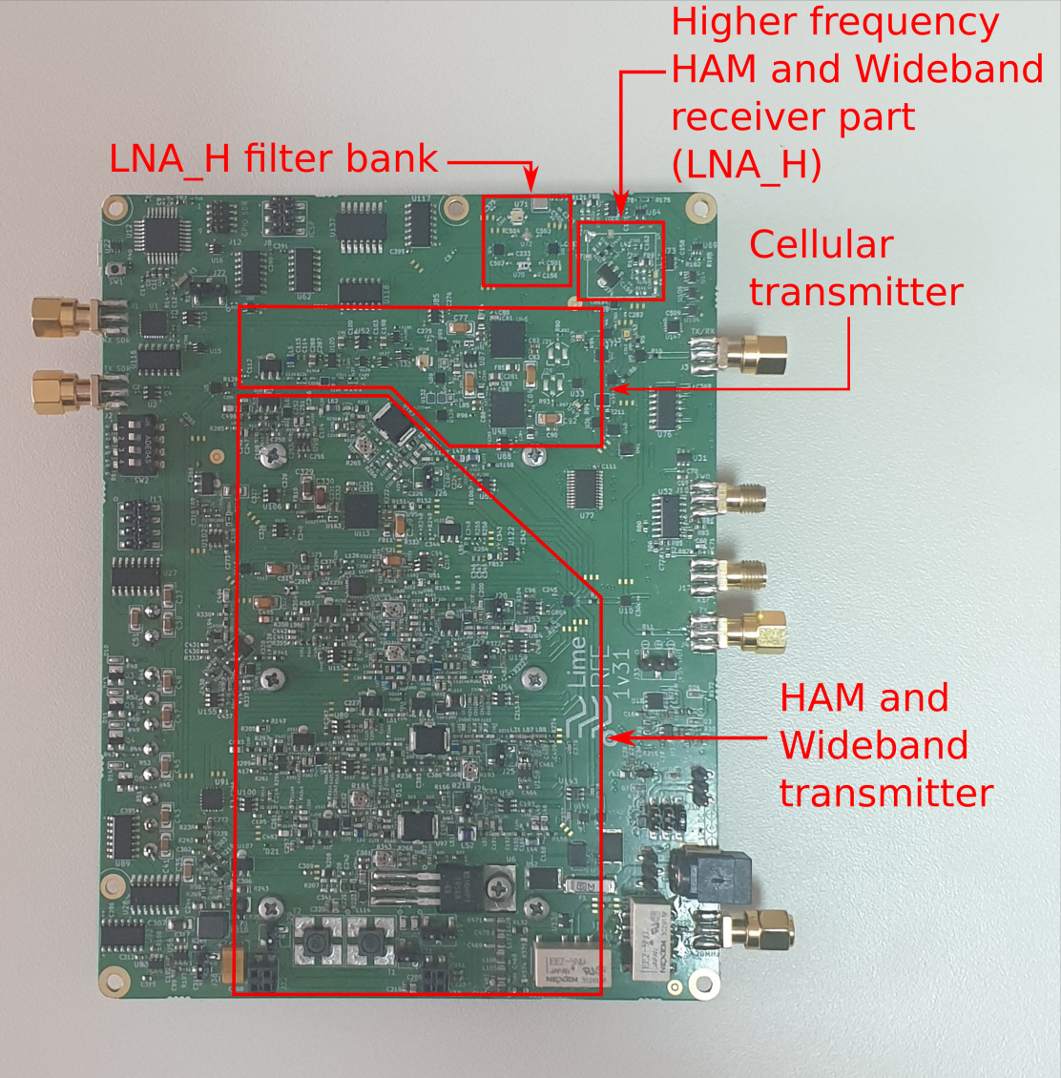
Figure 10: Receiver and transmitter sub-blocks – Top view
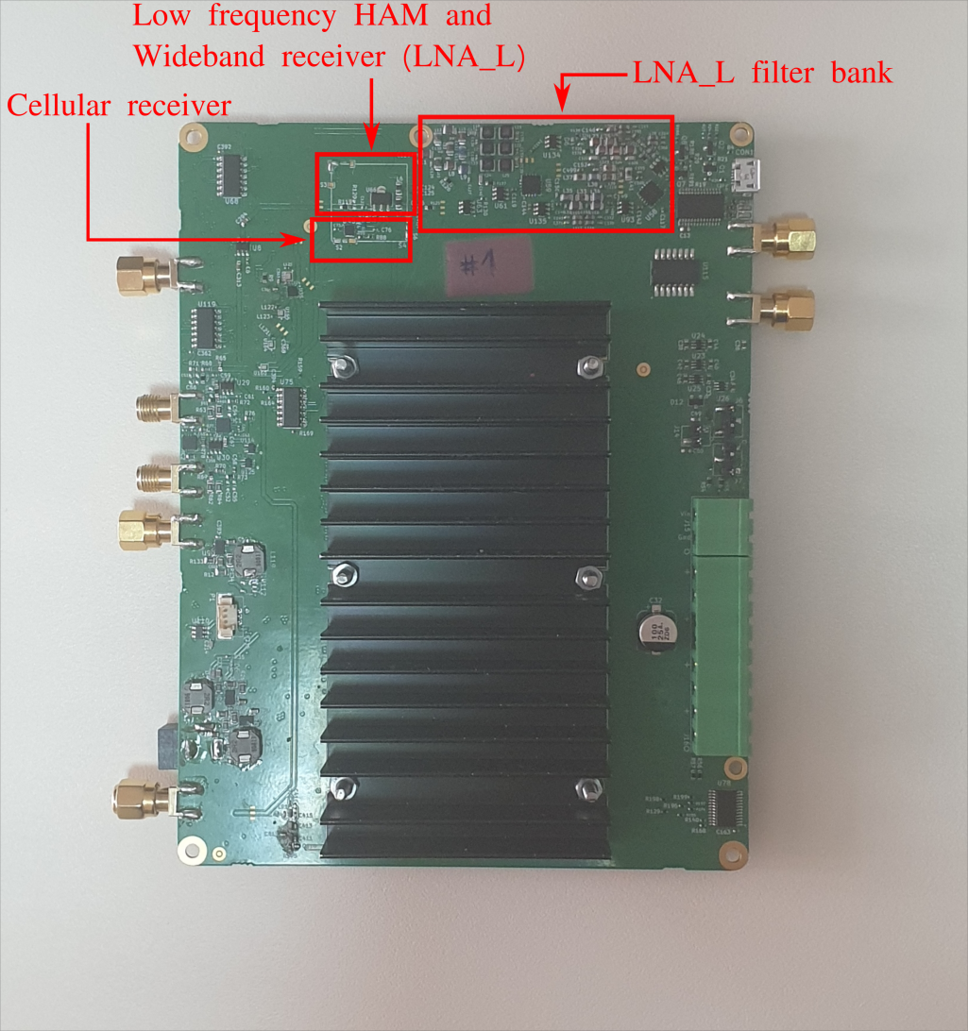
Figure 11: Receiver and transmitter sub-blocks – Bottom view

Receiver block uses connectors:
- J3 as input connector for all bands;
- J5 as input connector, but without bands:
HAM 902 – 928 MHz (33 cm), HAM 1240 – 1325 MHz (23 cm), HAM 2300 – 2450 (13 cm), 3300 – 3500 MHz (9 cm), Cellular Band 1, Cellular Band 2 / PCS – 1900, Cellular Band 3 / DCS – 1800, Cellular Band 7 and Cellular Band 38;
- J1 as output connector for all bands.
Receiver block consists of 2 sub-blocks:
- Cellular receiver,
- HAM/Wideband receiver.
From the RX input of the LimeRFE board, the signal is guided to Cellular or HAM/Wideband receive sub-blocks. Once again, depending on selected configuration (primarily regarding the frequency of received signal), the signal is guided through various switches, filters and duplexers to the amplifiers. After amplification, the signal passes again through various switches and filters and is brought to the variable attenuator. This software controlled attenuator can change attenuation 0−14 dB in 2 dB steps. Table 6 gives detailed description of the signal paths, depending on the chosen RX configuration.

Table 6: RX configurations and corresponding RF signal path
Configuration:  Type Channel/Band |  | Signal path
Wideband | 1 – 1000 MHz | (J3 / SKY13414) or (J5 / EE2-5NU-L) / HMC544A / GALI-74+ / PE4245 / (AM/FM Notch filter) or (bypass) / PE4245 / MASW-008566 / bypass / MASW-008566 / HMC544A / F1956NBGI8 / J1
Wideband | 1000 – 4000 MHz | J3 / SKY13414 / TQP3M9008 / SKY13415 / bypass / SKY13416 / HMC544A / F1956NBGI8 / J1
HAM | 30 MHz (HF) | (J5 / EE2-5NU-L) or (J3 / SKY13414) / HMC544A / GALI-74+ / PE4245 / (AM/FM Notch filter) or (bypass) / PE4245/ MASW-008566 / HMC5444A / filter 0−30 MHz / HMC544A / MASW-008566 / HMC544A / F1956NBGI8 / J1
HAM | 50 – 70 MHz (6&4 m) | (J5 / EE2-5NU-LI) or (J3 / SKY13414) / HMC544A / GALI-74+ / PE4245 / (AM/FM Notch filter) or (bypass) / PE4245/ MASW-008566 / HMC5444A / filter 50−70 MHz / HMC544A / MASW-008566 / HMC544A / F1956NBGI8 / J1
HAM | 144 – 146 MHz (2 m) | (J3 / SKY13414) or (J5 / EE2-5NU-L) / HMC544A / GALI-74+ / PE4245 / (AM/FM Notch filter) or (bypass) / PE4245 / MASW-008566 / HMC544A / filter 140−150 MHz / HMC544A / MASW-008566 / HMC544A / F1956NBGI8 / J1
HAM | 220 – 225 MHz (1.25 m) | (J3 / SKY13414) or (J5 / EE2-5NU-L) / HMC544A / GALI-74+ / PE4245 / (AM/FM Notch filter) or (bypass) / PE4245 / MASW-008566 / HMC544A / filter 219−225 MHz / HMC544A / MASW-008566 / HMC544A / F1956NBGI8 / J1
HAM | 430 – 440 MHz (70 cm) | (J3 / SKY13414) or (J5 / EE2-5NU-L) / HMC544A / GALI-74+ / PE4245 / (AM/FM Notch filter) or (bypass) / PE4245 / MASW-008566 / filter 400−450 MHz / MASW-008566 / HMC544A / F1956NBGI8 / J1
HAM | 902 – 928 MHz (33 cm) | J3 / SKY13414 / TQP3M9008 / SKY13415 / filter 902–928 GHz / SKY13416 / HMC544A / F1956NBGI8 / J1
HAM | 1240 – 1325 MHz (23 cm) | J3 / SKY13414 / TQP3M9008 / SKY13415 / filter 1.22–1.42 GHz / SKY13416 / HMC544A / F1956NBGI8 / J1
HAM | 2300 – 2450 MHz (13 cm) | J3 / SKY13414 / TQP3M9008 / SKY13415 / filter 2.3–2.5 GHz / SKY13416 / HMC544A / F1956NBGI8 / J1
HAM | 3300 – 3500 MHz (9 cm) | J3 / SKY13414 / TQP3M9008 / SKY13415 / filter 3.3–3.7 GHz / SKY13416 / HMC544A / F1956NBGI8 / J1
Cellular | Band 1 | J3 / SKY13414 / SKY13416 / QPQ1282 / F6QA1G950M2AA / SKY13416 / TQP3M9037 / SKY13416 / HMC544A / F1956NBGI8 / J1
Cellular | Band 2 / PCS − 1900 | J3 / SKY13414 / SKY13416 / TQM963014 / F6QA1G880M2AQ / SKY13416 / TQP3M963014 / SKY13416 / HMC544A / F1956NBGI8 / J1
Cellular | Band 3 / DCS − 1800 | J3 / SKY13414 / SKY13416 / QPQ1297 (TQQ6103) / F6QA1G747M2QS / SKY13416 / TQP3M9037 / SKY13416 / HMC544A / F1956NBGI8 / J1
Cellular | Band 7 | J3 / SKY13414 / SKY13416 / TQQ6107 (QPQ1270) / F6KA2G535L4AM / SKY13416 / TQP3M9037 / SKY13416 / HMC544A / F1956NBGI8 / J1
Cellular | Band 38 | J3 / SKY13414 / SKY13416 / 885026 / SKY13370 / SKY13415 / TQP3M9037 / SKY13416 / HMC544A / F1956NBGI8 / J1

Transmitter block uses the following connectors:
- J2 as input connector for all bands;
- J3 as output connector, but without 30 MHz (HF) and 50–70 MHz (6 & m) bands;
- J4 as output connector, but without 30 MHz (HF), 50–70 MHz (6 & 4 m) and all Cellular bands (Band 1, 2, 3, 7 and 38);
- J5 as output connector, only for 30 MHz (HF) and 50–70 MHz (6 & 4 m) bands.
Transmitter block consists of 2 sub-blocks:
- Cellular transmitter
- HAM/Wideband transmitter
From the TX input of the LimeRFE board, the signal is guided to Cellular or HAM/Wideband transmitter. Depending on selected configuration (primarily regarding the frequency of received signal), the signal is guided through various switches and filters to the amplifiers. After amplification, the signal passes again through various switches, duplexers and filters. Table 7 gives detailed description of the signal paths, depending on the chosen TX configuration.

Table 7: TX configurations and corresponding RF signal path
Configuration:  Type Channel/Band |  | Signal path
Wideband | 1−1000 MHz | J2 / HMC544A / MASW-008566 / QPA6489ATR13 / RD01MUS2B / SKY13418 / SKYA21003 / (J4) or (SKY13414 / J3)
Wideband | 1000−4000 MHz | J2 / HMC544A / SKY13414 / QPA6489ATR13 / SKY13415 / MAAM-009286 / SKY13418 / SKYA21003 / (J4) or (SKY13414 / J3)
HAM | 30 MHz (HF) | J2 / HMC544A / MASW-008566 / RD01MUS2B / RD16HHF1 /  EE2-5NU-L / filter 30 MHz / EE2-5NU-L / EE2-5NU-L / J5
HAM | 50–70 MHz (6&4 m) | J2 / HMC544A / MASW-008566 / RD01MUS2B / RD16HHF1 /  EE2-5NU-L / filter 70 MHz / EE2-5NU-L / EE2-5NU-L / J5
HAM | 144−146 MHz (2 m) | J2 / HMC544A / MASW-008566 / RD01MUS2B / AFT09MS007NT1 / filter 145 MHz / HMC544A / SKY13418 / SKYA21003 / (J4) or (SKY13414 / J3)
HAM | 220–225 MHz (1.25m) | J2 / HMC544A / MASW-008566 / RD01MUS2B / AFT09MS007NT1 / filter 225 MHz / HMC544A / SKY13418 / SKYA21003 / (J4) or (SKY13414 / J3)
HAM | 430−440 MHz (70 cm) | J2 / HMC544A / SKY13414 / RD01MUS2B / AFT09MS007NT1 / filter 435 MHz / SKY13418 / SKYA21003 / (J4) or (SKY13414 / J3)
HAM | 902–928 MHz (33 cm) | J2 / HMC544A / SKY13414 / QPA6489ATR13 / SKY13415 / RFM04U6P / filter 930 MHz / SKY13418 / SKYA21003 / (J4) or (SKY13414 / J3)
HAM | 1240−1325 MHz (23 cm) | J2 / HMC544A / SKY13414 / QPA6489ATR13 / SKY13415 / RD01MUS2B / RD01MUS2B / filter 1280 MHz / SKY13418 / SKYA21003 / (J4) or (SKY13414 / J3)
HAM | 2300−2450 MHz (13 cm) | J2 / HMC544A / SKY13414 / QPA6489ATR13 / SKY13415 / QPA9426 / filter 2400 MHz / SKY13418 / SKYA21003 / (J4) or (SKY13414 / J3)
HAM | 3300−3500 MHz (9 cm) | J2 / HMC544A / SKY13414 / QPA6489ATR13 / SKY13415 / MMZ38333B / DEA163800LT-5017C1 / SKY13418 / SKYA21003 / (J4) or (SKY13414 / J3)
Cellular | Band 1 | J2 / HMC544A / SKY13414 / RFGA2054 / MADL-011008-14120T / SKY13416 / B39212B9451P810 / SKY13416 / QPA9419 (TQP9421) / SKY13414 / QPQ1282 / SKY13416 / SKY13414 / J3
Cellular | Band 2 / PCS − 1900 | J2 / HMC544A / SKY13414 / RFGA2054 / MADL-011008-14120T / SKY13416 / B39202B9477P810 / SKY13416 / QPA9419 (TQP9421) / SKY13414 / TQM963014 / SKY13416 / SKY13414 / J3
Cellular | Band 3 / DCS − 1800 | J2 / HMC544A / SKY13414 / RFGA2054 / MADL-011008-14120T / SKY13416 / F6QA1G842M2AN-J / SKY13416 / QPA9419 (TQP9421) / SKY13414 / QPQ1297 (TQQ6103) / SKY13416 / SKY13414 / J3
Cellular | Band 7 | J2 / HMC544A / SKY13414 / RFGA2054 / MADL-011008-14120T / SKY13416 / F6QA2G655M2QH-J / SKY13414 / QPA9426 / SKY21003 / TQQ6107 (QPQ1270) / SKY13416 / SKY13414 / J3
Cellular | Band 38 | J2 / HMC544A / SKY13414 / RFGA2054 / MADL-011008-14120T / SKY13416 / DEA252400BT-2030A1 / SKY13414 / QPA9426 / SKY21003 / SKY13370 / 885026 / SKY13416 / SKY13414 / J3

Setting up the LimeRFE board – An Example
Steps for setting up the LimeRFE board for operation in HAM 144–146 MHz (2 m) band, TX mode, and measuring the TX gain are:
- Terminate connectors J1, J3 and J5 with 50 Ohm terminations.
- Connect the signal generator to J2 connector. It is recommended to use attenuators between signal generator and connector J2. For all our tests we used 6 dB / 2 W attenuators. Also, for initial test, set the signal power level below –30 dBm. For our test we used –40 dBm. Do not turn on the input signal yet.
- Connect connector J4 to the spectrum analyzer. It is highly recommended to use high-power high-level attenuators between J4 and spectrum analyzer in order to protect the spectrum analyzer. For all our tests we used 40 dB / 50 W attenuators.
- Connect your PC to LimeRFE board through USB cable.
- Place jumper at position – right at J11 (with jumper, connect pins 1 and 2 of the connector J11).
- Connect external 12 V DC power supply to J9 or to J23, and turn on the 12 V DC voltage.
- Open LimeSuite software.
- Go to Modules→LimeRFE to open the LimeRFE control window.
- Change communication from SDR to USB (in Communication panel).
- Refresh available COM ports by clicking Refresh button in USB panel.
- Select the port of the LimeRFE board. Open port by clicking Open Port button in the USB panel.
- In the TX Channel panel uncheck the Same as RX, and then select HAM.
- Select 144–146 MHz (2 m) band.
- Select TX (J4) port.
- Press Configure button.
- After the configuration is performed, the Mode panel is enabled. It contains two buttons TX and RX. Press the TX button. When the TX button is in pressed state, it means that the TX path of the configured channel is enabled.
- Turn on the input signal. Output signal should appear on the spectrum analyzer. The expected gain should be around 33 dB.

Changing the bias of TX amplifiers
All LimeRFE boards are shipped with already preset power amplifier bias currents. However, some minor deviation in bias currents might be possible, e.g. during the transport.
It is possible to change bias current of four power amplifiers on LimeRFE board. Please be sure you know what you are doing, since inappropriate bias might damage the amplifiers. The list of these amplifiers, as well as their default bias currents is given in Table 8.

Table 8: Default power amplifier with adjustable bias currents
Chanel/Band | Bias current | Jumper | Trimmer
30 MHz (HF) and  50 – 70 MHz (6 & 4 m) | 500 mA | J36* | R343
144 – 146 MHz (2 m) | 200 mA | J24 | R161
220 – 225 MHz (1.25 m) | 200 mA | J25 | R218
430 – 440 MHz (70 cm) | 200 mA | J26 | R226
902 – 928 MHz (33 cm) | 100 mA | J27 | R253
1240 – 1325 MHz (23 cm) | 40 mA | J20 | R176
*Jumpers on connectors J29, J31 and J19 (J32 and J30) must be properly placed (for detail description refer to Table 5)

Figure 12 shows the connectors and trimmers for power amplifier bias currents adjustment.

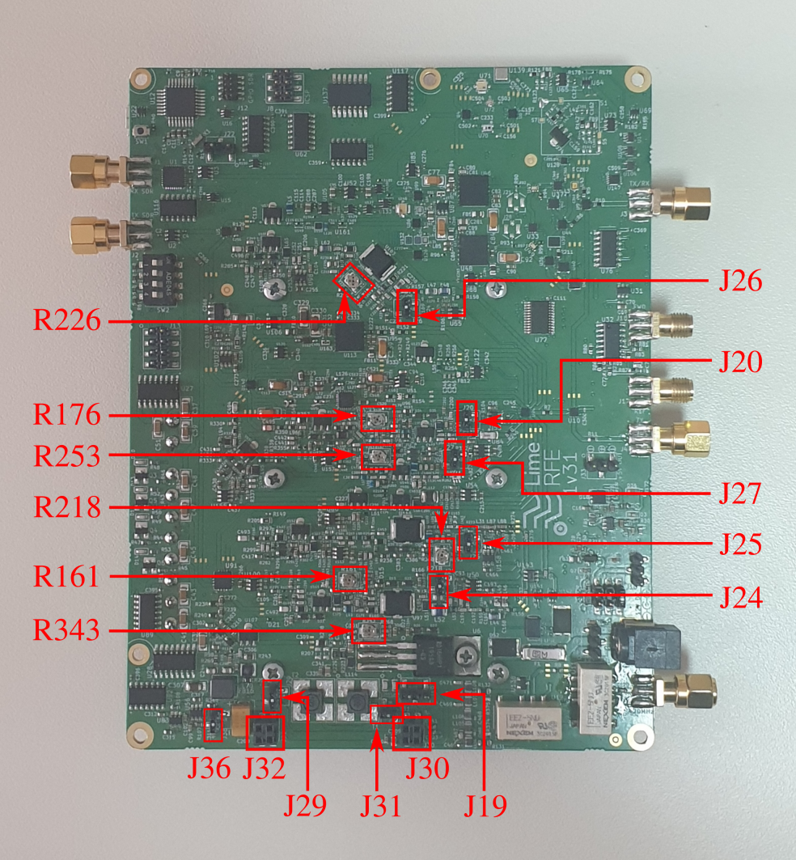
Figure 12: Connectors and trimmers for bias currents adjustments

Note: If you are not sure that the trimmers listed in Table 8 are adjusted properly, turn them fully counter-clockwise before providing 12 V supply. This will result in minimal bias currents and reduce risk of damaging the amplifiers.

Setup HAM 30 MHz (HF) and 50–70 MHz (6 & 4 m) power amplifier bias current
- Choose external DC power supply of 12 V and 5 V from on board DC-DC convertor by connecting pin 1 and pin 2 of connector J11 on the board (jumper position – right). Connect external DC supply unit to J9, but do not turn on 12 V from DC supply unit.
- Terminate J1, J2, J3 and J4 SMA connectors with 50 Ohm terminations.
- Connect J5 SMA connector (30 MHz out) to the termination or attenuator (> 10 dB) capable of withstanding 10 W of RF power.
- Connect USB cable from computer to the LimeRFE board.
- Turn the R343 trimmer fully in counter-clockwise direction.
- Connect J36 connector pins through ammeter (set 10 A range in ammeter).
- Jumpers on connectors J29, J31 and J19 (J32 and J30) must be properly placed (refer to Table 5 for details).
- Turn on 12 V from external DC supply unit. If possible, previously set the supply current limit to an appropriate value, e.g. 800 mA if the desired current is 500 mA.
- In software, setup the board for HAM, 30 MHz (HF) band.
- Turn off RX / Turn on TX mode.
- Turn R343 trimmer slowly in clockwise direction until ammeter shows 0.5 A.

Setup HAM 144–146 MHz (2 m) power amplifier bias current
- Choose external DC power supply of 12 V and 5 V from on board DC-DC convertor by connecting pin 1 and pin 2 of connector J11 on the board (jumper position – right). Connect external DC supply unit to J9, but do not turn on 12 V from DC supply unit.
- Terminate J1, J2, J3 and J5 SMA connectors with 50 Ohm terminations
- Connect J4 SMA connector to termination or attenuator (> 10 dB) capable of withstanding 5 W of RF power.
- Connect USB cable from computer to the LimeRFE board
- Turn the R161 trimmer fully in counter-clockwise direction.
- Connect J24 connector pins through ammeter (set 10 A range in ammeter).
- Turn on 12 V from external DC supply unit. If possible, previously set the supply current limit to an appropriate value, e.g. 400 mA if the desired current is 200 mA.
- In software, setup the board for HAM, 144–146 MHz (2 m) band, port TX (J4).
- Turn off RX / Turn on TX mode.
- Turn around trimmer R161 in clockwise direction until ammeter shows 0.2 A

Setup HAM 220–225 MHz (2 m) power amplifier bias current
- Choose external DC power supply of 12 V and 5 V from on board DC-DC convertor by connecting pin 1 and pin 2 of connector J11 on the board (jumper position – right). Connect external DC supply unit to J9, but do not turn on 12 V from DC supply unit.
- Terminate J1, J2, J3 and J5 SMA connectors with 50 Ohm terminations
- Connect J4 SMA connector to termination or attenuator (> 10 dB) capable of withstanding 5 W of RF power.
- Connect USB cable from computer to the LimeRFE board.
- Turn the R218 trimmer fully in counter-clockwise direction.
- Connect J25 connector pins through ammeter (set 10 A range in ammeter)
- Turn on 12 V from external DC supply unit. If possible, previously set the supply current limit to an appropriate value, e.g. 400 mA if the desired current is 200 mA.
- In software, setup the board for HAM, 220–225 MHz (1.25 m) band, with TX Connector (J4).
- Turn off RX / Turn on TX mode.
- Turn R218 trimmer slowly in clockwise direction until ammeter shows 0.2 A

Setup HAM 430–440 MHz (70 cm) power amplifier bias current
- Choose external DC power supply of 12 V and 5 V from on board DC-DC convertor by connecting pin 1 and pin 2 of connector J11 on the board (jumper position – right). Connect external DC supply unit to J9, but do not turn on 12 V from DC supply unit.
- Terminate J1, J2, J3 and J5 SMA connectors with 50 Ohm terminations.
- J4 SMA connector connect to termination or attenuator (> 10 dB) capable of withstanding 5 W of RF power.
- Connect USB cable from computer to the LimeRFE board.
- Turn the R226 trimmer fully in counter-clockwise direction.
- Connect J26 connector pins through ammeter (set 10 A range in ammeter).
- Turn on 12 V from external DC supply unit. If possible, previously set the supply current limit to an appropriate value, e.g. 400 mA if the desired current is 200 mA.
- In software, setup the board for HAM, 430–440 MHz (70 cm) band, port TX (J4).
- Turn off RX / Turn on TX mode.
- Turn R226 trimmer slowly in clockwise direction until ammeter shows 0.2 A.

Setup HAM 902–928 MHz (70 cm) power amplifier bias current
- Choose external DC power supply of 12 V and 5 V from on board DC-DC convertor by connecting pin 1 and pin 2 of connector J11 on the board (jumper position – right). Connect external DC supply unit to J9, but do not turn on 12 V from DC supply unit.
- Terminate J1, J2, J3 and J5 SMA connectors with 50 Ohm terminations.
- J4 SMA connector connect to termination or attenuator (> 10 dB) capable of withstanding 5 W of RF power.
- Connect USB cable from computer to the LimeRFE board.
- Turn the R253 trimmer fully in counter-clockwise direction.
- Connect J27 connector pins through ammeter (set 10 A range in ammeter).
- Turn on 12 V from external DC supply unit. If possible, previously set the supply current limit to an appropriate value, e.g. 300 mA if the desired current is 100 mA.
- In software, setup the board for HAM, 902–928 MHz (33 cm) band, port TX (J4).
- Turn off RX / Turn on TX mode.
- Turn R253 trimmer slowly in clockwise direction until ammeter shows 0.1 A.

Setup HAM 1240 – 1325 MHz (23 cm) power amplifier drain current
- Choose external DC power supply of 12 V and 5 V from on board DC-DC convertor by connecting pin 1 and pin 2 of connector J11 on the board (jumper position – right). Connect external DC supply unit to J9, but do not turn on 12 V from DC supply unit.
- Terminate J1, J2, J3 and J5 SMA connectors with 50 Ohm terminations.
- J4 SMA connector connect to termination or attenuator (> 10 dB) capable of withstanding 5 W of RF power.
- Connect USB cable from computer to the LimeRFE board.
- Turn the R176 trimmer fully in counter-clockwise direction.
- Connect J20 connector pins through ammeter (set 200 mA range in ammeter).
- Turn on 12 V from external DC supply unit. If possible, previously set the supply current limit to an appropriate value, e.g. 300 mA if the desired current is 40 mA.
- In software, setup the board for HAM, 1240–1325 MHz (23 cm) band, port TX (J4).
- Turn off RX / Turn on TX mode.
- Turn R176 trimmer slowly in clockwise direction until ammeter shows 40 mA.

API Functions
API functions for LimeRFE control are implemented in LimeSuite shared library.
Communication with LimeRFE is possible using USB, or through LimeSDR using I²C.
In the following API functions for control of the LimeRFE board will be detailed.
Definition of all the constants used are given in the file limeRFE.h which is located in <LimeSuite source>/scr/limeRFE/ folder.
  - Reference

RFE_Open

rfe_dev_t* RFE_Open(const char* serialport, lms_device_t *dev);

This functions opens LimeRFE device. Connection can be direct via USB or through SDR board.

Parameters
const char* serialport Serial port name, (e.g. COM3) for control via USB. NULL if LimeRFE is controlled via SDR.
lms_device_t *dev LimeSDR device obtained by invoking LMS_Open. May be NULL if direct USB connection is used.

Return value
0 on success, other on failure (see error codes in limeRFE.h).

RFE_Close

void RFE_Close(rfe_dev_t* rfe);

This function closes the device previously opened with RFE_Open.

Parameters
rfe_dev_t* rfe Handle previously obtained from invoking RFE_Open.

Return value
None.

RFE_GetInfo

int RFE_GetInfo(rfe_dev_t* rfe, unsigned char* cinfo);

This function gets the firmware and hardware version, as well as 2 status bytes (reserved for future use).

Parameters
rfe_dev_t* rfe Handle previously obtained from invoking RFE_Open.
unsigned char* cinfo Board info:
cinfo[0] – Firmware version
cinfo[1] – Hardware version
cinfo[2] – Status (reserved for future use)
cinfo[3] – Status (reserved for future use)

Return value
0 on success, other on failure (see error codes in limeRFE.h).

RFE_LoadConfig

int RFE_LoadConfig(rfe_dev_t* rfe, const char *filename);

This function loads LimeRFE configuration from an .ini file, and configures the board accordingly.

Parameters
rfe_dev_t* rfe Handle previously obtained from invoking RFE_Open.
const char *filename Full path to .ini configuration file.

Return value
0 on success, other on failure (see error codes in limeRFE.h).

RFE_Reset

int RFE_Reset(rfe_dev_t* rfe);

Resets the board. All channels are disabled.

Parameters
rfe_dev_t* rfe Handle previously obtained from invoking RFE_Open.

Return value
0 on success, other on failure (see error codes in limeRFE.h).

RFE_Configure

API_EXPORT int CALL_CONV RFE_Configure(rfe_dev_t* rfe, char channelIDRX, char channelIDTX, char portRX, char portTX, char mode, char notch, char attenuation, char enableSWR, char sourceSWR);

This function configures LimeRFE board.

Parameters
rfe_dev_t* rfe Handle previously obtained from invoking RFE_Open.
char channelIDRX RX channel to be acitvated (convenience constants defined in limeRFE.h). For example constant RFE_CID_HAM_0145 identifies 2m (144 – 146 MHz) HAM channel.
char channelIDTX TX channel to be acitvated (convenience constants defined in limeRFE.h). For example constant RFE_CID_HAM_0145 identifies 2m (144 – 146 MHz) HAM channel. If -1 then the same channel as for RX is used.
char portRX RX port (convenience constants defined in limeRFE.h).
char portTX TX port (convenience constants defined in limeRFE.h).
char mode Operation mode (defined in limeRFE.h). Not all modes are applicable to all configurations. HAM channels using same port for RX and TX are not allowed RFE_MODE_TXRX mode. Cellular FDD bands 1, 2, 3, and 7 are always in RFE_MODE_TXRX mode. Cellular TDD band 38 can not be in RFE_MODE_TXRX.
char notch Specifies whether the notch filter is applied or not (convenience constants defined in limeRFE.h).
char attenuation Specifies the attenuation in the receive path.
Attenuation [dB] = 2 * attenuation.
char enableSWR Enable SWR subsystem. (convenience constants defined in limeRFE.h).
char sourceSWR SWR subsystem source. (convenience constants defined in limeRFE.h).

Return value
0 on success, other on failure (see error codes in limeRFE.h).

RFE_ConfigureState

int RFE_ConfigureState(rfe_dev_t* rfe, rfe_boardState state);

This function configures the LimeRFE board. It's functionality is identical to RFE_Configure, with different arguments.

Parameters
rfe_dev_t* rfe Handle previously obtained from invoking RFE_Open.
rfe_boardState state Structure containing configuration parameters.

Return value
0 on success, other on failure (see error codes in limeRFE.h).

RFE_Mode

int RFE_Mode(rfe_dev_t* rfe, int mode);

This function sets the LimeRFE mode (receive, transmit, both, or none).

Parameters
rfe_dev_t* rfe Handle previously obtained from invoking RFE_Open.
int mode Operation mode (defined in limeRFE.h). Not all modes are applicable to all configurations. HAM channels using same port for RX and TX are not allowed RFE_MODE_TXRX mode. Cellular FDD bands 1, 2, 3, and 7 are always in RFE_MODE_TXRX mode. Cellular TDD band 38 can not be in RFE_MODE_TXRX.

Return value
0 on success, other on failure (see error codes in limeRFE.h).

RFE_ReadADC

int RFE_ReadADC(rfe_dev_t* rfe, int adcID, int* value);

This function reads the value of the speficied ADC.

Parameters
rfe_dev_t* rfe Handle previously obtained from invoking RFE_Open.
int adcID Specifies which ADC is to be read (convenience constants defined in limeRFE.h).
int* value ADC value

Return value
0 on success, other on failure (see error codes in limeRFE.h).

RFE_ConfGPIO

int RFE_ConfGPIO(rfe_dev_t* rfe, int gpioNum, int direction);

This function configures single GPIO pin. Only pins 4 and 5 are configurable.

Parameters
rfe_dev_t* rfe Handle previously obtained from invoking RFE_Open.
int gpioNum GPIO pin number. Only pins 0 and 1 are configurable.
int direction GPIO pin direction (convenience constants defined in limeRFE.h). 0 – Output; 1 – Input.

Return value
0 on success, other on failure (see error codes in limeRFE.h).

RFE_SetGPIO

int RFE_SetGPIO(rfe_dev_t* rfe, int gpioNum, int val);

This function sets the GPIO pin value. GPIO pin should have been previously configured as output using RFE_ConfGPIO function.

Parameters
rfe_dev_t* rfe Handle previously obtained from invoking RFE_Open.
int gpioNum GPIO pin number. Only pins 0 and 1 are configurable.
int val GPIO pin value.

Return value
0 on success, other on failure (see LimeRFE error codes).

RFE_GetGPIO

int RFE_GetGPIO(rfe_dev_t* rfe, int gpioNum, int* val);

This function reads the GPIO pin value. GPIO pin should have been previously configured as output using RFE_ConfGPIO function.

Parameters
rfe_dev_t* rfe Handle previously obtained from invoking RFE_Open.
int gpioNum GPIO pin number. Only pins 0 and 1 are configurable.
int* val GPIO pin value.

Return value
0 on success, other on failure (see error codes in limeRFE.h).

RFE_AssignSDRChannels

int RFE_AssignSDRChannels(rfe_dev_t* rfe, int rxChan, int txChan);

Links LimeRFE Rx and Tx to specific SDR boards channels for automatic band selection and RF switching purposes. By default channel 0 is used, so this function is only needed if different channel is going to be used.

Parameters
rfe_dev_t* rfe Handle previously obtained from invoking RFE_Open.
int rxChan Rx channel index.
int txChan Tx channels index.

Return value
0 on success, other on failure (see error codes in limeRFE.h).

RFE_Fan

int RFE_Fan(rfe_dev_t* rfe, int enable);

This function enables/disables the fan.

Parameters
rfe_dev_t* rfe Handle previously obtained from invoking RFE_Open.
int enable Fan state: 0 – disable; 1 - enable.

Return value
0 on success, other on failure (see error codes in limeRFE.h).

  - Examples
Examples are available in the <LimeSuite source>/scr/examples/ folder.
Examples are:
limeRFE_I2C_example.cpp – Simple example of configuring LimeRFE using I2C;
limeRFE_USB_example.cpp – Simple example of configuring LimeRFE using USB;
limeRFE_ADC_example.cpp – Simple example of reading SWR measurements.

In addition one Python example is provided in the same folder:
limeRFE_Python_example.py – Simple example in Python.

Default LimeRFE board I²C address is 0x51. In an unlikely situation that any other device on the same I²C bus has the same address, LimeRFE address can be changed in firmware.

