LimeRFE 1v31

Measurement Results

Version: 1.0
Revision: 6
Date: 12.03.2021

Table of Contents
LimeRFE 1v31 Performance Summary 3
Setup 4
TX 5
Wideband 1 – 1000 MHz 5
Wideband 1000 – 4000 MHz 6
HAM 30 MHz (HF) 6
HAM 50 – 70 MHz (6 & 4 m) 7
HAM 144 – 146 MHz (2 m) 7
HAM 220 – 225 MHz (1.25 m) 8
HAM 430 – 440 MHz (70 cm) 8
HAM 902 – 928 MHz (33 cm) 9
HAM 1240 – 1325 MHz (23 cm) 9
HAM 2300 – 2450 MHz (13 cm) 10
HAM 3300 – 3500 MHz (9 cm) 10
Cellular Band 1 11
Cellular Band 2 12
Cellular Band 3 13
Cellular Band 7 14
Cellular Band 38 15
RX 16
Wideband 1 – 1000 MHz 16
Wideband 1000 – 4000 MHz 18
HAM 30 MHz (HF) 19
HAM 50 – 70 MHz (6 & 4 m) 20
HAM 144 – 146 MHz (2 m) 21
HAM 220 – 225 MHz (1.25 m) 22
HAM 430 – 440 MHz (70 cm) 23
HAM 902 – 928 MHz (33 cm) 24
HAM 1240 – 1325 MHz (23 cm) 25
HAM 2300 – 2450 MHz (13 cm) 26
HAM 3300 – 3500 MHz (9 cm) 27
Cellular Band 1 28
Cellular Band 2 29
Cellular Band 3 30
Cellular Band 7 31
Cellular Band 38 32

LimeRFE 1v31 Performance Summary
Measured results of the several prototype boards are given in the table bellow.

No. | Band | TX |  |  |  |  |  | RX
No. | Band | Gain [dB] |  |  | OP1dB [dBm] |  |  | Gain [dB] |  |  | NF [dB] |  |  | IIP3 [dBm]
No. | Band | Min | Nom | Max | Min | Nom | Max | Min | Nom | Max | Min | Nom | Max | Min | Nom | Max
1 | WB 1000 | 27 |  | 45 | 22.5 |  | 28.5 | 17 |  | 21.8 | 3.4 |  | 4.4 | 11.5 |  | 18
2 | WB 4000 | 12 |  | 33 | 14 |  | 24 | 7.8 |  | 18.4 | 2.7 |  | 5.5 | 10 |  | 23
3 | HAM 30
3 | 5 – 30 MHz |  | 38 |  |  | 33 |  |  | 21 |  |  | 6 |  |  | 15
3 | 1 – 5 MHz |  |  |  |  |  |  |  |  |  |  | / |  | 0 |  | 14
4 | HAM 50-70 |  | 37 |  |  | 32 |  |  | 19 |  |  | 3.5 |  |  | 14
5 | HAM 145 |  | 31 |  |  | 34 |  |  | 18 |  |  | 3.7 |  |  | 12.6
6 | HAM 220 |  | 33 |  |  | 34 |  |  | 18 |  |  | 3.7 |  |  | 14.8
7 | HAM 435 |  | 33 |  |  | 34 |  |  | 15 |  |  | 4 |  |  | 10
8 | HAM 920 |  | 35 |  |  | 30 |  |  | 17 |  |  | 2.8 |  |  | 16
9 | HAM 1280 |  | 31 |  |  | 31 |  |  | 16 |  |  | 2.8 |  |  | 20
10 | HAM 2400 |  | 41 |  |  | 28.5 |  |  | 13 |  |  | 3.8 |  |  | 15.5
11 | HAM 3500 |  | 33 |  |  | 25 |  |  | 7.5 |  |  | 4.5 |  |  | 12.5
12 | Cell Band 1 |  | 37 |  |  | 28 |  |  | 11 |  |  | 6.5 |  |  | 19
13 | Cell Band 2 |  | 40 |  |  | 30.5 |  |  | 12 |  |  | 5.5 |  |  | 19.5
14 | Cell Band 3 |  | 40 |  |  | 29.5 |  |  | 13 |  |  | 6 |  |  | 19
15 | Cell Band 7 |  | 37 |  |  | 26 |  |  | 8 |  |  | 6 |  |  | 21
16 | Cell Band 38 |  | 38 |  |  | 26 |  |  | 8 |  |  | 6 |  |  | 20

Setup

Measurements results were corrected by 46 dB to account for the setup.
So, approximately, the additional setup contribution is:
@ 2.0 GHz approx. 0.8 dB
@ 2.5 GHz approx. 1.2 dB
@ 3.5 GHz approx. 1.5 dB
This additional setup contribution was not de-embedded from the results.
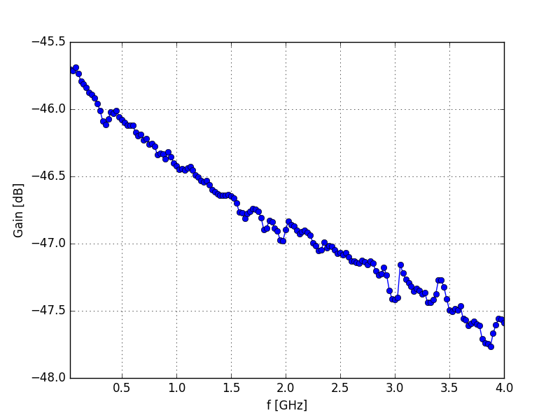
Figure 1: Setup gain
Measurement results are from the board #2.

TX

Wideband 1 – 1000 MHz

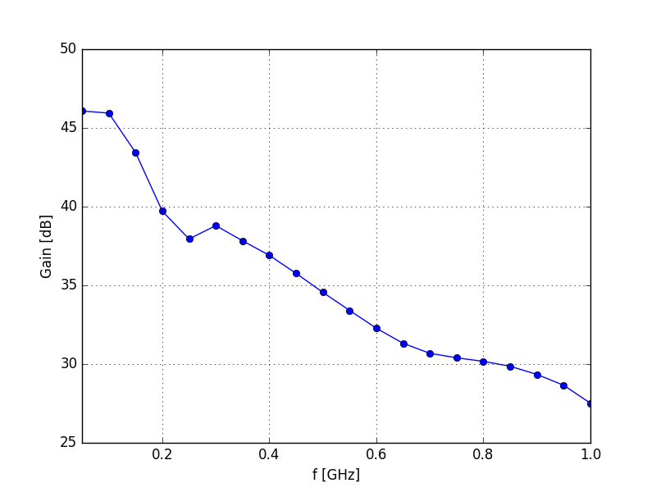 | 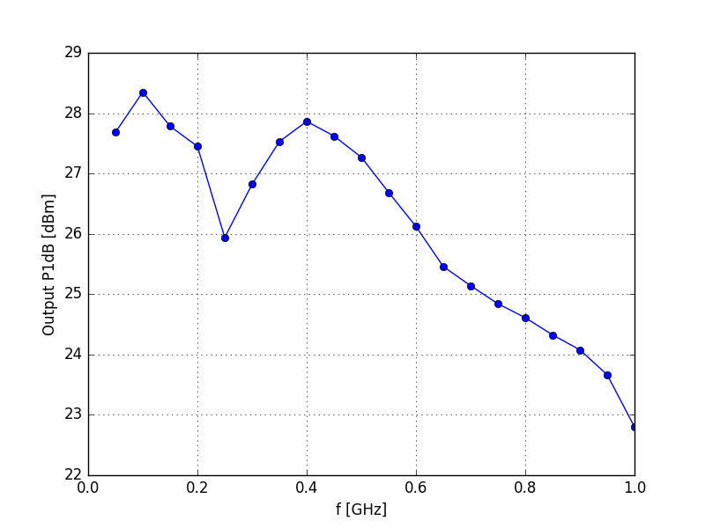
Figure 2: Gain | Figure 3: Output P1dB

HF Performance
The following graphs present the performance of the Wideband 1 – 1000 MHz channel for HF frequencies.

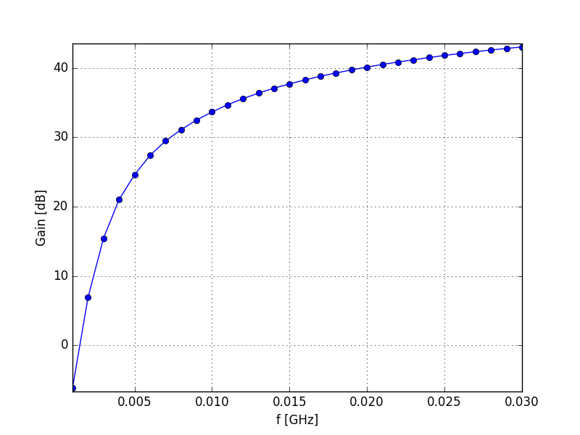 | 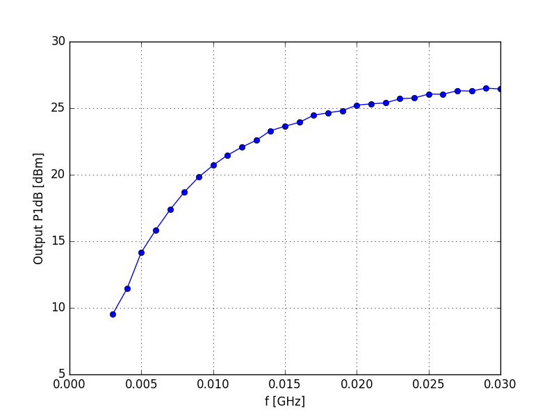
Figure 4: Gain (HF Band) | Figure 5: Output P1dB (HF Band)

Wideband 1000 – 4000 MHz

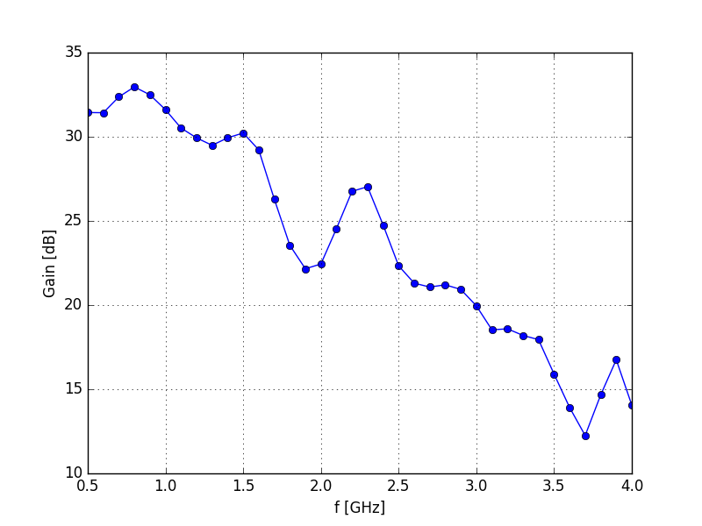 | 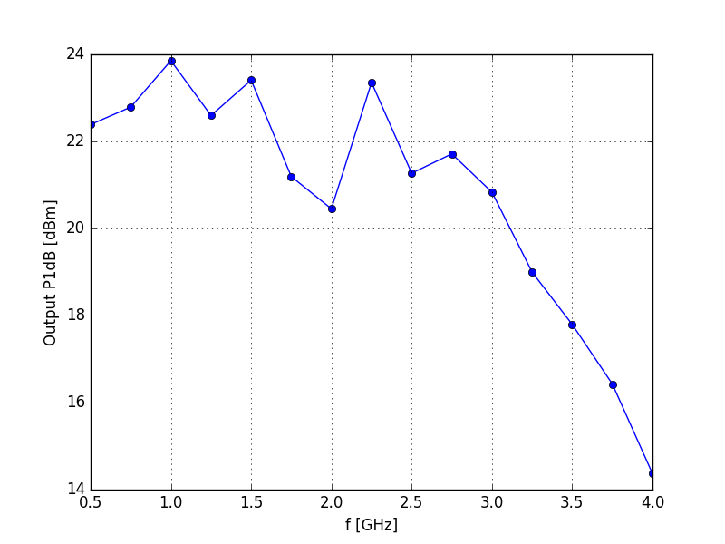
Figure 6: Gain | Figure 7: Output P1dB

HAM 30 MHz (HF)

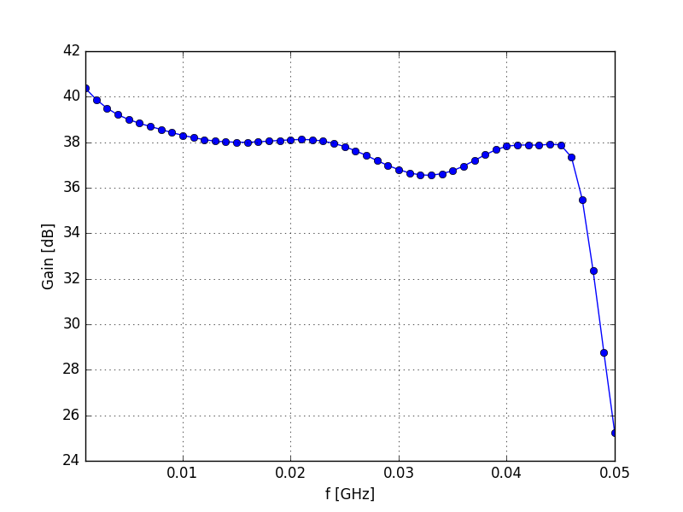 | 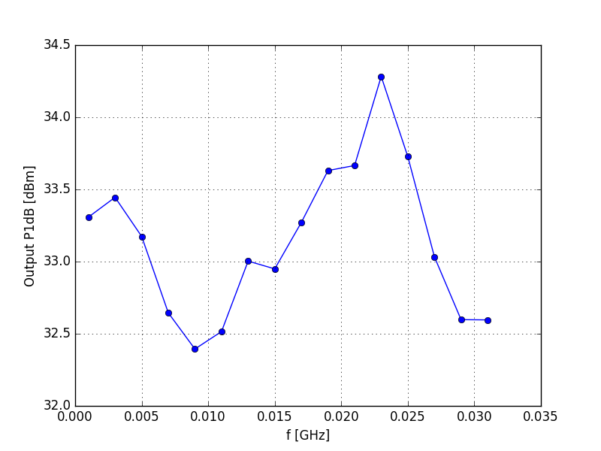
Figure 8: Gain | Figure 9: Output P1dB

HAM 50 – 70 MHz (6 & 4 m)

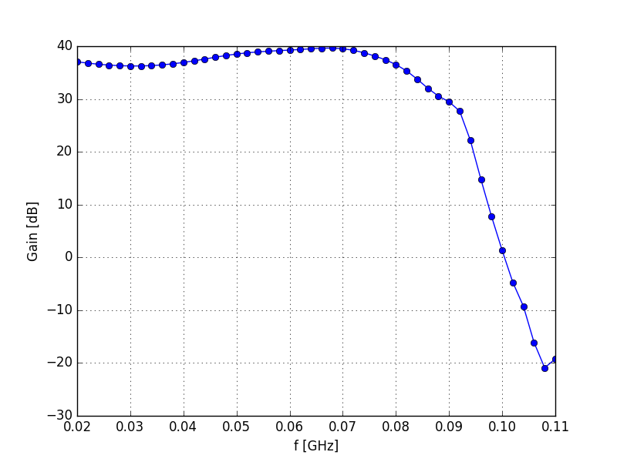 | 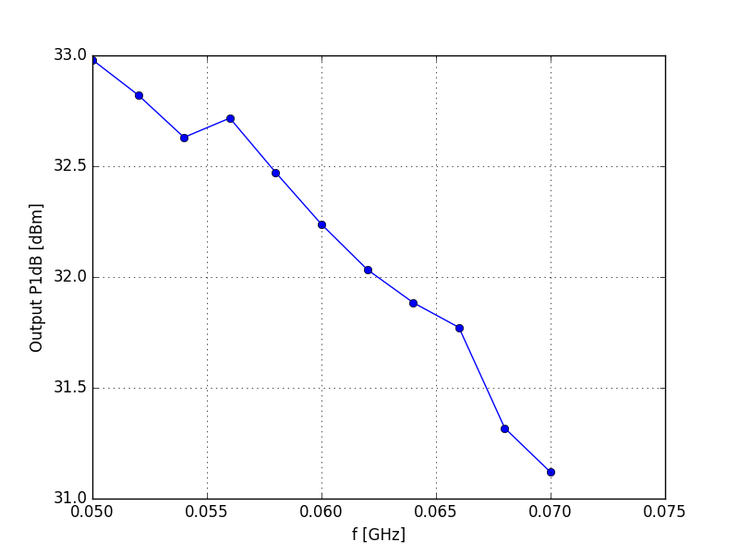
Figure 10: Gain | Figure 11: Output P1dB

HAM 144 – 146 MHz (2 m)

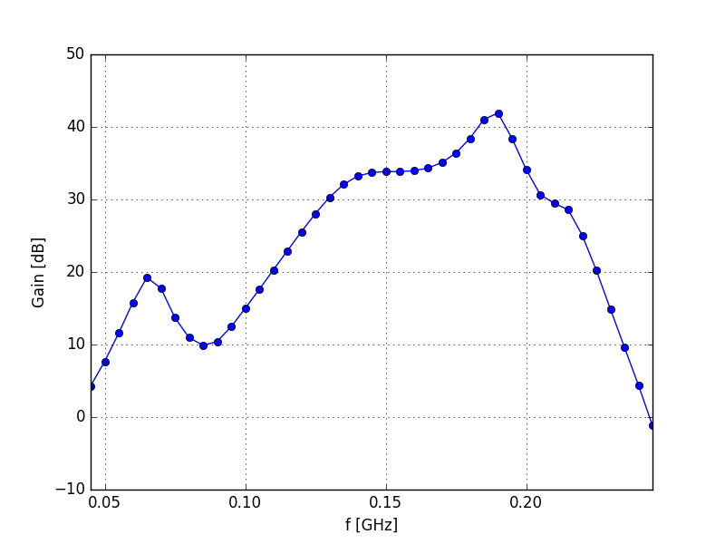 | 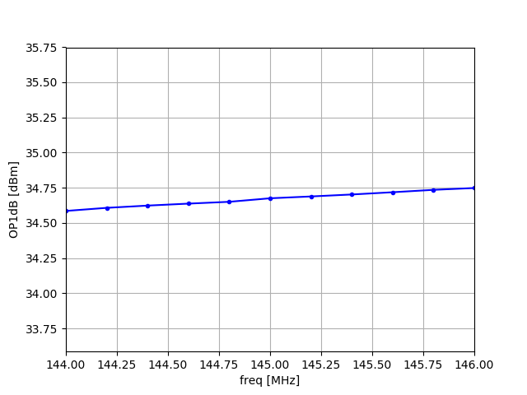
Figure 12: Gain | Figure 13: Output P1dB

HAM 220 – 225 MHz (1.25 m)

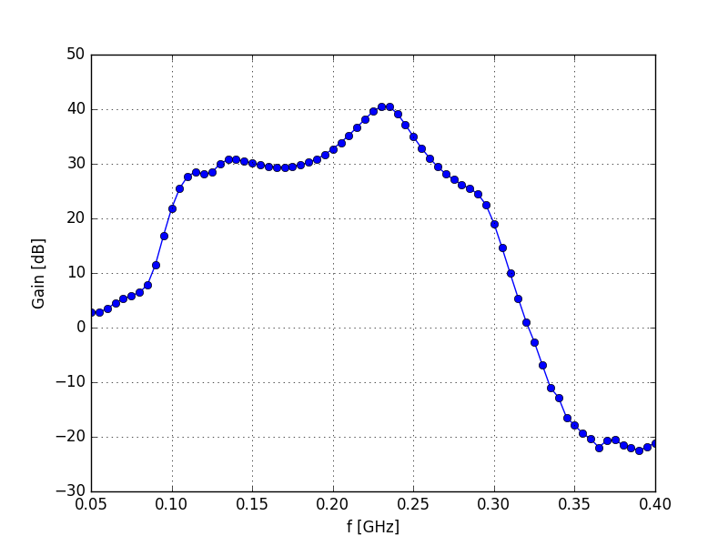 | 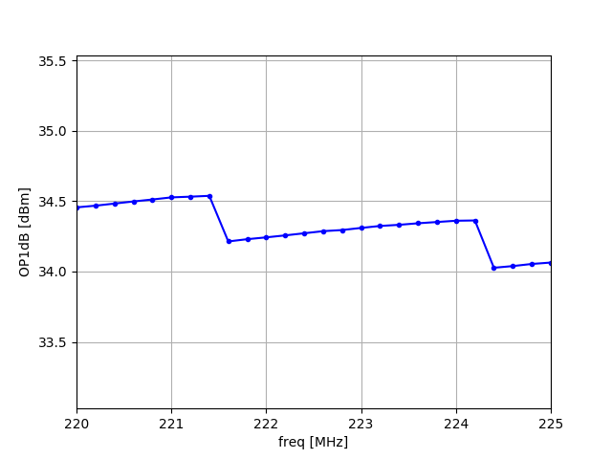
Figure 14: Gain | Figure 15: Output P1dB

HAM 430 – 440 MHz (70 cm)

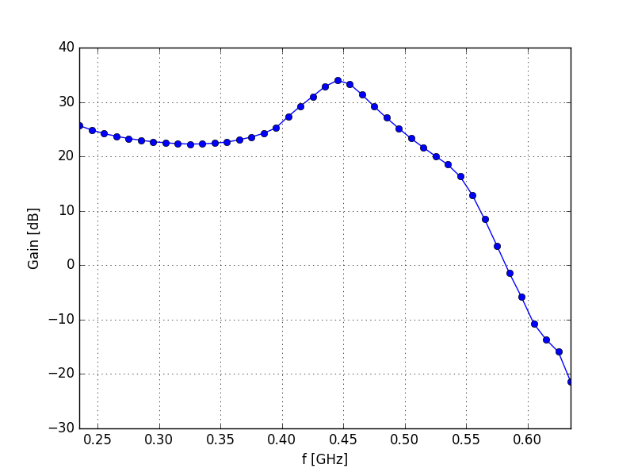 | 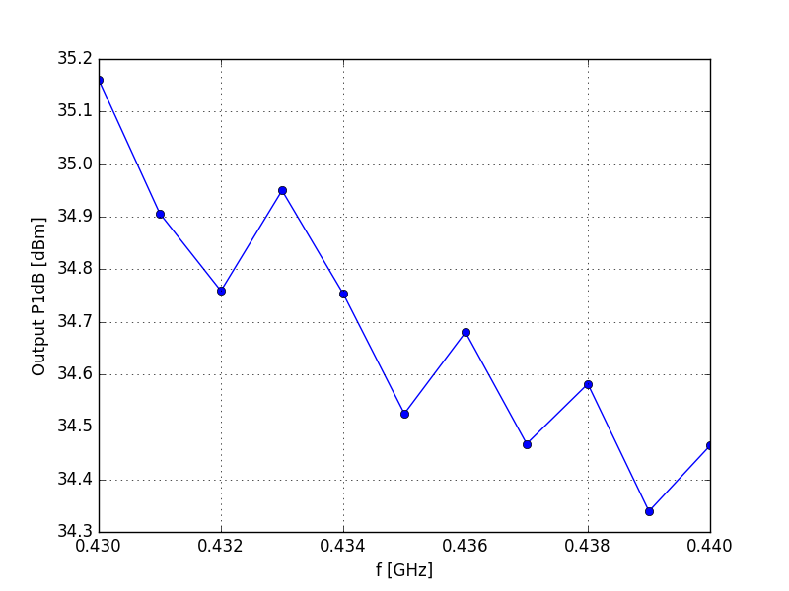
Figure 16: Gain | Figure 17: Output P1dB

HAM 902 – 928 MHz (33 cm)

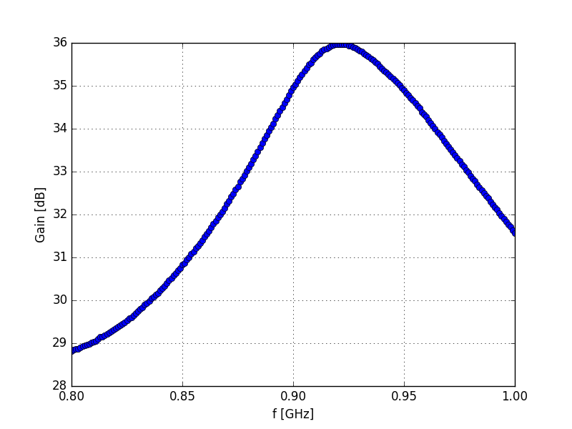 | 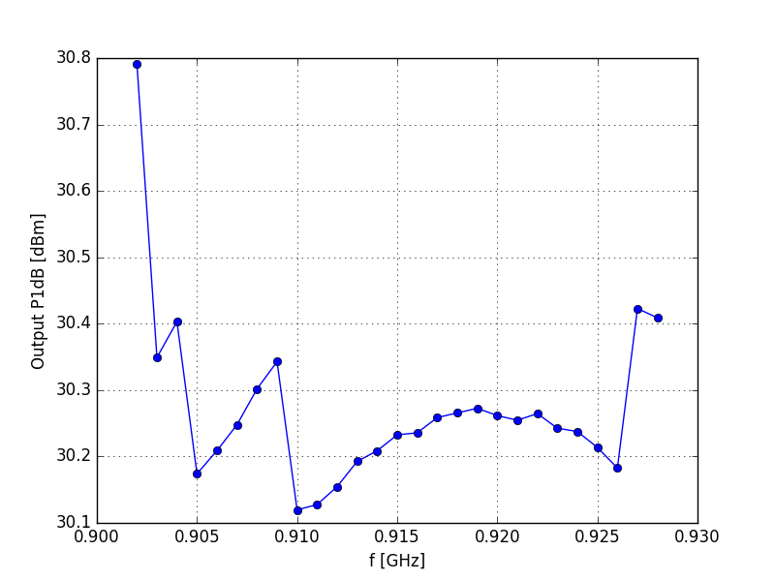
Figure 18: Gain | Figure 19: Output P1dB

HAM 1240 – 1325 MHz (23 cm)

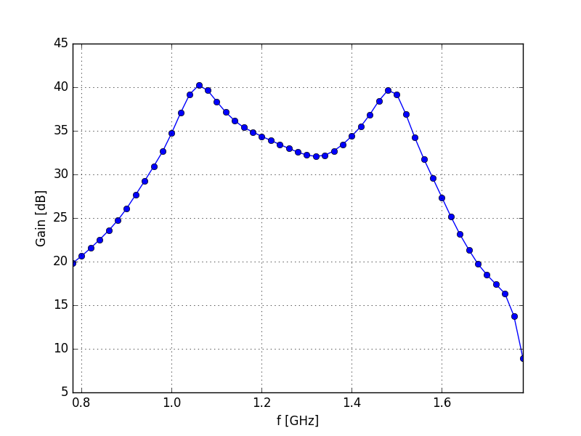 | 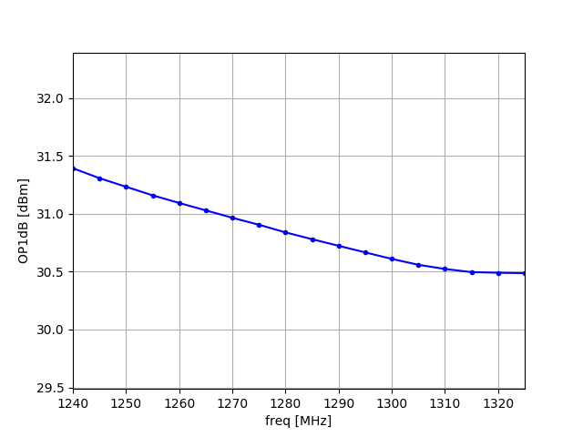
Figure 20: Gain | Figure 21: Output P1dB

HAM 2300 – 2450 MHz (13 cm)

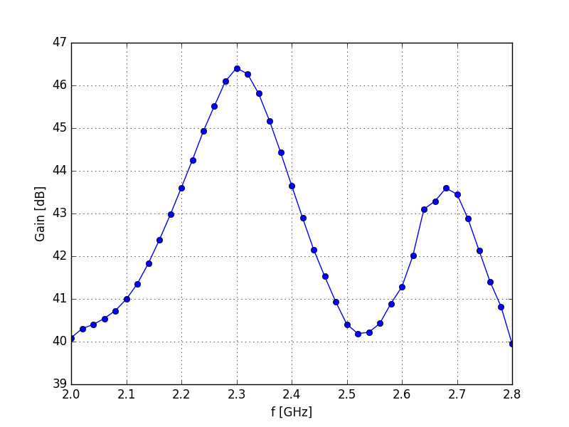 | 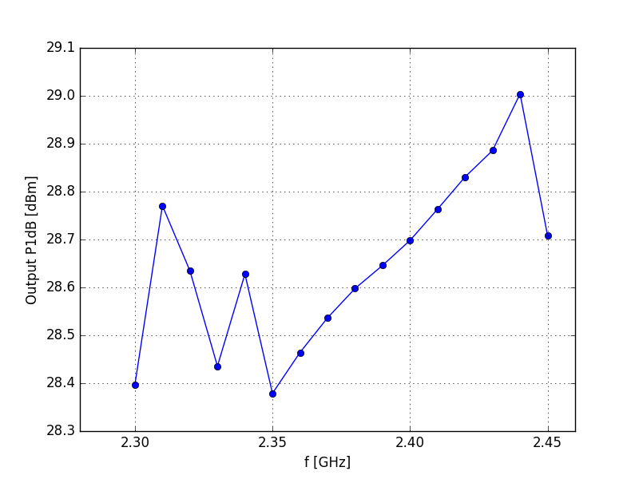
Figure 22: Gain | Figure 23: Output P1dB

HAM 3300 – 3500 MHz (9 cm)

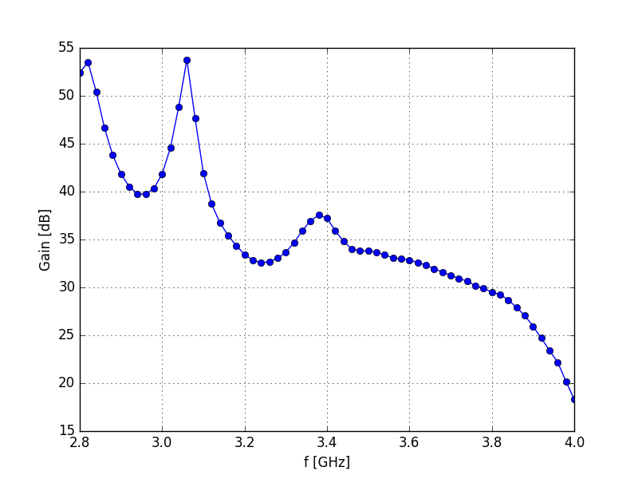 | 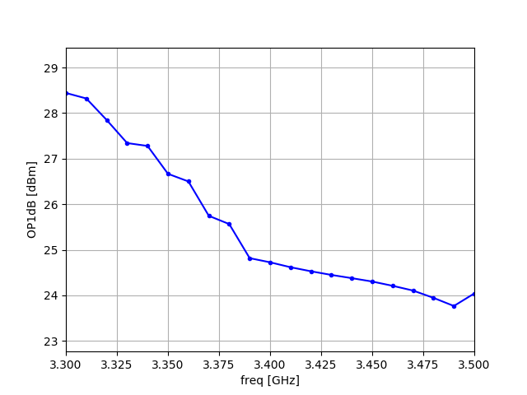
Figure 24: Gain | Figure 25: Output P1dB

Cellular Band 1

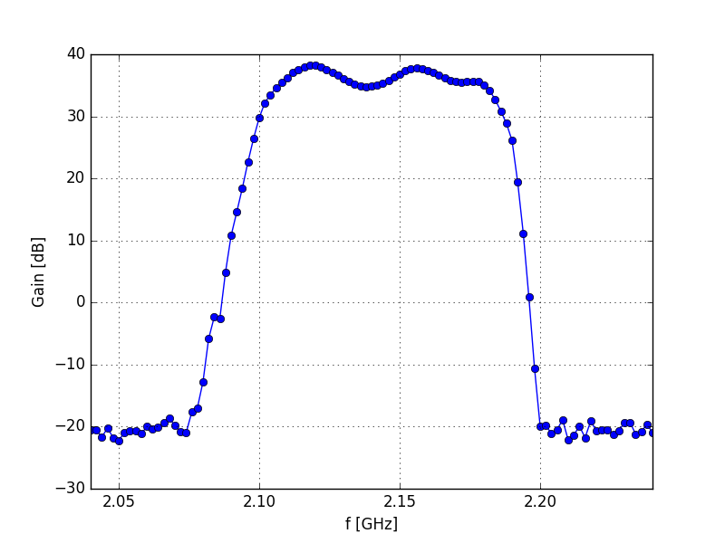 | 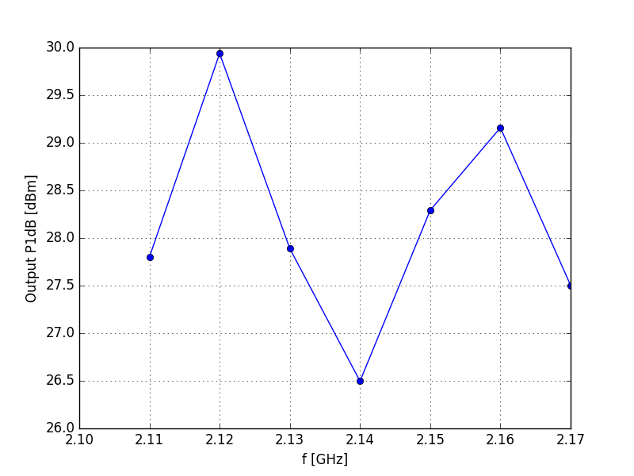
Figure 26: Gain | Figure 27: Output P1dB

Cellular Band 2

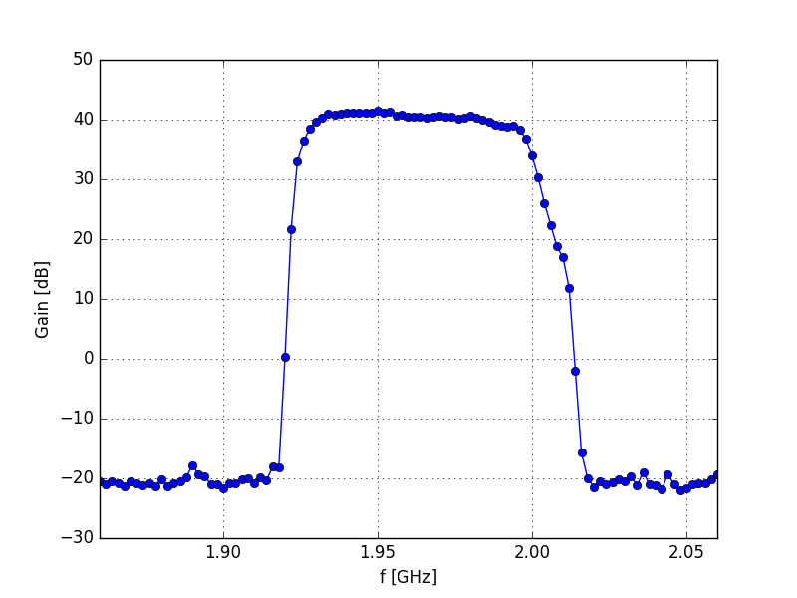 | 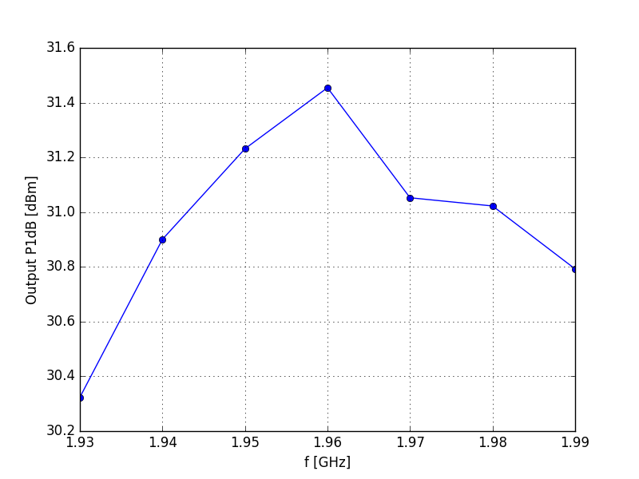
Figure 28: Gain | Figure 29: Output P1dB

Cellular Band 3

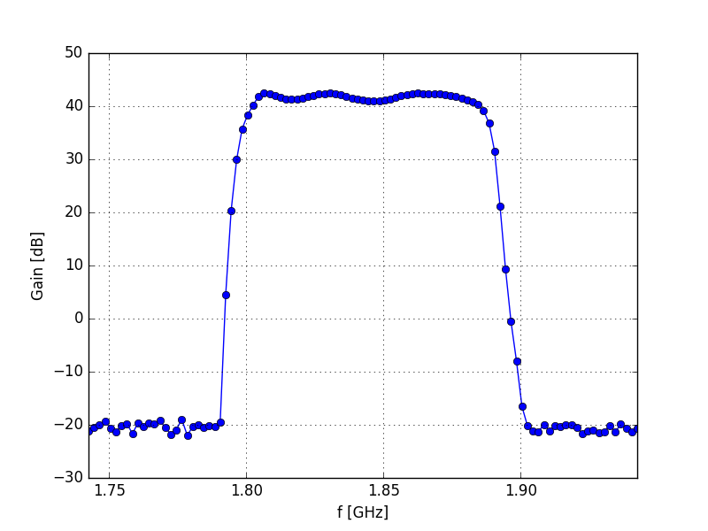 | 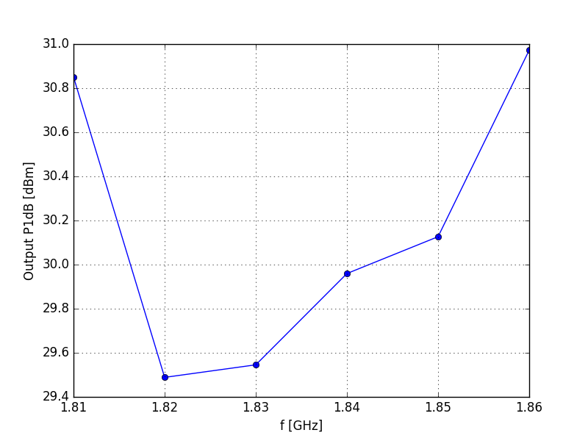
Figure 30: Gain | Figure 31: Output P1dB

Cellular Band 7

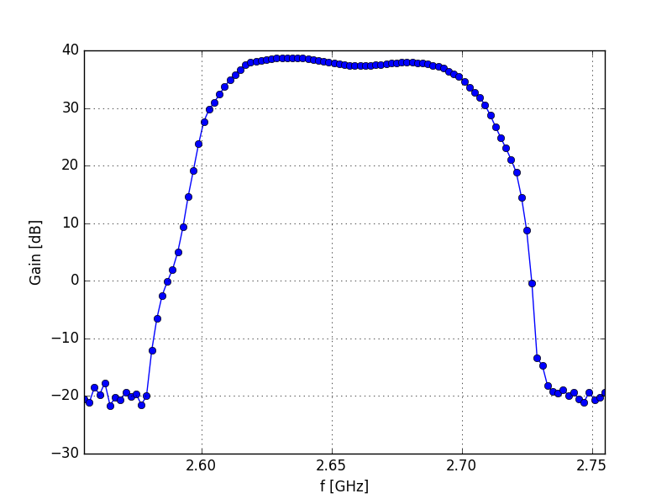 | 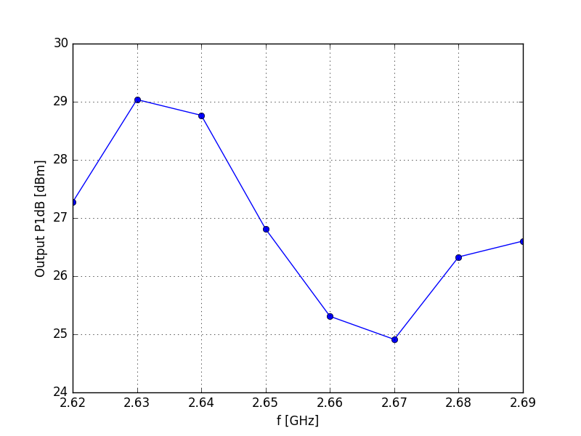
Figure 32: Gain | Figure 33: Output P1dB

Cellular Band 38

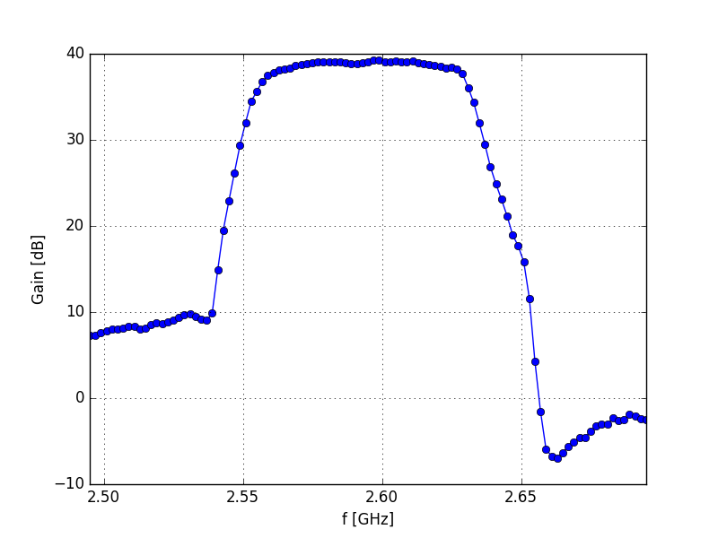 | 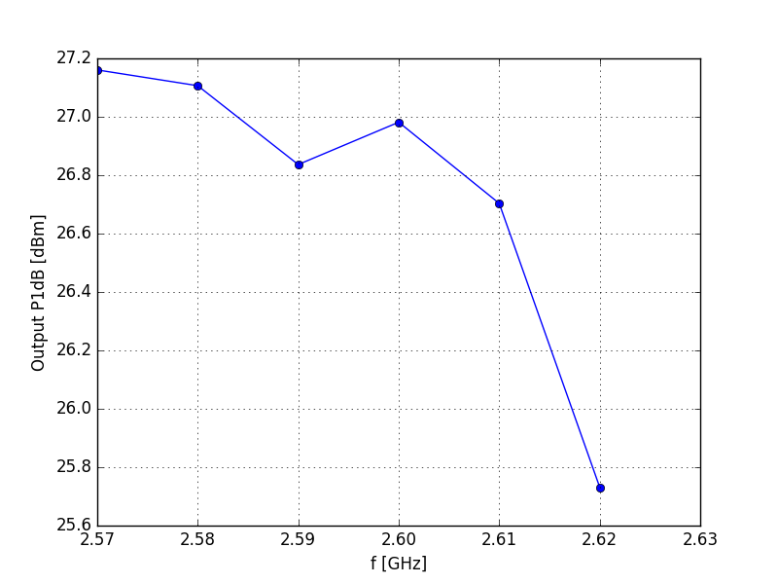
Figure 34: Gain | Figure 35: Output P1dB

RX

Wideband 1 – 1000 MHz

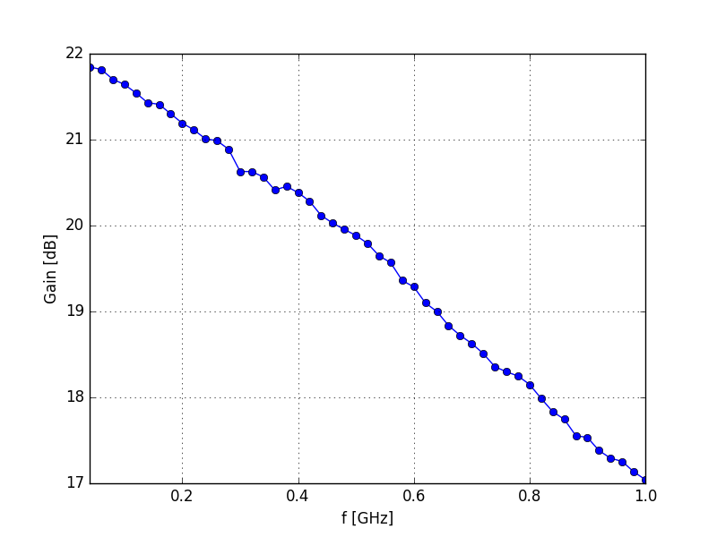 | 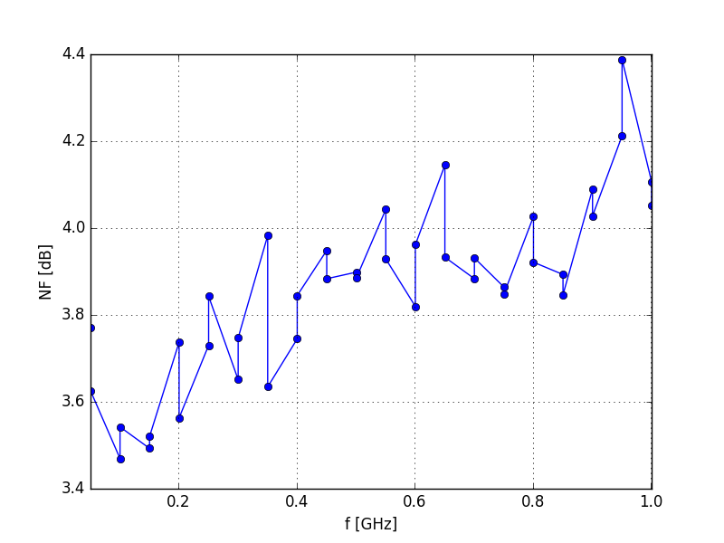
Figure 36: Gain | Figure 37: Noise Figure*
* Note: Extreme NF values resulted from inadequate EM isolation of the measured device. These values have not been taken into account in the Summary.
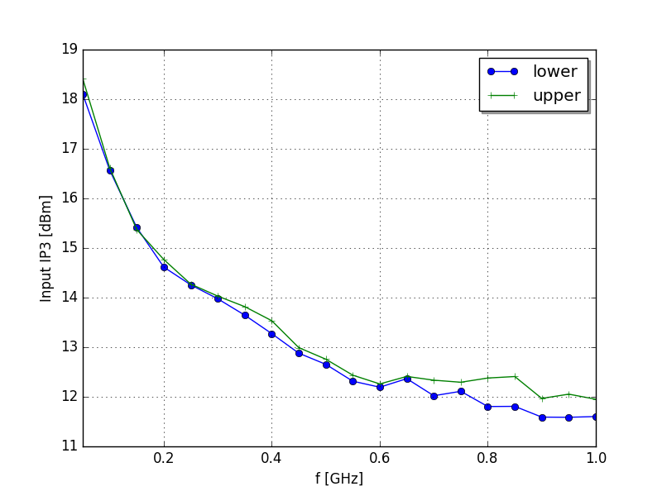
Figure 38: Input IP3

HF Performance
The following graphs present the performance of the Wideband 1 – 1000 MHz channel for HF frequencies.

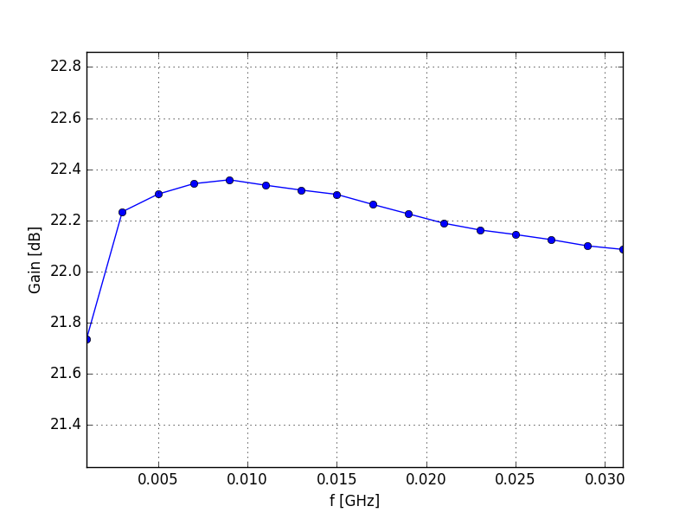 | 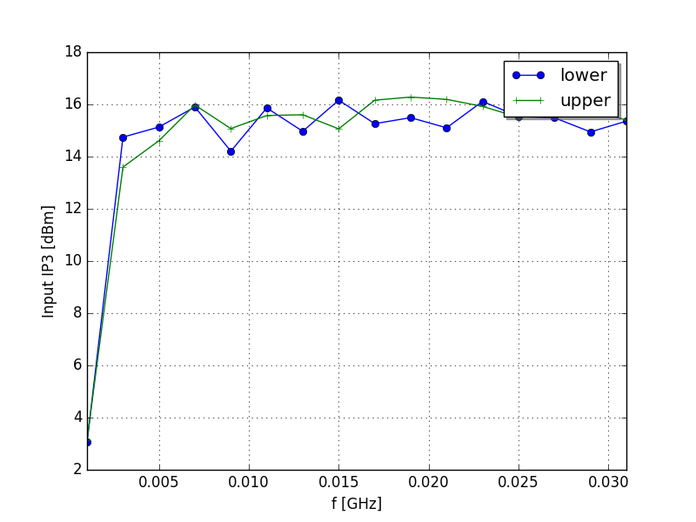
Figure 39: Gain (HF Band) | Figure 40: Input IP3 (HF Band)

Wideband 1000 – 4000 MHz

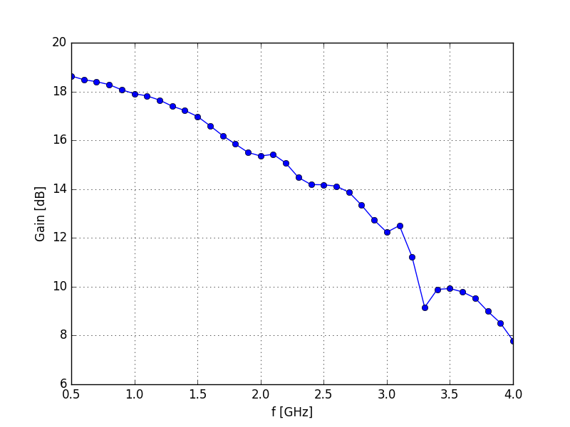 | 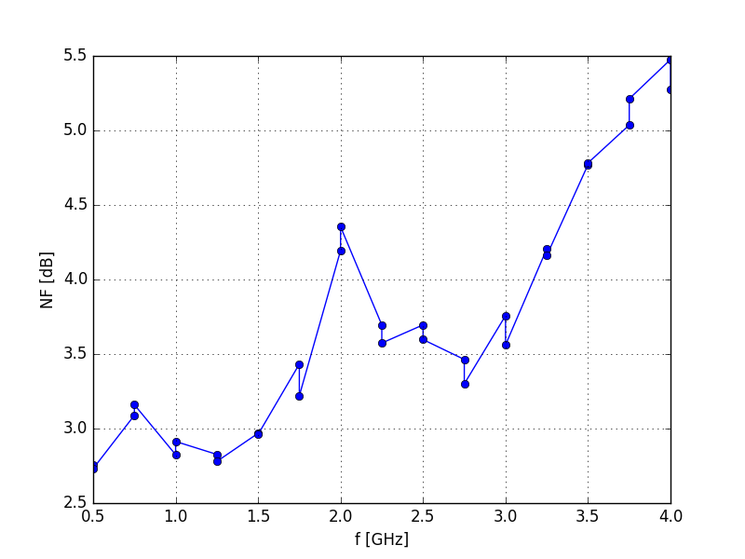
Figure 41: Gain | Figure 42: Noise Figure

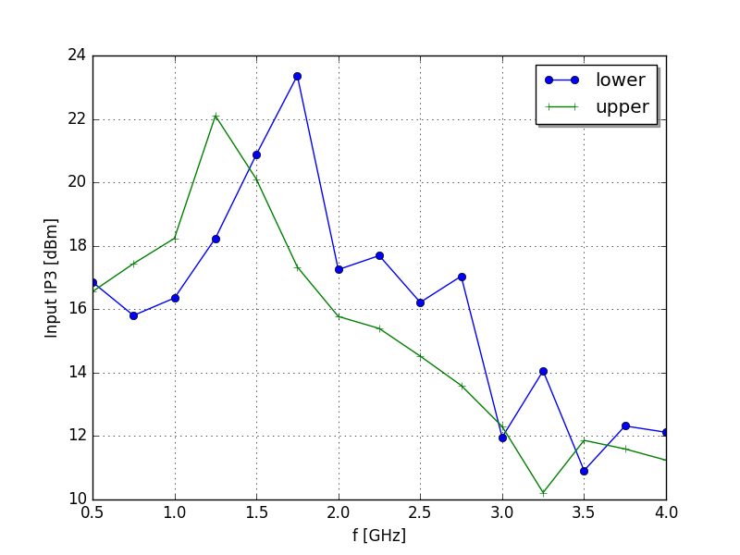
Figure 43: Input IP3

HAM 30 MHz (HF)

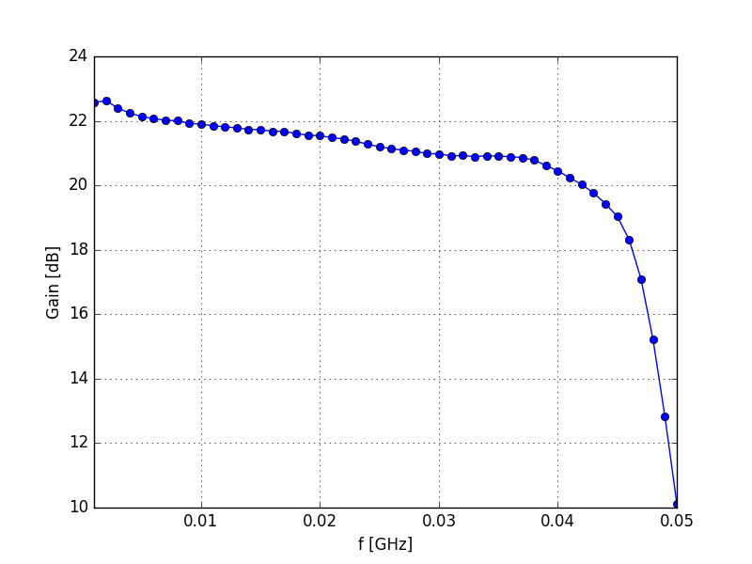 | 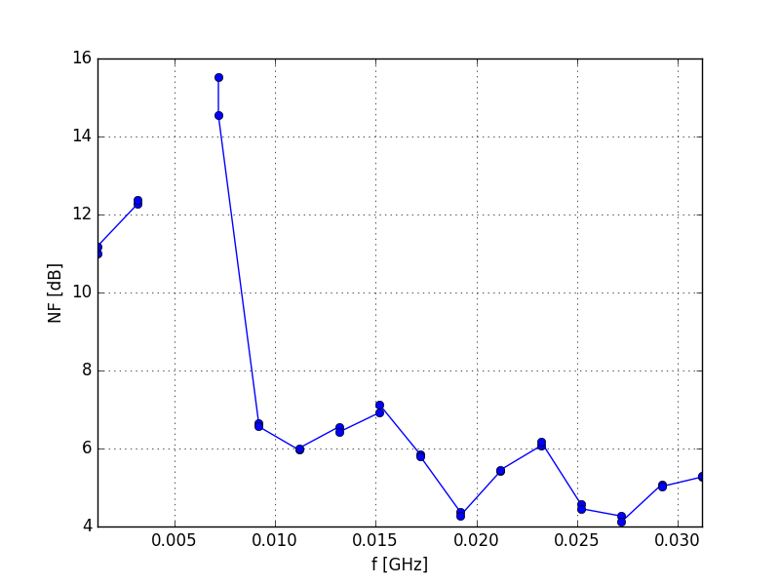
Figure 44: Gain | Figure 45: Noise Figure*
* Note: Extreme NF values resulted from inadequate EM isolation of the measured device. These values have not been taken into account in the Summary. NF measurements below 10 MHz are not valid, since the noise head used was not calibrated at these frequencies.
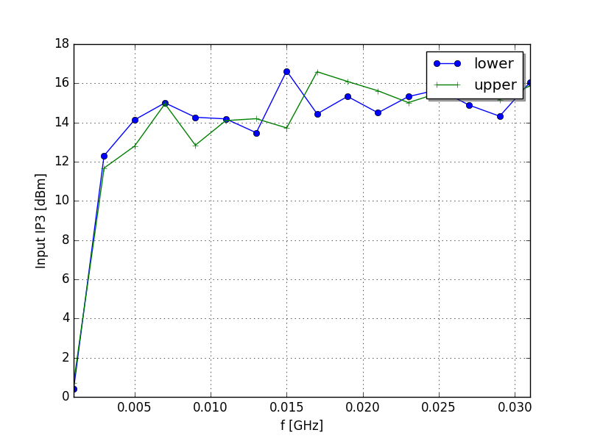
Figure 46: Input IP3**
** Note: Why does the IP3 deteriorates for frequencies below 5 MHz? This issues will be further investigated.

HAM 50 – 70 MHz (6 & 4 m)

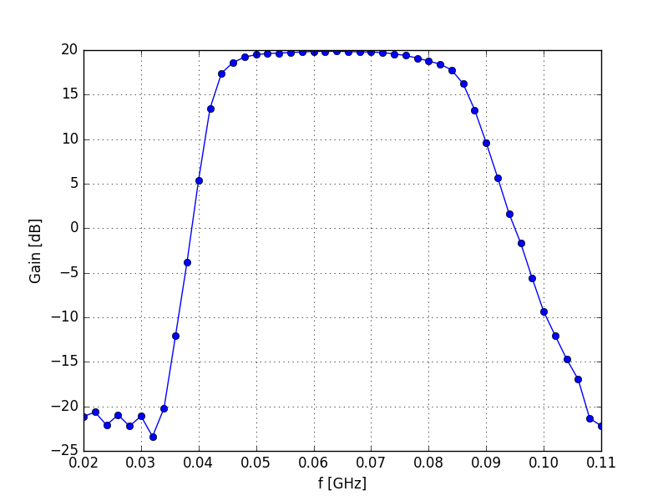 | 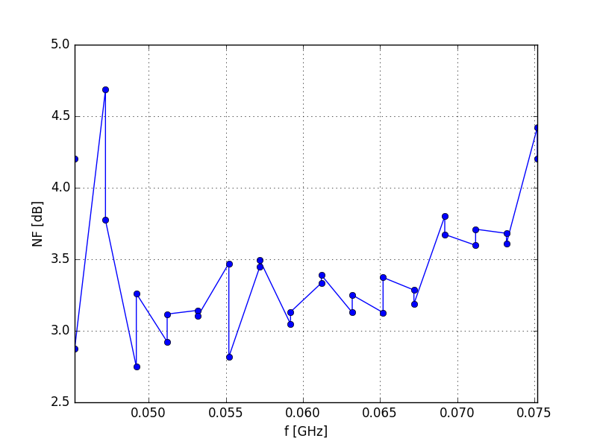
Figure 47: Gain | Figure 48: Noise Figure *

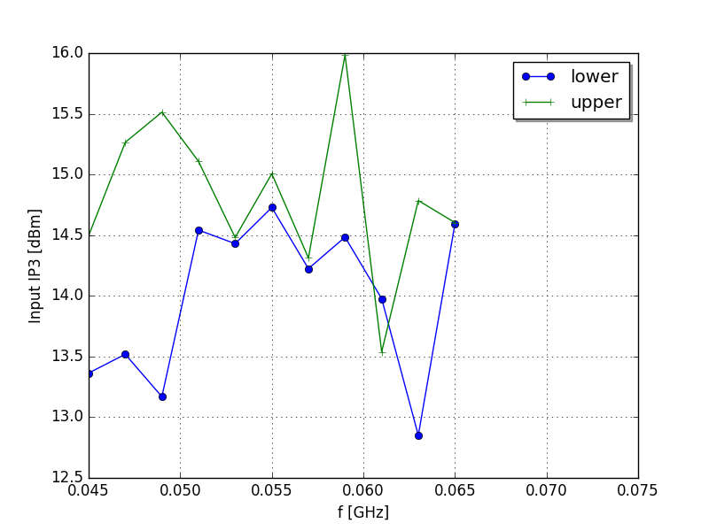
Figure 49: Input IP3

HAM 144 – 146 MHz (2 m)

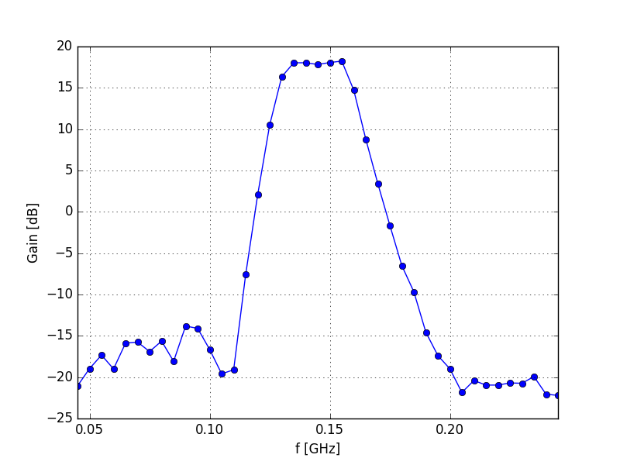 | 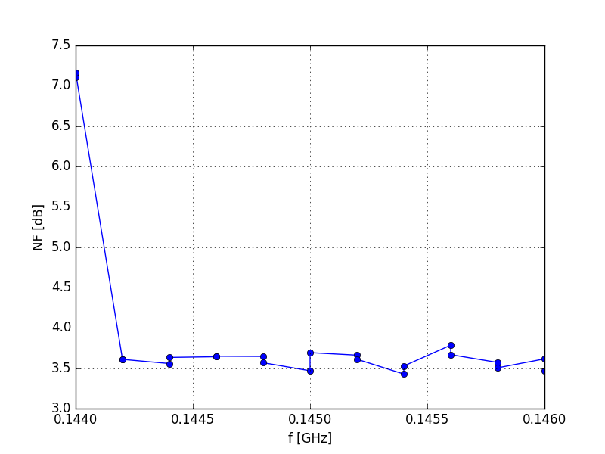
Figure 50: Gain | Figure 51: Noise Figure

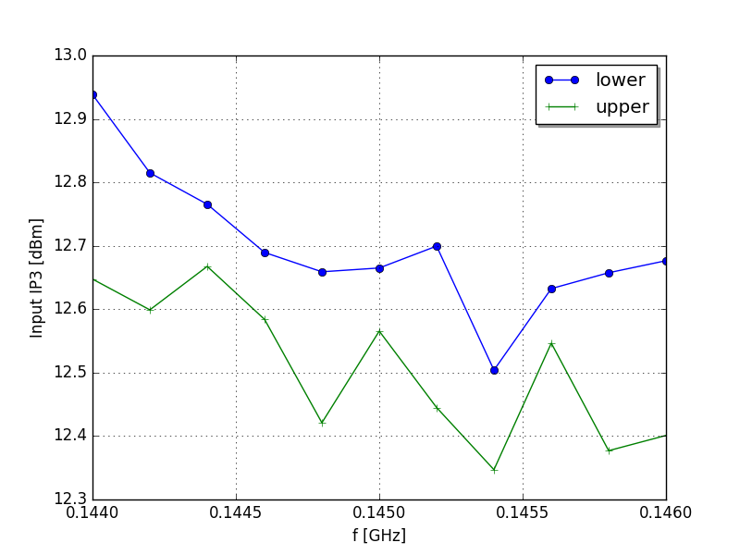
Figure 52: Input IP3

HAM 220 – 225 MHz (1.25 m)

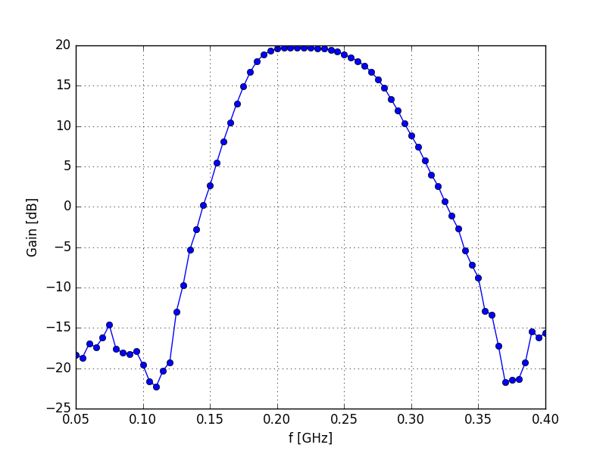 | 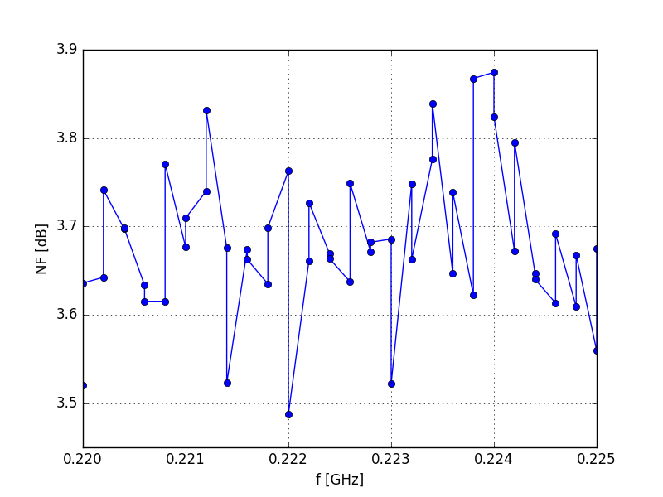
Figure 53: Gain | Figure 54: Noise Figure

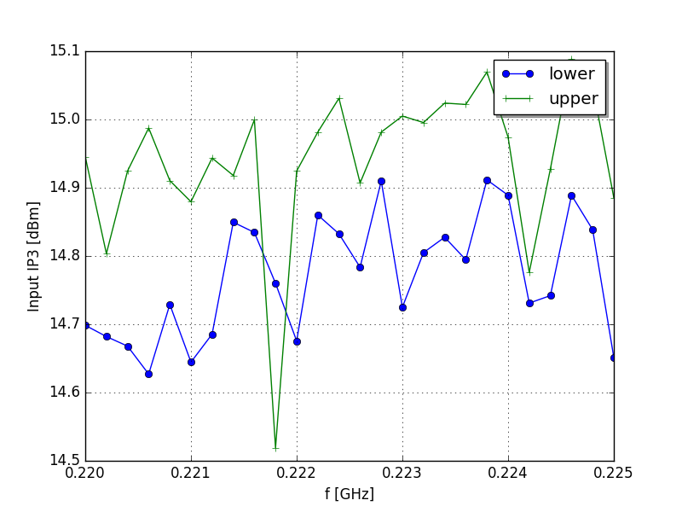
Figure 55: Input IP3

HAM 430 – 440 MHz (70 cm)

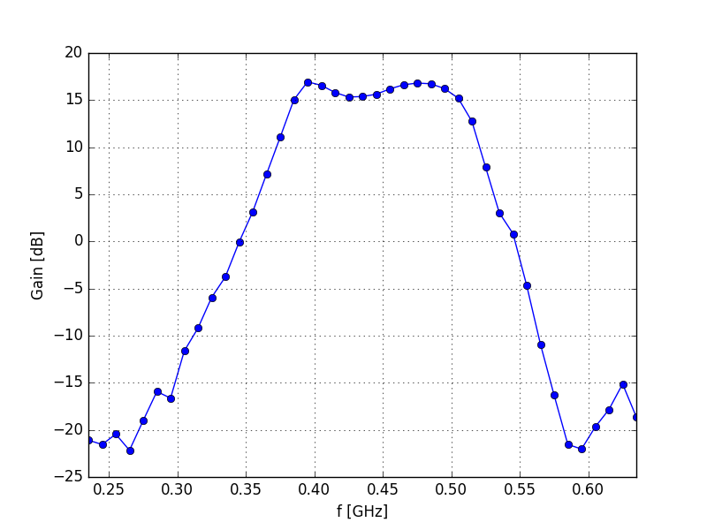 | 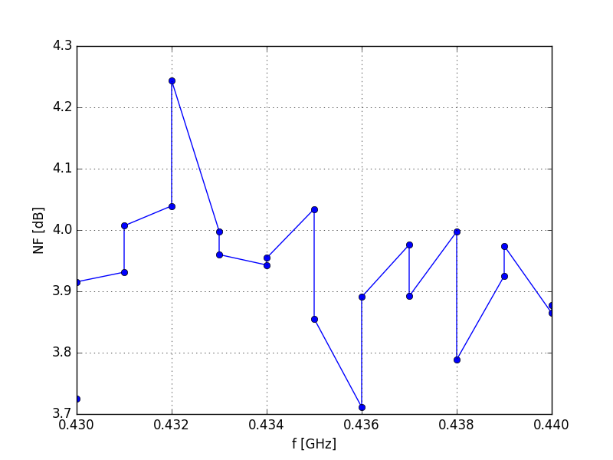
Figure 56: Gain | Figure 57: Noise Figure

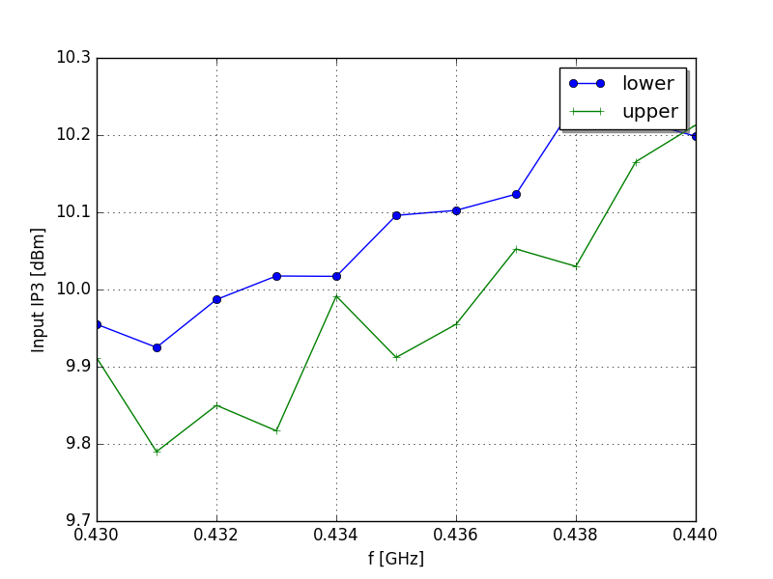
Figure 58: Input IP3

HAM 902 – 928 MHz (33 cm)

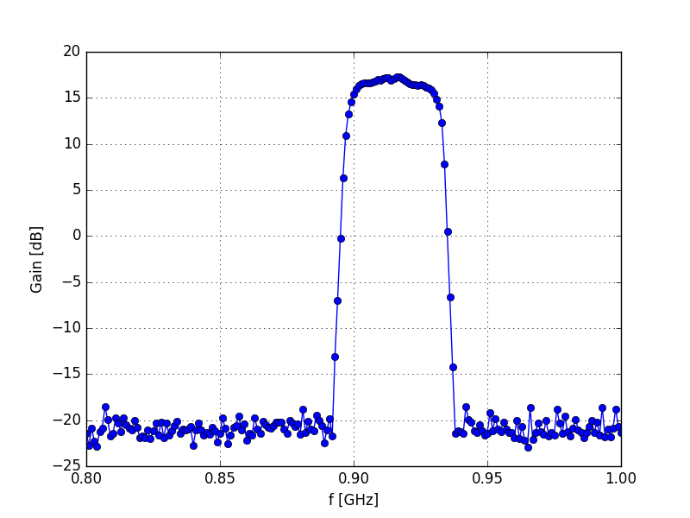 | 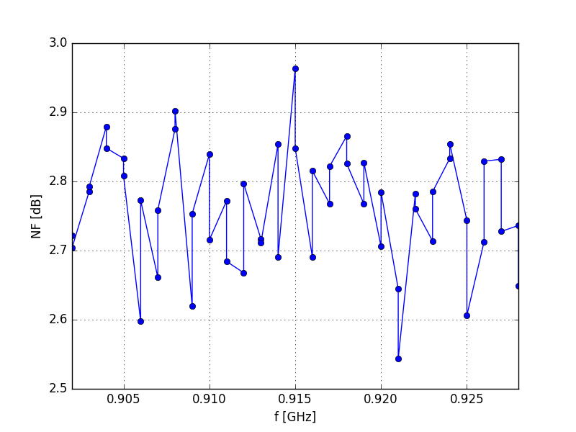
Figure 59: Gain | Figure 60: Noise Figure

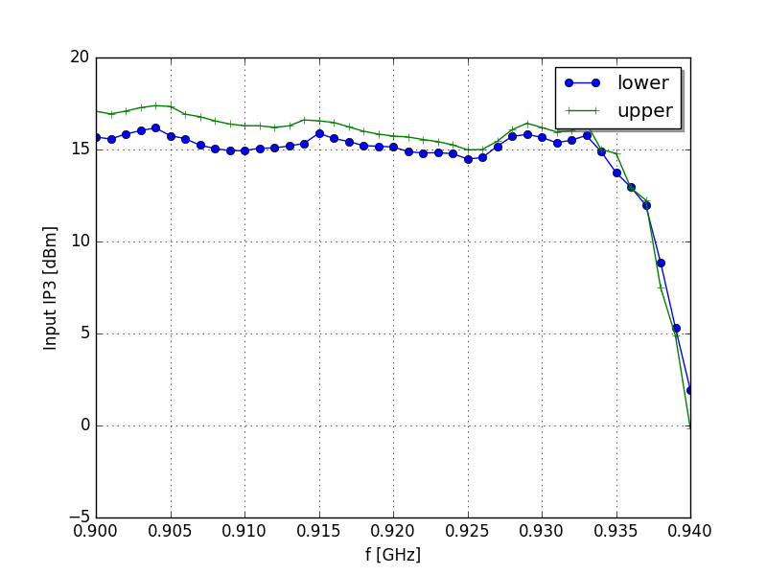
Figure 61: Input IP3

HAM 1240 – 1325 MHz (23 cm)

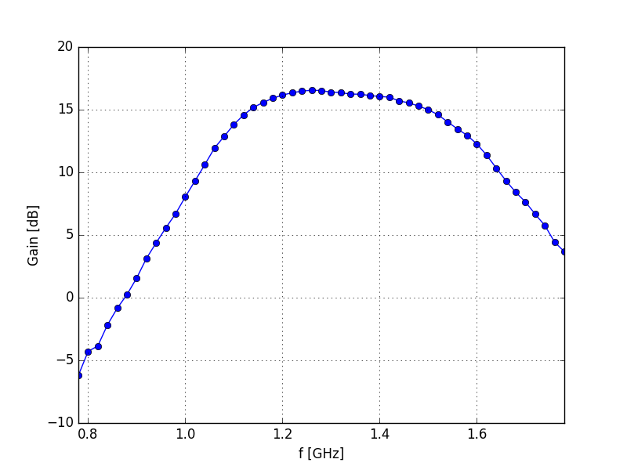 | 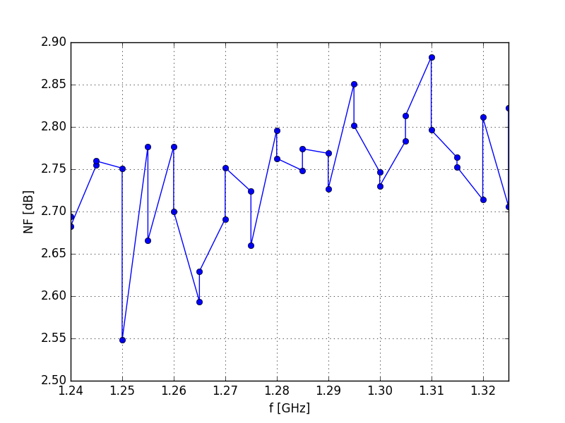
Figure 62: Gain | Figure 63: Noise Figure *
* Note: Extreme NF values resulted from inadequate EM isolation of the measured device. These values have not been taken into account in the Summary.
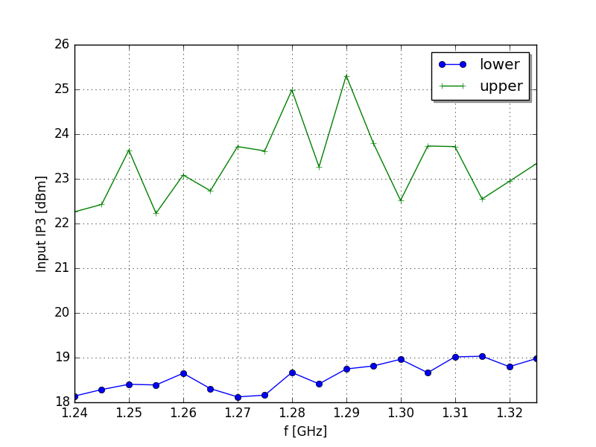
Figure 64: Input IP3

HAM 2300 – 2450 MHz (13 cm)

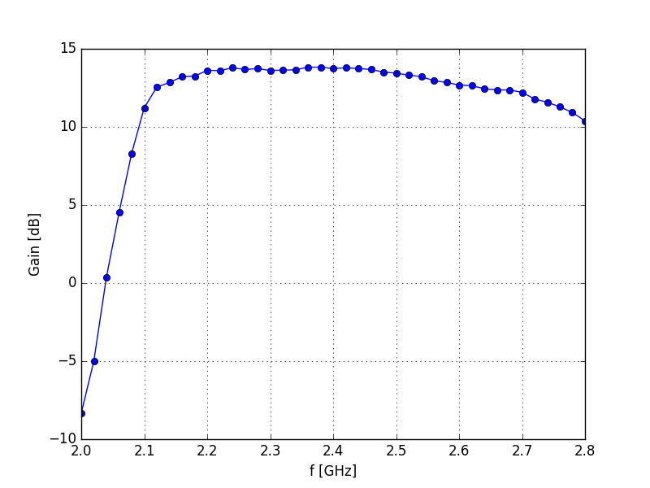 | 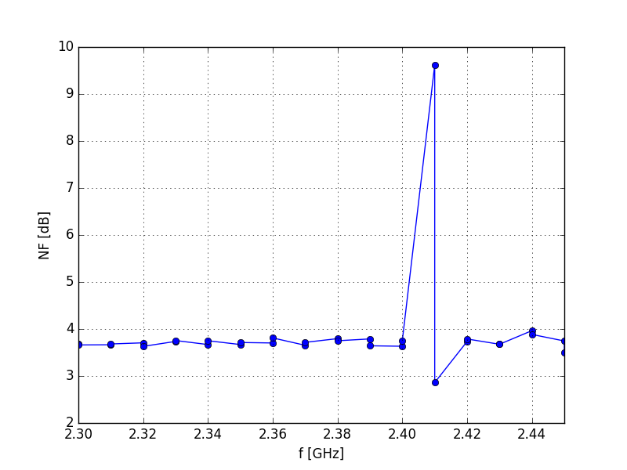
Figure 65: Gain | Figure 66: Noise Figure

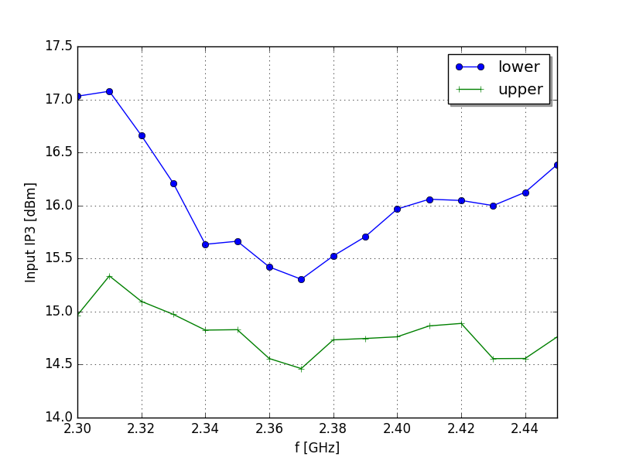
Figure 67: Input IP3

HAM 3300 – 3500 MHz (9 cm)

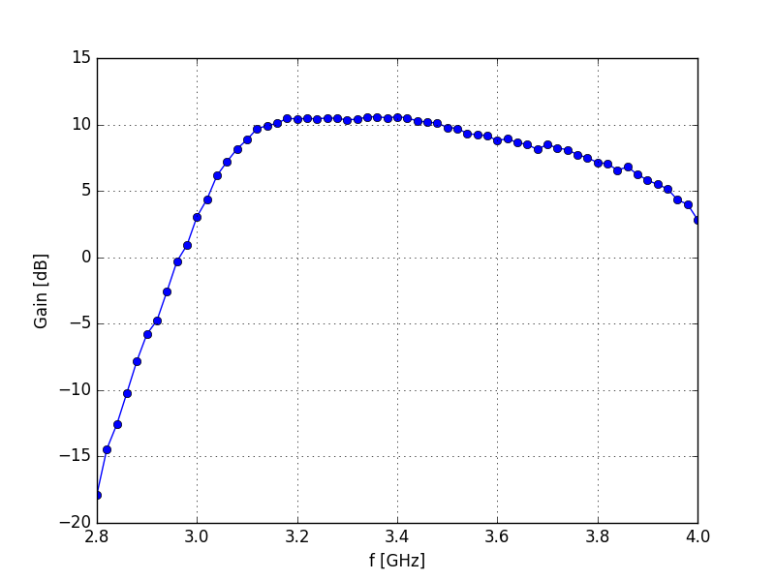 | 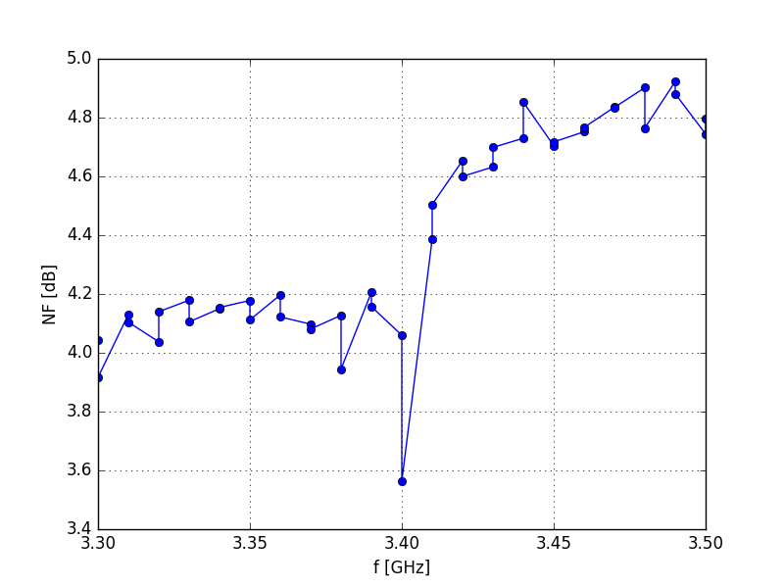
Figure 68: Gain | Figure 69: Noise Figure

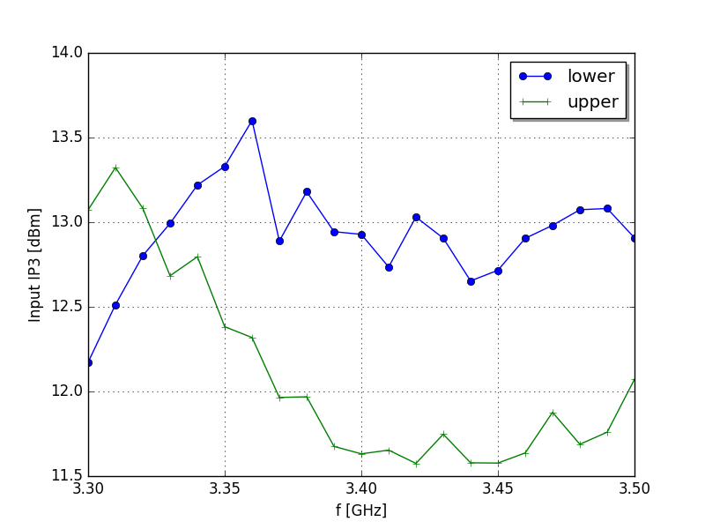
Figure 70: Input IP3

Cellular Band 1

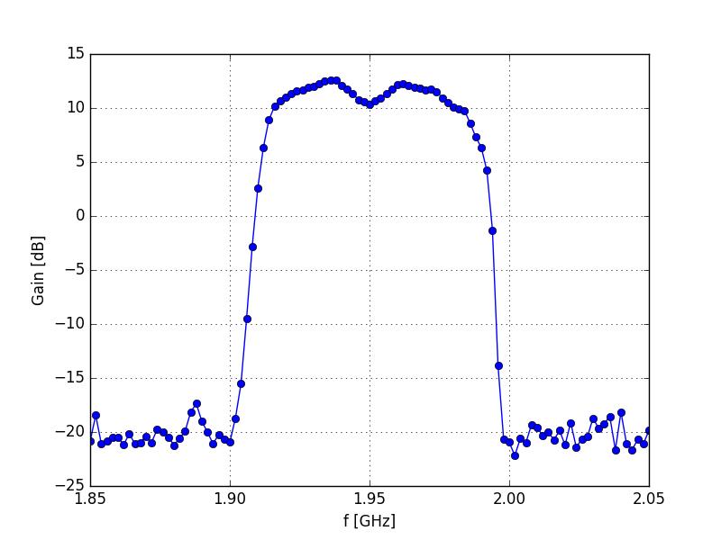 | 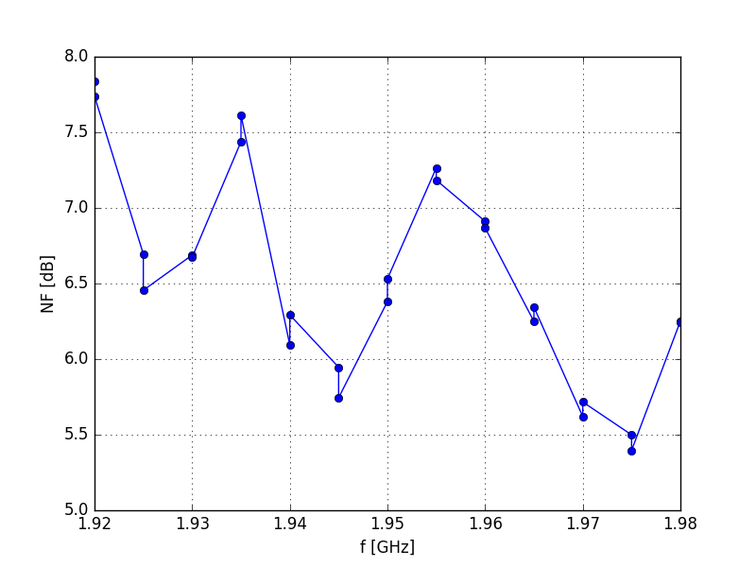
Figure 71: Gain | Figure 72: Noise Figure*
* Note: Extreme NF values resulted from inadequate EM isolation of the measured device. These values have not been taken into account in the Summary.
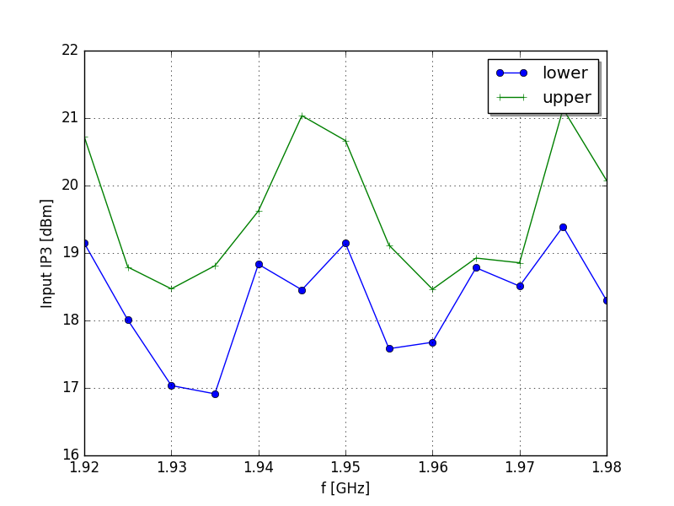
Figure 73: Input IP3

Cellular Band 2

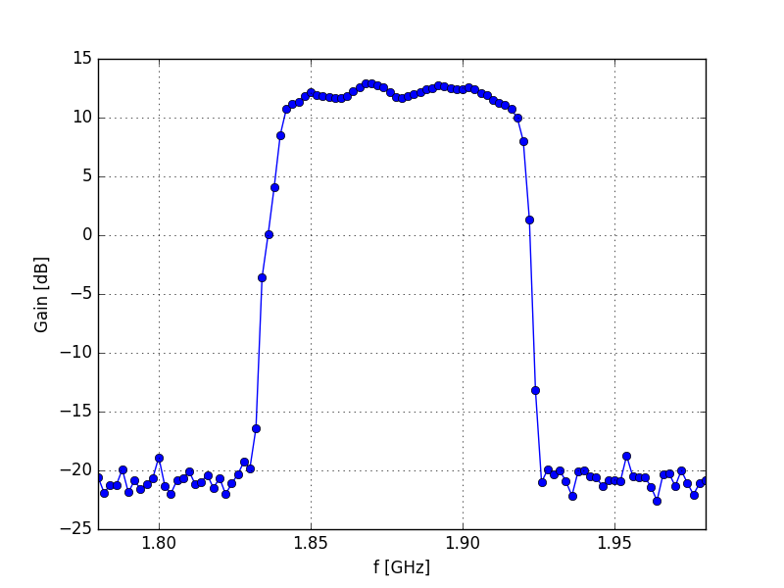 | 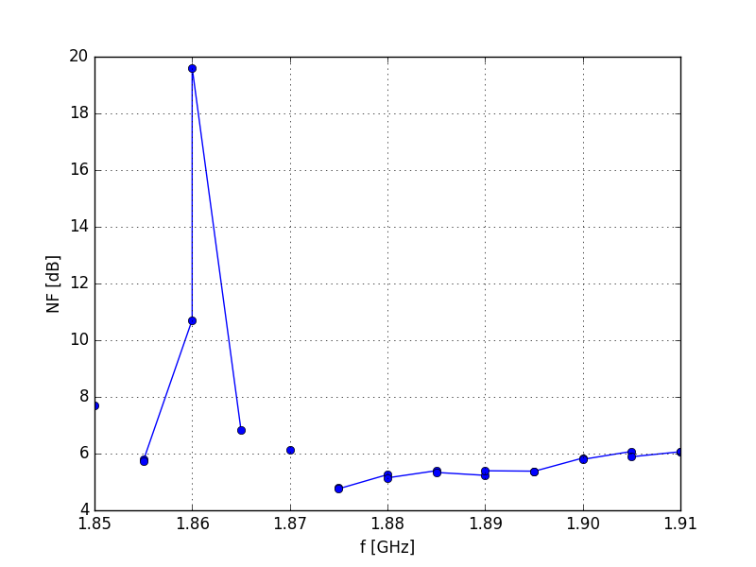
Figure 74: Gain | Figure 75: Noise Figure *
* Note: Extreme NF values resulted from inadequate EM isolation of the measured device. These values have not been taken into account in the Summary.
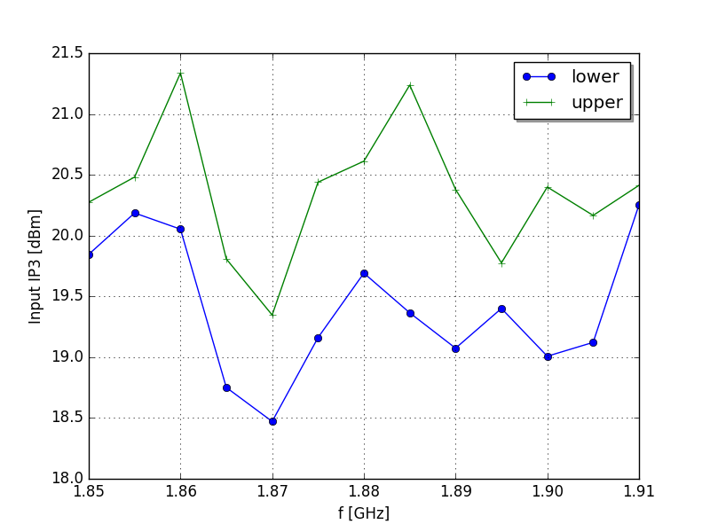
Figure 76: Input IP3

Cellular Band 3

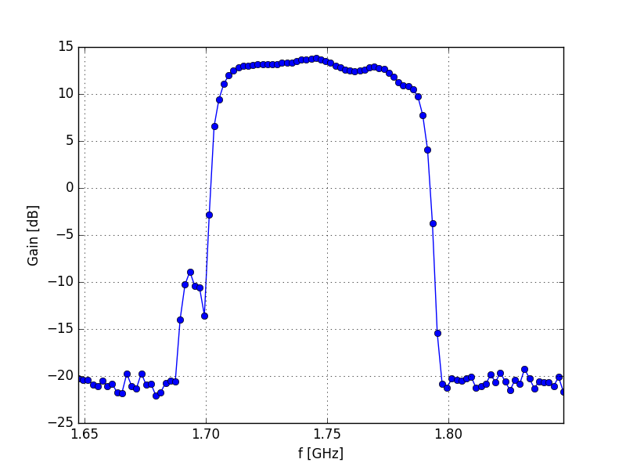 | 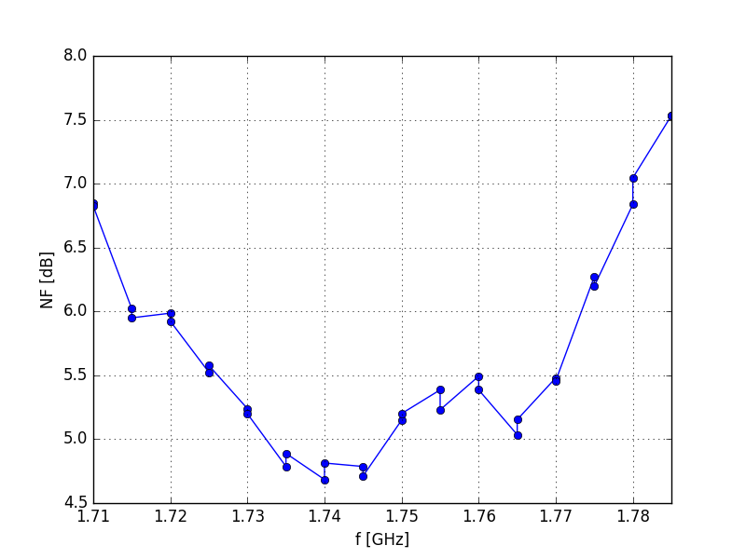
Figure 77: Gain | Figure 78: Noise Figure
* Note: Extreme NF values resulted from inadequate EM isolation of the measured device. These values have not been taken into account in the Summary.
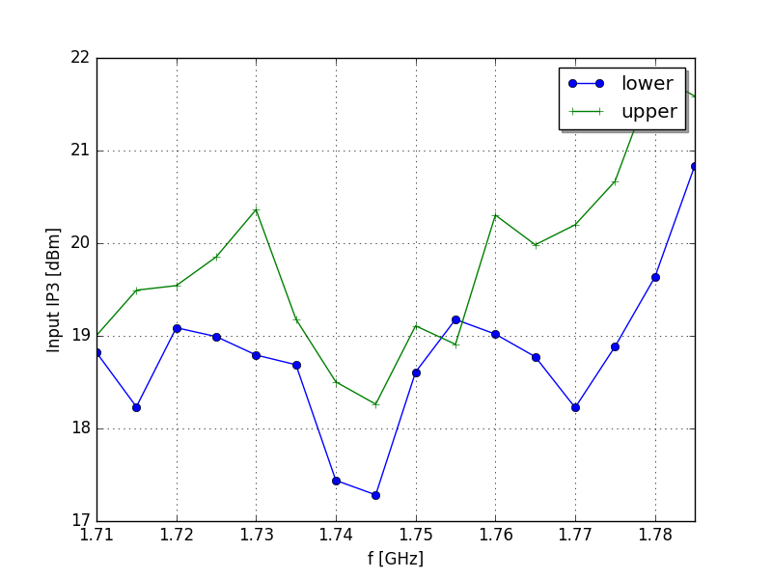
Figure 79: Input IP3

Cellular Band 7

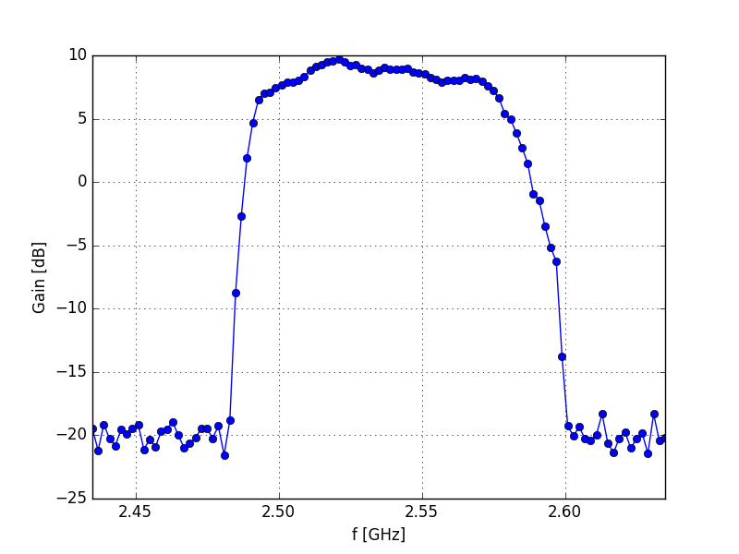 | 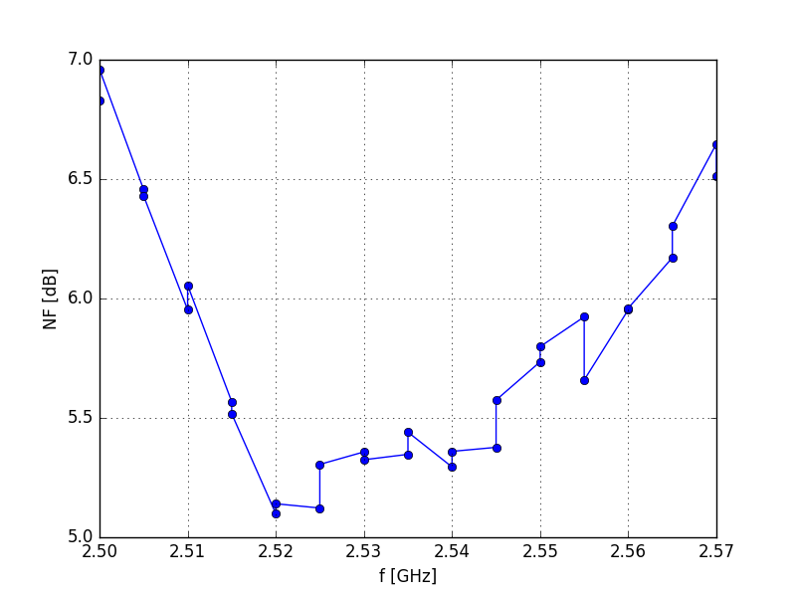
Figure 80: Gain | Figure 81: Noise Figure

* Note: Extreme NF values resulted from inadequate EM isolation of the measured device. These values have not been taken into account in the Summary.
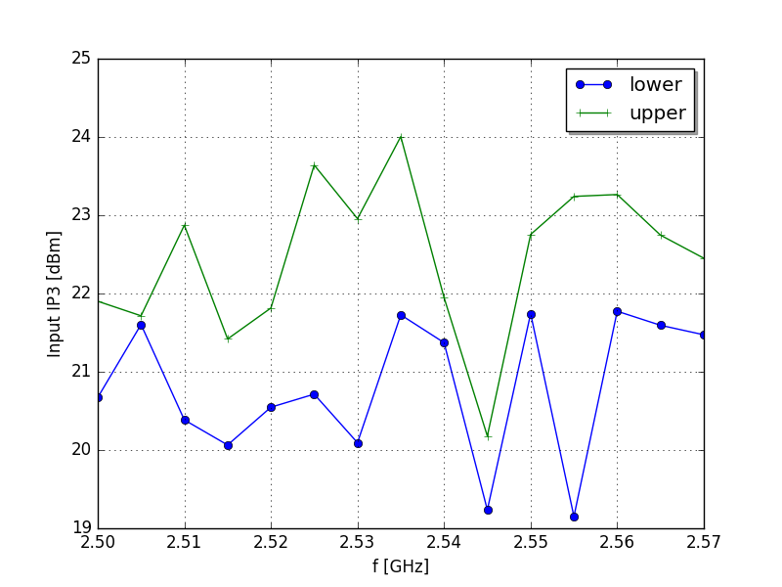
Figure 82: Input IP3

Cellular Band 38

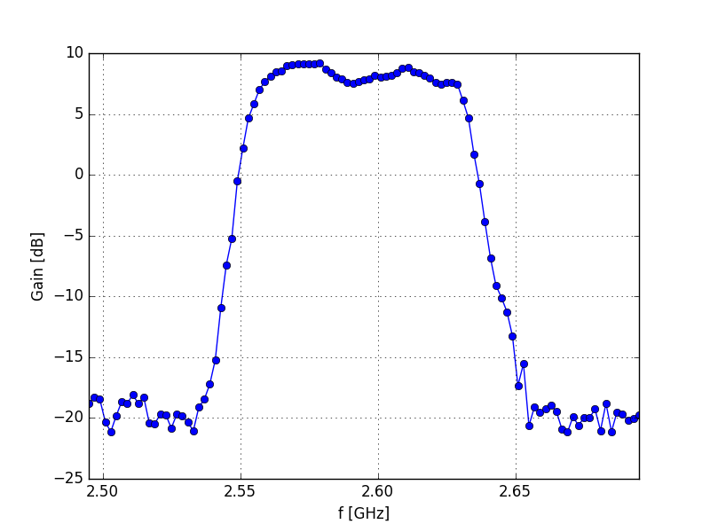 | 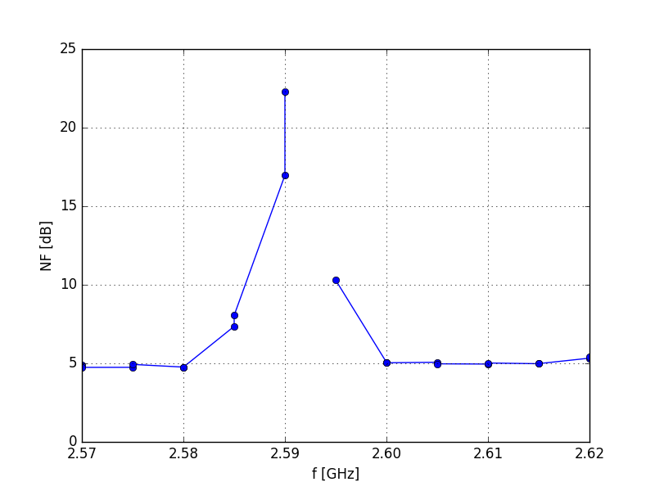
Figure 83: Gain | Figure 84: Noise Figure *
* Note: Extreme NF values resulted from inadequate EM isolation of the measured device. These values have not been taken into account in the Summary.
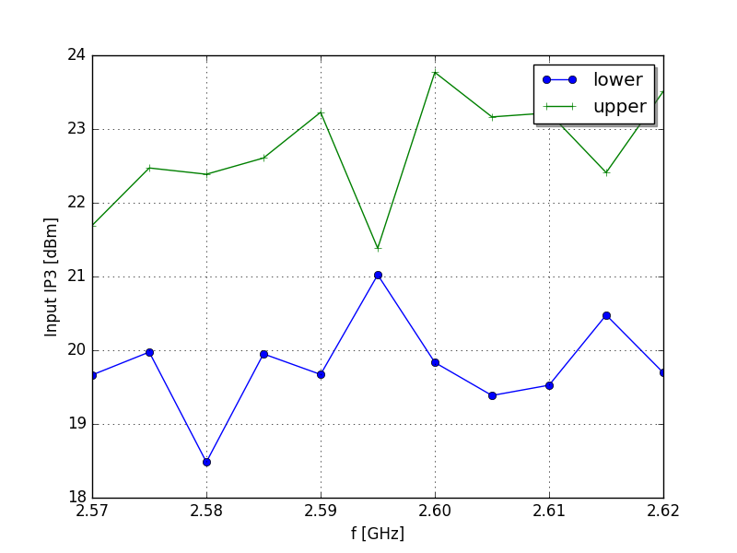
Figure 85: Input IP3

