**Lime Microsystems Limited**

Surrey Technology Centre

Occam Road

The Surrey Research Park

Guildford, Surrey GU2 7YG

United Kingdom

Tel: +44 (0) 1483 685 063

e-mail: [enquiries@limemicro.com](mailto:enquiries@limemicro.com)

**LimeSDR-X3 White Rabbit time pulse synchronization**

***- Configuration guide****-*

**REVISION HISTORY**

The following table shows the revision history of this document:

|  |  |  |
| --- | --- | --- |
| **Date** | **Version** | **Description of Revisions** |
| 10/11/2023 | 1.00 | Initial version |
|  |  |  |
|  |  |  |
|  |  |  |
|  |  |  |
|  |  |  |
|  |  |  |
|  |  |  |
|  |  |  |
|  |  |  |
|  |  |  |
|  |  |  |
|  |  |  |
|  |  |  |

**Table of Contents**

1 Introduction 4

2 Requirements 5

2.1 Board setup 5

2.2 WRPC core setup 6

2.2.1 First boot 6

2.2.2 Initializing EEPROM memory 7

2.2.3 Adding SFP part number into DB 7

2.2.4 WRPC initialization script creation 9

2.2.5 WRPC t24p value calibration 10

2.2.6 Performance evaluation 11

# Introduction

White Rabbit (WR) provides sub-nanosecond accuracy and picoseconds precision of synchronization for large distributed systems. In LimeSDR-X3 FPGA design White Rabbit PTP Core (WRPC) is used to synchronize “Time pulse” signal between two boards and synchronize startup of data transmit/receive.

This document provides list of required hardware/software and configuration steps to run WRPC core.

To successfully run WRPC core following steps are covered in this document:

* Hardware setup
* Adding SFP tranceiver part number and parameters into WRPC database
* WRPC mode configuration and initialization script creation
* One time t24p phase transition value calibration
* Performance evaluation

# Requirements

Required hardware can be found below:

* **2x LimeSDR-X3 boards**  – One board as master, second as slave
* **2x USB-to-Serial converters**– To access WR terminal and configure WR core. 3.3V interface levels.
* **1x Pair of SFP transceivers** – Pairs with 1310/1490 wavelength and single LC connector
* **1x Fiber optic patch cable** – With LC UPC / LC UPCconnectors, simplex.

Required software:

* **“Tera Term”** – or any other preferred terminal emulator for serial connection.

## Board setup

For simplicity one LimeSDR-X3 (board A) is chosen to be master and other LimeSDR-X3 (board B) – slave.

Before powering up LimeSDR-X3 board connect required hardware:

* Insert SFP transceivers into J24 SFP cage. SFP transceiver marked with violet color should be inserted into master board A, transceiver with blue color should be inserted into slave board B. See Figure 1.
* Connect master and slave boards with fiber optic patch cable. See Figure 1
* Connect USB-to-Serial converters to J19 PMOD_B connectors on both boards:

PMOD_B_PIN9 (WR TX) - USB-to-Serial (RX)

PMOD_B_PIN10 (WR RX) - USB-to-Serial (TX)

PMOD_B_PIN11 (GND) - USB-to-Serial (GND)

* Make sure that FPGA SWITCH SW1(1) is set into OFF position (See Figure 1), otherwise WR core will not start.

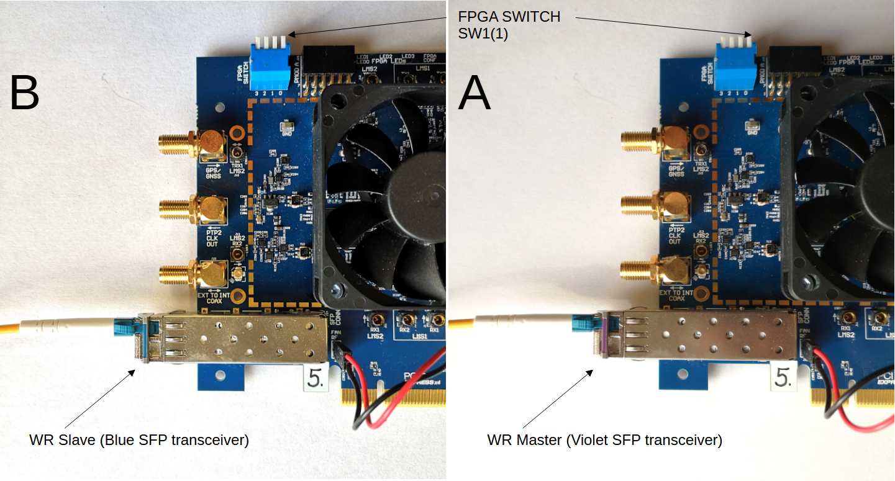Figure 1: Hardware setup

## WRPC core setup

### First boot

Connect USB-to-Serial converters to host PC and setup serial connections with following parameters for both bards:

* Speed - 115200
* Data - 8bit
* Parity - none
* Stop bits - 1 bit
* Flow control - none

Both terminals should be kept open, later they will be used to configure WRPC in both boards.

After power is applied WRPC core prints debug information into serial terminal, see Figure 1. Since “Init script” is empty WRPC core automatically starts in Slave mode. On first startup some error message will be printed which will be resolved by following configuration steps described in other chapters.

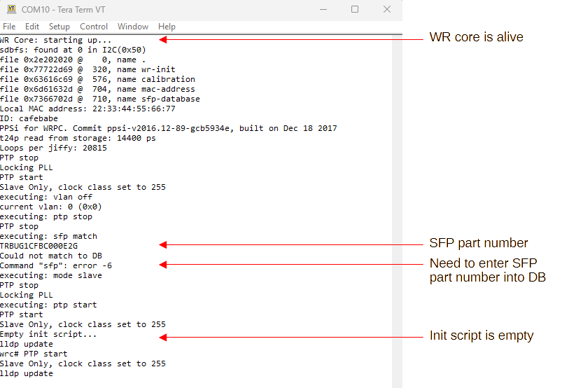Figure 2: WR core first boot

### Initializing EEPROM memory

EEPROM memory for storing WRPC configuration has to be initialized before use. This can be done by executing following command:

|  |
| --- |
| **Commands:**  sdb fs <MEM> <BASE ADDR> <EEPROM ADDR>  **Example:**  sdb fs 1 0 80  **NOTE:**  * Example is for LimeSDR-X3 v1.1 hardware  * <MEM> - Memory type, 1 - I2C EEPROM  * <BASE ADDR> - base address (depends from hardware)  * <EEPROM ADDR> - the decimal representation of 1010_000, the EEPROM I2C address and ID (depends from hardware) |

### Adding SFP part number into DB

SFP part number and calibration parameters has to be stored into WRPC database. Calibration parameters can be extracted by following calibration procedure described in [WR_Calibration-v1.1-20151109.pdf](https://white-rabbit.web.cern.ch/documents/WR_Calibration-v1.1-20151109.pdf) . If WRPC master and slave are connected with few meters of fiber patch cable calibration procedure can be skipped and zeros can be entered instead of real calibration parameters. Add both SFP transceivers into each board WRPC database.

To enter SFP into WRPC database execute commands:

|  |
| --- |
| **Commands:**  ptp stop  sfp match  sfp add <part number> <d TX> <d RX> <alpha>  sfp match  **Example:**  ptp stop  sfp match  sfp add TRBUG1CFBC000E2G 0 0 0  sfp match  **NOTE:**  * <part number> can be retrieved with sfp match command.  * Zeros can be entered for <d TX> <d RX> <alpha> parameters  * After successfully adding SFP into DB sfp match command should return no errors. |

Command description can be found in Table 1.

Table 1 SFP Database related WR terminal commands

|  |  |
| --- | --- |
| **Command** | **Description** |
| sfp erase | Erase SFP database |
| sfp match | Check SFP transceiver if it is present in database |
| sfp add <part n> <d TX> <d RX> <alpha> | Add SFP transceiver calibration parameters |
| sfp show | Show SFP transceiver database |

### WRPC initialization script creation

Both LimeSDR-X3 boards uses same programming file and has to be configured to operate as WRPC master or Slave trough WR terminal. If board has SFP transceiver with violet color marking configure it as a Master, if blue SFP – configure as slave. This is one time setup because configuration is stored into onboard EEPROM memory and loaded each time when WRPC core starts.

To configure WRPC core as master/slave add commands to “Init script” by executing these commands:

|  |
| --- |
| **Commands:**  ptp stop  init erase  init add ptp stop  init add mode <master/slave>  init add sfp match  init add ptp start  **Example:**  ptp stop  init erase  init add ptp stop  init add mode <master/slave>  init add sfp match  init add ptp start  **NOTE:**  * <master/slave> - if board has SFP transceiver with violet color marking configure it as a Master, if blue SFP – configure as slave. |

Table 2 SFP Database related WR terminal commands

|  |  |
| --- | --- |
| **Command** | **Description** |
| init erase | Erase user init script from EEPROM |
| init add <cmd> | Add command to user init scripts into EEPROM |
| init boot | Restart WRPC and execute init scrip |

### WRPC t24p value calibration

WRPC needs to make a calibration of t24p phase transition value. It has to be done only once for a new bitstream and is performed automatically when WRPC runs in the Slave mode. That is why it is very important, even if WRPC is meant to run in the Master mode, to configure it to Slave for a moment and connect to any WR Master. This has to be repeated every time a new bitstream (gateware) is deployed. The measured value is automatically stored to Flash/EEPROM and used later in the Master or GrandMaster mode.

After following previous chapters at this point user should have added SFP into WRPC database, created initialization scripts and should have flowing default hardware setup:

Table 3: Default setup

|  |  |  |
| --- | --- | --- |
|  | **Board A** | **Board B** |
| WRPC mode | Master | Slave |
| SFP transceiver | violet | blue |

In order to perform t24p value calibration:

* stop WRPC core with ptp stop command
* Exchange SFP transceivers and WRPC mode as described in Table 4.

Table 4: t24p calibration setup

|  |  |  |
| --- | --- | --- |
|  | **Board A** | **Board B** |
| WRPC mode | Slave | Master |
| SFP transceiver | blue | violet |

WRPC mode on the fly can be changed with following commands:

|  |
| --- |
| **Commands:**  ptp stop  mode <master/slave>  sfp match  sfp start  **Example (master):**  ptp stop  mode master  sfp match  sfp start  **Example (slave):**  ptp stop  mode slave  sfp match  sfp start |

### Performance evaluation

At this point user should have added SFP into database, created initialization scripts and performed t24p value calibration.

In order run WRPC:

* Stop WRPC core with ptp stop command
* Exchange SFP transceivers and WRPC mode to default setup as described in Table 5
* Run initialization script with init boot command or reapply power to boards.

Table 5: Default setup

|  |  |  |
| --- | --- | --- |
|  | **Board A** | **Board B** |
| WRPC mode | Master | Slave |
| SFP transceiver | violet | blue |

Figure 3 shows WR terminal print results after executing init boot command.

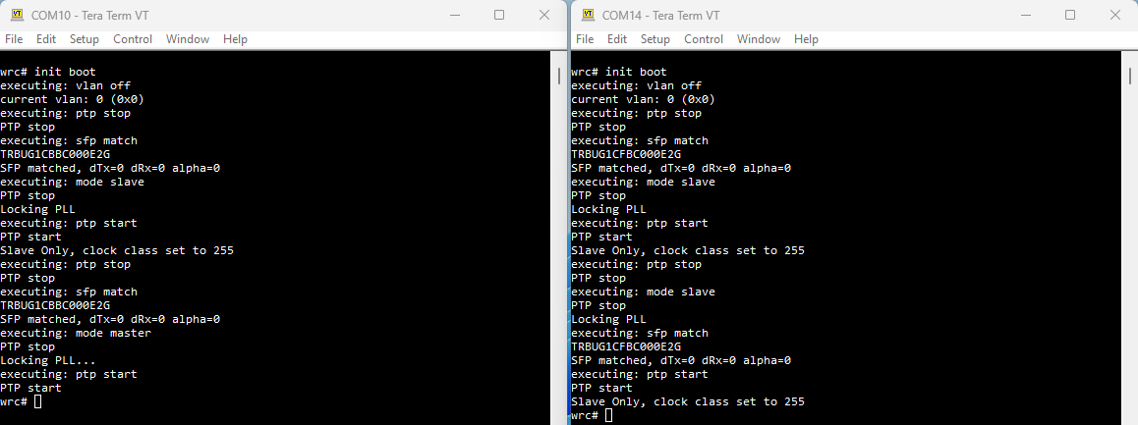Figure 3: Boot results

Open detailed synchronization log (Figure 4) by executing gui command on WR terminals. Check on slave board **Synchronization status** -> **Servo state** = **TRACK_PHASE**

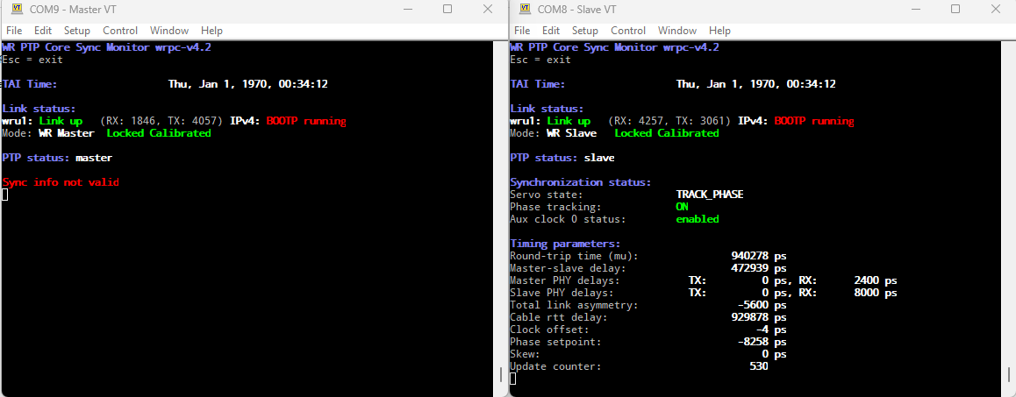Figure 4: Detailed synchronization status

Connect oscilloscope probes to both LimeSDR-X3 boards J25 connectors and observe aligned time pulse signals on both boards it should be less than 1ns (Figure 5).

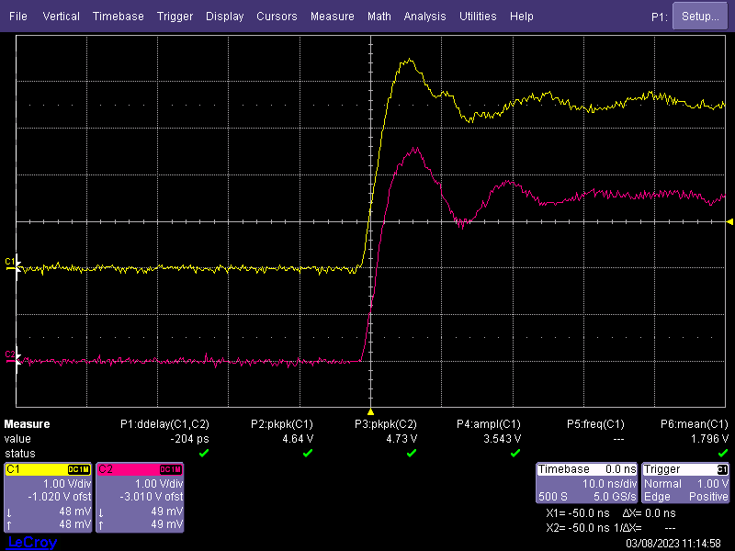Figure 5: Time pulse alignment