

Lime Suite Software

- Compilation guide -

Document version: | 1.00
Document revision: | 07
Last modified: | 1/23/2017 11:57:16 AM

Contents

1. Introduction 4
2. Windows OS 5
2.1. wxWidgets installation 5
2.2. Cypress EZ-USB FX3 SDK installation 6
2.3. Compiling Lime Suite 6
2.4. Running Lime Suite 7
3. Linux OS (Ubuntu) 9
3.1. Required libraries and tools 9
3.2. wxWidgets installation on Linux 10
3.3. Compiling Lime Suite 10
3.4. Running Lime Suite 11

Revision History

Version v01r01
Started: 3 Apr, 2015
Initial version

Version v01r02
Started: 3 Jul, 2015
Changed linux command line for compiling lms7suite

Version v01r03
Started: 11 April, 2016
Updated compilation instructions

Version v01r04
Started: 12 April, 2016
Detailed/fixed compilation commands

Version v01r05
Started: 18 April, 2016
Add run instructions

Version v01r06
Started: 23 August, 2016
Updated compilation instructions

Version v01r07
Started: 23 January, 2017
Changed naming form 'LMS7 Suite' to 'Lime Suite'
Updated compilation instructions

Introduction
The scope of this document is compilation of the Lime Suite using CMake under MS Windows OS and Linux OS. Because wxWidgets library is used for user interface, wxWidgets library set-up and compilation is discussed first. Then detailed procedure of Lime Suite compilation is provided.

When compiling LMS API library only (without GUI application) wxWidgets library is not required. If Cmake is not able to find wxWidgets library, LimeSuiteGUI application will not be compiled when compiling Lime Suite.

wxWidgets 3.0.2 library is used in this description (wxWidgets-3.0.2.zip).

Windows OS
This chapter contains instructions for installation and compilation of WxWidgets library, installation of Cypress USB SDK and compiling Lime Suite on Windows operating system.
Compiling is done using Microsoft Visual Studio 2013.
  - wxWidgets installation
Step by step instructions of how to install, prepare and compile wxWidgets library are provided bellow:

- Go to http://wxwidgets.org/downloads/ and download source code for Windows.
- Install wxWidgets library to the ‘C:\wxWidgets-3.0.2\’ directory.You can choose another install directory but instructions in this guide assumes wxWidgets to be installed in ‘C:\wxWidgets-3.0.2\’.
- Go to ‘C:\wxWidgets-3.0.2\build\msw’ directory and open ‘wx_vc10.sln’ project file.
NOTE: wxWidgets 3.0.2 does NOT compile with Visual Studio 2015, use Visual Studio 2013 instead.
- Change project configuration to Release as shown in Figure 1
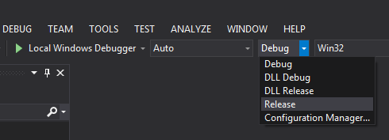
Figure 1 wxWidgets build configuration
- In Visual Studio top menu select BUILD->Build Solution as shown in Figure 2.
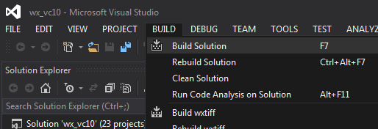
Figure 2 Compiling wxWidgets
- Compilation process will start right now. It will take some time to compile the library wait until this process is complete, please.
  - Cypress EZ-USB FX3 SDK installation
- Go to http://www.cypress.com/?rID=57990 and download EZ-USB FX3 SDK for Windows.
- Install SDK into desired directory.
  - Compiling Lime Suite
The steps 1 and 2 can be skipped if you already have Lime Suite package and this document came together with it. If you only have this document then proceed with steps 1 and 2 to obtain Lime Suite package.

- If Git is not already installed on your PC, download it from https://git-scm.com/download/win and install using default setting.
- Obtain source code from git repository. Open Git Bash (right-click in file explorer and choose “Git Bash Here”) and type the following:
git clone https://github.com/myriadrf/LimeSuite
- Launch CMake-gui.
- Browse where the source code is located, and create directory inside where to build binaries as shown in Figure 3.
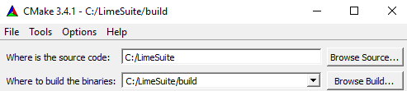
Figure 3 Selecting project source
- Click Configure button
- If wxWidgets installation directory is not detected CMake configuration will contain entries as shown in Figure 4. If you do not intend to compile LimeSuiteGUI you can ignore this and skip steps 6.1 and 6.2 to compile Lime Suite without GUI application.
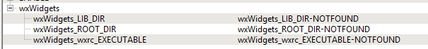
Figure 4 CMake can’t find wxWidgets
  - Select and replace wxWidgets_ROOT_DIR-NOTFOUND value with path to your wxWidgets installation directory (e.g. ‘C:/wxWidgets-3.0.2’)
  - Click Configure button again
- Click Generate button
- Go to ‘C:\LimeSuite\build\’ directory and open ‘LimeSuite.sln’ project file.
- Change project configuration to Release as shown in Figure 5.
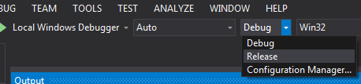
Figure 5 Lime Suite build configurations
- In Visual Studio top menu select BUILD->Build Solution.
- Compilation process will start right now. It will take some time to compile the software, please wait until this process is complete.
- Lime Suite binary files can be found in ‘C:/LimeSuite/build/bin/Release’ directory.

  - Running Lime Suite

- Navigate to ‘C:/LimeSuite/build/bin/Release’ directory
- Launch “LimeSuiteGUI.exe”
- From menu bar select: ‘Options->ConnectionSettings’ (Figure 6)

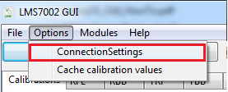
Figure 6 Opening connection settings
- Select the device to connect to and click “Connect” button (Figure 7).

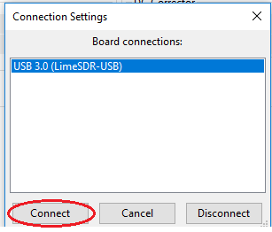
Figure 7 Connecting to device

Linux OS (Ubuntu)
This chapter contains instructions for installation and compilation of WxWidgets library and compiling Lime Suite on Ubuntu operating systems (tested on Ubuntu 14.04 LTS and Ubuntu 15.10). Compiling is done using CMake (v3.1.3+ required) and GCC tools.

  - Required libraries and tools
This is a list of required libraries and tools to compile wxWidgets and Lime Suite.
- CMake
- g++
- libusb-1.0
- libgtk2.0-dev
- libsqlite3-dev
- libi2c-dev
- freeglut3-dev
To install all these libraries and tools execute the following command in terminal:
sudo apt-get install cmake g++ libusb-1.0 libgtk2.0-dev libsqlite3-dev libi2c-dev freeglut3-dev

NOTE: (for Ubuntu 14.04 LTS only) currently executing the above command on Ubuntu 14.04 LTS installs CMake version 2.8. To install the required CMake version you need to compile it yourself or use PPA. To use PPA repository execute the following commands:
sudo apt-get install software-properties-common
sudo add-apt-repository ppa:george-edison55/cmake-3.x
sudo apt-get update
sudo apt-get install cmake

  - wxWidgets installation on Linux

Step by step instruction how to install, prepare and compile wxWidgets library is provided bellow. In this example the user home directory will be used as '/home/linuxuser'

- Download wxWidgets source code from http://wxwidgets.org/downloads/ (wxWidgets-3.0.2.tar.bz2)
- Create “libraries” directory in your home directory
- Extract wxWidgets-3.0.2 archive to '/home/linuxuser/'
- Open terminal and navigate to '/home/linuxuser//wxWidgets-3.0.2' directory
- Execute command “./configure --with-opengl”
- Execute command “make”
- Compilation process will start right now. It will take some time to compile the library, please wait until this process is complete.
- Execute command “sudo make install” and enter administrator password. This command will install and configure library paths.
- Now wxWidgets are installed and can be used for Lime Suite project.

  - Compiling Lime Suite
The steps 1 and 2 can be skipped if you already have Lime Suite package and this document came together with it. If you only have this document then proceed with steps 1 and 2 to obtain Lime Suite package.

- If git is not already installed on your PC, then install it (otherwise skip this step):
sudo apt-get install git
- Obtain source code from git repository:
git clone https://github.com/myriadrf/LimeSuite
- Go to 'LimeSuite' directory:
cd LimeSuite
- Go to the 'build' directory:
cd build
- Inside the 'build' directory execute command:
cmake ..
- Inside the 'build' directory execute command:
make
- Wait for the compilation process to complete
- To install Lime Suite on your system execute:
sudo make install
- Lime Suite binary files can be found in '/home/linuxuser/LimeSuite/build/bin' directory

  - Running Lime Suite

- Open terminal and navigate to '/home/linuxuser/LimeSuite/build/bin' directory.
- Run LimeSuiteGUI with root privileges:
sudo ./LimeSuiteGUI
- From menu bar select: 'Options->ConnectionSettings' (Figure 8)

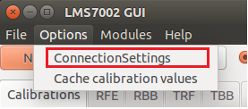
Figure 8 Opening connection settings
- Select the device to connect to and click 'Connect' button (Figure 9).

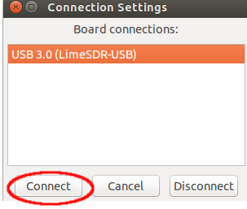
Figure 9 Connecting to device

