


LMS7Suite Software

- Compilation guide -

Document version: | 1.00
Document revision: | 04
Last modified: | 4/12/2016 02:08:00 PM

Contents

- Introduction 4
- Windows OS 5
2.1 wxWidgets installation 5
2.2 Cypress EZ-USB FX3 SDK installation 6
2.3 Compiling LMS7 Suite 6
- Linux OS 8
3.1 wxWidgets installation on Linux 8
3.2 Compiling LMS7 Suite 9

Revision History

Version v01r01
Started: 3 Apr, 2015
Initial version

Version v01r02
Started: 3 Jul, 2015
Changed linux command line for compiling lms7suite

Version v01r03
Started: 11 April, 2016
Updated compilation instructions

Version v01r04
Started: 12 April, 2016
Detailed/fixed compilation commands

Introduction
The scope of this document is compilation of the LMS7 Suite using CMake under MS Windows OS and Linux OS. Because wxWidgets library is used for user interface, wxWidgets library set-up and compilation is discussed first. Then detailed procedure of LMS7 Suite compilation is provided.

wxWidgets 3.0.0 library is used in this description (wxWidgets-3.0.0.zip).

Windows OS
This chapter contains instructions for installation and compilation of WxWidgets library, installation of Cypress USB SDK and compiling LMS7 Suite on Windows operating system.
Compiling is done using Microsoft Visual Studio 2013.
  - wxWidgets installation
Step by step instruction how to install, prepare and compile wxWidgets library is provided bellow:

- Go to http://wxwidgets.org/downloads/ and download source code for Windows.
- Install wxWidgets library to the C:\libraries\wxWidgets-3.0.0\ directory.
- Go to C:\libraries\wxWidgets-3.0.0\build\msw directory and open wx_vc10.sln project file.
NOTE: wxWidgets does NOT compile with Visual Studio 2015, use Visual Studio 2013 instead.
- Change project configuration to Release as shown in Figure 1
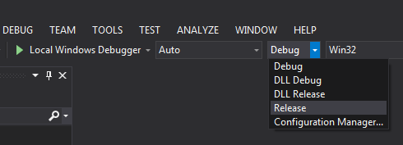
Figure 1 wxWidgets build configuration
- In Visual Studio top menu select BUILD->Build Solution as shown in Figure 2.
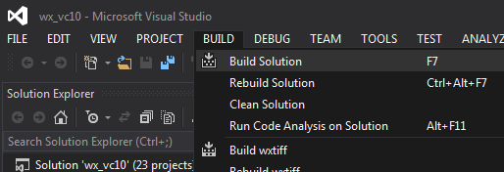
Figure 2 Compiling wxWidgets
- Compilation process will start right now. It will take some time to compile the library wait until this process is complete, please.
  - Cypress EZ-USB FX3 SDK installation
- Go to http://www.cypress.com/?rID=57990 and download EZ-USB FX3 SDK for Windows.
- Install SDK into desired directory.
  - Compiling LMS7 Suite
- If Git is not already installed on your PC, download it from https://git-scm.com/download/win and install using default setting.
- Obtain source code from git repository. Open Git Bash (right-click in file explorer and choose “Git Bash Here”) and type the following:
git clone https://github.com/limemicro/lms7suite
- Go to lms7suite directory:
cd lms7suite
- Lms7suite uses cpp-feather-ini-parser as submodule, execute this command to download it's source code:
git submodule update --init --recursive
- Launch CMake-gui.
- Browse where the source code is located, and create directory inside where to build binaries as shown in Figure 3.
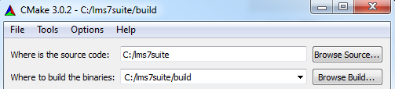
Figure 3 Selecting project source
- Click Configure button
- If wxWidgets installation directory is not detected CMake will return error as shown in Figure 4.
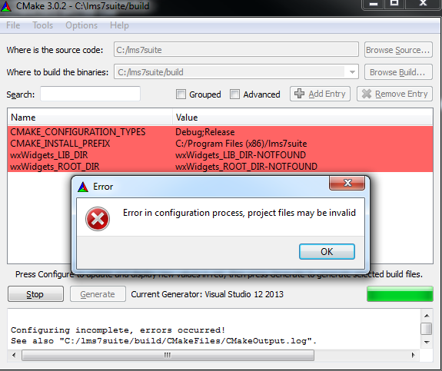
Figure 4 CMake can’t find wxWidgets
- Select and replace wxWidgets_ROOT_DIR-NOTFOUND value with path to your wxWidgets installation directory (e.g. D:/Libraries/wxWidgets-3.0.0)
- Click Configure button again
- Click Generate button
- Go to C:\lms7suite\build\ directory and open lms7suite.sln project file.
- Change project configuration to Release as shown in Figure 5.
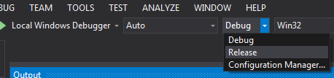
Figure 5 LMS7Suite build configurations
- In Visual Studio top menu select BUILD->Build Solution.
- Compilation process will start right now. It will take some time to compile the software, please wait until this process is complete.
- LMS7Suite binary file can be found in C:/lms7suite/build/bin/Release directory.

Linux OS
This chapter contains instructions for installation and compilation of WxWidgets library and compiling LMS7 Suite on Linux operating system. Compiling is done using CMake and GCC tools.
  - Required libraries
This is a list of required libraries to compile wxWidgets and LMS7Suite.
- Libusb-1.0
- libgtk2.0-dev
- libsqlite3-dev
To install these libraries execute the following command in terminal:
“sudo apt-get install libusb-1.0 libgtk2.0-dev libsqlite3-dev”
  - wxWidgets installation on Linux

Step by step instruction how to install, prepare and compile wxWidgets library is provided bellow. In this example the user home directory will be used as /home/linuxuser

- Download wxWidgets source code from http://wxwidgets.org/downloads/ (wxWidgets-3.0.0.tar.bz)
- Create “libraries” directory in your home directory
- Extract wxWidgets-3.0.0 archive to /home/linuxuser/libraries directory
- Open terminal and navigate to /home/linuxuser/libraries/wxWidgets-3.0.0 directory
- Execute command “./configure”
- Execute command “make”
- Compilation process will start right now. It will take some time to compile the library, please wait until this process is complete.
- Execute command “sudo make install” and enter administrator password. This command will install and configure library paths.
- Now wxWidgets are installed and can be used for LMS7Suite project.

  - Compiling LMS7 Suite
- If git is not already installed on your PC, then install it (otherwise skip this step):
sudo apt-get install git
- Obtain source code from git repository:
git clone https://github.com/limemicro/lms7suite
- Go to lms7suite directory:
cd lms7suite
- Lms7suite uses cpp-feather-ini-parser as submodule, execute this command to download it's source code:
git submodule update --init --recursive
- Go to the directory where the source code is located (/home/linuxuser/lms7suite/build)
- Inside the build directory execute command:
“cmake ../src –DCMAKE_BUILD_TYPE=Release”
- Inside the build directory execute command “cmake --build . ”
- Wait for the compilation process to complete
- LMS7Suite binary file can be found in /home/linuxuser/lms7suite/build/bin directory

