RFDIO Connector
Specification
v1.0

Copyright 2014 Lime Microsystems Ltd

CC BY 3.0

Contents
1General Description 3
2Mechanical Specifications 3
3Electrical Specifications 5
3.1Power 5
3.2CMOS Signals 5
3.3Bus Widths 5
3.4Termination 5
3.5Pinout 5

Table of Figures
Figure 1. RFDIO connectors 3
Figure 2. Recommended PCB footprint 5
Figure 3. MyriadRF card mechanical coordinates (Top view) 5

The information contained in this document is subject to change without prior notice. No responsibility for its use, nor for infringement of patents or other rights of third parties is assumed.

The information contained in this document is subject to change without prior notice. No responsibility for its use, nor for infringement of patents or other rights of third parties is assumed.

General Description

The Myriad-RF Radio Frequency Digital Input Output (RFDIO) connector specification defines the electrical and mechanical properties of a high speed card interface for Field Programmable Gate Array (FPGA) based carrier boards. This specification ensures interoperability between carrier (mother) boards and add-on (daughter) RF cards.

The connector is designed to meet the IEEE802.3ap backplane link to meet 10G Ethernet compliant signal channels.

Mechanical Specifications

The connector is based on the Hirose 0.5 mm pitch, 80 positions, surface-mount connector. The part numbers are:

The female part number is FX10A-80S/8-SV, to be assembled on the motherboard. The male part number is FX10A-80P/8-SV1, and is to be used by the daughterboard. A typical example of use for an RF application is an Altera FPGA motherboard, using a Myriad-RF daughterboard. This example with be used in the document for clarity.

Figure 1 shows the connectors in 3-D view.

Figure 1. RFDIO connectors

Figure 2 shows the recommended land pattern (Metal Mask) connector dimensions.

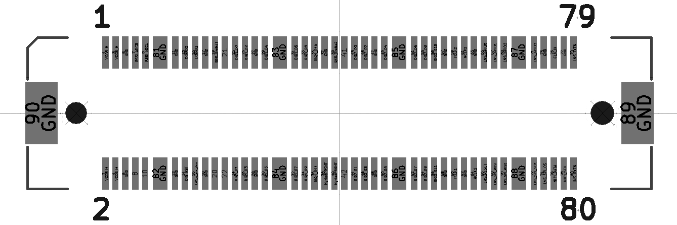
1.6
0.3
0.7
0.5
0.75
3.05
3.1
1.6
13.2
14.95
1.1 NPTH
1.2 NPTH
Figure 2. Recommended PCB footprint

A footprint for the open source EDA software, KiCad, is available via the database provided by the Myriad-RF Component Libraries project.

Figure 3 shows the dimensions of the Myriad-RF 1 daughterboard with the Hirose connector.

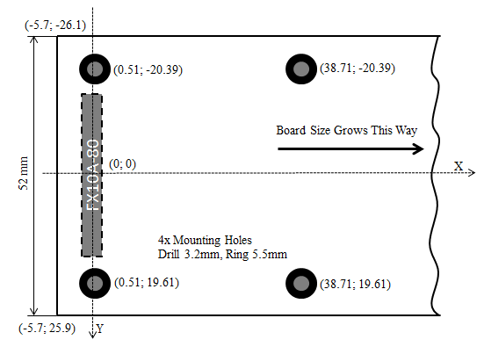
Figure 3. Myriad-RF card mechanical coordinates (Top view)

Electrical Specifications

Power
The carrier board must provide +5V (1.5A) DC to the RF card through the RFDIO connector. The maximum current via the Hirose connector is 0.3A per pin. To achieve the 1.5A specification, a number of defined supply and ground pins must be used. These are:

+5V: Pin 1, 2, 3, 4, 8 & 10.

GND: Pin 5, 6, 11, 12, 17, 18, 27, 28, 37, 38, 47, 48, 57, 58, 62, 63, 73, 77, 81, 82, 83, 84, 85, 86, 87, 88, 89 & 90

CMOS Signals
The CMOS class pins are intended to connect directly to pins that support LVTTL compatible single-ended I/O standards such as 3.3-V LVTTL/LVCMOS or 2.5-V LVTTL/LVCMOS.

All CMOS class pins must support bidirectional operation.

Signals between the host FPGA device and HSMC connector are intended to be D/C coupled.

Bus Widths
Daughterboards must be designed to support the full specified bus widths. This will guarantee interoperability with the greatest number of RF cards.

Termination
Tracks must have 50 Ω single-ended impedances. An optimum design will be obtained if the host FPGA supports driver strength control where 50 Ω output impedances can be selected. This output impedance will match the characteristic impedance of the tracks themselves. For long track lengths or heavy loads, drive strength may be increased as necessary until optimal signal integrity is achieved for the specific carrier board or RF card combination. When impedance control is not possible, it is recommended to place series resistors on each line of the host board to allow for tuning through resistor value changes. Default resistors should be a nominal 0 Ω since signal direction cannot be assumed on a carrier board and higher value resistors found near a receiver can significantly degrade signal integrity.

Pinout
The RFDIO connector has a total of 90 pins, including 54 digital signals pins, 6 power pins, 2 analog pins and 28 ground pins.

Table 1 (Part 1 of 2). RFDIO connector’s pinout

Pin Nr | Function | Description | Pin Nr | Function | Description
1 | 5V | Power | 2 | 5V | Power
3 | 5V | Power | 4 | 5V | Power
5 | GND | Power | 6 | GND | Power
7 | RSSI output | analog | 8 | 5V | Power
9 | RSSI output | analog | 10 | 5V | Power
81 | GND | Power | 82 | GND | Power
11 | GND | Power | 12 | GND | Power
13 | TXNRX2 | CMOS IN | 14 | GPIO5 | CMOS IO
15 | TXNRX1 | CMOS IN | 16 | G_PWR_DWN | CMOS IN
17 | GND | Power | 18 | GND | Power
19 | ENABLE_IQSEL1 | CMOS IN | 20 | GPIO6 | CMOS IO
21 | SPI_EN_BRD | CMOS IN | 22 | GPIO7 | CMOS IO
23 | DIQ1_D0 | CMOS IO | 24 | DIQ1_D1 | CMOS IO
25 | DIQ1_D2 | CMOS IO | 26 | DIQ1_D3 | CMOS IO
27 | GND | Power | 28 | GND | Power
29 | DIQ1_D4 | CMOS IO | 30 | DIQ1_D5 | CMOS IO
83 | GND | Power | 84 | GND | Power
31 | DIQ1_D6 | CMOS IO | 32 | DIQ1_D7 | CMOS IO
33 | DIQ1_D8 | CMOS IO | 34 | DIQ1_D9 | CMOS IO
35 | DIQ1_D10 | CMOS IO | 36 | DIQ1_D11 | CMOS IO
37 | GND | Power | 38 | GND | Power
39 | ENABLE_IQSEL2 | CMOS IN | 40 | BRDPRSNT | Board present, connects to GND on RF card
41 | GPIO4 | CMOS IO | 42 | VIO | Digital IOs supply
43 | DIQ2_D0 | CMOS IO | 44 | DIQ2_D1 | CMOS IO
45 | DIQ2_D2 | CMOS IO | 46 | DIQ2_D3 | CMOS IO
47 | GND | Power | 48 | GND | Power
49 | DIQ2_D4 | CMOS IO | 50 | DIQ2_D5 | CMOS IO
85 | GND | Power | 86 | GND | Power
51 | DIQ2_D6 | CMOS IO | 52 | DIQ2_D7 | CMOS IO
53 | DIQ2_D8 | CMOS IO | 54 | DIQ2_D9 | CMOS IO
55 | DIQ2_D10 | CMOS IO | 56 | DIQ2_D11 | CMOS IO
Table 1 (Part 2 of 2). RFDIO connector’s pinout

Pin Nr | Function | Description | Pin Nr | Function | Description
57 | GND | Power | 58 | GND | Power
59 | FCLK2 | CMOS CLK in | 60 | FCLK1 | CMOS CLK in
61 | MCLK2 | CMOS CLK out | 62 | GND | Power
63 | GND | Power | 64 | MCLK1 | CMOS CLK out
65 | GPIO0 | CMOS IN | 66 | RESET | CMOS IN
67 | GPIO1 | CMOS IN | 68 | SPI_MOSI | CMOS IN
69 | GPIO2 | CMOS IN | 70 | SPI_MISO | CMOS OUT
87 | GND | Power | 88 | GND | Power
71 | GPIO3 | CMOS IN | 72 | SPI_CLK | CMOS IN
73 | GND | Power | 74 | SPI_EN_LMS | CMOS IN
75 | CLK_IN | CMOS Reference CLK input for RF card | 76 | MIPI_SDA | CMOS IO
77 | GND | Power | 78 | MIPI_SCL | CMOS IN
79 | TXEN | CMOS IN | 80 | RXEN | CMOS IN
89 | GND | Power | 90 | GND | Power

*for complete signals description and timing diagrams refer to LMS6002D or LMS7002M datasheet

