RASDR
Distribution 1.2.3
October 10, 2015

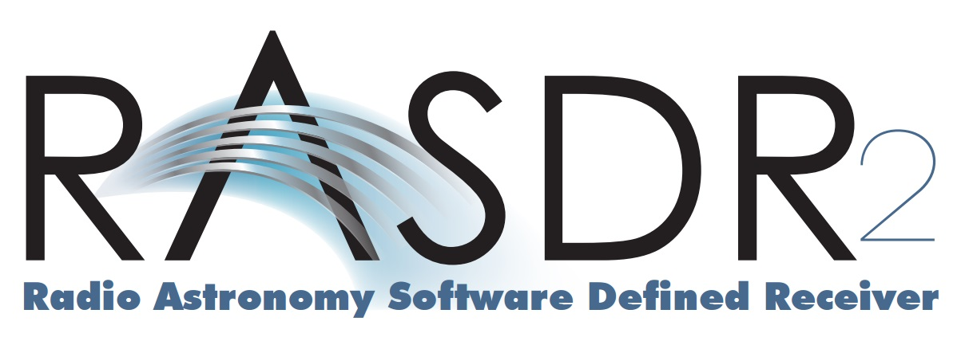
RASDR
Distribution 1.2.3
October 10, 2015

