
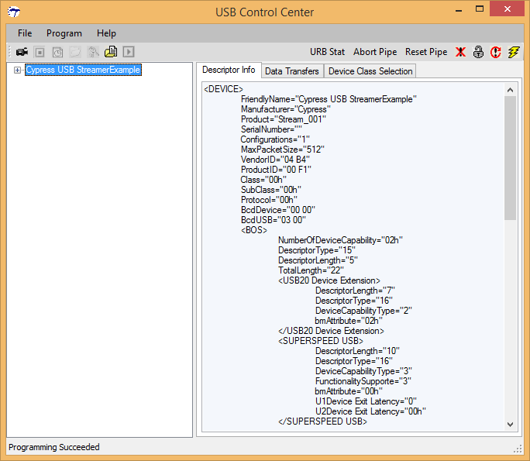
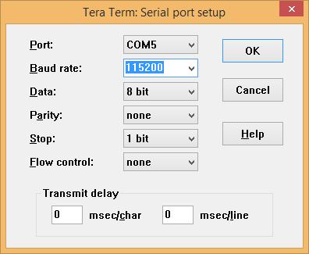
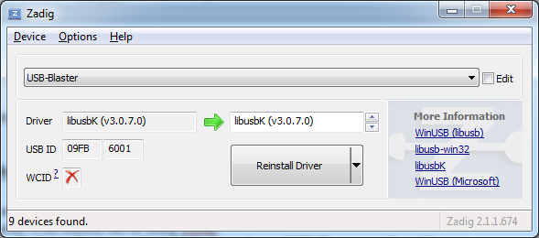
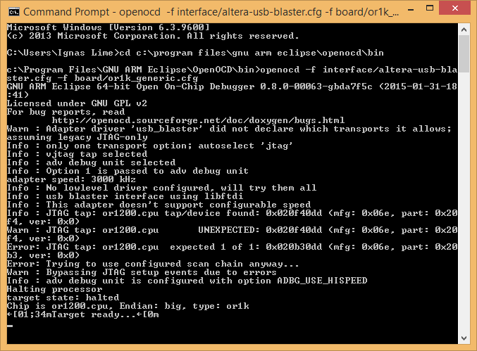
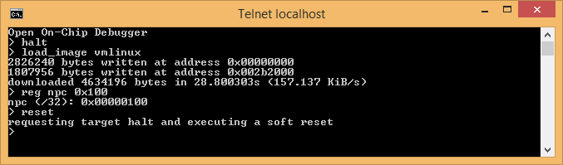
Lime Microsystems Limited

Surrey Technology Centre
Occam Road
The Surrey Research Park
Guildford, Surrey GU2 7YG
United Kingdom

Tel: +44 (0) 1483 685 063
Fax: +44 (0) 1428 656 662
e-mail: enquiries@limemicro.com

STREAM Development kit
User Guide

- User Guide for Linux OS Installation -

REVISION HISTORY

The following table shows the revision history of this document:

Date | Version | Description of Revisions
27/02/2015 | 1.0 | Initial version
03/04/2015 | 1.1 | Added document licence info (Creative Commons Attribution 3.0 Unported)

Table of Contents

1Requirements 5
2Step by step instructions 5
Step 1. Installing USB drivers 5
Step 2. Load FX3 firmware 6
Step 3. LMS7Suite for FPGA programming 6
Step 4. Serial connection setup 7
Step 5. Altera USB Blaster 7
Step 6. OpenOCD installation 8
Step 7. Installing Linux 8

Table of Figures

Requirements

Required Software:
- CyControl (Cypress USB control center)
- OpenOCD (>=0.8.0)
- Tera Term
- Zadig

Required Hardware:
- Altera USB Blaster
- 3.3V USB-to-Serial cable
- USB A to microB cable

Current manual describes how to load Linux image to FPGA via FX3 controller.
Information regarding software architecture and links to source codes are available in \Stream\stream_openrisc_soc_v2\doc directory.

Step by step instructions

Step 1. Installing USB drivers

Use J2 USB3.0 to connect to PC.
To install Cypress FX3 USB3.0 (IC6) drivers navigate driver installer to \Stream\Stream_LMS7EVB_distro_05v\fx3\drivers\bin\

Step 2. Load FX3 firmware

Run CyControl from \Stream\Stream_LMS7EVB_distro_05v\fx3\software
Press Program → FX3 → RAM → navigate to …\fx3\firmware_img\usb_trx_V2 → Open.
“Cypress USB BootLoader” should change to “Cypress USB StreamerExample”.

Figure . CyControl Cypress USB StreamerExample should appear

Step 3. LMS7Suite for FPGA programming

Run LMS7Suite from \Stream\Stream_LMS7EVB_distro_05v\gui directory.
Go to Options → Connection Settings → Cypress USB StreamerExample (Stream) → OK
Now connection between FX3 controller and PC is set.
Now it is time to load RISC architecture in to FPGA: go to Programming section. Press Open and navigate to \Stream\stream_openrisc_soc_v2\bin\stream.rbf. Press Program.

Figure . FPGA programming via LMS7Suite

Step 4. Serial connection setup
Connect 3.3V USB-to-Serial cable to J1 (FPGA GPIOs header).
Pin 1: FPGA RX pin (orange)
Pin 3: FPGA TX pin (yellow)
Pin 10: GND (black)
Establish connection using Tera Term via Serial Port.
Figure . Tera Term Serial Port setup
FPGA is not ready yet, so Terminal window is empty.

Step 5. Altera USB Blaster

Connect Altera USB Blaster to J23 FPGA JTAG header.
Install USB-Blaster driver using Zadig.
Run Zadig → Options → List All Devices. Select USB-Blaster and libusbK driver.

Figure . Zadig driver installer

Step 6. OpenOCD installation

Install OpenOCD.
Copy vmlinux (Linux image) from \stream_openrisc_soc_v2\bin to OpenOCD installation directory C:\Program Files\GNU ARM Eclipse\OpenOCD\bin
Run Windows Command Prompt.
Change current directory to OpenOCD installation directory:
cd C:\Program Files\GNU ARM Eclipse\OpenOCD\bin
Launch OpenOCD with:
Openocd –f interface/altera-usb-blaster.cfg –f board/or1k_generic.cfg

Figure . Launching OpenOCD

Step 7. Installing Linux

Turn ON Windows Telnet (Control Panel → Programs → Turn Windows features on or off)
Open a new Command Prompt window and connect to the OpenOCD proxy with telnet localhost 4444.
Run the following command to load the Linux image halt; load_image vmlinux; reg npc 0x100; reset.
Figure . Loading Linux image
The Linux boot process should now start in the terminal connected to the serial console.
After the boot is complete you should be greeted by a message saying Please press Enter to activate this console.
Press Enter and you can start using Linux commands.

Figure . Linux loading completed

